Our Wildlife Fact Sheet
  - Galah

The Galah is one of the most abundant bird species in Australia, occurring across most of the mainland as well as some off-shore islands.
Scientific name
Cacatua roseicapilla
Did you know?
Both male and female Galahs look the same. You can only tell the difference by the colour of their eyes; the males have brown eyes while the females have red.

Galahs are popular cage birds worldwide, also known as Rose-breasted or Roseate Cockatoos in some areas.

Galahs are sometimes considered a pest in grain growing areas because of the damage they can cause to crops. They are often observed eating grain spilt on roads or open-air storage that is awaiting transport.

Galahs are monogamous meaning that they will stay with the same breeding partner for life.

The word ‘Galah’ is Australian slang for fool or simpleton.
Description
Galahs range in size from 34 – 38 cm.

The Galah is quite easy to identify by its pink face and chest, with pale grey back and rump and a paler pink crown on its head. Juvenile Galahs will have a grey breast and back.

In areas of abundant food sources, Galahs are commonly found in huge flocks of 500 - 1000 birds, which can be very noisy.
Diet
The Galah feeds on seed from the ground as well as nuts, berries, fruit, roots and grubs. Other food sources include seed crops, especially wheat, oats and barley.
Galahs will forage for their food by sight. Feeding usually takes place after dawn, and before dusk during the cooler periods.

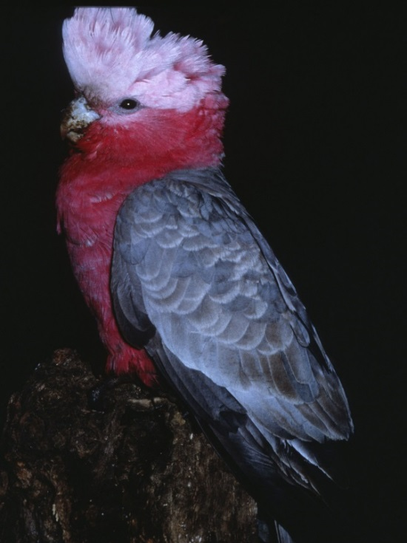

Figure 1. Male Galah © I. McCann DSE 2009
Habitat
Galahs have benefited greatly from European settlement, with cleared land and watering points for stock as their preferred areas of habitat.

They inhabit most areas of Australia including open woodlands, parks, roadside, fields and farmlands.

Distribution
The Galah is considered common and widespread over most of Australia and Victoria.
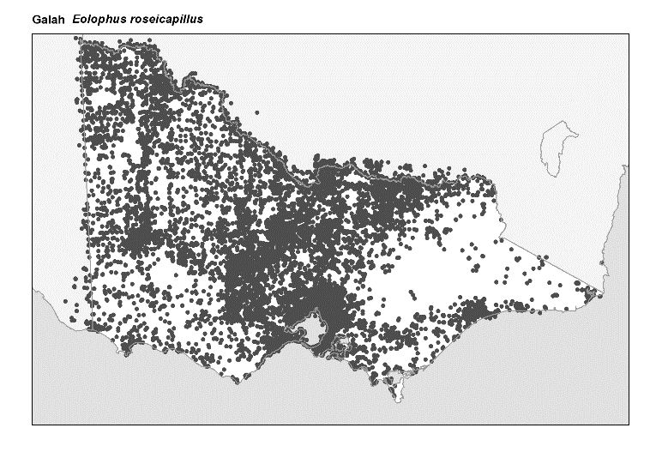
Figure 2. Recorded occurrences in Victoria
Source: Victorian Biodiversity Atlas (records post 1979), version 15/5/2017

Breeding
The breeding season for the Galah is from February to July in the north of Australia. In southern parts of Australia, the breeding season occurs in July to December.

The Galah is monogamous, meaning they will form a permanent bond with their mating partner. However, if one of the pair dies, the other will actively seek out a new mate.

The male Galah will court the female by chirping and screeching in an effort to impress her.

The female will lay two to six eggs in a nest lined with Eucalyptus leaves, generally in tree hollows in the vicinity of a water body.

Both the male and the female take turns to incubate the eggs over a 30-day period.

Once hatched, both parents take part in feeding the chicks who will only leave the nest after 8 weeks. After this time, the young will stay in a crèche system with the young of other breeding pairs for up to two months.

Chicks have a high mortality rate with up to 50% dying before they are 6 months old.

Galahs have been recorded breeding with other members of the cockatoo family such as the Sulphur-crested Cockatoo.
What you can do to help!
Report any suspected illegal activity regarding Galahs to the DELWP Customer Contact Centre on 136 186.

All wildlife is protected in Victoria. Visit the DELWP website for more information regarding protected wildlife - www.wildlife.vic.gov.au

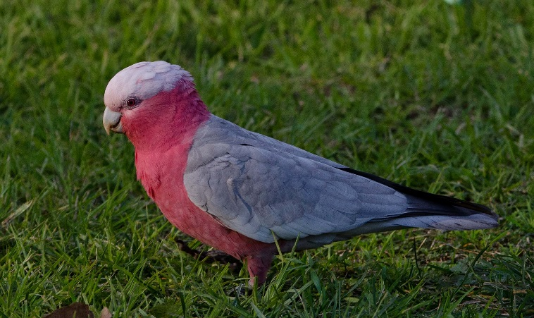
Figure 3. Female Galah © Nick Talbot
Further reading
Simpson, K. and Day, N., (2010), Field guide to the birds of Australia, (8th ed.), Penguin Books, Australia.
Morcombe, M., (2004), Field guide to Australian birds, Steve Parish Publishing, Australia.

