Our Wildlife Fact Sheet
  - Southern Toadlet

There are actually no native toads in Australia, however many Australian species, including the Southern Toadlet, are commonly known as toadlets. This is due to their similarity to the warty toads, which were familiar to the first European settlers.

Scientific name
Pseudophryne semimarmorata

Did you know?
The Southern Toadlet is a ground dweller and tends to walk rather than hop.
Once the female lays her eggs, they are guarded by a male Southern Toadlet.
This species of frog has a brilliantly patterned underside with marbled dark brown to black and bluish white.

Description
The Southern Toadlet can grow up to 35 mm in size.
This frog is dark olive green to chocolate brown on its back. The belly is marbled black and white or sometimes black and blue. The undersides of the legs and throat are bright orange, red, yellow or tan coloured.
The skin of the Southern Toadlet has a warty surface. Males have a granular belly while the females have a smooth belly.
This species does not have webbed toes.

Diet
The Southern Toadlet’s diet consists of small invertebrates including mosquitoes, moths and flies.

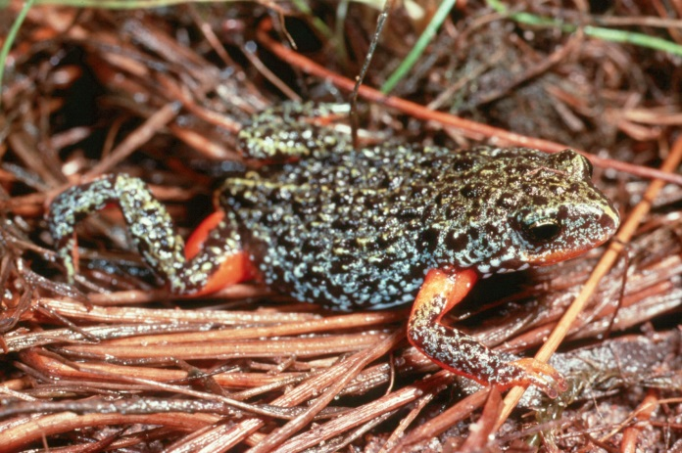
Figure 1. Southern Toadlet © P. Robertson

Habitat
This species is usually found in dry sclerophyll (gum) forests under bark, logs and leaf litter where it lives in small tunnels. They do not necessarily have to be near permanent water.

Distribution

The Southern Toadlet occurs in southern Victoria.
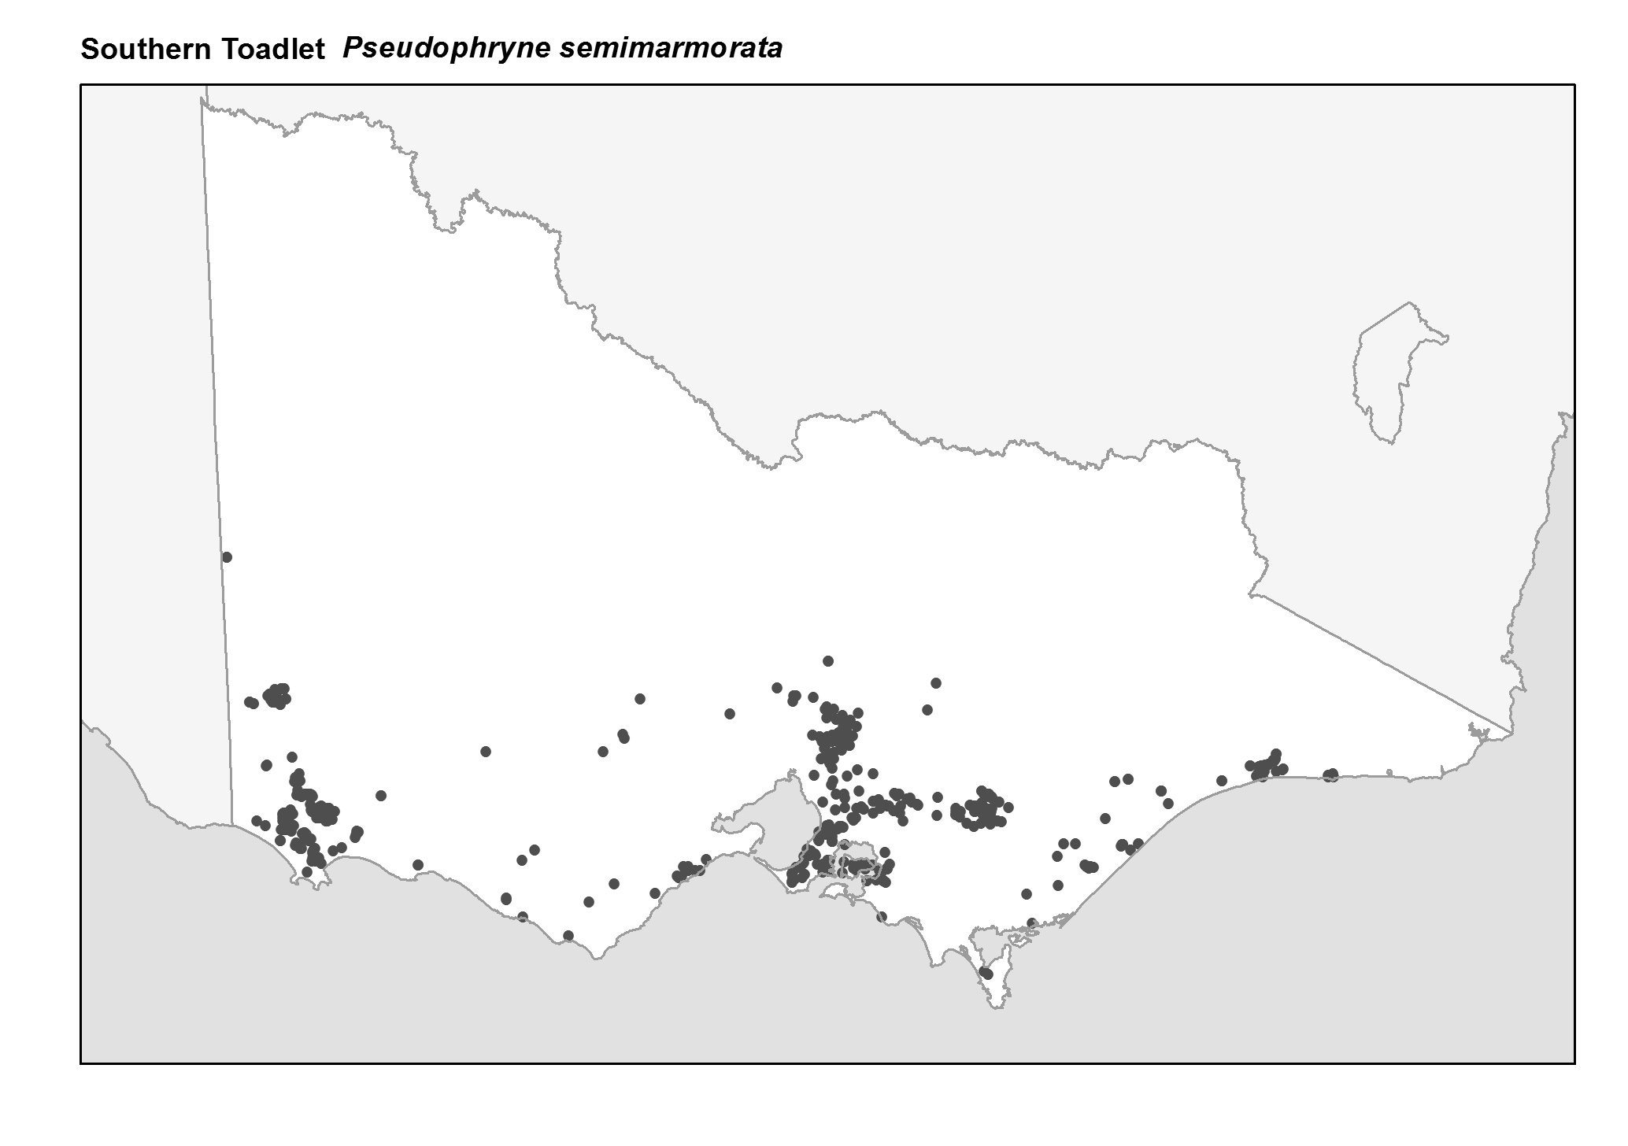
Figure 2. Recorded occurrences in Victoria
Source: Victorian Biodiversity Atlas (records post 1979), version 15/5/2017

Breeding
The Southern Toadlet breeds during the autumn months from March to June.

Males of this species call from a shallow nest or burrow in low lying areas, usually near water. The call is a very short harsh grating note - "cre-ek" - repeated every few seconds.

Females lay up to 200 eggs in burrows or shallow depressions. Eggs are laid in loose clutches, large in shape (up to 6 mm in diameter) and pigmented.

During periods of high rainfall, the hatching tadpoles can be washed into larger pools and wetlands. By late spring and summer the tadpoles undergo metamorphosis (meaning their body changes) from a tadpole to small toadlets.

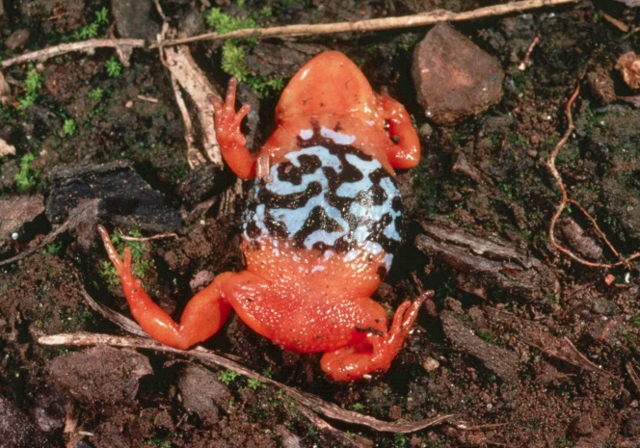
Figure 3. Underside markings of a Southern Toadlet © P. Robertson

What you can do to help!
Keep your waterways and drains clean by not dumping toxic liquids. Many frogs are vulnerable to pollution in their habitat due to their sensitive skin.
Frogs are also susceptible to an infectious disease caused by the chytrid fungus, which can make them sick or kill them. Help protect Southern Toadlets by not touching or moving them from one area to another.

One of the main threats to this species is the loss of suitable habitat associated with clearing of bushland, scrub and grasslands. This in turn causes rising salinity. Agricultural pesticide spraying may also impact frog species.

Keep a welcoming habitat for frogs in your backyard by providing leaf litter and logs in damp areas to attract them to your garden. By doing so, you will be rewarded with a natural insect and bug killer.

Further reading
Barker, J., Grigg, G. and Tyler, M. J. 1995. A Field Guide to Australian Frogs. Surrey Beatty & Sons, Sydney.

Cogger, H.G., (2000), Reptiles and amphibians of Australia (6th ed.), Reed New Holland, Sydney.

Hero, J-M., Littlejohn, M. and Marantelli, G. (1991). Frogwatch Field Guide to Victorian Frogs. Department of Conservation and Environment, Victoria.

Robinson, M. 2002. A Field Guide to Frogs of Australia. Australian Museum/Reed New Holland: Sydney.

Swan, G. 2001. Green Guide to Frogs of Australia. New Holland: Sydney.

Tyler, M. J. and Knight, F. (2009). Field Guide to the Frogs of Australia. CSIRO Publishing, Collingwood.

