Despite often roosting in large numbers in metropolitan areas, the Grey-headed Flying-fox is a threatened species in Victoria.

Known for their fly-outs at sunset, you may find flying foxes visiting your backyard, orchards and nearby parks to feed on tasty fruit, nectar and blossoms.

Tips for living with flying-foxes

* Enjoy their presence. They are a natural part of the landscape and an important part of the ecology.
* If you chose to net your fruit trees to protect them from birds and flying-foxes, please use wildlife-safe netting. Flying-foxes and other animals are easily entangled in netting with holes larger than 5mm x 5mm and it is the leading cause of death and injuries for flying-foxes in urban areas. See the DELWP Fruit tree netting and wildlife fact sheets for more information.
* Flying-foxes can also get caught on barbed wire. If you have fences including barbed wire on your property, consider painting it a light colour or taping on plastic bags to make it more visible.
* Please do not approach flying-foxes or attempt to touch them yourself. A small percentage of flying-foxes carry Australian Bat Lyssavirus, which is similar to rabies. If you are concerned about the welfare of flying-foxes in your area, contact a local wildlife carer who is trained to handle bats.
* If you find a lifeless flying-fox, do not touch it. Instead check if the animal is dead by gently turning it over with a shovel. If the animal is dead, use the shovel to place it in a plastic bag and double bag it for disposal in accordance with your local government by-laws. Make sure you use gloves. If you are unsure if the animal is dead, contact a local wildlife rescue organisation for assistance.

**Victoria’s flying-fox species**

|  |  |
| --- | --- |
| © The State of Victoria Department of Environment, Land, Water and Planning 2018  LogoThis work is licensed under a Creative Commons Attribution 4.0 International licence. You are free to re-use the work under that licence, on the condition that you credit the State of Victoria as author. The licence does not apply to any images, photographs or branding, including the Victorian Coat of Arms, the Victorian Government logo and the Department of Environment, Land, Water and Planning (DELWP) logo. To view a copy of this licence, visit http://creativecommons.org/licenses/by/4.0/  Disclaimer  This publication may be of assistance to you but the State of Victoria and its employees do not guarantee that the publication is without flaw of any kind or is wholly appropriate for your particular purposes and therefore disclaims all liability for any error, loss or other consequence which may arise from you relying on any information in this publication. | Accessibility  If you would like to receive this publication in an alternative format, please telephone the DELWP Customer Contact Centre on 136186, email [customer.service@delwp.vic.gov.au](mailto:customer.service@delwp.vic.gov.au), or via the National Relay Service on 133 677 [www.relayservice.com.au](http://www.relayservice.com.au). This document is also available on the internet at [www.wildlife.vic.gov.au](http://www.wildlife.vic.gov.au). |

There are two flying-fox species found in Victoria: the Grey-headed Flying-fox and the Little Red Flying-fox. Little red flying foxes are semi-permanent residents along the north of Victoria, while Grey-headed flying foxes migrate along the east coast of Australia following food resources.

The Grey-headed Flying-fox is the largest member of the flying-fox family and is the only species permanent to southern Victoria. Colony numbers fluctuate with the seasons and there are usually more flying-foxes in summer and fewer in winter.

Flying-foxes are ecologically important, playing a major role in the regeneration of native forests by pollinating trees and dispersing seeds as they move between trees and forests. A single flying-fox can disperse up to 60,000 seeds in one night!

Flying-foxes are nocturnal and typically roost by hanging upside down during the day.

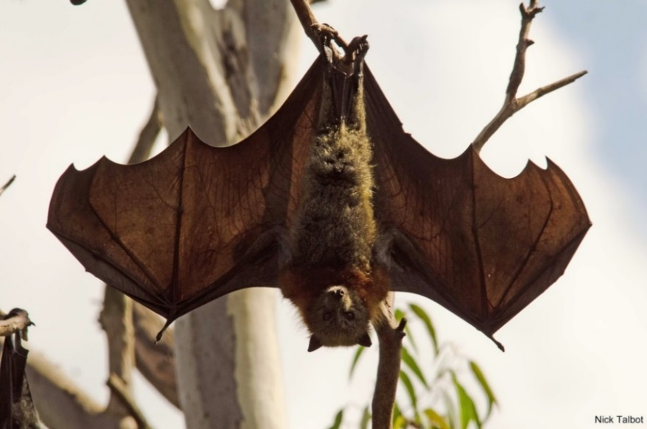

**For more information call 136 186**

**or go to** [wildlife.vic.gov,au](http://delwp.vic.gov.au/environment-and-wildlife/wildlife/wildlife-rehabilitation)

**For wildlife rescue, call your local wildlife rescue organisation**