|  |
| --- |
| Victorian kangaroo population survey |

Latest survey on Victorian kangaroo numbers released

## About the survey

In October and November 2020, the Department of Environment, Land, Water and Planning (DELWP) surveyed populations of Victoria’s three kangaroo species, the Eastern Grey Kangaroo, the Western Grey Kangaroo and the Red Kangaroo.

The latest survey builds on those from 2017 and 2018, the results help us understand Victoria’s kangaroo populations and their locations.

The results are used to help us ensure authorised kangaroo management in Victoria is sustainable

## Where are the survey zones?

To help analyse the survey data and develop estimates, the state is divided up into seven survey zones. Each zone is made up of ecologically similar local government areas (LGAs). LGAs within metropolitan Melbourne, and French Island are not included in any of the survey zones.

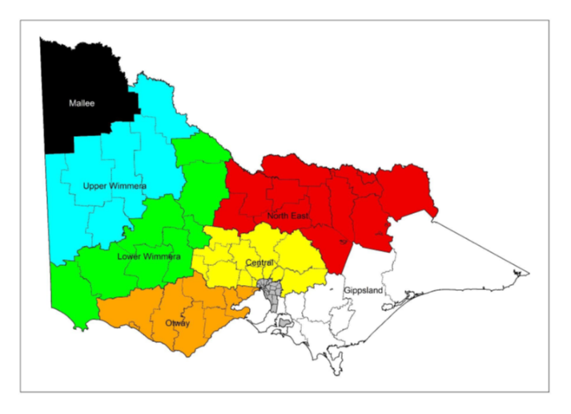Figure 1. Map of survey zones.

## What did the 2020 survey find?

The overall kangaroo population in Victoria, at the time of the survey in 2020 was estimated to be 1,942,000, an increase of over 500,000 from the 2018 survey. See the estimated population for each species in Table 1

This is approximate as forests and urban areas aren’t included in the survey.

Table 1: Estimated populations of Victoria’s three kangaroo species (rounded to the nearest 1000).

|  |  |  |
| --- | --- | --- |
| Species | Estimated population in 2018 | Estimated population in 2020 |
| Eastern Grey Kangaroo | 1,251,000 | 1,717,000 |
| Western Grey Kangaroo | 130,000 | 195,000 |
| Red Kangaroo | 44,000 | 30,000 |
| **Combined** | **1,425,000** | **1,942,000** |

## How was the survey conducted?

In 2020, DELWP used experienced operators in aerial counting by helicopter to cover 3,234km of transects.

It is difficult to distinguish between Eastern Grey and Western Grey Kangaroos from the air, to address this . 2,195km of ground surveys across the state were also completed to refine the distribution of the two species in areas where they overlap.

## How did the 2020 survey differ from 2018?

The 2020 and 2018 aerial and ground survey methods differed slightly as;

* Some areas couldn’t be studied from the air safely in 2018, so those were changed in 2020; and
* Additional transects were surveyed in 2020 to increase precision

## How do the 2020 results compare to the 2018 survey?

The 2020 estimates were larger than those from 2017 and 2018. There were an estimated 1,942,000 kangaroos in 2020 in total, 36% more than the estimated 1,425,000 in 2018. While overall populations have increased, in some areas such as the Mallee and North East of the state the numbers have fallen since 2018.

## Which areas of Victoria had the most kangaroos?

As in previous surveys, kangaroo numbers varied considerably across the state.

Table 2 lists the LGAs with the highest estimated populations. When comparing estimates, it’s important to consider that there are large differences in size between LGAs. The full report includes the area (km2) of habitat within each LGA.

The Mitchell Shire had the highest estimated abundance of kangaroos. 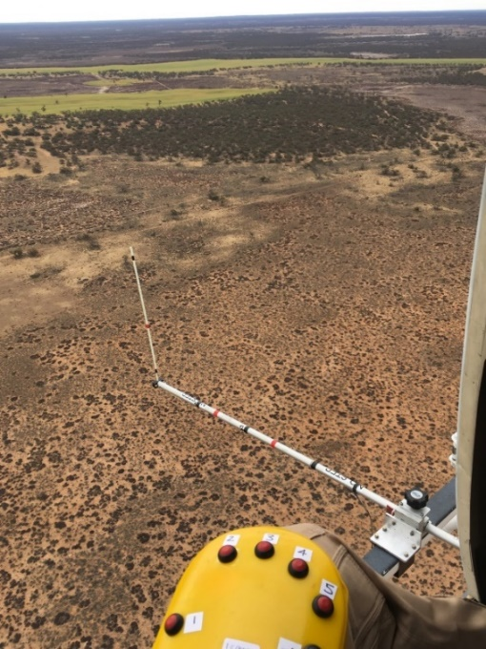

Figure 2: View from the helicopter conducting the aerial surveys

Credit: Michael Stead, EcoKnowledge

|  |  |
| --- | --- |
| © The State of Victoria Department of Environment, Land, Water and Planning 2021  LogoThis work is licensed under a Creative Commons Attribution 4.0 International licence. You are free to re-use the work under that licence, on the condition that you credit the State of Victoria as author. The licence does not apply to any images, photographs or branding, including the Victorian Coat of Arms, the Victorian Government logo and the Department of Environment, Land, Water and Planning (DELWP) logo. To view a copy of this licence, visit http://creativecommons.org/licenses/by/4.0/  ISBN 978-1-76077-029-7 (Online)  Disclaimer  This publication may be of assistance to you but the State of Victoria and its employees do not guarantee that the publication is without flaw of any kind or is wholly appropriate for your particular purposes and therefore disclaims all liability for any error, loss or other consequence which may arise from you relying on any information in this publication. | Accessibility  If you would like to receive this publication in an alternative format, please telephone the DELWP Customer Service Centre on 136186, email [customer.service@delwp.vic.gov.au](mailto:customer.service@delwp.vic.gov.au), or via the National Relay Service on 133 677 [www.relayservice.com.au](http://www.relayservice.com.au). This document is also available on the internet at [www.delwp.vic.gov.au](http://www.delwp.vic.gov.au). |

## How many kangaroos were found in my local area?

We estimated kangaroo numbers for 58 LGAs. The ten LGAs with the highest estimated numbers of kangaroo are listed below.

Table 2. Ten LGA’s with the highest combined abundance of kangaroos.

|  |  |  |  |  |
| --- | --- | --- | --- | --- |
| LGA | Eastern Grey | Western Grey | Red | Total |
| Mitchell | 123,500 |  |  | **123,500** |
| Murrindindi | 99,400 |  |  | **99,400** |
| Loddon | 52,300 | 31,500 |  | **83,800** |
| Moorabool | 77,600 |  |  | **77,600** |
| Southern Grampians | 59,500 | 16,500 |  | **76,000** |
| Moyne | 75,800 |  |  | **75,800** |
| Macedon Ranges | 74,400 |  |  | **74,400** |
| Mildura | 1,000 | 36,300 | 30,400 | **67,700** |
| Mount Alexander | 66,300 |  |  | **66,300** |
| Northern Grampians | 53,700 | 8,800 |  | **62,500** |

Estimates for the 58 LGA’s surveyed are listed in the full survey report.

## Find out More

Keep up to date on Victoria’s wildlife at <www.wildlife.vic.gov.au>

Read the full report at

[www.wildlife.vic.gov.au/our-wildlife/kangaroos](http://www.wildlife.vic.gov.au/our-wildlife/kangaroos)