|  |
| --- |
| Victorian Koala Management Strategy |
| Summary |

The Department of Energy, Environment and Climate Action has developed a new Victorian Koala Management Strategy (VKMS).

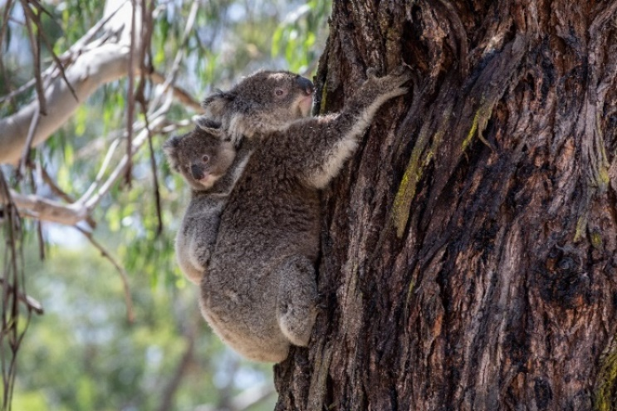This fact sheet provides a summary of the VKMS.

## Why is a new koala strategy needed?

Victoria’s previous Koala Management Strategy was released in 2004. Since that time, new issues impacting koalas have emerged and others have increased in significance including:

* climate change​
* major bushfire events​
* the establishment of commercial blue gum plantations within the koala’s distribution range. ​

Other issues identified in the 2004 strategy have evolved and there have been scientific advances in some areas, such as genetics. These new and evolved issues and scientific advances need to be reflected in a new strategy. ​

Photo credit: Marcia Riederer

Photo credit: Marcia Riederer

## How was the new strategy developed?

The VKMS has been developed collaboratively with a with a working group that included Traditional Owners, scientists, animal welfare organisations, wildlife carers, the blue gum plantation industry, veterinarians, Zoos Victoria, Phillip Island Nature Parks, Parks Victoria and other Government agencies from Victoria and interstate.

Feedback received from the community during the public consultation period for the draft strategy has also helped to inform the strategy. For more information about the public consultation process or to download a copy of the consultation report, please visit the consultation page on the Engage Victoria website at: <http://engage.vic.gov.au/VKMS>.

## Purpose

The VMKS sets out actions to address koala management issues over the next 10 years.

## Vision

## The vision for the VKMS is that Victoria’s koala populations and habitat are secure, healthy and sustainable in the long-term.

## VKMS content overview

The VKMS groups issues relating to koala management in Victoria into ten themes. It discusses previous management approaches and identifies knowledge gaps for each theme. It sets a goal for each theme and includes 1-2 high level actions to address the key issues in the theme.

A summary of the ten themes is provided below, along with a summary of the implementation and monitoring, evaluation, reporting and improvement sections of the VKMS.

## Theme 1: Traditional Owners and koalas

### Main issues discussed

* The importance of koalas to Aboriginal people in Victoria.
* The inherent cultural right that Aboriginal people have to care for Country.
* The impact that overabundant koala populations can have on culturally significant areas, such as the Budj Bim Cultural Landscape.

### Theme goal

Traditional Owner priorities for Country that relate to koalas are supported and the impacts of overabundant koala populations on culturally significant areas are minimised.

**Actions**

|  |  |
| --- | --- |
| Action 1.1 Partner with Traditional Owners to undertake actions on Country that will benefit koalas or their habitat | |
| *Action details* | ***Partners*** |
| This action will involve:   * Working with Traditional Owner groups to understand their priorities for Country and how these could benefit koalas or their habitat. * Linking the implementation of relevant actions in the VKMS to actions in Country Plans to enable the implementation of both the VKMS and Country Plans. * Establishing partnership arrangements with interested Traditional Owner groups to deliver relevant actions on Country. * Building capacity of Traditional Owners to deliver actions on Country that will benefit koalas or their habitat. | DEECA  Traditional Owners  Parks Victoria  Universities  TAFEs |

|  |  |
| --- | --- |
| Action 1.2 Support Traditional Owners to protect culturally significant areas from koala over-browsing | |
| *Action details* | ***Partners*** |
| This action will involve:   * Engaging with Traditional Owners to determine culturally or environmentally significant areas that may require protection from the impacts of overabundant koalas. * Establishing partnership arrangements with Traditional Owner groups to undertake koala management activities on Country including habitat and koala assessment and monitoring, and koala management program planning and delivery. * Building capacity of Traditional Owners to undertake koala and habitat monitoring and koala management programs. | DEECA  Traditional Owners  Parks Victoria |



Artist: Dixon Patten, Bayila Creative

## Theme 2: Koala overabundance

### Main issues discussed

* That koalas can reach unsustainable densities in parts of Victoria including Cape Otway, French Island and Raymond Island.
* The impacts that high koala densities have on habitat, koala welfare and other species.
* The methods used to manage overabundant populations and the cost of management programs.

### Theme goal

The impacts on ecosystems and koala welfare associated with overabundant koala populations are reduced.

### Actions

|  |  |
| --- | --- |
| Action 2.1 At key high-density koala population sites, undertake habitat monitoring to detect change in condition and implement evidence-based management programs to protect habitat and koala welfare. | |
| *Action details* | ***Partners*** |
| This action will involve:   * Identifying sites with high-density koala populations. * Developing and implementing a habitat monitoring program. * Developing an evidence-based framework for koala management programs that: * identifies trigger points for intervention prior to significant impacts on habitat or koala welfare occurring * identifies appropriate management interventions for different scenarios that consider habitat, land-use, carrying capacity, koala welfare, disease risk and genetic management * includes a standard protocol for data collection and management * includes a process for evaluating koala management programs. * Developing a database to store data from management programs that will enable data sharing and data analysis to inform improvements to the koala management framework. * Undertaking koala management programs at high-density populations, as needed, in accordance with the framework. * Exploring the development of regional koala management plans that consider the context of the broader landscape to determine how best to manage koala populations in an area. * Undertaking research into the causes of overabundance and the potential for novel contraceptive methods that have not been used in Victoria. * Supporting re-vegetation projects at impacted sites. | DEECA  Universities  Parks Victoria  Traditional Owners  Landholders/managers  Vets  Wildlife carers  Blue gum industry |

|  |  |
| --- | --- |
| Action 2.2 Revise the 2004 translocation protocol. | |
| *Action details* | ***Partners*** |
| This action will involve:   * Reviewing the translocation protocol from the 2004 VKMS to determine what changes are needed, based on the outcomes of previous translocation programs. * Development of a new translocation protocol that considers: * minimum habitat requirements and habitat availability for release sites, including identifying areas of suitable habitat that can be used as release sites * expertise of personnel involved in the translocation * disease risk * genetics * selection of individuals for translocation * translocation methods including capture, handling, transport and release requirements and equipment * post-release monitoring requirements * data recording requirements * community consultation requirements * requirements for future planned burns near release sites * guidance for relocation of koalas following bushfires. * The new translocation protocols will be used to inform koala conservation and management activities. | DEECA  Universities  Parks Victoria  Traditional Owners  Vets  Wildlife carers |

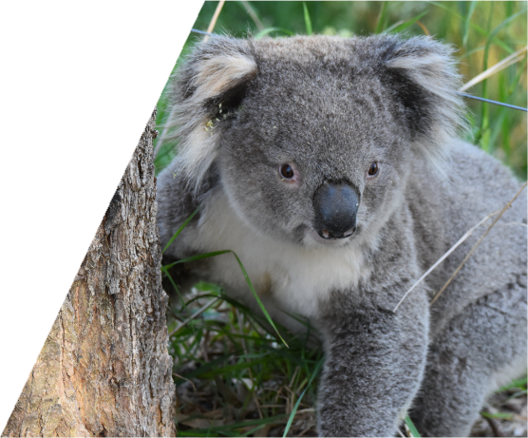

## Theme 3: Koala rehabilitation ​

### Main issues discussed

* That sick, injured and orphaned koalas need specialist care and facilities to be successfully rehabilitated.
* The limitations of the current Victorian wildlife rehabilitation system in relation to koalas.
* The issues associated with koala rehabilitation following the 2019-20 bushfires.

### Theme goal

The standard of care for koalas requiring rehabilitation is improved.

### Actions

|  |  |
| --- | --- |
| Action 3.1 Develop standards for koala rehabilitation to encourage a consistent, best practice approach to koala rehabilitation across the state. | |
| *Action details* | ***Partners*** |
| This action will involve:   * Engaging with vets, animal welfare experts, Zoos Victoria, wildlife carers and Animal Welfare Victoria to finalise the standards of care for koala rehabilitation. The standards may include guidance on topics such as: * minimum training/experience requirements * facilities and equipment * koala triage assessment * capture and handling * treatment * feed requirements * preparation for release * pre-release assessment * release protocols * post-release monitoring protocols * record keeping. * Supporting post-release monitoring where possible to investigate the success of rehabilitation. The information gained will be used to further refine the standards of care. | DEECA  Zoos Victoria  Vets  Animal welfare experts  Wildlife carers  Animal Welfare Victoria |

## Theme 4: Koala genetics ​

### Main issues discussed

* The low genetic diversity observed in some Victorian koala populations and the reasons for this.
* The impacts that low genetic diversity can have on a population and techniques for improving genetic diversity.
* The higher genetic diversity found in the South Gippsland koala population.
* The gaps in our understanding of the genetic diversity of Victoria’s koala populations.

### Theme goal

Understanding of the genetic structure of koala populations in Victoria is increased to aid conservation of Victoria’s koalas.

### Actions

|  |  |
| --- | --- |
| Action 4.1 Undertake state-wide genetic surveys of Victorian koala populations. | |
| *Action details* | ***Partners*** |
| This action will involve:   * Developing and implementing a genetic survey program to better understand: * the genetic diversity of koala populations across Victoria * the significance and spatial boundaries of the unique Strzelecki/South Gippsland genome * whether other populations of genetic significance exist * the level of gene flow between populations * population structure * disease prevalence. * Samples for the genetic surveys will be taken in both a targeted way and opportunistically, for example during koala management programs or when a koala requires veterinary treatment. * The genetic surveys may be conducted concurrently with disease surveillance (Action 5.1) and koala population monitoring (Action 7.1). * The genetic surveys will be conducted across all land tenures where permission is granted. | DEECA  Universities  Vets  Wildlife carers  Traditional Owners  Parks Victoria  Landholders/managers  Blue gum industry  General public |

|  |  |
| --- | --- |
| Action 4.2 Develop a genetic management plan for Victorian koalas. | |
| *Action details* | ***Partners*** |
| This action will involve:   * Developing a genetic management plan for Victorian koala populations, based on the results of the genetic surveys undertaken for Action 4.1. * The genetic management plan will be developed by a geneticist and will be used to inform koala management programs. The plan will consider approaches such as gene flow augmentation and translocation between states. | DEECA  Universities |

## Theme 5: Disease in koalas

### Main issues discussed

* The diseases that can affect koalas and the available treatment options.
* Known disease prevalence in Victorian koalas.
* The gaps in our understanding of disease prevalence and impact on Victorian koalas.

### Theme goal

The health status of koala populations in Victoria is better understood to inform koala conservation and management activities.

### Actions

|  |  |
| --- | --- |
| Action 5.1 Develop and implement a systematic koala disease surveillance program across Victoria that will enable early detection of new diseases and ongoing monitoring of established diseases. | |
| *Action details* | ***Partners*** |
| This action will involve:   * Developing and supporting a systematic koala disease surveillance program that includes clinical sign/syndromic reporting of koala health observations (which may trigger sample collection or field investigation), submission of samples for targeted disease testing and pathological examination of dead koalas. The surveillance program will: * provide disease diagnosis, disease agent identification and will allow early detection of new or previously un-detected diseases and ongoing monitoring of established or endemic diseases * be distributed across the state to represent key koala populations * be collaborative and obtain data and samples from a variety of sources including koala management programs, wildlife carers, vets, researchers and the general public * have an iterative design and be updated with new knowledge and recommendations from Disease Risk Analyses. * Reviewing and building on existing wildlife disease surveillance networks in Victoria. * Reporting disease surveillance into existing wildlife health databases. * Developing and distributing information to assist people identify and report diseased koalas. * Using the information gained through the disease surveillance program to inform koala conservation and management activities. * Disease surveillance may be conducted concurrently with the genetic surveys (Action 4.1) and koala population monitoring (Action 7.1). | DEECA  Universities  Vets  Wildlife carers  General public  Traditional Owners  Parks Victoria  Zoos Victoria  Landholders/managers  Blue gum industry |

|  |  |
| --- | --- |
| Action 5.2 Review the National Koala Disease Risk Analysis (DRA) to identify priority diseases, effective mitigation strategies and knowledge gaps for Victoria | |
| *Action details* | ***Partners*** |
| This action will involve:   * Undertaking a review of the National Koala DRA to determine the priority diseases and effective mitigation strategies for Victoria. * Considering whether there are different factors in Victoria that may impact disease that were not considered in the National Koala DRA that warrant an additional DRA process to fill the knowledge gaps. Factors to be considered may include: * genetics and connectivity between populations * population density and population trends * habitat and land-use * climate change predictions * environmental contaminants * different strains of infections present in Victoria. * Using the DRA results to inform koala conservation and management activities. | DEECA  Universities  Vets  Australian Government |

## Theme 6: Habitat conservation

### Main issues discussed

* The causes of habitat loss in Victoria.
* The impact of habitat loss and fragmentation on koalas.
* The impact that overabundant koalas can have on habitat.
* The need for a joint approach to habitat protection and management across land tenures.

### Theme goal

Koala habitat is conserved and initiatives to increase and connect habitat are supported.

### Actions

|  |  |
| --- | --- |
| Action 6.1 Develop a comprehensive koala population and habitat decision support tool for Victoria to inform koala and habitat management activities, including koala translocation programs, fire management and habitat protection and restoration. | |
| *Action details* | ***Partners*** |
| This action will involve:   * Using the results of koala population surveys to develop koala population distribution maps and population models. * Undertaking koala habitat modelling to develop koala habitat maps and determine habitat availability. * Developing the decision support tool that can be used to identify: * priority areas of habitat for protection or restoration * potential climate refuge areas * koala populations at high risk of requiring management to protect habitat * potential translocation release sites. | DEECA  Universities |

|  |  |
| --- | --- |
| Action 6.2 Develop and support initiatives to increase the extent of koala habitat and improve habitat connectivity. | |
| *Action details* | ***Partners*** |
| This action will involve:   * Identifying areas where koala habitat should be increased, or habitat connectivity improved. * Working with Councils, CMAs, NGOs, Landcare, Traditional Owners, Parks Victoria, landholders/managers, the blue gum industry, community groups and the community to develop and support initiatives to increase the extent of koala habitat and increase habitat connectivity. * Providing information to landholders about how to increase koala habitat, including which tree species to plant. | DEECA  Councils  CMAs  NGOs  Landcare  Traditional Owners  Parks Victoria  Landholders/managers  Blue gum Industry  Community groups  General public |

## Theme 7: Understanding koala populations ​

### Main issues discussed

* The reasons why it is important to understand koala population dynamics.
* Koala population survey methods.
* Our current understanding of Victoria’s koala populations.

### Theme goal

Knowledge of the size and distribution of Victoria’s koala populations is improved to inform koala conservation and management activities.

**Actions**

|  |  |
| --- | --- |
| Action 7.1 Establish a long-term state-wide monitoring program to improve knowledge of koala population distribution, abundance and population trends. | |
| *Action details* | ***Partners*** |
| This action will involve:   * Developing a koala population monitoring program, which may involve a citizen science component. * Surveying koala populations throughout Victoria, including lower-density inland populations and the Strzelecki/South Gippsland populations. * Implementing the monitoring program across all land tenures where permission is granted. * The monitoring program will complement the National Koala Monitoring Program (NKMP) established by the Australian Government and the CSIRO. * The monitoring program may be conducted concurrently with the genetic surveys (Action 4.1) and disease surveillance (Action 5.1). * Results from the monitoring program will be published and made available to the NKMP and the community. * Results from the monitoring program will be used to inform koala management programs and habitat protection and restoration activities. | DEECA  Universities  Australian Government  CSIRO  Traditional Owners  Parks Victoria  Landholders/managers  Blue gum industry  General public  Community groups |

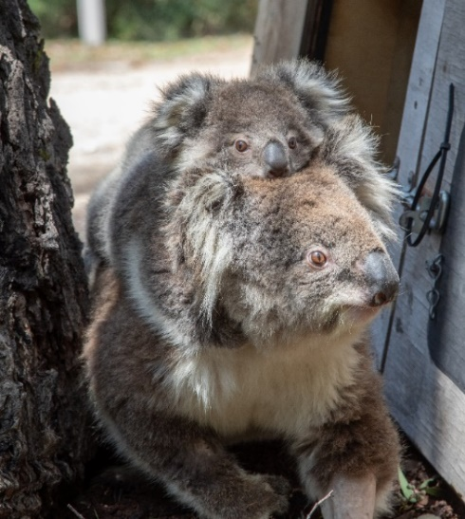

Photo credit: Marcia Riederer

## Theme 8: Climate change and managing fire impacts ​

### Main issues discussed

* The reasons why koalas are particularly vulnerable to climate change.
* Predicted impacts to koalas from climate change.
* The impact of bushfires on koalas.
* The Fire Analysis Module for Ecological values (FAME) tool used for planned burns.

### Theme goal

The potential impacts of climate change and bushfires on Victoria’s koala population are understood and actions are taken to mitigate them.

### Actions

|  |  |
| --- | --- |
| Action 8.1 Use existing climate change models to better understand what a changed climate means for koalas and habitat across the whole of Victoria. | |
| *Action details* | ***Partners*** |
| This action will involve:   * Identifying existing climate change models that are relevant to koalas and koala habitat. * Determining if refinements to the models are required and undertaking these refinements. * Considering how the predictions from the models can be incorporated into koala management programs and habitat protection and restoration activities. * The models will be used to identify potential climate refuge habitat, to better understand predicted koala responses to drought and increased temperature, to understand potential impacts to koala habitat from climate change and to identify potential mitigation strategies. | DEECA  Universities |

|  |  |
| --- | --- |
| Action 8.2 Use koala population data to inform planned burning activities and the wildlife welfare response during bushfires. | |
| *Action details* | ***Partners*** |
| This action will involve:   * Using koala population data to inform: * planned burning activities * standard mitigations during planned burning activities, such as designation of wildlife welfare arrangements * the wildlife welfare response initiated during bushfires. | DEECA  Parks Victoria  Wildlife carers  Vets |

## Theme 9: Koalas in blue gum plantations ​

### Main issues discussed

* The impacts on koalas from the establishment of commercial plantations within the koala’s distribution range in south-west Victoria.
* The regulatory framework that has been introduced to reduce the impacts of plantation management operations on koalas.
* The improvements the industry have made to their practices to protect koala welfare.

### Theme goal

Impacts to koala welfare from blue gum plantation harvesting continue to be minimised.

### Actions

|  |  |
| --- | --- |
| Action 9.1 Investigate options to manage koala populations in blue gum plantations that protect koala welfare and ensure the industry remains viable and can continue to operate. | |
| *Action details* | ***Partners*** |
| This action will involve:   * Considering a range of factors to determine options to manage koala populations in blue gum plantations. * Factors to be considered include: * results of koala population surveys * habitat availability modelling * industry knowledge and experience * technology and infrastructure options available * cost implications. | DEECA  Blue gum industry  Universities |

|  |  |
| --- | --- |
| Action 9.2 Investigate options to manage the impact of koala displacement on koala welfare and other values and incorporate them into management. | |
| *Action details* | ***Partners*** |
| This action will involve:   * Undertaking research to better understand koala movement from plantations following harvesting and associated impacts on koala welfare and other values. * Identifying and assessing potential options to manage these impacts. | DEECA  Blue gum industry  Universities  Landholders/managers  Wildlife carers  Vets |

## Theme 10: Community perception and socioeconomic significance ​

### Main issues discussed

* The importance of koalas to the Australian and international community and the impact this has on koala management.
* The public’s perception of the status of Victoria’s koala populations.
* The importance of involving the community in koala management activities.

### Theme goal

### The community has a greater understanding of the complexity of managing Victoria’s koala populations and are supported to contribute to koala conservation and management.

### Actions

|  |  |
| --- | --- |
| Action 10.1 Develop and implement a community and stakeholder education and engagement program that promotes the VKMS and the issues it addresses. | |
| *Action details* | ***Partners*** |
| This action will involve:   * Working with experts in communications, behavioural science, ecology and animal welfare to develop and implement an education and engagement program about the VKMS and the issues it addresses. | DEECA  Universities  Vets  Traditional Owners  Wildlife welfare organisations  Wildlife carers  Communication experts  Blue gum industry  Councils  CMAs  Schools  Community groups  General public |

|  |  |
| --- | --- |
| Action 10.2 Increase opportunities for community involvement in koala conservation and management. | |
| *Action details* | ***Partners*** |
| This action will involve:   * Identifying active community-based koala conservation and management programs so that existing efforts can be supported. * Identifying new opportunities for community involvement in koala conservation and management activities, for example: citizen science surveys, ongoing monitoring and revegetation. * Facilitating community involvement in these activities and supporting communities to conserve and manage koalas in their local area. * Providing information to the community about how they can help to conserve and manage koalas and koala habitat. | DEECA  Traditional Owners  Councils  CMAs  Parks Victoria  Community groups  General public |

## Implementation

### The delivery of the actions in the strategy is the responsibility of DEECA in partnership with Traditional Owners, public and private landholders and managers, Parks Victoria, Zoos Victoria, Local Government, Catchment Management Authorities, universities, the blue gum plantation industry, wildlife carers, vets, conservation and community groups, and the Victorian community.

### A separate implementation plan for the strategy has been developed by DEECA and will be published on DEECA’s wildlife website at: <https://www.wildlife.vic.gov.au/our-wildlife/koalas>. The implementation plan outlines how each of the actions will be delivered, the timing of their delivery and who will be involved. The implementation plan will be a live document and will be updated as needed throughout the life of the strategy.

|  |  |
| --- | --- |
| Action 11.1 Establish a working group that includes government and non-government representatives to facilitate the delivery of actions in the VKMS and monitor its implementation | |
| *Action details* | ***Potential working group members*** |
| This action will involve:   * Identifying and engaging government and non-government representatives to be part of a working group that will be responsible for: * assisting in the development of a monitoring, evaluation, reporting and improvement framework * facilitating the delivery of actions in the VKMS * monitoring the delivery of actions and progress towards the strategy's goals * publishing progress reports on the delivery of the strategy. | DEECA  Traditional Owners  Parks Victoria  Zoos Victoria  Animal Welfare Victoria  Wildlife carers  Wildlife welfare organisations  Blue gum industry  Melbourne Vet School  Universities  CMAs  Local Government |

## Monitoring, Evaluation, Reporting and Improvement

The working group that will be established under Action 11.1 will help monitor the delivery of the actions in the strategy. A monitoring, evaluation, reporting and improvement (MERI) framework will be developed by DEECA in collaboration with the working group. The MERI framework will measure the success of individual actions and identify how each contributes to the strategy’s goals and vision.

The strategy will be reviewed after it has been in place for two years to assess progress towards delivering the strategy’s vision, goals and actions. The review will also determine the priority actions for the next phase of delivery. A further review schedule for the strategy will be determined by the working group.

The review schedule and reports on the progress made towards delivering the strategy will be published on DEECA’s wildlife website at: <https://www.wildlife.vic.gov.au/our-wildlife/koalas>**.**

## Where to find out more about the VKMS

For more information about the VKMS or to download a copy of the strategy or implementation plan, please visit DEECA’s wildlife website at: <https://www.wildlife.vic.gov.au/our-wildlife/koalas>**.**

For more information about the public consultation process for the draft VKMS or to download a copy of the consultation report, please visit the consultation page on the Engage Victoria website at: <http://engage.vic.gov.au/VKMS>.

If you have questions about the VKMS, please contact DEECA’s Wildlife Policy Team at: [wildlife.policy@delwp.vic.gov.au](mailto:wildlife.policy@delwp.vic.gov.au).

|  |  |
| --- | --- |
| © The State of Victoria Department of Energy, Environment and Climate Action 2023  LogoThis work is licensed under a Creative Commons Attribution 4.0 International licence. You are free to re-use the work under that licence, on the condition that you credit the State of Victoria as author. The licence does not apply to any images, photographs or branding, including the Victorian Coat of Arms, the Victorian Government logo and the Department of Energy, Environment and Climate Action (DEECA) logo. To view a copy of this licence, visit http://creativecommons.org/licenses/by/4.0/  ISBN 978-1-76136-073-2 (pdf/online/MS word)  Disclaimer  This publication may be of assistance to you but the State of Victoria and its employees do not guarantee that the publication is without flaw of any kind or is wholly appropriate for your particular purposes and therefore disclaims all liability for any error, loss or other consequence which may arise from you relying on any information in this publication. | Accessibility  If you would like to receive this publication in an alternative format, please telephone the DEECA Customer Service Centre on 136186, email [customer.service@delwp.vic.gov.au](mailto:customer.service@delwp.vic.gov.au), or via the National Relay Service on 133 677 [www.relayservice.com.au](http://www.relayservice.com.au). This document is also available on the internet at [www.delwp.vic.gov.au](http://www.delwp.vic.gov.au). |

**Artist:** Dixon Patten, Bayila Creative

**Art Narrative:**

This artwork is titled: *kula karan bulam bulam*, which means '*Koala amongst plenty of trees'* in Gunnai Language.

*The koala's natural habitats are under threat, this artwork encourages our connection to Country and our responsibilities to caring for our environment(s). The circle motifs depict us coming together to play our part in education and conservation, which has a ripple effect beyond our place and time. The 6 gum leaves around the circle depict our 6 seasons and acknowledging such things make us aware of how to adapt and work with the environments in a purposeful way.*