Our Wildlife Fact Sheet
  - Humpback Whale

The leap of a playful Humpback Whale is one of the great spectacles of nature. These acrobatic giants can be seen regularly along Victoria’s coastline during winter as they make their way from Antarctic waters to breeding grounds in warmer tropical waters off north eastern and north-western Australia.
Species name
Megaptera novaeangliae
Did you know?
Humpbacks are very acrobatic, often leaping or ‘breaching’ high out of the water before crashing back down. Sometimes they twirl around in the air while breaching. Nobody’s sure why they do this, but it could be for communication, play or to loosen skin parasites.
Humpback whales belong to the genus Megaptera, which is derived from the Greek words ‘mega’ meaning great and ‘pteron’ meaning wing. The ‘great-wing’ the Greeks were referring to is the pectoral (side) fins which can be up to 6 m long on a Humpback.
The Humpback Whale has one of the longest migrations of any mammal in the world, travelling over 12,000 km annually.
Description
Humpback Whales are named after the humped appearance of their back, which is displayed when they dive.
Humpbacks have long pectoral fins, which are white underneath and have a jagged edge on one side.
Their body colour ranges from grey to black on the back, with varying patterns of white on the underside of their body, tail fluke and flippers.
Their blow (cloud of vapour that comes out of the blowhole) is distinctly small and bushy, and can reach up to 5 m in height.
Adult whales are about 16 m long and weigh up to 40 tonnes. Newborn calves weigh up to 2 tonnes.
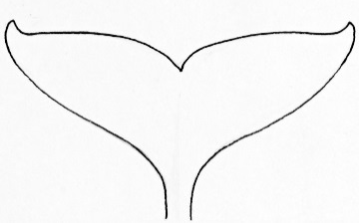
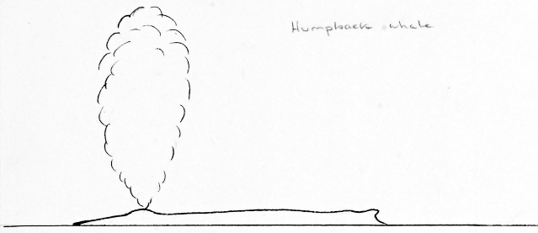
Figure 1. Humpback Whale tail fluke and blow pattern © B. Jarrett 2010
Diet
Humpbacks don’t have teeth; instead they eat by sifting seawater through their mouths to catch shrimp-like animals. The seawater is filtered through sieves called baleen plates.
Humpbacks also feed by slapping the water with their fins to stun fish, allowing the whale to swallow them with ease.
Humpbacks are known to form co-operative hunting groups where several animals simultaneously blow bubbles into the water whilst swimming in a circle. This traps the prey in a “bubble” net allowing the whales to swallow lots of food in one go.
Habitat
Humpback Whales are found in oceans worldwide, from polar to tropical waters. They are regularly found in Arctic, Atlantic and Pacific oceans and at times in Antarctic waters.
There are three separate populations of humpbacks, those living in the North Pacific Ocean, those in the North Atlantic Ocean, and those roving the oceans of the Southern Hemisphere.
Distribution
Humpback Whales can be seen off the Victorian coast between April and October each year as they make the long journey from their summer Antarctic feeding grounds to their winter breeding grounds in warmer waters.
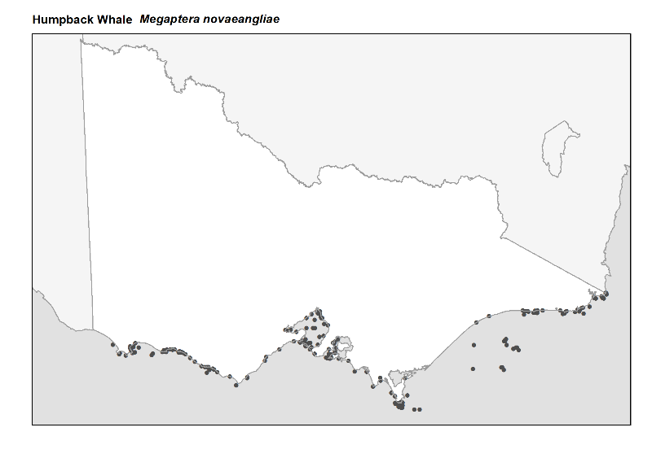
During migration, Humpbacks separate into groups according to sex and age, and travel at average speeds of approximately 7 km per hour.
Figure 2. Recorded occurrences in Victoria
Source: Victorian Biodiversity Atlas (records post 1979), version 15/5/2017
Breeding
Humpback Whales have a life expectancy of about 50 years.
Females reach sexual maturity at 4-5 years. Humpback Whales give birth to one young, generally every 2 years. Pregnancy lasts around 11 months.
The calving and mating season takes place in winter between June and October.
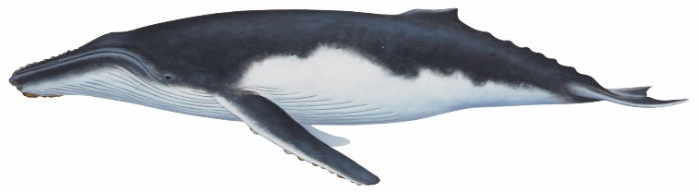
Calves are about 4 metres long and can weigh up to 2 tonnes at birth. They grow quickly and put on a heavy layer of insulating blubber before returning to the Southern Ocean with their mothers.

Calves are weaned at approximately 11 months and are vulnerable to attacks from sharks and Killer Whales.
Conservation status
Humpback Whales were nearly hunted to extinction during the early 1900s.
Numbers have increased in recent times but they are still considered a threatened species with about 80,000 left in the world.
What you can do to help!
It’s important not to get too close to whales. They need space to move, feed and take care of their young.

Boating can disturb these behaviours and threaten their well being. If you are out on the ocean and see a whale, make sure you stay at least 200 metres away! When riding a jetski then you need to stay at least 300 metres away.

If you are flying a drone, remember that you must not allow the drone to get closer than 500 metres above or around the whale.
Don’t drop litter! The litter you drop on the street ends up in the oceans and can be harmful to all marine life.
Don’t discard fishing line into the ocean. It can harm marine life for many years to come. If you see a whale entangled in fishing gear or stranded on a beach, call the Whale and Dolphin Emergency Hotline on 1300 136 017.
Further reading
Menkhorst, P.W. (ed), (1995), Mammals of Victoria, Oxford University Press, Melbourne.

