Our Wildlife Factsheet
  - Laughing Kookaburra

The distinctive laugh of the Kookaburra is one of the special sounds of the Australian bush. Known as the “bushman’s clock”, this laugh can be heard for miles.
Scientific name
Dacelo novaeguineae
Did you know?
Laughing Kookaburras are the largest Kingfisher in the world.
Its laugh is used to signal their territory to other birds.
They live in families, with siblings remaining in the family till they are old enough to look after themselves. They also act as helpers during the breeding season.
The Kookaburra’s brown and white feathers help it blend in with the environment, which makes it more difficult for prey or predators to see them.
In favourable conditions Kookaburras can live for more than 20 years and have the same partner for life.
Description
The Kookaburra is one of Australia’s most recognisable bird species, with its large head, long beak and loud ‘laughing’ call.
It measures up to 46 cm from the tip of its beak to the end of its tail.
Kookaburras have an off-white head, which is marked by a distinctive dark brown stripe which runs around each eye and along the centre of the head. Their eyes are deep brown.
The Kookaburra has off-white underparts, brown wings with lighter flecks and a reddish-brown tail with pale tips.
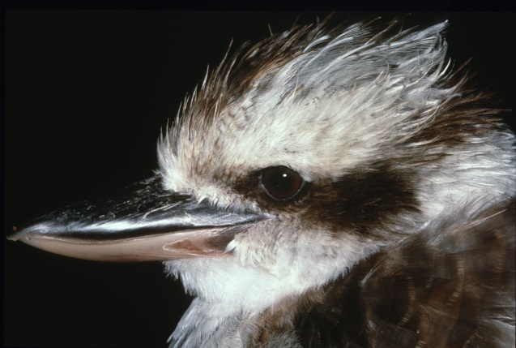 Figure 1. Laughing Kookaburra © I. McCann DSE 2009
Diet
Kookaburras are not selective feeders. They feed on a wide range of food sources depending on what is available. They eat snakes, lizards, small mammals, frogs, rodents, bugs, beetles and worms.

Kookaburras are often seen waiting for prey on low tree branches or powerlines. When prey appears, the Kookaburra dives down and grabs the prey with its strong beak.

Large prey items such as lizards and snakes are bashed against rocks or trees to kill and soften them before being swallowed.
Habitat
Kookaburras live in sclerophyll (Eucalyptus) woodlands and open forests.
They can occur in almost any area with trees big enough to contain their nests and open patches with sufficient hunting areas.

Distribution
The Kookaburra is found right across Victoria and most of eastern Australia, from Cape York Peninsula in Queensland to the Eyre Peninsula in South Australia. They have been introduced to Tasmania and south-western Australia.

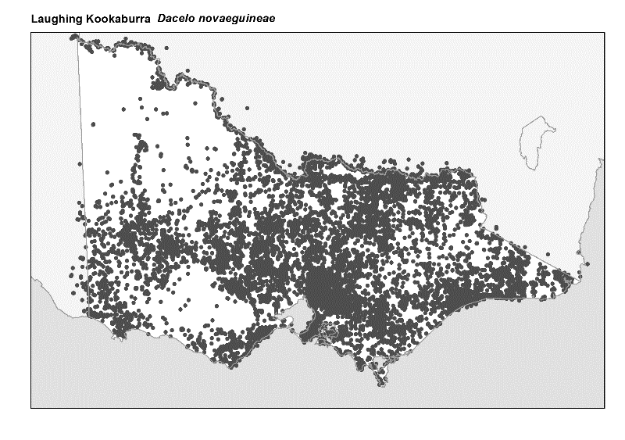 Figure 2. Recorded occurrences in Victoria
Source: Victorian Biodiversity Atlas (records post 1979), version 15/5/2017

Breeding
Kookaburras breed from September to January. They create nests in any hole which is big enough to fit an adult, such as a tree hollow.
The females lay between one and four round white eggs in the nest, which she incubates (keep warm) for approximately 24 days.
Pairs bond for life and young chicks are cared for by all members of the family.
What you can do to help!
To help protect the Kookaburra’s habitat, retain as many trees as possible around your home. Kookaburras need trees for nesting, roosting (sleeping or resting) and for perching on while waiting for food.

You can also plant trees that are native to your area. This will ensure that Kookaburras and other wildlife have suitable habitat in the future. Contact your local nursery for a list of plants native to your area.
Reducing or eliminating the use of chemicals such as pesticides in your garden can also be helpful. If Kookaburras eat insects affected by insecticides, they absorb the chemicals and can become sick.
Mulching your garden with leaf litter can create a perfect habitat for worms, insects and lizards, which Kookaburras love to feed on.
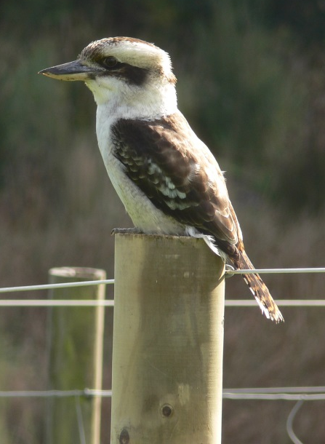 Figure 3. Laughing Kookaburra © A. Mann DSE 2009
Further reading
Simpson, K. and Day, N., (2010), Field guide to the birds of Australia, (8th ed), Penguin Books, Australia.
Morcombe, M., (2004), Field guide to Australian birds, Steve Parish Publishing, Australia.

