www.delwp.vic.gov.au

|  |
| --- |
| Kangaroo Pet Food Trial  Developmental Wildlife Trade Operation Plan |

|  |  |
| --- | --- |
|  |  |

|  |
| --- |
| © The State of Victoria Department of Environment, Land, Water and Planning 2017  Logo  This work is licensed under a Creative Commons Attribution 4.0 International licence. You are free to re-use the work under that licence, on the condition that you credit the State of Victoria as author. The licence does not apply to any images, photographs or branding, including the Victorian Coat of Arms, the Victorian Government logo and the Department of Environment, Land, Water and Planning (DELWP) logo. To view a copy of this licence, visit <http://creativecommons.org/licenses/by/4.0/>  ISBN 978-1-76047-098-2 (pdf)  Disclaimer  This publication may be of assistance to you but the State of Victoria and its employees do not guarantee that the publication is without flaw of any kind or is wholly appropriate for your particular purposes and therefore disclaims all liability for any error, loss or other consequence which may arise from you relying on any information in this publication.  Accessibility  If you would like to receive this publication in an alternative format, please telephone the DELWP Customer Service Centre on 136186, email [customer.service@delwp.vic.gov.au](mailto:customer.service@delwp.vic.gov.au), or via the National Relay Service on 133 677 [www.relayservice.com.au](http://www.relayservice.com.au). This document is also available on the internet at [www.delwp.vic.gov.au](http://www.delwp.vic.gov.au). |

Contents

1 Introduction 2

1.1 Species controlled under the KPFT 2

1.2 KPFT area 2

1.3 KPFT carcass utilisation 3

1.4 Relevant state legislation 3

2 Objectives 4

2.1 Objectives of the KPFT 4

2.2 Objectives of the DWTO 4

3 KPFT details 4

3.1 Overview of the KPFT ATCW system 4

3.1.1 Overview of the ATCW system 4

3.1.2 KPFT carcass utilisation system 5

3.2 Licensing and regulation 6

3.2.1 Landholders 6

3.3 Current and predicted carcass utilisation 7

3.4 Method of control 8

3.5 Timing and duration 9

3.6 Existing stocks 9

4 Impacts of the KPFT on the Eastern Grey Kangaroo and Western Grey Kangaroo 9

4.1 Distribution, conservation status and biology 9

4.2 Threats and assessment of impacts 11

5 Monitoring and assessment 12

6 Management strategies 12

7 Compliance 13

8 Reports 13

9 References 13

Appendix 1 – Kangaroo survey method 16

# 1 Introduction

The Department of Environment, Land, Water and Planning (DELWP) authorises the control of kangaroos in Victoria through the Authority to Control Wildlife (ATCW) system under section 28A of the *Wildlife Act 1975* where they are damaging property (e.g. crops, pastures, fences).

Prior to the KPFT, between 30,000 to 70,000 kangaroos were being controlled in Victoria each year under the ATCW system. While authorisation holders are allowed to utilise the meat from controlled kangaroos for personal use, the vast majority of the kangaroos are buried or left onsite to decompose.

In March 2014, the Victorian Government commenced a two-year Kangaroo Pet Food Trial (KPFT) which allowed the use of kangaroos shot under ATCWs to be used for processing into pet food. A secondary use also under the trial was the export of the kangaroo skins overseas.

In February 2016, the Victorian Government announced that the trial would be extended for another two years to March 2018. The extension of the trial is considered to be the 'second phase' of the original trial ('phase one'). The extension of the trial resulted in the expansion of the trial into new areas, commencing on the 19th September 2016, and will allow the testing of a number of additional objectives, as outlined in section 2.1.

The export of wildlife products from Australia requires Commonwealth Government approval under the *Environment Protection and Biodiversity Conservation Act 1999* (EPBC Act). Under phase one of the trial, individual pet meat processing facilities obtained approval from the Commonwealth Government for their Small Scale Wildlife Trade Operations in order to export kangaroo skins collected under the trial.

With the recent extension and expansion of the trial, it is now required that DELWP, as the State Government department responsible for the protection, and regulation of activities relating to kangaroos in Victoria, apply for a Developmental Wildlife Trade Operation approval, instead of the individual processing facilities.

This Kangaroo Pet Food Trial Developmental Wildlife Trade Operation Plan (the Plan) has been developed to satisfy the requirements of the EPBC Act to enable the continued export of kangaroo skins resulting from the KPFT.

## 1.1 Species controlled under the KPFT

The two kangaroo species under the KPFT are the:

* Eastern Grey Kangaroo (*Macropus* giganteus); and the
* Western Grey Kangaroo (*Macropus fuliginosus*).

Further details regarding the species' biology, ecology and conservation can be found in section 4.1.

## 1.2 KPFT area

The KPFT was originally conducted in 12 local government areas (LGAs) in North East and Western Victoria. In North East Victoria the trial was conducted in the LGAs of Benalla, Mansfield, Mitchell, Murrindindi, Strathbogie and Wangaratta. In Western Victoria the trial was conducted in the LGAs of Ararat, Horsham, Pyrenees, Northern Grampians, Southern Grampians and Yariambiack. These were areas where the highest number of ATCWs had been issued for the control of kangaroos on private land.

In September 2016, after consultation with relevant local governments and other key stakeholders, the LGAs of Greater Bendigo, Glenelg, West Wimmera and Loddon were also added to the trial area (see Figure 1).

Kangaroos controlled under ATCWs on public land are not able to be used under the KPFT.

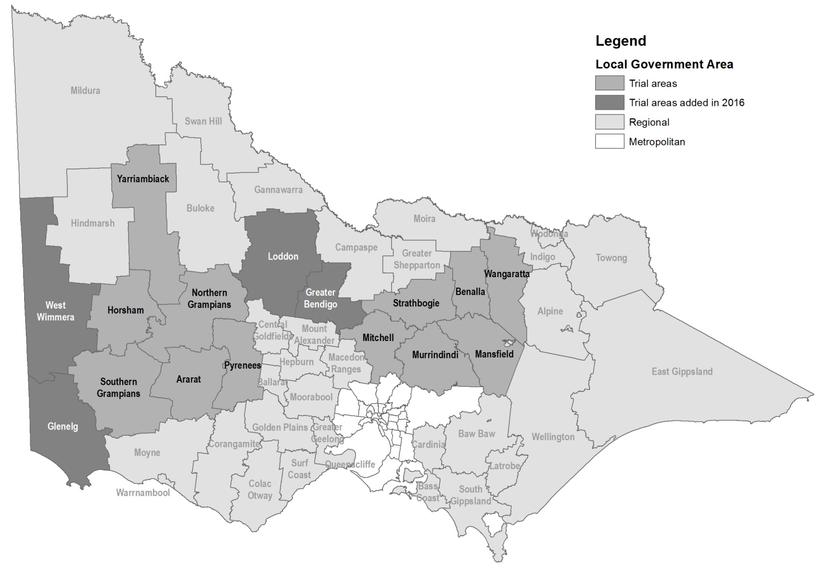

Figure 1: KPFT area

## 1.3 KPFT carcass utilisation

There is no harvesting program for kangaroos in Victoria. Instead, the KPFT allows the utilisation of kangaroo carcasses of those authorised to be controlled under damage mitigation ATCW permits on private land in the trial LGAs shown in Figure 1. Under the trial, the carcasses may be used for the production of pet food and the export of the skins overseas.

## 1.4 Relevant state legislation

All wildlife in Victoria, including the Eastern Grey Kangaroo and the Western Grey Kangaroo, are protected under the Victorian *Wildlife Act 1975*. It is illegal to destroy or wilfully disturb protected wildlife without approval. The most common form of approval is an ATCW. DELWP can issue ATCWs under section 28A of the *Wildlife Act 1975* to authorise land managers to scare, disperse, trap or destroy wildlife if it is damaging buildings, pasture, crop or other property, threatening human safety or impacting on biodiversity.

Neither kangaroo species is listed as threatened under the Victorian *Flora and Fauna Guarantee Act 1988*, nor under the Commonwealth EPBC Act.

# 2 Objectives

## 2.1 Objectives of the KPFT

The objectives of the initial trial were to:

1. test the uptake of the commercial use of carcasses from kangaroos controlled under ATCWs for pet food for domestic consumption;
2. test the effectiveness of this commercial use in reducing the waste of those carcasses; and
3. assess the needs and costs regarding compliance with the *Wildlife Act 1975* and the *Meat Industry Act 1993*.

A mid-trial review found the trial to have been generally successful at the time of the evaluation, although the trial duration limited some of the conclusions. As a result, the above objectives have remained in place with the extension of the trial, with the following additional objectives:

1. test the above objectives over a longer period to better understand the sustainability of these arrangements;
2. enable the performance of the trial to be tested under varying kangaroo populations; and
3. test the uptake in some areas where the number of kangaroos authorised for control are lower or more remote from processors.

## 2.2 Objectives of the DWTO

The objectives of this DWTO are to:

1. to allow the assessment of the KPFT against the objectives of Part 13A of the EPBC Act with respect to the export of skins; and
2. allow DELWP to begin collecting the information and data required for a Wildlife Trade Management Plan (WTMP) should the decision be made to convert the trial into an ongoing arrangement.

# 3 KPFT details

## 3.1 Overview of the KPFT ATCW system

### 3.1.1 Overview of the ATCW system

The use of kangaroo carcasses in Victoria under the KPFT is not based on a harvesting model. Instead the KPFT was designed around the existing ATCW system, in order to minimise waste of kangaroos (i.e. the carcasses) that are being controlled for damage mitigation purposes.

The ATCW system allows landholders to apply for authorisations to scare, disperse, trap or destroy wildlife if it is damaging buildings pasture, crops or other property, posing risks to human safety, or impacting on biodiversity.

In applying for an authorisation, landholders must specify the:

* location of the property where the wildlife problem is occurring;
* species and number of wildlife that is causing the problem;
* type and extent of the damage caused by the wildlife;
* actions attempted by the landholder to manage the wildlife problem using non-lethal methods that do not require an ATCW; and
* proposed control method (e.g. scaring, shooting, trapping and release, destroying eggs and nests).

Applications are assessed by DELWP Wildlife Officers who consider:

* the severity of the problem (e.g. the extent of the property damage);
* the underlying cause of the problem (e.g. whether the damage is being caused by wildlife or pest species like rabbits);
* whether non-lethal control methods have been attempted;
* whether the control method proposed is the most effective method to resolve the problem;
* the local and broader environmental context;
* whether the control will have a detrimental effect on the conservation status of the species or the environment; and
* the minimum number of animals that may need to be controlled to resolve the problem.

A site inspection is usually conducted to confirm the above information. If, after assessing the application and considering the above points, the DELWP officer is not satisfied that the control is necessary, then the application will be refused.

If it is determined that an authorisation is required to mitigate the problem, then an ATCW is issued and the control undertaken by the landholder or his/her agents, in accordance with conditions.

### 3.1.2 KPFT carcass utilisation system

The KPFT utilises the already established ATCW system (see Figure 2 below). Landholders in the KPFT areas are able to apply for a KPFT ATCW if they are experiencing damage from Eastern or Western Grey Kangaroos on their property (e.g. fence, pasture or crop damage).

Like normal ATCW applications, landholders have to specify the above mentioned information on the location, species of wildlife, number of animals, the type of damage being caused etc. The application is also assessed by DELWP Wildlife Officers on the same basis as the standard ATCW system. The KPFT does not change the requirement for an ATCW applicant to demonstrate that kangaroos are causing damage and that they have considered practical non-lethal control methods prior to applying for the ATCW.

If the application is approved and the KPFT ATCW is issued, the control is not undertaken by the landholder or his/her agents, but instead by professional shooters working with licensed pet meat processing facilities.

For all KPFT ATCWs issued after early October 2016, the carcasses of all kangaroos controlled by professional shooters must be tagged with a white plastic tag that is labelled with “VIC KPFT” and a unique tag number. Professional shooters are required to keep records of the control work undertaken and provide the record sheet and all unused tags back to the landholder, who then has to submit them back to DELWP at the expiry of the authorisation.

The professional shooter then transports all tagged kangaroo carcasses to a licensed pet meat processing facility who processes the carcasses into pet food, and provides records back to DELWP on a 3 monthly basis. The tags will remain on the skins to enable identification and traceability of its origin.

If the landholder is not serviced by a professional shooter (e.g. due to distance or small number of kangaroos), the landholder may control the kangaroos themselves, however resulting carcasses are unable to be processed under the trial due to PrimeSafe requirements.

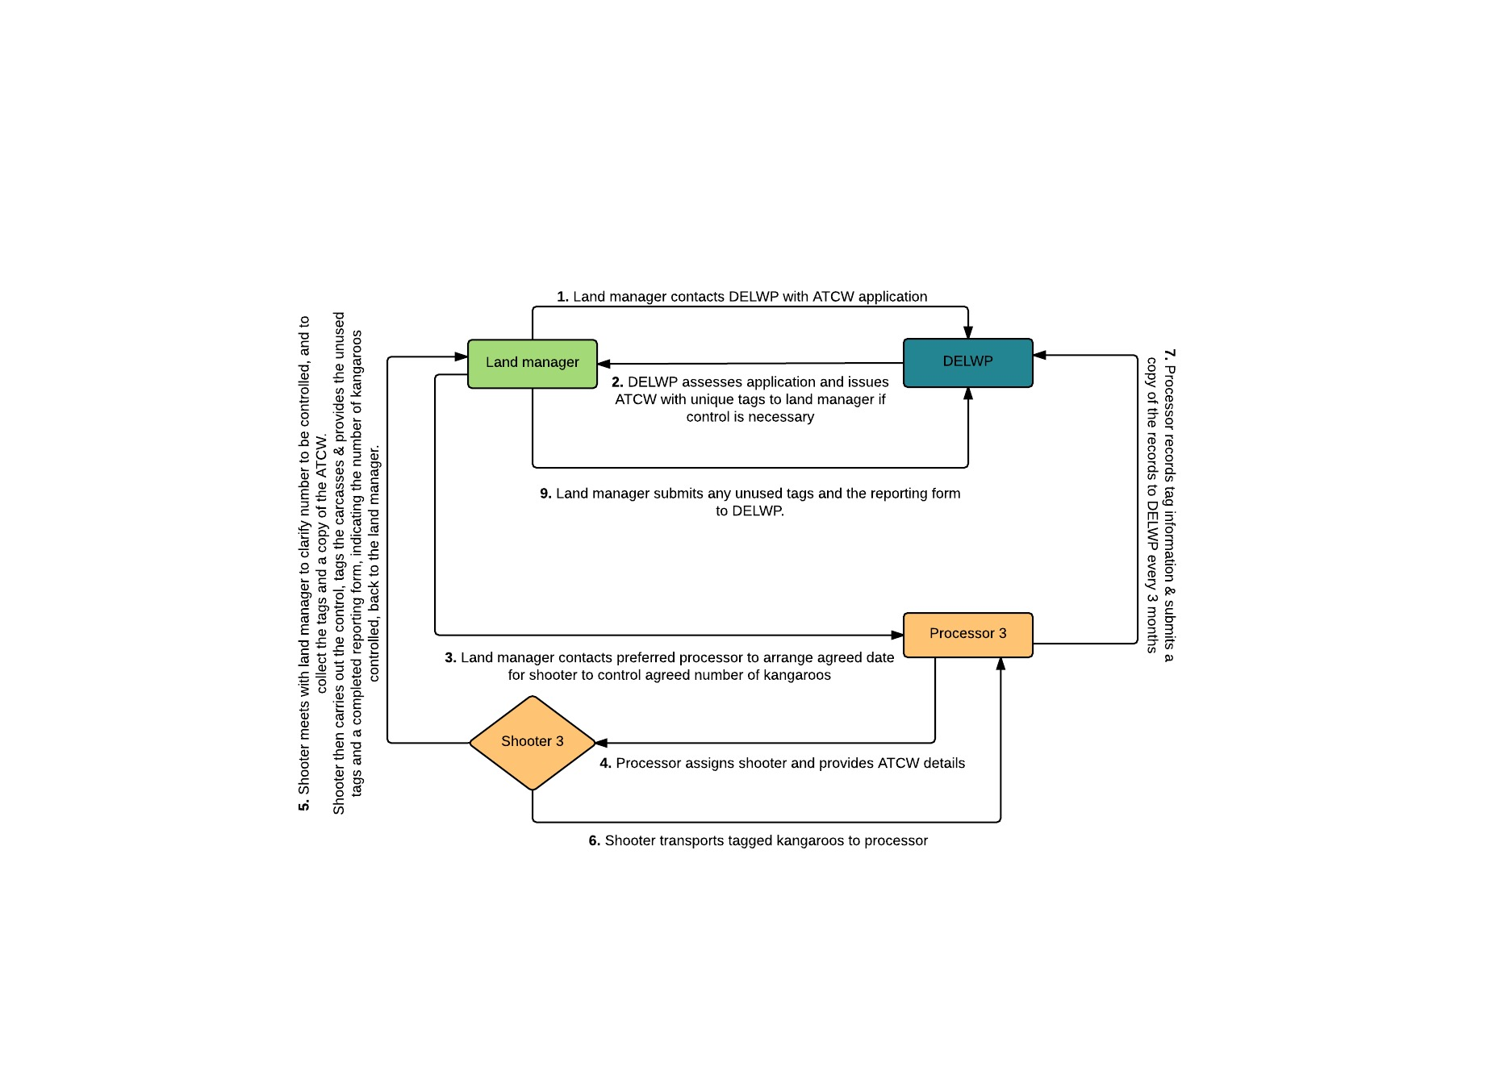

Figure 2: Diagram of the KPFT system

## 3.2 Licensing and regulation

### 3.2.1 Landholders

Private landholders are regulated under the requirements of the *Wildlife Act 1975* when undertaking management of wildlife, including kangaroos, on their property. KPFT ATCWs are only issued if DELWP is satisfied that it is necessary to manage the kangaroos to reduce damage and financial loss, and that non-lethal control methods are not feasible. The trial does not change the requirement for a landholder applying for an ATCW to demonstrate that kangaroos are causing damage and is not intended to increase the number of kangaroos controlled.

KPFT ATCWs issued to the landholder, while allowing the control of kangaroos on their properties and the subsequent sale of the resultant carcasses by the professional shooter, also have a number of additional conditions. The authorisation states which species (i.e. Eastern or Western Grey Kangaroo), and how many of that species may be controlled.

The conditions restrict the sale by declaring that no part of any kangaroo taken under the authorisation may be given away, sold or traded in any way except for the purposes of the DELWP KPFT. As with the standard ATCWs, the KPFT ATCWs also allow the personal use of kangaroo carcasses. Landholders are not able to receive any remuneration for kangaroo carcasses controlled on their property under the KPFT ATCW.

The conditions also include requirements for how the kangaroos must be shot, which are consistent with the *National Code of Practice for the Humane Shooting of Kangaroos for Commercial Purposes*. While the selection of males or females for control are not restricted by the conditions, they do forbid the control of animals with obvious dependent young.

3.2.2 Processors

In Victoria, the processing of kangaroos for pet meat is primarily regulated by two acts; the *Wildlife Act 1975* and the *Meat Industry Act 1993*.

The *Wildlife Act 1975*, and its underlying Wildlife Regulations 2013, requires those processing wildlife in Victoria to obtain a ‘Wildlife Processor Licence’, issued and administered by DELWP. While many of those process wildlife only to produce fur, skins or leather, some may also hold a license to operate a ‘Pet Meat Processing Plant’ under the *Meat Industry Act 1993*, in which case the wildlife may be processed to produce pet food. Wildlife Processor Licences are subject to conditions, and can be issued annual or 3 yearly, with a common expiry date of 30 June. Holders of a Wildlife Processor Licence are required to keep record books and submit them to DELWP annually. DELWP wildlife officers undertake random inspections of all commercial licence holders to monitor compliance with the legislation and licence conditions.

The *Meat Industry Act 1993* establishes the legal framework for regulation of meat production for human consumption and pet food. It enables the setting of standards for meat production. Pet food is produced in Victoria through ‘Pet Meat Processing Plants’ which wholesale, package and/or prepare pet food/meat for sale. These facilities require a license under the *Meat Industry Act 1993*, administered by Victoria's meat safety regulatory body, PrimeSafe. Licences are issued annually, commencing on 1 July of each year, and applicants pay a licence fee. PrimeSafe licensees are required to engage directly a third party auditor to conduct inspections. Further, the *Meat Industry Act 1993* regulates meat transport vehicles.

Pet food processing plants are required to submit a Food Safety Plan (also known as a Quality Assurance Program) identifying preferred suppliers of meat. Licensed pet food processing plants can only receive carcasses from preferred suppliers who have satisfied certain requirements. Preferred suppliers are required to undertake training that satisfies national standards. Pet food plants must also comply with the *'Standard for the Hygienic Production of Pet Food'*, which prescribes outcomes and the methods for achieving those outcomes (for further information see relevant sections below).

3.2.3 Shooters

Shooters under the KPFT are essentially engaged as both agents of the landholders and as preferred suppliers for pet meat processing plants. This means that they must comply with both the conditions of the KPFT ATCWs and the requirements of their supervising processor's Food Safety Plan when controlling, treating and transporting kangaroos to meet animal welfare and hygiene requirements.

Shooters must hold a current firearms licence (administered by Victoria Police). It is also a requirement of PrimeSafe that the processors provide appropriate training to the shooters, including to ensure they meet the requirements of the *National Code of Practice for the Humane Shooting of Kangaroos for Commercial Purposes*.

## 3.3 Current and predicted carcass utilisation

3.3.1 Numbers authorised for control

#### Current numbers authorised for control

During phase one of the KPFT (31 March 2014 - 31 March 2016), 546 KPFT ATCWs were issued for 53,631 kangaroos to be controlled. In the 12 KPFT LGAs, these KPFT ATCWs formed 27% of the total authorisations issued for the control of kangaroos and 41% of the total kangaroos.

#### Predicted numbers authorised for control

The KPFT does not operate on a quota system, and only kangaroos that are authorised for control for damage mitigation purposes are able to be used under the trial. Therefore the following figures are predictions only, and may not be accurate. However they do provide an idea of what the uptake of the kangaroo carcasses might be for the remainder of the trial. The predictions are based on past numbers of kangaroos authorised for control under the standard ATCW system and the KPFT.

The trial area has expanded to an additional 4 LGAs, Greater Bendigo, Glenelg, Loddon and West Wimmera in September 2016, taking the total number of LGAs under the trial area to 16. Therefore the number of kangaroos authorised for control under phase two of the KPFT will be higher than it was for phase one.

Prior to the trial expanding to Greater Bendigo, Glenelg, Loddon and West Wimmera, 566 authorisations were issued for the control of 24,102 kangaroos under standard ATCWs in these areas. Assuming that the subscription to the trial in the new areas is consistent with the rate of uptake in the original trial areas in the first two-years of the trial (41% of the total kangaroos authorised for control), it is estimated that approximately 9,881 kangaroos will be authorised for control under KPFT ATCWs in those four areas.

It is assumed that subscription to the trial for phase two will be at least consistent with phase one in the original trial areas. By adding the estimated number of additional kangaroos authorised for control in the four new trial areas (based on previous ATCW numbers), it is estimated that the total number of kangaroos authorised for control under the KPFT for 2016 – 2018 will be at least 63,512.

The above figure assumes a stable kangaroo population over the period of the second phase of the trial, however, anecdotal evidence suggests that kangaroo populations have increased across the state. In 2015, the total number of kangaroos authorised for control across the state was 134,737 - an 80% increase on the number authorised in 2014. This is consistent with increases in kangaroo populations in other states over the same period.

If the kangaroo populations in Victoria continue to increase, then the number of kangaroos authorised for control under phase two of the KPFT is likely to be higher than those estimated above based on the figures from phase one. Whether the kangaroo populations continue to increase will depend on a number of environmental factors, including food availability due to climatic conditions.

3.3.2. Estimated numbers of carcasses processed

For phase one of the trial (March 2014 – March 2016), a total of 27,736 kangaroo carcasses have been processed into pet food. Given the trial has been extended to four new areas as of September 2016, the estimated number of kangaroos processed under phase two of the trial is expected to be greater than 27,736. However it is difficult to predict how much greater this figure will be, as it will depend on the operations of the processing facilities participating in the trial.

## 3.4 Method of control

Kangaroos controlled under a KPFT ATCW must be controlled in accordance with the following requirements:

1. Kangaroos must only be shot with a calibre of ammunition that equals or is greater than:
   1. 0.224 inches or 5.69 millimetres with a cartridge size of .222R, .223, .22/250 with a soft or hollowpoint projectile of 50 grains or more; or
   2. 0.204 inches or 5.18 millimetres with a cartridge size of .204 Ruger with a soft or hollowpoint projectile of 40 grains or more.
2. Kangaroos must not be shot from a moving vehicle or any other moving platform.
3. Kangaroos with obvious dependent young must not be shot.
4. A shooter must aim to hit the target kangaroo by a single shot to the brain. The target kangaroo must be clearly visible, standing and stationary (injured animals excepted) and not greater than 200 metres from the shooter.
5. Each kangaroo must be dead before another kangaroo is targeted. If a kangaroo is injured or has young at foot, no further kangaroos can be shot until all reasonable efforts have been made to humanely kill it and any young at foot.
6. Female kangaroos must be examined for pouch young as soon as carcasses are retrieved. Pouch young must be killed by destroying the brain.

These requirements are consistent with the *National Code of Practice for the Humane Shooting of Kangaroos and Wallabies for Commercial Purposes*.

## 3.5 Timing and duration

The KPFT commenced on 31 March 2014 and was initially a two-year trial due to finish on 31 March 2016. In 2016 the decision was made to extend the KPFT for another two years, ending on 31 March 2018.

Kangaroos controlled under a KPFT ATCW may be controlled at any time during the year while the trial is in operation. KPFT ATCWs are issued one a case-by-case basis for anywhere between 6 months to 1 year duration.

## 3.6 Existing stocks

Under phase one of the trial, individual pet meat processing facilities obtained approval from the Commonwealth Government for their Small Scale Wildlife Trade Operations in order to export kangaroo skins collected under the trial. However these approvals were only valid for the period of the original trial (March 2014 – March 2016). As of 1 April 2016, all participating pet meat processing plants have been stockpiling skins collected under the trial, until such time as this DWTO is put in place. Therefore, this DWTO is also accompanied with an Existing Stocks WTO application, in order to enable the processing plants to export any skins that are collected or currently stockpiled under the trial.

# 4 Impacts of the KPFT on the Eastern Grey Kangaroo and Western Grey Kangaroo

## 4.1 Distribution, conservation status and biology

Since European settlement, the populations of some macropod species, such as the Eastern Grey Kangaroo and Western Grey Kangaroo, have dramatically increased. This is thought to be mainly due to the removal of natural predators, an increase in improved pastures across the landscape through the clearing of forests for pasture and grazing, and the proliferation of reliable water sources in previously arid and semi-arid areas (Calaby and Grigg 1989, Pople and Grigg 1999).

The Eastern Grey Kangaroo and Western Grey Kangaroo are regarded as secure in Victoria. The International Union for the Conservation of Nature (IUCN) regards both species as species of 'Least Concern' due to their wide distribution (see Figures 3 and 4), large populations, occurrence in a number of protected areas, lack of major threats and lack of observable declines.

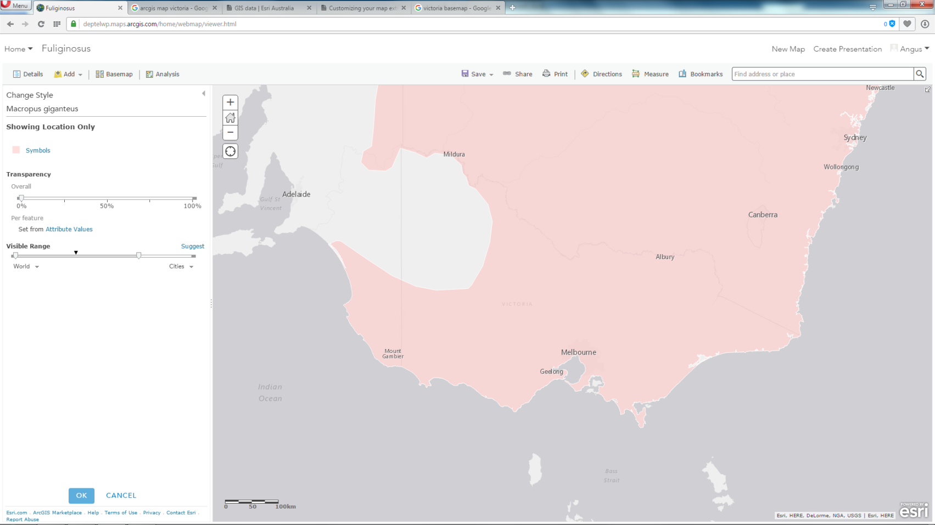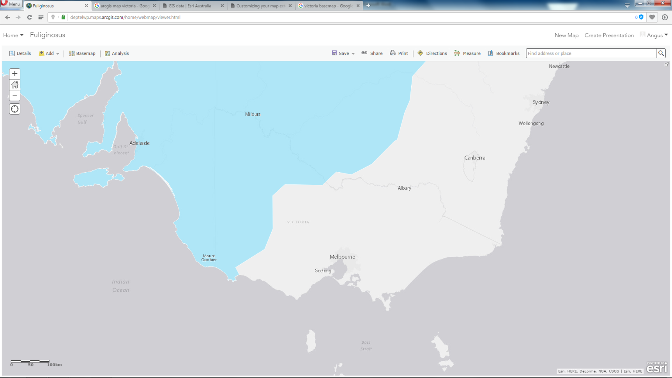

Figure 4: Western Grey Kangaroo distribution in Victoria

Figure 3: Eastern Grey Kangaroo distribution in Victoria

4.1.1 Biology

The Eastern Grey Kangaroo is found across the east coast of Australia from northern Queensland to the south-eastern corner of South Australia, they also extend down to Tasmania (Figure 3). It is thought that the development of improved pastures has resulted in an increase in the abundance of Eastern Grey Kangaroos and an increase in their range inland westwards due to the increase in watering points for sheep and cattle (Tyndale-Biscoe 2005).

The Eastern Grey Kangaroo are an abundant species that occupies a range of habitats including semi-arid mallee scrubs, shrub woodlands and forests (Poole 1982). They are a large kangaroo with grey fur apart from their lighter bellies. Males can reach weights of over 70kg, while females rarely exceed 35kg (Dawson 2012).

The Western Grey Kangaroo has a lower abundance that the Eastern Grey Kangaroo, and although its range seems to have increased in recent times the extent of this increase is unknown (Dawson 2012). The species occurs in a range of habitats including sclerophyll forest, woodland (including mallee), shrubland, heathland and farmland with remnant native vegetation (Coulson 1990, 1993).

Western Grey Kangaroos were only recognised as a separate species in the 1970s (Kirsch and Poole 1972) however they are usually more brown in appearance when compared to Eastern Greys and are also slightly more slender in appearance (Dawson 2012). They are thought to have diverged from a common ancestor relatively recently (i.e. sometime in the Pleistocene epoch) (Dawson T.J. 2012) and as such, differ little in their ecology and biology.

The reproductive biology of Western and Eastern Grey Kangaroos has been extensively studied (Tyndale-Biscoe and Renfree 1987); they are seasonal breeders with oestrus and births occurring between September and March and lactational anoestrus (sexual inactivity) between April and August (Poole 1973, 1976). Post-partum ovulation does not occur in either species and, unlike other large macropod species like the Red Kangaroo, they do not generally carry dormant embryos in the uterus (known as diapause) (Tyndale-Biscoe 2005). While there is the potential for diapause in Eastern Grey Kangaroos (albeit rarely) the function has been completely lost in Western Grey Kangaroos (Poole 1975).

These species are gregarious (Southwell 1984a) and occur in mobs that can range from only a few to hundreds (Fletcher 2006). The size of these groups has been found to be positively correlated to the population density in the area (Taylor 1982, Southwell 1984a, Jarman and Coulson 1989) and is also affected by habitat, with groups in dense woodland areas smaller than those at equivalent densities in open cleared pasture habitat (Coulson and Raines 1985, Heathcote 1987, Jarman and Coulson 1989).

Eastern Grey Kangaroos are thought to occupy small overlapping home ranges which they show high fidelity to (Jarman and Taylor 1983). These home ranges have been found to be large in cleared agricultural areas (Jarman and Taylor 1983) and in semi-arid areas (e.g. 430 and 528 ha respectively) as compared to areas of mixed woodland and adjacent farmland (e.g. 27 to 158 ha) (Moore, Coulson and Way 2002). Home ranges of Eastern Grey Kangaroos in areas of woodland with adjacent farmland may be influenced in their size by disturbance through control by farmers, dogs and domestic stock, with kangaroos remaining close to cover to avoid these disturbances (Moore, Coulson and Way 2002, Viggers and Hearn 2005).

## 4.2 Threats and assessment of impacts

In the context of the KPFT in Victoria; threats to the conservation status of the Eastern Grey Kangaroo or the Western Grey Kangaroo are thought to be negligible given the uptake of kangaroo carcasses is from an already existing ATCW system.

The ATCW system on which the KPFT is based has been in operation since the establishment of the *Wildlife Act 1975*. Since that time, the number of ATCWs issued for kangaroo control have been increasing (Fletcher 2006). This trend has continued in recent years, with 2015 recording the highest numbers of kangaroos authorised for control (Figure 5).

This trend is consistent with population data from surveys conducted across South Australia, New South Wales and Queensland which have shown kangaroo numbers have been consistently increasing after a low point around the mid-2000s (South Australia Department of Environment, Water and Natural Resources, New South Wales Office of Environment & Heritage and Queensland Department of Environment and Heritage Protection). Numbers peaked in 2013 in Queensland and 2014 in New South Wales, while South Australian numbers were still increasing between 2014 and 2015, this is thought to be due to climatic variation.

In Victoria, this trend upwards is also thought to be due to an increase in the level of land manager subscription to the ATCW system since its inception, with more land holders opting to comply and seek an authorisation rather than undertaking un-authorised kangaroo control.

Figure 5: Number of kangaroos (Eastern Grey Kangaroo and Western Grey Kangaroo) authorised for control in Victoria 2002 - 2015. Consistent with previous pre-2002 data (Fletcher 2006), peaks have occurred in drought years.

The ATCW system is based around damage mitigation, not population management of wildlife. This means that authorisations are issued for the purposes of mitigating damage occurring on specific properties (i.e. damage to crops, pasture or fences), not for landscape scale population management of species. As a result, decisions around kangaroo management are made at a regional level by DELWP Wildlife Officers and are based around local knowledge of the regional population, and site inspections to assess the actual numbers of the kangaroos in question.

The result is a responsive system that self-adjusts to rises and falls in the state's kangaroo population. Kangaroo population numbers fluctuate in response to changes in the conditions of vegetation (generally related to climatic variation, specifically, rainfall and temperature) (Bayliss 1987; Cairns & Grigg 1993; Cairns *et al*. 2000; Caughley, Grigg and Smith 1985; McCarthy 1996; Pople 2003; Pople *et al*. 2010; Robertson 1986).

The KPFT is unlikely to significantly impact either of the species concerned as it is simply a modification to the already established ATCW system. The same damage assessment process is maintained, however the kangaroo carcasses are instead authorised to be utilised for pet meat processing and for their skins, rather than being wasted.

# 5 Monitoring and assessment

A review was conducted of the KPFT in mid-2015 to examine its effectiveness against the objectives and key evaluation criteria of the trial. The review identified that the uptake of carcasses under the trial has been largely successful, however some of the objectives would benefit further from assessment over a longer time period and in areas where the number of kangaroos authorised for control are lower or more remote from processors. With the recent extension and expansion of the trial, another review will be undertaken in 2017.

The evaluation of the trail will commence in mid-2017 to inform the Minister’s decision on whether the trial will become an ongoing program. The trial will be evaluated against key evaluation criteria to determine whether it has met its objectives. The evaluation will include:

* a survey of landholders, processors, shooters and animal welfare organisations to gain their thoughts on the trial and why they did or did not participate
* analysis of KPFT and non-KPFT ATCW data to determine trends inside and outside trial areas and whether the trial has driven permit applications
* analysis of compliance issues that arose during the trial and the cost to the Department to undertake compliance activities in relation to the trial
* analysis of the commercial viability of the trial for the participating processors.

There have previously been no state-wide population distribution or abundance surveys conducted for the Eastern Grey and Western Grey Kangaroo in Victoria, as it has not been necessary in the past for the administration of the ATCW damage mitigation system. However, DELWP has now developed a survey method (Appendix 1) to gather data on the species distribution and abundance for the Eastern and Western Grey Kangaroo in Victoria. The survey will be conducted in 2017 to inform the evaluation of the KPFT and prepare for the development of a Wildlife Trade Management Plan, should the decision be made to move to an ongoing program.

# 6 Management strategies

Should the decision be made to proceed with a WTMP, population distribution and abundance surveys will be conducted to inform DELWP of fluctuations of Victoria’s kangaroo populations. The trial review in 2017 will also be used to inform the decision, along with consideration of other models for the commercial use of kangaroos, such as a resource allocation or harvesting based system similar to those used in other Australian states in which zones are established to ensure that take pressure is distributed across the range of the species.

# 7 Compliance

Compliance with KPFT ATCWs and Wildlife Processor Licences is monitored by DELWP Wildlife Officers, through various means, including review of submitted records, random inspections and investigation of reports of non-compliance. There are severe penalties for non-compliance with the conditions of authorisations and licences, which may result in suspension or cancellation of the authorisation or licence and/or prosecution.

The requirement that all kangaroos controlled under a KPFT ATCW be tagged from the point of control through to the processing, and submission of all unused tags back to DELWP along with records, enables traceability and accountability of all kangaroos controlled under the trial. The tags will also remain affixed to the skins, to ensure traceability.

# 8 Reports

An annual report will be provided to the Commonwealth on the operations conducted under the KPFT and the approved DWTO.

# 9 References

Bayliss 1987, Kangaroo dynamics. In ‘Kangaroos: Their ecology and management in the sheep rangelands of Australia’ (Eds Caughley, N Shepherd and J. Short), 119 – 134.

Cairns *et al*. 2000, Western grey kangaroos, *Macropus fuliginosus*, in the South Australian pastoral zone: populations at the edge of their range. *CSIRO Publishing*: *Wildlife Research*, 27, 301-318.

Cairns & Grigg 1993, Population dynamics of Red Kangaroos (*Macropus rufus*) in relation to rainfall in the South Australian pastoral zone. *Journal of Applied Ecology*, 444 – 458.

Calaby and Grigg 1989, Changes in Macropodoid communities and populations in the past 200 years and the future. In ‘Kangaroos, Wallabies and Rat Kangaroos’ (Eds G. Grigg, P. Jarman and I. Hume), 813 – 820.

Caughley, Grigg and Smith 1985, The effect of drought on kangaroo populations. *Journal of Wildlife Management*, 49(3): 679 – 685.

Coulson 1990, Habitat separation in the Grey Kangaroos, Macropus giganteus Shaw and M. fulifinosus (Desmarest) (Marsupialia: Macropodidae) in Grampians National Park, Western Victoria. Australian Mammology, 13, 33 – 40.

Coulson 1993, Use of heterogeneous habitat by the Western Grey Kangaroo, *Macropus fuliginosus*. *CSIRO Publishing: Wildlife Research*, 20, 137-149.

Coulson and Raines 1985, Methods for small-scale surveys of Grey Kangaroo populations. *Australian Wildlife Research*, 12, 119 – 125.

Dawson T.J. 2012, Kangaroos. CSIRO Publishing.

Fletcher 2006, Population dynamics of Eastern Grey Kangaroos in temperate grasslands. Diss. University of Canberra.

Heathcote 1987, Grouping of Eastern Grey Kangaroos in open habitat. *Australian Wildlife Research*, 14, 343 – 348.

[International Union for the Conservation of Nature (IUCN)](https://www.iucn.org/)

Jarman and Coulson 1989, Dynamics and adaptiveness of grouping in macropods. *Kangaroos, wallabies and rat kangaroos,* 2, 527 – 547.

Jarman and Taylor 1983, Ranging of Eastern Grey Kangaroos and Wallaroos on a New England pastoral property. *Australian Wildlife Research*, 10, 33 – 38.

Kirsch and Poole 1972, Taxonomy and distribution of the Grey Kangaroos, *Macropus giganteus* Shaw and *Macropus fuliginosus* (Desmarest), and their subspecies (*Marsupialia macropodidae*). *Australian Journal of Zoology*, 20, 315 - 339

McCarthy 1996, Red Kangaroo (*Macropus rufus*) Dynamics: Effects of rainfall, density dependence, harvesting and environmental stochasticity. *The Journal of Applied Ecology*, 33, No. 1, 45 – 53.

Moore, Coulson and Way 2002, Habitat selection by adult female Eastern Grey Kangaroos. *CSIRO Publishing: Wildlife Research,* 29, 439 – 445.

New South Wales Office of Environment & Heritage, [New South Wales Commercial Kangaroo Harvest Management Plan 2012-16: 2016 Quota Report.](http://www.environment.nsw.gov.au/resources/nature/kmp/150701-kmp-quota-report.pdf)

Poole 1973, A study of breeding in grey kangaroos, *Macropus giganteus* Shaw and *M. fuliginosus* (Desmarest), in central New South Wales. *Australian Journal of Zoology*, 21(2), 183-212.

Poole 1975, Reproduction in the Two Species of Grey Kangaroos, *Macropus Giganteus* Shaw and *M. Fuliginosus* (Desmarest). Ii. Gestation, Parturition and Pouch Life. *Australian Journal of Zoology*, 23(3), 333-353.

Poole 1976, Breeding Biology and Current Status of the Grey Kangaroo, *Macropus Fulginosus* *Fulginosus*, of Kangaroo Island, South Australia. *Australian Journal of Zoology*, 24(2), 169-187.

Poole 1982, *Macropus giganteus*. Mammalian Species, 187, 1 – 8.

Pople and Grigg 1999, Commercial harvesting of Kangaroos in Australia. Prepared for Environment Australia.

Pople *et al.* 2003, Monitoring Kangaroo populations in Southeastern New South Wales. Prepared for the New South Wales National Parks and Wildlife Service.

Pople *et al*. 2010, Reassessing the spatial and temporal dynamics of kangaroo populations. *Macropods: the biology of kangaroos, wallabies, and rat-kangaroos*, p.197.

Queensland Department of Environment and Heritage Protection, [2015 Quota Submissions for Commercially Harvested Macropods in Queensland.](https://www.qld.gov.au/environment/assets/documents/plants-animals/macropods/quota-submission2015.pdf)

Robertson 1986, The mortality of kangaroos in drought. *Australian Wildlife Research*, 13, 349 – 354.

South Australia Department of Environment, Water and Natural Resources, [South Australian kangaroo harvesting statistics.](http://www.google.com.au/url?sa=t&rct=j&q=&esrc=s&source=web&cd=20&ved=0ahUKEwisjauqlufKAhVD26YKHa3iAAQ4ChAWCEswCQ&url=http%3A%2F%2Fwww.environment.sa.gov.au%2Ffiles%2Fsharedassets%2Fpublic%2Fplants_and_animals%2Fkangaroo-harvesting-statistics-gen.pdf&usg=AFQjCNFB8RLueQKAXOfa18Ab0Lb0BT6q_g&bvm=bv.113370389,d.dGY)

Southwell 1984a, Variability in grouping in the Eastern Grey Kangaroo, Macropus giganteus: 1. Group Density and group size. *Australian Wildlife Research*, 11, 423 – 435.

Taylor 1982, Group size in the Eastern Grey Kangaroo, *Macropus giganteus*, and the Wallaroo, *Macropus robustus.* *Australian Wildlife Research*, 9, 229 – 237.

Tyndale-Biscoe C. H. (2005) Life of Marsupials

Tyndale-Biscoe and Renfree 1987. *Reproductive physiology of marsupials*. Cambridge University Press.

Viggers and Hearn 2005, The kangaroo conundrum: home range studies and implications for land management. *Journal of Applied Ecology*, 42, 99 – 107.

**State Legislation**

*Wildlife Act 1975*

*Flora and Fauna Guarantee Act 1988*

*Meat Industry Act 1993*

**Commonwealth Legislation**

*Environment Protection and Biodiversity Conservation Act 1999*

**Relevant Codes of Practice - Commonwealth**

*National Code of Practice for the Humane Shooting of Kangaroos for Commercial Purposes*.

**Relevant Codes of Practice - State**

*Standard for the Hygienic Production of Pet Food*

# Appendix 1 – Kangaroo survey method

*(Will be submitted once final version received)*

delwp.vic.gov.au