|  |
| --- |
| State-wide abundance of kangaroos in Victoria  Results from the 2018 aerial survey |
| P.D. Moloney, D.S.L. Ramsey and M.P Scroggie |
| January 2019 |

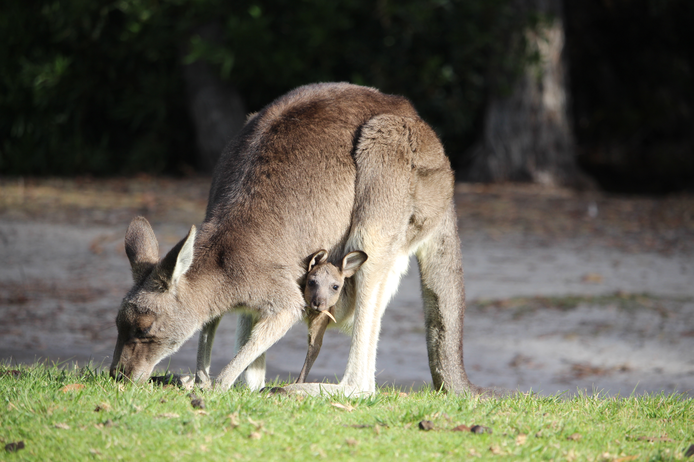

Arthur Rylah Institute for Environmental Research   
Technical Report Series No. 296



|  |
| --- |
| Arthur Rylah Institute for Environmental Research Department of Environment, Land, Water and Planning PO Box 137 Heidelberg, Victoria 3084 Phone (03) 9450 8600 Website: [www.ari.vic.gov.au](http://www.ari.vic.gov.au)  **Citation**: Moloney, P.D., Ramsey, D.S.L., and Scroggie, M.P. (2018). State-wide abundance of kangaroos in Victoria: results from the 2018 aerial survey. Arthur Rylah Institute for Environmental Research Technical Report Series No. 296. Department of Environment, Land, Water and Planning, Heidelberg, Victoria.  **Front cover photo**: Eastern grey kangaroo and joey (Jemma Cripps).  Logo© The State of Victoria Department of Environment, Land, Water and Planning 2018    This work is licensed under a Creative Commons Attribution 3.0 Australia licence. You are free to re-use the work under that licence, on the condition that you credit the State of Victoria as author. The licence does not apply to any images, photographs or branding, including the Victorian Coat of Arms, the Victorian Government logo, the Department of Environment, Land, Water and Planning logo and the Arthur Rylah Institute logo. To view a copy of this licence, visit <http://creativecommons.org/licenses/by/3.0/au/deed.en>  ISSN 1835-3827 (print)  ISSN 1835-3835 (pdf))  ISBN 978-1-76077-469-1 (print) ISBN 978-1-76077-470-7 (pdf/online/MS word)  **Disclaimer** This publication may be of assistance to you but the State of Victoria and its employees do not guarantee that the publication is without flaw of any kind or is wholly appropriate for your particular purposes and therefore disclaims all liability for any error, loss or other consequence which may arise from you relying on any information in this publication.  Accessibility  If you would like to receive this publication in an alternative format, please telephone the DELWP Customer Service Centre on 136 186, email [customer.service@delwp.vic.gov.au](mailto:customer.service@delwp.vic.gov.au) or contact us via the National Relay Service on 133 677 or [www.relayservice.com.au](http://www.relayservice.com.au). This document is also available on the internet at [www.delwp.vic.gov.au](http://www.delwp.vic.gov.au) |

State-wide abundance of kangaroos in Victoria

Results from the 2018 aerial survey

P.D. Moloney, D.S.L. Ramsey and M.P. Scroggie

Arthur Rylah Institute for Environmental Research   
123 Brown Street, Heidelberg, Victoria 3084

Date

Arthur Rylah Institute for Environmental Research  
Technical Report Series No. 296

# Acknowledgements

We thank Kirsty Greengrass, Emma Hickinbotham, Jemma Cripps and Graeme Newell who provided valuable feedback on drafts of this report. This report was commissioned by the Regulation Strategy and Design Branch, Biodiversity Division, of the Department of Environment, Land, Water and Planning. Aerial surveys were conducted by Terrestrial Ecosystem Services Pty Ltd, ([www.ecoknowledge.com.au](http://www.ecoknowledge.com.au)). Ground surveys were conducted by Graeme Coulson (Macropus Consulting).

Contents

Acknowledgements ii

1 Summary 4

2 Introduction 5

3 Methods 6

3.1 Species distribution, study area and stratification 6

3.2 Aerial surveys 7

3.3 Ground surveys 8

3.4 Proportions of Eastern and Western Grey Kangaroos in the overlap zone 9

3.5 Kangaroo abundance estimates for each LGA 10

4 Results 10

4.1 Kangaroo density estimates for each stratum 10

4.2 Proportions of Eastern and Western Grey Kangaroos in the overlap zone 13

4.3 Kangaroo abundance estimates for each LGA 14

5 Discussion 16

5.1 Recommendations 17

6 References 18

Appendix 19

1. Summary

**Context:**

The Authority to Control Wildlife (ATCW) provisions of the *Wildlife Act 1975* (Victoria) allows wildlife, including three species of kangaroos [Eastern Grey Kangaroo (*Macropus giganteus*), Western Grey Kangaroo (*M. fuliginosus*) and Red Kangaroo (*Osphranter rufus*)] to be subject to legal culling in Victoria for damage mitigation purposes. To determine whether control of kangaroos under the ATCW provisions is ecologically sustainable, the state of Victoria is conducting state-wide aerial population surveys of these three species of kangaroo.

**Aims:**

To estimate the abundance of the three species of kangaroo in the non-forested regions of Victoria.

**Methods:**

Aerial surveys conducted in September and October 2018 were used to estimate kangaroo abundance within seven strata comprising 58 non-metropolitan Victorian local government areas (LGA). These surveys update population estimates derived from an earlier program of surveys conducted in 2017 (Moloney *et al*. 2017) and incorporated methodological improvements intended to increase the precision of the population estimates. Heavily-forested areas were excluded from kangaroo abundance estimates as these could not be reliably monitored using aerial surveys. As Eastern and Western Grey Kangaroos cannot be reliably identified from aerial surveys, concurrent ground surveys were also undertaken within areas of Victoria where these two species overlap to estimate the relative proportions of each species.

**Results:**

Based on an analysis of the aerial and ground survey data, the overall kangaroo population in Victoria was estimated to be 1,425,000 (95% confidence interval; 1,045,000 – 1,942,000). There were an estimated 1,251,000 (889,000 – 1,762,000) Eastern Grey Kangaroos, accounting for the overwhelming majority (88%) of Victorian kangaroos. The remaining part of the kangaroo population was comprised of an estimated 130,000 (91,000 – 185,000) Western Grey Kangaroos and 44,000 (25,000 – 77,000) Red Kangaroos.

The Central stratum had the highest density of Eastern Grey Kangaroos (22.7 kangaroos/km2), much greater than the next highest density in the Lower Wimmera stratum (12.9 kangaroos/km2). The Upper Wimmera stratum had the lowest density of kangaroos (2.3 kangaroos/km2).

**Conclusions:**

Compared to estimates from 2017, the density of grey kangaroos was similar for most strata except for the Otway (higher in 2018), Central and Gippsland strata (lower in 2018). The density of red kangaroos in the Mallee stratum was higher in 2018 compared with the 2017 estimate. Precision of estimates also improved for most strata compared with the 2017 estimates. However, precision for some strata (i.e. North-East and Otway) were lower than expected due to high level of clustering of kangaroos on some transects.

**Recommendations:**

* If future state-wide kangaroo surveys are undertaken, consideration could be given to reducing the frequency of surveys to every three years. The frequency of surveys may need to be increased (e.g. every two years) during periods of severe and prolonged drought.
* Consideration should be given to collecting some additional ground survey data in South Australia, adjacent to the Victorian border to help clarify the location and width of the Grey Kangaroo Overlap Zone in south-west Victoria.
* Given the high level of kangaroo aggregation observed during this aerial survey, consideration could be given to determining optimal sampling strategies for strata likely to have high levels of kangaroo clustering on transects.
* Some further adjustments of existing transects should also be undertaken to avoid obstacles impeding the safe operation of the aircraft, such as high-tension power lines.

1. Introduction

The Authority to Control Wildlife (ATCW) provisions of the *Wildlife Act 1975* (Victoria) allows wildlife, including three species of kangaroos [Eastern Grey Kangaroo (*Macropus giganteus*), Western Grey Kangaroo (*M. fuliginosus*) and Red Kangaroo (*Osphranter rufus*)] to be subject to legal culling in Victoria for damage mitigation purposes. To determine whether control of kangaroos under the ATCW provisions is ecologically sustainable, the state of Victoria is conducting state-wide aerial population surveys of these three species of kangaroo. Ecological sustainability can be defined in terms of the maximum culling or harvesting rate that can be sustained in the long-term, while ensuring a low risk of declines in the conservation status of kangaroos. Sustainable culling or harvest rates of kangaroos are usually based on a fixed proportion of the estimated population size, with harvest proportions of 10 – 20% of the population generally considered to be ecologically sustainable (Caughley *et al.* 1987; Hacker *et al.* 2004; McLeod *et al.* 2004).

The first aerial and ground survey of Victoria’s kangaroo population was conducted in 2017 (Moloney *et al.* 2017). That survey estimated Victoria’s kangaroo population to be 1,442,000 with a relative precision (coefficient of variation) of 19%. However, precision of the estimates for some regions were inadequate. Hence, improvements to the survey design were recommended (Moloney *et al.* 2018). These recommendations sought to establish the minimal amount of survey effort that would be required to estimate the population abundance of kangaroos within each of seven geographic regions (strata), with a specified level of confidence (expressed as a coefficient of variation (CV) of 20% or less). Strata were chosen to reflect the likely regional variation in the density of Victoria’s kangaroo population. Due to the difficulty in distinguishing the two species of grey kangaroo during aerial surveys, ground surveys were undertaken to estimate the relative proportions of Eastern and Western Grey Kangaroos within the overlap zone where the two species co-occur (Lower and Upper Wimmera). These proportions were then used to derive separate estimates of the abundances of the two grey kangaroo species within the overlap zone. Strata-level estimates of density for each species were then used to estimate kangaroo abundances in each of 58 non-metropolitan Local Government Areas (LGA). Heavily forested areas in each stratum or LGA were excluded from kangaroo abundance estimates as these could not be reliably monitored using aerial surveys.

In this report, we present the results of the second state-wide aerial survey of kangaroos in Victoria. Kangaroo abundance estimates (and their precision) are provided for each stratum and LGA. Comparisons are made between the results from the initial aerial survey conducted in 2017 with the results from the current survey. We also make some recommendations for improvements in the survey design that could increase the efficiency of aerial surveys and the precision of estimates for future state-wide surveys.

1. Methods
   1. Species distribution, study area and stratification

Aerial and ground surveys using the methodology outlined in (Moloney *et al.* 2018) were conducted in September and October 2018 to estimate the kangaroo population in Victorian LGAs. Aerial survey effort undertaken during 2018 amounted to 150 transects comprising a total of 3182 km, which was a substantial increase over the 79 transects (1600 km) undertaken in 2017 (Moloney *et al.* 2017). Ground survey effort was also increased from 1000 km in 2017 to 1800 km in 2018. The survey and estimates exclude LGAs entirely (or almost entirely) located within highly urbanised parts of the Melbourne metropolitan area. Estimates also excluded thickly forested areas due to the unreliability of kangaroo detection in those areas. Therefore, the survey and the resulting population estimates were restricted to the 58 non-metropolitan LGA listed in Table 1.

Table 1. Local government areas and strata included in the survey and estimates.

|  |  |  |  |
| --- | --- | --- | --- |
| Strata | LGA | Strata | LGA |
| Central | Ballarat | North East | Alpine |
|  | Brimbank |  | Benalla |
|  | Hepburn |  | Campaspe |
|  | Hume |  | Greater Bendigo |
|  | Macedon Ranges |  | Greater Shepparton |
|  | Melton |  | Indigo |
|  | Mitchell |  | Mansfield |
|  | Moorabool |  | Moira |
|  | Mount Alexander |  | Strathbogie |
|  | Murrindindi |  | Towong |
|  | Nillumbik |  | Wangaratta |
|  | Whittlesea |  | Wodonga |
|  | Yarra Ranges | Otway | Colac Otway |
| Gippsland | Bass Coast |  | Corangamite |
|  | Baw Baw |  | Golden Plains |
|  | Cardinia |  | Greater Geelong |
|  | Casey |  | Hobsons Bay |
|  | East Gippsland |  | Moyne |
|  | Latrobe |  | Surf Coast |
|  | Mornington Peninsula |  | Warrnambool |
|  | South Gippsland |  | Wyndham |
|  | Wellington | Upper Wimmera | Buloke |
| Lower Wimmera | Ararat |  | Hindmarsh |
|  | Central Goldfields |  | Horsham |
|  | Gannawarra |  | Swan Hill |
|  | Glenelg |  | West Wimmera |
|  | Loddon |  | Yarriambiack |
|  | Northern Grampians | Mallee | Mildura |
|  | Pyrenees |  |  |
|  | Southern Grampians |  |  |

Three kangaroo species are widely distributed over parts of Victoria. Red Kangaroos (*Osphranter rufus* - RK) are restricted to the far north-west corner of the state. Eastern Grey Kangaroos (*Macropus giganteus* - EGK) are found across most of Victoria, apart from the far north-west of the state. Western Grey Kangaroos (*M. fuliginosus* - WGK) are found only in the north-west of Victoria. The range of EGK and WGK overlap in a broad band across the west of the state, known as the Grey Kangaroo Overlap Zone (GKOZ). To account for the different kangaroo distributions and potential differences in density, Moloney *et al*. (2018) subdivided Victoria into seven strata by amalgamating ecologically similar LGAs (Figure 1).

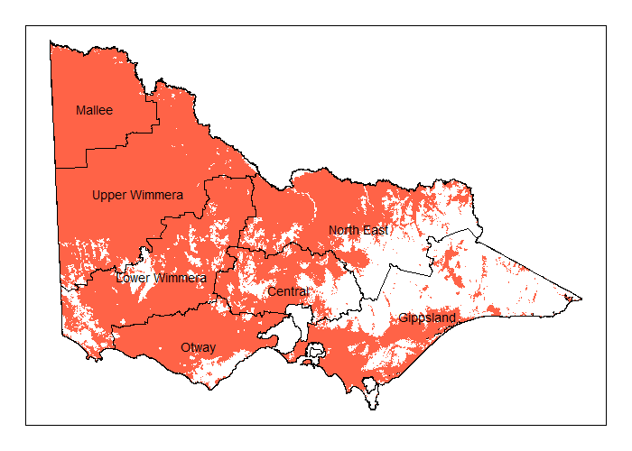

Figure 1. Map of stratification scheme for the state-wide kangaroo survey. Each stratum is formed by aggregating several ecological similar and geographically proximate LGAs. Coloured shading corresponds to open or lightly forested areas and/or mallee vegetation types that are included in the survey and estimates. Unshaded areas are heavily forested, highly urbanised or are kangaroo-free islands and therefore excluded from survey and estimates.

* 1. Aerial surveys

Aerial surveys and line-transect distance sampling (Buckland *et al.* 1993) were used to estimate kangaroo densities across Victoria. Aerial surveys were conducted by Terrestrial Ecosystem Services Pty Ltd in September/October 2018 using a Bell LongRanger helicopter using similar methods as were undertaken in 2017 (Lethbridge and Stead 2017). A total of 3182 km of transects were flown within three hours of sunrise or sunset in an easterly or westerly direction (flying away from the sun) at a height of 200 feet (AGL) (~60 m), at a speed of 50 knots (~90 km/h) (Priority 1 & 2 transects – Figure 2). A few of these transects had to be substituted with backup (contingency) transects due to the presence of obstructions such as power lines that precluded safe operation of the aircraft. Backup transects were selected from the contingency pool transects for that strata (Figure 2). A five-zone survey pole was used on either side of the aircraft, allowing observed kangaroos to be placed into one of five distance classes (0-20m, 20-40m, 40-70m, 70-100m and 100-150m). The species, size and distance class of the first observation of each group of kangaroos observed was recorded. Due to the difficulties in accurately determining the difference between EGK and WGK from the air, only two “species” of kangaroos were recorded, RK and grey kangaroo (GK) representing both EGK and WGK combined. For further details of the aerial surveys methodology see Lethbridge and Stead (2017).

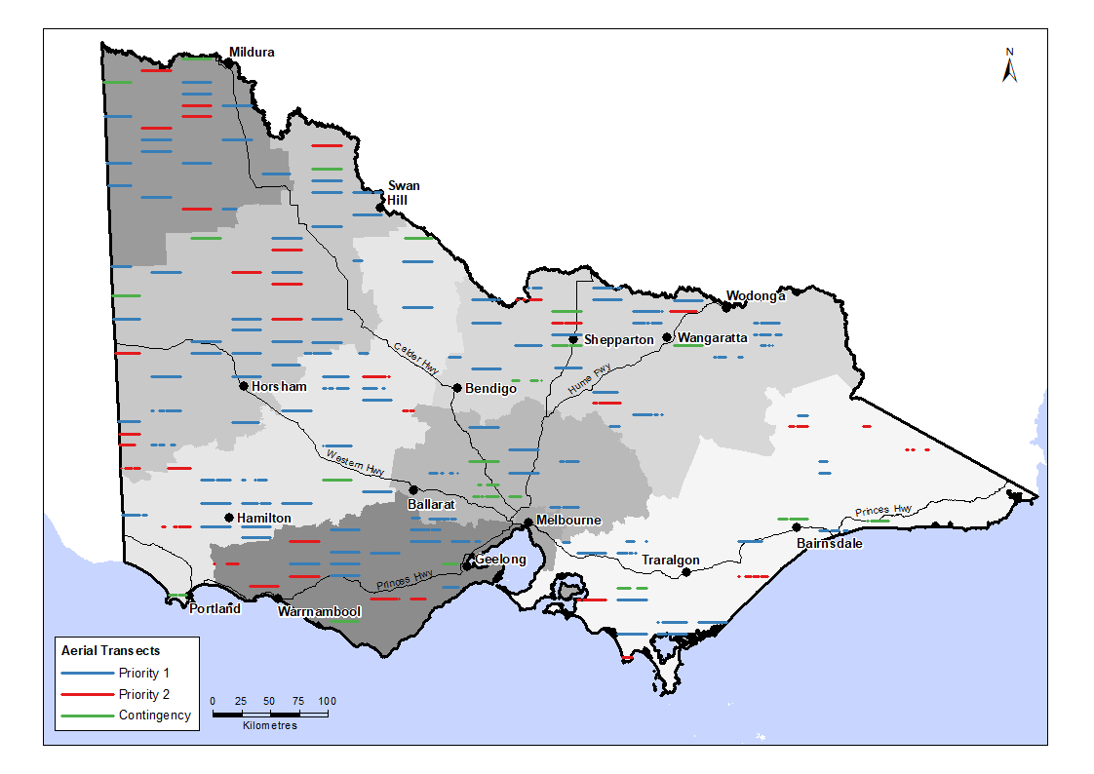

Figure 2. Map of transects flown in the 2018 kangaroo aerial survey (from Moloney et al. 2018). Both Priority 1 and Priority 2 transects were surveyed with Contingency transects substituted in the event that Priority 1 or Priority 2 transects could not be safely flown. Shading indicates different strata.

* 1. Ground surveys

Both EGK and WGK occur within Victoria, and to enable effective management separate population estimates are required for the two species. It is not possible to reliably distinguish the two species of GK during aerial surveys, so distance sampling estimates derived from the aerial surveys are for both species combined. In strata occupied only by EGK (i.e. North East, Central, Otway, Gippsland), the estimates of total GK abundance could be safely assumed to equate to the number of EGK. However, where the two species overlap (primarily the Upper and Lower Wimmera strata – the GKOZ), it was necessary to apportion the total population estimate between the two species. This was undertaken using ground surveys of the relative proportions of EGK and WGK within the GKOZ.

Ground surveys to estimate the ratio of EGK to WGK in western Victoria were conducted in the GKOZ in September 2018 (Coulson 2018). Eleven ground transects traversed roads in the GKOZ in the Upper and Lower Wimmera and a portion of the Mallee strata. The transects were selected to ensure thorough coverage of the GKOZ, with approximately equal coverage of areas on either side of the estimated location of the GKOZ mid-line. The transects were roughly perpendicular to the mid-line, totalling nearly 1850 km of roads (Figure 3). GKs were observed from a slow-moving vehicle while driving each transect around dawn and dusk, and all GKs that were encountered were identified to species level wherever possible. This included identification of road-killed kangaroos, and other individuals encountered dead. Only animals that could confidently be identified to species were considered further. A few dead kangaroos encountered during 2018 were identified using genetic analysis of tissue samples obtained from badly damaged carcasses that could not otherwise have been identified (Graeme Coulson, pers. comm.).

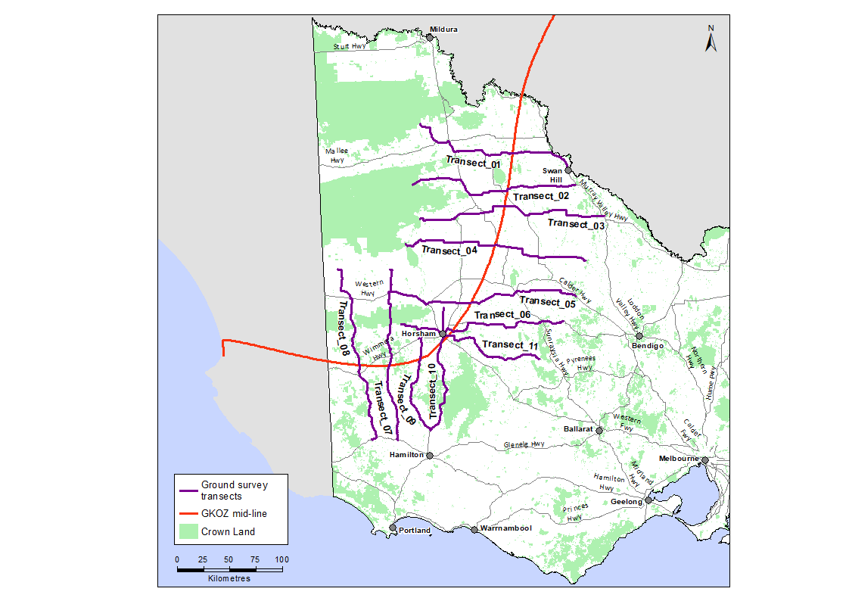

Figure 3. Map of ground transects used to sample the Grey Kangaroo Overlap Zone (GKOZ) in Victoria (purple lines). The red line indicates the estimated mid-point of the GKOZ used to plan the ground survey transects.

* 1. Proportions of Eastern and Western Grey Kangaroos in the overlap zone

We used the ground survey data to estimate the proportion of EKG and WKG occurring in different parts of the GKOZ and, more specifically, for each LGA within each stratum. WGK occur only in the north-west of the state, so it was explicitly assumed that the proportions of WGKs in the Otway, North East, Central and Gippsland strata were zero and hence, estimation focused on the strata in the north west (Mallee, Upper Wimmera and Lower Wimmera) known to be occupied by both species of GKs.

Additional locational data for EGK and WGK in south-eastern Australia (including Vic, SA and NSW) was obtained from the Atlas of Living Australia database. As there is some evidence that the location of the GKOZ within Victoria has moved over time (unpublished data), it was necessary when analysing the various sources of data (Atlas data and ground survey data from 2017 and 2018) to account for movement of the GKOZ over time. Accordingly, a space-time Generalized Additive Model (GAM) was fitted to the set of location/year data, which allowed for movement in the zone over time.

The space-time GAM models the probability that a randomly observed kangaroo will be an EGK, conditional on the latitude, longitude and year of the observation. The model includes smooth terms for the temporal trend, a spatial smoothing surface, and a tensor-product interaction between the temporal trend and the spatial smooth, to allow for spatial variability in the temporal trend. The model was fitted to the data using the R package mgcv (Wood 2017). A soap-film smoothing approach (Wood *et al.* 2008) was applied to the spatial component of the model, to allow for the effects of the edges (i.e. coastline) of the modelled area, and to prevent unrealistic smoothing of the spatial surface around peninsulas and other coastal features. Predictions of the model (expressed as probabilities that a random grey kangaroo was an Eastern Grey Kangaroo) were generated for the whole of south-eastern Australia on a 2-minute grid resolution (approximately 4.5 km).

We used the fitted model to estimate the mean proportion of EGKs within each of the Mallee, Upper Wimmera and Lower Wimmera strata. This was calculated by taking the mean of the estimated probability that a random GK was an EKG at all points on the 2-minute prediction grid that fell within the bounds of each stratum polygon. Uncertainty in the proportions for each stratum was estimated using a parametric bootstrap procedure (Wood 2017). A sample of 500 random values was drawn from the multivariate normal distribution describing the joint parameters of the GAM, and for each set of parameters a new prediction surface was generated. By computing the mean of the estimated proportions of EGKs for each set of randomly generated parameters, a sample of 500 estimates of the proportion of GKs for each stratum could be computed and estimates of uncertainty around the point estimates (standard deviation, variance, confidence intervals). The estimates of the proportions of WGK are simply the complement of the proportion of EGKs in each stratum or LGA across the entire study area. The estimates for each stratum were then used to apportion the total population estimates for GKs in each stratum between the two species.

* 1. Kangaroo abundance estimates for each LGA

The density of GK and RK (kangaroos/km2) was estimated for each stratum using standard line-transect distance sampling techniques (Buckland et al. 1993). Half-normal and hazard-rate detection functions with potential second and third order cosine adjustment terms were considered, with the model with the lowest Akaike’s Information Criterion (AIC; Burnham and Anderson 2002) used for the final inferences. Kangaroo abundance estimates for each LGA were then calculated by multiplying the stratum density estimates for each kangaroo species by the area (in square kilometres) of habitat (i.e. non-forested) in each LGA. In LGAs outside the GKOZ, GK can be assumed to be either EGK or WGK and densities can be estimated directly from the distance sampling model. However, within the GKOZ the density of GK needed to be assigned to EGK and WGK*.* This was done by multiplying the relevant density estimates by the modelled proportion of GK in that LGA that were EGK and WGK, respectively. Bootstrapping, based on 10,000 replicate samples, was used to estimate the standard error and confidence intervals of the EGK and WGK densities within the GKOZ (Efron and Tibshirani 1993). The analysis was carried out using the statistical program R (R Development Core Team 2018), with the package “Distance” (Miller 2017) used to estimate the distance sampling model.

1. Results
   1. Kangaroo density estimates for each stratum

A total of 4,707 GK and 91 RK individuals were observed from the 3,182 km of transects during the aerial survey. Studies have shown that at least 80 distance observations are required to provide a reasonable estimate of the detection function, which is necessary to estimate density with acceptable precision and accuracy (Buckland *et al*. 1993). Since there were only 49 RK clusters observed (and therefore, only 49 distance observations for the 91 RK individuals), a single detection function was fitted for all kangaroos, with the assumption that the distance detection function for GK and RK was identical. A half-normal detection function with second and third order cosine adjustments was selected after comparing the fit of the half-normal and hazard rate distance functions, with up to fourth order cosine adjustments (Table A1). The monotonicity assumption was not violated, with the estimated detection function decreasing as distance from the transect increased (Figure 4). A goodness-of-fit test indicated that the model was an adequate fit to the data (*p*-value = 0.144).

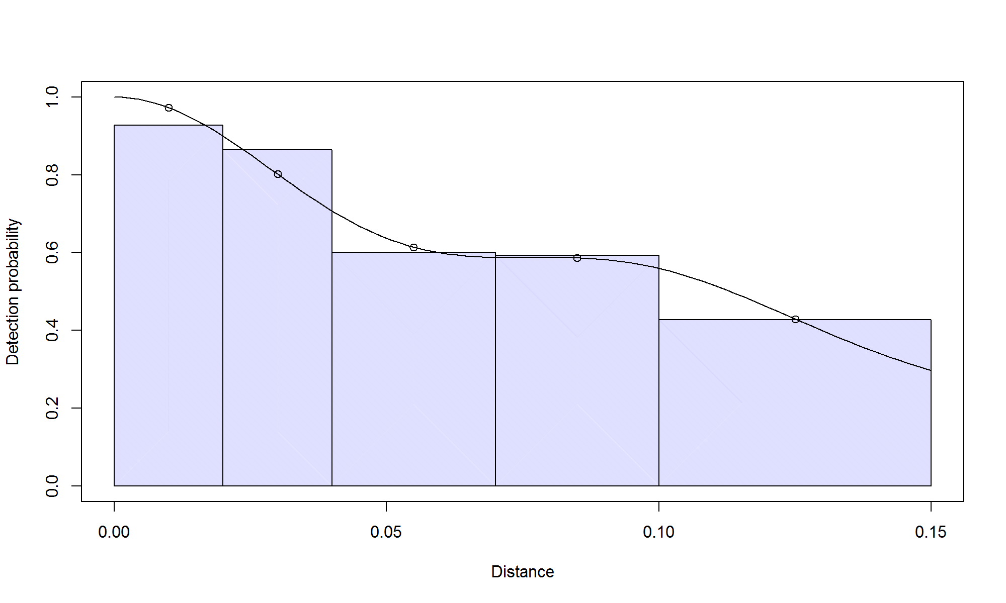

Figure 4. Estimated probability of detection of kangaroos with distance from the transect during the 2018 kangaroo aerial survey. Bars indicate the relative number of kangaroos observed in that distance category. The x-axis denotes distance from the helicopter flight line, measured in km (0.15 km = 150 m).

The distance sampling model was used to estimate the density of GK and RK (kangaroos/km2) for each of the seven strata (Table 2). The highest density was estimated to be for GK in the Central stratum (22.7/km2, 95% confidence interval; 11.1 – 46.4), nearly double the density of the next highest stratum, the Lower Wimmera (12.9/km2, 95% confidence interval; 7.8 – 21.4). The north-west of Victoria (Mallee and Upper Wimmera) had the lowest densities of GK. As expected, the majority of RK were observed in the Mallee stratum. However, one mob of three RK were observed in the Upper Wimmera region. This mob was treated as an outlier and removed from the data for analysis. Hence, RK density and abundance estimates were only provided for the Mallee stratum.

The estimated density of grey kangaroos in the Mallee, Upper and Lower Wimmera and North East strata in 2017 and 2018 were similar (Figure 5). However, in the Otway stratum the estimated density was higher in 2018, while in the Central and Gippsland strata the estimate was lower (Figure 5). The density of red kangaroos in the Mallee stratum increased in 2018, compared with 2017 and was more precise (CV of 26% Table 2). In most strata, the precision of GK density estimates was acceptable, but was unexpectedly low for the North East and Otway strata, despite the increase in the number of transects flown (Table 2). An unexpectedly high amount of clustering of kangaroos on some transects most likely led to the lower precision of estimates for these strata. For example, one transect in the North East (“NE18”) had a cluster of 105 kangaroos detected out of a total of 109 for that transect. Another transect (“NE09”), had a total of 528 kangaroos, which was 48% of all kangaroos detected in the North East stratum and more than twice the number observed at the transect with the next highest total in the state.

Based on the density estimates for each stratum derived from the distance sampling analysis, and the known surveyable areas of each stratum, the estimated overall kangaroo population in Victoria was estimated to be 1,425,000 (95% confidence interval; 1,045,000 – 1,942,000). This was very similar to the estimate from 2017 of 1,442,000 (95% confidence interval; 976,000 – 2,132,000) (Moloney *et al.* 2017).

Table 2. Kangaroo density (kangaroos/km2) estimates by strata for grey and red kangaroos. Lower and upper bounds indicate the 95% confidence intervals.

|  |  |  |  |  |  |  |
| --- | --- | --- | --- | --- | --- | --- |
| Species | Strata name | Density estimate | Standard error | Coefficient of variation | Lower bound | Upper bound |
| Grey | Mallee | 2.2 | 0.51 | 0.23 | 1.3 | 3.5 |
| Grey | Upper Wimmera | 2.3 | 0.75 | 0.33 | 1.2 | 4.3 |
| Grey | Lower Wimmera | 12.9 | 3.21 | 0.25 | 7.8 | 21.4 |
| Grey | Otway | 10.9 | 4.49 | 0.41 | 4.7 | 25.3 |
| Grey | Central | 22.7 | 7.13 | 0.31 | 11.1 | 46.4 |
| Grey | North East | 11.7 | 5.64 | 0.48 | 4.5 | 30.1 |
| Grey | Gippsland | 5.7 | 1.73 | 0.30 | 3.1 | 10.6 |
| Red | Mallee | 1.8 | 0.47 | 0.26 | 1.0 | 3.2 |

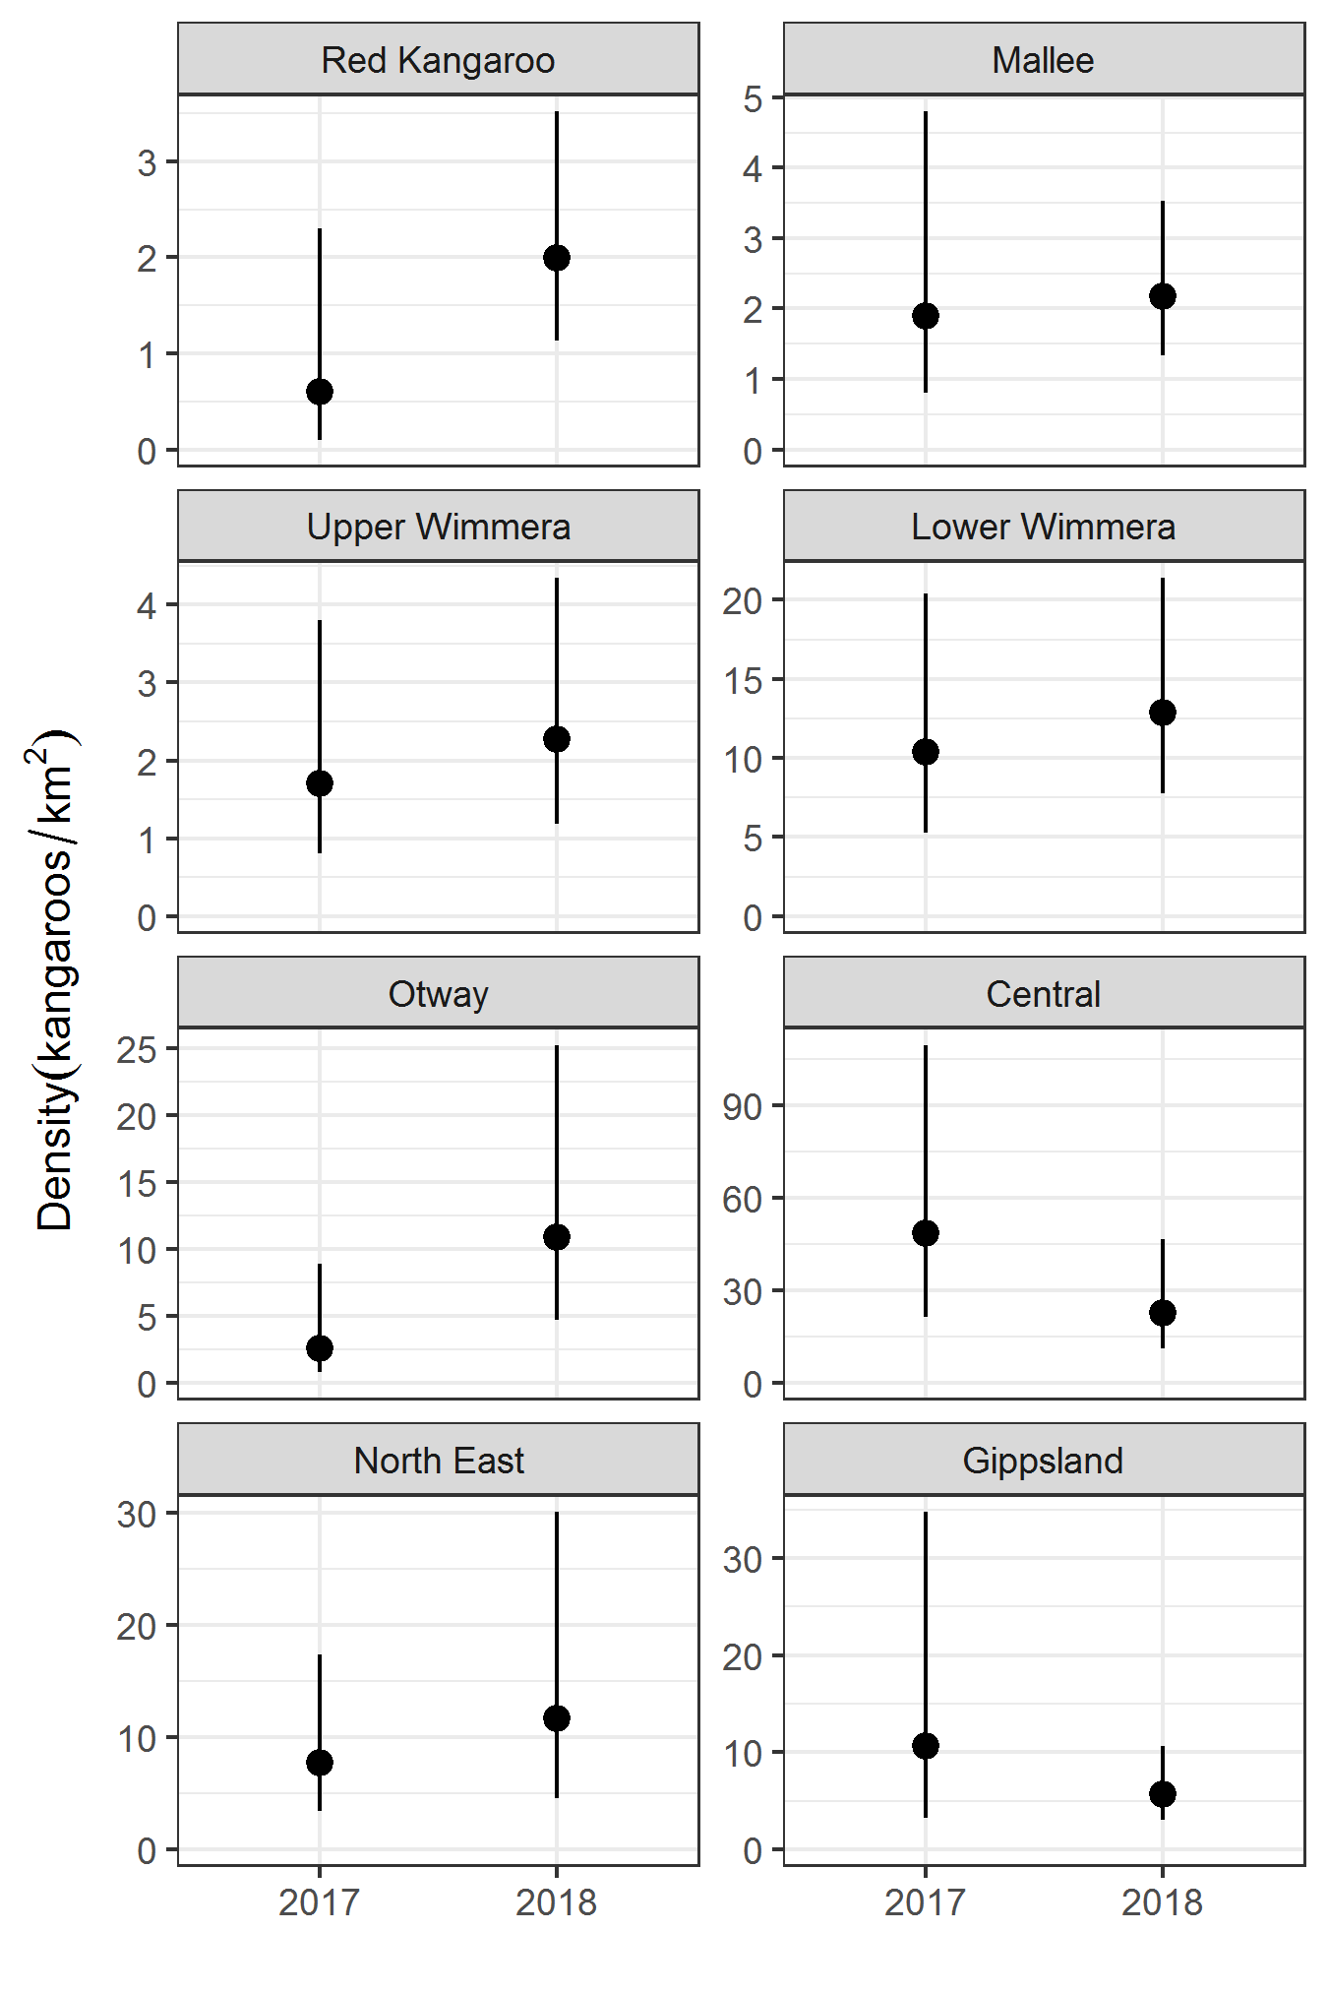

Figure 5. Comparison of stratum density estimates in 2017 and 2018. Density is kangaroos per square kilometre. RK only specifies the Mallee stratum. All other strata estimates are for GK. Error bars are 95% confidence intervals. Note the density scale differs among strata.

* 1. Proportions of Eastern and Western Grey Kangaroos in the overlap zone

The space-time GAM model fitted to the ground survey and atlas data indicated both the space and time terms in the model and their interactions were significant, with the model overall explaining 93% of the space-time variation in the proportions of the two GK species. The significant time and space-time interaction terms were consistent with the hypothesis that the GKOZ had moved over recent decades, with predictions over time (not shown here) suggesting a general movement of the zone to the northwest (i.e. an expansion in the range of EKG, and a commensurate reduction in the range of WKG).

The predictions of the space-time GAM model as of 2018 are shown in Figure 6, along with the ground survey data results for 2017 and 2018. Overall, the fitted model coincides well with existing knowledge of the current position and extent of the GKOZ.

Estimated proportions of EKG in the Mallee, Upper Wimmera and Lower Wimmera strata ranged from 12 to 91% (Table 3). These estimates were then used to apportion the total estimate of GK abundance between the two species.

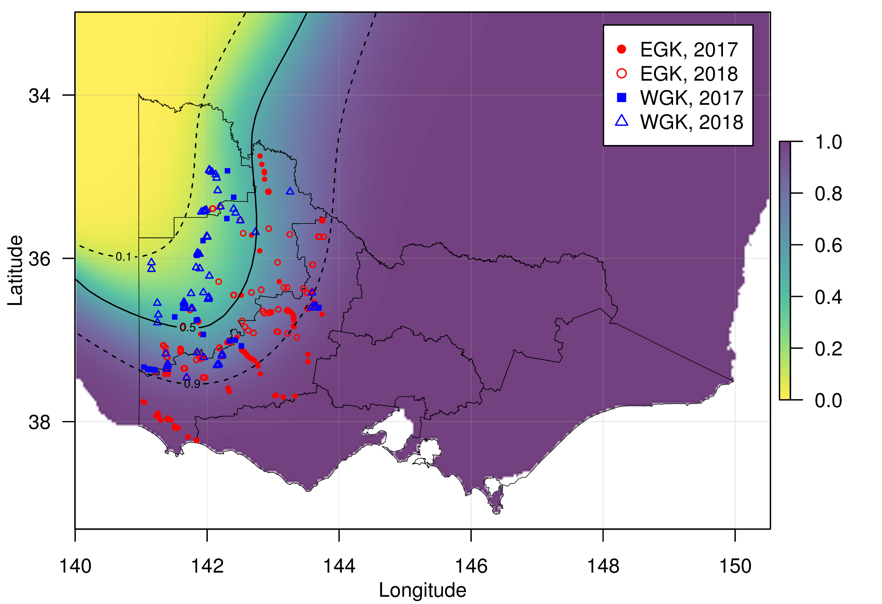

Figure 6. Spatial variation in the estimated proportion of EGK across the study area, as predicted by the space-time Generalized Additive Model. Predictions are for the year 2018. Overlaid points are observations of Eastern and Western Grey Kangaroos during the ground surveys conducted in 2017 and 2018. Contour lines are 10, 50 and 90 percent iso-probability lines.

Table 3. Estimated proportions of EKG in each stratum within the GKOZ, along with estimates of uncertainty (SD - standard deviation, Lower and Upper bounds - 95% confidence interval).

|  |  |  |  |  |
| --- | --- | --- | --- | --- |
| Stratum | Estimate | SD | Lower bound | Upper bound |
| Mallee | 0.12 | 0.036 | 0.07 | 0.21 |
| Upper Wimmera | 0.47 | 0.042 | 0.40 | 0.56 |
| Lower Wimmera | 0.91 | 0.020 | 0.86 | 0.94 |

* 1. Kangaroo abundance estimates for each LGA

Estimates of the number of EGK, WGK and RK in each LGA are provided in the Appendix (Tables A2, A3 and A4 respectively). A visual summary of those results for EGK and WGK are shown in Figures 7 and 8. The overall estimates from 2018 were similar to those from 2017 (Moloney *et al.* 2017). However, the overall estimate for 2018 was relatively more precise (Table 5 and Figure 9). The overwhelming majority (88%) of kangaroos were EGK and their population estimate in 2018 was similar to 2017, while the estimated populations of the other two species (WGK and RK) were higher in 2018 (Figure 9).

The precision of abundance estimates at the strata level increased for most strata compared with the corresponding estimates in 2017. However, the increase in the number of transects flown in 2018 did not improve the precision of abundance estimates to the extent expected in most cases. The greatest increases in precision occurred for the abundance estimates in the Mallee (both GK and RK), Lower Wimmera and Gippsland (Table 5). However, despite the increase in the number of transects flown in 2018, the abundance estimates for the North East and Otway strata remained relatively imprecise. Overall, the relative precision of estimates for each species has improved, especially for WGK and RK (Table 5).

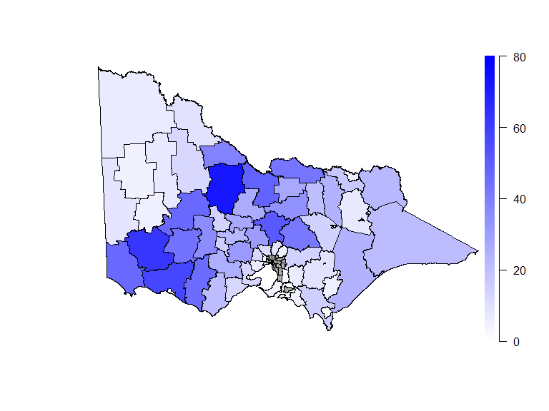

Figure 7. EGK abundance estimates by LGA. Scale is in thousands of kangaroos. LGAs shaded grey were not surveyed and were excluded from the analysis.

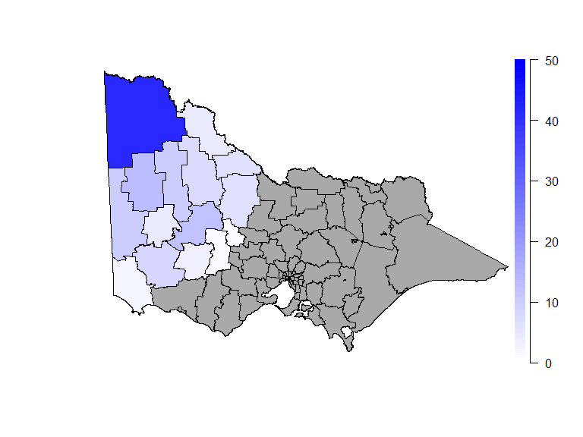

Figure 8. WGK abundance estimates by LGA. Scale is in thousands of kangaroos. LGAs shaded grey were excluded from the analysis as Western Grey Kangaroos are known to be absent from these areas.

Table 5. Relative precision (coefficient of variation - CV) of kangaroo abundance estimates as a percentage for various populations of kangaroos across Victoria in 2017 and 2018. Lower values indicate higher precision.

|  |  |  |  |
| --- | --- | --- | --- |
|  |  | Coefficient of variation (%) | |
| Region | Species | 2017 | 2018 |
| Central | EKG | 35.0 | 31.4 |
| Gippsland | EKG | 53.0 | 30.2 |
| Lower Wimmera | Grey | 32.0 | 24.9 |
| Mallee | Grey | 43.0 | 23.4 |
| Mallee | Red | 67.0 | 25.9 |
| North East | EKG | 40.0 | 48.2 |
| Otway | EKG | 54.0 | 41.2 |
| Upper Wimmera | Grey | 39.0 | 32.8 |
| Victoria-wide | EGK | 19.6 | 17.6 |
| Victoria-wide | WGK | 28.8 | 18.2 |
| Victoria-wide | RK | 67.0 | 25.9 |
| Victoria-wide | Total | 18.8 | 15.7 |

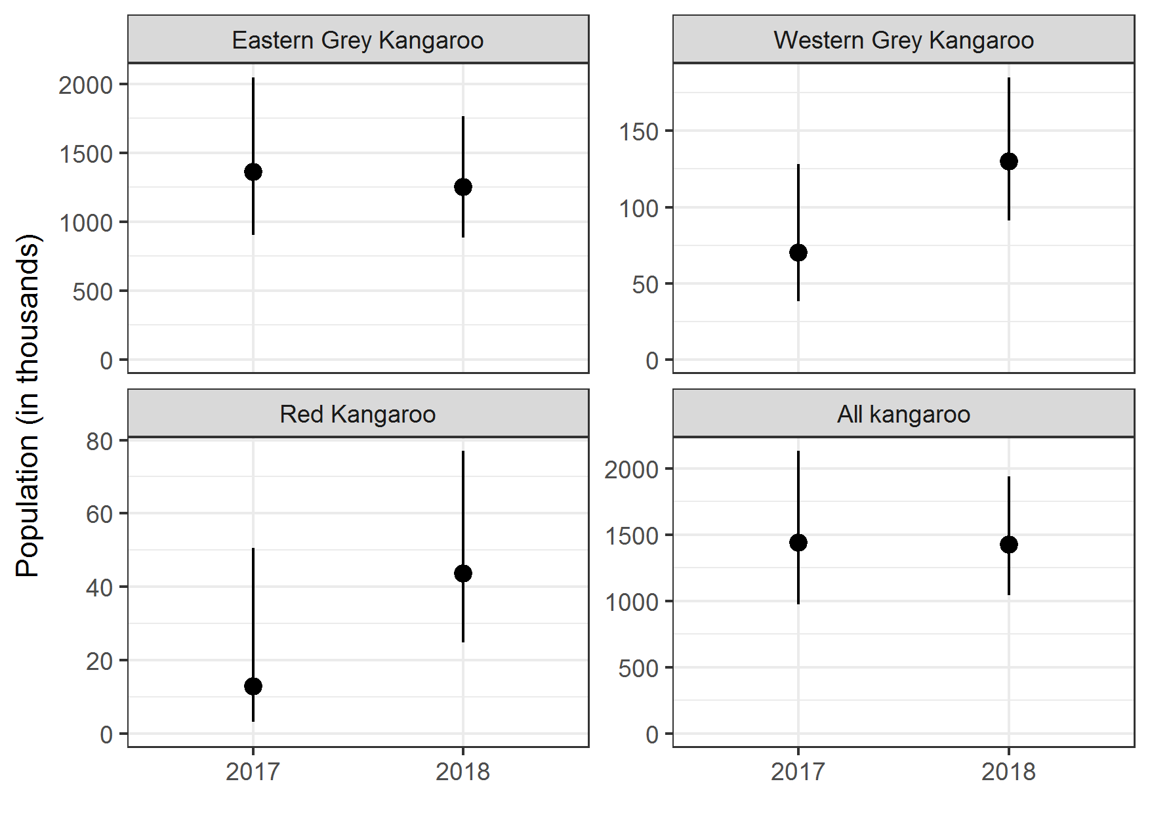

Figure 9. Comparison of Victorian-wide abundance estimates for the three species of kangaroos in 2017 and 2018. Scales are in thousands of kangaroos. Error bars are 95% confidence intervals.

1. Discussion

Based on our analysis of the aerial survey data we estimated that the overall kangaroo population in Victoria was 1,425,000 (95% confidence interval; 1,045,000 – 1,942,000). There were an estimated 1,251,000 (889,000 – 1,762,000) EGK, accounting for the overwhelming majority (88%) of Victorian kangaroos. The remaining part of the total kangaroo population was comprised of an estimated 130,000 (91,000 – 185,000) WGK and 44,000 (25,000 – 77,000) RK. The overall estimate for 2018 was similar to the estimate from the 2017 survey (1,442,000). However, the estimates for EKG were slightly lower than the estimate from the 2017 survey (1,359,000 EKG) while the estimates for WGK and RK were higher compared with the 2017 survey (WKG – 70,000; RK – 13,000) (Moloney *et al.* 2017).

The Victoria-wide estimate of kangaroo population met the precision goal, having a precision (expressed as the coefficient of variation – CV) of 15.7%, which was less than the target CV of 20% identified in the sampling design (Moloney *et al.* 2018). The precision of abundance estimates for each individual species has also improved over the 2017 estimates, especially for WKG and RK. Precision of abundance estimates for individual strata ranged from 23.4% (Mallee stratum for GK) to 48.2% (North East stratum for GK). While the precision of the abundance estimates for individual strata had generally improved from the 2017 survey (with the exception of the North East), the level of improvement was less than expected in some strata. The main reason for this was the high level of aggregation of kangaroos within some strata. Transects in the North East and Otway strata were subject to the chance sampling of large numbers of kangaroos on some transects, which formed a large proportion of the totals seen in these strata. High aggregation of kangaroos inflates the transect-level variance for the stratum, leading to decreased precision. Although population estimates with high precision (CV < 25%) are generally required for most management objectives (Skalski and Millspaugh 2002), population estimates with a relative precision over 50% can increase the risk of over-harvesting (Pople 2008). The CV for GK for the North East stratum is marginally below this 50% threshold while all other strata are clearly below the 50% threshold. Hence, the level of precision reached for the estimates from the 2018 survey are considered to be suitable for determining if culling rates are ecological sustainable.

Use of the space-time GAM model provided an effective means of apportioning the population estimates for GKs derived from the aerial survey between the two species (EGK and WGK). This approach allows estimation of spatial variation in the proportions of the two species to be based on both historic occurrence records derived from the Atlas of Living Australia, and systematically collected ground survey data, effectively increasing the precision of the resulting estimates, and allowing insight into the structure of the GKOZ in space and time. The use of systematically collected ground transect data also helps to limit the effects of sampling biases in data derived from the Atlas of Living Australia on the resulting inferences. The parametric bootstrap procedure provided an effective and simple method of estimating uncertainty in the aggregate proportions of each species within the aerial survey strata, or local government areas. It is recommended that this approach to modelling the occurrence of the two species of GKs be maintained when interpreting any future aerial surveys of GK populations in Victoria, to allow for possible ongoing change in the location and width of the GKOZ.

It was noted during the analysis that very few recent records of either species of GK exist from areas of South Australia immediately adjacent to the border with Victoria. This leads to some uncertainty regarding the actual location of the GKOZ in far western Victoria, as the smoothing model was relatively imprecise in this region. Consideration should be given to collecting some additional ground survey data in South Australia adjacent to the Victorian border to help to clarify the actual location of the GKOZ in this region of the state. This will lead to more precise estimation of the proportions of WGK and EGK in these areas, which in turn will result in more precise estimates of density and abundance for the two species of Grey Kangaroos in and around the GKOZ.

Interestingly, the smoother did not accurately capture the occurrence of a well-known, and apparently isolated population of WGKs that occurs near Wedderburn in north-western Victoria. In this part of the GKOZ, the model appears to be over-smoothing its estimates of the location and width of the GKOZ and failing to accurately describe this isolated population of WGKs. This minor lack of spatial accuracy is unlikely to be of much consequence for our estimates of the proportions of EGKs and WGKs in each stratum, given the very small area of occupancy of this isolated population.

In conclusion, the results from the 2018 aerial survey have indicated that Victoria’s kangaroo population has changed little since 2017. Although high levels of kangaroo aggregation in some strata continue to hamper precise estimation of density and abundance, the level of precision obtained is nevertheless adequate for management purposes. Hence, if future state-wide kangaroo surveys are undertaken, then consideration could be given to reducing the frequency of aerial surveys to reduce ongoing costs. Studies have shown that surveys every three years do not substantially increase the risk of over-culling while substantially reducing the long-term survey costs (Pople 2008). A more cautious approach, with more frequent surveys could be considered under conditions where substantial declines in abundance are expected, for example during periods of severe and prolonged drought.

* 1. Recommendations
* If future state-wide kangaroo surveys are undertaken, consideration could be given to reducing the frequency of surveys to every three years. The frequency of surveys may need to be increased (e.g. every two years) during periods of severe and prolonged drought.
* In relation to the ground surveys, consideration should be given to collecting some additional survey data in South Australia, adjacent to the Victorian border to help clarify the location of the GKOZ in the south-west of Victoria.
* Given the high level of kangaroo aggregation observed during this aerial survey, consideration could be given to determining optimal sampling strategies for strata likely to have high levels of kangaroo clustering on transects.
* Some further adjustments of existing transects should also be undertaken to avoid obstacles impeding the safe operation of the aircraft, such as high-tension power lines.

1. References

Buckland, S. T., Anderson, D. R., Burnham, K. P., and Laake, J. (1993). ‘Distance sampling: estimating abundance of biological populations’. (Chapman & Hall: London.)

Burnham, K. P., and Anderson, D. R. (2002). ‘Model selection and multimodel inference: a practical information-theoretic approach’. (Springer-Verlag, New York: New York.)

Caughley, G., Shepherd, N., and Short, G. (1987). ‘Kangaroos, their ecology and management in the sheep rangelands of Australia’. (Cambridge University Press: Cambridge.)

Coulson, G. (2018). Ground surveys of grey kangaroos in Victoria, September 2018. Macropus Consulting report to the Department of Environment, Land, Water and Planning, Victoria.

Efron, B., and Tibshirani, R. J. (1993). ‘An introduction to the bootstrap’. (Chapman and Hall: London, UK.)

Hacker, R., Mcleod, S., Druhan, J., Tenhumberg, B., and Pradhan, U. (2004). Kangaroo management options in the Murray-Darling Basin. Murray-Darling Basin Commission, Canberra, Australia.

Lethbridge, M., and Stead, M. (2017). Victorian aerial kangaroo population survey: Insights and learnings from Victoria’s first state-wide kangaroo aerial survey. Report to the Department of Environment, Land, Water and Planning, Victoria.

McLeod, S. R., Hacker, R. B., and Druhan, J. P. (2004). Managing the commercial harvest of kangaroos in the Murray-Darling Basin. *Australian Mammalogy* **26**, 9–22.

Miller, D. L. (2017). Distance: Distance Sampling Detection Function and Abundance Estimation. Available at: https://cran.r-project.org/package=Distance

Moloney, P. D., Ramsey, D. S. L., and Scroggie, M. P. (2017). A state-wide aerial survey of kangaroos in Victoria. Arthur Rylah Institute for Environmental Research Technical Report Series No. 286, Department of Environment, Land, Water and Planning, Heidelberg, Victoria.

Moloney, P. D., Scroggie, M. P., and Ramsey, D. S. L. (2018). Revisiting the Victorian kangaroo aerial survey design. Unpublished Client Report. Arthur Rylah Institute for Environmental Research, Department of Environment, Land, Water and Planning, Heidelberg, Victoria.

Pople, A. R. (2008). Frequency and precision of aerial surveys for kangaroo management. *Wildlife Research* **35**, 340–348. doi:10.1071/WR07066

R Development Core Team (2018). R: A language and environment for statistical computing. Available at: http://www.r-project.org

Skalski, J. R., and Millspaugh, J. J. (2002). Generic variance expressions, precision, and sampling optimization for the sex-age-kill model of population reconstruction. *Journal of Wildlife Management* **66**, 1308–1316.

Wood, S. N. (2017). ‘Generalized additive models: an introduction with R’ 2nd ed. (CRC Press, Taylor and Francis Group: Boca Raton, Florida.)

Wood, S. N., Bravington, M. V., and Hedley, S. L. (2008). Soap film smoothing. *Journal of the Royal Statistical Society, Series B* **70**, 931–955.

# Appendix

Table A1. Akaike’s Information Criterion (AIC) for detection function models considered in the analysis of the distance sampling data. Models with lower AIC values (ΔAIC) are better supported by the data.

|  |  |  |
| --- | --- | --- |
| Model | AIC | ΔAIC |
| Half-normal with second and third order cosine adjustments | 4,005.1 | 0.0 |
| Half-normal with second order cosine adjustments | 4,006.6 | 1.5 |
| Half-normal with second to fourth order cosine adjustments | 4,006.8 | 1.7 |
| Hazard-rate | 4,007.7 | 2.6 |
| Hazard-rate with second order cosine adjustments | 4,009.2 | 4.1 |
| Half-normal | 4,012.8 | 7.7 |

Table A2. Abundance estimates for EGK by LGA to the nearest 100. SE – standard error, Lower, Upper bounds – 95% confidence intervals. Area is in km2.

| LGA name | Strata name | Area | Estimate | SE | Lower bound | Upper bound |
| --- | --- | --- | --- | --- | --- | --- |
| Alpine | North East | 607 | 7,100 | 3,800 | 2,800 | 17,200 |
| Ararat | Lower Wimmera | 3,649 | 44,200 | 11,500 | 26,900 | 71,700 |
| Ballarat | Central | 659 | 14,800 | 4,900 | 8,100 | 26,900 |
| Bass Coast | Gippsland | 846 | 4,800 | 1,500 | 2,700 | 8,700 |
| Baw Baw | Gippsland | 1,530 | 8,800 | 2,800 | 4,800 | 15,900 |
| Benalla | North East | 1,727 | 20,200 | 10,900 | 8,400 | 49,700 |
| Brimbank | Central | 123 | 2,800 | 900 | 1,500 | 5,200 |
| Buloke | Upper Wimmera | 7,991 | 11,600 | 4,200 | 6,000 | 22,100 |
| Campaspe | North East | 4,267 | 49,400 | 27,100 | 20,000 | 122,400 |
| Cardinia | Gippsland | 967 | 5,500 | 1,800 | 3,100 | 10,100 |
| Casey | Gippsland | 391 | 2,200 | 700 | 1,200 | 4,000 |
| Central Goldfields | Lower Wimmera | 1,159 | 14,400 | 3,700 | 9,000 | 23,700 |
| Colac Otway | Otway | 1,907 | 20,700 | 9,200 | 9,500 | 44,700 |
| Corangamite | Otway | 4,230 | 45,800 | 20,600 | 20,700 | 100,100 |
| East Gippsland | Gippsland | 3,617 | 20,700 | 6,600 | 11,600 | 37,300 |
| Gannawarra | Lower Wimmera | 3,490 | 39,300 | 10,400 | 23,900 | 64,700 |
| Glenelg | Lower Wimmera | 3,816 | 47,200 | 12,000 | 29,300 | 76,200 |
| Golden Plains | Otway | 2,295 | 24,900 | 11,000 | 11,600 | 53,900 |
| Greater Bendigo | North East | 2,268 | 26,200 | 13,900 | 10,600 | 63,900 |
| Greater Geelong | Otway | 1,220 | 13,300 | 5,900 | 6,000 | 28,100 |
| Greater Shepparton | North East | 2,317 | 27,100 | 14,400 | 11,400 | 65,600 |
| Hepburn | Central | 965 | 21,800 | 7,100 | 11,900 | 39,400 |
| Hindmarsh | Upper Wimmera | 7,523 | 3,600 | 1,500 | 1,700 | 7,500 |
| Hobsons Bay | Otway | 65 | 700 | 300 | 300 | 1,600 |
| Horsham | Upper Wimmera | 3,844 | 4,700 | 1,700 | 2,400 | 8,900 |
| Hume | Central | 503 | 11,400 | 3,700 | 6,200 | 20,800 |
| Indigo | North East | 1,421 | 16,600 | 8,900 | 6,700 | 40,600 |
| Latrobe | Gippsland | 880 | 5,000 | 1,600 | 2,800 | 9,100 |
| Loddon | Lower Wimmera | 6,119 | 73,100 | 19,000 | 45,300 | 118,800 |
| Macedon Ranges | Central | 1,372 | 31,100 | 10,300 | 17,100 | 56,800 |
| Mansfield | North East | 1,205 | 14,100 | 7,500 | 5,700 | 33,900 |
| Melton | Central | 508 | 11,500 | 3,800 | 6,300 | 20,800 |
| Mildura | Mallee | 21,875 | 5,800 | 2,300 | 2,700 | 11,500 |
| Mitchell | Central | 2,278 | 51,600 | 16,800 | 28,100 | 93,200 |
| Moira | North East | 3,651 | 42,700 | 22,700 | 17,000 | 105,400 |
| Moorabool | Central | 1,431 | 32,400 | 10,600 | 17,600 | 58,800 |
| Mornington Peninsula | Gippsland | 644 | 3,700 | 1,200 | 2,000 | 6,600 |
| Mount Alexander | Central | 1,223 | 27,500 | 9,000 | 15,100 | 50,300 |
| Moyne | Otway | 5,387 | 58,100 | 26,300 | 26,600 | 128,000 |
| Murrindindi | Central | 1,832 | 41,600 | 13,900 | 22,800 | 76,400 |
| Nillumbik | Central | 225 | 5,100 | 1,700 | 2,700 | 9,400 |
| Northern Grampians | Lower Wimmera | 4,564 | 47,000 | 12,200 | 28,600 | 76,200 |
| Pyrenees | Lower Wimmera | 2,891 | 35,800 | 9,100 | 22,200 | 57,500 |
| South Gippsland | Gippsland | 2,686 | 15,400 | 4,900 | 8,600 | 27,200 |
| Southern Grampians | Lower Wimmera | 5,552 | 63,200 | 16,400 | 38,500 | 102,500 |
| Strathbogie | North East | 2,901 | 33,900 | 18,200 | 14,100 | 82,900 |
| Surf Coast | Otway | 1,063 | 11,600 | 5,100 | 5,200 | 25,000 |
| Swan Hill | Upper Wimmera | 5,903 | 8,900 | 3,300 | 4,500 | 17,300 |
| Towong | North East | 1,871 | 21,900 | 11,800 | 9,000 | 54,000 |
| Wangaratta | North East | 2,059 | 24,100 | 13,000 | 9,700 | 58,800 |
| Warrnambool | Otway | 120 | 1,300 | 600 | 500 | 2,900 |
| Wellington | Gippsland | 4,277 | 24,500 | 7,900 | 13,700 | 44,200 |
| West Wimmera | Upper Wimmera | 8,054 | 8,200 | 3,000 | 4,200 | 15,700 |
| Whittlesea | Central | 392 | 8,900 | 3,000 | 4,800 | 16,400 |
| Wodonga | North East | 403 | 4,700 | 2,500 | 1,900 | 11,800 |
| Wyndham | Otway | 542 | 5,900 | 2,700 | 2,700 | 12,900 |
| Yarra Ranges | Central | 638 | 14,500 | 4,800 | 8,000 | 26,500 |
| Yarriambiack | Upper Wimmera | 7,320 | 6,700 | 2,500 | 3,400 | 13,200 |

Table A3 Abundance estimates for WGK by LGA to the nearest 100.

|  |  |  |  |  |  |  |
| --- | --- | --- | --- | --- | --- | --- |
| LGA name | Strata name | Area | Estimate | SE | Lower bound | Upper bound |
| Ararat | Lower Wimmera | 3,649 | 2,800 | 1,200 | 1,200 | 5,700 |
| Buloke | Upper Wimmera | 7,991 | 6,600 | 2,600 | 3,200 | 13,200 |
| Central Goldfields | Lower Wimmera | 1,159 | 500 | 300 | 100 | 1,400 |
| Gannawarra | Lower Wimmera | 3,490 | 5,700 | 2,500 | 2,300 | 12,000 |
| Glenelg | Lower Wimmera | 3,816 | 1,900 | 900 | 700 | 4,100 |
| Hindmarsh | Upper Wimmera | 7,523 | 13,500 | 4,700 | 7,100 | 25,100 |
| Horsham | Upper Wimmera | 3,844 | 4,100 | 1,500 | 2,000 | 7,800 |
| Loddon | Lower Wimmera | 6,119 | 5,700 | 3,000 | 2,000 | 13,700 |
| Mildura | Mallee | 21,875 | 41,700 | 10,100 | 26,400 | 66,000 |
| Northern Grampians | Lower Wimmera | 4,564 | 11,800 | 3,800 | 6,300 | 21,200 |
| Pyrenees | Lower Wimmera | 2,891 | 1,400 | 700 | 500 | 3,300 |
| Southern Grampians | Lower Wimmera | 5,552 | 8,300 | 2,800 | 4,300 | 14,900 |
| Swan Hill | Upper Wimmera | 5,903 | 4,500 | 1,900 | 2,000 | 9,400 |
| West Wimmera | Upper Wimmera | 8,054 | 10,100 | 3,700 | 5,200 | 19,500 |
| Yarriambiack | Upper Wimmera | 7,320 | 10,000 | 3,600 | 5,200 | 19,200 |

Table A4. Abundance estimates for RK by LGA to the nearest 100.

|  |  |  |  |  |  |  |
| --- | --- | --- | --- | --- | --- | --- |
| LGA name | Strata name | Area | Estimate | SE | Lower bound | Upper bound |
| Mildura | Mallee | 21,875 | 43,600 | 11,300 | 24,700 | 77,000 |

[www.delwp.vic.gov.au](http://www.delwp.vic.gov.au)

www.ari.vic.gov.au