Victorian Koala Management Strategy

Acknowledgements
The Department of Energy, Environment and Climate Action (DEECA) acknowledges the individuals and organisations who helped to develop the strategy. We thank you for sharing your knowledge and time with us.

Photo credit
With thanks to Marcia Riederer, Peter Menkhorst, Jo Sumner, Latrobe City Council, Victorian Landcare Program and DEECA.
Koala Art Narrative Theme 1. Traditional Owners and koalas (cover and page 6)
Artist: Dixon Patten, Bayila Creative
This artwork is titled: Kula karan bulam, which means 'Koala amongst plenty of trees' in Gunnai Language.
The koala's natural habitats are under threat, this artwork encourages our connection to Country and our responsibilities to caring for our environment(s). The circle motifs depict us coming together to play our part in education and conservation, which has a ripple effect beyond our place and time. The six gum leaves around the circle depict our six seasons and acknowledging such things make us aware of how to adapt and work with the environments in a purposeful way.

Traditional Owner acknowledgement
We acknowledge and respect Victorian Traditional Owners as the original custodians of Victoria's land and waters, their unique ability to care for Country and deep spiritual connection to it.
We honour Elders past and present whose knowledge and wisdom has ensured the continuation of culture and traditional practices.
We are committed to genuinely partner, and meaningfully engage,
with Victoria's Traditional Owners and Aboriginal communities to support the protection of Country, the maintenance of spiritual and cultural practices and their broader aspirations in the 21st century and beyond.

© The State of Victoria Department of Energy, Environment and Climate Action 2023.

ISBN 978-1-76136-033-6 (pdf/online/MS word) This work is licensed under a Creative Commons Attribution 4.0 International licence. You are free to re-use the work under that licence, on the condition that you credit the State of Victoria as author. The licence does not apply to any images, photographs or branding, including the Victorian Coat of Arms, the Victorian Government logo and the Department of Energy, Environment and Climate Action (DEECA) logo. To view a copy of this licence, visit http://creativecommons.org/licenses/by/4.0/
Disclaimer
This publication may be of assistance to you but the State of Victoria and its employees do not guarantee that the publication is without flaw of any kind or is wholly appropriate for your particular purposes and therefore disclaims all liability for any error, loss or other consequence which may arise from you relying on any information in this publication.

Accessibility

If you would like to receive this publication in an alternative format,

please telephone the DEECA Customer Service Centre on 136186, email customer. service@delwp.vic.gov.au, or via the National Relay Service on 133 677 www.relayservice.com.au. This document is also available on the internet at www.delwp.vic.gov.au.

Contents

Ministerial foreword 2
Introduction 3
Koala management issues in Victoria 5
Theme 1. Traditional Owners and koalas 6
Theme 2. Koala overabundance 8
Theme 3. Koala rehabilitation 14
Theme 4. Koala genetics 16
Theme 5. Disease in koalas 18
Theme 6. Habitat conservation 21
Theme 7. Understanding koala populations 25
Theme 8. Climate change and managing fire impacts 27
Theme 9. Koalas in blue gum plantations 29
Theme 10. Community perception and socioeconomic significance 32
Implementation 34
Monitoring, Evaluation, Reporting and Improvement 35
Definitions 36
References 38
Appendix 1: Koala management actions summary 41

Ministerial foreword

Koalas are an important species for many Victorians and are a vital part of Country for Traditional Owners around the state. Koalas are an iconic symbol of Australia and its unique wildlife and are valued by people around the world.
Victoria is fortunate to have the largest population of koalas in Australia. However, koalas in Victoria face threats such as climate change, bushfires, drought and disease. This is why the Victorian Government is taking action to ensure the long-term protection and survival of Victoria’s koala populations and their habitat with the release of the Victorian Koala Management Strategy.
Conserving Victoria’s koalas and their habitat requires a collective effort, which is reflected in the collaborative way this strategy was developed. Traditional Owners, scientists, veterinarians, animal welfare organisations, wildlife carers, the blue gum plantation industry, government agencies from Victoria and interstate, and the Victorian community all contributed to the development of the strategy.
This strategy will guide how we work together to conserve and manage Victoria’s koalas over the next ten years. The actions in the strategy will improve our understanding of the size, distribution and health of Victoria’s koala populations and will enable us to manage the threats Victoria’s koalas and their habitat face.
The delivery of the actions in this strategy ensure that Victoria’s koalas and their habitat are secure, healthy and sustainable, and will also contribute to the conservation of this wonderful species nationally.

Ingrid Stitt MP
Minister for Environment

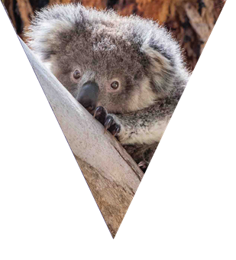

2

Introduction

The koala (Phascolarctos cinereus) is arguably Australia’s most recognised and iconic wildlife species. Koalas are an important part of Australia’s biodiversity and contribute significantly to the Australian economy as a major drawcard for domestic and international tourism. For these reasons, there is significant national and international interest in the protection of koalas and their habitat.

Victoria is fortunate to have large and secure koala populations. This is not the case nationally. Koala populations in Queensland, New South Wales (NSW) and the Australian Capital Territory (ACT) have been declining over the past 20 years and koala populations in these states have recently been listed as endangered under the Environment Protection and Biodiversity Conservation Act 1999 (EPBC Act). The main threats to koalas in these states are human-induced land use change and climate change, other threats include disease, drought, extreme heat and vehicle strike. (Department of Agriculture, Water and the Environment, 2022).
The conservation status of koalas in Victoria and South Australia is very different to the northern states. Koalas in Victoria and South Australia are not listed under the EPBC Act as these states have large koala populations and, in some areas, koalas persist at such high densities that they over-browse habitat, resulting in tree defoliation and tree death in extreme cases.
Victoria has a long history of koala management. In the late 19th and early 20th centuries, koala populations declined sharply in Victoria due to hunting for fur, habitat destruction, bushfires and disease (Menkhorst, 2008).
By the 1920s, only a few remnant populations were thought to exist on mainland Victoria in the south-west, on the Mornington Peninsula and in Gippsland. In addition to the mainland populations, koalas had been introduced onto offshore islands including French and Phillip Islands in the late 1800s (Wedrowicz et al., 2017a). The French Island population expanded rapidly, and this success led to other island populations being established in an effort to conserve the species.
An extensive translocation program commenced in the early 1920s and koalas from French Island were translocated to other Victorian islands and across the border to Kangaroo Island in South Australia. These island populations later became the source of many of the current established mainland populations in Victoria, with over 40,000 koalas being released at more than 250 sites since the 1920s (Menkhorst, 2008).
As a result of the translocation program, koala populations in Victoria have expanded greatly since the 1920s. While this translocation program successfully re-established koalas in Victoria, it has also created some contemporary management issues, including over-browsing and low genetic diversity (McAlpine et al., 2015, Wedrowicz et al., 2017a).
Recent estimates indicate that the total Victorian koala population is over 450,000 (Heard and Ramsey, 2020), although koala densities vary across the state.

In drier inland forests, koalas persist at low densities, however, in patches of high-quality habitat (i.e. areas with reliable rainfall, fertile soils, and preferred forage tree species) in southern Victoria, koalas reach much higher population densities.
In some coastal areas, koala populations have increased to unsustainable densities, resulting in over-browsing and defoliation of favoured food trees, particularly Manna Gum (Eucalyptus viminalis). In severe and prolonged cases, this over-browsing has led to tree death, koala starvation and changes to habitat that have impacted other species (McAlpine et al., 2015, Whisson et al., 2016). Translocation of koalas still occurs in Victoria, but it is now used as a tool to manage the over-browsing and animal welfare issues associated with these high-density populations (Menkhorst, 2008).
While Victoria’s koala populations are currently secure, threats such as habitat loss, climate change, bushfire, drought and disease have potential to cause significant future population declines. The relative security of Victoria’s koala populations compared to those in the northern states imposes a responsibility on Victoria to manage its koala populations in a way that ensures the species remains secure in the wild and koala habitat is protected into the future.
The previous Victorian Koala Management Strategy (2004 VKMS) was released in 2004 (Department of Sustainability and Environment, 2004). Since that time, issues that were not considered in the 2004 VKMS that impact koalas and their habitat have emerged or increased in significance, including climate change, increased bushfire risk and the establishment of commercial blue gum plantations within the koalas' distribution. Other issues that were identified in the 2004 VKMS have evolved, and the best available science has improved, requiring these changes and increased knowledge to be reflected in a new strategy.
This koala management strategy has been developed by the Department of Energy, Environment and Climate Action (DEECA), in collaboration with Traditional Owners, scientists, animal welfare organisations, vets, wildlife carers, the blue gum plantation industry, Zoos Victoria, Phillip Island Nature Parks, Parks Victoria and other Victorian and interstate government agencies involved in koala management. Feedback received from the community during the public consultation period for the draft strategy has also helped to inform the strategy. DEECA is grateful for and extends its thanks to the organisations and individuals that contributed to the development of the strategy.

Department of Energy, Environment and Climate Action

Purpose

This strategy sets out targeted actions to address koala management issues over the next 10 years.

Vision

Victoria’s koala populations and habitat are secure, healthy and sustainable in the long-term.

Key legislation and policies
The conservation and management of koalas in Victoria is governed by State and Federal law and associated policies.

Victorian Acts of Parliament
Koalas and koala habitat are protected by the following state conservation and animal welfare legislation.

Wildlife Act 1975
The Wildlife Act 1975 (Wildlife Act) provides for the protection, conservation and management of all wildlife, the sustainable use or access to wildlife, and research into wildlife and its habitat. It also provides for the control of wildlife in situations where wildlife may be causing damage to vegetation or property. The koala is ‘protected wildlife’ under the Wildlife Act. It is illegal to take, interfere with, disturb or destroy koalas without authorisation. Actions to control koala populations that have been authorised under the Wildlife Act include translocation and fertility control. Wildlife habitat is also protected under the Wildlife Act. DEECA is responsible for administering the Wildlife Act.

Prevention of Cruelty to Animals Act 1986
All animals in Victoria are protected under the Prevention of Cruelty to Animals Act 1986 (POCTA). It is an offence under the POCTA to do or omit to do an act that would result in pain or suffering of any animal, including koalas. DEECA is responsible for administering the POCTA.

Planning and Environment Act 1987
The Planning and Environment Act 1987 (Planning and Environment Act) establishes a framework for planning the use, development and protection of land in Victoria. It establishes a system of planning schemes based on municipal districts to enable land-use policy and planning to be easily integrated with environmental, social, economic, conservation and resource management policies at state, regional and municipal levels. The planning schemes include state-wide controls for the removal of native vegetation. These controls require that the state-wide biodiversity impacts from the removal of native vegetation are considered when assessing an application for a permit to remove native vegetation. In most cases the administration and enforcement of planning schemes is the responsibility of local councils.

Victorian policies
The development of this strategy aligns with two overarching Victorian Government environment policies: Protecting Victoria’s Environment – Biodiversity 2037 (Biodiversity 2037) and the Living with Wildlife Action Plan.

Protecting Victoria’s Environment – Biodiversity 2037
Biodiversity 2037 was released in 2017 and is a
long-term plan for stopping the decline of Victoria’s biodiversity and improving our natural environment. It has two goals: Victorians value nature and Victoria’s natural environment is healthy. Many of the actions identified in this strategy align with those goals.

Living with Wildlife Action Plan 2018
The Living with Wildlife Action Plan (action plan) was released in 2018. The development of the action plan was an initiative to meet priority 17 of Biodiversity 2037 - to deliver excellence in management of all land and waters. The action plan's aims are for Victorian communities to value wildlife and to work together to achieve the sustainable management and conservation of wildlife. A key action in the plan is to update the 2004 VKMS to ensure Victoria’s koala populations are secure and healthy, and to guide their current and future management.

Federal Acts of Parliament

Environment Protection and Biodiversity Conservation Act 1999
The Environment Protection and Biodiversity Conservation Act 1999 (EPBC Act) provides a legal framework to protect and manage nationally and internationally important flora, fauna, ecological communities and heritage places, which are defined in the EPBC Act as matters of national environmental significance. While Victorian koala populations are not currently eligible for listing under the EPBC Act due to the estimated population size, if data is obtained in the future that makes Victoria's koala population eligible for listing, then this Act will apply once they are listed.

Federal policies

National Recovery Plan for the Koala Phascolarctos cinereus (combined populations of Queensland, New South Wales and the Australian Capital Territory)
This recovery plan was released in March 2022, following the change in listing of the Queensland, NSW and ACT koala populations from vulnerable to endangered under the EPBC Act. While many of the actions in this recovery plan do not apply to Victoria's koala populations as they are not listed, some actions, such as the establishment of the National Koala Monitoring Program, will also be undertaken in Victoria.
It is important that all states and territories work together to conserve koalas. The Victorian Government will support the implementation of actions under the National Recovery Plan as they apply to Victoria's koala populations.

Koala management issues in Victoria

This strategy focuses on the key issues relating to koala management in Victoria, which have been grouped into ten themes. While the themes are numbered, all of the themes are considered to be of equal importance for the management of Victoria’s koalas. Some of the themes and the associated actions under them are interconnected. The themes are:
- Traditional Owners and koalas
- koala overabundance
- rehabilitation
- genetics
- disease
- habitat conservation
- understanding koala populations
- climate change and fire impacts
- koalas in blue gum plantations, and
- community perception and socioeconomic significance.

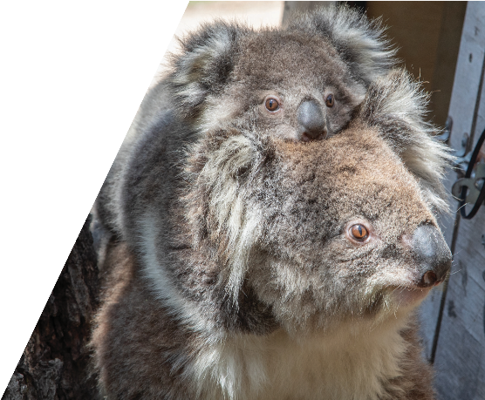
For each theme, the associated issues are described and examples of how the issues have been managed are provided. A goal for the theme is then identified, along with one to two actions that the Victorian Government and its delivery partners commit to in order to address the issues identified for the theme. The goals and actions have been determined through extensive consultation with Traditional Owners, scientists, animal welfare stakeholders, wildlife carers, vets, the blue gum plantation industry, Zoos Victoria, Phillip Island Nature Parks, Parks Victoria, other Victorian and interstate government agencies involved in koala management and the Victorian community.

Theme 1. Traditional Owners and koalas

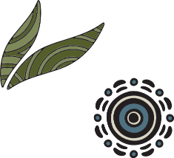

Aboriginal people and koalas have coexisted in what is now Victoria for thousands of years. Aboriginal people were living in Victoria even before koalas, with the fossil evidence suggesting koalas may only have expanded their range into Victoria around 10,000 years ago (Sherwin et al., 2000; Wedrowicz et al., 2017a), whereas Aboriginal people have lived in Victoria for at least 40,000 years (Presland, 1997). The 10,000-year relationship between Aboriginal people and koalas in Victoria is in stark contrast with that of European people and koalas, with the first recorded sighting of a koala by a European person anywhere in Australia occurring in New South Wales in 1798, a mere 223 years ago (Schlagloth et al., 2018).
Koalas are a totemic species for some Aboriginal groups in Eastern Australia and are featured in a number of Dreaming and creation stories. Many of these stories relate to water supply and tell the story of why the koala does not need to drink water like other animals (Schlagloth et al., 2018). The English word koala is derived from a word from the language of the Dharug people from the New South Wales area – “gula” meaning no water (Schlagloth et al., 2018).
Aboriginal people have an inherent cultural right to protect and care for Country, and in caring for Country, Aboriginal people care for koalas and their habitat. Historically, the relationship between Aboriginal people in Victoria and koalas differed between groups across the state. For example, koalas were an important food source for some groups in Victoria but were not hunted by other groups (Schlagloth et al., 2018).
It is important to note that koalas are now found in areas that they were not historically known to inhabit due to the extensive translocation program that commenced in the early 1920s. Previous generations of Aboriginal people in some areas of the state may therefore never have encountered a koala. Conversely, koala populations have declined in some areas of the state where they were previously known to occur and may therefore be missing from Country.
While koalas are an important part of Country,
in some areas of Victoria, such as the south-west, koalas can become overabundant and damage trees in culturally significant areas.

This affects not only the habitat, but also other wildlife that relies on that habitat, and the health of the koalas themselves. An example of this occurred within the Budj Bim Landscape; a significant heritage site for the Gunditjmara people in far south-west Victoria. Koala densities in some areas of the Budj Bim Landscape were so high that the koalas were over-browsing the trees and causing a decline in the health of the manna gum habitat.
In November 2017, a koala management program was undertaken by the department, in partnership with the Gunditj Mirring Traditional Owners Aboriginal Corporation and Parks Victoria. The program involved conducting koala health checks and fertility control of as many koalas as possible and translocating over 40 healthy koalas to Mt Napier State Park. Overabundant koala populations and their management are discussed in more detail in Theme 2: Koala overabundance.
The Victorian Government is committed to supporting Aboriginal self-determination, which includes the management of Country. Some Traditional Owner groups have developed, or are in the process of developing, Country Plans. These plans outline the priorities the group has for Country and the actions that will help achieve those priorities. While the priorities and actions in the plans may not specifically identify koalas, any action to improve the health of Country, particularly those that improve the quality and connectivity of habitat, will benefit koalas. While some on-ground projects are already underway under Country Plans, additional resources and support are needed to ensure that Traditional Owner priorities for Country can be realised.
Some Traditional Owner groups across the state are already involved in koala management programs for overabundant koala populations on Country. Additional resources and support are needed so that ongoing habitat and koala population monitoring can occur in areas with higher koala densities, which will enable proactive management of koala populations to minimise damage to culturally significant areas from over-browsing.
Traditional Owners are key delivery partners for the strategy. Their knowledge and involvement will support delivery of the entire strategy, and for this reason, Traditional Owners have been listed as partners for most actions in the strategy.

Case study: Raymond Island Koala Program
Since 2014, the Gunaikurnai Land and Waters Aboriginal Corporation (GLaWAC), who are joint managers of Raymond Island’s reserves, have partnered with Parks Victoria and DEECA staff to conduct the annual Raymond Island Koala Program. The process of conducting the koala count involves teams that include different roles such as a catcher, a transporter, a scribe, spotters and team leader. The GLaWAC Rangers have been integral to the program’s success, skilful in many different roles and able to pass on their knowledge to new Rangers and volunteers.
Looking after Country is vital to GLaWAC JM Manager Robbie Farnham. “Our people have lived sustainably on this land for generations. It’s important that our JM Rangers understand our traditional ways, and also explore western scientific methods of managing Country through partnerships like the Raymond Island Koala Program”.
The program was created in response to an overabundance of koalas which were introduced to Raymond Island in the 1950s. As the koala numbers have increased over the years, the need to keep a balance between a healthy habitat for the animals and environment has become important.

Theme 1 actions:
Traditional Owners and koalas
Goal: Traditional Owner priorities for Country that relate to koalas are supported and the impacts of overabundant koala populations on culturally significant areas are minimised.

Action 1.1 Partner with Traditional Owners to undertake actions on Country that will benefit koalas or their habitat
Action details | Partners
This action will involve:  - Working with Traditional Owner groups to understand their priorities for Country and how these could benefit koalas or their habitat.  - Linking the implementation of relevant actions in the VKMS to actions in Country Plans to enable the implementation of both the VKMS and Country Plans.  - Establishing partnership arrangements with interested Traditional Owner groups to deliver relevant actions on Country.  - Building capacity of Traditional Owners to deliver actions on Country that will benefit koalas or their habitat. | DEECA  Traditional Owners  Parks Victoria  Universities  TAFEs
Action 1.2 Support Traditional Owners to protect culturally and environmentally significant areas from koala over-browsing
Action details |  |  | Partners
 |  | This action will involve:  - Engaging with Traditional Owners to determine culturally or environmentally significant areas that may require protection from the impacts of overabundant koalas.  - Establishing partnership arrangements with Traditional Owner groups to undertake koala management activities on Country including habitat and koala assessment and monitoring, and koala management program planning and delivery.  - Building capacity of Traditional Owners to undertake koala and habitat monitoring and koala management programs. | DEECA  Traditional Owners  Parks Victoria

* For the story behind the feature artwork on these pages please see the inside front cover.

Theme 2. Koala overabundance

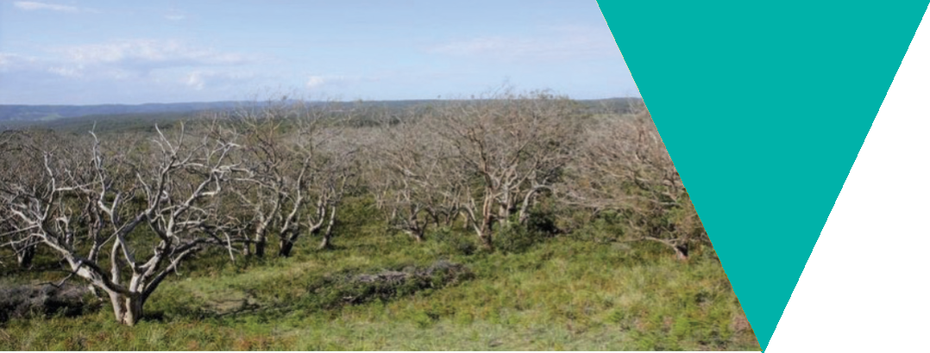

What is the issue?
In some areas of Victoria, such as the south-west of the state and where populations have been established on islands, koalas occur at unsustainable densities, leading to a loss of habitat through over-browsing and significant koala welfare impacts (Menkhorst, 2008; Whisson et al., 2016).

Similar koala overabundance issues are also seen in South Australia (Whisson and Ashman, 2020). It is important to note that this is in contrast to koala populations in Queensland and NSW, where koala numbers have been declining for some time (Adams-Hosking et al., 2016).
Sustainable koala densities in native forest vary with eucalypt species and site conditions, however, intervention to prevent over-browsing is recommended when the density reaches 1.6 koalas per hectare (Ramsey, Tolsma and Brown, 2016). In some overabundant koala populations, densities of more than 18 koalas per hectare have been observed (Whisson et al., 2016).

High koala densities and the impacts of associated over-browsing have led to significant impacts on:
- Koala welfare – due to starvation, increased disease susceptibility and increased competition between individuals for resources (Whisson et al., 2016; Watchorn and Whisson 2020).
- Biodiversity and local flora and fauna communities – koala over-browsing has resulted in the death of preferred food trees, ultimately changing the composition of vegetation communities, with flow-on effects to other species that inhabit the same area. For example, koala over-browsing is a significant threat to the survival of two Ecological Vegetation Classes: Damp Sands Herb-rich Woodland and Stony Rises Woodland (Menkhorst, 2008).
- Cultural values of the landscape – for example, within the Budj Bim Indigenous Protected Area, koala over-browsing has resulted in substantial defoliation and death of many culturally significant trees.
- Local amenity – due to dying and dead trees and altered vegetation communities in some landscapes.
- Broader landscape issues – impacts on revegetation works and primary production.

Overabundance has mainly occurred in koala populations that have been established through translocation programs and in areas containing manna gum (Eucalyptus viminalis) and swamp gum (E. ovata) (Menkhorst, 2008). It is not clear why koalas become overabundant in some areas of southern Australia. It has been suggested that it could be related to complex site-specific and climatic factors, or to the low genetic diversity of koala populations established through translocation programs, which may have led to specific behaviour traits. For example, low aggression in koalas may enable them to congregate in small areas and become overabundant (Whisson and Ashman, 2020).
A lack of available habitat has also been suggested as a cause for over-browsing. While this may be a factor in some areas, there are clear examples where koala over-browsing has occurred, despite there being ample surrounding habitat that the koalas could disperse into. One such example is at Cape Otway, where a significant koala over-browsing issue in 2013 resulted in the death of many koalas from starvation or through euthanasia on welfare grounds (Whisson et al., 2016). In this case, koalas had over-browsed the manna gum to the point where the canopy was completely defoliated and koalas were starving but had not moved into the surrounding available habitat (Whisson et al., 2016).
Recent research suggests that the reluctance to disperse could be a result of the gut microbiome of the koalas becoming highly specialised to specific eucalypt species which may affect their ability to alter their diet to other eucalypt species (Blyton et al., 2019). However, the success of historic translocation programs that frequently involved releasing koalas into novel eucalypt communities (Menkhorst, 2008; 2016; 2019) indicates that koalas can adapt to new forage species in some circumstances.
Further research into the causes of overabundance is needed.

How are overabundant populations managed?
Management of overabundant koala populations relies on non-lethal control methods, except in circumstances where health assessments require euthanasia of animals in very poor condition. Given the koala's status as an iconic species and low community awareness of the impacts of overabundant koala populations, the lack of support for lethal control is understandable. Methods for managing overabundant koala populations include habitat protection and population management via translocation, fertility control and health assessments. In contrast, lethal control (culling) is used for some other overabundant native species, such as Eastern Grey Kangaroos.
The differing status of koalas across their range and inaccurate media reports stating that the koala is ‘functionally extinct’ in the wild, has led to a misunderstanding in some parts of the community about the most urgent issues facing Victoria's koalas. There is a need to work with the community to raise their awareness of the secure status of koalas in Victoria compared to other states, the issues associated with managing Victoria's koala populations, including shorter and longer-term welfare impacts of different management options, and the limitations of the existing management methods.
To date, management of koala overabundance and over-browsing impacts in Victoria has occurred only when significant impacts to tree health or koala welfare have already been observed. Ideally, management actions should be undertaken earlier to prevent the impacts becoming significant and should be repeated regularly, this would lead to better outcomes for koala welfare and tree health.
Examples of populations requiring intensive management include Budj Bim National Park (formerly Mt Eccles National Park), French Island, Raymond Island, and on private and public land at Cape Otway. For most of these populations, regular management programs have been required over many years, for example, the population on French Island has been intensively managed since 1920 (Menkhorst, 2008). Management at these sites has included habitat protection and monitoring and population management via translocation, fertility control and health assessments.

Habitat protection
Habitat protection measures used have included tree banding, guards and fencing to restrict koala access to individual trees or areas. While banding, guards and fencing can be effective at excluding koalas from particularly significant trees and areas, it is a localised mitigation measure and is labour intensive and costly to implement across large areas.

Habitat monitoring
Monitoring the condition of habitat enables early intervention so that the koala population can be managed before the impacts to habitat become significant. A 'habitat health trigger' has been developed by the Arthur Rylah Institute for Environmental Research (ARI) to help determine when an intervention is needed to protect habitat from over-browsing. The habitat health trigger has been used at Cape Otway.

Population management
Population management has involved health assessments, translocation and fertility control. Further information about each of these population management techniques is outlined below.

Koala health assessments

In areas where there has been significant over-browsing and starving koalas have been observed, health assessment programs involving capture and veterinary assessment of koalas have been undertaken. These welfare-based programs have resulted in euthanasia of koalas that were suffering due to low body condition, disease or injury, while healthy koalas were either released at the capture location or translocated to suitable habitat elsewhere.

Koala health assessment programs can be expensive due to the number of personnel required, the specialised equipment and experience needed, such as for tree climbing and veterinary assessment, and the duration of the operation, which can be weeks.

Translocation
Translocation requires extensive preparation and planning to be successful. There are a number of factors that must be considered prior to undertaking translocation including the risk of spreading disease or parasites, genetic risks (e.g. introduction of undesirable genetic traits), release site suitability and potential impacts of the translocated animals on other fauna or flora at the release site. There are also regulatory requirements that must be met, such as obtaining land manager approval for the release site and authorisation under the Wildlife Act 1975 to undertake the translocation.
Translocation has been used in Victoria to immediately reduce koala numbers at locations where over-browsing is occurring to reduce pressure on the habitat and improve koala welfare outcomes. However, finding suitable release sites with sufficient habitat is becoming more difficult.
The condition and area of available habitat at the release site is critical to the survival rate of koalas following translocation. While there are some small patches of habitat available in areas of Victoria, the number of koalas that can be supported in these areas is unlikely to be sufficient for the number of koalas that may require translocation to address overabundance issues in the future.
The selection of release sites in Victoria has been determined by the protocols and criteria provided in Appendix 2 of the 2004 VKMS and recent translocations have also been supported by a spatial model of koala habitat developed by ARI. Data collected before and after translocations of koalas from Cape Otway using these protocols has shown that translocated koalas have improved welfare when compared to koalas that have remained in high-density populations in degraded habitat (Menkhorst et al., 2019). Translocation must be combined with ongoing population control at both the source and release sites, otherwise a rapid return to the previous unsustainable density is likely.
While translocation of koalas from Victoria to northern states has occurred periodically under earlier management programs (Menkhorst, 2008), there have been no recent attempts to translocate Victorian koalas to northern states. This is due to concerns about the risk of spreading disease and genetic issues, and the impact that the morphological differences seen in Victorian koalas compared to those in northern populations (e.g. longer fur due to adaptation to colder climates) may have on animal welfare (Kjeldsen et al., 2018; Waugh et al., 2016).

Fertility control
Healthy female koalas without fertility control can produce one young a year and are fertile for approximately 8-10 years (McLean and Handasyde, 2007; Whisson and Carlyon, 2010). Recent modelling estimated that without fertility control, the Chlamydia-free population on French Island would double its size within 5.5 years (Hynes et al., 2019). Fertility control has been used to control population growth in overabundant koala populations since the 1990s. Field trials of contraceptive hormone implants for female koalas and vasectomy for male koalas commenced in 1996 and both were found to be effective at reducing population growth (Menkhorst, 2008). Surgical sterilisation of female koalas was also undertaken in some populations; however, this practice was ceased due to animal welfare concerns (Menkhorst, 2008).

The cost of managing overabundant populations
The cost of managing overabundant koala populations varies significantly between programs due to a range of factors including:
- management action being undertaken (e.g. translocation, fertility control or health assessment)
- duration of the program
- location of the program
- amount of equipment required
- number of vets and other staff required
- accommodation and food costs; and
- logistics (e.g. the distance from the program site to the translocation site).

Recent examples of the variation in costs across programs include a four-week program at French Island in 2018 involving health checks, fertility control and translocation of a small number of koalas which cost approximately $120,000. Whereas a two-week program at Cape Otway in 2018 involving health checks, fertility control and translocation cost approximately $80,000.
During the 22 years between 1996 and 2018 in the Barwon South West Region alone, intensive management interventions involving the translocation of more than 6700 koalas to 51 separate locations and the sterilisation of over 8500 koalas has occurred at Framlingham Forest (1997–1999), Tower Hill State Game Reserve (1996–2013), Budj Bim National Park (1999–2018) and on private land at Cape Otway (2013–2017). The cost of these management interventions has been conservatively estimated at over $4 million.
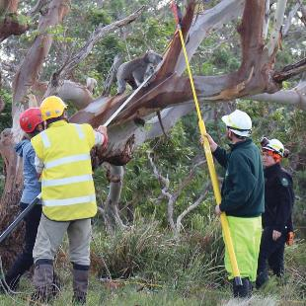

Fertility control via contraceptive implant for female koalas has been routinely used in conjunction with translocation programs to manage population growth at release sites since 2004 (Menkhorst et al., 2019). This method of fertility control has been demonstrated to be long-lasting and safe, with no evidence of significant harmful side effects, and can be reversed by removing the implant (Hynes et al., 2010; 2011; 2019).
Although fertility control has been successful at reducing the growth rate of current populations, it does not produce a rapid reduction in population size and can take years to reduce the population to a sustainable level and for improvements in tree health to be observed (Todd et al., 2008). In addition, a significant proportion of the population must be fertility controlled in order for a reduction in the population to be achieved (Todd et al., 2008). The long-term effectiveness of fertility control is also limited if there is migration of koalas without fertility control treatment into the population (Whisson and Ashman, 2020).
While the exact cost of treatment per koala varies between sites and management programs, koala management programs involving fertility control are expensive to implement on a large scale as they require veterinary staff, veterinary equipment and drugs, including the hormone implants.

Managing overabundant koala populations at Cape Otway
In 1981, 75 koalas were reintroduced to Cape Otway from French Island, these animals were the founding individuals of the current Cape Otway koala population. The Cape Otway koala population inhabits Manna Gum woodland, which occurs predominantly on private land. The favourable diet and climatic conditions at Cape Otway, along with the absence of predators and a high koala fertility rate resulted in rapid population growth.
The numbers of koalas considered sustainable varies with habitat type; however, intervention to prevent over-browsing is recommended when the density reaches 1.6 koalas per hectare (Ramsey, Tolsma and Brown, 2016). By 2013, koala population densities at Cape Otway were more than18 koalas per hectare. The unsustainable koala densities and subsequent over-browsing of the trees at Cape Otway resulted in many trees dying, with an estimated loss of approximately 480 hectares of Manna Gum woodland on private property. Without a sufficient food source to sustain them, the health of the koala population quickly declined, resulting in significant koala welfare issues with many animals ultimately dying as a result of starvation.
When the Cape Otway koala population density reached an unsustainable peak in 2013, an emergency welfare intervention program was initiated. During the interventions, koalas were assessed by veterinarians based on Koala Welfare Assessment Guidelines, developed by Zoos Victoria veterinarians and the former Department of Environment and Primary Industries. The koala welfare assessments assess a koala’s body condition, approximate age based on tooth wear and any obvious injuries, deformities, or disease. During the emergency interventions in 2013-2014, approximately 1400 koalas were euthanised on welfare grounds.
Population densities at Cape Otway remained high, however. In early 2015, the department sought advice from animal welfare and ecological experts on how to proactively manage the koala overabundance at Cape Otway. Since 2015, the department has been delivering management programs to improve the health and sustainability of the koala population and their habitat at Cape Otway. Key management actions include health assessments, translocation, fertility control and the euthanasia of animals assessed by wildlife vets where their re-release would prolong suffering.
Since May 2015, eight management programs and two additional population and habitat surveys have been delivered at Cape Otway.
The overabundance of koalas at Cape Otway is a difficult, long-term issue and the population requires ongoing management to ensure it remains at a sustainable density to prevent impacts to habitat and koala welfare. The difficulty in making decisions around how to manage localised overabundance cannot be overstated as the options are limited.

Theme 2 actions:

Koala overabundance
Goal: The impacts on ecosystems and koala welfare associated with overabundant koala populations are reduced.

Action 2.1 At key high-density koala population sites, undertake habitat monitoring to detect change in condition and implement evidence-based management programs to protect habitat and koala welfare
Action details | Partners
This action will involve:  - Identifying sites with high-density koala populations.  - Developing and implementing a habitat monitoring program.  - Developing an evidence-based framework for koala management programs that:  - identifies trigger points for intervention prior to significant impacts on habitat or koala welfare occurring  - identifies appropriate management interventions for different scenarios that consider habitat, land-use, carrying capacity, koala welfare, disease risk and genetic management  - includes a standard protocol for data collection and management  - includes a process for evaluating koala management programs.  - Developing a database to store data from management programs that will enable data sharing and data analysis to inform improvements to the koala management framework.  - Undertaking koala management programs at high-density populations, as needed, in accordance with the framework.  - Exploring the development of regional koala management plans that consider the context of the broader landscape to determine how best to manage koala populations in an area.  - Undertaking research into the causes of overabundance and the potential for novel contraceptive methods that have not been used in Victoria.  - Supporting re-vegetation projects at impacted sites. | DEECA  Universities  Parks Victoria  Traditional Owners  Landholders/managers  Blue gum industry  Vets  Wildlife carers

Action 2.2 Revise the 2004 translocation protocol
Action details | Partners
This action will involve:  - Reviewing the translocation protocol from the 2004 VKMS to determine what changes are needed, based on the outcomes of previous translocation programs.  - Development of a new translocation protocol that considers:  - minimum habitat requirements and habitat availability for release sites, including identifying areas of suitable habitat that can be used as release sites  - expertise of personnel involved in the translocation  - disease risk  - genetics  - selection of individuals for translocation  - translocation methods including capture, handling, transport and release requirements and equipment  - post-release monitoring requirements  - data recording requirements  - community consultation requirements  - requirements for future planned burns near release sites  - guidance for relocation of koalas following bushfires.  - The new translocation protocols will be used to inform koala conservation and management activities. | DEECA  Universities  Parks Victoria  Traditional Owners  Vets  Wildlife carers

Theme 3. Koala rehabilitation

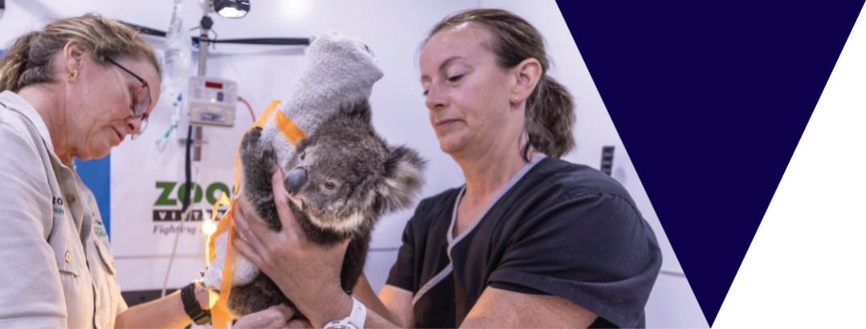

What is the issue?
Rehabilitation of sick, injured or orphaned koalas attracts significant public attention and support. However, the challenges in achieving successful koala rehabilitation, and the point at which pain and suffering outweighs the benefit of attempting rehabilitation, are not widely understood.
Koalas can require care and rehabilitation for a variety of reasons including collision with motor vehicles, dog attack, incidents relating to timber harvesting and bushfire. Due to their highly specialised dietary requirements and unique physiology, caring for sick, injured and orphaned koalas requires specialist expertise to be successful. Appropriate housing that allows natural climbing and jumping behaviours is also critical to ensure rehabilitated koalas are fit for release.
In Victoria, wildlife care and rehabilitation is undertaken by authorised volunteer wildlife shelters and foster carers (collectively referred to as rehabilitators). Currently Victoria does not require wildlife rehabilitators to complete specialised training for species that have challenging requirements. Wildlife shelter and foster carer authorisations do include conditions that the shelters and foster carers must meet when caring for wildlife that aim to protect animal welfare and manage biosecurity risks, however, there are no conditions specific to the care and rehabilitation of koalas.

There are opportunities to improve information about koalas entering care, and outcomes for those koalas following release into the wild. While wildlife shelters and foster carers keep records of the wildlife they treat, this information is not collated centrally and is therefore unable to be used to improve treatment and management of koalas in care. Post release monitoring is also not typically undertaken, so the fate of released koalas is often unknown.
One study conducted in NSW with koalas rehabilitated following bushfires found that rehabilitated koalas had a similar survival rate to uninjured koalas (Lunney et al., 2004), however more post-release monitoring is required to better understand koala survival rates following rehabilitation (Burton and Tribe, 2016). Zoos Victoria is currently leading a project to undertake post-release monitoring of koalas that were rehabilitated after the 2019/2020 bushfires. The results of this project will be used to inform rehabilitation for koalas in the future.
The 2019/2020 bushfires had a devastating impact on wildlife and wildlife habitat across Victoria, particularly in East Gippsland. Fortunately, less than four per cent of koala habitat in Victoria was estimated to have been affected (Heard and Ramsey, 2020); however, koalas were still directly impacted by the bushfires, with many requiring euthanasia or treatment for burns and other injuries.

The bushfires also highlighted that there is a limited number of vets in Victoria with the specialist expertise needed to treat burnt and injured wildlife, including koalas. Access to vets with wildlife expertise is particularly limited in regional areas of Victoria and after hours. The gap in veterinary knowledge and experience of treating wildlife, particularly koalas, has previously been identified in relation to the availability of experienced vets to treat koalas injured during timber harvesting operations.
Veterinary training in Victoria has minimal content relating to the specific treatment needs of wildlife species. Vets who are experienced in wildlife care are therefore in high demand, particularly during emergency situations.

In addition to the limited wildlife-specific veterinary training available, the Australian Wildlife Health Centre at Healesville Sanctuary is Victoria’s only specialised wildlife veterinary hospital, although other Zoos Victoria facilities are able to provide suitable housing and care for wildlife. As a result of the generous donations from the general public for the 2019/2020 bushfire response, a new wildlife hospital has been built at Werribee Open Range Zoo. The new wildlife hospital will significantly increase Victoria’s capacity to care for sick or injured wildlife, including koalas. A program to provide specialist wildlife training to vets is also being undertaken by Zoos Victoria.

Theme 3 actions:
Koala rehabilitation

Goal: The standard of care for koalas requiring rehabilitation is improved.

Action 3.1 Develop standards for koala rehabilitation to encourage a consistent, best practice approach to koala rehabilitation across the state
Action details | Partners
This action will involve:  - Engaging with vets, animal welfare experts, Zoos Victoria, wildlife carers and Animal Welfare Victoria to finalise the standards of care for koala rehabilitation. The standards may include guidance on topics such as:  - minimum training/experience requirements  - facilities and equipment  - koala triage assessment  - capture and handling  - treatment  - feed requirements  - preparation for release  - pre-release assessment  - release protocols  - post-release monitoring protocols  - record keeping.  - Supporting post-release monitoring where possible to investigate the success of rehabilitation. The information gained will be used to further refine the standards of care. | DEECA  Zoos Victoria  Vets  Animal welfare experts  Wildlife carers  Animal Welfare Victoria

Theme 4. Koala genetics

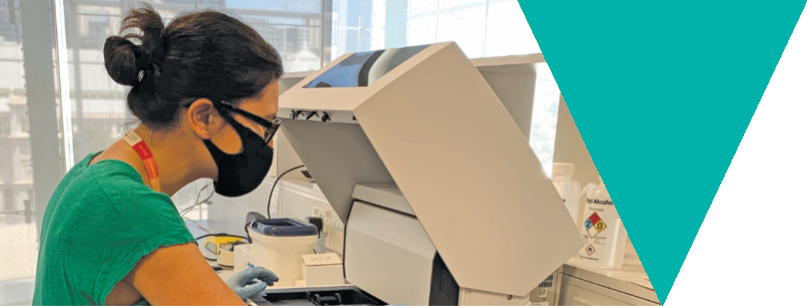

What is the issue?
Some koala populations in Victoria have been found to have much lower levels of genetic diversity than koala populations in other states of Australia (Houlden et al., 1996; 1999; Johnson et al. 2018). The low genetic diversity observed in these populations is due to many of the existing koala populations being established through historic reintroduction programs from island populations that were founded with only a small number of individuals. This resulted in a genetic bottleneck which has restricted the genetic diversity of the species across Victoria (Houlden et al., 1996; Martin and Handasyde 1990).
Genetic bottlenecks increase the risk of inbreeding in a population, which can lead to greater instances of abnormalities (Ralls et al., 2018), such as testicular aplasia and jaw malocclusion, which have been observed in a number of Victorian koala populations. While there is evidence of inbreeding in some Victorian koala populations, this does not appear to have impacted their fecundity, as evidenced by their population growth rates and capacity for becoming overabundant in some areas (Menkhorst, 2008).
Low genetic diversity ultimately increases the extinction likelihood of a population if conditions change (Weeks et al., 2016). Genetic diversity is an important measure of a population’s resilience, as it aids in adaptation to emerging environmental pressures, such as disease and climate change. Due to their low genetic diversity, Victorian koala populations may be at an increased risk of decline from such threats in the future (Weeks et al., 2016).

A Genetic Risk Index has been developed for Victorian flora and fauna that can provide a preliminary assessment of a species’ genetic risk (Kriesner et al., 2020). The Index combines available genetic and demographic metrics that have the potential to contribute to or influence overall genetic risk for a given species and is communicated as “very high”, “high”, “medium” or “low” risk. The initial assessment for koalas identified a medium genetic risk and indicated that some populations would benefit from genetic intervention (Kriesner et al., 2020).
The known exception to the low genetic diversity in Victorian koala populations is a distinct population in South Gippsland (Lee et al., 2011; Wedrowicz et al., 2018). This population has significantly higher genetic diversity compared to other Victorian populations studied and is thought to be an original population that was largely unaffected by hunting pressure in the late 1800s and the later reintroduction programs (Menkhorst, 2008). Given the higher levels of genetic diversity, this population may have a greater ability to adapt to future environmental pressures and conservation of the population and its genetic diversity is of high importance (Department of Sustainability and Environment, 2004; Lee et al., 2011).
Historically, there was a tendency for wildlife populations that are not highly mobile or wide-ranging to be managed in isolation to preserve their genetic distinctiveness (Ralls et al., 2018). However, recent research has identified that there is a need to consider the genetic diversity of a species as a whole, rather than focussing on conserving unique populations, to reduce the likelihood of species extinction (Weeks et al., 2016).

It is recognised that gene flow between populations can not only prevent inbreeding depression, but also reduce extinction likelihood if conditions change (Weeks et al. 2011; Ralls et al. 2018). Increasing gene flow between populations can promote adaptation to changing environmental conditions by spreading beneficial genetic differences, such as those that allow greater tolerance of stressors like elevated temperatures (Bell et al., 2019). Therefore, increasing gene flow between populations could also be used to conserve the genetic potential of Victorian koalas.
Consideration should also be given to the need and potential for augmenting gene flow between Victorian koala populations and populations in other states (Johnson et al., 2018). Some local adaptation does exist between koala populations across their range due to environmental factors, such as differences in the thickness of fur (Kjeldsen et al., 2018).
This local adaptation will need to be considered and may limit the potential for gene flow augmentation interstate, unless populations from similar bioregions can be identified. The risk of spreading disease is also an important consideration for gene flow augmentation (Waugh et al., 2016).
There are data gaps that would need to be filled prior to gene flow augmentation being considered. While some studies into the genetic diversity in South Gippsland populations have occurred, there has been no comprehensive study of genetic diversity of koala populations across the state (Wedrowicz et al., 2017a) and no research into the practicality and value of augmenting gene flow from the South Gippsland koala population to other koala populations to improve genetic diversity.

Theme 4 actions:
Koala genetics

Goal: Understanding of the genetic structure of koala populations in Victoria is increased to aid conservation of Victoria’s koalas.

Action 4.1 Undertake state-wide genetic surveys of Victorian koala populations
Action details | Partners
This action will involve:  - Developing and implementing a genetic survey program to better understand:  - the genetic diversity of koala populations across Victoria  - the significance and spatial boundaries of the unique Strzelecki/South Gippsland genome  - whether other populations of genetic significance exist  - the level of gene flow between populations  - population structure  - disease prevalence.  - Samples for the genetic surveys will be taken in both a targeted way and opportunistically, for example during koala management programs or when a koala requires veterinary treatment.  - The genetic surveys may be conducted concurrently with disease surveillance (Action 5.1) and koala population monitoring (Action 7.1).  - The genetic surveys will be conducted across all land tenures where permission is granted. | DEECA  Universities  Vets  Wildlife carers  Traditional Owners  Parks Victoria  Landholders/managers  Blue gum industry  General public

Action 4.2 Develop a genetic management plan for Victorian koalas
Action details | Partners
This action will involve:  - Developing a genetic management plan for Victorian koala populations, based on the results of the genetic surveys undertaken for Action 4.1.  - The genetic management plan will be developed by a geneticist and will be used to inform koala conservation and management activities. The plan will consider approaches such as gene flow augmentation and translocation between states. | DEECA  Universities

Theme 5. Disease in koalas

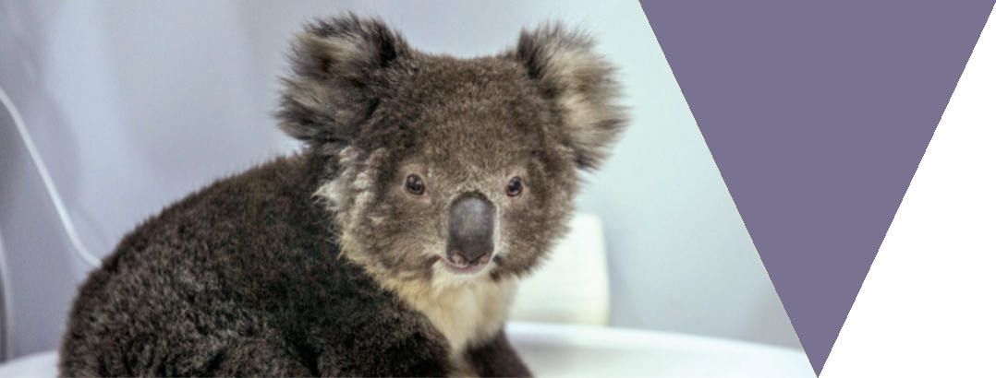

What is the issue?
Some infectious diseases that affect koala populations in Australia include Chlamydia pecorum, koala retrovirus, sarcoptic mange and kidney disease (oxalate nephrosis). The impact of disease varies significantly between populations, both within and between states. For example, Chlamydia is widespread throughout populations in NSW and Queensland, but is less common in South Australian populations.
Disease severity within a population can be influenced by the presence of other stressors, such as other diseases, nutritional stress or overcrowding (McAlpine et al., 2017). Translocation poses a risk of spreading diseases between populations, however, this risk can be mitigated through disease screening prior to translocation (Kock et al. 2010; Waugh et al., 2016).
Chlamydia is the most common koala disease and can spread quickly through a population. In Victoria, many mainland populations are Chlamydia-positive but the koala population on French Island is considered Chlamydia-free (Legione et al. 2016). Chlamydia in koalas is caused by two different species of similar bacteria, C. pecorum and C. pneumoniae, although the latter is very rare in Victoria (Legione et al., 2016).
While it can have a significant impact on individual koala welfare and population growth rates, Chlamydia is sometimes asymptomatic, showing no symptoms in up to 50 per cent of infected koalas (Nyari et al., 2017). When symptoms manifest, they can involve keratoconjunctivitis, urinary tract infections and reproductive tract infections, leading to infertility. Populations unaffected by Chlamydia generally have fertility rates of 66–81 per cent and can double in size every few years, whereas impacted populations have fertility rates ranging from 0–56 per cent (Martin and Handasyde, 1990).

Successful Chlamydia treatment is difficult, involving a daily antibiotic injection for 14–28 days (Robbins et al., 2018). These injections can negatively impact the koala’s highly specialised gut microbiome, resulting in nutritional stress (Roehr, 2018). Clinical trials for vaccines have had promising results (e.g. Nyari et al., 2018), but these have not yet become commercially available. There is some difficulty associated with vaccinating wild animals, particularly as many Chlamydia vaccines for koalas require three doses, however more feasible single dose methods have also been developed (Khan et al. 2014).
Koala retrovirus and sarcoptic mange have become more significant issues since the 2004 VKMS was released. Retroviruses are viruses that insert themselves into the genome. There are two main varieties of koala retrovirus: KoRV-A, which is widespread across Australia and often endogenous (i.e. it inserts itself into the host’s DNA in reproductive cells which enables it to be inherited by the host’s offspring); and KoRV-B, which is rarer, more virulent and exogenous (i.e. it can’t be inherited) (Quiqley et al. 2018).
There is limited knowledge on the effects of koala retrovirus, but it is believed to weaken the animal’s immune system and make affected koalas more susceptible to diseases such as Chlamydia (Waugh et al., 2017; Legione et al., 2017), leukaemia and lymphoma (Xu et al., 2013; Tarlinton et al., 2005).
In Victoria, koala retrovirus is exogenous, although KoRV-A is believed to be in the process of endogenizing into the koala genome (Maher et al., 2019; Tarlinton, Meers and Young, 2006). The prevalence of koala retrovirus in Victorian populations sampled between 2010 and 2016 was found to range from 17–40 per cent, with an overall prevalence of 24.7 per cent (Legione et al., 2017).

A koala retrovirus vaccine has not yet been developed, but the success of vaccines in treating the related feline leukaemia virus suggests vaccination will become a promising prevention strategy in future (Quigley et al., 2017).
In 2008, sarcoptic mange outbreaks were detected in free-ranging Victorian koalas for the first time. Prior to this, few cases of mange in Victorian koala populations had been detected. Mange is prevalent in Bare-nose Wombat (Vombatus ursinus) populations and is thought to have originally spread from dogs or foxes (Speight et al., 2017). Mange is caused by the mite Sarcoptus scabiei burrowing deep into the affected animal’s skin.
The disease is associated with severe thickening and scaling of skin, poor body condition and secondary infections, sometimes resulting in death (Speight et al., 2017). Mange can be treated through Ivermectin injections (Rowe et al., 2019), or by applying Ivermectin topically (on the animal’s skin), although these treatments have not yet been scientifically validated for koalas (Rowe et al., 2019).
A greater understanding of the prevalence and impact of disease in koala populations across Victoria is needed to identify priority diseases impacting koala welfare and to inform koala management programs, particularly those involving translocation to ensure that disease is not spread between populations.
The Australian Government has funded the development of a National Koala Disease Risk Analysis (DRA), which aims to identify disease hazards for koala populations and encourage a nationally coordinated and collaborative approach to disease prevention and control. The National Koala DRA will be used to inform koala disease management in Victoria.

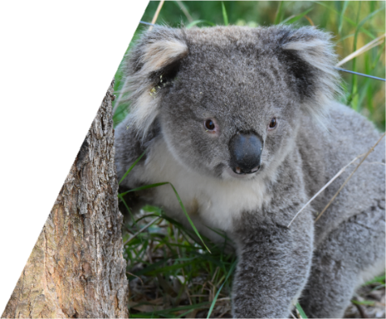

Theme 5 actions:
Disease in koalas

Goal: The health status of koala populations in Victoria is better understood to inform koala conservation and management activities.

Action 5.1 Develop and implement a systematic koala disease surveillance program across Victoria that will enable early detection of new diseases and ongoing monitoring of established diseases
Action details | Partners
This action will involve:  - Developing and supporting a systematic koala disease surveillance program that includes clinical sign/syndromic reporting of koala health observations (which may trigger sample collection or field investigation), submission of samples for targeted disease testing and pathological examination of dead koalas. The surveillance program will:  - provide disease diagnosis, disease agent identification and will allow early detection of new or previously un-detected diseases and ongoing monitoring of established or endemic diseases  - be distributed across the state to represent key koala populations  - be collaborative and obtain data and samples from a variety of sources including koala management programs, wildlife carers, vets, researchers and the general public  - have an iterative design and be updated with new knowledge and recommendations from Disease Risk Analyses.  - Reviewing and building on existing wildlife disease surveillance networks in Victoria.  - Reporting disease surveillance into existing wildlife health databases.  - Developing and distributing information to assist people identify and report diseased koalas.  - Using the information gained through the disease surveillance program to inform koala conservation and management activities.  - Disease surveillance may be conducted concurrently with the genetic surveys (Action 4.1) and koala population monitoring (Action 7.1). | DEECA  Universities  Vets  Wildlife carers  General public  Traditional Owners  Parks Victoria  Zoos Victoria  Landholders/managers  Blue gum industry

Action 5.2 Review the National Koala Disease Risk Analysis (DRA) to identify priority diseases, effective mitigation strategies and knowledge gaps for Victoria
Action details | Partners
This action will involve:  - Undertaking a review of the National Koala DRA to determine the priority diseases and effective mitigation strategies for Victoria.  - Considering whether there are different factors in Victoria that may impact disease that were not considered in the National Koala DRA that warrant an additional DRA process to fill the knowledge gaps. Factors to be considered may include:  - genetics and connectivity between populations  - population density and population trends  - habitat and land-use  - climate change predictions  - environmental contaminants  - different strains of infections present in Victoria.  - Using the DRA results to inform koala conservation and management activities. | DEECA  Universities  Vets  Australian Government

Theme 6. Habitat conservation

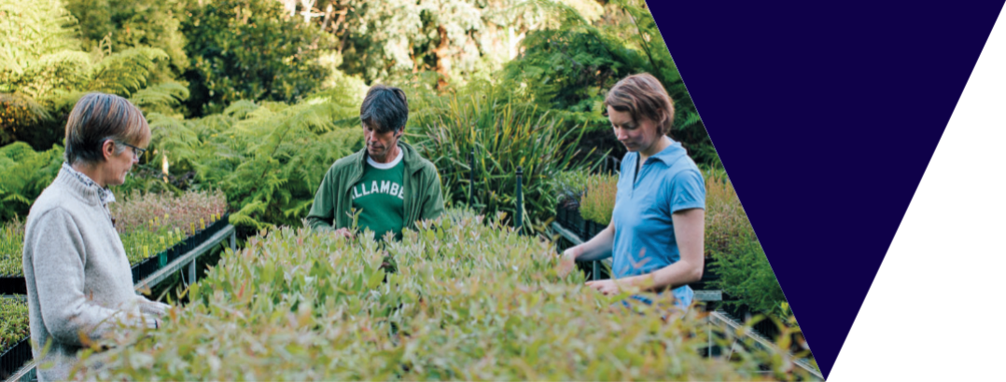

What is the issue?
Land clearing for urban, industrial and agricultural development is the primary cause of koala habitat loss across eastern Australia (ANZECC 1998). Koalas predominately feed on the leaves of eucalyptus species (Martin and Handasyde, 1999) and due to this highly specialised diet, they are particularly vulnerable to habitat loss (Bender and Fahrig, 2005; Melzer et al., 2014). In addition, as their diet is low in energy and nutrition, it leaves koalas particularly vulnerable to habitat fragmentation, since it limits the energy they have available to travel between patches of food trees.
In peri-urban habitats, the impact of habitat loss and fragmentation is compounded by an increased risk of exposure to dog predation and vehicle collisions when koalas cross cleared areas or roads (McAlpine et al., 2006). While the protection of high-quality koala habitat is critical for koala conservation, the protection of lower quality habitat is also important, as these areas can facilitate koala dispersal (McAlpine et al., 2006; Smith et al., 2013).
Widespread historic clearing of Victorian forests has resulted in Victoria being the most cleared state in Australia (VEAC, 2011). Therefore, ongoing, incremental habitat loss, degradation and fragmentation are a particular concern for the conservation of Victoria’s koala populations (Menkhorst, 2008). This is likely to be exacerbated by climate change, as an increase in atmospheric carbon dioxide will impact habitat quality by reducing the nutritional quality of eucalyptus foliage (Johnson, De Gabriel and Moore, 2009).

Koala selection of individual feed trees is influenced by tree size and structure, as well as leaf chemistry and water content (Moore and Foley, 2000; Moore et al. 2010). Koalas prefer feeding on larger trees with higher levels of leaf nitrogen and water, and lower levels of plant secondary metabolites, which are toxic compounds that plants use as a defence against herbivores (Moore and Foley, 2005). Leaf chemistry and water content is influenced by environmental factors such rainfall, climate and soil nutrient levels (Close et al. 2003; Recher, Majer and Ganesh, 1996).
Whether an area of habitat is considered high quality for koalas therefore depends not only on the presence of preferred eucalyptus species in a sufficient area of habitat (McAlpine et al., 2006), but also on the size and nutritional quality of individual trees (Callaghan et al. 2011; Moore and Foley, 2005).
While habitat loss due to human development impacts koalas, koalas can also cause habitat loss due to over-browsing, with consequences for both koalas and other species (Whisson et al., 2016; Whisson, Orlowski and Weston 2018) (see Theme 2: Koala Overabundance). The most severe example of habitat loss due to koala over-browsing occurred at Cape Otway.
In 1981, 75 koalas from French Island were introduced to Cape Otway. A favourable climate and good food availability, along with the absence of fire, disease and predators, provided ideal conditions for the population to grow rapidly. By 2013, koala population densities were over 18 koalas per hectare in some areas, far exceeding sustainable levels (Whisson et al., 2016).

The koalas over-browsed the trees, causing severe defoliation and tree deaths, and koalas were observed to be distressed and malnourished (Ramsey, Tolsma and Brown, 2016). By September 2013, significant habitat destruction had occurred, causing large numbers of koalas to starve to death (Whisson et al., 2016). This prompted emergency welfare interventions by the department, in which over 70% of the koalas assessed were determined to be in sufficiently poor health to require euthanasia (Ramsey, Tolsma and Brown, 2016).
Habitat loss due to koala over-browsing also has flow-on effects for other species. For instance, Whisson, Orlowski and Weston (2018) found that the defoliation of Manna Gums at Cape Otway by koalas caused a reduction in bird species diversity and richness. Similarly, increased light infiltration and changes to microhabitats resulting from defoliation can result in changes to subcanopy vegetation and microhabitats (Valladares et al., 2016).
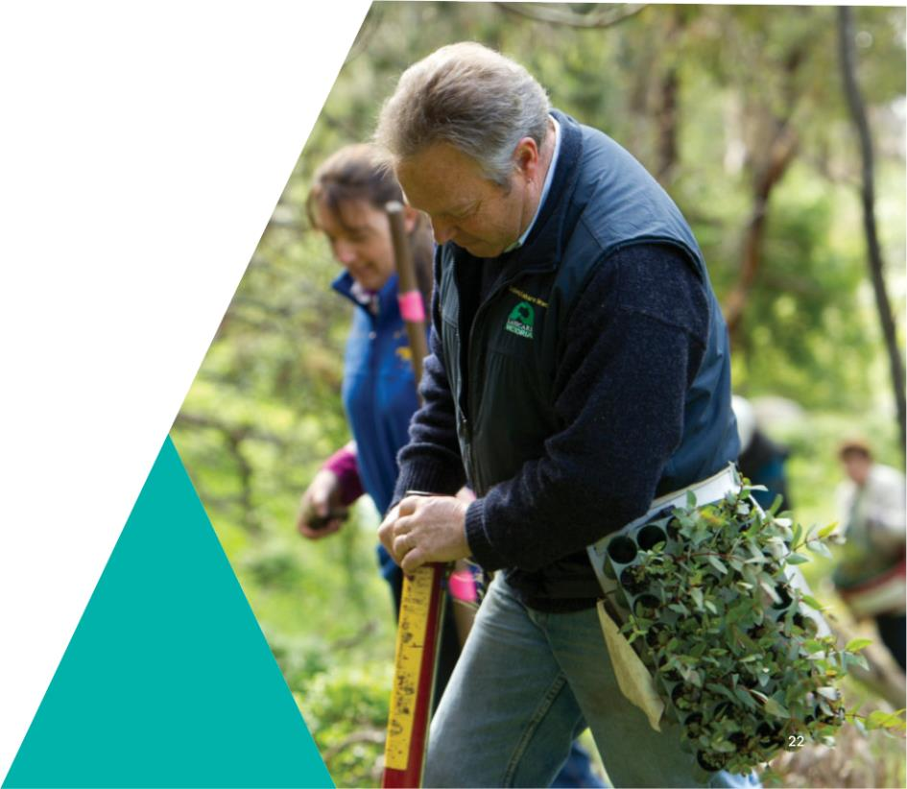
Measures to protect koala habitat from over-browsing include fencing, tree banding, koala fertility control and translocation. ARI has also developed a ‘habitat health trigger’ that can be used to initiate koala management actions to relieve unsustainable browsing pressure before forests and koala populations collapse (Ramsey, Tolsma and Brown, 2016).
Effective habitat conservation requires the protection of remaining core areas of high-quality habitat and habitat restoration programs to improve lower quality habitat, increase habitat extent and improve connectivity between habitat patches (Januchowski et al. 2008).
Land tenure is an important consideration for effective habitat conservation. While koala habitat exists in National Parks and other areas of Crown land, in some areas of Victoria, the remaining koala habitat is largely located on private land (Januchowski et al., 2008). This means that koala habitat conservation and restoration is not solely the responsibility of government, but instead needs to be a joint effort involving all landholders and land managers.

Case study
An example of a cooperative approach to koala habitat conservation is the Strzelecki-Alpine Bio-link project (the Bio-link).
The Bio-link is a Latrobe City Council initiative that aims to restore habitat connectivity between the Strzelecki Ranges and Baw Baw Alpine Ranges through habitat protection and revegetation. While the Bio-link’s objective is to benefit the movement of all wildlife, the koala is the flagship species for the project.
The Strzelecki koala population (also referred to as the South Gippsland koala population) has been identified as one of the most genetically diverse populations in Victoria. The Bio-link aims to expand the range of this important population by facilitating koala movement between patches of remnant habitat and by improving habitat quality. Restoring these connections across a broader landscape area is considered critical to the resilience of this unique koala population given increasing bushfire risk.
Significant areas of koala habitat exist throughout the Bio-link across both public and private land,
so effective partnerships between government and landholders are crucial to enabling landscape-scale habitat conservation and revegetation. In this case, only 3 per cent of land within the planned Bio-link habitat corridor is a public park or reserve, whereas 40 per cent is farmland, 24 per cent is rural lifestyle properties and 26 per cent comprises timber plantations.

Latrobe City Council has driven the Bio-link by leading a feasibility study, incorporating the Bio-link into the local planning scheme and establishing a working group that includes government, Traditional Owners, Federation University, industry, not-for- profit organisations, scientists and community representatives to develop strategies and partnerships that will progress the Bio-link’s development through collaborative effort.
The council is also exploring opportunities that would provide landholders with incentives to undertake revegetation on their property, for example through carbon credit programs, and is working with government and industry to consider the Bio-link’s priorities in the delivery of existing programs.
Ongoing collaboration with land managers and organisations like Landcare and Greening Australia, along with funding secured through local government and industry partnerships, will be essential to undertaking the habitat conservation and restoration that will advance the Bio-link’s objectives.

Theme 6 actions:
Habitat conservation

Goal: Koala habitat is conserved and initiatives to increase and connect habitat are supported.

Action 6.1 Develop a comprehensive koala population and habitat decision support tool for Victoria to inform koala and habitat management activities, including koala translocation programs, fire management and habitat protection and restoration.
 | Action details | Partners
 | This action will involve:  - Using the results of koala population surveys to develop koala population distribution maps and population models.  - Undertaking koala habitat modelling to develop koala habitat maps and determine habitat availability.  - Developing the decision support tool that can be used to identify:  - priority areas of habitat for protection or restoration  - potential climate refuge areas  - koala populations at high risk of requiring management to protect habitat  - potential translocation release sites. | DEECA  Universities

Action 6.2 Develop and support initiatives to increase the extent of koala habitat and improve habitat connectivity.

Action details | Partners
This action will involve:  - Identifying areas where koala habitat should be increased or habitat connectivity improved.  - Working with Councils, CMAs, NGOs, Landcare, Traditional Owners, Parks Victoria, landholders/managers, the blue gum industry, community groups and the community to develop and support initiatives to increase the extent of koala habitat and improve habitat connectivity.  - Providing information to landholders about how to increase koala habitat, including which tree species to plant. | DEECA  Councils  CMAs  NGOs  Landcare  Traditional Owners  Parks Victoria  Landholders/managers  Blue gum industry  Community groups  General public

Theme 7. Understanding koala populations

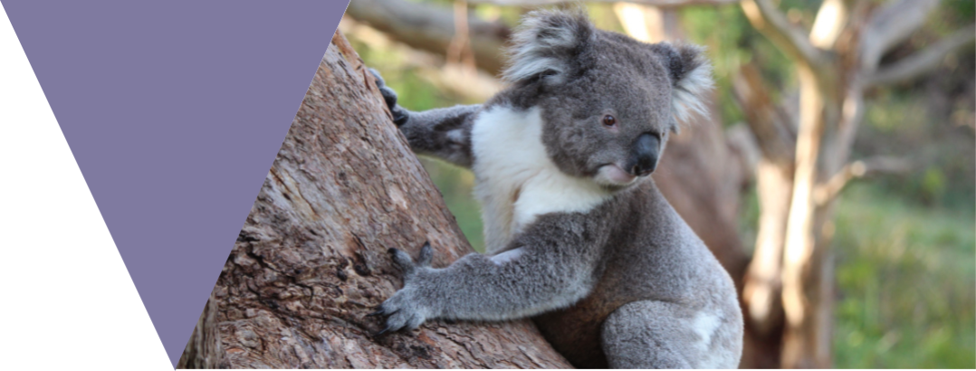

What is the issue?
Understanding koala population dynamics is essential to help define and address the issues relating to koala management across the state. There are significant regional variances in koala population dynamics in Victoria. In some areas of the state populations are overabundant, while in other areas they are declining (Menkhorst, 2008; Phillips, 2000). These variances present different management challenges that cannot be addressed with a one-size-fits-all approach. These differences have been influenced by a history of extensive human intervention with past hunting, habitat clearing, land use change, and translocation programs shaping the current distributions (Menkhorst 2008; Wedrowicz et al., 2017a).
While some koala population data is available, historically, monitoring and surveillance of koala populations in Victoria has been undertaken based on management need or as part of largely uncoordinated research projects. This has resulted in knowledge gaps, particularly for lower-density populations that are not subject to management programs. Adding to this bias is an inconsistency in survey techniques and quality, which increases uncertainty in the data itself and in attempts at species modelling (Heard and Ramsey, 2020).
The double count transect method is currently the recommended surveying method for koala populations. However, this method is very intensive, requires well-trained and dedicated surveyors, and has limitations for monitoring lower density populations across greater distances. Emerging surveying techniques including infrared cameras on drones, passive acoustic surveying and detection dogs are options that could overcome such limitations but do still present their own challenges (Gonzalez-Astudillo et al., 2016; Hagens, Rendall and Whisson, 2018; Cristescu et al., 2015).
Improvements in genetic assessments and surveying also allow a deeper understanding of genetic variability within and between populations, providing further insight into population processes (e.g. genetic fragmentation, inbreeding, population size) (Wedrowicz et al., 2017b).

Understanding koala population dynamics has important ramifications for all issues relating to koala management, informing solutions, and allowing coordination and prioritisation of management actions at the necessary scales. For example, improved population monitoring can aid in the early identification of unsustainably high population growth rates, and if acted upon, can inform intervention to prevent cases of tree death and koala starvation (Ramsey, Tolsma and Brown, 2016; Whisson and Ashman, 2020).
A better understanding of population trends can also identify early impacts of emerging threats such as climate change, genetic decline and disease, with quality data critical in modelling and scenario planning (McAlpine et al., 2015; Reckless, Murray and Crowther, 2017). Additionally, an improved model of current abundance and suitable habitat can improve the initial scoping process for translocation programs.
Having robust population estimates for Victoria is also important to inform the national management of koalas. There have been misleading reports circulating in the media that koalas are ‘functionally extinct’ in the wild, with these reports receiving increased attention during the 2019/20 bushfires. These types of claims can have significant influence on the public’s perception of koalas, which can then impact the ability to manage overabundant populations in the states where they are not listed as endangered (i.e. Victoria and South Australia).
The Australian Government has funded the development and implementation of a National Koala Monitoring Program (NKMP). The Victorian Government supports the NKMP and will ensure that monitoring programs established in Victoria are complementary to the NKMP and that data sharing arrangements are in place.

Koala abundance model
In 2020, scientists from ARI developed the first state-wide estimate of koala abundance in Victoria. The study reviewed and utilised existing distribution data from the previous 15 years to develop a model to predict koala abundance. The model estimated a Victorian population of 459,865, with an estimated 412,948 (95% credible interval of 324,772–519,578) individuals in native forest and woodland and a further 46,917 (95% credible interval, 35,998–60,054) in the eucalypt plantation estate (Heard and Ramsey, 2020).
The review of the available koala distribution data revealed strong regional biases, with quality long-term data largely restricted to areas of overabundance and management programs (south-west Victoria, French Island and Raymond Island) and hardwood plantations in the Strzelecki Ranges. Large areas of the Loddon-Mallee, Grampians, Port Phillip, Hume and Gippsland regions were either represented by a few scattered counts, or no counts at all. Furthermore, the dataset was constructed from surveys that were conducted for purposes other than population modelling at large spatial scales and were undertaken using a variety of survey methods. The report provides recommendations for ways to improve the underlying dataset and model and should be considered when designing any future koala population monitoring programs in Victoria.

Theme 7 actions:
Understanding koala populations

Goal: Knowledge of the size and distribution of Victoria’s koala populations is improved to inform koala conservation and management activities.

Action 7.1 Establish a long-term state-wide monitoring program to improve knowledge of koala population distribution, abundance and population trends.
 | Action details | Partners
 | This action will involve:  - Developing a koala population monitoring program, which may involve a citizen science component.  - Surveying koala populations throughout Victoria, including lower-density inland populations and the Strzelecki/South Gippsland populations.  - Implementing the monitoring program across all land tenures where permission is granted.  - The monitoring program will complement the National Koala Monitoring Program (NKMP) established by the Australian Government and the CSIRO.  - The monitoring program may be conducted concurrently with the genetic surveys (Action 4.1) and disease surveillance (Action 5.1).  - Results from the monitoring program will be published and made available to the NKMP and the community.  - Results from the monitoring program will be used to inform koala management programs and habitat protection and restoration activities. | DEECA  Universities  Australian Government  CSIRO  Traditional Owners  Parks Victoria  Landholders/managers  Blue gum industry  General public  Community groups

Theme 8. Climate change and managing fire impacts

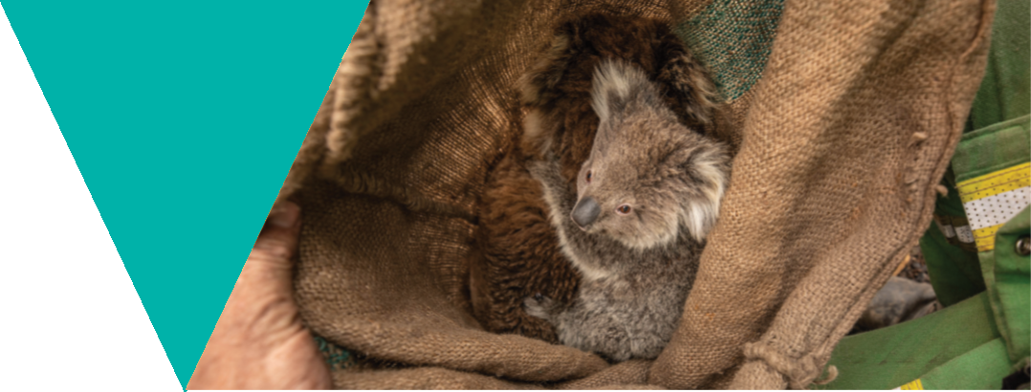

What is the issue?
Koalas may be particularly vulnerable to the impacts of climate change. They are prone to heat-related stress and dehydration and are poorly adapted to cope with increased temperatures and severe heat events (Johnson, De Gabriel and Moore, 2009; Briscoe et al., 2014). Climate change is likely to further stress unfit individuals and potentially exacerbate disease. For example, it has been shown that hot and dry summer/autumn periods contribute to an increased risk of koala deaths due to kidney disease (Speight et al. 2018).
As outlined in Theme 4: Koala genetics, due to their low genetic diversity and therefore their reduced potential for adaptation, Victorian koala populations may be at an increased risk of decline due to climate change (Weeks et al., 2016).
The knowledge base for climate change impact is growing nationally, with climate change the most academically studied threat to koalas in the last 10 years (Ashman, Watchorn and Whisson, 2019). Climate change is predicted to have considerable impacts on koala habitat and their food trees.
Altered rainfall and increased atmospheric CO2 is predicted to change the chemical composition and water content of eucalypt leaves, reducing the hydrational and nutritional value whilst also increasing their toxicity (Reckless, Murray and Crowther, 2017). Increased atmospheric CO2 has been shown to decrease the amount of proteins in eucalyptus leaves whilst also increasing the ratio of toxic tannins, making foliage less digestible (Moore et al., 2004; Johnson, De Gabriel and Moore, 2009). This reduces the nutritional value and puts further pressure on food availability for koalas.

Koalas obtain the majority of the water they need from the leaves they eat, therefore changes to leaf hydration due to drought may require koalas to obtain water from other sources. This could put them at increased risk of collisions with vehicles, dog or cattle attacks or other hazards as they move through the landscape in search of water (Johnson, De Gabriel and Moore 2009; Lunney et al., 2012).
Climate change is likely to alter the future distribution of koalas as the requirements and availability of habitat, food and water change. There is considerable complexity and uncertainty when modelling future distributions, however it is likely that the koala-suitable climate will generally shift south easterly compared to current distributions (Briscoe et al., 2015; Adams-Hosking et al., 2012; 2014).
As relatively slow-moving, tree-dwelling mammals that often show high site fidelity when in quality native habitat (Whisson et al. 2016), koalas are also at risk from bushfire. Fire can have significant impact to koalas at the population level and also creates a range of welfare issues at the individual level. Koalas are particularly vulnerable to smoke and fires that move through the canopy. With limited ability to flee fire zones, koalas can suffer smoke-induced respiratory diseases, and are vulnerable to burn-injuries on their feet when moving through firegrounds. This can greatly impact their ability to escape danger, seek food and refuge in trees, and presents an infection risk.
Fires can devastate much of the koala’s food supply and habitat, which can result in starvation and force koalas to disperse from an area to find food and shelter. Successful dispersal is impeded by the koala’s unwillingness to leave burnt areas and the risk of vehicle collisions and predation by dogs (Johnson, De Gabriel and Moore, 2009; Reckless, Murray and Crowther, 2017; Lunney et al., 2004).

Since the release of the 2004 VKMS, Victoria has experienced a significant increase in intense landscape-scale bushfires (Lindenmayer and Taylor 2020) that have impacted koala habitat across the state, including the 2009 Black Saturday fires, the 2015 fires near Wye River and the 2019/2020 fires in East Gippsland and Budj Bim National Park. Climate change is likely to lead to hotter and longer fire seasons in Victoria (Clarke et al. 2019).
Planned burning is conducted throughout Victoria to reduce fuel loads. The Fire Analysis Module for Ecological values (FAME) is a tool developed by scientists from ARI, the University of Melbourne and La Trobe University that is used by fire planners to consider the potential impact of a planned burn on flora and fauna. FAME allows fire planners to evaluate alternative fire regimes and their impact on a species. While planned burning has significantly less impact on koalas and their habitat than large-scale bushfires, there can still be impacts. With the right data, there is potential to apply FAME to achieve better outcomes for koalas and their habitat during planned burning.

Theme 8 actions:
Climate change and managing fire impacts

Goal: The potential impacts of climate change and bushfires on Victoria’s koala population are understood and actions are taken to mitigate them.

Action 8.1 Use existing climate change models to better understand what a changed climate means for koalas and habitat across the whole of Victoria.
Action details | Partners
This action will involve:  - Identifying existing climate change models that are relevant to koalas and koala habitat.  - Determining if refinements to the models are required and undertaking these refinements.  - Considering how the predictions from the models can be incorporated into koala management programs and habitat protection and restoration activities.  - The models will be used to identify potential climate refuge habitat, to better understand predicted koala responses to drought and increased temperature, to understand potential impacts to koala habitat from climate change and to identify potential mitigation strategies. | DEECA  Universities
Action 8.2 Use koala population data to inform planned burning activities and the wildlife welfare response during bushfires.
Action details | Partners
This action will involve:  - Using koala population data to inform:  - planned burning activities  - standard mitigations during planned burning activities, such as designation of wildlife welfare arrangements  - the wildlife welfare response initiated during bushfires. | DEECA  Parks Victoria  Wildlife carers  Vets

Theme 9. Koalas in blue gum plantations

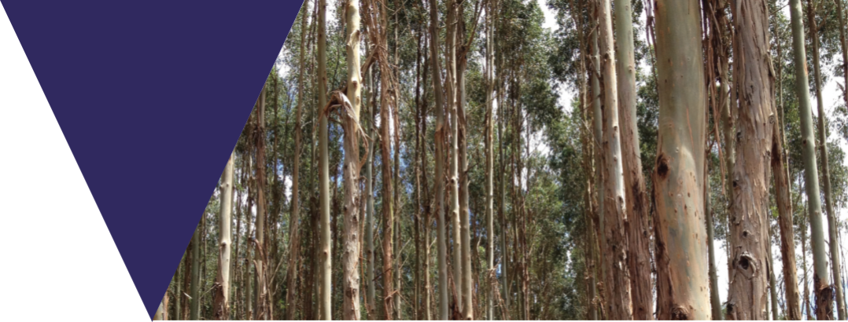

What is the issue?
An emergent issue since the release of the 2004 VKMS is the establishment of large koala populations within blue gum (Eucalyptus globulus) plantations in Victoria. In the late 1990s and early 2000s, large areas of Eucalyptus globulus ssp. globulus (Tasmanian blue gum) plantations were established across Victoria as the result of a 1997 Commonwealth Government strategy, ‘Plantations for Australia: The 2020 Vision’, which aimed to effectively triple Australia’s plantation estate by 2020 (Mercer and Underwood, 2002). While blue gum plantations were also established in central Victoria and Gippsland, the majority were established on farmland in the Green Triangle Region of south-west Victoria (Mercer and Underwood, 2002).
The blue gum plantations established in south-west Victoria unintentionally provide large areas of suitable habitat for koalas because they are planted in areas that overlap with the koala’s spatial distribution (Menkhorst, 2016; Ashman et al. 2020) and are located on fertile soils with regular rainfall (Mercer and Underwood, 2002), which increases the nutrient levels in the leaves (Braithwaite et al, 1983). Due to the structure of the plantations, they provide abundant food, shade and shelter and as a result may support koalas at a higher density than native forest (Menkhorst, 2016). Consequently, koala numbers in the region have increased over the last 20 years (Menkhorst, 2016).
The density of koalas within blue gum plantations in south-west Victoria varies across the range, however, in some areas it has been reported to be as high as ten koalas per hectare (Menkhorst, 2016). Previous estimates have identified a total koala population in the blue gum plantations in south-west Victoria at up to 200,000 individuals (Menkhorst, 2016).

However, recent koala population modelling undertaken by ARI estimated that there were 46,917 individuals in plantations across the state and that koala density within plantations was predicted to be similar to surrounding native forest (Heard and Ramsey, 2020).
Blue gum plantations are grown on short rotation of 10–15 years (Mercer and Underwood, 2002). Since the release of the 2004 VKMS, harvesting has commenced in a large proportion of the plantations across the state. Due to the high koala density in the plantations in south-west Victoria, harvesting has resulted in koala welfare impacts as the plantations are clear-felled and koalas can be injured, killed, and displaced as a result of the harvesting operations.
While harvesting has also commenced in the plantations in South Gippsland, koalas are present at much lower densities in this area, estimated at an average of 0.07 koalas per hectare (Heard and Ramsey, 2020), and the plantations are generally located close to extensive areas of native vegetation that koalas can disperse to. The impacts to koalas from plantation harvesting in South Gippsland have therefore been far less than in the south-west.
DEECA and the blue gum industry are working together with the aim of reducing the koala incident rate to zero, however, this is a considerable challenge due to the difficulty detecting koalas in the plantations. To address the impacts to koala welfare from blue gum plantation harvesting, the department introduced a new regulatory approach in 2017.

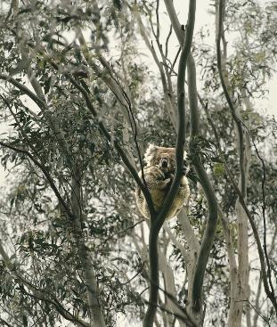
The blue gum plantation industry is required to comply with this approach to minimise risks to koala welfare during operations. Plantation management companies must apply for an authorisation to disturb koalas in order to continue to harvest in areas where koalas are present and may be impacted. The authorisation conditions set out minimum standards that the company must comply with and are underpinned by a Koala Management Plan that the company must develop to ensure their operations minimise impacts to koalas.
The authorisation and Koala Management Plan include requirements for the training of personnel; detection of koalas prior to and during harvesting; and protection of koalas from harvesting by retaining a specified number of trees around any trees where koalas are located to provide short-term shelter and food and help facilitate the koala’s movement into surrounding habitat. As the plantations are located on private land and are essentially an as-of-right land use crop, there are no requirements to retain areas of plantation for koala habitat long-term and retained trees can be removed once the koalas are no longer present. The regulatory approach supports industry innovation and continuous improvement, and includes a focus on data collection, analysis and transparency.
While the authorisation and Koala Management Plans address the immediate risks to koala welfare from harvesting, they do not consider the long-term impacts to koalas or surrounding habitat from koala dispersal following harvesting. An estimated 8,000– 10,000 hectares is harvested annually in south-west Victoria. Given the size of the koala population in the plantations, this could result in significant koala displacement and impacts on surrounding native forest, roadside vegetation and other plantations in the coming years due to an increasing koala population and fewer mature plantations for koalas to disperse to (Ashman et al., 2020).
In addition, there are likely to be significantly more plantations established throughout Victoria to meet the demand for timber in the future. New plantations or subsequent rotations are likely to be rapidly occupied by koalas displaced by harvesting in other plantations (Menkhorst, 2016). The only way to exclude koalas from new or regenerating plantations is to fence the entire boundary with koala-proof fencing (Menkhorst, 2016), however this would be costly due to the size of the plantations.
To date, translocation from plantations in the south-west has not been supported due to the large number of koalas that would likely require translocation, the already significant koala populations located in surrounding native forest and, more generally, the lack of suitable unoccupied habitat across Victoria. More precise estimates of koala abundance in the plantations are needed to inform management approaches in the future. There are currently no cost-effective management techniques available that would be acceptable to the community, or clear objectives for the management of koalas in blue gum plantations. This will continue to be an issue without options for, and agreement on, appropriate interventions.
While this theme only discusses blue gum plantations as it is the plantation type with the highest density of koalas and where most issues have occurred, strategies to minimise impacts to koalas from timber harvesting can be adapted to other plantation types as needed in the future.

Theme 9 actions:
Koalas in blue gum plantations

Goal: Impacts to koala welfare from blue gum plantation harvesting continue to be minimised.

Action 9.1 Investigate options to manage koala populations in blue gum plantations that protect koala welfare and ensure the industry remains viable and can continue to operate.
Action details | Partners
This action will involve:  - Considering a range of factors to determine options to manage koala populations in blue gum plantations.  - Factors to be considered include:  - results of koala population surveys  - habitat availability modelling  - industry knowledge and experience  - technology and infrastructure options available  - cost implications. | DEECA  Blue gum industry  Universities

Action 9.2 Investigate options to manage the impact of koala displacement on koala welfare and other values and incorporate them into management.
 | Action details | Partners
 | This action will involve:  - Undertaking research to better understand koala movement from plantations following harvesting and associated impacts on koala welfare and other values.  - Identifying and assessing potential options to manage these impacts. | DEECA  Blue gum industry  Universities  Landholders/managers  Wildlife carers  Vets

Theme 10. Community perception and socioeconomic significance

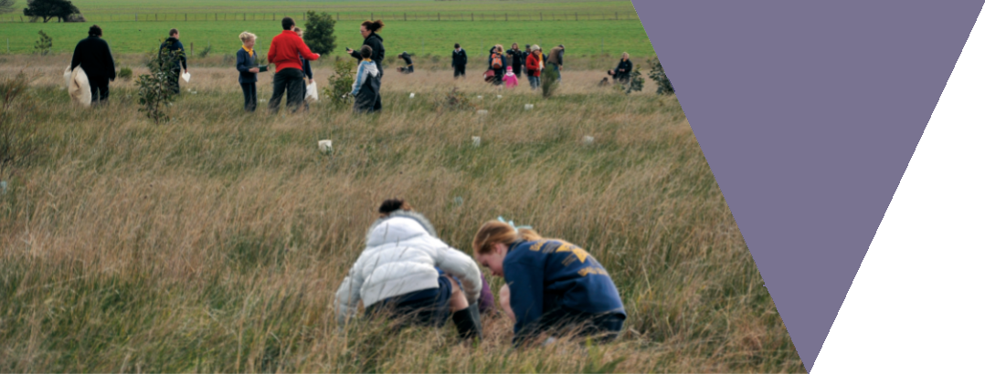

What is the issue?
The koala is perhaps the most iconic of all Australian mammals. It represents significant cultural, economic and environmental value and as a result can capture public attention disproportionate to that of other species of conservation importance. This creates both challenges and benefits for koala management outcomes.
As a unique and internationally cherished animal, the koala is a major drawcard for both domestic and international visitors. Tourism in Australia has grown significantly in the last two decades, with an estimated $39.1 billion generated in tourism exports in 2019, compared to $16.1 billion in 1997 (Tourism Research Australia, 2019; Hundloe and Hamilton, 1997). While it is difficult to determine how much of the expenditure by overseas tourists can be attributed to seeing koalas, the 2019 International Visitors Survey found that Australia’s local wildlife was the second highest reason (behind beauty of natural environments) for selecting Australia as a holiday destination (30 per cent of respondents, up from 22 per cent in 1997) (Tourism Research Australia, 2019; Hundloe and Hamilton, 1997).
Public perception of koala conservation locally and internationally is influenced by the dominant discourse in media channels of declining koala populations in NSW and Queensland. It is often not understood that there is a substantial disparity between the endangered populations in the northern states and the thriving and sometimes overabundant populations in Victoria and South Australia.
This disparity is characterised by large regional differences in the types of management challenges faced, prevalence of threats and population viability (McAlpine et al., 2015; Briscoe et al., 2015).

The pervasiveness of the message that koala populations are in serious decline has led to fundraising campaigns dedicated to koala conservation raising considerable amounts of money based on the public’s concern for koalas.
The koala is a flagship species for multiple environmental NGOs including the World Wildlife Fund (WWF) and was also the face of a number of fundraising campaigns during the 2019/20 bushfires, with over $10 million raised for koala-specific GoFundMe campaigns alone, with donations received from people around the world (GoFundMe, 2020).
The public’s love of koalas and the perception of their conservation status by both the international and local community has complicated the management of overabundant populations in Victoria and South Australia. Methods of population control widely used for other native wildlife species are not used for koalas. Even the humane euthanasia of severely injured koalas on welfare grounds following events such as fires or starvation due to habitat loss as a result of extreme koala overabundance has resulted in significant public outcry (Whisson and Ashman, 2020; Boulet, Spano and Smith, 2019).
Unsustainably high population densities act as tourist attractions as they increase the chance of human–koala interactions, often in unnatural environments like townships, roadsides and backyards. Misleading tourism material promoting overabundant populations as “sizeable and healthy” further perpetuates the incorrect association of sightings with koala wellbeing.
It is essential to improve the community's understanding of the conservation status of Victoria's koala populations and the different issues koalas in Victoria face compared to those in NSW and Queensland.

Apart from public education programs, community participation in koala management activities can also be used to raise awareness of issues and provide an opportunity for dialogue between community members and policy makers, potentially influencing public acceptance of management decisions in the future (Hollow et al., 2015; Boulet, Spano and Smith, 2019).
Encouraging community participation in koala management activities also aligns with one of the goals of Biodiversity 2037 – Victorians value nature. While there are already some community-based groups in Victoria contributing to koala management activities, such as tree planting and monitoring local koala populations, these opportunities could be increased and used in conjunction with a public education campaign to raise the awareness of koala management issues in Victoria more broadly.

Theme 10 actions:
Community perception and socioeconomic significance
Goal: The community has a greater understanding of the complexity of managing Victoria’s koala populations and are supported to contribute to koala conservation and management.

Action 10.1 Develop and implement a community and stakeholder education and engagement program that promotes the VKMS and the issues it addresses.
Action details |  | Partners
This action will involve:  - Working with experts in communications, behavioural science, ecology and animal welfare to develop and implement an education and engagement program about the VKMS and the issues it addresses. |  | DEECA  Universities  Vets  Traditional Owners  Wildlife welfare organisations  Wildlife carers  Communication experts  Blue gum industry  Councils  CMAs  Schools  Community groups  General public
Action 10.2 Increase opportunities for community involvement in koala conservation and management.
Action details | Partners
This action will involve:  - Identifying active community-based koala conservation and management programs so that existing efforts can be supported.  - Identifying new opportunities for community involvement in koala conservation and management activities, for example: citizen science surveys, ongoing monitoring and revegetation.  - Facilitating community involvement in these activities and supporting communities to conserve and manage koalas in their local area.  - Providing information to the community about how they can help to conserve and manage koalas and koala habitat. | DEECA  Traditional Owners  Councils  CMAs  Parks Victoria  Landholders/managers  Landcare  Schools  Community groups  General public

Implementation

The delivery of the actions in the strategy is the responsibility of DEECA in partnership with Traditional Owners, public and private landholders and managers, Parks Victoria, Zoos Victoria, Local Government, Catchment Management Authorities, universities, the blue gum plantation industry, wildlife carers, vets, conservation and community groups, and the Victorian community.
The success of the strategy relies on effective governance, ongoing funding arrangements and strong, effective partnerships between all stakeholders involved in delivering the actions.

A separate implementation plan for the strategy has been developed by DEECA. The implementation plan outlines how each of the actions in the strategy will be delivered, when they will be delivered and who will be involved in their delivery. It is intended that the implementation plan will be a live document and will be updated as needed throughout the life of the strategy.
The working group that will be established under Action 11.1 will be involved in monitoring the delivery of the actions in the strategy.

Overall action to help implement the strategy (not part of a theme)

Action 11.1 Establish a working group that includes government and non-government representatives to facilitate the delivery of actions in the VKMS and monitor its implementation
Action details | Potential working group members
This action will involve:  - Identifying and engaging government and non-government representatives to be part of a working group that will be responsible for:  - assisting in the development of a monitoring, evaluation, reporting and improvement framework  - facilitating the delivery of actions in the VKMS  - monitoring the delivery of actions and progress towards the strategy's goals  - publishing progress reports on the delivery of the strategy. | DEECA  Traditional Owners  Parks Victoria  Zoos Victoria  Animal Welfare Victoria  Wildlife carers  Wildlife welfare organisations  Blue gum industry  Melbourne Vet School  Universities  CMAs  Local Government

Monitoring, Evaluation, Reporting and Improvement

The implementation working group that will be established under Action 11.1 will be involved in monitoring the delivery of actions and progress towards the strategy’s goals.
A monitoring, evaluation, reporting and improvement (MERI) framework will be developed by DEECA in collaboration with the working group.
The MERI framework will measure the success of individual actions and identify how each contributes to the strategy’s goals and vision. The MERI framework will ensure that reporting on progress towards the actions and goals in the strategy is transparent and identifies learnings and opportunities for improvement.
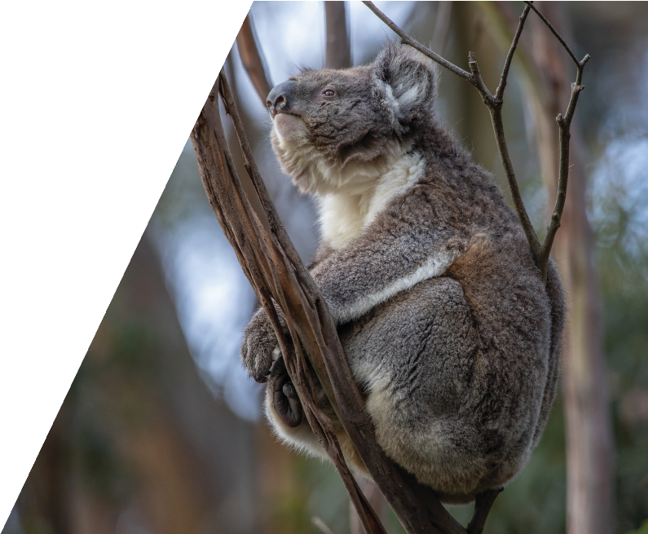
The strategy will be reviewed after it has been in place for two years to assess progress towards delivering the strategy’s vision, goals and actions. The review will also determine the priority actions for the next phase of delivery. Reports on the progress made towards delivering the strategy will be made publicly available.
A successful Victorian Koala Management Strategy is one which can be adapted based on new knowledge and information. If new issues have emerged, or our understanding of an issue has changed, the strategy may be revised following the two-year review.
A further review schedule for the strategy will be determined by the implementation working group. Review timelines will be made publicly available.

Definitions
The table below provides definitions for words and acronyms used in this document.

Term | Definition
Adaptation | An evolutionary process by which changes to an organism’s structure, physiology or behaviour improve its chance of survival in a particular environment.
Alleles | Pairs or series of genes on a chromosome that determine hereditary characteristics.
ARI | Arthur Rylah Institute for Environmental Research
Browsing | A type of herbivory where the herbivore eats the leaves, shoots, or fruits of woody plants.
Chlamydia | A sexually transmitted infection caused by a bacterium.
CMA | Catchment Management Authority
DEECA | The Department of Energy, Environment and Climate Action.  DEECA was established on 1 January 2023 and replaced the Department of Environment, Land, Water and Planning (DELWP).
Defoliation | To strip a tree of leaves.
DELWP | The Department of Environment, Land, Water and Planning.  DELWP was replaced by DEECA on 1 January 2023.
Ecological Vegetation Class | A classification system for vegetation used to map floristic biodiversity in Victoria. It describes distinct floristic communities that are associated with an environmental niche.
Endogenizing | A virus inserting itself into the host’s DNA in germline cell (cells that produce sperm and eggs), which enables it to be inherited by the host’s offspring.
EPBC Act | Environment Protection and Biodiversity Conservation Act 1999
FAME | The Fire Analysis Module for Ecological values
Fecundity | The reproductive rate of an individual over its lifetime.
Functionally extinct | When a species no longer has enough individual members to produce future generations or play a role in the ecosystem. This can refer to local extinctions (species no longer being viable in a region it once was), extinctions in the wild (captive population exists), or entire species extinctions.
Genetic diversity | The variety of genes within a species.
Gene flow | The introduction of genetic material from one population to another through interbreeding.
Genetic rescue / genetic augmentation | Improving the genetic diversity of a genetically-poor population by increasing gene flow. This can be achieved by restoring/protecting environments to connect populations or by facilitated migration of individuals i.e. translocation.
Genetic bottleneck | An event that drastically reduces the size of a population, reducing the available gene pool. An example is establishing an island population with a small number of individuals.
Genetic drift | Random change in occurrence of particular genes from generation to generation. This can lead to the loss or preservation of certain genes resulting in reduced genetic variation.
Genetic potential | The maximum level of a particular trait that an organism is capable of attaining.
Genetic swamping | Where the local genotypes are replaced by hybrids.
Genotype | The particular type and arrangement of genes that an organism has.
Gut microbiome | The assembly of microorganisms in an animal’s gut that play an important role in digesting food and extracting energy and nutrients.
Habitat fragmentation | The process of larger and continuous areas of habitat being divided and broken down into smaller and isolated patches of habitat. This is often caused by human development - e.g. the building of roads, housing, clearing for agriculture.
Inbreeding | The breeding of individuals that are related by a common ancestor.
Ivermectin | A medication used to treat parasitic infestations.
Jaw malocclusion | Misalignment or incorrect positioning of the teeth when jaws are closed. Malocclusion can increase risk of oral disease and impact an individual's ability to chew food, having impacts on body condition.
Keratoconjunctivitis | Inflammation of the cornea (the part of the eye that covers the iris and pupil) and conjunctiva (the tissue that covers the white of the eye).
Kidney Disease | A general term for when the kidneys become damaged and no longer filter the blood adequately.
Koala Retrovirus (KoRV) | A retrovirus is a type of virus that inserts itself into the host’s DNA. Koala retrovirus is a retrovirus that affects koalas.
Land covenant | A voluntary legal agreement made by a private landowner to preserve the natural, scientific or cultural values of the land.
Leukaemia | Cancer in the body’s blood-forming tissue, such as bone marrow.
Lymphoma | A type of cancer that begins in the lymphatic system (lymph glands).
Morphology | The physical structure and attributes of living things - e.g. body size, fur length.
Mortality rate | Number of deaths in a population, scaled to the size of the population, in a particular time frame.
Moxidectin | A medication used to treat parasitic infestations.
NGO | Non-government Organisation
Overabundance / overpopulation | When a species occurs in population densities exceeding the normal and viable range for the habitat they reside in. This can result in negative impacts on the environment and for the welfare of individuals of the overabundant species.
Over-browsing | When overpopulated herbivores exert extreme pressure on plants through browsing, altering the ecological functions of the habitat and sometimes resulting in mass plant death.
Population demographics | The study of characteristics of populations and how these change over time. Important parameters include population size, density, age structure, birth rates, death rates and sex ratio. Understanding population demography helps in determining the viability of species’ populations.
Sarcoptic Mange | A contagious skin infection caused by an infestation of the burrowing mite Sarcoptes scabiei
Tannin | A class of toxic biomolecules found in plants to protect them from predation. Tannins interfere with digestive enzymes and protein absorption, making it difficult for an animal to digest and obtain nutrients from their feed.
Testicular aplasia | Absence or underdevelopment of the testicles.
Translocation | The deliberate human-assisted movement of individuals from one area and subsequent release in another. The three main classes of translocation are:  Introduction: the intentional or accidental dispersal by human agency of a living organism outside its historically-known native range.  Re-introduction: an attempt to establish a species in an area that was once part of its historical range, but where it no longer exists.  Re-enforcement: the addition of individuals to an existing population of the same species (this is also sometimes referred to as supplementation or re-stocking).
Translocation Exclusion Zone | Designated area in South Gippsland that is excluded from translocations in order to protect the genetically valuable populations that reside there.
Tree banding | The act of placing plastic or metal sheets around the trunk or main branches of a tree to prevent koalas climbing and browsing on the trees leaves.
VKMS | Victorian Koala Management Strategy

References

Adams-Hosking, C., McBride, M., Baxter, G., Burgman, M., Villiers, D., Kavanagh, R., Lawler, I., Lunney, D., Melzer, A., Menkhorst, P., Molsher, R., Moore, B., Phalen, D., Rhodes, J., Todd, C., Whisson, D., McAlpine, C. and Richardson, D. (2016). ’Use of expert knowledge to elicit population trends for the koala (Phascolarctos cinereus)’. Diversity & Distributions,
22(3), pp. 249-262.
ANZECC (1998). National Koala Conservation Strategy.
Environment Australia, Canberra.
Ashman, K.R., Watchorn, D.J. and Whisson, D.A. (2019). ‘Prioritising research efforts for effective species conservation: a review of 145 years of koala research’. Mammal Review, 49, pp. 189–200.
Ashman, K., Rendall, A., Symonds, M. and Whisson, D. (2020).’Understanding the role of plantations in the abundance of an arboreal folivore’. Landscape and Urban Planning, 193.
Bell, D., Robinson, Z., Funk, W., Fitzpatrick, S., Allendorf, F., Tallmon, D. and Whiteley, A. (2019). ‘The Exciting Potential and Remaining Uncertainties of Genetic Rescue’. Trends in Ecology & Evolution, 34(12), pp. 1070–1079.
Bender, D. and Fahrig, L. (2005). ‘Matrix structure obscures the relationship between interpatch movement and patch size and isolation’. Ecology, 86, pp. 1023–1033.
Blyton, M., Soo, R., Whisson, D., Marsh, K., Pascoe, J., Le Pla, M., Foley, W., Hugenholtz, P. and Moore, B. (2019). ‘Faecal inoculations alter the gastrointestinal microbiome and allow dietary expansion in a wild specialist herbivore, the koala’. Animal Microbiome, 1(6).
Boulet, M., Spano, M., and Smith, L. (2019). Managing wildlife is managing people: literature and practice review on building public acceptance of wildlife management in Victoria. BehaviourWorks Australia, Monash Sustainable Development Institute, Monash University, Clayton, Victoria.
Braithwaite, R., Lumsden, L., and Dixon, J. (1980). Sites of zoological significance in the Westernport region (W04-903): Interim report, “top of the bay” area, p. 66. Melbourne, Australia: National Museum of Victoria.
Briscoe, N., Handasyde, K., Griffiths, S., Porter, W., Krockenberger, A. and Kearney, M. (2014). ‘Tree-hugging koalas demonstrate a novel thermoregulatory mechanism for arboreal mammals’. Biology Letters, 10(6), pp. 1–5.
Briscoe, N., Krockenberger, A., Handasyde, K. and Kearney, M. (2015). ‘Bergmann meets Scholander: geographical variation in body size and insulation in the koala is related to climate’. Journal of Biogeography, 42, pp. 791–802.
Burton, E. and Tribe, A. (2016). ‘The Rescue and Rehabilitation of Koalas (Phascolarctos cinereus) in Southeast Queensland’. Animals, 6(9).
Callaghan, J., McAlpine, C., Mitchell, D., Thompson, J., Bowen, M., Rhodes, J., de Jong, C., Domalewski, R., and Scott, A. (2011). ‘Ranking and mapping koala habitat quality for conservation planning on the basis of indirect evidence of tree-species use: a case study of Noosa Shire, south-eastern Queensland’. Wildlife Research, 38, pp.89–102.
Clarke, J., Grose, M., Thatcher, M., Round, V. and Heady, C. (2019). Victorian Climate Projections 2019. CSIRO, Melbourne Australia.
Close, D., McArthur, C., Paterson, S., Fitzgerald, H., Walsh A. and Kincade, T. (2003) ‘Photoinhibition: a link between effects of the environment on eucalypt seedling leaf chemistry and herbivory’. Ecology, 84, pp. 2952–2966.
Cristescu, R., Foley, E., Markula, A., Jackson, G., Jones, D. and Frère, C. (2015). ‘Accuracy and efficiency of detection dogs: a powerful new tool for koala conservation and management’. Scientific Reports, 5(1).

Department of Agriculture, Water and the Environment (2022). [online] National Recovery plan for the Koala: Phascolarctos cinereus (combined populations of Queensland, New South Wales and the Australian Capital Territory). Department of Agriculture, Water and the Environment, Canberra. . Available at: https://www.dcceew.gov.au/sites/default/files/documents/recovery-plan-koala-2022.pdf. Accessed 3 August 2022.
Department of Sustainability and Environment (2004). Victoria’s Koala Management Strategy. Department of Sustainability and Environment, Melbourne, Victoria.
GoFundMe (2020). https://www.gofundme.com/en-au. Accessed 30 September 2020.
Gonzalez-Astudillo, V., Allavena, R., Larkin, R., McKinnon, A. and Henning, J. (2016). Can passive surveillance aid in the understanding of decline of an iconic marsupial? The koala in SEQLD. Wildlife Society & Wildlife Disease Association Conference, Christchurch, New Zealand, 23–30 November 2016.
Hagens, S., Rendall, A. and Whisson, D. (2018). ‘Passive acoustic surveys for predicting species’ distributions: Optimising detection probability’. PLOS ONE, 13(7).
Heard, G.W., and Ramsey, D.S.L. (2020). Modelling Koala abundance across Victoria. Unpublished Client Report for Biodiversity Division, Department of Environment, Land, Water and Planning. Arthur Rylah Institute for Environmental Research, Department of Environment, Land, Water and Planning, Heidelberg, Victoria.
Hollow, B., Roetman, P., Walter, M. and Daniels, C. (2015). ‘Citizen science for policy development: The case of koala management in South Australia’. Environmental Science and Policy, 47, pp. 126–136.
Houlden, B., England, P., Taylor, A., Greville, W. and Sherwin, W. (1996). ‘Low genetic variability of the koala Phascolarctos cinereus in south-eastern Australia following a severe population bottleneck’. Molecular Ecology, 5(2), pp. 269–281.
Houlden, B., Costello, B., Sharkey, D., Fowler, E., Melzer, A., Ellis, W., Carrick, F., Baverstock, P. and Elphinstone, M. (1999). ‘Phylogeographic differentiation in the mitochondrial control region in the koala, Phascolarctos cinereus (Goldfuss 1817)’. Molecular Ecology, 8(6), pp. 999–1011.
Hundloe, T. and Hamilton C. (1997). Koalas and Tourism: An economic evaluation. Discussion paper 13. The Australia Institute, Canberra.

Hynes, E., Handasyde, K., Shaw, G. and Renfree, M. (2010). ‘Levonorgestrel, not etonogestrel, provides contraception in free-ranging koalas’. Reproduction, Fertility and Development, 22(6), pp. 913-919.
Hynes, E., Handasyde, K., Shaw, G. and Renfree, M. (2011). 'The effects of gestagen implants on the behaviour of free-ranging female koalas'. Applied Animal Behaviour Science, 134(3-4), pp. 209-216.
Hynes, E., Shaw, G., Renfree, M and Handasyde, K. (2019). ‘Contraception of prepubertal young can increase cost effectiveness of management of overabundance koala populations’. Wildlife Research, 46, pp. 317–325.
Januchowski, S. R., McAlpine, C. A., Callaghan, J. G., Griffin, C. B., Bowen, M., Mitchell, D. and Lunney, D. (2008). ‘Identifying multiscale habitat factors influencing koala (Phascolarctos cinereus) occurrence and management in Ballarat, Victoria, Australia’. Ecological Management & Restoration, 9(2),
pp. 134–142.

Johnson, R., O’Meally, D., Chen, Z., Etherington, G., Ho, S., Nash, W., Grueber, C., Cheng, Y., Whittington, C., Dennison, S., Peel, E., Haerty, W., O’Neill, R., Colgan, D., Russell, T., Alquezar-Planas, D., Attenbrow, V., Bragg, J., Brandies, P., Chong, AY-Y., Deakin, J., Di Palma, F., Duda, Z., Eldridge, M., Ewart, K., Hogg, C., Frankham, G., Georges, A., Gillett, A., Govendir, M., Greenwood, A., Hayakawa, T., Helgen, K., Hobbs, M., Holleley, C., Heider, T., Jones, E., King, A., Madden, D., Graves, J., Morris, K., Neaves, L., Patel, H., Polkinghorne, A., Renfree, M., Robin, C., Salinas, R., Tsangaras, K., Waters, P., Waters, S., Wright, B., Wilkins, M., Timms, P. and Belov, K. (2018). ‘Adaptation and conservation insights from the koala genome’. Nature Genetics, 50(8), pp. 1102–1111.
Johnson, C., DeGabriel, J. and Moore, B. (2009). [online] Koalas and climate change. IUCN. Available at: http://www.iucn.org/sites/dev/ files/import/downloads/fact_sheet_red_list_koala_v2.pdf. Accessed 6 April 2020.
Khan, S., Waugh, C., Rawlinson, G., Brumm, J., Nilsson, K., Gerdts, V., Potter, A., Polkinghorne, A., Beagley, K. and Timms, P. (2014). ‘Vaccination of koalas (Phascolarctos cinereus) with a recombinant chlamydial major outer membrane protein adjuvanted with poly I: C, a host defense peptide and polyphosphazine, elicits strong and long lasting cellular and humoral immune responses’. Vaccine, 32(44), pp. 5781–5786.
Kjeldsen, S., Raadsma, H., Leigh, K., Tobey, J., Phalen, D., Krockenberger, A., Ellis, W., Hynes, E., Higgins, D. and Zenger, K. (2018). ‘Genomic comparisons reveal biogeographic and anthropogenic impacts in the koala (Phascolarctos cinereus): a dietary-specialist species distributed across heterogeneous environments’. Heredity, 122(5), pp. 525–544.
Kock, R., Woodford, M. and Rossiter, P. (2010). ‘Disease risks associated with the translocation of wildlife’. Revue scientifique et technique (International Office of Epizootics), 29(2), pp. 329–50.
Kriesner, P., Weeks, A., Razeng, E. and Sunnucks, P. (2020).
Assessing genetic risks to Victorian flora and fauna. Unpublished Report for Department of Environment, Land, Water and Planning. Cesar, Parkville, Victoria and Monash University, Clayton, Victoria.
Lee, T., Zenger, K., Close, R. and Phalen, D. (2011). ‘Genetic analysis reveals a distinct and highly diverse koala (Phascolarctos cinereus) population in South Gippsland, Victoria, Australia’. Australian Mammalogy, 34(1), pp. 68–74.
Legione, A., Patterson, J., Whitely, P., Amery-Gale, J., Lynch, M., Haynes, L., Gilkerson, J., Polkinghorne, A., Devlin, J., and Sansom, F. (2016). ‘Identification of unusual Chlamydia pecorum genotypes in Victorian koalas (Phascolarctos cinereus) and clinical variables associated with infection’. Journal of Wildlife Diseases, 52(2), pp. 426–429.
Legione, A., Patterson, J., Whiteley, P., Firestone, S., Curnick, M., Bodley, K., Lynch, M., Gilkerson, J., Sansom, F. and Devlin, J. (2017). ‘Koala retrovirus genotyping analyses reveal a low prevalence of KoRV-A in Victorian koalas and an association with clinical disease’. Journal of Medical Microbiology, 66(2), pp. 236–244.
Lindenmayer, D. and Taylor, C. (2020). ‘New spatial analyses of Australian wildfires highlight the need for new fire, resource and conservation policies’. Proceedings of the National Academy of Science, 117(22), pp. 12481–12485.
Lunney, D., Crowther, M., Wallis, I., Foley, W., Lemon, J., Wheeler, R., Madani, G., Orscheg, C., Griffith, J., Krockenberger, M., Retamales, M. and Stalenberg, E. (2012). ‘Koalas and climate change: a case study on the Liverpool Plains, north- west New South Wales’. In: D. Lunney and P. Hutchings, ed., Wildlife and Climate Change: towards robust conservation strategies for Australian fauna. Mosman: Royal Zoological Society of NSW, pp. 150–168.
Lunney, D., Gresser, S., Mahon, P. and Matthews, A. (2004). ‘Post-fire survival and reproduction of rehabilitated and unburnt koalas’. Biological Conservation, 120(4), pp. 567–575.

Maher, I., Patterson, J., Curnick, M., Devlin, J. and Higgins, D. (2019). ‘Altered immune parameters associated with Koala Retrovirus (KoRV) and Chlamydial infection in free ranging Victorian koalas (Phascolarctos cinereus)’. Scientific Reports, 9(1).
Martin, R., and Handasyde, K. (1990). ‘Translocations and the re-establishment of koala populations in Victoria (1944–1988): the implications for New South Wales’. In: Lunney, D., Urquhart,
C. and Reed, P. eds., Koala summit: Managing koalas in New South Wales. NSW National Parks and Wildlife Service, Sydney.
Martin, R. and Handasyde, K. (1999). The Koala: Natural History, Conservation and Management. Sydney: UNSW Press.
McAlpine, C., Rhodes, J., Callaghan, J., Bowen, M., Lunney, D., Mitchell, D., Pullar, D. and Possingham, H. (2006). ‘The importance of forest area and configuration relative to local habitat factors for conserving forest mammals: A case study of koalas in Queensland, Australia’. Biological Conservation, 132(2), pp. 153–165.
McAlpine, C., Lunney, D., Melzer, A., Menkhorst, P., Phillips, S., Phalen, D., Ellis, W., Foley, W., Baxter, G., de Villiers, D., Kavanagh, R., Adams-Hosking, C., Todd, C., Whisson, D., Molsher, R., Walter, M., Lawler, I. and Close, R. (2015). ‘Conserving koalas: A review of the contrasting regional trends, outlooks and policy challenges’. Biological Conservation, 192, pp. 226–236.
McAlpine, C., Brearley, G., Rhodes, J., Bradley, A., Baxter, G., Seabrook, L., Lunney, D., Liu, Y., Cottin, M., Smith, A. and Timms,
P. (2017). ‘Time-delayed influence of urban landscape change on the susceptibility of koalas to chlamydiosis’. Landscape Ecology, 32(3), pp. 663–679.

McLean, N., and Handasyde, K. (2007), ‘Sexual maturity, factors affecting the breeding season and breeding in consecutive seasons in populations of overabundant Victorian koalas (Phascolarctos cinereus)’. Australian Journal of Zoology, 54 (6), pp. 385–392.
Melzer, A., Cristescu, R., Ellis, W., Fitzgibbon, S. and Manno, G. (2014). ‘The habitat and diet of koalas (Phascolarctos cinereus) in Queensland’. Australian Mammalogy, 36, pp. 189–199.
Menkhorst, P. (2008). ‘Hunted, marooned, re-introduced, contracepted: A history of Koala management in Victoria’. Australian Zoologist, 34, pp. 73–92.
Menkhorst, P. (2016). Koala management in Barwon South West Region: issues and options. Unpublished Client Report for Barwon South West Region, Department of Environment, Land, Water and Planning. Arthur Rylah Institute for Environmental Research, Department of Environment, Land, Water and Planning, Heidelberg, Victoria.
Menkhorst, P., Ramsey, D., O’Brien, T., Hynes, E. and Whisson, D. (2019). ‘Survival and movements of koalas translocated from an over-abundant population’. Wildlife Research, 46(7), pp. 557–565.
Mercer, D. and Underwood, A. (2002) ‘Australian timber plantations: national vision, local response’, Land Use Policy, 19(2), p. 107.
Moore, B., and Foley, W. (2000). ‘A review of feeding and diet selection in koalas (Phascolarctos cinereus)’. Australian Journal of Zoology, 48(3), pp. 317–333.
Moore, B. and Foley, W. (2005). ‘Tree use by koalas in a chemically complex landscape’. Nature, 435(26), pp. 488–490.
Moore, B., Lawler, I., Wallis, I., Beale, C. and Foley, W. (2010). ‘Palatability mapping: a koala’s eye view of spatial variation in habitat quality’. Ecology, 91, pp.3165–3176.

Moore, B., Wallis, I., Wood, J. and Foley, W. (2004). ‘Foliar Nutrition, Site Quality, and Temperature Influence Foliar Chemistry of Tallowwood (Eucalyptus Microcorys)’. Ecological Monographs, 74(4), pp. 553–568.
Nyari, S., Waugh, C., Dong, J., Quigley, B., Hanger, J., Loader, J., Polkinghorne, A. and Timms, P. (2017). ‘Epidemiology of chlamydial infection and disease in a free-ranging koala (Phascolarctos cinereus) population’. PLOS ONE, 12(12).
Nyari, S., Khan, S., Rawlinson, G., Waugh, C., Potter, A., Gerdts, V. and Timms, P. (2018). ‘Vaccination of koalas (Phascolarctos cinereus) against Chlamydia pecorum using synthetic peptides derived from the major outer membrane protein’. PLOS ONE, 13(6).
Phillips, S. (2000). ‘Population trends and the koala conservation debate’. Conservation Biology, 14, pp. 650–659.
Quigley, B., Ong, V., Hanger, J. and Timms, P. (2017). ‘Molecular Dynamics and Mode of Transmission of Koala Retrovirus as it invades and spreads through a wild Queensland koala population’. Journal of Virology, 92(5).
Ralls, K., Ballou, J., Dudash, M., Eldridge, M., Fenster, C., Lacy, R., Sunnucks, P. and Frankham, R. (2018). ‘Call for a paradigm shift in the genetic management of fragmented populations’. Conservation Letters, 11(2), pp. 1–6.
Ramsey, D., Tolsma, A. and Brown, G. (2016). Towards a habitat condition assessment method for guiding the management of overabundant Koala populations. Arthur Rylah Institute for Environmental Research Technical Report Series No. 272. Department of Environment, Land, Water and Planning, Heidelberg, Victoria.
Recher, H., Majer, J. and Ganesh, S. (1996). ‘Eucalypts, arthropods and birds: on the relation between foliar nutrients and species richness’. Forest Ecology and Management, 85(1–3), pp. 177–195.
Reckless, H., Murray, M. and Crowther, M, (2017). ‘A review of climatic change as a determinant of the viability of koala populations’. Wildlife Research, 44(7), pp. 458–470.
Robbins, A., Loader, J., Timms, P., and Hanger, J. (2018) ‘Optimising the short and long-term clinical outcomes for koalas (Phascolarctos cinereus) during treatment for chlamydial infection and disease’. PLOS ONE, 13(12).
Roehr, B. (2018). ‘Medicine for poorly koalas is killing them’. New Scientist, 237(3171), p.12.
Rowe, M., Whiteley, P. and Carver, S. (2019). ‘The treatment of sarcoptic mange in wildlife: a systematic review’. Parasites & Vectors, 12(1).
Schlagloth, R., Cahir, F. and Clark, I. (2018). 'The importance of the koala in Aboriginal society in nineteenth-century Victoria (Australia): A reconsideration of the archival record'. Anthrozoös, 31(4), pp. 433-441.
Sherwin, W., Timms, P., Wilcken, J., and Houlden, B. (2000). 'Analysis and Conservation Implications of Koala Genetics'. Conservation Biology, 14(3), pp. 639–49.
Smith A., McAlpine C., Rhodes J., Lunney D., Seabrook L. and Baxter G. (2013). ‘Out on a limb: habitat use of a specialist folivore, the koala, at the edge of its range in a modified semi-arid landscape’. Landscape Ecology, 28(3), pp. 415–426.
Speight, K., Whiteley, P., Woolford, L., Duignan, P., Bacci, B., Lathe, S., Boardman, W., Scheelings, T., Funnell, O., Underwood, G. and Stevenson, M. (2017). ‘Outbreaks of sarcoptic mange in free-ranging koala populations in Victoria and South Australia: a case series’. Australian Veterinary Journal, 95(7), pp. 244–249.
Speight, N., Colella, D., Boardman, W., Taggart, D., Haynes, J. and Breed, W. (2018). 'Seasonal variation in occurrence of oxalate nephrosis in South Australian koalas (Phascolarctos cinereus)'. Australian Mammalogy, 41(1), p.92.

Tarlinton, R., Meers, J., Hanger, J. and Young, P. (2005). ‘Real-time reverse transcriptase PCR for the endogenous koala retrovirus reveals an association between plasma viral load and neoplastic disease in koalas’. Journal of General Virology, 86(3), pp. 783–787.
Tarlinton, R., Meers, J., and Young, P. (2006). ‘Retroviral invasion of the koala genome’. Nature, 442, pp. 79–81.
Tourism Research Australia (2019). International Visitor Survey 2019. [online] Canberra: Australian Government. Available at: https://www.tra.gov.au/data-and-research [Accessed 7 April 2020].
Todd, C.R., Forsyth, D.M. and Choquenot, D. (2008). ‘Modelling the effects of fertility control on koala-forest dynamics’. Journal of Applied Ecology, 45, pp. 568–578.
Valladares, F., Laanisto, L., Niinemets, U. and Zavala, M. (2016). ‘Shedding light on shade: ecological perspectives of understorey plant life’. Plant Ecology & Diversity, 9(3), pp. 237–251.
VEAC (2011). Remnant native vegetation Investigation, final report. Victorian Environmental Assessment Council. Melbourne.
Watchorn, D. and Whisson, D. (2020). ‘Quantifying the interactions between koalas in a high-density population during the breeding period’. Australian Mammalogy, 42(1), pp. 28–37.
Waugh, C., Hanger, J., Timms, P. and Polkinghorne, A. (2016). ‘Koala translocations and Chlamydia: Managing risk in the effort to conserve native species’. Biological Conservation, 197, pp. 247–253.
Waugh, C., Hanger, J., Loader, J., King, A., Hobbs, M., Johnson, R. and Timms, P. (2017). ‘Infection with koala retrovirus subgroup B (KoRV-B), but not KoRV-A, is associated with chlamydial disease in free-ranging koalas (Phascolarctos cinereus)’. Scientific Reports, 7(1), pp. 1–15.
Wedrowicz, F., Wright, W., Schlagloth, R., Santamaria, F. and Cahir, F. (2017a). ‘Landscape, koalas and people: A historical account of koala populations and their environment in South Gippsland’. Australian Zoologist, 38(4), pp. 518–536.
Wedrowicz, F., Mosse, J., Wright, W. and Hogan, F. (2017b). Validating the use of non-invasively sourced DNA for population genetic studies using pedigree data. Web Ecology, 17(1), pp.9–18.
Wedrowicz, F., Mosse, J., Wright, W. and Hogan, F. (2018). ‘Genetic structure and diversity of the koala population in South Gippsland, Victoria: a remnant population of high conservation significance’. Conservation Genetics, 19, pp. 713–728.
Weeks, A., Stoklosa, J. and Hoffmann, A. (2016). ‘Conservation of genetic uniqueness of populations may increase extinction likelihood of endangered species: the case of Australian mammals’. Frontiers in Zoology, 13(1).
Whisson, D. and Ashman, K. (2020). ‘When an iconic native animal is overabundant: The koala in southern Australia'. Conservation Science and Practice, 188. Available at:
https://conbio.onlinelibrary.wiley.com/doi/pdf/10.1111/csp2.188
[Accessed 7 April 2020].
Whisson, D. and Carlyon, K. (2010). ‘Temporal variation in reproductive characteristics of an introduced and abundant island population of koalas’. Journal of Mammalogy, 91(5), pp. 1160–1167.
Whisson, D., Dixon, V., Taylor, M. and Melzer, A. (2016). ‘Failure to Respond to Food Resource Decline Has Catastrophic Consequences for Koalas in a High-Density Population in Southern Australia’. PLOS ONE, 11(1).
Whisson, D., Orlowski, A. and Weston, M. (2018). ‘Tree canopy defoliation impacts avifauna’. Forest Ecology and Management, 428, pp. 81–86.
Xu, W., Stadler, C., Gorman, K., Jensen, N., Kim, D., Zheng, H., Tang, S., Switzer, W., Pye, G. and Eiden, M. (2013). ‘An exogenous retrovirus isolated from koalas with malignant neoplasias in a US zoo’. Proceedings of the National Academy of Sciences, 110(28), pp. 11547–11552.

Appendix 1:

Koala management actions summary
Action no. | Action
Theme 1: Traditional Owners and koalas
1.1 | Partner with Traditional Owners to undertake actions on Country that will benefit koalas or their habitat.
1.2 | Support Traditional Owners to protect culturally and environmentally significant areas from koala over-browsing.
Theme 2: Koala overabundance
2.1 | At key high-density koala population sites, undertake habitat monitoring to detect change in condition and implement evidence-based management programs to protect habitat and koala welfare.
2.2 | Revise the 2004 translocation protocol.
Theme 3: Koala rehabilitation
3.1 | Develop standards for koala rehabilitation to encourage a consistent, best practice approach to koala rehabilitation across the state.
Theme 4: Koala genetics
4.1 | Undertake state-wide genetic surveys of Victorian koala populations.
4.2 | Develop a genetic management plan for Victorian koalas.
Theme 5: Disease in koalas
5.1 | Develop and implement a systematic koala disease surveillance program across Victoria that will enable early detection of new diseases and ongoing monitoring of established diseases.
5.2 | Review the National Koala Disease Risk Analysis (DRA) to identify priority diseases, effective mitigation strategies and knowledge gaps for Victoria.
Theme 6: Habitat conservation
6.1 | Develop a comprehensive koala population and habitat decision support tool for Victoria to inform koala and habitat management activities, including koala translocation programs, fire management and habitat protection and restoration.
6.2 | Develop and support initiatives to increase the extent of koala habitat and improve habitat connectivity.
Theme 7: Understanding koala populations
7.1 | Establish a long-term state-wide monitoring program to improve knowledge of koala population distribution, abundance and population trends.
Theme 8: Climate change and managing fire impacts
8.1 | Use existing climate change models to better understand what a changed climate means for koalas and habitat across the whole of Victoria.
8.2 | Use koala population data to inform planned burning activities and the wildlife welfare response during bushfires.
Theme 9: Koalas in blue gum plantations
9.1 | Investigate options to manage koala populations in blue gum plantations that protect koala welfare and ensure the industry remains viable and can continue to operate.
9.2 | Investigate options to manage the impact of koala displacement on koala welfare and other values and incorporate them into management.
Theme 10: Community perception and socioeconomic significance
10.1 | Develop and implement a community and stakeholder education and engagement program that promotes the VKMS and the issues it addresses.
10.2 | Increase opportunities for community involvement in koala conservation and management.
Overall action
11 | Establish a working group that includes government and non-government representatives to facilitate the delivery of actions in the VKMS and monitor its implementation.

deeca.vic.gov.au

