Our Wildlife Fact Sheet
  - Living with Snakes

If you see a snake, keep calm, and move yourself and anyone with you (including children and pets) away from the area.
As the days become warm, snakes start to emerge from their winter hibernation to bask in the sun, search for food and find a mate.
If you are very close to a snake - and especially if the snake is obviously agitated and adopting a defensive posture (striking position) - it is best to 'freeze' and stand very still until the snake has stopped posturing and has moved off.
When out walking when snakes are active, it is best to be dressed in long pants and shoes or boots and ensure you can see where you are putting your feet.
Always have wide elastic (not crepe) bandages when out on walks, as well as a charged mobile phone.

Did you know?
Victoria is home to some of the most venomous snakes in the world. Most Victorian snakes belong to the family Elapidae (front-fanged venomous land snakes). All members of this family are venomous. Even very young small snakes can deliver a lethal bite.

Treating a bite
It is important to treat all incidents of snakebite as potentially serious. If someone is bitten, dial 000 immediately.
Undertaking first aid training and ensuring your first aid kit contains several compression bandages will help you be prepared.
Cases of snakebite in urban Victoria are very rare - and the swift application of modern first aid techniques, followed by treatment in hospital, means that most bite victims survive these ordeals.
Information on modern first aid techniques can be found here: https://www.healthdirect.gov.au/snake-bites#searchGeneralResults
You do not need to capture the snake or know what species it is for antivenom to be administered.
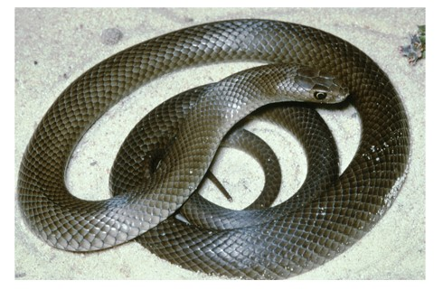
Figure 1. Eastern Brown Snake © I. McCann DSE 2008

What should I do if I have a snake on my property?
Never attempt to move a snake yourself. If there are unwanted snakes around your home, one option is to call a licensed snake controller.
Snake controllers are licensed to safely and legally remove the reptile from the area. This is on a user pays basis. Prices for these services are determined by individual companies.
DELWP’s Customer Service Centre on 136 186 can provide a list of snake controllers in your area. These companies are not recommended or endorsed by DELWP. Their contacts are simply provided as an alternative for customers who would like a snake removed rather than waiting for it to move on. DELWP does not provide a snake removal service.
Snakes are generally very shy and prefer to keep away from people. Often when a snake is found in a backyard it is moving through the area to another habitat.

When left alone, snakes present little or no danger to people.
Removal may not fix the risk permanently, as another snake may soon move into the same location.

What can I do to prevent snakes from coming onto my property?
- Keep grass short
- Remove rubbish, piles of wood and other cover, such as sheets of iron or rock piles
- Modify your garden to be less attractive to mice and frogs (as these attract snakes)
- Snakes may hibernate in compost bins or piles of leaves
- Stop snakes entering your home by screening doors and windows and blocking off potential access points.

Why can't I kill snakes?
Snakes are protected under the Wildlife Act 1975 and it is illegal to capture, harm, disturb or kill them. Reports of people wilfully destroying protected wildlife will be investigated accordingly.
While we need to be careful around these animals, they are an important part of our environment and need to be respected and conserved.
People should never attempt to capture or harm snakes as this places people in considerable danger.
Many snake bites happen when people are trying to catch or kill snakes. The best strategy is to leave them alone or, if they are near the house and likely to be a danger to occupants or pets, use a licensed snake catcher to remove them.

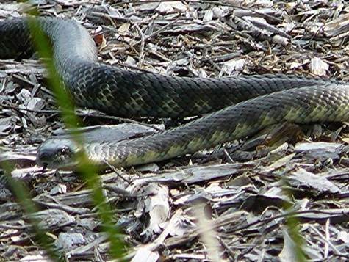
Figure 2. Tiger Snake © A. Houston DSE 2008

Further reading
Cogger, H.G., (2000), Reptiles and amphibians of Australia (6th ed.), Reed New Holland, Sydney.
Wilson, S.K. and Knowles, D.G., (1988), Australia’s reptiles, Collins, Sydney.

Never attempt to approach or handle a snake.
All snakes should be considered venomous and highly dangerous.
If bitten by a snake dial 000 immediately.

