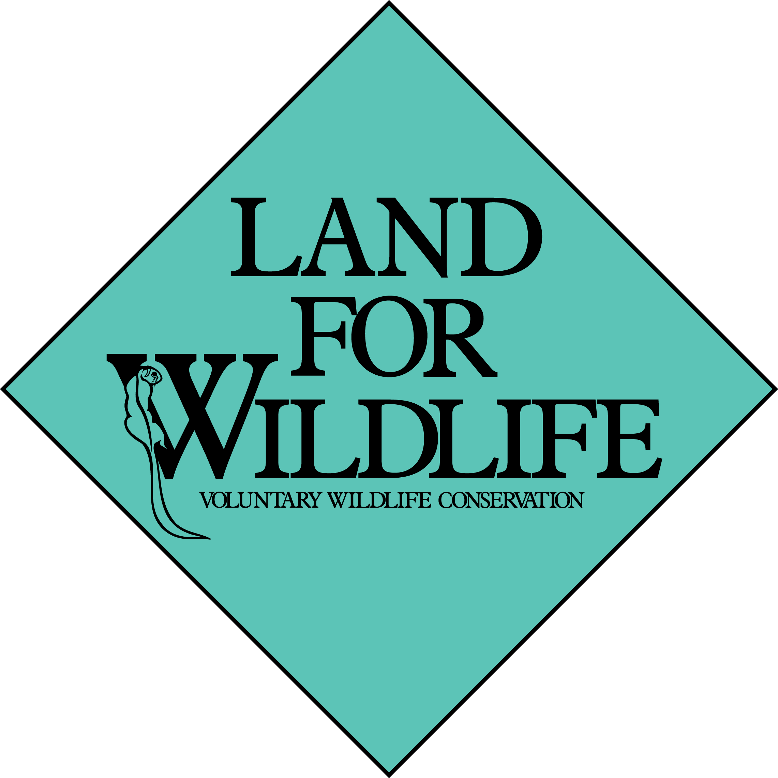

Land for Wildlife Application Form

Applying for Land for Wildlife is easy.
Simply follow these 3 steps:

- Save a copy of this application form to your computer
- Complete the form with your details
- Email it to LFW@delwp.vic.gov.au

A Land for Wildlife officer will contact you as soon as possible to provide further advice.

Name:

Postal Address:

Daytime Telephone & Mobile (if applicable):
Email (if applicable):

Organisation (if applicable):

Date of application:

I/we wish to apply for Land for Wildlife registration for the property at:
Property name:

Property Location:

Size of whole property:

First application? | Yes / No
How much and what type of remnant vegetation do you have (in hectares or % of property)?
Do you have any threatened species?
How you heard about Land for Wildlife? (e.g. friend, neighbour, saw the sign, etc)

© The State of Victoria, 2023

wildlife.vic.gov.au/land-for-wildlife

