Chapter 1. Bandicoots

Contents
1.1. Introduction 2
1.2. Species information 3
1.3. Animal and human safety considerations 8
1.3.1. Human safety considerations 8
1.3.2. Animal safety considerations 9
1.4. Capture, restraint, and transport 9
1.4.1. Visual observations 9
1.4.2. Equipment 11
1.4.3. Technique 14
1.4.4. Transport 16
1.5. Monitoring animal health and welfare 16
1.5.1. Physical examination 17
1.5.2. Ongoing monitoring of health and welfare 20
1.5.3. Common and emerging health conditions 21
1.5.4. Administering treatment 32
1.6. Housing 32
1.6.1. General housing information for bandicoots 32
1.6.2. Enclosure hygiene & biosecurity 33
1.6.3. Housing types 34
1.7. Feeding and nutrition 40
1.8. Hand raising 42
1.8.1. Equipment required for hand raising 42
1.8.2. Growth, feeding and housing of orphaned offspring 43
1.9. Release protocol 55
1.9.1. Pre-release assessment 55
1.9.2. At the release site 55
1.9.3. Release checklist 56
1.10. Key references and additional reading 56

In Victoria, sick, injured or orphaned wildlife can only be rehabilitated by a wildlife shelter operator or foster carer who is authorised under section 28A of the Victorian Wildlife Act 1975 (Wildlife Act). Wildlife rehabilitators are subject to strict conditions. The mandatory requirements that they must meet are set out in the Wildlife Shelter and Foster Carer Authorisation issued under the Wildlife Act. These conditions enforce the minimum standards required for the humane treatment and successful rehabilitation of wildlife in care. The Wildlife Rehabilitator Authorisation Guide: Things You Need To Know explains how wildlife rehabilitators can meet these mandatory requirements and can be found here:
https://www.vic.gov.au/wildlife-rehabilitation-shelters-and-foster-carers.
The Victorian Wildlife Rehabilitation Guidelines have been developed to incorporate evidenced-based best practice in wildlife care and rehabilitation to equip rehabilitators to deliver positive welfare outcomes for individual animals in their care from first aid to post-release into the wild.
You must comply with the conditions of your authorisation. These guidelines must be read in conjunction with the conditions of your authorisation.

1.1. Introduction
There are three species of bandicoot in Victoria: the long-nosed bandicoot, the eastern barred bandicoot, and the southern brown bandicoot. Registered carers with the appropriate skills, knowledge and experience can care for sick, injured or orphaned long-nosed bandicoots. Eastern barred bandicoots and southern brown bandicoots are both listed as endangered under the Victorian Flora and Fauna Guarantee Act 1988 and the Australian Environment Protection and Biodiversity Conservation Act 1999.
STOP – If an endangered species comes into care, please STOP and refer to your authorisation for mandatory conditions, including notification and release requirements.
When bandicoots come into care it is the responsibility of the wildlife rehabilitator to ensure that the five domains of animal welfare are satisfied. These include providing optimal nutrition, and an environment appropriate to the stage of rehabilitation. The focus should be on the animal’s return to health and release, which is facilitated through regular collaboration with a veterinarian. It is also important to consider the animal’s mental state and ability to exhibit normal behaviours without detrimentally affecting its recovery. Welfare may be temporarily compromised by the necessity of a gradual return to normal activity, depending on its stage of rehabilitation. Further information about the five domains of animal welfare is in Part A of these guidelines.

1.2. Species information
Profiles for the bandicoot species found in Victoria are detailed in Table 1.1.
For assistance in identification of bandicoot species, refer to the recommended reading and reference material at the end of this chapter.
Table 1.1: Species profiles
Species | Eastern barred bandicoot (Perameles gunnii)
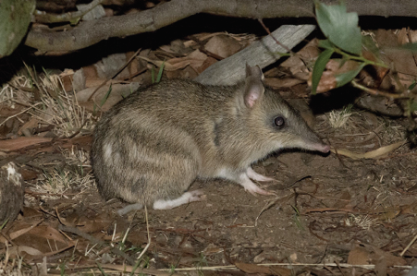  Photo credit: David Paul, Museums Victoria | Distribution map  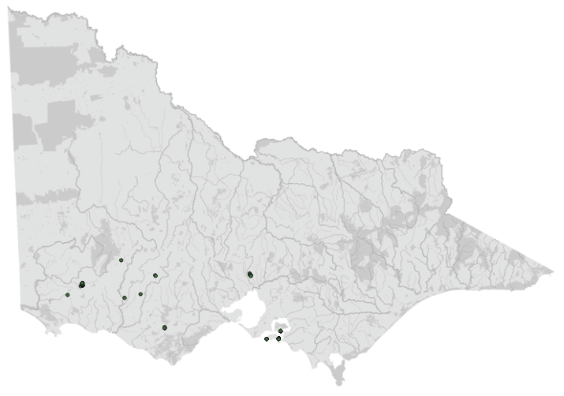  Data source: Victorian Biodiversity Atlas Jan 2023  www.environment.vic.gov.au/biodiversity/victorian-biodiversity-atlas
General appearance | Grey-brown fur with 3–4 pale/fawn/cream bars on hindquarters, short tail. Long muzzle
Conservation status* | Endangered
Sexual dimorphism | Males heavier and longer, with paired external testes in pedunculated, furred scrotum. Females have a backward-opening pouch with 8 nipples
Adult morphometrics | Body weight: 750–800 g  Head and body length: 300–480 mm  Tail length: 60–110 mm
Home range | Male: 4–13 ha  Female: 1.9–6.4 ha  Home ranges overlap
Behaviour | Principally nocturnal, some emerge at dusk. Solitary unless mating. Mutual avoidance common, males can be territorial
Diet | Omnivorous: range of adult and larval invertebrates (earthworms, cockroaches, crickets, moths, caterpillars); plant material (tubers, bulbs, fruits, berries of native and introduced plants)
Longevity | 2–3 years on average
Sexual maturity | Male: 4 months  Female: 3 months
Mating season | Year round
Gestation length | ~12.5 days
Litters per year | Up to 5 (average 2–3 young per litter)

Species | Southern brown bandicoot (Isoodon obesulus)
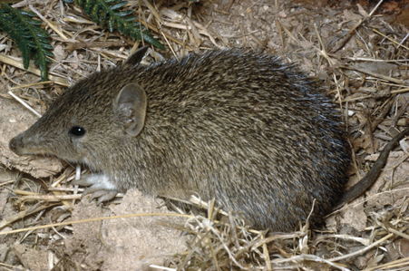  Photo credit: David Paul, Museums Victoria | Distribution map  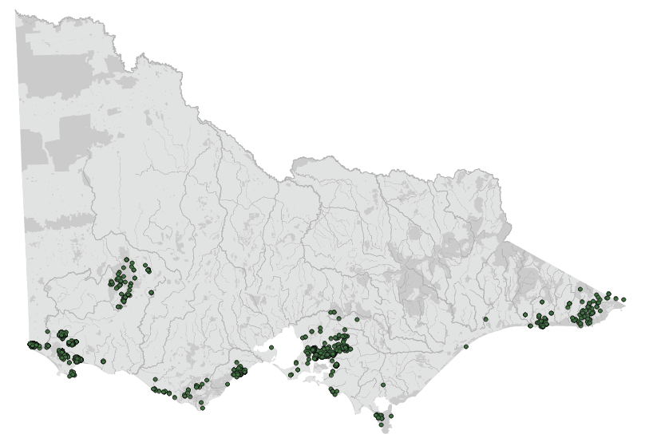  Data source: Victorian Biodiversity Atlas Jan 2023  www.environment.vic.gov.au/biodiversity/victorian-biodiversity-atlas
General appearance | Fur coarse, grey or yellowish brown above, with whitish belly. Small round ears, brown feet
Conservation status* | Endangered
Adult morphometrics | Body weight: 400–1850 g  Head and body length: 280–360 mm  Tail length: 90–145 mm
Home range | Male and female: 0.5–5 ha
Behaviour | Nocturnal. Solitary unless mating. Territorial.
Diet | Omnivorous: range of adult and larval invertebrates (earthworms, cockroaches, crickets, moths, caterpillars); plant material (tubers, bulbs, fruits, and berries of native and introduced plants), occasionally moss
Longevity | Up to 4 years
Sexual maturity | Male: 7 months  Female: 7 months
Mating season | Year round
Gestation length | ~12 days
Litters per year | 2–3 (2–3 young per litter)

Species | Long-nosed bandicoot (Perameles nasuta)
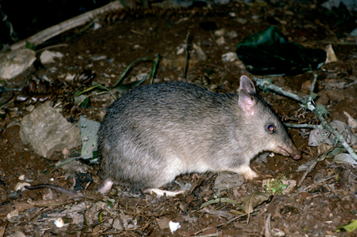Photo credit: David Paul, Museums Victoria | Distribution map  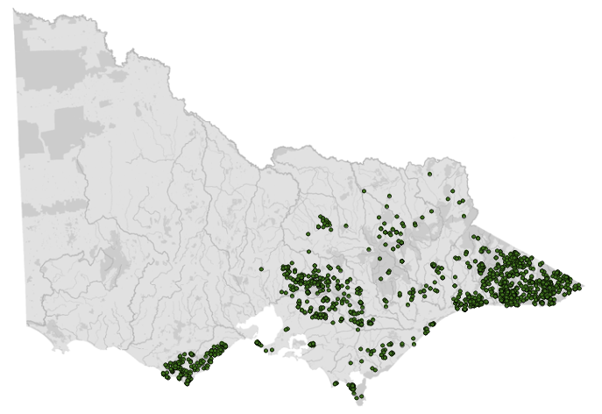  Data source: Victorian Biodiversity Atlas Jan 2023  www.environment.vic.gov.au/biodiversity/victorian-biodiversity-atlas
General appearance | Typically dark, greyish-brown fur, with creamy white below. Muzzle is long and pointed. Larger ears, white feet
Conservation status* | Least concern
Adult morphometrics | Body weight: 750–1100 g  Head and body length: 310–445 mm  Tail length: 120–160 mm
Home range | Male: 3–5 ha  Female: 1–2 ha
Behaviour | Nocturnal. Solitary unless mating. Territorial
Diet | Omnivorous: range of adult and larval invertebrates (earthworms, cockroaches, crickets, moths, caterpillars); plant material (tubers, bulbs, fruits, and berries of native and introduced plants)
Longevity | Up to 3 years
Sexual maturity | Male: 5 months  Female: 4 months
Mating season | Year round
Gestation length | ~12 days
Litters per year | 2–4 (2–3 young per litter)
*From the Flora and Fauna Guarantee Act 1988 Threatened List June 2023. This list is updated regularly throughout the year. For the most current list, please visit https://www.environment.vic.gov.au/conserving-threatened-species/threatened-list.

1.3. Animal and human
safety considerations
In general, animals in the wild have limited contact with people, pets, and the hustle and bustle of our daily lives. When sick, injured or orphaned wild animals come into care, this unnaturally close contact can carry risks to the health and safety of both people and animals. For general information on biosecurity and approaches to minimise these risks see Part A of these guidelines. Specific information on enclosure hygiene and biosecurity for bandicoots is in Section 1.6.2.
The following information relates to human and animal health and safety considerations specifically related to the rehabilitation of bandicoots.

1.3.1. Human safety considerations
- Bandicoots can give a painful bite that can draw blood.
• Bandicoot hindlimbs can kick strongly, and their hind claws may break human skin.

1.3.2. Animal safety considerations
- Bandicoots can be very flighty and will jump when disturbed, and are highly stressed by human handling, so gentle but firm handling is required.
- Some bandicoots, particularly southern brown bandicoots, can lose significant amounts of fur in clumps during handling.
- Do not hold bandicoots by the tail or hind legs as they can kick back very strongly leading to joint dislocations, or fractures of the leg bones or vertebrae.
- Capture is ideally timed for when they are resting/sleeping in their daytime nests. Carers should be vigilant in detecting signs of excessive stress (panting, salivation, open mouth breathing, rapid/shallow respiration) as prolonged chasing or handling of bandicoots has been associated with death due to capture myopathy. Injuries such as fractures or damage to the nose, digits or nails are common if bandicoots jump or attempt to climb enclosure walls during capture. If not successful on the first attempt, leave the enclosure or area, and return once the animal has had time to recover.
- Bandicoots are sensitive to high temperatures and prone to development of hyperthermia. Capture, handling, and transport of bandicoots should not occur when temperature is >25°C unless there is an urgent need to capture the bandicoot for veterinary assessment. Transport should only occur in enclosed vehicles which can be maintained between 15–25°C.
- Bandicoots are solitary animals, and should always be housed individually, unless they are orphaned litter mates.

1.4. Capture, restraint, and transport
STOP – A visual examination must be done BEFORE the animal is captured. This applies to the initial capture from the wild as well as prior to captures which occur during time in rehabilitation. See Section 1.4.1 for information on what to look for when conducting a visual health assessment.
Refer to Part A of these guidelines for general advice on wildlife welfare, biosecurity and hygiene, and record requirements. The following information relates to the capture, restraint, and transport of sick, injured and orphaned bandicoots.

1.4.1. Visual observations
Visual observations of wildlife should be conducted prior to any attempts to capture the animal. This is just as important prior to the first capture from the wild as it is before any capture conducted while an animal is in captive care. Observations should be conducted quietly, by one person, and from a distance which provides a clear view of the animal with as little disturbance as possible. Visual observation should focus on the animal’s demeanour, behaviour, movement, and posture. Check for evidence of injury/severe disease or deterioration and assess their breathing as demonstrated in the following table.
Table 1.2: Visual health observations in bandicoots
 | What to look for
Demeanour | - As a small, shy prey species, healthy wild bandicoots are bright, alert and respond quickly to stressful stimuli such as noise, bright lights, sudden movements or the presence of people or other animals
Behaviour | - Healthy bandicoots should be active at night, although some individuals may emerge from nest boxes at dusk  - Note that is it not unusual to see southern brown bandicoots out during the day  - Bandicoots forage for food using their forepaws and nose. If you don’t see this behaviour directly, look for evidence in substrate which suggests it has occurred overnight  - Bandicoots drag nesting materials, such as dried leaf litter, grass or hay, into a nest (such as a nest box or tree hollow) to create a dense nesting area in which they sleep during the day
Movement and posture | - Bandicoots can stand upright, with weight bearing completely on their hindlimbs  - Slow movement is described as a ‘slow bunny hop’, with both hindlimbs and then both forelimbs moving alternately. When moving fast, the use of limbs retains the same pattern, but is much faster and is described as a ‘bound’ or ‘gallop’. This movement can often be in a zig-zag pattern  - When alert, the head is held upright, and the animal will respond to sound by moving the head or ears towards the sound
Breathing | - Quietly observe the animal without disturbing. Since bandicoots are small animals, it may be difficult to visualise normal respiration in a healthy animal  - Panting (rapid, shallow breaths, often accompanied by head bobbing) in an animal at rest may be a sign of severe stress or disease. It may indicate the onset of capture myopathy, severe debilitation, or respiratory disease, and is an indication that veterinary attention is urgently required. Keep handling/stress to a minimum until veterinary advice is sought
Enclosure sand pads | - Indirect visual observation of sand pads in an enclosure can indicate drag marks, activity around food bowls and faecal matter

1.4.2. Equipment
- Cage Trap: If cage trapping of an injured animal is needed, authorisation is required. Contact the Office of the Conservation Regulator (OCR) for advice regarding an Authority to Control Wildlife application available here: vic.gov.au/wildlife-management-and-control-authorisations.
- Net: Square or round commercially purchased nets are used (See Figure 1.1). Hoop diameter ~40 cm is suitable but should be padded with foam. Netting material should be removed from commercially purchased nets (it is abrasive and can cause injuries to eyes, digits/nails and nose) and replaced with a breathable material ‘bag’ such as an inside out flannel pillowcase.
- Catch bag: Breathable material bags can be used to confine the animal for short periods of time or to allow for physical examination (See Figure 1.2). Ensure there are no unfinished seams or loose threads inside, as these can lead to entanglement. Bags with an unfinished seam may be used inside out. A strong material (such as calico) is preferred as the strong claws can rip through a pillowcase. Bags can be secured with elastic bands/pipe cleaners or ties which are attached to one seam to prevent escape.
- Transport container: The transport container should be large enough to ensure the bandicoot can turn around, (~ 40 cm (L) x 20 cm (W) x 20 cm (H)). The transport container should close securely to prevent escape. A solid-walled container is preferred. Plastic pet carriers can be used for short distances and can be easily cleaned between uses. Wooden boxes are commonly used and sturdier, but harder to clean/disinfect. (See Figure 1.3a and b). Adequate ventilation is required and can be achieved by drilling small holes into the sides and top of the box, or by including a panel of small gauge mesh wire, lined on the internal surface with hessian or shade cloth to prevent injury to nose, digits and nails.
Figure 1.1: Nets suitable for bandicoot capture. Photo credit: Zoos Victoria
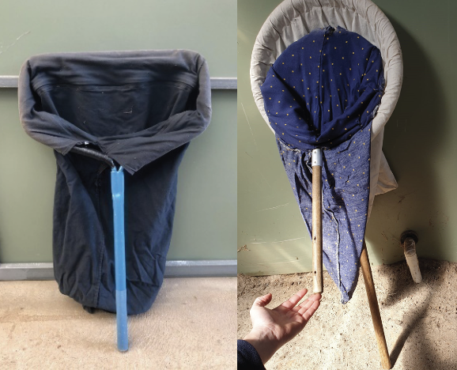
Figure 1.2: Catch bag suitable for bandicoots. Photo credit: Zoos Victoria
Figure 1.3: Suitable transportation boxes for bandicoots: a. Wooden transport box
b. Suitable transportation boxes for bandicoots, collapsible pet pack. Photo credit: Zoos Victoria
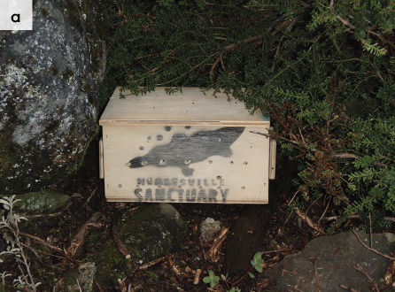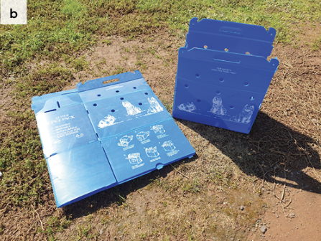

1.4.3. Technique
It is beyond the scope of these guidelines to outline techniques for every situation that may be encountered. Examples of techniques for some specific situations are outlined in the following section.
In addition to this information, for further advice please also refer to the recommended reading list, zoological institutions, veterinarians and/or wildlife experts. Inexperienced rescuers should request assistance where possible.
- Care should be taken when capturing bandicoots from enclosures with natural substrate. Naturally built nests can be hard to spot, and bandicoots can easily be stepped on. They can be identified by a small mound of soil in the ground or enclosure substrate. Bandicoots may also be nesting under logs, under tree branches or at the base of shrubs. Bandicoots can be very flighty, even when restrained in a bag or net, kicking out with their hind legs.
- All bandicoot handling should occur at ground level to minimise the risk of injury. For example, do not attempt to transfer from a net to a handling bag on a table or elevated surface, as the animal may kick and jump off the table causing injury.
- Free ranging bandicoots (in the wild, or in a captive enclosure with natural substrate) are most safely captured using a net. If the bandicoot is in a natural nest, place the net at the opening of the nest and gently encourage the bandicoot to enter the net using your hands to apply pressure from the other side. Quickly close off the net once the animal is inside by holding the top or twisting it and placing it back on the ground, to prevent the animal’s escape and to restrict movement.
- To move the animal from the net to the handling bag there are two methods:
- Turn the catch bag inside out, with hands inside and reach into the net to cup the individual. Lifting the animal up (within the net still), fold the catch bag around the individual so your hands are now on the outside of the bag; or place one hand into the net, not allowing too much light to enter, and position at the front end of the bandicoot. Once in place, lower the net (keeping the eyes covered), and place a second hand on the hind end of the bandicoot. Manually lift the bandicoot, keeping it in a firm semi-circle, and place into the catch bag.
- If the bandicoot is nesting in a box, you may need to part the nesting material to locate the animal and then roll down the catch bag, place the opening over the animal and gently use your hands to encourage the animal into the bag before closing.
- If the animal requires examination, this should be done with the animal still restrained within the catch bag, gently extracting each body part sequentially, as required. The bandicoot is less likely to struggle or attempt to escape if the eyes are covered.
- While manual restraint outside of a bag will rarely be required, this can be achieved by firmly and gently placing the thumb and index finger of one hand either side of the head, with the other hand used to support the back end of the body as demonstrated in Figure 1.4 a and b. The hind limbs should be left free to allow the animal to kick freely. Restraining hind limbs can result in dislocations and fracture of the bones of the legs and spine.
Figure 1.4: a, b and c. Bandicoot manual restraint technique: Wrap your fore and middle finger of one hand firmly but gently around the neck behind the ears, while the other hand supports the body, leaving the feet free to kick out. Photo Credit: Zoos Victoria
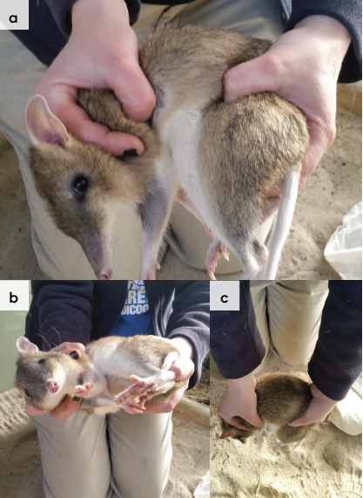

1.4.4. Transport
- When moving bandicoots, the transport box should be loosely filled with nesting material such as hay, grass or shredded paper, with a hole in the centre to provide a ‘nest like’ environment to provide security and reduce stress. Animals should be nested in the transport box without the handling bag to ensure adequate ventilation.
- Note that animals being transported for release should be transported in shredded paper to prevent the spread of unwanted grass seeds to release locations.
- Transport containers should only be opened in safe environments at ground level and handlers should be prepared for animals that might jump out (ensure a net is available nearby).
- Ideally temperatures should be kept between 18–25°C. Transporting animals on extremely hot days should be avoided.
- A quiet, air-conditioned, enclosed vehicle should be used for all transportation. Ensure that there is adequate ventilation, that the boxes are out of direct sunlight, and if transporting animals in a car, ensure air-conditioning is on, to reduce heat stress.
- Ensure that noise is minimal during transportation.

1.5. Monitoring animal health and welfare
The goal of wildlife rehabilitation is to address health and welfare concerns quickly and effectively so wildlife can be released back to the wild as soon as possible. Decision-making from the time of capture through to release, should be guided by an accurate understanding of the animal’s true state of health and welfare. Careful monitoring throughout the rehabilitation period ensures that significant issues, or deterioration in health condition, are identified immediately and quickly addressed.
It is preferred that all sick, injured or orphaned wildlife be assessed by a veterinarian to ensure that non-obvious signs of trauma or disease can be assessed and treated as soon as practicable. No medication should be provided prior to this assessment, as this can mask clinical signs and make an accurate health assessment by the veterinarian very difficult.
Templates for record-keeping of visual and physical observations and daily care can be found in Part A of these guidelines.
This section provides guidance on health assessment on arrival and on effective monitoring of the health and welfare of individuals in care through minimising human-animal interactions and stress to the animal, to maximise successful release back to the wild.
Please note: A common behavioural response to chronic high-level stress is ‘learned helplessness’. This is exhibited as increasingly passive behaviour in response to aversive stimuli and can be misinterpreted as having ‘settled in’ or being ‘relaxed’ or ‘chilled out’. Carers should always aim to treat animals as efficiently as possible, so that they can be returned to the wild in the shortest possible time. This section provides guidance on assessment of health on arrival and on effective monitoring of the health and welfare of animals up to the point of release back to the wild.

1.5.1. Physical examination
Once visual observations are complete, and the animal is stable enough to withstand capture and handling, a basic physical examination should be conducted. This can be repeated when required any time the carer has the animal in the hand, such as for an enclosure change. However, if a full physical exam is not conducted, body condition and weight should be assessed every time the animal is in the hand for other reasons. Carers should make sure weighing scales are available and ready to use before capturing the animal. Physical examinations are also required if the carer notices any changes suggestive of deteriorating health or an injury.
Always record the physical examination findings, so that you can compare findings as the animal’s rehabilitation progresses. This ensures any health concerns are identified as soon as possible, and the carer can plan release as soon as appropriate. A template for recording Physical Examination findings can be found in the Appendices to Part A of these guidelines.
Examinations should be conducted in a quiet location, away from any domestic animals. Only one person should handle the animal, while a second person takes notes. All other people should move away, and noise kept to a minimum. Handling should also be kept to a minimum, with careful monitoring for any signs of distress (such as panting, salivating, vocalisation or sudden deterioration in demeanour). If these are seen, the examination should be stopped immediately, and the animal returned to its catch bag, transport box or enclosure and allowed to recover.

Species specific considerations:
- Physical examination of bandicoots should be conducted with the animal safely restrained inside the catch bag (See Figure 1.4).
- Specific parts of the body can be gently exposed as required for the physical examination.
- Bandicoots will be calmer during manual restraint if their eyes remain covered by the catch bag.
- Handling should be kept to a minimum as over handling can lead to weight loss.
- Table 1.3 provides additional guidance on what to look for during physical examinations.
Table 1.3: Physical examination of bandicoots (See Section 1.6 for further information)
 | What to look for
Body weight | - Will very with age.  - Record body weight on arrival and at least weekly whilst in care.  - Bandicoots are prone to obesity in care – adults that present in good body condition should not gain more than 10% of body weight during rehabilitation. Orphaned bandicoots should gain weight according to the growth and development chart presented in Section 1.9 of this chapter.  - A greater than 10% change in body weight over a week is cause for concern, and the carer should seek veterinary advice immediately.  - Note that some animals can take between 1–3 weeks to acclimatise.
Body condition | With the bandicoot safely restrained in the catch bag with its eyes covered, body condition can be assessed by carefully and gently palpating over the shoulders, spine, and rump.  Body condition can be described as follows:  - Under condition: The bones of the pelvis, vertebrae and scapular spine are very prominent, and are easily seen and palpated. There is very little muscle coverage over the pelvis and rump area.  - Ideal condition: The pelvic bones, vertebrae and scapular spine can be palpated, but they are not protruding significantly. There is good muscle coverage over the hips and rump area, along the spine, and over the shoulders.  - Over condition: A layer of fat/padding can be felt over the pelvis, spine and scapular spine, and the bones are difficult to feel. There are bulges of fat around the neck and abdomen.
Hydration status | - In healthy bandicoots, the skin slides easily over the shoulder blades/spine, and when the skin is ‘tented’ (or gently pinched up) over the spine/between the shoulder blades, it should fall back within one second. Bandicoots that are dehydrated have dry looking gums, sunken eyes and a slow skin tent.
Eyes | - With the bandicoot still restrained in the bag, expose one eye at a time for examination to minimise stress.  - Basic internal structures of eyes (e.g. pupil, iris) appear symmetrical.  - There should be no cloudiness or grey colour (See Figure 1.5). Eyelids open, with no discharge or crust.  - If observed at night with a torch, eye-shine should be symmetrical, round, bright light from both eyes.
Ears | - Ears are held alert and move quickly in response to noise.  - Some parasites (ticks and mites) may be present and can be left if there isn’t an excessive load and there is no evidence of irritation/excessive scratching inside the ears.  - Healthy wild males may present with tears in their ears due to territorial disputes.
Mouth | - With the bandicoot gently restrained in the bag, and both eyes covered, expose the mouth and gently lift the lip along one side to examine the teeth and gums.  - Look for any wartlike growths/masses on the lips (See Section 1.6, this chapter for more information). If present, the bandicoot should be seen by a veterinarian as soon as possible.  - Gums are pink and slightly moist, no excessive salivation or blood coming from inside the mouth.  - Teeth in healthy bandicoots have sharp pointy edges. Healthy aged bandicoots have worn teeth. Excessive wear of molars (down to gumline) is seen in geriatric bandicoots.  - Ulcers on the tongue have recently been seen in wild eastern barred bandicoots (see Figure 1.6), but the cause is unknown. If ulcers/lesions are seen on the tongue, the bandicoot should be seen by a veterinarian.  - An undershot jaw has been seen in some eastern barred bandicoot wild populations (See Figure 1.11)
Skin and coat condition | - Healthy wild bandicoots, particularly males, may present with some fur patches missing, torn ears or tail injuries because of territorial disputes (see Figure 1.7). This is not a cause for concern.  - A small number of parasites (fleas, ticks, mites) is normal. Trombiculid mites are commonly seen in wild eastern barred bandicoots (See Figure 1.8). Raised wartlike lesions, particularly around the lips and eyes, on the feet (see Figure 1.9), around the pouch and surrounding the cloaca have been seen in wild bandicoots in Western Australia and are associated with a virus. If present, the bandicoot should be seen by a veterinarian as soon as possible.
Limbs, feet, and tail | - Check all feet and nails (See Figure 1.10). Bandicoots can damage toes or pull nails as a result of capture, handling, and captive housing and transport. Examine each digit for injury to toes or nails.  - Nail loss is painful and can result in bone exposure and infection. Seek urgent veterinary assessment.
Sex determination | - The sex of bandicoots is easily determined by the presence of testicles (males) or a pouch (females).
Pouch check | - Faces backwards. Eight teats should be present. These may be elongated, with or without swollen mammary glands.  - If pouch young are present, count the number and assess age, as a lactating female may require additional food.  - Rehabilitators should minimise handling where possible when pouch young are present to reduce the chance that the mother will reject them.

1.5.2. Ongoing monitoring of health and welfare
The aim of wildlife rehabilitation is to ensure animals recover and can be released back to the wild as quickly as possible. Careful, daily monitoring is required to ensure that animals are responding as expected to the treatment being provided and so that any deterioration or welfare concerns can be identified and addressed as soon as possible. Rehabilitators should ensure that record-keeping is a priority to maximise positive welfare outcomes. Templates to assist wildlife rehabilitators to record and monitor wildlife health and welfare can be found in the Appendices to Part A of these guidelines. These records will be valuable tools to share with veterinarians to support decision-making.
The following is recorded daily:
- demeanour
- food consumption
- faecal/urine output
- behaviour observed
- medical treatment provided
- evidence of overnight activity.
The following is recorded weekly:
- weight
- body condition.
Over time, regular monitoring will also help to develop carer skills and knowledge, as regular observation and recording will result in a deep understanding of the expected behaviour and response to treatment for the species in care.

Species specific considerations:
- Schedule your health and welfare observations for times of the day when the animal is expected to be active.
- The use of infra-red cameras can allow monitoring of behaviour overnight.
- If the animal is being medicated, schedule treatment for the morning, use this time to perform a visual check. If the animal is receiving medication in the morning and evening, the evening medication may be delivered in a cricket, to minimise the need for extra handling.
- Ideally, physical observations should be undertaken at the beginning and/or end of the resting period to minimise disturbance and maximise the rest/sleep period for rapid healing and ensure ease of capture.
- If using sand for a portion of the substrate in larger housing, inspect and rake at the same time each day, ideally morning. This allows for observations of the animal’s nocturnal activities and may identify any new injuries (e.g. dragging foot, different shape print).
- Food and water dishes may be placed in the sand area, this can indicate if the animal is visiting the food dish at night.
- If diarrhoea is noticed, a faecal sample should be collected and submitted to the veterinarian for assessment as soon as possible. Do not treat on suspicion of coccidiosis or a bacterial infection, as this can make definitive diagnosis very difficult and potentially prolong the course of the disease.

1.5.3. Common and emerging health conditions
Clear guidance on conditions that may require euthanasia can be found in Part A of these guidelines.
Table 1.4 lists common clinical signs and possible causes of injury/disease. Carers should be aware that these are not exhaustive. Aside from first aid, carers should avoid administering medications prior to receiving veterinary advice.
Unusual clinical signs or mass mortality events – a number of animals dying, or found dead at the same time, with similar signs – may indicate an animal disease emergency, an emerging/new infectious disease or an environmental/human related toxicity which needs further investigation. Report these immediately to the Emergency Animal Disease Watch Hotline on 1800 675 888 (24 hours).
Table 1.4: Common injuries and clinical signs of emerging health conditions seen on presentation or during care
Clinical signs and possible causes | Possible Causes | Rehabilitator observations and response
Note: Do not provide pain relief or other medication, including antibiotics, unless under veterinary guidance and supervision, as these can have severe side effects, particularly in dehydrated/shocked animals. Use of antibiotics when not indicated can contribute to antimicrobial resistance and reduce drug efficacy.
Unable to walk or move normally  Swollen limb  Bruising  Fractures  Dislocation | Found adjacent to road/suspect motor vehicle accident,  Caught in wire or netting, predation injury caused by raptor, fox, cat or dog, gunshot  Poorly designed transport box/enclosure  Capture injury  Injury sustained in captivity, due to stress | - Urgent veterinary attention is required. Do not delay transfer to veterinarian to apply first aid, other than to stop excessive bleeding.  - Move animal to a small transport box to restrict movement. Ensure temperature is appropriate for species and minimize stress.  - Do not attempt to stabilise fractures as this is very painful, and risks making the injury worse. Fracture stabilization should only be attempted by a veterinarian following physical exam, x-rays and under general anaesthesia.  - Do not provide pain relief or other medication unless under veterinary guidance and supervision, as these can have severe side effects, particularly in dehydrated/shocked animals.  - If suspected as the cause, assess the enclosure/box/bag to find the source of injury. Fix loose wire/gaps or sharp edges before returning the animal to its enclosure. See Section 1.4 and Section 1.6 this chapter for further advice on housing and transport.  - If stress is deemed a factor, consider whether the animal is a candidate for rehabilitation. Seek advice from species experts.
Swollen foot or toe  Wound to foot or toe  Bleeding foot or toe  Damaged or missing nail  Bleeding nail | Toe, foot or leg caught in netting, wire or bag  Predation injury caused by raptor, fox, cat or dog  Poorly designed transport box/enclosure  Capture injury  Injury sustained in captivity, due to stress | - Seek prompt veterinary attention. Apply first aid to minor wounds (See Part A for First Aid guidance).  - Injuries to nails are very painful and lesions can be very slow to heal. There is a risk of nail bed infection, veterinary management is required. Move animal to a small transport box to restrict movement. Ensure temperature is appropriate for species and minimize stress.  - Do not provide pain relief or other medication unless under veterinary guidance and supervision, as these can have severe side effects, particularly in dehydrated/shocked animals.  - If suspected as the cause, assess the enclosure/box/bag to find the source of injury. Fix loose wire/gaps or sharp edges before returning animal to enclosure. See Section 1.4 and Section 1.6 this chapter for further advice on housing and transport.  - If stress is deemed a factor, consider whether the animal is a candidate for rehabilitation. Seek advice from species experts.
Bleeding  Puncture wounds  Bruising  Fur loss | Conspecific aggression, breeding season injuries  Found adjacent to road/suspect motor vehicle accident,  Predation injury caused by raptor, fox, cat or dog  Poorly designed transport box/enclosure  Capture injury  Injury sustained in captivity, due to stress | - Seek prompt veterinary assessment.  - Move animal to a small transport box to restrict movement. Ensure temperature is appropriate for species and minimize stress.  - Do not provide pain relief or other medication unless under veterinary guidance and supervision, as these can have severe side effects, particularly in dehydrated/shocked animals.  - Bite wounds/scratches may not be immediately obvious, these can carry a very poor prognosis and animals often present as moribund, very lethargic, poorly responsive, and cold. Look for small clumps of dried fur stuck together with saliva, part the fur and look for very small puncture wound/s.
Swollen tail  Wound under tail  Swelling around/above cloaca | Conspecific aggression, breeding season injuries  Found adjacent to road/suspect motor vehicle accident,  Predation injury caused by raptor, fox, cat or dog  Poorly designed transport box/enclosure  Capture injury  Injury sustained in captivity, due to stress | - Seek urgent veterinary advice.  - Move animal to a small transport box to restrict movement. Ensure temperature is appropriate for species and minimize stress.  - Do not provide pain relief or other medication unless under veterinary guidance and supervision, as these can have severe side effects, particularly in dehydrated/shocked animals.  - Injuries to tails are very painful and lesions can be very slow to heal. Veterinary management is required. Tail injuries can occur in captivity in stressed animals jumping in enclosure and causing tail trauma.  - If stress is deemed a factor, consider whether the animal is a candidate for rehabilitation. Seek advice from species experts.
Blindness  Deafness  Neurological signs  Wobbly movement or ataxia  Circling movement  Strange behaviour, easily caught  Lethargic  Moribund, collapsed | Infectious disease, such as toxoplasmosis, bacterial meningitis, cranial trauma, toxicity (e.g. 1080 poisoning) | - Seek urgent veterinary advice.  - Move animal to a small transport box to restrict movement. Ensure temperature is appropriate for species and minimize stress.  - Do not provide pain relief or other medication unless under veterinary guidance and supervision, as these can have severe side effects, particularly in dehydrated/shocked animals.  - Carer may observe animal bumping into objects in enclosure or fail to respond to short sharp noises (such as a loud clap from behind animal).  - Pupils may be fixed/dilated and not responsive to changes in light level. You should see pupils constrict if a pen light is shone in the eye.  - If multiple animals are seen with similar signs, this may indicate a newly emerging infectious disease or a toxicity (such as plant toxicity or poisoning). Contact the Emergency Animal Disease Watch Hotline on 1800 675 888 (24 hours) as soon as possible.  - If unusual toxicity or infection is suspected, you or your veterinarian can contact the Veterinary Department at Zoos Victoria to discuss options for disease investigation.
Diarrhoea  Loose, smelly faeces | Inappropriate diet, infectious disease, alteration of microbiome, stress, parasites, antibiotic treatment | - Seek veterinary advice.  - Seek urgent veterinary advice if diarrhoea does not resolve rapidly (e.g. within 24–36 hours), or if there is any evidence of dehydration, blood in faeces or change in demeanour. Do not treat on assumption of infectious disease (e.g. coccidia or bacterial infection) as this can make veterinary diagnosis more difficult if the animal does not improve.  - If the animal has been otherwise stable and doing well, there are several responses carers may implement to try to resolve the diarrhoea. Consider any recent changes which may have led to the diarrhoea and remove the inciting cause where possible (such as rapid change in diet, unusual levels of sound/intervention or handling, contact with recently arrived animals).  - Seek advice from species experts, ensure diet and husbandry practices are correct.  - If stress is deemed a factor, consider whether the animal is a candidate for rehabilitation.  - Be careful of rapid diet changes for animals undergoing hand rearing.  - Do not mix oral rehydration fluids in with milk as it changes the digestibility of the milk. Oral rehydration fluids/water can be provided in between milk feeds.  - Ensure excellent hygiene standards to prevent spread to other animals/carer and isolate this animal from any others in care, if possible.
Skin irritation/fur loss | Conspecific aggression, breeding season interactions, mite infestation | - Seek veterinary advice or assessment.  - Some fur loss/minor skin lesions are commonly seen due to fighting or in the breeding season and may not require any intervention.  - A small number of ticks/mites can be normal, and do not require treatment or removal. However, if there is a very high number of ticks/mites seen, the animal is scratching/irritated, or the skin is red and inflamed, seek veterinary attention to treat ectoparasites.
Raised wartlike lesions | Bandicoot papillomavirus | - Observation of these lesions may indicate a newly emerging disease issue, contact one of Zoos Victoria’s Veterinary Departments as soon as possible. Raised wartlike lesions have been seen in wild bandicoots in Western Australia. These lesions are caused by newly identified viruses and are a newly emerging infectious disease issue in wild bandicoots.
Ulcerative lesions on tongue | Cause undetermined, rarely seen in eastern barred bandicoots | - Observation of these lesions may indicate a newly emerging disease issue, contact one of Zoos Victoria’s Veterinary Departments as soon as possible. Tongue lesions/ulcerations have recently been seen in wild eastern barred bandicoots, but the cause is not known.
Emaciation  Lethargy  Poor coat condition  Excessive tooth wear | Sick, diseased or injured animal, geriatric animal | - Seek veterinary assessment.  - Geriatric bandicoots often present with worn teeth, this is a normal finding however, if a geriatric bandicoot has come into care because it is in poor health and thin, euthanasia may be the most humane outcome for this animal as it is at the end of its life.
Figure 1.5: a and b. Normal eyes are shiny, bright and open. Pupil will contract if a pen light is shone into the eye. Cloudiness in the eye (see b) can be caused by lens degeneration (e.g. cataracts) or severe inflammation/trauma to the cornea. If seen, seek veterinary advice. Photo credit: (a) David Paul, Museums Victoria and (b) Zoos Victoria
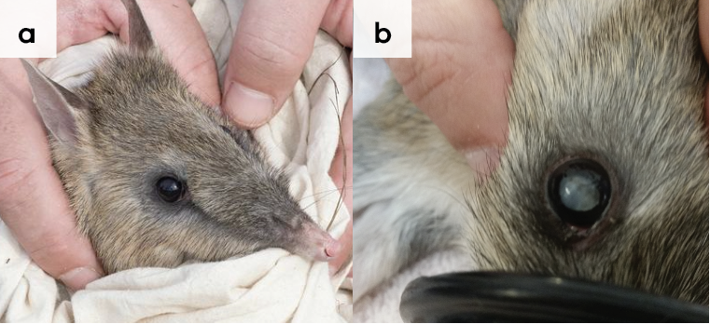
Figure 1.6: Tongue lesion in eastern barred bandicoot (viewed under anaesthetic). Photo credit: Zoos Victoria
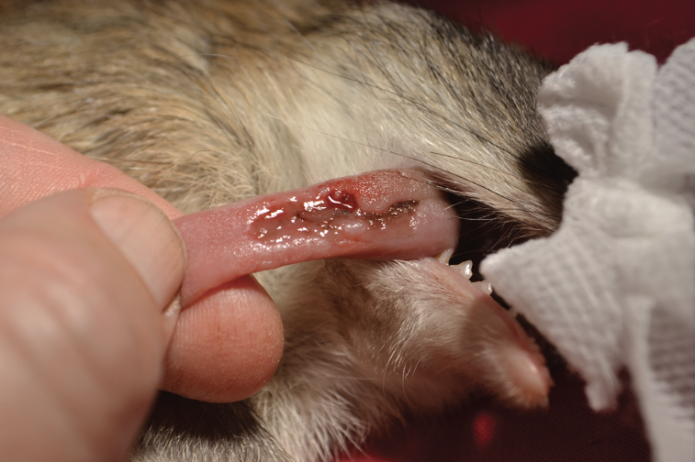
Figure 1.7: A wild, adult bandicoot with patches of fur missing over its rump, likely due to fighting with another wild male. These patches can be associated with scratch marks and bruising and commonly occur in the wild. Photo credit: David Paul, Museums Victoria
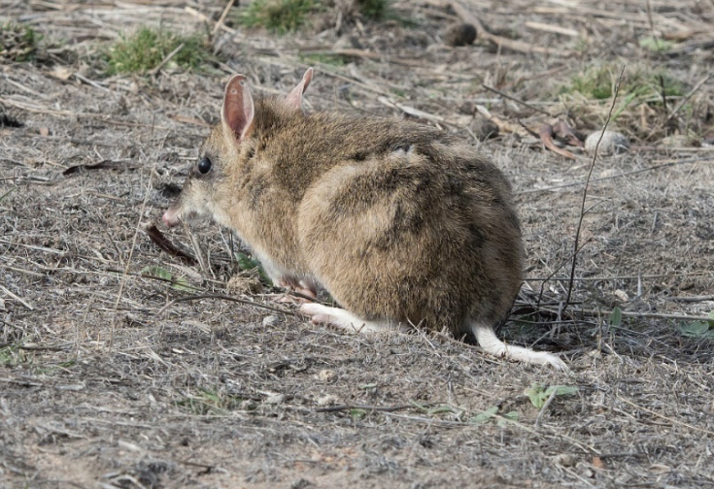
Figure 1.8: Trombiculid mites commonly cluster around the scrotum in males and around the edge of the pouch in females as seen here. Numbers are generally higher in summer and are known to cause irritation and inflammation on the skin. Seek veterinary advice. Photo credit: Zoos Victoria
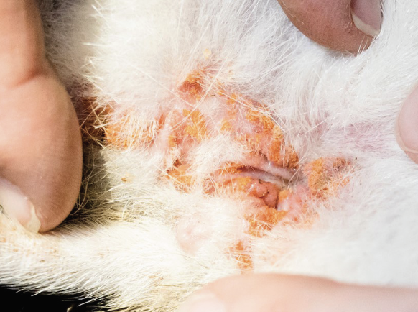
Figure 1.9: Bandicoot papillomavirus has been seen in western barred bandicoots and southern brown bandicoots in Western Australia. While it has not been seen in Victoria, carers should be aware of this as a potential emerging condition. If any raised, wartlike lesions are seen on bandicoots, seek veterinary advice urgently from Zoos Victoria. Photo credit: Zoos Victoria
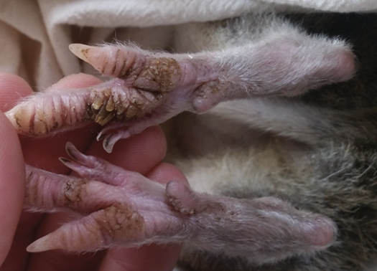
Figure 1.10: a. Healthy hind foot of eastern barred bandicoot, b. Evidence of toe lesions,
c. Nail loss and bone exposed. Photo credit: David Paul (a), Museums Victoria (b), & Zoos Victoria (c)
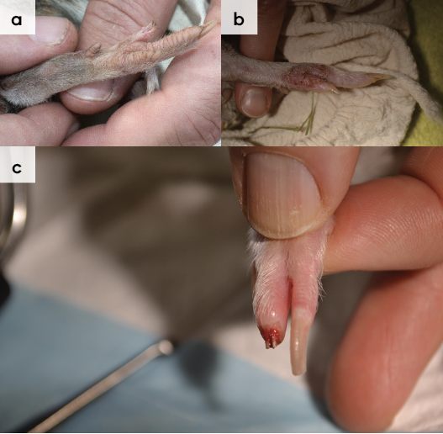
Figure 1.11: Undershot jaw seen in eastern barred bandicoot
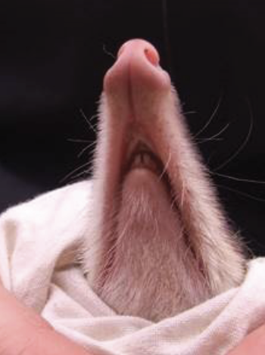

1.5.4. Administering treatment
- Bandicoots housed in enclosures that support easy and frequent capture for intensive care will tolerate handling for medication or treatment twice a day for up to ~1 week (see Table 1.5).
- Toe injuries and nail avulsion which occur during captive care are very difficult to treat, are very painful and carry a poor prognosis. These lesions can be incredibly slow to heal and are prone to becoming non-healing wounds. These wounds should be managed by a veterinarian, including, bandage removal and wound assessment being performed by a veterinarian under general anaesthesia. Wildlife rehabilitators can support this process by ensuring bandages remain clean and dry and monitoring wounds daily. Pay particular attention to use of the affected limb and see a veterinarian promptly if lameness appears or increases or the bandage slips or appears too tight, evident by limb swelling.
- Oral medications can most easily be delivered in a 1mL or 3mL syringe directed into the cheek from the side of the mouth while the bandicoot is restrained in a catch bag. Palatable oral medicine may be delivered indirectly, by injecting a food item such as a mealworm or mixing with a high value reward such as blended fruit. Morning treatments may be delivered into the mouth during the daily examination, and bandage check, the animal can then be left to rest for the day. Evening doses can be given in a mealworm or cricket, reducing the need to handle again. Be sure to note the location of the medicated insect in the food dish and ensure it is eaten.
- Fruit is no longer provided in captive bandicoot diets because it causes dental disease and is not required for a balanced diet. However, judicious use of a small amount of chopped fruit, such as blackberries, blueberries or apples, mixed with the captive diet may help to encourage eating in a sick/stressed bandicoot. This should be discussed with a veterinarian. Sudden changes in diet should be avoided, as they can lead to constipation or diarrhoea.

1.6. Housing
Below are several key considerations when housing adult animals in care.

1.6.1. General housing information for bandicoots
- To reduce noise and disturbance, a bandicoot should be situated in quiet locations, away from noise, heavy foot or road traffic, aerial stressors, and domestic pets.
- Visual barriers can be incorporated into enclosures through the addition of vegetation.
- Since they are prone to hyperthermia, ambient temperature should remain between 15–25°C. Enclosures should be designed to provide protection from environmental elements while still ensuring adequate ventilation and access to sun and UV for basking.
- Bandicoots are nocturnal, so indoor enclosures need to consider provision of appropriate photoperiod (cycles of light and dark periods) and UV access.
- Since bandicoots are prone to severe, difficult to treat digit and nail injuries, care should be taken to ensure:
- no gaps in corners/joins or holes in sheet metal in which a nose or limbs could get trapped
- no sharp edges or rough finishes
- sufficient substrate (min 15 cm) to prevent digging to wire
- no furnishings with sharp/jagged edges
- no mesh wire starting lower than 1.2 m.
- Bandicoots are solitary in the wild. Adult bandicoots being held in captivity for rehabilitation should be housed individually.
- Bandicoots being handled frequently for treatment or confined in very small spaces for prolonged periods can become increasingly stressed.

1.6.2. Enclosure hygiene & biosecurity
General information about hygiene and biosecurity can be found in Part A of these guidelines. New diseases emerge frequently and sick and injured animals in care are often more susceptible to picking up pathogens from the environment. It is important to maintain the highest levels of hygiene to avoid inadvertently transferring diseases between animals and from humans and, to protect the wild population where the animal will eventually return to.

Species specific considerations:
- Any direct or indirect exposure to cats should be avoided as bandicoots are extremely sensitive to toxoplasmosis, a disease transmitted through contact with cat faeces.
- Ideally, examination gloves should be worn and changed in between animals.
- Leftover food and faecal matter should be spot cleaned daily.
- Any wet/sodden or soiled organic furnishings, substrate or enrichment items should be removed as soon as possible and replaced with clean/dry alternative. When provided with sand substrate (on floor of enclosure or shallow tray) bandicoots often defaecate in this area. This provides an opportunity for monitoring faecal output and allows for easy spot cleaning.
- Since these enclosures are used to house sick/injured bandicoots, they should have all organic matter removed, and be cleaned/disinfected after each animal has used it. Careful consideration of construction materials will improve hygiene and make cleaning easier.
- Enclosures should be disinfected with products such as F10 SC, bleach or Virkon S at the recommended concentrations and contact times. Virkon S and bleach must be rinsed off following the appropriate disinfection times.
- Soil substrate floors provide an opportunity for digging and are inexpensive, however they must be underwired to ensure animals do not escape. Use of soil substrate enclosures should be considered carefully. The risk of infectious disease transmission is increased, as they cannot be disinfected. Some bacteria and parasites will exist in soil for long periods of time.

1.6.3. Housing types
Different set ups are required for animals at different stages of treatment and care. Table 1.5 describes the housing type, suggested dimensions and requirements at each stage of care. For information on housing animals during hand raising see Section 1.8.
Table 1.5: Rehabilitation housing for adult bandicoots
Intensive care housing
Indications for use | Suggested min. dimensions | Suggested requirements
Short term critical care  (<48 hours)  Intensive veterinary treatment – frequent medication, oxygen supplementation, temperature control  Longer periods under veterinary supervision where strict cage rest/confinement is indicated | 60 cm (L) x 40 cm (W) x 40 cm (H) (surface area 0.24 m²)  Large enough for adult to stand and turn around comfortably | ENCLOSURE CONSTRUCTION  - Enclosed wooden/plastic tub with adequate ventilation, or purpose-built intensive care unit designed for small animals.  ENCLOSURE FURNISHING  - Newspaper, shredded paper or towels may be used to line the floor, changed daily.  - A small hide should be provided – a variety of materials can be used (e.g. cardboard box, small nest box, PVC pipe or bark).  - A small towel can be used to fully or partially cover any gaps to reduce stress.  ENVIRONMENTAL VARIABLES  - Narrow temperature range ~20–23ºC.  - Reverse light cycle.  PROVISION OF FOOD/WATER  - Fresh water (always available) and captive diet should be provided in stable dishes.  - Regular check of substrate to ensure water has not spilt/enclosure is not wet.

Intermediate housing (Treatment/cage rest)
Indications for use | Suggested min. dimensions | Suggested requirements
Provision of daily medication, close monitoring once animal is stabilised and no longer requires intensive care.  Enclosure furnishings can be arranged to reduce opportunities to climb/dig or move excessively so that ‘cage rest’ can be achieved with slightly more space/reduced contact | Enclosure:  1 m (L) x 1 m (W) x 1 m (H) (Surface area 1 m²)  Nest box: 30 cm (L) x 30 cm (W) x 24 cm (H)  Enclosure allows some movement and normal behaviour but movement is restricted. Handling for rehabilitation and/or medication is still required | ENCLOSURE CONSTRUCTION  - Solid floor/walls and roof with adequate ventilation.  - The internal surface of any wire mesh walls should be fully covered with shade cloth to prevent damage to digits and nose.  ENCLOSURE FURNISHING  - A 10–15 cm deep layer of clean, non-compactable organic matter is required to allow the bandicoot to forage (such as clean leaf litter, shredded paper, clean/dry straw).  - Nesting opportunities should be provided (such as a wooden nest box, grass tussock, wooden board against the enclosure edge or bark/halved hollow log with hay underneath.  - Fresh grass, straw or hay should be placed inside the enclosure to allow bandicoots to line their nest/hide, this allows the display of natural nesting behaviour.  ENVIRONMENTAL VARIABLES  - Narrow temperature range ~20–23°C.  - Reverse light cycle.  - UVB light during daylight hours.  PROVISION OF FOOD/WATER  - Fresh water (always available) and captive diet should be fed in stable dishes.  - Regular check of substrate to ensure water has not spilt/enclosure is not wet.

Pre-release
Indications for use | Suggested min. dimensions | Suggested requirements
No longer require regular handling/medication  Development of fitness/strength prior to release  Monitoring/assessment of behaviour (foraging, digging, nest building)  Pre-release assessment | Enclosure:  4 m (L) x 4 m (W) x 2 m (H)  (Surface area 16 m²)  Nest box:  30 cm (L) x 30 cm (W) x 25 cm (H)  Enclosure allows expression of a full range of natural behaviours | ENCLOSURE CONSTRUCTION  - Rodent proofing achieved with a solid floor (preferably concrete). If mesh flooring is used, minimum 15 cm soil covering to prevent nail/nose damage by digging, which significantly reduces the ability to clean/maintain hygiene.  - Walls require solid surface to at least 1.5 m from ground level. Solid tin sheets/HDPE plastic sheeting can be used to cover mesh walls. Ensure no sharp edges if tin is used.  - Adequate drainage to prevent pooling of water. At least 1/3 of the surface area of the enclosure should be completely covered (solid roof and solid walls to the roofline).  - Commercially available bird/chicken aviaries can be suitable as a base/frame.  ENCLOSURE FURNISHING  - A 10–20 cm layer of clean, non-compactable organic matter laid over the soil/concrete flooring to allow digging activity. Graded bark or leaf litter can be used (avoid anything dyed or treated and replace leaf litter frequently to prevent mould).  - Nesting opportunities should be provided, this can be achieved by the provision of a wooden nest box, grass tussock, hollow log/bark, (40–80 cm long), wooden board leaning against the enclosure wall to create a cavity for nesting material, branches laid on the substrate or a halved plastic tub with hay (See Figure 1.12).  - Fresh grass, straw or hay should be placed inside the enclosure to allow the bandicoot to line nest/hide – allows display of natural nesting behaviour.  - Replace any hides/furnishings or substrate which is wet/soiled.  ENVIRONMENTAL VARIABLES  - Sufficient areas with sunshine during the day to dry out materials and prevent mould under leaf litter etc.  - Roof sprinklers/misters on open section of the enclosure – used to reduce ambient temperature when temperatures exceed 28ºC. Bursts of 10–15 minutes are sufficient. Care should be taken to avoid flooding and creating a humid environment.  - Use of shade cloth blinds (rolled up or down as required) on open parts of walls/roof provide flexibility/dynamic response to sunlight/heat.  PROVISION OF FOOD/WATER  - Fresh water (always available), changed daily, provided in a sturdy/non-spill bowl or a fillable drinker.  - Food scattered over a tray/shallow dish of fine whitewashed sand substrate placed in the roofed/protected area of the enclosure.
Figure 1.12: Young bandicoot in intermediate housing. Photo credit: Zoos Victoria
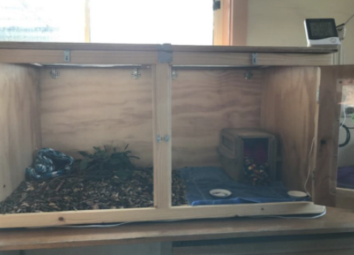
Figure 1.13: Pre-release bandicoot enclosure, showing sheet metal to 1.5 m to avoid nail/digit damage, and enclosure furnishing as described in Table 1.5. Photo credit: Zoos Victoria
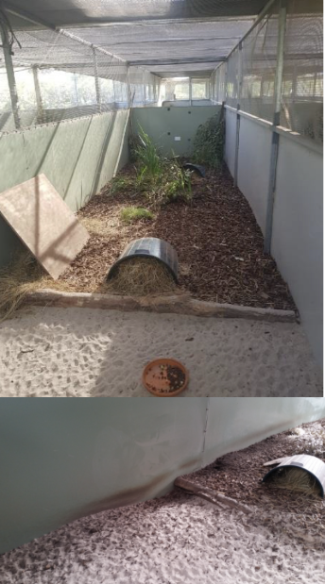

1.7. Feeding and nutrition
Keeping daily records of food offered (item and volume fed) and food consumed is good practice and will allow the rehabilitator to observe how the animal is responding to food on offer and inform future choices.
Please note: Food suppliers and specific products mentioned in these guidelines are intended as examples only. Other suitable products may also be available.
This section refers to feeding and nutrition of fully independent bandicoots in rehabilitation. Information on feeding orphaned bandicoots can be found under Section 1.8 Hand raising.
- Bandicoots are omnivorous and eat a wide range of invertebrates (mainly insects) and plant material. Wild bandicoot diets are presented in Table 1.1.
- Bandicoots have a high metabolic rate and wild bandicoots spend a significant proportion of their waking hours actively foraging for food. Bandicoots are prone to obesity when fed high volumes of calorie dense food without the need to expend energy foraging. Body weight and Body Condition Score should be measured and recorded at the time of arrival into care, and at least weekly until released to the wild.
- Rehabilitators should record the amount of food offered in the afternoon and measure the amount of food remaining in the morning so that they are aware of how much food the animal is consuming, or whether there is a diet item which the animal does not appear to like eating. Diets are formulated to provide balanced nutrition, so simply removing one diet item may lead to an unbalanced diet. If the animal continues to leave a single diet item, seek veterinary advice. For wild bandicoots not familiar with a captive diet, the addition of a judicious amount of one of the preferred diet items can encourage eating. Examples include a small quantity of canned dog food, highly palatable supplements such as Ilium Nutrigel or Nutripet (Troy High Energy Vitamin Concentrate) or a small volume of blended fruit (such as apple). However, it is important to reduce the volume of this high value feed over a few days (volume should be reduced by about 25% per day) once the bandicoot has started eating other diet items. Fresh water should always be available and provided in a stable/non-spill bowl or automatic drinker. Water should be changed daily.
Table 1.6: Daily feeding and diet guide for adult bandicoots during rehabilitation
Diet | Meal worms are high in fat and should never comprise 100% of the invertebrate portion of the diet.  The following diet should be fed:  - 20 g gut loaded, mixed live invertebrates (fly pupae, cockroaches, grasshoppers, crickets, mealworms, earthworms, isopods). The invertebrate portion of the diet should be made up of more than one species.  - 20 g good quality puppy kibble. Note: where insects are not reliably available, increase puppy kibble portion to 40 g per day, and feed as many insects as possible.  - 5 g greens (choose from endive, alfalfa sprouts or mung bean sprouts).  - 20 g mixed diced (pea sized) vegetables (choose a combination of sweet potato, broccoli, corn, peas, zucchini).
Pre-release considerations | - If live invertebrates have not comprised 50% of the protein component of the diet until this time, the proportion of live food fed should be gradually increased so that 50% of the protein portion of the diet is comprised of live invertebrates at least two weeks prior to release.  - The following diet change schedule can be followed:  - Baseline diet: 40 g kibble/0 g live invertebrates.  - Day 1: 35 g kibble/5 g live invertebrates.  - Day 3: 30 g kibble/10 g live invertebrates.  - Day 6: 25 g kibble/15 g live invertebrates.  - Day 9: 20 g kibble/20 g live invertebrates.  - Monitor appetite, behaviour and faecal consistency closely during diet change. If any change is noted, do not proceed to the next diet change step and seek veterinary advice. The length of time between percentage change in kibble offered can be increased to reduce potential impact on gut health.  - A variety of live insects should be offered, scattered throughout the enclosure to encourage foraging behaviour. See Release Protocol at Section 1.9 below for more detailed information.
Frequency/time of feeding | Feed once per day, in the late afternoon (just before sunset).

1.8. Hand raising
Hand raising record templates for growth, development, feeding and other observations are found in the Appendices to Part A in these guidelines.

1.8.1. Equipment required for hand raising
- Milk provision: Small/narrow silicon syringe teat (for example, those designed to fit the end of the hub of a syringe), eye dropper or a short length of human infant nasogastric feeding tube for smaller joeys. Shallow dish or plastic lid can be used for larger joeys once they are lapping (See Figure 1.14).
- Bedding material: Small pouch made from non-abrasive materials such as close-knit wool or polar fleece with a cotton or brushed cotton inner layer. A woollen beanie works well as an outer pouch layer.
- Housing: Refer to housing sections in species specific table in Section 1.8.2. While bandicoots have been hand raised successfully in simple transport boxes with a heat pad, a thermostatically controlled portable animal intensive care unit is ideal until the age of permanent emergence from the pouch. This ensures a constant thermal environment to avoid over or underheating.
- Other: Set of scales, record charts, digital thermometer/datalogger to monitor temperature inside the pouch/enclosure.
Figure 1.14: Young eastern barred bandicoot lapping milk from shallow lids. Photo credit: Zoos Victoria
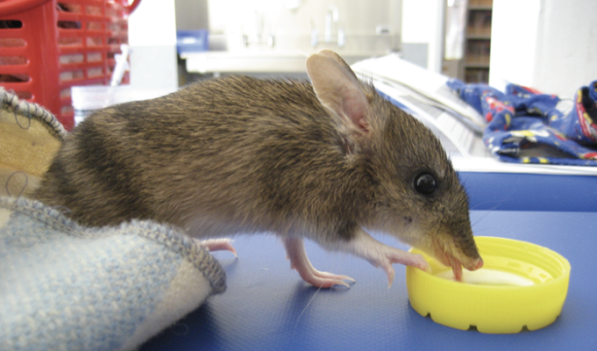

1.8.2. Growth, feeding and housing of orphaned offspring
STOP – Please refer to your authorisation for mandatory conditions regarding unfurred bandicoot joeys.
- Ensure enclosures are secure and are constructed in a manner which prevents injury. Bandicoot joeys are very nimble, energetic and have a flighty, nervous disposition. They are fast, and can easily slip through small spaces, and climb wire mesh. If joeys are housed at bench height be mindful of their speed, as they could dart out and fall from a height. The carer should place their torso across the box door opening to block the exit.
- Orphaned bandicoots imprint/bond easily with their rehabilitators. Handling should be kept to a minimum and they should be encouraged to lap from a small dish as soon as possible.
- Milk: Bandicoot milk is extremely high in fat which continues to rise during lactation, supporting one of the fastest marsupial growth rates. Bandicoots also wean at a relatively young age, making them much quicker to hand raise than many other Australian native species. Several different milk replacers have been used to successfully hand raise bandicoots (see Species Table 1.7, Table 1.8 and Table 1.9 below for detailed information). Rehabilitators are advised to follow package instructions to ensure appropriate concentration and volume is fed, and to contact providers with any questions.
- Growth and development: Since bandicoot joeys develop rapidly, close monitoring of weight and development is vital to identify concerns as soon as possible. A small amount of weight loss can be expected over the first few days in care, however, once settled, weight should steadily increase. While weight increases of up to 20 g per day have been documented, an average increase of 4–6 g per day is expected (see Species Tables below for detailed information).
- Toileting: Hand reared pouch young need to be stimulated to urinate and defaecate after each feed by gently wiping the cloaca using a warm moist cotton ball. Bandicoot joeys pass urine after each feed, and faeces 1–2 times per day. Maintaining daily records of urination/defaecation is vital. Seek veterinary advice if diarrhoea or constipation are seen over multiple feeds. If a joey does not drink well at a feed time, it is recommended to temporarily stop the feed and try stimulating first, then return to feeding.
- Weaning: As soon as weaning begins, food can be placed in a tray of fine sand to encourage natural digging and foraging behaviours while still allowing the carer to carefully monitor food consumption and see which food items are preferred. Choose solid food items from the adult diet items listed in Table 1.6. Live invertebrates should be adequately gut loaded to ensure muscle and bone development.
Table 1.7: Feeding and housing requirements for long-nosed bandicoots
Age  (days) | Weight / Morphometrics | Observation | Feeding | Housing
40 | 50 g | - Eyes open  - Fine fur emerging  - Teeth erupt | - Milk formula: Wombaroo >0.7 Kangaroo Milk Replacer, Biolac M100 transitioning to M150 once fully furred.  - Feed volume and frequency: 10-15% body weight per day divided evenly across all feeds; feed every 4 hours, aim towards spacing out over 12 hours (dusk till dawn) to allow rest during the day.  - Feeding technique: Milk from syringe teat, small teat.  - Toilet: after each feed. | - Bedding material: Pouch can be left open to allow emergence.  - Enclosure: Secure box or thermostatically controlled, portable animal intensive care unit.  - Temperature range: 28–30°C.
45 | 65 g | - Short, velvet fur | - Milk formula: Wombaroo >0.7 Kangaroo Milk Replacer, Biolac M150 transitioning to M200 once pelleted faeces formed.  - Feed volume and frequency per day: 10–15% bodyweight, 4 times daily spaced over 12 hours (dusk till dawn) to allow rest during the day.  - Feeding technique: Milk from syringe teat, small teat, but also encourage lapping by providing small amount of volume in a dish/lid during each feed.  - Toilet: after each feed. | - Bedding material Pouch can be left open to allow emergence.  - Enclosure: Inside in a large tub with leaf litter. Ensure sufficient ventilation. If wire is used in lid, cover inside with shade cloth.  - Temperature range: Ambient temp maintained around 28°C.
50 | 80 g | - Fur becoming longer and changing colour | - Milk formula: Wombaroo >0.7 Kangaroo Milk Replacer, Biolac M200.  - Feed volume and frequency: 10–15% bodyweight, 3 times spaced over 12 hours (dusk till dawn) to allow rest during the day.  - Feeding technique: Milk offered in dish only, no more bottle feeds. Offer gut-loaded invertebrates in evening.  - Toilet: toileting not required but monitor faecal output. | - Bedding material: Pouch kept closed to keep animal contained, placed within a wooden nest box.  - Enclosure: Inside in a large tub with leaf litter. Ensure sufficient ventilation. If wire is used in lid, cover inside with shade cloth.  - Temperature range: Ambient temp maintained around 28°C.
60 | 100–150 g | - Fully furred | - Milk formula: Wombaroo >0.7 Kangaroo Milk Replacer, Biolac M200.  - Feed volume and frequency: 10% bodyweight. Start to reduce milk feeds during this period, aiming for once a day only, by 150 g.  - Feeding technique: Milk offered in dish only. Offer gut loaded invertebrates, small amount of crushed dog kibble and mixed vegetables in the evening.  - Water: always available and provided in spill proof dish.  - Toilet: toileting not required, but monitor faecal output. | - Bedding material: Continue to use wooden nest box but remove pouch and offer nesting materials in box and enclosure floor to encourage nest building.  - Enclosure: Inside in a large tub with leaf litter. Ensure sufficient ventilation. If wire is used in lid, cover inside with shade cloth. Start to introduce to outside enclosure – e.g. supervised time during evening feed, weather dependent.  - Temperature range: no supplementary heating required; ambient temp maintained around 20–24°C.
70 –80 | 200 –250 g | - Small adult in size and appearance | - Fully weaned, no milk feeds.  - Adult diet (see Table 1.6 above). | - Housing to follow recommendations in Table 1.5 above, pre-release enclosure.
Table 1.8: Feeding and housing requirements for eastern barred bandicoots
Age (days) | Weight / Morphometrics | Observation | Feeding | Housing
50–55 | Head length 45–50 mm | - Emerging from pouch  - Very short, fine velvet fur  - Eyes fully open  - Faeces soft, but formed and dark tan in colour | - Milk formula: Wombaroo >0.7 Kangaroo Milk Replacer supplemented with 10% canola oil.  - Feed volume and frequency: ~15–20% body weight per day divided evenly across all feeds. Feed 4–5 times over eight hours.  - Feeding technique: Milk provided in dish only, no more bottle feeds. Introduce solids by offering 1–2 invertebrates after milk feed, gradually increasing in number and variety of invertebrates offered.  - Toilet: after each feed. | - Bedding material: Pouch opened to allow emergence, placed within a wooden nest box.  - Enclosure: Larger enclosure (e.g. 1200 mm length x 600 mm width x 570 mm height) but should still be kept indoors.  - Temperature range: 28–30°C.
55–60 | Head length 50–60 mm | - Fully out of pouch  - Finely furred  - Faeces become darker, firmer brown pellet (smaller but otherwise very similar in appearance to adult bandicoot faeces) | - Milk formula: Wombaroo >0.7 Kangaroo Milk Replacer supplemented with 10% canola oil.  - Feed volume and frequency: ~15–20% body weight per day divided evenly across all feeds. Feed 4–5 times over eight hours.  - Feeding technique: Milk provided in dish only, no more bottle feeds. Offer gut loaded invertebrates, and crushed kibble and vegetables in the evening. Joeys are likely to show less interest in milk. Monitor weight carefully to ensure sufficient food is being consumed to maintain growth rate.  - Toilet: not required, but monitor faecal output. | - Bedding material: Pouch opened to allow emergence, placed within a wooden nest box.  - Enclosure: Larger enclosure (e.g. 1200 mm length x 600 mm width x 570 mm height), kept inside. Provide digging tray containing moist soil. Sand and mulch can be added to encourage digging/foraging.  - Temperature range: From this point on, no heat mat/supplementary heat should be provided. Ambient temperature: 26–28°C, can reduce lower end of thermal range to 24°C.
60–70 | Head length 60–65 mm | - Fully furred | - Milk formula: Wombaroo >0.7 Kangaroo Milk Replacer supplemented with 10% canola oil.  - Feed volume and frequency: ~10% body weight per day divided evenly across all feeds. Feed 2–4 times over eight hours.  - Feeding technique: Milk provided in dish only, cease feeding milk if none being consumed. Offer gut loaded invertebrates, and crushed kibble and vegetables in the evening. Joeys likely to show less interest in milk. Monitor weight carefully to ensure sufficient food is being consumed to maintain growth rate – up to 10 g per day at this stage.  - Water: always available and provided in a spill proof dish.  - Toilet: not required but monitor faecal output. | - Bedding material: Continue to use wooden nest box. But remove pouch and offer nesting materials in box and enclosure floor to encourage nest building.  - Enclosure: Ward, or secure indoor room. Set up to encourage foraging and nest building with access to open pouch in box in hay. Can be set up in small outdoor enclosure if very well sheltered.  - Temperature range: Ambient temperature: 20–24°C. If moved outdoors, consider supplementary heat lamp.
70–75 | Head length ~65 mm | - Fully furred | - Milk formula: Wombaroo >0.7 Kangaroo Milk Replacer supplemented with 10% canola oil – to be fed once per day only until fully weaned.  - Feeding technique: Offer adult diet in evening (See Table 1.6 above). Monitor weight carefully to ensure sufficient food is being consumed to maintain growth rate, up to 10 g per day.  - Water: always available and provided in a spill proof dish.  - Toilet: not required. But monitor faecal output. | - Bedding material: Continue to use wooden nest box but remove pouch and offer nesting materials in box and enclosure floor to encourage nest building.  - Enclosure: Ward, or secure indoor room set up to encourage foraging and nest building with access to open pouch in box in hay. Start to introduce to outside enclosure – e.g. supervised time during evening feed, weather dependent.  - Temperature range: Ambient temperature 20–24°C.
>75 | 250 g  Head length 60–65 mm | - Small adult in size and appearance | - Fully weaned, no milk feeds.  - Adult diet (see Table 1.6 above). | - Housing to follow recommendations in Table 1.5 above, pre-release enclosure. Supplemental heat should be considered during the transition to being fully outside, particularly if the ambient temperature is cool.
Table 1.9: Feeding and housing requirements for southern brown bandicoots
Age (days) | Weight / Morphometrics | Observation | Feeding | Housing
45 | 40 g  Head length 45 mm | - Eyes opening  - Short, fine fur appearing  - Chewing food  - Standing and walking, moves very fast and increasingly active  - Olive velvet fur. | - Milk formula: Wombaroo >0.7 Kangaroo Milk Replacer supplemented with 0.5 ml of ‘The Good Oil’ or canola oil per 10 mL milk formula.  - Feed volume and frequency: ~10–15% body weight per day divided evenly across all feeds, six times daily spaced over 12 hours.  - Feeding technique: keep inside pouch during feeds. Feed using small syringe. Start to introduce lapping by offering small amount of each feed on a small dish.  - Toilet: after each feed. | - Bedding material: Pouch opened to allow emergence, placed within a wooden nest box.  - Enclosure: Larger enclosure (e.g. 1200 mm L x 600 mm W x 600 mm H), Secure to prevent escape. Enclosure kept indoors. Introduce small amounts of natural substrate (e.g. dry tussocks, dirt, leaf litter).  - Temperature range: 26 –30°C.
50–60 | 60 g | - Eyes open  - Well furred, golden-brown coat  - Emerging from pouch. | - Milk formula: Wombaroo >0.7 Kangaroo Milk Replacer supplemented with 0.5 mL of ‘The Good Oil’ or canola oil per 10 mL milk formula.  - Feed volume and frequency: ~10–15% body weight per day divided evenly across all feeds, four times daily spaced over 12 hours  - Feeding technique: Milk fed in small dish – cease bottle feeds. Introduce solids by offering 1–2 invertebrates after milk feed, gradually increasing in number and variety of invertebrates offered.  - Water: available water provided in a spill proof dish.  - Toilet: not required but monitor faecal output. | - Bedding material: Pouch opened to allow emergence, placed within a wooden nest box.  - Enclosure: Larger enclosure (e.g. 1200 mm L x 600 mm W x 600 mm H), Secure to prevent escape, Enclosure kept indoors. Introduce small amounts of natural substrate (e.g. dry tussocks, dirt, leaf litter).  - Temperature range: 26–27°C.
60–70 | 100–180 g | - Fully furred  - Fully out of pouch  - Starting to nest build at night. | - Milk formula: Wombaroo >0.7 Kangaroo Milk Replacer supplemented with 0.5 mL of ‘The Good Oil’ or canola oil per 10 mL milk formula.  - Feed volume and frequency: ~10–15% body weight per day divided in two feeds only.  - Feeding technique: Milk fed in small dish. Offer gut loaded invertebrates, and crushed kibble and vegetables in the evening. Joeys likely to show less interest in milk. Monitor weight carefully to ensure sufficient food is consumed to maintain growth rate – up to 10 g per day at this stage.  - Water: available water always provided in a spill proof dish.  - Toilet: not required. But monitor faecal output. | - Bedding material: Continue to use wooden nest box but remove pouch and offer nesting materials in box and enclosure floor to encourage nest building.  - Enclosure: Ward or secure indoor room or sheltered outdoor space. Set up to encourage foraging and nest building with access to open pouch in box in hay. Start to introduce to outside enclosure–– e.g. supervised time during evening feed, weather dependent.  - Temperature range: No supplementary heating required, ambient temperature 25–27°C.
70– 90 | 180–350 g | - Small adult in size and appearance | - Fully weaned, no milk feeds.  - Adult diet (see Table 1.6 above). | - Housing to follow recommendations in Table 1.5 above, pre-release enclosure.

1.9. Release protocol
Ideally, wild animals will be rehabilitated and released in a short timeframe. If this is not possible and the animal is in care for significant extended periods, ensure that the animal is regularly assessed against the welfare domains to support decision-making. Animals in care for extended periods may have a reduced ability to survive in the wild. Talk to your veterinarian and consider whether euthanasia will provide the best welfare outcome for such individuals.

1.9.1. Pre-release assessment
Pre-release assessment of animals in care is essential to support improved outcomes once back in the wild. Animals should be assessed based on body condition, fitness and the ability to engage in natural species-specific behaviours prior to release.
The following check list should be used to guide decision-making regarding release suitability for bandicoots:
- Individual is in a state of good health – presenting injury/sickness is completely resolved (consider pre-release veterinary check).
- Individual is within a healthy weight range and appropriate body condition (refer to Table 1.1).
- Individual displays ability to actively forage for and consume natural foods.
- Individual displays ability to select suitable nesting site and build nest.

1.9.2. At the release site
Post release survival will be maximised by ensuring that both the release site and the way in which the animal is released are carefully considered.
Bandicoots require the following:
- Note the various habitat types for the different bandicoot species to ensure they are released into suitable habitat.
- Suitable vegetation, including grasses and dense lower storey vegetation. Foraging areas need to be close to dense vegetation.
- Dense vegetation cover for building nests. Introduced species, such as Lantana, have been used by bandicoots.
- Soil soft enough for digging: most bandicoots will dig shallow, conical pits to retrieve invertebrates in the top layer of the soil or leaf litter.
For more information on the ecology and requirements of bandicoots that may help with their release, please refer to Table 1.1.

1.9.3. Release checklist
Check all of the requirements of your authorisation are being met, and consider the following:

Release location
- Suitable vegetation is available, including grasses and dense lower storey vegetation.
- Ample foraging areas close to dense vegetation.
- Dense vegetation cover for nest building.
- Soil layer soft and suitable for foraging/digging.

Release Procedure
- Limit the number of people at the release.
- Appropriate timing (one hour after dusk – during natural peak activity).
- Open transport container away from yourself near dense cover, ensuring that people are standing behind the animal’s flight zone.
- Allow the bandicoot to leave in its own time.
- Appropriate transport container padded with shredded paper (Note: Hay should not be used, to prevent the dispersal of seeds into the natural environment).
- Release around dusk to allow them time to settle prior to their peak natural activity in the wild.
- Release by opening the transport container away from yourself, allowing the bandicoot to leave the box in its own time.

1.10. Key references and additional reading
Brown, GW & Main, ML 2010, National Recovery Plan for the Southern Brown Bandicoot (Isoodon obesulus), Victorian Government Department of Sustainability, Melbourne.
Kingston, J. and McCracken, H. 2018. A review of and recommendations for hand rearing of the eastern barred bandicoot (Perameles gunnii) at Zoos Victoria.
Maher, C. 2006. Husbandry manual for long-nosed bandicoot (Perameles nasuta) https://aszk.org.au/wp-content/uploads/2020/05/Mammals.-Long-nosed-Bandicoot-2006CM.pdf
Pauligk, Y. 2021. Eastern barred bandicoot (Perameles gunnii) captive husbandry manual
Read, B.E. 2016. Husbandry guidelines for the southern brown bandicoot (Isoodon obesulus) https://aszk.org.au/wp-content/uploads/2020/06/Southern-Brown-Bandicoot-Isoodon-obesulus-Read-B.-2016.pdf

