Chapter 10: Wombats

Contents
10.1. Introduction 2
10.2. Species information 3
10.3. Animal and human safety considerations 5
10.3.1. Human safety considerations 5
10.3.2. Animal safety considerations 5
10.4. Capture, restraint, and transport 5
10.4.1. Visual observations 6
10.4.2. Equipment 7
10.4.3. Technique 8
10.4.4. Transport 10
10.5. Monitoring animal health and welfare 11
10.5.1. Physical examination 12
10.5.2. Ongoing monitoring of health and welfare 15
10.5.3. Common and emerging health conditions 16
10.5.4. Administering treatment 25
10.6. Housing 26
10.6.1. General housing information for wombats 26
10.6.2. Enclosure hygiene & biosecurity 26
10.6.3. Housing types 26
10.7. Feeding and nutrition 32
10.8. Hand raising 35
10.8.1. Equipment required for hand raising 35
10.8.2. Growth, development and housing orphaned young 38
10.9. Release protocol 43
10.9.1. Pre-release assessment 43
10.9.2. At the release site 43
10.9.3. Release checklist 43
10.10. Key references and additional reading 46

In Victoria, sick, injured or orphaned wildlife can only be rehabilitated by a wildlife shelter operator or foster carer who is authorised under section 28A of the Victorian Wildlife Act 1975 (Wildlife Act). Wildlife rehabilitators are subject to strict conditions. The mandatory requirements that they must meet are set out in the Wildlife Shelter and Foster Carer Authorisation issued under the Wildlife Act. These conditions enforce the minimum standards required for the humane treatment and successful rehabilitation of wildlife in care. The Wildlife Rehabilitator Authorisation Guide: Things You Need To Know explains how wildlife rehabilitators can meet these mandatory requirements and can be found here:
https://www.vic.gov.au/wildlife-rehabilitation-shelters-and-foster-carers.
The Victorian Wildlife Rehabilitation Guidelines have been developed to incorporate evidenced-based best practice in wildlife care and rehabilitation to equip rehabilitators to deliver positive welfare outcomes for individual animals in their care from first aid to post-release into the wild.
You must comply with the conditions of your authorisation. These guidelines must be read in conjunction with the conditions of your authorisation.

10.1. Introduction
There is only one species of wombat that comes into care in Victoria, the common wombat or bare-nosed wombat, (Vombatus ursinus).
When wombats come into care it is the responsibility of the wildlife rehabilitator to ensure that the five domains of animal welfare are satisfied. These include providing optimal nutrition and an environment appropriate to the wombat’s stage of rehabilitation. The focus should be on the animal’s return to health and release, which is facilitated through regular collaboration with a veterinarian. It is also important to consider the animal’s mental state and ability to exhibit normal behaviours without detrimentally affecting its recovery. Welfare may be temporarily compromised by the necessity of a gradual return to normal activity, depending on its stage of rehabilitation. Further information about the five domains of animal welfare is in Part A of these guidelines.

10.2. Species information
A profile for the wombat species found in Victoria is detailed in the following table (Table 10.1).
Table 10.1: Species Profile
Species | Common wombat / bare-nosed wombat (Vombatus ursinus)
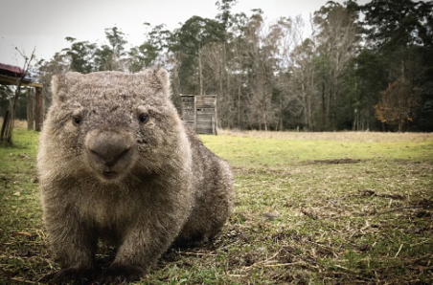  Photo credit: Emily Small | Distribution map  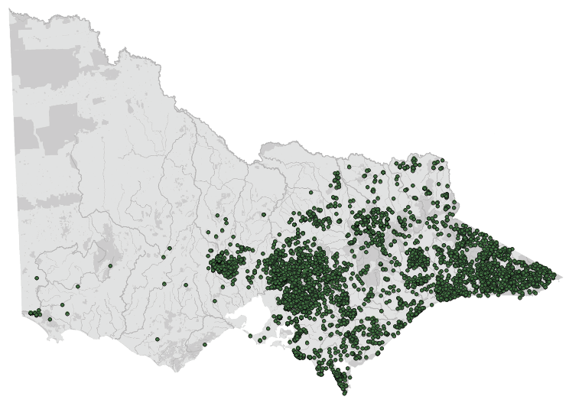  Data source: Victorian Biodiversity Atlas Jan 2023  www.environment.vic.gov.au/biodiversity/victorian-biodiversity-atlas
General appearance | Large animal with coarse fur; nose lacks fur. The coat colour varies from dark brown to grey, as well as sandy coloured
Conservation status* | Common
Sexual dimorphism | Similar in appearance, but female has a pouch, and the male has testicles
Adult morphometrics | Body weight: 20–38 kg  Head and body length: 84–115 cm
Home range | 2–82 ha: reflects availability of food
Behaviour | Wombats are mainly nocturnal and are usually solitary  Wombats live in a burrow that they make by digging. Wombats are territorial but will share a burrow if territories overlap. Although only one wombat may permanently reside in one burrow at a time, the burrow may be shared with other wombats over time
Diet | The common wombat eats a wide variety of grasses, roots and shrubs
Longevity | Up to 11 years in the wild
Sexual maturity | 2 years
Mating season | November to July however, the timing of mating and birth is dependent upon local conditions. Sub-alpine wombats may breed at a different time of year to wombats in warmer areas
Gestation length | 20–21 days
Litters per year | One young, born every two years  Wombats stay in the pouch for approximately 6–10 months and wean at 14–15 months. Young may disperse through all months of the year from approximately 18 months onward
*From the Flora and Fauna Guarantee Act 1988 Threatened List June 2023. This list is updated regularly throughout the year. For the most current list, please visit https://www.environment.vic.gov.au/conserving-threatened-species/threatened-list.

10.3. Animal and human
safety considerations
In general, animals in the wild have limited contact with people, pets, and the hustle and bustle of our daily lives. When sick, injured or orphaned wild animals come into care this unnaturally close contact can carry risks to the health and safety of both people and animals. For general information on biosecurity and approaches to minimise these risks see Part A of these guidelines. Specific information on enclosure hygiene and biosecurity for wombats is in Section 10.6.2.
The following information relates to human and animal health and safety considerations specifically related to the rehabilitation of wombats.

10.3.1. Human safety considerations
- Wild adult wombats can be aggressive and dangerous, making manual restraint difficult if not impossible. Chemical sedation via injection or dart (requiring veterinary support) may be needed.
- Wombats have strong jaws and sharp teeth. They can produce a painful bite resulting in bleeding and bruising.
- Wombats can push a person over when they charge toward them.
- Adult wombats are heavy (20–38 kg) and may require more than one person to lift them. Two people will be required for most adult wombat captures.
- Wombats can carry Sarcoptes mites which are readily transmissible to humans. This mite results in a skin rash.

10.3.2. Animal safety considerations
- Common wombats do not sweat and can suffer from heat stress when transported at temperatures greater than 24°C, even if only for a short period of time.

10.4. Capture, restraint, and transport
STOP – A visual examination must be done BEFORE the animal is captured. This applies to the initial capture from the wild as well as prior to captures which occur during time in captive care. See Section 10.4.1 for information on what to look for when conducting a visual health assessment.
Refer to Part A of these guidelines for general advice on wildlife welfare, biosecurity and hygiene, and record requirements. The following information relates to the capture, restraint, and transport of sick, injured and orphaned wombats.

10.4.1. Visual observations
Visual observations of wildlife should be conducted prior to any attempts to capture the animal. This is just as important prior to the first capture from the wild as it is before any capture conducted while an animal is in captive care. Observations should be conducted quietly, by one person, and from a distance which provides a clear view of the animal with as little disturbance as possible. Visual observation should focus on the animal’s demeanour, behaviour, movement and posture, looking for evidence of injury/severe disease or deterioration and observe their breathing as demonstrated in the following table.
Table 10.2: Visual health observations in wombats
 | What to look for
Demeanour | - Bright, aggressive, (screaming or growling is normal)  - Abnormal observations include:  - No attempt to avoid capture, or little struggle  - Slow responses
Behaviour | - Moves away rapidly when approached  - In burrow during the day  - Abnormal observations include:  - No fear of humans, poor attempt to escape  - Wandering in the middle of the day
Fur condition | - Sleek, with or without patches of hair loss on back (from wombat aggression)  - No crusting on ears, eyes or sides  - Often carry ticks (normal)  - Abnormal observations include:  - Crusting around eyes, ears, elbows, sides, belly  - Weeping wounds that smell
Movement and posture | - Able to walk  - No evidence of lameness  - Abnormal observations include:  - Not walking  - Lame  - Walking in circles
Breathing | - 10–15 breaths per minute  - Abnormal observations include:  - Shallow, rapid breathing  - Gasping, open mouth breathing

10.4.2. Equipment
- Trap: Cage traps may be required at some sites (operating under authorisation).
- Net: Robust hoop nets can be utilised.
- Catch bag: Hessian sacks or large strong capture bags.
- Transport container: Sturdy plastic tub with ventilation or a large dog carry crate: (80 cm (L) x 60 cm (W) x 50–60 cm (H). Recommended size for a transport container will depend on the size of the wombat. See Section 10.4.4.
- Thick blanket: to wrap the wombat.
- Wooden panels or garbage lids: to herd wombats.
- Spray can to mark an animal as checked.
Figure 10.1: Hoop net used for catching a wombat. Photo credit: A. Sriram
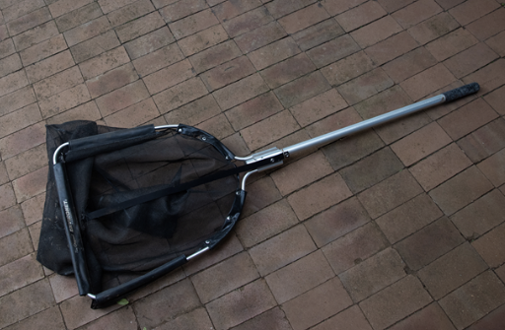

10.4.3. Technique
It is beyond the scope of these guidelines to outline techniques for every situation that may be encountered. Examples of techniques for some specific situations are outlined in the following section.
In addition to this information, for further advice please also refer to the recommended reading list, zoological institutions, veterinarians and/or wildlife experts. Inexperienced rescuers should request assistance where possible.
- Manual restraint of large, wild wombats should never be attempted by inexperienced rehabilitators. Chemical restraint administered by a veterinarian is usually the preferred option regardless of operator experience.
- If chemical sedation is not available, the wombat should be approached from behind so that it cannot reverse and is less able to bite the operator. The hands hold the shoulders firmly in place and move back towards the armpits, where one arm slides under the armpit and across the chest. The animal is then picked up with one arm under both armpits and the second arm supporting the rump. This technique cannot be used on large or highly aggressive individuals, as they will struggle vigorously and attempt to turn their heads and bite.
- Juvenile or large docile wombats can be picked up in a similar manner, with one arm held high under their forearms while the other arm supports the weight of the animal (See Figure 10.2).
Figure 10.2: A large tame docile wombat is lifted under its arms. Photo credit: Jenny Mattingley
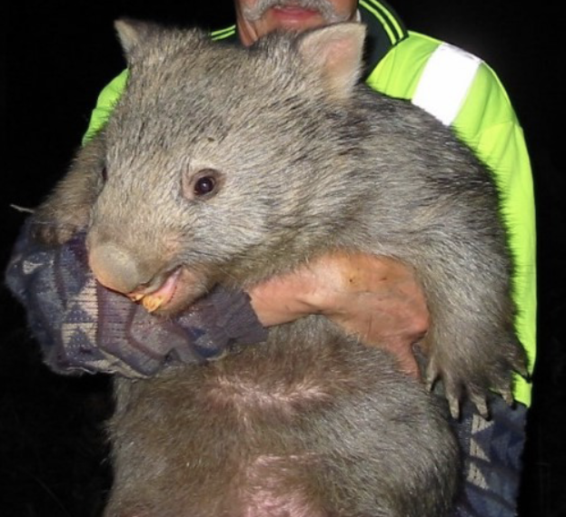

Wombats found under a house or in a confined space
Following an injury, wombats may sleep or seek safety under a house, or in a drain or similar structure. They will usually emerge on dusk or during the evening and may be lured out with food. The entry point can be blocked while the wombat is foraging during the night. Do not go under a house to chase the wombat, due to risk of injury. If the wombat leaves the confined space of its own accord, it does not require capture. If cage trapping an injured animal is needed, authorisation is required. Contact the Office of the Conservation Regulator (OCR) for advice regarding an Authority to Control Wildlife application.

Wombats found next to a road
Be careful near roads. Park the car off the road with hazard lights on and wear reflective vests during the capture. Contact the police assistance line on 131 444 to assist with traffic management.
A sub-adult or adult wombat may be injured from vehicle trauma and require capture and treatment. Even with broken limbs, wombats can still move quickly. A wheelie bin placed on its side may be used to contain the wombat. For animals that are unable to move, roll them gently onto a blanket and lift, using a person on either end of the blanket.

Wombat joeys may be retrieved from the pouch of the mother, who has died from vehicle trauma. Safely remove the mother’s body from the road before attempting to remove the joey. The pouch faces backwards and may need to be cut to remove the joey, taking care not to injure the joey. If a pouch is empty, check teats for evidence of feeding. ‘At-foot’ young that survive vehicle trauma may hide in nearby burrows. Attempts should be made to locate these animals as they are not yet independent and are unlikely to survive by themselves. Mark the mother’s body with spray paint to indicate that the pouch has been checked.

10.4.4. Transport
Recommended size for a transport container will depend on the size of the wombat.

Construction
- Wombats can be transported in a sturdy plastic tub or a large dog carry crate, 80 cm (L) x 60 cm (W) x 50–60 cm (H). This will be adequate for most adult wombats, but too small for the largest wombats. For a large wombat, a carrier of around 100 cm (L) x 60 cm (W) x 100 cm (H) will be required. A wheelie bin can be used for short trips (less than 30 minutes). Adequate ventilation is required, and the lid/gate should be securely fastened (See Figure 10.3).
- A soft bag made of shade cloth or hessian (as utilised for kangaroos) can be used to restrain a wombat. It should not be used to transport wombats for longer than 30 minutes, due to the risk of overheating.
- Pouch young can be transported in a home-made pouch or pillowcase.
- Use air-conditioning in the vehicle and monitor the animal regularly during transport. Wet towels could be used on the floor of the transport enclosure.
Figure 10.3: a. A solid wooden container used to transport large wombats. b. A large dog carry pack can be used. Photo credit: Jenny Mattingley
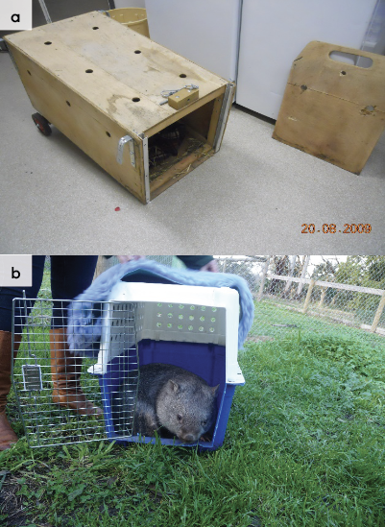

10.5. Monitoring animal health and welfare
The goal of wildlife rehabilitation is to address health and welfare concerns quickly and effectively so wildlife can be released back to the wild as soon as possible. Decision-making from the time of capture through to release should be guided by an accurate understanding of the animal’s true state of health and welfare. Careful monitoring throughout the rehabilitation period ensures that significant issues, or deterioration in health condition, are identified immediately and rapidly addressed.
It is preferred that all sick, injured or orphaned wildlife be assessed by a veterinarian to ensure that non-obvious signs of trauma or disease can be assessed and treated as soon as practicable. No medication should be provided prior to this assessment, as this can mask clinical signs and make an accurate health assessment by the veterinarian very difficult.
Templates for record-keeping visual and physical observations and daily care can be found in Part A of these guidelines.
This section provides guidance on health assessment on arrival and on effective monitoring of the health and welfare of individuals in care through minimising human-animal interactions and stress to the animal to maximise successful release back to the wild.
Please note: Carers should always aim to treat animals as efficiently as possible, so that they can be returned to the wild in the shortest possible time. This section provides guidance on assessment of health on arrival and on effective monitoring of the health and welfare of animals up to the point of release back to the wild.

10.5.1. Physical examination
Once visual observations are complete, and the animal is stable enough to withstand capture and handling, a basic physical examination should be conducted. This can be repeated when required any time the carer has the animal in the hand, such as for an enclosure change. However, if a full physical exam is not conducted, body condition and weight should be assessed every time the animal is in the hand for other reasons. Carers should make sure scales are available and ready to use before capturing the animal. Physical examinations are also required if the carer notices any changes suggestive of deteriorating health or an injury.
Always record the physical examination findings, so that you can compare findings as the animal’s rehabilitation progresses. This ensures any health concerns are identified as soon as possible and the carer can plan release as soon as this is appropriate. A template for recording Physical Examination findings can be found in the Appendices to Part A in these guidelines.
Examinations should be conducted in a quiet location with no access to burrows, away from any domestic animals. Only one person should handle the animal, while a second person takes notes. All other people should move away, and noise kept to a minimum. Handling should also be kept to a minimum, with careful monitoring for any signs of distress (such as panting, salivating, vocalisation or sudden deterioration in demeanour). If these are seen, the examination should be stopped immediately and the animal returned to its catch bag, transport box or enclosure and allowed to recover.

Species specific considerations:
- Physical examination of adult wombats can be difficult due to their size and strength and will often require sedation by a veterinarian.
- It is important that the animal is first assessed awake so the veterinarian can direct the examination at the problem.
- Table 10.3 provides additional guidance on what to look for during physical examinations.
Table 10.3: Physical examination of wombats
 | What to look for
Body weight | - Will vary with age. Record for reference.
Body condition | - Wombats in ideal condition should be rounded and feel firm all over. The spine should not be easily felt.
Hydration status | - Skin tent in inguinal (groin) area falls down within 1 second. Note that skin between shoulder blades is naturally tight and not representative.
Eyes | - Basic internal structures of eyes (e.g. pupil, iris) appear symmetrical.  - There should be no cloudiness or grey colour.  - Eyelids open, with no discharge or crust.
Ears | - Erect, no crusting.  - Some parasites (ticks and mites) may be present and can be left if there isn’t an excessive load and there is no evidence of irritation/excessive scratching inside the ears.
Mouth | - No blood visible.  - Incisors intact and aligned.  - Gums are pink.  - A full dental assessment can only be performed by a veterinarian under anaesthesia.
Skin and coat condition | - Skin is smooth, pale pink.  - It is normal to have a moderate burden of ticks (1–20), but 100s can indicate ill health. While a healthy wombat would be expected to be covered in normal fur, it is not unusual for some hair loss to occur over the back from wombat aggression. However, deep wounds may need treatment.  - Crusty, thickened skin, perhaps with cracking may indicate mange.
Limbs and feet | - Able to walk normally.  - Nails should not be broken.  - Foot pads should be intact, free of wounds.
Sex determination | - The sex of the common wombat is determined by looking for the presence of a pouch or testicles.
Pouch check | - The pouch should be checked for a joey. An enlarged teat and mammary gland may indicate a joey is still dependent on the mother.
Figure 10.4: Physical examination of an anaesthetised wombat, mother with joey in pouch. Photo credit: Phillipa Mason
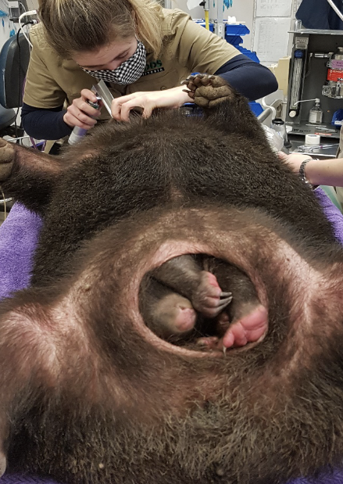
Figure 10.5: Examination of the teeth, normal incisors. Photo credit: Phillipa Mason
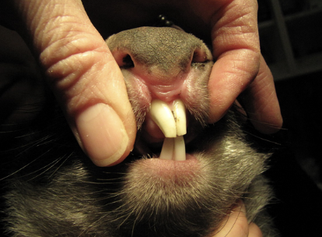

10.5.2. Ongoing monitoring of health and welfare
The aim of wildlife rehabilitation is to ensure animals recover and can be released back to the wild as quickly as possible. Careful, daily monitoring is required to ensure that animals are responding as expected to the treatment being provided and so that any deterioration or welfare concerns can be identified and addressed as soon as possible. Rehabilitators should ensure that record-keeping is a priority to maximise positive welfare outcomes. Templates to assist wildlife rehabilitators to record and monitor wildlife health and welfare can be found in the appendices to Part A of these guidelines. These records will be valuable tools to share with veterinarians to support decision-making.
The following is recorded daily:
- demeanour
- food consumption
- faecal/urine output
- behaviour observed
- medical treatment provided
- evidence of overnight activity.
The following is recorded weekly:
- weight
- body condition.
Over time, regular monitoring will also help to develop carer skills and knowledge, as regular observations and recording will result in a deep understanding of the expected behaviour and response to treatment for the species in care.

Species specific considerations:
- Ideally, physical observations and medications should be undertaken at the beginning and/or end of the resting period to minimise disturbance and maximise the rest/sleep period for rapid healing and ensure ease of capture.
- The wombat should be observed at least daily.
- Note the animal’s demeanour and behaviour every time food is introduced or taken away, the animal is medicated, or the enclosure is cleaned. Pay particular attention to any changes that have occurred since the previous day.
- Gently encourage the wombat to walk, in order to assess its movement and demeanour.
- Note faecal consistency daily. If diarrhoea is noticed, a faecal sample should be collected and submitted to the veterinarian for assessment as soon as possible. Do not treat on suspicion of a bacterial or parasitic infection, as this can make definitive diagnosis very difficult and potentially prolong the course of the disease.

10.5.3. Common and emerging health conditions
Clear guidance on conditions that may require euthanasia can be found in Part A of these guidelines.
Table 10.4 lists common clinical signs and possible causes of injury/disease. Carers should be aware that these are not exhaustive. Aside from first aid, carers should avoid administering medications prior to the provision of veterinary advice.
Unusual clinical signs or mass mortality events – a number of animals dying or found dead at the same time, with similar signs – may indicate an emergency animal disease, an emerging/new infectious disease or an environmental/human related toxicity which needs further investigation. Report these immediately to the Emergency Animal Disease Watch Hotline on 1800 675 888 (24 hours).
Table 10.4: Common injuries and clinical signs of emerging health conditions seen on presentation or during care
Injury or clinical signs | Possible causes | Rehabilitator observations and response
Note: Do not provide pain relief or other medication, including antibiotics, unless under veterinary guidance and supervision, as these can have severe side effects, particularly in dehydrated/shocked animals. Use of antibiotics when not indicated can contribute to antimicrobial resistance and reduce drug efficacy.
Unable to walk or move normally  Swollen limb  Bruising  Fractures  Dislocation  Nail injury, missing nail | Found adjacent to road/suspect motor vehicle accident,  Caught in wire or netting, predation injury caused by raptor, fox, cat or dog, gunshot  Capture injury  Injury sustained in captivity | - Urgent veterinary attention is required. Do not delay transfer to veterinarian to apply first aid, other than to stop excessive bleeding.  - Move animal to a small transport box to restrict movement. Ensure temperature is appropriate for species and minimise stress.  - Do not attempt to stabilise fractures as this is very painful, and risks making the injury worse. Fracture stabilisation should only be attempted by a veterinarian following physical exam, x-rays and under general anaesthesia.  - Do not provide pain relief or other medication unless under veterinary guidance and supervision, as these can have severe side effects, particularly in dehydrated/shocked animals.  - If suspected as the cause, assess the enclosure/box/bag to find the source of injury. Fix loose wire/gaps or sharp edges before returning animal to enclosure. See Section 10.4 and Section 10.6 this chapter for further advice on housing and transport.
Thickened, cracked skin, crusting around ears and eyes | Sarcoptic mange | - Present to a veterinarian for assessment, to confirm diagnosis and direct treatment.  - If indicated, give medications to kill parasites and treat any secondary infection, as prescribed by a veterinarian (see Figure 10.7).  - Where wildlife rehabilitators have more than one wombat or other mammal species in care, strict biosecurity procedures are required to reduce the risk of spread of mange from infected to non-infected individuals.  - Dispose of bedding from in-contact animals by placing it into a bag and incinerating it or placing in general waste. Towels, pouches, etc. should be machine washed in hot water. Affected wombats should be housed separately to other wombats. Feed and clean them last, to reduce risk of transmission to others. After release or euthanasia, the enclosure should be cleaned and then isolated for a minimum of three weeks before using again.  - Sarcoptic mange is a zoonosis. Refer to Part A Chapter 4 of these guidelines for additional information on Biosecurity & Hygiene including zoonoses and minimising disease risks.
Fur loss  Skin irritation, itching | External parasites, other skin condition | - Seek veterinary advice or assessment to diagnose the cause and advise on treatment.  - Heavy burdens in animals may indicate an underlying disease or injury, these animals require veterinary assessment  - For light burdens, generally no treatment is required. However, if in care, consider other animals in care contracting parasites.  - Ticks can be manually removed. For heavy burdens apply medication as directed by a veterinarian.  - Ensure good hygiene and biosecurity practices.
Blindness  Deafness  Neurological signs  Wobbly movement, or ataxia  Circling movement  Strange behaviour (out in the daytime) Easily caught  Lethargic  Moribund, collapsed | Infectious disease, such as toxoplasmosis or bacterial meningitis, cranial trauma, toxicity (e.g. 1080 poisoning) | - Seek prompt veterinary assessment.  - Do not provide pain relief or other medication unless under veterinary guidance and supervision, as these can have severe side effects, particularly in dehydrated/shocked animals.  - Carer may observe the animal bumping into objects in enclosure or fail to respond to short sharp noises (such as a loud clap from behind animal).  - Pupils may be fixed/dilated and not responsive to changes in light level. Pupils should constrict if a pen light is shone in the eye.  - If multiple animals are seen with similar signs, this may indicate a newly emerging infectious disease or a toxicity (such as plant toxicity or poisoning). Contact the Emergency Animal Disease Watch Hotline on 1800 675 888 to report concerns.  - If unusual toxicity or infection is suspected, you or your veterinarian can contact Zoos Victoria’s Veterinary Department to discuss options for disease investigation.
Burns | Recent bushfire, campfire injury, chemical burn | - Seek urgent veterinary attention.  - Burn injuries are extremely painful, treatment and bandage changes must only occur under anaesthesia and with adequate pain management.  - Animals must be returned to a veterinarian for ongoing bandage changes.  - Give other medication as prescribed by a veterinarian.  - House the wombat in a fly-proof enclosure.
Joey failing to pass faeces  Bloating | Constipation in joeys, other gastrointestinal problems | - Seek veterinary advice or assessment.  - Seek urgent veterinary advice if constipation does not resolve rapidly (e.g. within 24–36 hours), or if there is any evidence of dehydration, blood in faeces or change in demeanour.  - Constipation may be seen in orphaned young as a result of dehydration. Offer the appropriate milk for the age of the joey. If the joey feeds well, no additional treatment should be necessary. If the joey is dehydrated, adequate hydration in the first week of care is vital. This is achieved by offering oral electrolyte replacers in between milk feeds.  - Seek advice from species experts.
Weight loss, reluctance to eat | Tooth malocclusion (misalignment), other dental disease, failure to thrive, other disease or injury | - Seek veterinary assessment to determine the cause.  - Dental problems can only be assessed properly by a veterinarian with the animal under anaesthesia (see Figure 10.8).
Nails loss/toe injury  Swollen foot or toe  Wound to foot or toe  Bleeding foot or toe  Damaged or missing nail  Bleeding nail | Toe, foot or leg caught in netting, wire or bag  Predation injury caused by raptor, fox or dog  Poorly designed transport box/enclosure  Capture injury  Injury sustained in care due to stress | - Seek prompt veterinary attention.  - Injuries to nails are very painful and lesions can be very slow to heal. There is a risk of nail bed infection, veterinary management is required.  - Do not provide pain relief or other medication unless under veterinary guidance and supervision, as these can have severe side effects, particularly in dehydrated/shocked animals.  - If suspected as the cause, assess the enclosure/box/bag to find the source of injury. Fix loose wire/gaps or sharp edges before returning animal to enclosure. See Section 10.4 and Section 10.6 of this chapter for further advice on housing and transport.  - If stress is deemed a factor, consider whether the animal is a candidate for rehabilitation. Seek advice from species experts.
Bleeding  Puncture wounds  Bruising  Fur loss | Conspecific aggression, breeding season injuries  Found adjacent to road/suspect motor vehicle accident,  Predation injury caused by raptor, fox or dog  Severe case mange  Poorly designed transport box/enclosure  Capture injury  Injury sustained in captivity, due to stress | - Seek prompt veterinary assessment, euthanasia may be the most humane response if the wounds are extensive.  - The severity of bite wounds/scratches may not be immediately obvious, but they are frequently encountered in wombats. If they are deep, they can take a long time to heal and may become flyblown.
Diarrhoea  Loose, smelly faeces | Inappropriate diet, change in diet, infectious disease, alteration of microbiome, stress, internal parasites, antibiotic treatment | - Seek veterinary advice.  - Seek urgent veterinary advice if diarrhoea does not resolve rapidly (e.g. within 24–36 hours), or if there is any evidence of dehydration, blood in faeces or change in demeanour.  - Do not treat on assumption of infectious disease (such as coccidia or bacterial infection) as this can make veterinary diagnosis more difficult if the animal does not improve.  - If animal has been otherwise stable and doing well, there are a number of responses carers may implement to try to resolve diarrhoea. Consider any recent changes which may have led to diarrhoea remove inciting cause where possible. These could include: rapid change in diet, unusual levels of sound/intervention or handling, contact with recently arrived animals.  - If milk has recently changed, immediately switch back to previous milk, wait until diarrhoea has resolved and then implement a slower diet change.  - Seek advice from species experts, ensure diet and husbandry practices are correct.  - If stress is deemed a factor, consider whether the animal is a candidate for rehabilitation.  - Do not mix oral rehydration fluids with milk as it changes the digestibility of the milk. Oral rehydration fluids/water can be provided in between milk feeds.  - Ensure excellent hygiene standards to prevent spread to other animals/carers, and isolate this animal from any others in care, if possible.
Skin irritation/fur loss | Conspecific aggression, breeding season interactions, mite infestation | - Seek veterinary advice or assessment.  - Some fur loss/minor skin lesions are commonly seen due to fighting or in the breeding season and may not require any intervention.  - A small number of ticks/mites can be normal, and do not require treatment or removal. However, if there is a very high number of ticks/mites seen, the animal is scratching/irritated, or the skin is red and inflamed, seek veterinary attention to treat ectoparasites.
Figure 10.6: Head trauma caused by collision with a motor vehicle. Photo credit: Zoos Victoria
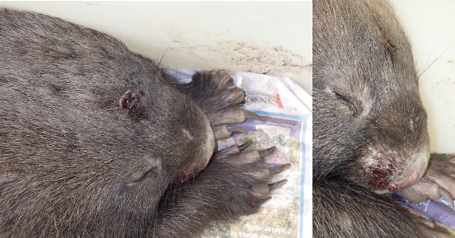
Figure 10.7: a. A common wombat with severe sarcoptic mange. b. the mite that causes sarcoptic mange. Photo credit: Zoos Victoria
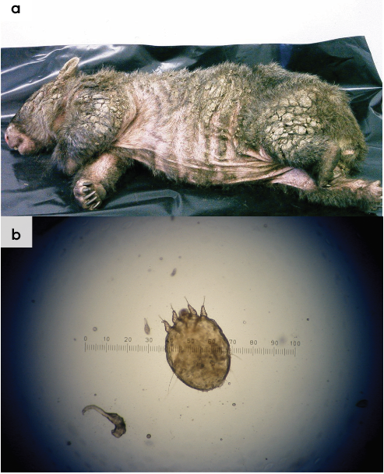
Figure 10.8: a. Malocclusion of the right upper incisor in a young common wombat caused by vehicle trauma. b. Spurs visible on the cheek teeth (arrow) due to malocclusion. If left untreated they will lacerate the tongue and cheeks. Photo credit: Anne Fowler and Zoos Victoria
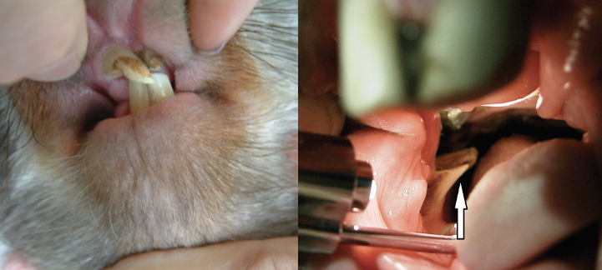
Figure 10.9: Wombat with a cataract. Photo credit: Zoos Victoria
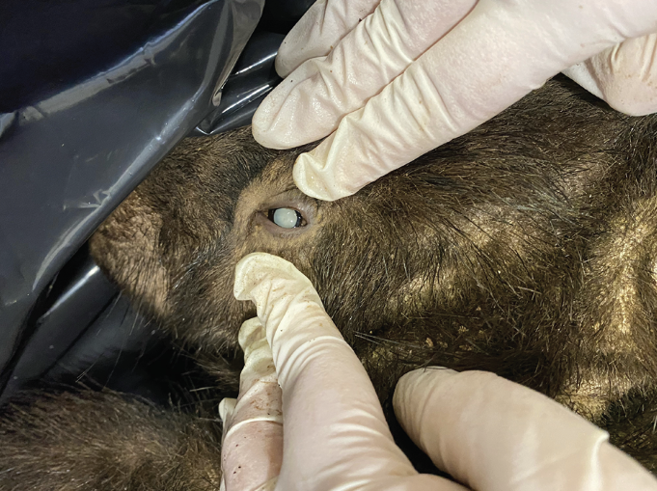

10.5.4. Administering treatment
- Oral medications can be delivered in a syringe directed into the side of the mouth while the animal is restrained. Care is required to avoid biting.
- Injectable medications can be administered under the skin, between the shoulder blades. Only experienced carers should give injections.
- Fluids (Lectade or Hydralyte) are best administered orally to address dehydration.
- Subcutaneous fluids should be given under anaesthesia as it is a painful process. Wombats do not have a good subcutaneous space and the skin is very thick.

10.6. Housing
Below are several key considerations when housing adult animals in care.

10.6.1. General housing information for wombats
- Housing adult wild wombats for any length of time can be very difficult and often causes significant stress to the animal. Consideration needs to be given as to where the animal will go for treatment/rehabilitation.
- Wombats are sensitive to noise, and the sight and smell of domestic pets. They should be housed individually in a quiet area of the property.
- Wombats should have access to fresh water and fresh grass every day.
- Wombats are very strong and will try to escape if they are not too sick. Enclosures should be very sturdy; flooring should be solid so they cannot dig out.
- Adult wombats are reluctant to eat and difficult to feed adequately in captivity so housing for periods of over a week may necessitate euthanasia for welfare reasons.

10.6.2. Enclosure hygiene & biosecurity
General information about hygiene and biosecurity can be found in Part A of these guidelines. New diseases emerge frequently and sick and injured animals in care are often more susceptible to picking up pathogens from the environment. It is important to maintain excellent levels of hygiene to avoid inadvertently transferring diseases between animals, and from humans, and to protect the wild population where the animal will eventually return to.

Species specific considerations:
- All straw and grass used in enclosures or for feeding should be free of cat faeces to prevent the introduction of Toxoplasma.
- Wombat enclosures that have housed wombats with mange should be thoroughly cleaned and left empty for at least three weeks.
- Remove faeces daily to prevent a build-up of coccidial and other parasitic oocysts.
- The only way to eliminate coccidia from an enclosure with a soil floor is to remove the top layer of soil. Regular topsoil removal should be part of a shelter biosecurity management plan. A concrete floor can be cleaned with boiling water, as this has been shown to kill oocysts.
- Enclosure furniture and bedding must be replaced in between animals.

10.6.3. Housing types
Different set ups are required for animals at different stages of treatment and care. Table 10.5 describes the housing type, suggested dimensions and requirements at each stage of care. For information on housing animals during hand raising see Section 10.8.
Table 10.5: Rehabilitation housing for adult wombats
Intensive care housing
Indications for use | Suggested min. dimensions | Suggested requirements
Short term critical care (<48 hours)  Intensive veterinary treatment – frequent medication, oxygen supplementation, temperature control  Longer periods under veterinary supervision where strict cage rest/confinement is indicated | A recommended size is 1 x 2 m with a wall height of 2 m (H).  It should be large enough for the animal to turn around, but small enough to permit easy capture. | ENCLOSURE CONSTRUCTION  - A small stable or enclosed area with solid walls and floor and subdued lighting is recommended.  - Solid walls (at least to 1 m) are required for wombat enclosures, as animals may injure themselves while attempting to climb mesh walls.  - It is expected that the wombat would be housed for less than seven days in an enclosure of this size.  ENCLOSURE FURNISHING  - The bedding may be a deep layer of straw to provide support for recumbent animals.  ENVIRONMENTAL VARIABLES  - Warmth should be provided if the animal is recumbent, but adult wombats don’t need temperatures above 25°C.  PROVISION OF FOOD/WATER  - Easy access to grass and low-profile water bowls are required.

Intermediate housing (Treatment/cage rest)
Indications for use | Suggested min. dimensions | Suggested requirements
Provision of daily medication, close monitoring once animal is stabilised and no longer requires intensive care.  Enclosure furnishings can be arranged to reduce opportunities to climb/dig or move excessively so that ‘cage rest’ can be achieved with slightly more space/reduced contact | Suggested minimum size is 2 x 3 m with walls of 2 m (H).  It should be large enough for the animal to move around, but small enough to permit easy capture. | ENCLOSURE CONSTRUCTION  - A stable or shed with solid walls and floor is suitable.  - A double hinged half door permits the animal to be checked without too much disturbance.  - It is ideal if this housing leads directly out to the pre-release pen.  ENCLOSURE FURNISHING  - As for the intensive housing enclosure with the addition of a wooden box (120 cm x 50 cm x 50 cm), large dog carry pack or wooden A-frame which can be used as a temporary burrow.  - The flooring may be soil or concrete. However, wombats may damage their nails on concrete floors if housed for a long period of time. If flooring is soil, it will need buried wire to stop the wombat digging out.  - Provide some bedding using grass, hay or straw.  ENVIRONMENTAL VARIABLES  - No heat should be needed at this stage.  PROVISION OF FOOD/WATER  - Access to fresh grass and water is required.

Pre-release
Indications for use | Suggested min. dimensions | Suggested requirements
No longer require regular handling/medication  Development of fitness/strength prior to release  Monitoring/ assessment of behaviour (foraging, digging)  Pre-release assessment | 10 m x 5 m x 2 m high | ENCLOSURE CONSTRUCTION  - Solid sides to 1 m preferred.  - Natural ground to dig preferred, but buried wire or concrete will be necessary to stop escape or burrow formation.  ENCLOSURE FURNISHING  - Artificial burrows can be made from concrete pipes, wooden boxes or metal drums. It is important to ensure that metal drums or artificial boxes are covered with adequate soil or cover to prevent them from overheating.  - Offer material for bedding such as hay, grasses, bracken fern, gum leaves and bark.  - The wildlife rehabilitator should be able to access the burrow.  THERMAL ENVIRONMENT  - Ambient.  PROVISION OF FOOD/WATER  - Access to fresh grass and water is required.
Figure 10.10: A stable that is suitable to house an injured adult wombat. Note the solid walls and easy access to both grass and pellets. Photo credit: Jenny Mattingley
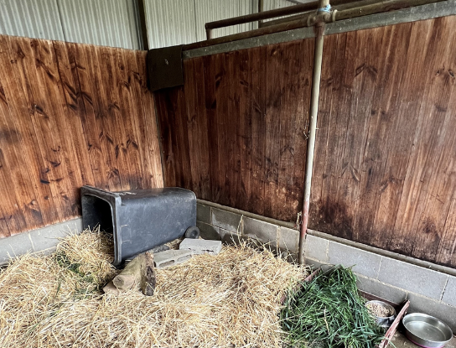
Figure 10.11: A pre-release yard with tin fencing. Photo credit: John Merrick
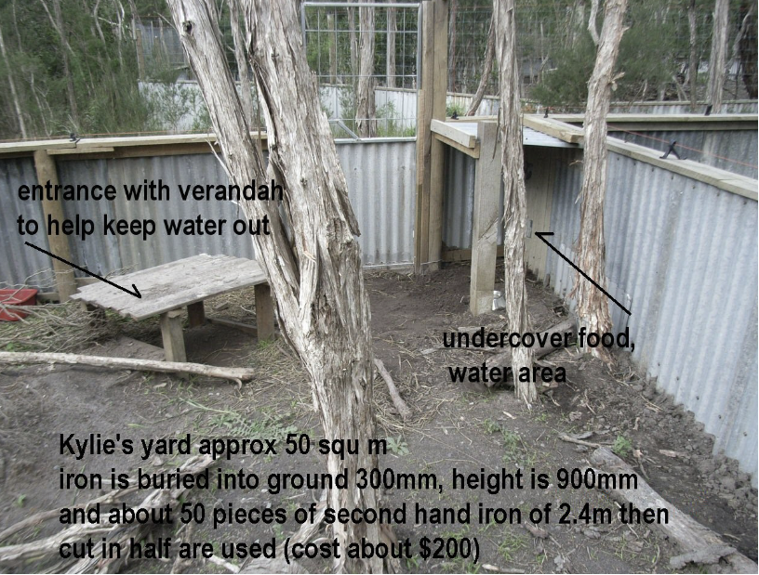
Figure 10.12: An artificial burrow under construction in a pre-release yard. Photo credit: John Merrick
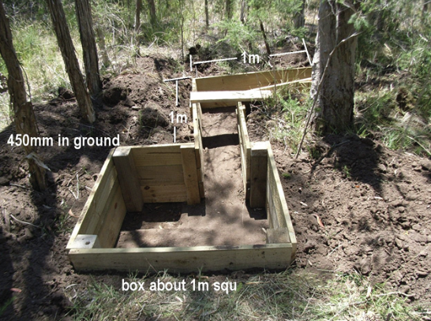
Figure 10.13: Artificial burrow entrances may need to be reinforced with wooden sleepers. Photo credit: Anne Fowler
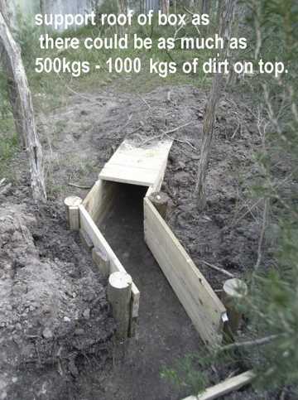
Figure 10.14: Pre-release wombat enclosure. Note solid walls, artificial den with door for easy access and food placed in a tray on concrete flooring for ease of cleaning and to minimise faecal build up. Photo credit: Zoos Victoria
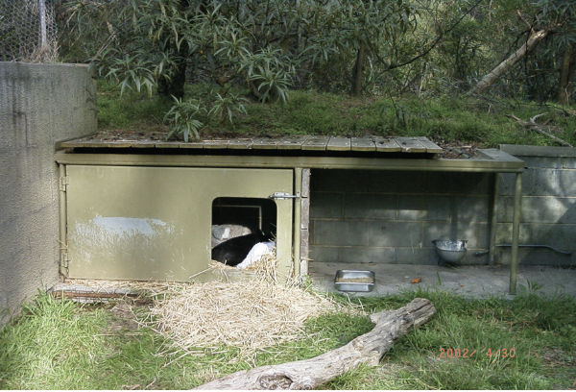

10.7. Feeding and nutrition
Keeping daily records of food offered (item and volume fed) and food consumed is good practice and will allow the rehabilitator to observe how an animal is responding to food on offer and inform future choices.
Please note: Food suppliers and specific products mentioned in these guidelines are intended as examples only. Other suitable products may also be available.
This section refers to feeding and nutrition of older hand-raised and adult wombats in rehabilitation. Information on feeding orphaned individuals can be found below under Section 10.8 Hand raising.
Table 10.6: Daily feeding and diet guide for adult wombats during rehabilitation
Species | Adult wombats
Diet | - Food to offer older hand-reared wombats or adults includes:  - One to two shopping bags by volume of freshly picked, native and introduced grasses. These should be offered once the teeth begin to emerge. The roots and dirt should be left on and, where possible, the grass clumps should be secured, so that the wombats use their teeth and jaw muscles, as they would in the wild, to pull the grass out of the ground. This is equivalent to about 2 kg of grass per day. Suitable grass species are shown in Table 10.7.  - One to two biscuits of commercially produced grass (meadow) hay daily.  - One new tussock of native grass daily.  - Bark and sticks from native tree branches such as stringybark.  - Charcoal (ensure it was burnt native hardwood).  - Water.  - Animals with a lack of appetite can be offered the following palatable items:  - Freshly picked green grass.  - Grass based pellets, which should constitute no more than 10% of the daily diet and should be low in protein and Vitamin D. Suitable pellets include those for horses, goats and macropods. Avoid medicated pellets such as cattle and chicken pellets as these may contain medications (for example coccidiostats) that may be fatal to wombats.
Pre-release considerations | - Grasses from the release area should be fed and consumed by the wombat before release.
Frequency/time of feeding | - Wombats should be fed daily in the evening.  - Fresh water should always be available, provided in a stable/non-spill bowl or automatic drinker. Water should be changed daily.
Table 10.7: Grasses eaten by adult, wild common wombats
Native species | Latin name
Tussock grass | Poa sp
Kangaroo grass | Themeda australis
Wallaby grass | Danthonia pencillata
Australian salt grass | Distichlis distichophylla
Spear grass | Stipa sp
Weeping grass | Microlaena stipoides
Club rushes | Scirpus sp
Marram grass | Ammophila arenaria
Hairy spinifex | Spinifex hirsutus
Reed bent grass | Deyeuxia quadriseta
Tall sedge | Carex appressa
Spiny-headed Mat-rushes | Lomandra longifolia
Bark from stringybark tree | Eucalyptus baxteri
Roots apple bark | Eucalyptus bridgesiana
Oat grass | Avena sativa
Perennial rye grass | Lolium perenne
Annual rye grass | Lolium rigidum
Sorghum | Sorghum sp
Parramatta grass | Sporobolis africanus
Paspalum | Paspalum dilatatum
Yorkshire fog grass | Holcus lanatus
Meadow fescue | Festuca pratensis
Cocksfoot | Dactylis glomerata

10.8. Hand raising
Hand raising record templates for growth, development, feeding and other observations can be found in the appendices to Part A of these guidelines.

10.8.1. Equipment required for hand raising
- Housing: Initially joeys will be housed in pouches which are then housed in a pet carrier or cot. Many carers raise them in pairs (though they are almost always solitary offspring and will be solitary as adults) as they spend the first 15–18 months with their mother.
Figure 10.15: Housing for orphaned joeys. The pouch is placed inside a child’s playpen. Photo credit: Jenny Mattingley
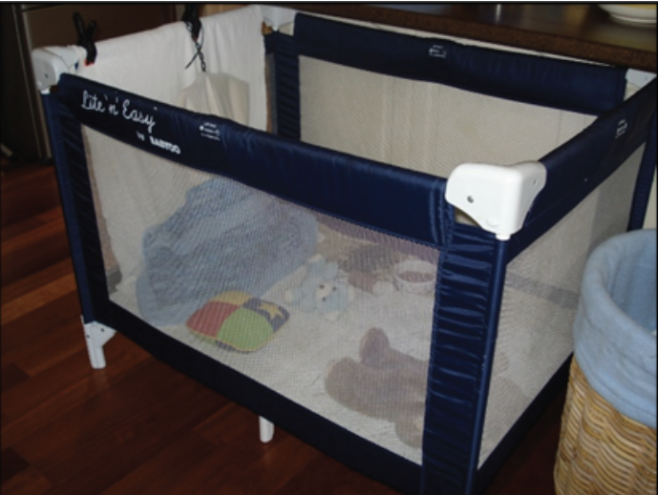
- Milk: There are a variety of low lactose milk formulas available to raise wombats. Follow the manufacturer’s instructions when making up the milk formula. Milks that can be used include:
- Wombaroo Wombat Milks provide appropriate levels of protein, fat, carbohydrates and energy for all stages of growth.
- Biolac produces three milks which provide sufficient protein, fat, carbohydrates and energy for all stages of growth.
- Di-Vetelact is an older product but many carers have had success with it. It is a single formula that is diluted according to the age of the joey.
- Supplements: Suitable supplements that may be added to milk include:
- Wombaroo Impact is used to boost immunity and protein in orphaned joeys after the first month in care.
- Critical Care for Herbivores is used to provide a source of easily digestible energy to sick joeys that have started eating solids.
- Do not add human infant vitamin supplements to the milk formula.
- Pouches: Pouches are usually constructed as follows:
- An inner lining made from a natural fibre without exposed strands, which may be achieved by using French seams. It may have curved edges.
- Outer pouch may be made from a variety of materials such as wool, polyfibre, cotton or synthetic fleece fabric.
- This pouch can then be placed in a hanging pouch which can be suspended on a frame. For wombats this should still rest on padding on the bottom of the enclosure so they can climb in (they don’t roll in like a macropod).
- Pouch size will vary with the size of the joey. A young joey should feel snug, but the pouch will become more open with increasing age.
- Thermometer
- Scales
- Record Charts
- Appropriately sized teats and bottles: A variety of teats are available, but the best shape for wombats is a broad, elongated teat.
Figure 10.16: a. LD teat suitable for in pouch wombats. b. FM teat suitable for out of pouch wombats. Photo credit: Jenny Mattingley
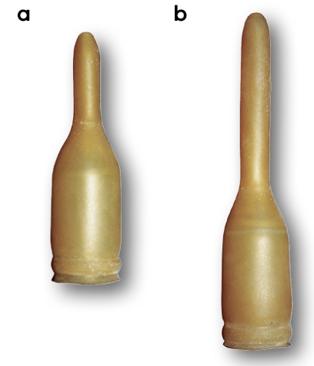
Figure 10.17: Joey being nursed. Eyes and body are covered with blanket. Photo credit: Zoos Victoria
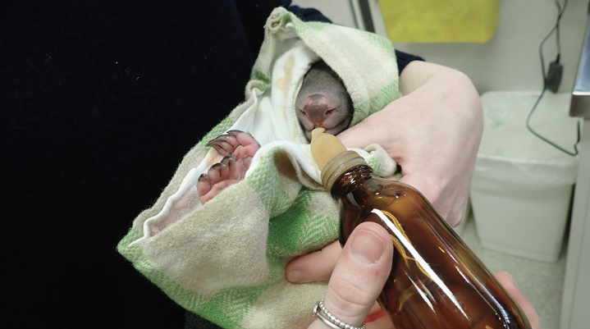

10.8.2. Growth, development and housing orphaned young
STOP – Please refer to your authorisation for mandatory conditions regarding unfurred joeys.
- Raising wombats to the point of release can take up to two years. Wombats are usually released at around 18 to 24 months of age, or approximately 18 kg.
- The ambient temperature is reduced slowly until pouch emergence when the joey is furred. See the developmental chart in Table 10.8 for heating recommendations. To avoid burns, a heat pad/heat pack/hot water bottle should never be placed directly against the animal’s skin, especially if the joey is not yet furred. A thermometer is used to monitor the temperature in the pouch by placing it between the inner and outer pouches.
- Buddying joeys with others, improves success rates and should occur as soon as possible.
- Offer grasses with roots and dirt.
- See Table 10.8 for details on growth, development and housing of orphaned young.
- Foods that should not be fed to wombats include:
- Processed cereals – such as bread, cereal biscuits or muesli mixes. These predispose to gum infections, bloat and are inadequate in fibre.
- Chaff (made from short, chopped hay (such as lucerne chaff) is easily trapped between teeth and may predispose to gum infections.
- Carrots are used as bait for rabbit control. Feeding carrots to hand-reared young wombats may teach them that this food is safe in the wild, when it is not.
- Fresh clover and cabbage leaves, as these may cause stomach bloat.
- Phalaris grass, as it can be difficult to determine whether mould is present.
- Dog and cat food as the vitamin and mineral levels are not suitable for wombats.
- Toileting: While in the pouch, joeys will need to be stimulated to urinate and defaecate after each feed. This is done by gently wiping a damp cloth over the cloaca. This usually requires less than 10 wipes to stimulate the joey to toilet.
- Food and water bowls should be low profile and sturdy to prevent spillage.
- Wombats at the burrow stage will seek a dark, quiet place to toilet. Place faeces in a part of the yard that is to become the wombat toileting area. (A cat litter tray can be used in a porta-cot.)
Table 10.8: Feeding and housing requirements for wombats
Age (days) | Weight (kg) | Morphometrics (where relevant) | Observation | Food type, amount, and frequency | Housing
120 | 0.38 | Body Length = 169 mm | - Eyes open, lips part open, unfurred | - Milk: see product instructions for amount and frequency | - Intensive stage inside pouch 28–30°C
130 | 0.51 | Body Length = 175 mm | - Faeces: custard consistency | - Milk: see product instructions for amount and frequency | - Pouch 28–30°C
140 | 0.65 | Body Length = 182 mm | - Fine fur, eyes open, lips open | - Milk: see product instructions for amount and frequency | - Pouch 28°C
150 | 0.8 | Body Length = 188 mm | - Fine fur, lower incisors erupting | - Offer dirt outside pouch  - Milk: see product instructions for amount and frequency | - Pouch  - 24–26°C
160 | 0.96 | Body Length = 195 mm | - Faeces: toothpaste consistency | - Milk: see product instructions for amount and frequency | - Pouch and cot
170 | 1.14 | Body Length = 201 mm | - | - Can offer dry grasses  - Milk: see product instructions for amount and frequency | - Buddying can begin
180 | 1.43 | Body Length = 208 mm | - Short fur, upper incisors erupt | - Offer dry grasses with roots and dirt  - Milk: see product instructions for amount and frequency | - Intermediate stage
190 | 1.58 | Body Length = 214 mm | - | - Milk: see product instructions for amount and frequency | - Beginning to emerge from the pouch
200 | 1.8 | Body Length = 221 mm | - | - Milk: see product instructions for amount and frequency | -
210 | 2.2 | Body Length = 228 mm | - Fully furred, pink soles of feet | - Milk: see product instructions for amount and frequency  - Solid food can be introduced  - Free access to grass | - Faeces: soft pellets  - Emerge from pouch to burrow
220 | 2.52 | Body Length = 234 mm | - | - Milk: see product instructions for amount and frequency | - Out during the day
240 | 3.26 | Body Length = 247 mm | - Full fur  - End of good buddying time  - Can start short walks | - Milk: see product instructions for amount and frequency | - No heating required  - Faeces formed pellets
260 | 4.06 | Body Length = 260 mm | - Soles of feet are darker | - Pellets can be introduced as part of the diet  - Milk: see product instructions for amount and frequency | - Permanently leaves pouch between 8–10 months of age.  - Starts to dig
290 | 5.40 | Body Length = 280 mm | - Small adult in appearance  - Longer walks daily | - Eating more grass  - Milk: see product instructions for amount and frequency | - Pre-release stage  - Outside at night  - Access to burrow
300–390 | 6–10 | - | - | - Weaning off milk  - Completely weaned by 8–10 kg | - Outside all the time
450 | 15 | - | - | - Offer grasses and tussocks from release area | - Seeks burrow for safety  - Starts to defecate in prominent places
540 | 18–20 | - | - | - Offer grasses and tussocks from release area | - Independent. Ready for release
Figure 10.18: A common wombat at the minimum age to rear: note that the eyes and mouth are open. Photo credit: Jenny Mattingley
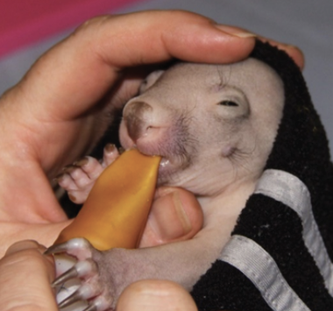
Figure 10.19: A common wombat weighing about 1 kg. Photo credit: Jenny Mattingley
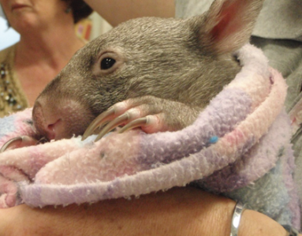

10.9. Release protocol
Ideally, wild animals will be rehabilitated and released in a short timeframe. If this is not possible and the animal is in care for significant extended periods, ensure that the animal is regularly assessed against the welfare domains to support decision-making. Animals in care for extended periods may have a reduced ability to survive in the wild. Talk to your veterinarian and consider whether euthanasia will provide the best welfare outcome for the animal.

10.9.1. Pre-release assessment
Pre-release assessment of animals in care is essential to support improved outcomes once back in the wild. Animals should be assessed based on body condition, fitness and the ability to engage in natural species-specific behaviours prior to release.
The following check list should be used to guide decision-making regarding release suitability for wombats:
- Individual is in a state of good health; presenting injury/sickness is completely resolved (consider pre-release veterinary check).
- Individual is within a healthy weight range and appropriate body condition.
- Individual displays ability to actively forage for and consume natural foods found in the release location.
- Individual shows appropriate fear responses to humans and dogs.

10.9.2. At the release site
Post release survival will be maximised by ensuring that both the release site and the way in which the animal is released are carefully considered.
Important factors about the site to consider before releasing a wombat:
- Sloping ground to assist in making a burrow, some forest cover to avoid predators and the presence of grass for feed.
- Wombat burrows are commonly found within 200 m of a watercourse.
- For more information on the ecological characteristics and requirements of common wombats that may help with their release, please refer to Table 10.1 of this chapter.

10.9.3. Release checklist
Check all of the requirements of your authorisation are being met, and consider the following:

Release location
- Release where the wombat was found (where suitable, or within home range).
- Suitable vegetation is available, including grasses and dense lower storey vegetation.
- Ample foraging areas close to dense vegetation and away from roads.
- Dense vegetation cover for burrow building.
- Soil layer soft and suitable for foraging/digging.

Release Procedure
- Limit the number of people at the release.
- Appropriate timing (one hour after dusk – during natural peak activity).
- If possible, find a suitable, unoccupied burrow within approximately 150 m of where the wombat was originally found. Occupied burrows will have scats, tracks, and loose soil at the entrance. A wombat should not be released into an occupied burrow.
- Open transport container away from yourself, near dense cover, ensuring people are standing behind the animal’s flight zone.
- Allow the wombat to leave in its own time.
Figure 10.20: a. An occupied burrow. A wombat is visible at the entrance, which appears clear of vegetation and has a worn path leading from it. b. An unoccupied burrow. Vegetation has grown around the entrance and no paths leading from the burrow are seen. Photo credit: Anne Fowler, Emily Small
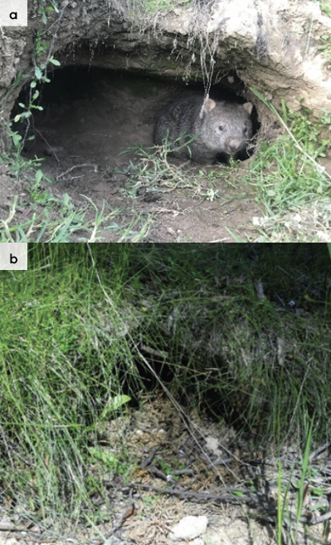

10.10. Key references and additional reading
http://www.australasianzookeeping.org/Husbandry%20Manuals/wombat_husbandry_manual.pdf
https://taswildlife.org/wp-content/uploads/2016/12/Bare-Nosed-Growth-and-Feeding-Chart.pdf
http://nswfmpa.org/Husbandry%20Manuals/Published%20Manuals/Mammalia/Common%20Wombat%20(Elliott).pdf
Triggs, B. 2002. The Wombat. UNSW Press, Sydney

