|  |
| --- |
| The Victorian Corella Strategy  2022-2032 |

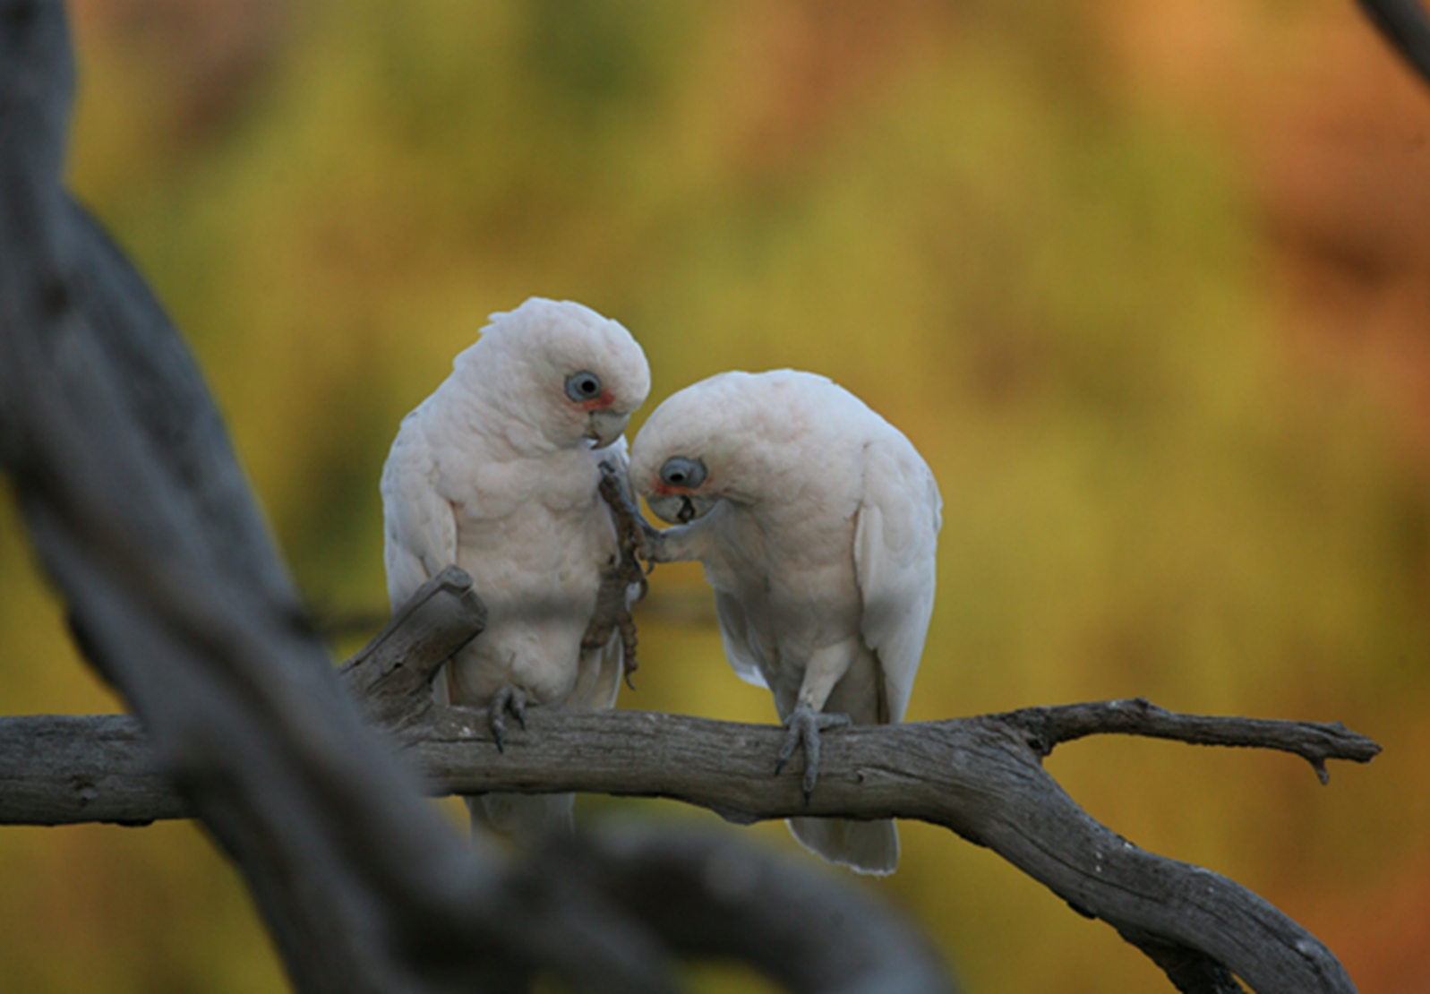

Acknowledgements

The Department of Energy, Environment and Climate Action acknowledges the individuals and organisations who helped to develop the strategy. We thank you for sharing your knowledge and time with us.

|  |
| --- |
| Acknowledgment  We acknowledge and respect Victorian Traditional Owners as the original custodians of Victoria's land and waters, their unique ability to care for Country and deep spiritual connection to it. We honour Elders past and present whose knowledge and wisdom has ensured the continuation of culture and traditional practices.  We are committed to genuinely partner, and meaningfully engage, with Victoria's Traditional Owners and Aboriginal communities to support the protection of Country, the maintenance of spiritual and cultural practices and their broader aspirations in the 21st century and beyond. |
| © The State of Victoria Department of Energy, Environment and Climate Action 2023  LogoThis work is licensed under a Creative Commons Attribution 4.0 International licence. You are free to re-use the work under that licence, on the condition that you credit the State of Victoria as author. The licence does not apply to any images, photographs or branding, including the Victorian Coat of Arms, the Victorian Government logo and the Department of Energy, Environment and Climate Change (DEECA) logo. To view a copy of this licence, visit <http://creativecommons.org/licenses/by/4.0/>  ISBN 978-1-76105-946-9 (pdf/online/MS word)  Disclaimer  This publication may be of assistance to you but the State of Victoria and its employees do not guarantee that the publication is without flaw of any kind or is wholly appropriate for your particular purposes and therefore disclaims all liability for any error, loss or other consequence which may arise from you relying on any information in this publication.  Accessibility  If you would like to receive this publication in an alternative format, please telephone the DEECA Customer Service Centre on 136186, email [customer.service@delwp.vic.gov.au](mailto:customer.service@delwp.vic.gov.au) or via the National Relay Service on 133 677 [www.relayservice.com.au](http://www.relayservice.com.au). This document is also available on the internet at [www.delwp.vic.gov.au](http://www.delwp.vic.gov.au). |

Contents

Executive Summary 5

Introduction 5

Policy and legislative context and role of government 6

Principles 6

Outcomes 6

Traditional Owners 7

Overview of corella species 8

Description 8

Distribution and populations 10

Corella impacts 10

Climate change 12

Community 12

Management issues, strategies and actions 13

Issue 1 – Range expansion 14

Management issues 14

Management options 14

Strategies 14

Actions 14

Issue 2 – Impacts on agriculture 14

Management issues 14

Management options 14

Strategies 15

Actions 15

Issue 3 – Impacts on infrastructure 15

Management issues 15

Management options 15

Strategies 16

Actions 16

Issue 4 – Impacts on communities 17

Management issues 17

Management options 17

Strategy 17

Actions 17

Issue 5 – Animal welfare 19

Management issues 19

Management options 19

Strategy 19

Actions 19

Issue 6 – Loss of nesting trees 19

Management issues 19

Management options 19

Strategy 20

Actions 20

Issue 7 – Social and economic costs of corella damage 20

Management issues 20

Management options 20

Strategy 20

Actions 20

Issue 8 – Lack of understanding of economic, social, cultural, and environmental value of corellas 21

Management issues 21

Management options 21

Strategies 21

Actions 21

Implementation and review 21

Appendix 1. Methods to manage issues caused by corellas 23

Appendix 2. Summary of strategies and actions 25

References 1

Image credits 3

# Executive Summary

Victoria's two corella species, the Long-billed Corella and the Little Corella, are intelligent, conspicuous, iconic cockatoos. Their noisy communal roosting impacts on infrastructure and agriculture and can lead to challenging human-wildlife interactions. On the other hand, their engaging play activities and the spectacle of large flocks flying or feeding on the ground are enjoyed by the community.

Recent years have seen an increase in interactions between the Victorian community and corellas. Some key contributing factors include demographic changes including urbanisation and population increase as well as other factors such as climate change, agricultural practices and modified environments. This can lead to tensions between the need to control corellas to protect assets and agriculture and increased awareness and concern for wildlife, particularly about welfare.

Victorian communities interacting with corellas have diverse values and expectations in relation to their management.  Understanding these values at place is integral to communities working together and with the Victorian Government to deliver positive outcomes for the community and for the corellas.

This strategy focuses on the key management issues relating to corella management in Victoria, including range expansion, impacts on agriculture, impacts on infrastructure, impacts on communities, animal welfare, loss of nesting trees, social and economic costs of corella damage and economic, social, cultural and environmental value.

Strategies and actions have been developed to address each of these management issues through a comprehensive engagement process with the key stakeholders.

A collaborative strategy will encourage community owned solutions and improved management of the impacts of corellas and interactions between corellas and communities. The strategies and actions outlined in this document will contribute to the following long-term outcomes:

* Protection of animal welfare
* Healthy and sustainable wildlife populations and habitat
* Reduced impact of wildlife on environmental, social, cultural and economic assets and values
* Community values wildlife and contributes to wildlife management.

# Introduction

The Victorian Corella Strategy was developed in consultation with Traditional Owner groups, Birdlife Australia, Victorian Local Governments, feedlot operators, grape growers, Wildlife Victoria and Australian Sports Turf Management Association.

Recent years have seen an increase in interactions between the Victorian community and corellas. Some key contributing factors include demographic changes including urbanisation and population increase as well as other factors such as climate change, agricultural practices and modified environments. This can lead to tensions between the need to control corellas to protect assets and agriculture as well as increased awareness and concern for wildlife, particularly about welfare.

The area over which these undesired interactions occur has increased in recent decades resulting in challenges such as damage to cereal crops, playing surfaces and to a variety of private and public infrastructure. The varying views and aspirations of different communities mean that responses to apparently similar situations may differ.

## Policy and legislative context and role of government

The management of wildlife including corellas is a shared responsibility across multiple levels of government and the community.

The objectives of biodiversity conservation outlined in the *Protecting Victoria’s Environment – Biodiversity 2037* guides the overall management approaches for wildlife.

In Victoria corellas are protected under the *Wildlife Act 1975* which makes it an offence to destroy, take or control wildlife without appropriate authorisation. DEECA sets policy and strategy relating to wildlife management and administers the Act and its associated regulatory instruments through the Conservation Regulator. DEECA can also provide policy and technical advice to assist landowners, managers, and occupiers to manage impacts caused by wildlife on their land.

A Governor in Council (GIC) Order of 2 July 1996 declared the Long-billed Corella, Sulphur-crested Cockatoo and Galah “unprotected wildlife”, under the Wildlife Act in certain circumstances and in identified areas of the state.  Landowners or occupiers and committees of management (CoM) are permitted under the GIC Order to control these species on their land, where they are causing severe damage to trees, vineyards, orchards, recreational reserves, or commercial crops.

Little Corellas remain protected, but an Authority to Control Wildlife (ATCW) can be applied for this species if necessary.

The *Prevention of Cruelty to Animals Act 1986* (the POCTA Act) sets out the laws that seek to protect all animals from acts of cruelty and suffering. The POCTA Act is administered by the Department of Jobs, Precincts and Regions (DJPR) and applies to both wild and domestic animals.

## Principles

* The success of this strategy will be dependent on effective communication and collaboration between relevant agencies, industry, and the broader community. The principles underlying this strategy are:
* Corellas are native wildlife and managing their impacts is a shared responsibility between communities, industries, and the Victorian Government.
* Wildlife is a part of the cultural heritage of Victoria’s Traditional Owners.
* Strategies and actions should enable collaborative solutions and focus on education in managing corella impacts.
* Management decisions for corellas are made based on the best available information and adaptive management approaches.
* Where the control of corellas is justified, it must be delivered in a way that is appropriate and humane.

## Outcomes

The implementation of the Corella Strategy will contribute to the objectives of biodiversity conservation outlined in the ‘Protecting Victoria’s Environment – Biodiversity 2037’. These include better understanding and response to key threats and opportunities as well as partnerships with Traditional Owners in managing biodiversity across Victoria.

The strategy promotes a ‘living with wildlife’ approach to encourage positive attitudes to corellas, as part of a broader strategy for management of native wildlife in Victoria. It aims to achieve long-term outcomes for wildlife and for the community through:

* Protection of animal welfare
* Healthy and sustainable wildlife populations and habitat
* Reduced impact of wildlife on environmental, social, cultural and economic assets and values
* Community values wildlife and contributes to wildlife management.

# Traditional Owners

The Victorian Government is committed to understanding Aboriginal biodiversity values and uses by working in respectful partnership with Traditional Owners. It recognises that the connection of Traditional Owners with Country is the result of a long history and the unique role and status of Traditional Owners in biodiversity conservation and management of wildlife.

The beliefs, laws and traditions and a connection with the land and waters of Traditional Owners are the foundation of their cultural identities.

The Victorian Government will ensure that the implementation of the strategy appropriately considers impacts on Aboriginal interests, including native title rights and cultural heritage, through further engagement with the Traditional Owners.

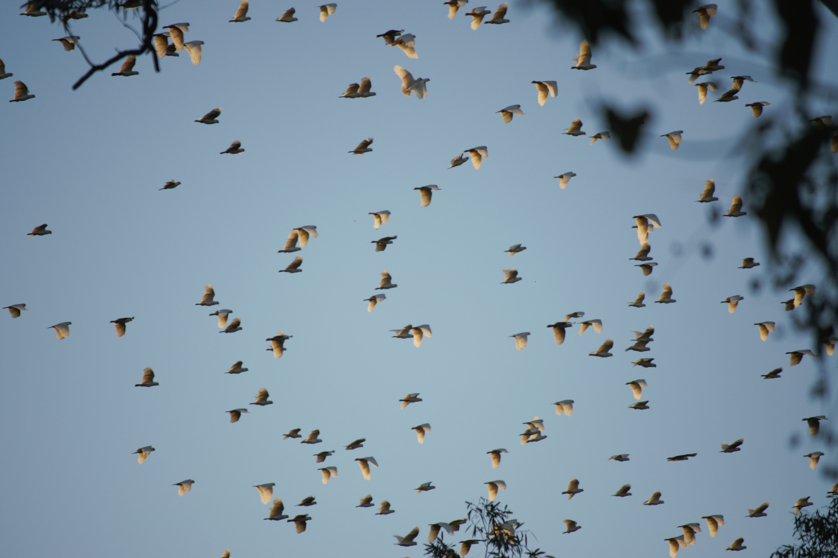

# 

# Overview of corella species

Victoria's two corella species, the Long-billed Corella and the Little Corella, are intelligent, conspicuous, iconic cockatoos. Their noisy communal roosting impacts on infrastructure and agriculture and can lead to challenging human-wildlife interactions. On the other hand, their engaging play activities and the spectacle of large flocks flying or feeding on the ground inspire the admiration and enjoyment of the community.

## Description

**The Little Corella** (*Cacatua sanguinea)* (Figure 1) is one of 14 species of cockatoos in the subfamily *Cacatuidae* in Australia, which includes all cockatoos and the Cockatiel *Nymphicus hollandicus*.  The Little Corella is 350-400 mm in total length, weighs 430-580 gm, is white above and below, with an upright white crest raised when the bird is aroused.  The undersides of the wings and tail have a yellow wash.  The bill is light blue-grey to whitish and the large naked eye ring is blue.  There is an area of pink to red on the lores, sometimes forming a band over the bill.  The sexes are externally indistinguishable.  The sub-species in Victoria is *Cacatua sanguinea gymnopis*.

Figure 1. The Little Corella (*Cacatua sanguinea*)

**The Long-billed Corella** (*C. tenuirostris)* is easily confused with the Little Corella but can be distinguished from that species by several features (Figure 2).  The Long-billed Corella is about 400 mm in total length, average weight 540-580 gm, is white above and below, with a short white crest raised when the bird is aroused.  The undersides of the wings and tail have a very faint yellow wash.  The bill is bone white with a very long and narrow upper mandible and the naked eye ring is light grey-blue.  There is an area of orange-red on the lores, forming a band over the bill and extending behind the eye, and a reddish crescent on the lower neck.  The sexes are externally indistinguishable.

Figure 2 The Long-billed Corella *(Cacatua tenuirostris)*

## Distribution and populations

Both the Long-billed Corella and Little Corella species have increased their population and range across the state, and they are now common not only in many rural towns but in urban areas of Melbourne as well. Due to climate change, changing farming practices, clearing of bushland for developments and the creation of modified open spaces such as recreation facilities corellas may continue to expand their range. They are likely to remain in areas they inhabit if food and shelter is available.

Monitoring the size of the corella population is difficult.  In the cooler months, the birds are dispersed in suitable habitat, making counting difficult, while in summer, large flocks roost quietly during the heat of the day and can easily be missed.  There is, however, little doubt that both corella species’ populations have increased over the past 30 years in Victoria, with the range expansions of both species being one possible indicator of this, but the magnitude of the population increases is unknown.

Recent modelling by the Arthur Rylah Institute for Environmental Research estimated that there are approximately 5.2 million Long-billed Corella and 2.9 million Little Corella in Victoria. The populations of both species have further increased since 2010, likely due to improved environmental conditions following the end of the Millennium Drought. The Little Corella has increased in density in western Victoria, while the Long-Billed Corella has increased in north-central Victoria. Figure 3 illustrates the predicted densities of both corella species across Victoria.

Figure 3. Predicted densities (individuals per hectare) of the two corella species across Victoria (lighter colour indicates higher predicted density).

The Long-billed Corella occurs in grassy woodlands, particularly those dominated by River Red Gums, but also where plantations of non-indigenous eucalypts and exotic conifers have been established and created elements of a grassy woodland.

The Little Corella, in contrast, was until recently a bird of inland waterways, seldom seen anywhere in southern Victoria. However, over the past 40 years it has expanded its range into southern and eastern areas of the state.  It is now a common species in many parts of Victoria, including many suburban areas of Melbourne, and throughout Gippsland.  The reasons for this rapid expansion of range are not clear but likely to be related to expansion of grain cropping and availability of onion grass.

## Corella impacts

Complaints about damage caused by Long-billed Corellas in Victoria began in the 1960s but were infrequent, reflecting the smaller distribution and relatively low numbers of corellas at that time.  Complaints increased during the 1970s, mostly in the Wimmera, and by the 1980s were being received from many parts of western Victoria where cereal crops were being grown.

Large numbers of corellas of both species are now frequent in many towns, and corella impacts are common across the state. As a result, community concerns of damage to commercial and community infrastructure associated with these birds have increased.

As predominantly ground-feeding birds, the impacts of corellas in agriculture are largely to annual crops, particularly cereal crops. Damage to cereal crops can occur at the sowing and germination phase, and at the “milky” stage of grain formation. Corellas can also cause damage in vineyards, where they may prune growing vines in spring, and prune off bunches of grapes in late summer.

A range of impacts on infrastructure includes damage to plumbing, shade sails, light fittings, antennae, roofing, streetlights, electrical wiring, and sports grounds. Damage to sports grounds playing surfaces including golf courses, football ovals, basketball courts, bowling greens and tennis courts are all caused by corellas digging holes, usually in the search of food (Figure 4).

Noise caused by large flocks of corellas is a source of frustration for many communities.

Corellas are dispersed during the cooler months of the year, feeding largely on onion grass corms, however, flocks also gather in germinating crops.  During these months, corellas are less conspicuous, and many people are unaware of their presence. Post-breeding aggregations of large flocks with noisy fledgelings around towns lead many to think that their population has “exploded”, when this is simply a normal part of their annual behavioural cycle.

Strategies to manage corella impacts or to control corellas range from wide variety of scaring methods to exclusion and lethal control.

One of the first options considered when faced with problems caused by wildlife is to reduce numbers to mitigate impact. In practice, this approach is not always effective, particularly for birds, due to their ability to move across the landscape in search for food and suitable habitat.

Corellas are highly intelligent and rapidly habituate to most measures employed to deter them other than physical exclusion unless they perceive real danger to be associated with the scaring measures.

Figure 4: Damage to a green (Kilmore, Victoria).

# Climate change

The CSIRO Report *State of the Climate 2020* shows that for the southeast of the continent, seasonal rainfall for the period 2000 to 2019 has decreased by around 12 per cent. There is an overall drying trend for the state of Victoria.

Aggregations of corellas at summer food sources disperse with rainfalls in autumn.  Declining and less predictable rains in autumn may lead to growing cereal crops, one of the main food sources for corellas in summer, further south. With declining cool-season rainfall corellas would remain on modified areas such as sports fields for longer periods leading to increased human-wildlife conflicts with corellas in both towns and agricultural settings.

This highlights the need for improved community education, better information sharing, and tools and strategies to support the community's adaptation to climate change driven impacts by corellas.

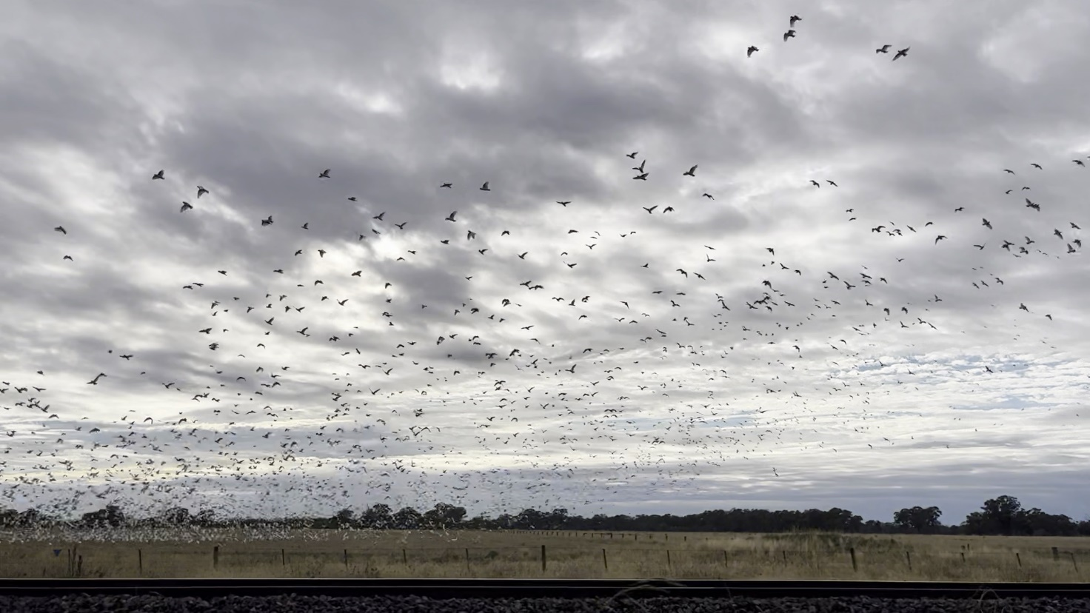

# 

# Community

There is a community expectation that the Victorian Government provides leadership in facilitating solutions for increasing conflicts between people and wildlife, while also protecting them from harm. Balancing these competing roles is complex and the Victorian Government plays a key role through providing policy direction, advice and facilitating collaboration within communities.

The corella management actions outlined in this strategy are aimed at facilitating collaboration and partnerships between land managers, interest groups and communities to achieve positive outcomes for the community and corellas.

Victorian communities interacting with corellas have diverse values and expectations in relation to their management.  Figure 5 below outlines the key factors driving community interest in corella management.

Figure 5. Factors surrounding community interest in corella management.

# Management issues, strategies and actions

This strategy focuses on the key issues relating to corella management in Victoria. These issues are:

1. Range expansion
2. Impacts on agriculture
3. Impacts on infrastructure
4. Impacts on communities
5. Animal welfare
6. Loss of nesting trees
7. Social and economic costs of corella damage
8. Economic, social, cultural, and environmental value

This section describes these management issues and the current and future management options available to address them. Further description of the management options is provided in Appendix 1. Methods to manage issues caused by corellas.

Strategies and actions have been developed to address each of these management issues through a comprehensive engagement process with the key stakeholders. The strategies and actions are presented in this section and a summary reference table is provided in Appendix 2. Summary of strategies and actions.

## Issue 1 – Range expansion

### Management issues

* The expanding range of corella populations results in increased corella impacts and increases the chance of human-wildlife conflicts.
* Factors contributing to the range expansion are not well understood, however it is believed that corella population growth is a critical factor as well as agriculture and cropping providing feeding opportunities for corellas.

### Management options

Preventing range expansion is a significantly challenging objective as there are few practical options for managing the future expansion of both species in Victoria. The focus of management is best directed to improving our understanding of and sharing information on corellas’ current and future potential range in order to proactively manage local issues and risks of conflict.

|  |
| --- |
| Strategies Improve community, industry and government’s understanding of the expanding range of corellas to inform shared approaches to proactively managing impacts.  Proactively plan for corella impacts where corellas are expected to expand their range and as part of planning new land use and infrastructure developments within their current range. |

### Actions

|  |  |
| --- | --- |
| 1.1 | Raise community awareness and understanding of corella ecology, behaviour and distribution through improved public information and education initiatives. |
| 1.2 | Support and undertake research that builds on the current understanding of corella ecology, behaviour and distribution. Research will inform improved corella population modelling and determining the triggers for range expansion of corellas to inform proactive management options. |
| 1.3 | Apply research outcomes to develop more sophisticated, evidence-based approaches to proactively manage issues arising from corella range expansion and communicate the most up to date information to community, industry and stakeholders. |

## Issue 2 – Impacts on agriculture

### Management issues

* The impacts of corellas on agriculture are largely to annual crops, particularly cereal crops, of which, oat crops are most affected.
* The extent of damage varies and can be difficult to assess. While individual crops can be severely damaged, it is typical for most crops to have little or no damage.
* A major impediment to assessing the cost-effectiveness of corella deterrent measures, is the lack of methods for measuring and reporting damage caused by corellas.
* Corellas can also cause damage to vineyards in western Victoria, where they may prune growing vines in spring, and prune off bunches of grapes in late summer.
* Corellas are a minor contributor to losses in horticultural crops, particularly nut crops, where damage by Galahs and Sulphur-crested Cockatoos is of far greater significance.

### Management options

One of the first options considered when faced with problems caused by wildlife is to reduce numbers to mitigate their impact. In practice, this approach is not always effective, particularly for corellas, due to their ability to move across the landscape in search for food and suitable habitat.

The most effective option is to deter birds from places where they cause impact to minimise damage. In the case of crops or grain and seed handling sites, this can be undertaken through the provision of decoy foods, scaring strategies, use of alternative crops that are not preferred by corellas, crop screening, and crop design and management strategies. These approaches are described in Appendix 1. Methods to manage issues caused by corellas.

|  |
| --- |
| Strategies Improve community, industry and government’s understanding of best practice methods to reduce the impacts of corellas on agriculture.  Promote implementation of best practice methods of reducing negative impacts of corellas within Victoria’s agricultural industry. |

### Actions

|  |  |
| --- | --- |
| 2.1 | Develop and distribute up-to-date, accessible information for Victorian farmers and industry partners on best management practices to reduce the impact of corellas on agriculture. |
|  | Examples of current best practice management strategies for reducing the impacts of corellas on agriculture include scaring strategies, use of alternative crops, crop screening, and crop design and management strategies. |
| 2.2 | Support and undertake priority research and development tasks to improve current approaches to managing the impacts of corellas on agriculture, including improving damage assessment methods and evaluating new and emerging management techniques. |

## Issue 3 – Impacts on infrastructure

### Management issues

* Corellas gather in large flocks over summer, and roost both by day and night around buildings on farms, in towns, and in urban areas. Within this environment, corellas can damage infrastructure through chewing and digging behaviours.
* Corellas have been reported damaging a range of items including polythene pipe, hot water systems on roofs, irrigation pipes, sprinkler fittings, tyre valves, hoses on machinery, shade sails, light fittings, antennae, rubber washers under roofing screws, timber decking and insulation on electrical wires.
* Corellas may also dig in a variety of playing surfaces for food, or damage artificial playing surfaces. Playing surfaces including golf courses, football ovals, basketball courts, bowling greens and tennis courts are all damaged by corellas digging holes, usually in the search for food.
* Corellas that congregate close to airport runways to feed or collect grit can be a hazard to aircraft.
* This damage can be costly to rectify and can be a cause of frustration for affected people, particularly as the damage is often repeated.

### Management options

Corella-proofing is the main management option to reduce impacts on infrastructure. Preventing damage to infrastructure is possible in some instances by excluding the birds or making perching difficult or uncomfortable.

Ideally, corella proofing should be implemented during the planning stage for any infrastructure development in areas where corellas may be present or may move within range expansion. Currently, much infrastructure planning is undertaken without potential vulnerability to wildlife damage being considered.

The use of decoy food sources and scaring strategies used in agricultural settings can be equally useful in built-up areas, however greater consultation with the community and consideration to factors such as noise restrictions are required.

All these management options are described in Appendix 1. Methods to manage issues caused by corellas.

|  |
| --- |
| Strategies Improve community, industry and government’s understanding of best practice methods to reduce impacts of corellas on infrastructure.  Promote implementation of best practice methods for reducing impacts of corellas on infrastructure and proactively mitigating potential risks of corellas through improved infrastructure planning. |

### Actions

|  |  |
| --- | --- |
| 3.1 | Raise asset managers’ and owners’ awareness and understanding of best management practices to reduce the impact of corellas on infrastructure through improved public information and education initiatives. |
|  | Examples of current best practice methods for reducing impacts of corellas on infrastructure include implementing deterrent or exclusion methods, providing decoy food sources, and removing known sources of attraction. |
| 3.2 | Investigate the use of planning processes to reduce the risk of future damage by corellas and other cockatoos when infrastructure projects are being developed and apply a risk management approach in land and infrastructure planning processes where impacts may occur. |
| 3.3 | Support and undertake priority research and development tasks to inform and improve approaches to managing risks and issues arising from corella impacts to infrastructure. |
|  | Examples of areas for further research and development include methods of corella-proofing vulnerable infrastructure (electrical cables, irrigation systems, street light sealing and roofing screws) and the use of food additives for deterring corellas and other birds at feedlots. |

## Issue 4 – Impacts on communities

### Management issues

* Many people are affected in a variety of ways by the presence of corellas including through noise disturbance, loss of amenity, damage to both private and public infrastructure and consequent fixation on corellas.
* Corellas are highly vocal and communicate loudly and frequently. While the corellas can be quiet at times when roosting at night and while resting during the day, they will periodically start calling en-masse especially at dawn and dusk.
* Whenever corellas are roosting in trees, they prune twigs off and the ground below roosting trees is often littered with pruned material. This material can create a trip or slip hazard in urban areas and many people find it unsightly. Stripping of the tops of trees also create an aesthetic impact, particularly within townships.
* Compounding the challenges posed by corellas are conflicts within communities when there are opposing views about the need to “do something” about the birds, and the methods that may be proposed.

### Management options

The social impacts from corellas can be reduced through the provision of accurate information and through education. This improves the community’s understanding of corellas and what can, and cannot, be done about their impacts.

Scaring and decoy feeding strategies and reducing impacts to agriculture and infrastructure through deterrents and exclusion methods can also be used to reduce the issues people have with corellas.

The use of decoy food sources and scaring strategies (refer to management options for agriculture) requires consultation with the community and consideration of factors such as noise restrictions particularly in built up areas.

Management options are described further in Appendix 1. Methods to manage issues caused by corellas.

Community impacts are best managed through collaboration with key stakeholders. Networks and partnerships can be established through formal or informal processes e.g. discussing and exchanging information at meetings/forums or establishment of partnership agreements and Memorandum of Understanding (MOUs).

|  |
| --- |
| Strategy Increase community awareness and understanding of corella behaviour and potential impacts.  Improve community understanding of best practice methods of reducing potential impacts of corellas.  Foster a shared approach of managing impacts of corellas on communities with local ownership and commitment, with a focus on long-term outcomes. |

### Actions

|  |  |
| --- | --- |
| 4.1 | Raise community awareness and understanding of corella behaviour, potential impacts, and best practice methods of reducing impacts through improved public information and education initiatives. |
| 4.2 | Establish and maintain community partnerships and networks that share information and develop action plans to manage corella impacts. |
|  | Examples include establishing local, regional or state-wide networks focusing on specific locations or industries to collaboratively share, plan and implement actions. |
| 4.3 | Implement integrated, community-based approaches to managing corella impacts informed by community views and values and best-practice approaches to reducing risks. |
|  | Examples include approaches that use multiple methods deployed at different locations, such as scaring and decoy feeding strategies at multiple locations. |
| 4.4 | Work with communities and stakeholders to identify geographic sites and infrastructure with features that attract corellas (such as grain storage and processing facilities) and develop solutions to reduce potential impacts. |
| 4.5 | Support and undertake priority research and development tasks to inform and improve approaches to managing risks and issues arising from corella impacts on communities. |
|  | Opportunities for further research include evaluating the effectiveness of different scaring and corella diversion techniques. |

## Issue 5 – Animal welfare

### Management issues

* Lethal control by shooting of Long-billed Corellas is permitted under GIC order where they are causing specific types of damage. The lethal control of Little Corellas can be authorised under the conditions of an ATCW if such control is necessary. These lethal control options cause community concerns for animal welfare.
* In some instances, other approaches to lethal control are not applied using best practice and may be inhumane, dangerous, illegal and subject to penalties.

### Management options

Use of a range of non-lethal damage mitigation measures that are humane and minimise adverse welfare issues should be considered as the first option.

Where lethal control (shooting is the only legal option) of corellas is required and permitted, it must be undertaken in the most humane way possible, with any injured birds euthanised humanely.

There are several laws that make up the regulatory framework for the protection of wildlife in Victoria including animal welfare laws (refer to Policy and legislative context and role of government). The Victorian Government undertakes a range of activities to support compliance with these laws including education, compliance support, and enforcement.

|  |
| --- |
| Strategy Increase community awareness and understanding of animal welfare issues and promote use of non-lethal methods to manage the impacts of corellas.  Improve community understanding of relevant legislation and regulations relating to animal welfare and wildlife protection. |

### Actions

|  |  |
| --- | --- |
| 5.1 | Raise community, industry, and stakeholders’ awareness and understanding of legal and humane methods of reducing potential impacts of corellas through improved public information and education initiatives. |

## Issue 6 – Loss of nesting trees

### Management issues

* Many species of fauna use tree hollows for shelter, nesting, or roosting. While not known to be an issue for corellas at present, the loss of this resource is likely to be a future challenge for corellas.

### Management options

Support the establishment and protection of hollow bearing trees through:

* Retention of isolated paddock trees, whether living or dead.
* Planting of replacement trees for long-term succession in agricultural landscapes.
* Fencing off remnant trees or patches to facilitate natural regeneration.

|  |
| --- |
| Strategy Promote the protection and regeneration of hollow bearing trees through education and incentives. |

### Actions

|  |  |
| --- | --- |
| 6.1 | Promote the protection and regeneration of hollow bearing trees through improved public information for landowners and public land managers. |
| 6.2 | Promote opportunities for grants and other incentives that encourage and invest in the protection and regeneration of hollow bearing trees. |

## Issue 7 – Social and economic costs of corella damage

### Management issues

* There are economic costs associated with corella damage to agriculture, horticulture, infrastructure and amenity. Corellas can also cause disturbance for residents and visitors with flow on social and economic impacts. These issues impact both individuals and communities.
* There is a lack of data available on the social and economic costs associated with corella damage. This reduces the ability to understand the scale of economic and social impacts and enable assessment of the cost-effectiveness of management strategies.

### Management options

Improve our understanding of and capacity to assess the scale of economic and social costs associated with corella damage. This could include, for example, the development of methods for cereal crop damage assessment and yield reduction.

|  |
| --- |
| **Strategy** Support the development of methods and systems for understanding and evaluating corella damage to enable cost-benefit assessment of management strategies. |

### Actions

|  |  |
| --- | --- |
| 7.1 | Promote the establishment of data collection methods and systems that will improve current understanding of and measure the costs of corella impacts across the agricultural sector, infrastructure and communities. |
|  | This includes the collation of measured costs to infrastructure and communities by corellas, so that cost-benefit assessment of deterrence strategies is possible. |
| 7.2 | Develop an understanding of the social and economic benefits and trade-offs associated with different corella management options to inform cost-benefit assessments. |

## Issue 8 – Lack of understanding of economic, social, cultural, and environmental value of corellas

### Management issues

* While it is understood that corellas provide economic, social, cultural and environmental values, these benefits have not been assessed and documented.
* These values include economic benefits from tourism where tourists enjoy seeing large flocks of cockatoos, including corellas.
* Communities also value their presence for a range of reasons.
* There is an opportunity for Traditional Owners to be involved in improving our approaches to management of corellas.
* Digging activity of corellas in rural areas may have benefits for soil health. For example, increasing fertility through incorporation of vegetable matter and creating a seedbed for a variety of plants. This process is well documented for small native mammals that dig for their food, similarly for corella digging.

### Management options

Assess community views on the economic, social, cultural, and environmental value of corellas and promote community understanding and awareness.

Improve partnerships and information sharing with Traditional Owners in relation to corella management.

|  |
| --- |
| Strategies Develop a greater understanding of community views on corellas and their economic, social, cultural and environmental value to inform management approaches.  Establish and maintain partnerships to ensure ongoing information sharing on the cultural value of corellas for Traditional Owners and incorporate traditional knowledge in the management of corella impacts. |

### Actions

|  |  |
| --- | --- |
| 8.1 | Promote broader understanding of the economic, social, cultural and environmental value of corellas through improved public awareness and education initiatives and information sharing across stakeholders. |
| 8.2 | Establish and maintain partnerships with Traditional Owners and support their use of traditional knowledge in managing corellas and their self-determination in managing Country. |
|  | For example, provide opportunities for Traditional Owner leadership of and involvement in corella monitoring and management. |
| 8.3 | Develop a greater understanding of community views about corellas and the economic, social, cultural and environmental values of corellas through engagement and research to inform management approaches and cost-benefit assessments. |

# Implementation and review

An implementation plan including a monitoring, evaluation and reporting approach will be developed to implement the Corella Strategy.

The following organisations and communities impacted by corellas are the potential partners and, where relevant, will be invited to collaborate to deliver the strategy. The nature of partnerships will be outlined as part of the development of the implementation plan through relevant consultation processes:

* Local Governments
* Department of Jobs, Precincts and Regions
* Parks Victoria
* Traditional Owners
* Wildlife/Welfare organisations (e.g. Wildlife Victoria, Birdlife Australia)
* Industry (e.g. Australian Turf Managers Association, Graincrop)
* Victorian Farmers Federation
* Research Institutions (e.g. Universities, Arthur Rylah Institute)
* Other land managers (e.g. Farmers, delegated land managers) and community groups

The strategy will be reviewed to ensure that it is an effective tool for the community to manage corella issues in the long-term and reflect any policy changes, new information and techniques.

# Appendix 1. Methods to manage issues caused by corellas

The following table describes methods that can be used to manage the issues caused by corellas in different situations. This includes addressing issues in agriculture and horticulture, and where they are causing problems for infrastructure and communities.

The methods below are usually most effective when used in combination through a strategic integrated approach.

| Method | Description |
| --- | --- |
| Scaring program | If the aim is to encourage the corellas to roost or feed elsewhere, then a scaring program can be beneficial.  Examples include the use of noises (gas guns, whip cracking, recorded alarm calls), bird of prey silhouettes or kites, pyrotechnics.  This can be an effective method where corellas are an issue in agriculture or for infrastructure and communities.  Most active scaring methods require an Authority to Control Wildlife (ATCW). If unsure, contact DEECA on 136186.  Scaring devices can be effective but requires an integrated approach using different devises to reduce habituation and often, where appropriate, some shooting to associate the scaring methods with real danger is required.  It requires coordination, persistence, a variety of scaring stimuli, motivated people and depending on the situation it is ideally part of an integrated strategy including removal of attractions such as easy food sources or provision of decoy food sources at suitably distant site(s).  Community consultation is required in townships and regulations such as noise restrictions need to be considered. Ideally, these methods are used at a time of low visitor use in townships or at other tourist attractions.  It is important to consider that there is little or no control over where the corellas will go if they are successfully deterred, and it is possible that they may create further problems at the new site.  Some of the devices that are sold have not been found to be effective. Ultrasonic noises are sounds that humans cannot hear – and neither can most birds, including corellas, whose range of hearing is similar to ours. Bird of prey calls are a popular part of some noise-making devices, yet birds of prey do not call when they are hunting; their calls are used when interacting with each other or defending their nesting territory. Their calls are meaningless to corellas and other birds. Artificial sounds have no biological meaning for birds and are unlikely to add much to a scaring strategy.  Gas guns can be effective provided they are used sparingly, supported by some real shooting, and moved to a new position every day or two. Recorded alarm calls and pyrotechnic cartridges can be useful components of a scaring strategy. Other scaring devices include a wide range of visual scarers, from scarecrows to ribbons, kites, artificial hawks, owls and snakes, mirrors of various kinds, including “Eagle Eyes”, and balloons or balls with large predator-type eyes. Some of these devices can have a role as part of an integrated scaring strategy, but the novelty of most of these devices wears off very quickly since they pose no threat, and they are therefore of no benefit if relied upon without being part of an integrated strategy. |
| Corella proofing - exclusion | Preventing damage is possible in some instances by excluding the birds or making perching difficult or uncomfortable.  Perching deterrents such as bird spikes can be useful for other species that prefer ledges, but there are few situations where it is useful to deter corellas. It may be of use on top of fences around tennis courts and best combined with other strategies. This option is most useful when there are few options for perching, or there are preferred perches where the birds land before they cause damage.  It may be possible to install “rolling perches” – sections of pvc pipe – on the arms of aerials to inhibit perching and damage to the aerials. These work by rolling when the bird tries to land, preventing it from doing so.  Nets are used extensively in vineyards to reduce bird damage – this kind of damage by corellas can be eliminated with netting.  Netting or shade cloth over bowling greens and certain other sporting venues may be feasible in some cases. |
| Infrastructure planning | Early planning of infrastructure development should consider potential susceptibility to bird damage and design accordingly to prevent or minimise damage by corellas.  Such planning is likely to avoid later expensive remedies to repair predictable damage by corellas. |
| Remove/relocate/cover food sources that attract corellas | If birds are attracted by local food sources that can be made unavailable, this may reduce frequency of visits by corellas.  Grain-handling facilities near towns frequently attract large numbers of corellas to spilled grain. Removing spilled grain could alleviate problems near such facilities. Enclosing grain storage sheds with nets or doors can also exclude birds.  Nets can be used over feedlots to exclude birds. |
| Make current food sources unpalatable | This involves making food sources distasteful to birds but harmless to stock. This method requires further research and needs to meet food safety standards and regulation. |
| Decoy food sources | This involves providing alternative food sources to corellas while crops are most susceptible. It has been shown to be cost-effective as a diversion method.  Providing an easily accessible alternative food source in this way is intended to divert birds away from sites where they are causing problems while feeding. If it is done at a time of year when food is not scarce, provision of extra food will not attract birds from other areas, or lead to population increase.  Provision of decoy crops and free feed sites is well-established practice in the USA, and in trials in South Australia where oats was fed to around 4,000 corellas over ten weeks while cereal crops were germinating, there was a 10-15-fold benefit over the cost of providing the feed, including wages. Elsewhere in Victoria, cereal crops were left untouched by corellas after rice hulls were dumped that provided an unplanned alternative food source. Onion grass corms, exposed by ploughing, attract corellas and can be used as a decoy food source instead of grain.  A decoy feeding site should be several hundred metres from the crop or site being protected, so that scaring activities there do not disturb birds at the decoy site. The site should be in the open, but with trees within 50-100 metres so that the corellas have a nearby vantage point to ensure there is no danger, and to which they can return readily if alarmed. It is a good idea to have the decoy site between the night roost and where they have been causing problems. Several small decoy sites may be more effective than one large one, since the birds are likely to show a preference for some sites over others. Clean oats grain is generally the best food to place at the decoy site. Placing the grain in a line, rather than a pile, may allow more birds to feed. |
| Alternative crops | Where a particular crop appears highly prone to damage by corellas, there is a good case for investigating whether other crops which could be grown on the same site would be commercially as viable, but less attractive, to the birds. Many Victorian farmers who used to grow sunflower, switched to safflower, a crop less severely affected by corellas, or have elected not to grow bird-attracting oilseeds at all, thereby limiting their options for crop rotation for sustainability. It should be noted that sunflower was only able to be grown in some years when conditions were suitable. Opportunity costs arising from not growing a particular crop may be substantial but are largely unquantified. |
| Crop design and management strategies | Since corellas usually attack the edges of maturing crops, it is beneficial to minimise the amount of edge in a crop.  Areas of poor germination due to waterlogging or bird damage at germination can create edges within the crop which could be vulnerable to later attack by corellas. |
| Visual screens | Shade cloth or other screens around tennis courts bowling greens and similar small areas can inhibit entry by corellas as they cannot then see approach of potential predators. |
| Removal of onion grass | Strategic removal of this key corella food source can reduce corella attraction to sites.  Removal on agricultural properties and social infrastructure such as golf courses and artificial playing surfaces. |
| Crop screening | Corellas generally feed at sites where they can see the approach of potential predators (chiefly birds of prey or people) and fly to safety if they feel threatened. Visual barriers, either living or artificial, that impede corellas’ view of the surroundings will inhibit their willingness to feed in such areas and facilitate scaring. Broadacre crops are seldom suited to this protective method but there may be situations where it is of value. Damage to sunflower crops in New South Wales was significantly reduced during trials over two seasons comparing screened to unscreened crops where a screen of forage sorghum was planted around the crop |

# Appendix 2. Summary of strategies and actions

The following table provides a list of the strategies and actions to be delivered through implementation of this Strategy to address the key management issues.

|  |  |  |
| --- | --- | --- |
| **ISSUE 1 – RANGE EXPANSION** | | |
| Strategy | Improve community, industry and government’s understanding of the expanding range of corellas to inform shared approaches to proactively managing impacts.  Proactively plan for corella impacts where corellas are expected to expand their range and as part of planning new land use and infrastructure development within their current range. | |
| Actions: | 1.1 | Raise community awareness and understanding of corella ecology and behaviour and distribution through improved public information and education. |
| 1.2 | Support and undertake research that builds on the current understanding of corella ecology, behaviour and distribution. Research will inform improved corella population modelling and determining the triggers for range expansion of corellas to inform proactive management options. |
| 1.3 | Apply research outcomes to develop more sophisticated, evidence-based approaches to proactively manage issues arising from corella range expansion and communicate the most up to date information to community, industry and stakeholders. |
| **ISSUE 2 – IMPACTS ON AGRICULTURE** | | |
| Strategies | Improve community, industry and government understanding of best practice methods to reduce the impacts of corellas on agriculture.  Promote implementation of best practice methods of reducing negative impacts of corellas within Victoria’s agricultural industry. | |
| Actions: | 2.1 | Develop and distribute up-to-date, accessible information for Victorian farmers and industry partners on best management practices to reduce the impact of corellas on agriculture. |
| 2.2 | Support and undertake priority research and development tasks to improve current approaches to managing the impacts of corellas on agriculture, including improving damage assessment methods and evaluating new and emerging management techniques. |
| **ISSUE 3 – IMPACTS ON INFRASTRUCTURE** | | |
| Strategies | Improve community, industry and government’s understanding of best practice methods to reduce impacts of corellas on infrastructure.  Promote implementation of best practice methods for reducing impacts of corellas on infrastructure and proactively mitigating potential risks of corellas through improved infrastructure planning. | |
| Actions: | 3.1 | Raise asset managers’ and owners’ awareness and understanding of best management practices to reduce the impact of corellas on infrastructure through improved public information and education initiatives. |
| 3.2 | Investigate the use of planning processes to reduce the risk of future damage by corellas and other cockatoos when infrastructure projects are being developed and apply a risk management approach in land and infrastructure planning processes where impacts may occur. |
| 3.3 | Support and undertake priority research and development tasks to inform and improve approaches to managing risks and issues arising from corella impacts to infrastructure. |
| **ISSUE 4 – IMPACTS ON COMMUNITIES** | | |
| Strategy | Increase community awareness and understanding of corella behaviour and potential impacts.  Improve community understanding of best practice methods of reducing potential impacts of corellas.  Foster a shared approach of managing impacts of corellas on communities with local ownership and commitment, with a focus on long-term outcomes. | |
| Actions: | 4.1 | Raise community awareness and understanding of corella behaviour, potential impacts, and best practice methods of reducing impacts through improved public information and education initiatives. |
| 4.2 | Establish and maintain community partnerships and networks that share information and develop action plans to manage corella impacts. |
| 4.3 | Implement integrated, community-based approaches to managing corella impacts informed by community views and values and best-practice approaches to reducing risks. |
| 4.4 | Work with communities and stakeholders to identify geographic sites and infrastructure with features that attract corellas (such as grain storage and processing facilities) and develop solutions to reduce potential impacts. |
| 4.5 | Support and undertake priority research and development tasks to inform and improve approaches to managing risks and issues arising from corella impacts on communities. |
| **ISSUE 5 – ANIMAL WELFARE** | | |
| Strategy | Increase community awareness and understanding of animal welfare issues and promote use of non-lethal methods to manage the impacts of corellas.  Improve community understanding of relevant legislation and regulations relating to animal welfare and wildlife protection. | |
| Actions: | 5.1 | Raise community, industry, and stakeholders’ awareness and understanding of legal and humane methods of reducing potential impacts of corellas through improved public information and education initiatives. |
| **ISSUE 6 – LOSS OF NESTING TREES** | | |
| Strategy | Promote the protection and regeneration of hollow bearing trees through education and incentives. | |
| Actions: | 6.1 | Promote the protection and regeneration of hollow bearing trees through improved public information for landowners and public land managers. |
| 6.2 | Promote opportunities for grants and other incentives that encourage and invest in the protection and regeneration of hollow bearing trees. |
| **ISSUE 7 – SOCIAL AND ECONOMIC COSTS OF CORELLA DAMAGE** | | |
| Strategy | Support the development of methods and systems for understanding and evaluating corella damage to enable cost-benefit assessment of management strategies. | |
| Actions: | 7.1 | Promote the establishment of data collection methods and systems that will improve current understanding of and measure the costs of corella impacts across the agricultural sector, infrastructure and communities. |
| 7.2 | Develop an understanding of the social and economic benefits and trade-offs associated with different corella management options to inform cost-benefit assessments. |
| **ISSUE 8 – ECONOMIC, SOCIAL, CULTURAL, AND ENVIRONMENTAL VALUE** | | |
| Strategies | Develop a greater understanding of community views on corellas and their economic, social, cultural and environmental value to inform management approaches.  Establish and maintain partnerships to ensure ongoing information sharing on the cultural value of corellas for Traditional Owners and incorporate traditional knowledge in the management of corella impacts. | |
| Actions | 8.1 | Promote broader understanding of the economic, social, cultural and environmental value of corellas through improved public awareness and education initiatives and information sharing across stakeholders. |
| 8.2 | Establish and maintain partnerships with Traditional Owners and support their use of traditional knowledge in managing corellas and their self-determination in managing Country. |
| 8.3 | Develop a greater understanding of community views about corellas and the economic, social, cultural and environmental values of corellas through engagement and research to inform management approaches and cost-benefit assessments. |

# References

Alexander, P 1990, ‘Progress report on investigations into Long-billed Corellas and other ground-feeding cockatoos in the south-east of South Australia’ in Fleming, P, Temby, I & Thompson, J (eds) National Bird Pest Workshop Proceedings, Armidale, p. 31.

Allen, L 1990, ‘Habitat manipulation and the control of cockatoos and galahs in sunflower’ in Fleming, P., Temby, I. & Thompson, J., (eds) National Bird Pest Workshop Proceedings, Armidale, p. 126.

Beardsell, CM & Emison, WE 1985, ‘The Little Corella in the south-east of South Australia’, The South Australian Ornithologist, vol. 29, no. 8, pp. 206-207.

Blythman, M & Porter, G 2020, ‘Movement of introduced Little Corellas Cacatua sanguinea and Long-billed Corellas C. tenuirostris in south-western Western Australia’, Australian Field Ornithology 2020, vol. 37, pp. 48–55.

Bomford, M & O'Brien, P 1990, ‘Sonic deterrents in animal damage control: a review of device tests and effectiveness’, Wildlife Society Bulletin, vol. 18, pp. 411-422.

Bomford, M 1990, ‘Ineffectiveness of a sonic device for deterring starlings’, Wildlife Society Bulletin, vol. 18, pp. 151-156.

Bureau of Meteorology 2020, *State of the Climate 2020* from https://www.bom.gov.au/state-of-the-climate

Burkhart, RL & Page, LA 1971, ‘Chapter 13: Chlamydiosis (Ornithosis-Psittacosis)’ in Davis, J.W., Anderson, R.C., Karstad, L. & Trainer, D.O., (eds) *Infectious and parasitic diseases of wild birds*. The Iowa State University Press, Ames, Iowa.

Clarke JM, Grose, M, Thatcher, M, Hernaman, V, Heady, C, Round, V, Rafter, T, Trenham, C & Wilson, L 2019, *Victorian Climate Projections 2019 Technical Report*, CSIRO, Melbourne Australia.

Conover, MR 1985, ‘Protecting vegetables from crows using an animated crow-killing owl model’, Journal of Wildlife Management, vol. 49, pp. 643-645.

Crocker, J 1984, ‘How to build a better scarecrow’, New Scientist 29 March 1984, pp. 10-12.

Davies GTO, Kirkpatrick JB, Cameron EZ, Carver S, & Johnson CN 2019, ‘Ecosystem engineering by digging mammals: effects on soil fertility and condition in Tasmanian temperate woodland’, Royal Society Open Science, vol. 6, no. 1, pp. 1-10.

De la Motte, K & Jones, D 1990, ‘Comments regarding bioacoustics’ in Fleming, P, Temby, I & Thompson, J (eds) National Bird Pest Workshop Proceedings, Armidale, p. 119.

Decker, DJ & Purdy, KG 1988, ‘Toward a concept of wildlife acceptance capacity in wildlife management’, Wildlife Society Bulletin, vol. 16, pp. 53-57.

Department for Environment and Heritage 2007, *Little Corella (Cacatua sanguinea) Resource Document*, Unpublished Report, Adelaide.

Department of Premier and Cabinet 2020, *A framework for place-based approaches*, from https://www.vic.gov.au/framework-place-based-approaches

Du Guesclin, PB, Emison, WB & Temby, ID 1983, ‘Deliberate misuse of the organophosphorous pesticide, fenthion-ethyl, to poison birds in Victoria’, Corella, vol. 7, no.2, pp. 37-39.

Emison, WE & Beardsell, CM 1985, ‘Distribution of the Long-billed Corella in South Australia’, The South Australian Ornithologist, vol. 29, no. 8, pp. 197-205.

Emison, WE, Beardsell, CM & Temby, ID 1994, ‘The biology and status of the Long-billed Corella in Australia’, Proceedings of the Western Foundation of Vertebrate Zoology, vol. 5, no. 4. pp. 211-247.

State Parliament of Victoria 1995, *Problems in Victoria caused by Long-billed Corellas, Sulphur-crested Cockatoos and Galahs*, Environment & Natural Resources Committee, State Parliament of Victoria, Melbourne.

Gibbons, P & Boak, M 2002, ‘The value of paddock trees for regional conservation in an agricultural landscape’, Ecological Management and Restoration, vol. 3, pp. 205–210.

Gibbons, P, Lindenmeyer, DB, Fischer, J, Manning, AD, Weinberg, A, Seddon, J, Ryan, P & Barrett, G 2008, ‘The future of scattered trees in agricultural landscapes’, Conservation Biology, vol. 22, no. 5, pp. 1309–1319.

Grant, A 1993, ‘Wild Kea management statement’, Canterbury Conservancy Miscellaneous Series No 4, Department of Conservation, Christchurch, p. 10.

Higgins, PJ (ed.) 1999, ‘Volume 4: Parrots to Dollarbird’, Handbook of Australian, New Zealand and AntarcticBirds, Oxford University Press, Melbourne.

Inglis, IR & Isaacson, AJ 1987, ‘Development of a simple scaring device for Woodpigeons (*Columba palumbus*)’, Crop Protection, vol. 6, no. 2, pp. 104-108.

Inglis, IR, Isaacson, AJ, Thearle, RJP & Westwood, NJ 1990, ‘The effects of changing agricultural practice upon Woodpigeon, *Columba palumbus,* numbers’, Ibis, vol. 132, pp. 262-272.

Jaremovic, R 1990, ‘Bioacoustical scaring trials’ in Fleming, P, Temby, I & Thompson, J (eds) National Bird Pest Workshop Proceedings, Armidale, pp. 98-110.

Jongman, E, Selby, E, Barnett, J, Fisher, P & Temby, I 2000, ‘Feeding preferences in captive corellas for green-dyed and plain oats’, Corella, vol. 24, no. 4, pp. 62-64.

Kentish, B, Robertson, D & Temby, I 2003. ‘Field trials of the efficacy of “Grain 96-1”: a methyl anthranilate bird repellent’, Plant Protection Quarterly, vol. 18, no. 2, pp. 55-59.

Lumsden, LF & Bennett, AF 2005, ‘Scattered trees in rural landscapes: foraging habitat for insectivorous bats in south-eastern Australia’, Biological Conservation, vol. 122, pp. 205–222.

Maron, M 2005, ‘Agricultural change and paddock tree loss: Implications for an endangered subspecies of Redtailed Black-Cockatoo’, Ecological Management and Restoration, vol. 6, no. 3, pp. 206-211.

Mawson, P & Long, J 1990, ‘Appendix 3. Bird pests in Western Australia’ in Fleming, P, Temby, I & Thompson, J (eds), National Bird Pest Workshop Proceedings, Armidale, p. 225.

National Parks and Wildlife Service (SA) 1990, *Proceedings of public meeting to discuss Long-billed Corella management and crop damage*, Naracoorte, December 1990.

Ozolins, A, Brack, C & Freudenberger, D 2001, ‘Abundance and decline of isolated trees in the agricultural landscapes of central New South Wales, Australia’, Pacific Conservation Biology, vol. 7, pp. 195– 203.

QED Pty Ltd 2003, *Corella Research Project: Towards integrated management of the Little Corella on the Fleurieu Peninsula. Final Report*, Report commissioned by City of Onkaparinga, Alexandrina Council and Department for Environment and Heritage.

Rowley, I 1990, *Behavioural ecology of the Galah Eolophus roseicapillus in the wheatbelt of Western Australia*, Surrey Beatty & Sons Pty Ltd, Chipping Norton.

Scanlon, A, Roetman, P, Stead, M, Gray, S, Lethbridge, M 2017, *Little Corellas: social and ecological research for management in South Australia. Discovery Circle Initiative*, University of South Australia, Adelaide.

Scroggie, MP & Ramsey, DSL 2021, *Assessing the abundance of four cockatoo species in Victoria*, Arthur Rylah Institute for Environmental Research, Melbourne.

Temby, ID & Emison, WB 1986, ‘Foods of the Long-billed Corella’, Australian Wildlife Research, vol.13, p. 61.

Tracey, J, Bomford, M, Hart, Q, Saunders, G & Sinclair, R 2007, *Managing Bird Damage to Fruit and Other Horticultural Crops*, Bureau of Rural Sciences, Canberra.

# Image credits

|  |  |  |
| --- | --- | --- |
| Page | Description | Photographer/Credit |
| Cover | Two Little corella birds on branch grooming each other. | Ian Temby |
| Page iv | Little Corella looking at camera. | Ian Temby |
| Page 7 | Little Corella in tree with crest raised. | Wayne Robins |
| Page 8 | Flock of corellas flying against a blue sky. | Wayne Robins |
| Page 9 | Figure 1. The Little Corella (Cacatua sanguinea) | Ian Temby |
| Page 9 | Figure 2. The Long-billed Corella (Cacatua Tenuirostris) | Ian Temby |
| Page 10 | Figure 3 Predicted densities | M.P. Scroggie & D.S.L. Ramsey |
| Page 11 | Figure 4 Damage to a green on golf course. | Therese Davis |
| Page 12 | Flock of corellas flying silouetted against overcast sky. | Therese Davis |

deeca.vic.gov.au