Chapter 2: Dasyurids

Contents
2.1. Introduction 2
2.2. Species information 3
2.3. Animal and human safety considerations 18
2.3.1. Human safety considerations 19
2.3.2. Animal safety considerations 19
2.4. Capture, restraint, and transport 19
2.4.1. Visual observations 19
2.4.2. Equipment 20
2.4.3. Technique 21
2.4.4. Transport 23
2.5. Monitoring animal health and welfare 23
2.5.1. Physical examination 24
2.5.2. Ongoing monitoring of health and welfare 26
2.5.3. Common and emerging health conditions 28
2.5.4. Administering treatment 35
2.6. Housing 35
2.6.1. General housing information for dasyurids 36
2.6.2. Enclosure hygiene & biosecurity 36
2.6.3. Housing types 36
2.7. Feeding and nutrition 40
2.8. Hand raising 42
2.8.1. Equipment required for hand raising 42
2.8.2. Growth of orphaned young 43
2.9. Release protocol 45
2.9.1. Pre-release assessment 45
2.9.2. At the release site 45
2.9.3. Release checklist 46
2.10. Key references and additional reading 47

In Victoria, sick, injured or orphaned wildlife can only be rehabilitated by a wildlife shelter operator or foster carer who is authorised under section 28A of the Victorian Wildlife Act 1975 (Wildlife Act). Wildlife rehabilitators are subject to strict conditions. The mandatory requirements that they must meet are set out in the Wildlife Shelter and Foster Carer Authorisation issued under the Wildlife Act. These conditions enforce the minimum standards required for the humane treatment and successful rehabilitation of wildlife in care. The Wildlife Rehabilitator Authorisation Guide: Things You Need To Know explains how wildlife rehabilitators can meet these mandatory requirements and can be found here:
https://www.vic.gov.au/wildlife-rehabilitation-shelters-and-foster-carers.
The Victorian Wildlife Rehabilitation Guidelines have been developed to incorporate evidenced-based best practice in wildlife care and rehabilitation to equip rehabilitators to deliver positive welfare outcomes for individual animals in their care from first aid to post-release into the wild.
You must comply with the conditions of your authorisation. These guidelines must be read in conjunction with the conditions of your authorisation.

2.1. Introduction
Members of the family Dasyuridae are polyprotodont (with many front teeth) carnivorous marsupials ranging in size from the small antechinus to the larger Tasmanian devil. Information for some of the dasyurids that may come into care in Victoria is found in Table 2.1. Some of these are listed as endangered or vulnerable under the Victorian Flora and Fauna Guarantee Act 1988 and the Australian Environment Protection and Biodiversity Conservation Act 1999.
STOP – If an endangered or vulnerable species comes into care, please STOP and refer to your authorisation for mandatory conditions, including notification and release requirements.
When wildlife comes into care it is the responsibility of the wildlife rehabilitator to ensure that the five domains of animal welfare are satisfied. These include providing optimal nutrition, and an environment appropriate to the stage of rehabilitation. The focus should be on the animal’s return to health and release, which is facilitated through regular collaboration with a veterinarian. It is also important to consider the animal’s mental state and ability to exhibit normal behaviours without detrimentally affecting its recovery. Welfare may be temporarily compromised by the necessity of a gradual return to normal activity, depending on its stage of rehabilitation. Further information about the five domains of animal welfare is in Part A of these guidelines.

2.2. Species information
Profiles for the most common dasyurid species found in Victoria are detailed in Table 2.1. For further assistance in identification, refer to the recommended reading and reference material at the end of this chapter.
Note that antechinuses may be mistaken for introduced rats and mice by members of the public. They can be differentiated from introduced rodents by their teeth (as shown in Figure 2.1), snout, shape of their heads, feet, scent and scats. Antechinuses have a narrower snout compared with rodents that have a more rounded head. Male antechinuses have obvious testicles while rodent testicles are much less discernible. Rodents have a musky smell while antechinuses have no odour. Antechinus scats are larger and more cylindrical than rodent ones, which usually have pointed ends.
Figure 2.1: a. Large paired incisors of a rat. b. Small incisors and cheek teeth in the mouth of an antechinus. Antechinuses have eight small sharp front teeth (incisors) on the top arcade and six on the bottom arcade, plus one longer canine on the top and bottom arcades, on each side of the mouth. Rats and mice have only two long incisors on the top arcade, two on the bottom arcade and no canines. Photo credit: Zoos Victoria
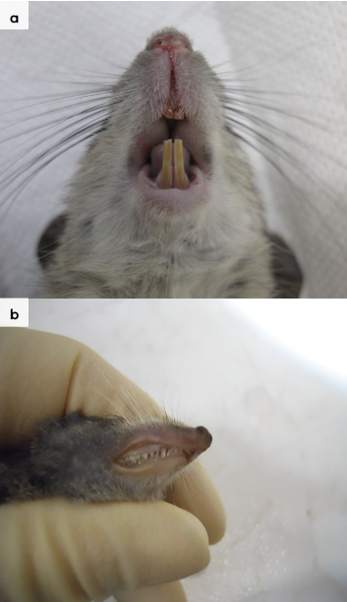
Table 2.1: Species profiles
Species | Agile antechinus (Antechinus agilis)
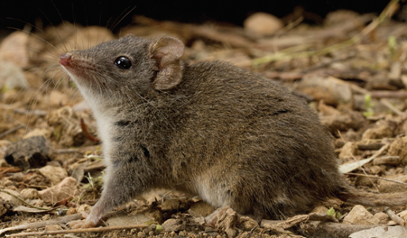  Photo credit: David Paul Museums Victoria | Distribution map  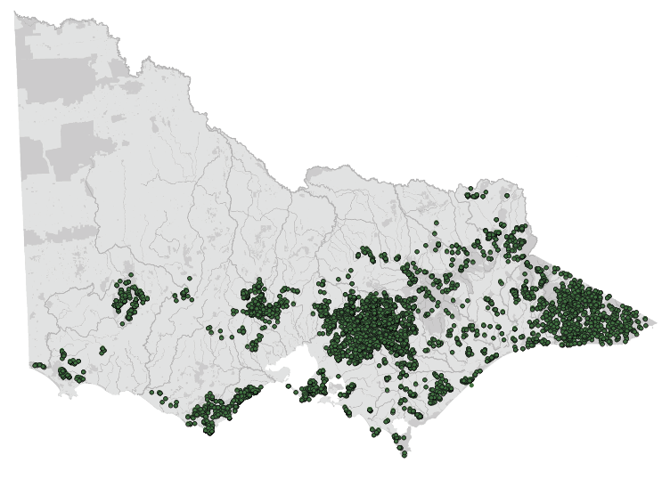  Data source: Victorian Biodiversity Atlas Jan 2023  www.environment.vic.gov.au/biodiversity/victorian-biodiversity-atlas
General appearance | Brown fur with pale fur on belly
Conservation status* | Common
Adult morphometrics | Body weight: Males 20–40 g, Females 16–25 g  Head and body length: 80–116 mm  Tail length: 75–102 mm
Habitat | Wet to dry forest
Home range | Male: 1.8–5.3 ha  Female: 1.2–2 ha
Behaviour | Nocturnal. Communal nests. Not territorial
Diet | Invertebrates (beetles, weevils, spiders, cockroaches)  Small vertebrates (lizards)  Berries
Longevity | Male: 11 months  Female: 24 months
Sexual maturity | Male: 9–10 months  Female: 10–11 months
Mating season | Late July to September
Gestation length | 26–25 days
Litters per year | 1 litter of 6–10

Species | Dusky antechinus (Antechinus mimetes)
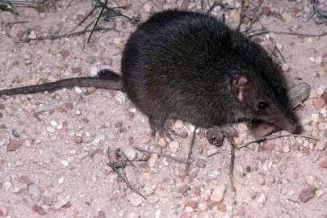  Photo credit: David Paul, Museums Victoria | Distribution map  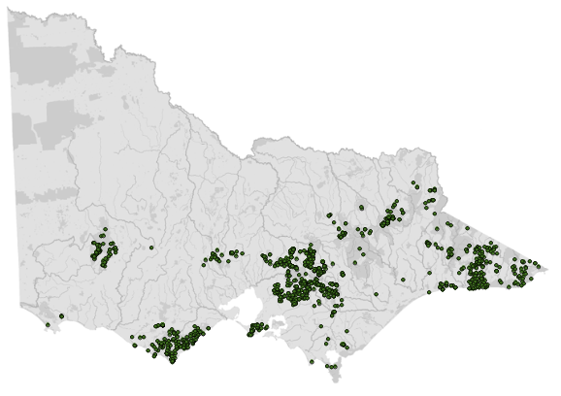  Data source: Victorian Biodiversity Atlas Jan 2023  www.environment.vic.gov.au/biodiversity/victorian-biodiversity-atlas
General appearance | Largest of Victorian antechinuses, the dusky antechinus has brown-black or grey-brown fur
Conservation status* | Common
Adult morphometrics | Body weight: Male 43–130, Female 37–70 g  Head and body length: 90–185 mm  Tail length: 75–120 mm
Habitat | Dry to wet forest with dense undergrowth
Home range | Male: Likely to be 1–2 ha  Female: Likely to be 1–2 ha
Behaviour | Diurnal and nocturnal. Solitary. Mostly ground dwelling
Diet | Invertebrates (beetles, weevils, spiders, cockroaches)  Small vertebrates (lizards)  Berries
Longevity | Male: 11 months  Female: 24–36 months
Sexual maturity | Male: 8 months  Female: 11 months
Mating season | May–September (resource dependent)
Gestation length | 29–36 days
Litters per year | 1 litter of 6–10

Species | Swamp antechinus (Antechinus minimus maritimus)
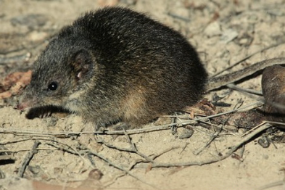  Photo credit: Trevor Pescott with permission to use image by the State Wide Integrated Flora and Fauna Teams (SWIFFT) | Distribution map  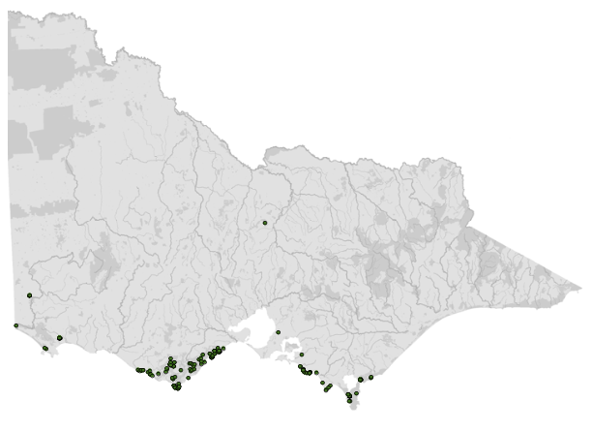  Data source: Victorian Biodiversity Atlas Jan 2023  www.environment.vic.gov.au/biodiversity/victorian-biodiversity-atlas
General appearance | Medium sized antechinus, with golden brown rump and flanks, and grey head and shoulders. Pale belly and short hair on tail. Tail and ears short, and eyes small. Pale eye ring present
Conservation status* | Vulnerable
Adult morphometrics | Body weight: Male 50–129 g, Female 36–68 g  Head and body length: 99–140 mm  Tail length: 65–100 mm
Habitat | Coastal, damp forest, woodland, heathland, sedgeland and tussock grassland with dense undergrowth  Close to drainage lines and reedy swamps
Home range | Male: 2.7 ha  Female: 1.7 ha
Behaviour | Nocturnal or diurnal depending on the population  Solitary, but communal burrows used  Ground dwelling
Diet | Invertebrates (beetles, weevils, spiders, cockroaches)
Longevity | Male: 12 months  Female: 18–36 months
Sexual maturity | Male: unknown (likely to be 8–10 months)  Female: unknown (likely to be 10–12 months)
Mating season | May–August
Gestation length | 28–32 days
Litters per year | 1 litter of 6–8

Species | Yellow-footed antechinus (Antechinus flavipes)
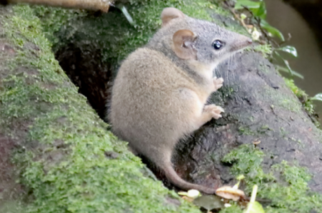  Photo credit: Esky’s Images | Distribution map  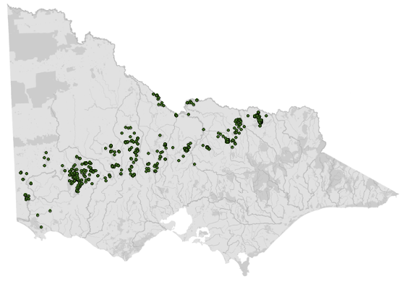  Data source: Victorian Biodiversity Atlas Jan 2023  www.environment.vic.gov.au/biodiversity/victorian-biodiversity-atlas
General appearance | Fur colour change from a grey head to rufous rump, light eye rings, black tail tip. Sparse hair on tail
Conservation status* | Common
Adult morphometrics | Body weight: Male 26–79 g, Female 21–52 g  Head and body length: 90–160 mm  Tail length: 65–140 mm
Habitat | Dry woodland
Home range | Male: 0.27–0.31 ha, Female: 0.27–0.31 ha
Behaviour | Nocturnal
Diet | Invertebrates (beetles, weevils, spiders, cockroaches)  Small vertebrates (birds, mice)  Flowers, nectar
Longevity | Male: 11 months  Female: 24 months
Sexual maturity | 11 months
Mating season | July
Gestation length | 30 days
Litters per year | 1 litter of 10–14

Species | Brush-tailed phascogale (Phascogale tapoatafa)
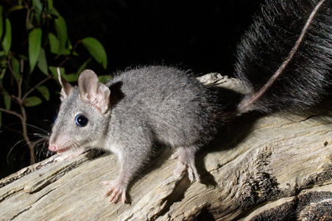  Photo credit: Zoos Victoria | Distribution map  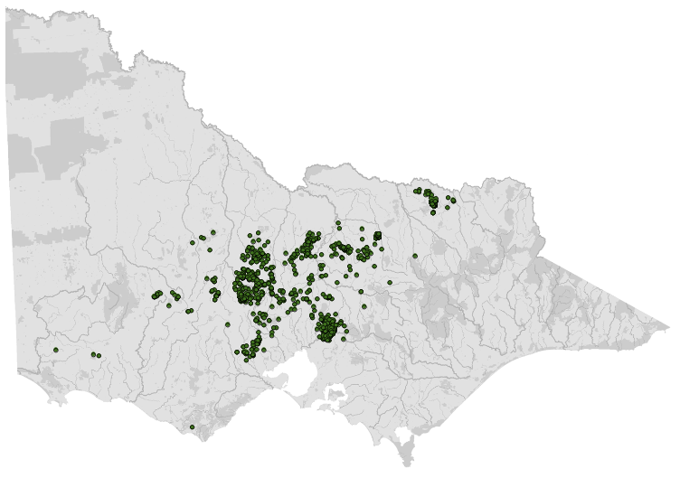  Data source: Victorian Biodiversity Atlas Jan 2023  www.environment.vic.gov.au/biodiversity/victorian-biodiversity-atlas
General appearance | Black bushy tail, naked ears, fine white rings around eyes
Conservation status* | Vulnerable
Adult morphometrics | Body weight: Male 175–311 g, Female 106–212 g  Head and body length: 150–260 mm  Tail length: 165–235 mm
Habitat | Dry woodland
Home range | Male: >100 ha  Female: 20–40 ha
Behaviour | Nocturnal. Usually solitary. Climbs trees
Diet | Invertebrates (beetles, weevils, spiders, cockroaches)  Small vertebrates (lizards)  Nectar
Longevity | Male: 11 months  Female: 24–36 months
Sexual maturity | Male: 8 months  Female: 11 months
Mating season | May to July
Gestation length | 30 days
Litters per year | 1 litter of 6–8

Species | Spotted-tailed quoll (Dasyurus maculatus maculatus)
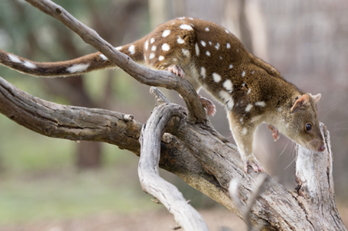  Photo credit: David Paul, Museums Victoria | Distribution map  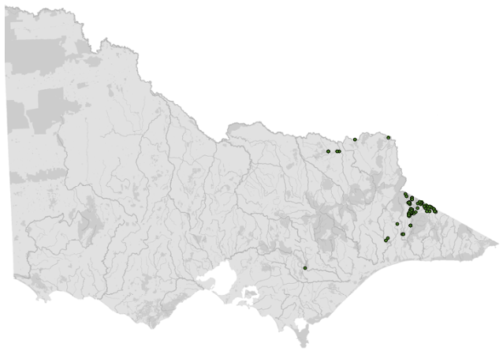  Data source: Victorian Biodiversity Atlas Jan 2023  www.environment.vic.gov.au/biodiversity/victorian-biodiversity-atlas
General appearance | Brown with white spots on body and tail
Conservation status* | Endangered
Adult morphometrics | Body weight: Male 1500–5000 g, Female 900–2500 g  Head and body length: 350–750 mm  Tail length: 350–550 mm
Habitat | Wet to dry forest
Home range | Male: 2000–5000 ha  Female: 180–1000 ha
Behaviour | Nocturnal. Climbs trees. Territorial.
Diet | Invertebrates, reptiles, birds, mammals, carrion
Longevity | 11–60 months
Sexual maturity | Male: 11 months  Female: 11 months
Mating season | May to August
Gestation length | 21 days
Litters per year | 1 litter of 4–6

Species | Fat-tailed dunnart (Sminthopsis crassicaudata)
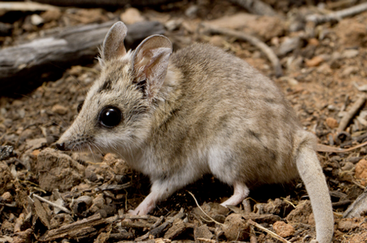  Photo credit: David Paul, Museums Victoria | Distribution map  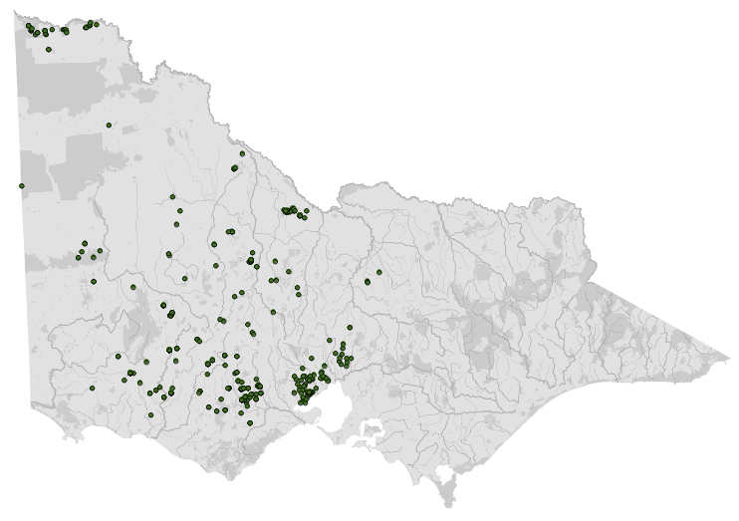  Data source: Victorian Biodiversity Atlas Jan 2023  www.environment.vic.gov.au/biodiversity/victorian-biodiversity-atlas
General appearance | Tail shorter than body and swollen. Large ears
Conservation status* | Vulnerable
Adult morphometrics | Body weight: 10–20 g  Head and body length: 60–90 mm  Tail length: 45–70 mm
Habitat | Open woodland, spinifex grasslands
Home range | Not recorded
Behaviour | Nocturnal. Solitary. Can be communal in colder months
Diet | Invertebrates (beetles, weevils, spiders, cockroaches).Small vertebrates
Longevity | Male: 15 months  Female: 18 months
Sexual maturity | Male: 4–5 months  Female: 4–5 months
Mating season | July to February
Gestation length | 13 days
Litters per year | Up to 2 litters of 8–10. (Only 5 make it to weaning)
*From the Flora and Fauna Guarantee Act 1988 Threatened List June 2023. This list is updated regularly throughout the year. For the most current list, please visit https://www.environment.vic.gov.au/conserving-threatened-species/threatened-list.

2.3. Animal and human
safety considerations
In general, animals in the wild have limited contact with people, pets, and the hustle and bustle of our daily lives. When sick, injured or orphaned wild animals come into care this unnaturally close contact can carry risks to the health and safety of both people and animals. For general information on biosecurity and approaches to minimise these risks see Part A of these guidelines. Specific information on enclosure hygiene and biosecurity for dasyurids is in Section 2.6.2.
The following information relates to human and animal health and safety considerations specifically related to the rehabilitation of dasyurids.

2.3.1. Human safety considerations
- The smaller dasyurids have sharp teeth that can penetrate human skin. Bites are only mildly painful.
- Quolls have larger teeth and stronger jaws and can inflict more painful bites. Handle with caution as they can bite during capture and restraint.
- Dasyurids will defaecate and urinate if stressed during handling.
- Bacteria that can cause disease in people, such as Salmonella, have been found in dasyurid faeces.

2.3.2. Animal safety considerations
- Small species move quickly and can easily escape.
- Tail holds should not be used for capture and restraint.
- Smaller dasyurids should not be clasped too firmly as suffocation is possible.
- Take care when felling trees as brush-tailed phascogales and antechinus nest in tree hollows.
- Take care around the house as phascogales and antechinus also regularly nest inside roofs, in confined spaces such as under old hot water boiler tanks, or under pieces of timber or corrugated iron. Feathers, wool, or stripped pieces of bark may indicate the presence of a nest.

2.4. Capture, restraint, and transport
STOP – A visual examination must be done BEFORE the animal is captured. This applies to the initial capture from the wild as well as prior to captures which occur during time in captive care. See Section 2.4.1 for information on what to look for when conducting a visual health assessment.
Refer to Part A of these guidelines for general advice on wildlife welfare, biosecurity and hygiene, and record requirements. The following information relates to the capture, restraint, and transport of sick, injured and orphaned dasyurids.

2.4.1. Visual observations
Visual observations of wildlife should be conducted prior to any attempts to capture the animal. This is just as important prior to the first capture from the wild as it is before any capture conducted while an animal is in captive care. Observations should be conducted quietly, by one person, and from a distance which provides a clear view of the animal with as little disturbance as possible. Visual observation should focus on the animal’s demeanour, behaviour, movement and posture, looking for evidence of injury/severe disease or deterioration and observe their breathing as demonstrated in the following table.
Table 2.2: Visual health observations in dasyurids
 | What to look for
Demeanour | - Bright, alert  - Should avoid capture
Behaviour | - Actively moving in a co-ordinated manner. This may be quite rapid for the smaller dasyurids  - Investigating their environment
Movement and posture | - Normal use of all four limbs. No evidence of lameness or open wounds. Older quolls may develop a swaying movement, instability and intermittent swaying of the hind legs as a result of intervertebral disc disease
Breathing | - Regular. May be quite rapid for the smaller dasyurids  - Panting or open mouth breathing is abnormal and may indicate respiratory distress or over heating

2.4.2. Equipment
- Net: A cloth net can be used to catch quolls.
- Catch bag: A calico bag 0.3 m (L) x 0.3 m (W) or a pillow case can be used to restrain small dasyurids. Thick blankets, fleece bags or hessian sacks are suitable for quolls. Bags should be turned inside out so that any seams or potential loose threads are on the outside. When handling quolls, take care not to get bitten through the bag.
- Transport container: Solid-walled containers with ventilation holes can be used for transportation. Examples of suitable containers include wooden boxes, plastic tubs or small cardboard boxes for antechinuses or dunnarts. Pet packs are suitable for quolls. The dimensions of the transport container will vary with the size of the species. The enclosure needs to be large enough for the animal to turn around. Care should be taken to ensure appropriate ventilation during transport.
Figure 2.2: a. Two different sizes of cloth nets which may be used to catch quolls b. A catch bag to restrain small dasyurids. Photo credits: Zoos Victoria
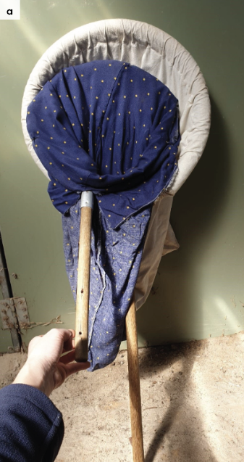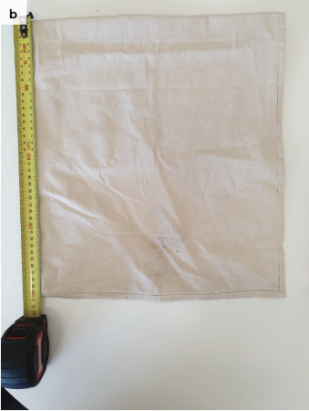

2.4.3. Technique
It is beyond the scope of these guidelines to outline techniques for every situation that may be encountered. Examples of techniques for some specific situations are outlined in the following section.
In addition to this information, for further advice please also refer to the recommended reading list, zoological institutions, veterinarians and/or wildlife experts. Inexperienced rescuers should request assistance where possible.
- Antechinuses and dunnarts can be handled with one hand holding the back of the neck, using two fingers or the thumb and index finger, while the palm of the same hand restrains the body. See Figure 2.3. This can be done with bare hands or through a bag. For phascogales a second hand is required to support the hind legs.
- Small dasyurids should not be held by the tail as this can lead to degloving injuries, where the skin is stripped off the underlying muscle.
- Quolls should be handled with two hands. With the quoll’s body on the ground or on a bench, grip the back of the neck with one hand, using the thumb on the opposite side of the neck to all four fingers. With the second hand, hold the animal over the back around the pelvic region or at the base of the tail. Restraint through thick canvas, hessian or blankets is recommended.
- Dasyurids tend to quieten if their eyes are covered during handling.
Figure 2.3: Restraint of an antechinus in the hand. Photo credit: Zoos Victoria
Figure 2.4: A quoll is manually restrained. Photo credit: Zoos Victoria
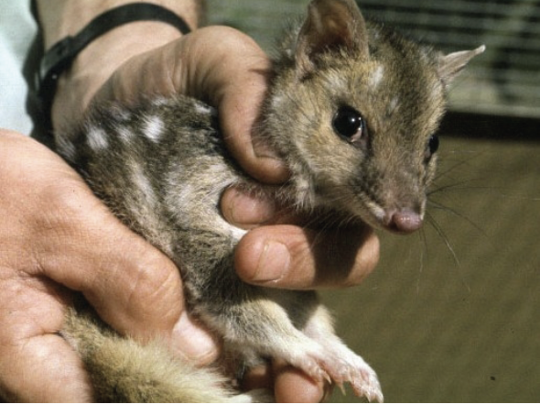

2.4.4. Transport
- Dasyurids may be transported in a tied calico or hessian bag placed inside a solid-walled appropriately sized container.
- Alternatively, cover the transport box with a towel to darken the interior, while maintaining adequate ventilation.
- Secure the container to prevent rolling or sliding.
- Food and water do not need to be provided.
- Avoid travel at environmental temperatures greater than 25°C. If travel in hot conditions is unavoidable an air-conditioned vehicle should be used. Juvenile dasyurids such as phascogales have difficulty maintaining a constant body temperature and can overheat quickly.

2.5. Monitoring animal health and welfare
The goal of wildlife rehabilitation is to address health and welfare concerns quickly and effectively so wildlife can be released back to the wild as soon as possible. Decision-making from the time of capture through to release should be guided by an accurate understanding of the animal’s true state of health and welfare. Careful monitoring throughout the rehabilitation period ensures that significant issues, or deterioration in health condition, are identified immediately and rapidly addressed.
It is preferred that all sick, injured or orphaned wildlife be assessed by a veterinarian to ensure that non-obvious signs of trauma or disease can be assessed and treated as soon as practicable. No medication should be provided prior to this assessment, as this can mask clinical signs and make an accurate health assessment by the veterinarian very difficult.
Templates for record-keeping visual and physical observations and daily care can be found in Part A of these guidelines.
This section provides guidance on health assessment on arrival and on effective monitoring of the health and welfare of individuals in care. This is aided by minimising human-animal interactions and stress to the animal, maximising successful release back to the wild.

2.5.1. Physical examination
Once visual observations are complete, and the animal is stable enough to withstand capture and handling, a basic physical examination should be conducted. This can be repeated when required any time the carer has the animal in the hand, such as for an enclosure change. However, if a full physical exam is not conducted, body condition and weight should be assessed every time the animal is in the hand for other reasons. Carers should make sure weighing scales are available and ready to use before capturing the animal. Physical examinations are also required if the carer notices any changes suggestive of deteriorating health or injury.
Always record the physical examination findings, so that you can compare findings as the animal’s rehabilitation progresses. This ensures any health concerns are identified as soon as possible, and the carer can plan release as soon as appropriate. A template for recording physical examination findings can be found in the appendices to Part A of these guidelines.
Examinations should be conducted in a quiet location, away from domestic animals. Only one person should handle the animal, while a second person takes notes. All other people should move away, and noise kept to a minimum. Handling should also be kept to a minimum, with careful monitoring for any signs of distress (such as panting, salivating, vocalisation or sudden deterioration in demeanour). If these are seen, the examination should be stopped immediately, and the animal returned to its catch bag, transport box or enclosure and allowed to recover.

Species specific considerations:
- Physical examination of small dasyurids can be challenging as they will attempt to bite and wriggle out of the handler’s grasp. Hold the individual in a cupped hand or bag and gently examine the various parts of the body.
- Physical examination of quolls can be conducted with the animal contained within the catch bag. The opening of the bag is peeled back, and individual body parts gently examined.
- Alternatively, the quoll can be restrained by one person and examined by a second person.
- Dasyurids will be calmer if their eyes are covered during the examination.
- Physical restraint and examination of any dasyurid is a stressful procedure and should be conducted as quickly and efficiently as possible.
- Only a cursory examination will be possible. More detailed examinations require the animal to be anaesthetised.
- Table 2.3 provides additional guidance on what to look for during physical examinations.
Table 2.3: Physical examination of dasyurids
 | What to look for
Body weight | - Record body weight on arrival and at least weekly while in care. This can be done by putting the smaller species in a bag and weighing them while bagged, to reduce the chance of escape. Larger species such as the quoll can be weighed in a pet pack or similar container.  - A greater than 10% change in body weight is cause for concern, and the carer should seek veterinary advice immediately.
Body condition | Body condition can be scored by palpation of the prominence of the scapula in relation to the muscle on either side. For smaller animals the prominence of the spine can be used. Condition can also be judged by body weight with reference to the normal weight range for that species. Body condition can be described as follows:  - Under condition: Concave muscles either side of the scapula. Backbone can be easily felt on top and sides.  - Ideal condition: Flat muscle either side of the scapula. Backbone can only be felt on top. Sides are covered with muscle.  - Over condition: Convex muscles either side of the scapula. Difficult to feel the backbone.
Hydration status | - The skin slides easily over the shoulder blades/spine, and when the skin is ‘tented’ (or gently pinched up) over the spine/between the shoulder blades, it should fall back within one second.  - Dasyurids which are dehydrated have dry looking gums, sunken eyes, and a slow skin tent.
Eyes | - Eyes look bright.  - There should be no cloudiness or grey colour.  - Eyelids open, with no discharge or crust.  - Basic internal structures of eyes (e.g. pupil, iris) appear symmetrical.
Ears | - Ears are held alert and move quickly in response to noise.  - Some parasites (ticks and mites) may be present and can be left if there isn’t an excessive load and there is no evidence of irritation/excessive scratching inside the ears.  - Healthy wild males may present with tears in their ears due to territorial disputes.
Mouth | - Gums are pink and slightly moist, no excessive salivation or blood coming from inside the mouth.  - Teeth have sharp pointy edges.
Skin and coat condition | - Coat will look shiny and smooth.  - Males may have patches of fur missing during the breeding season.
Limbs, feet, and tail | - No broken nails or obvious wounds.  - No crackling or grinding detected when the legs are manipulated. Legs not held at odd angles to the body.  - No swelling or bruising on limbs, toes or tail.
Sex determination | - Determined by the presence of testicles (males) or a pouch (females).
Pouch check | - Antechinus have an open pouch while the pouches of other dasyurids are more enclosed. If pouch young are present, count the number and assess age, as a lactating female may require additional food, and carers should monitor for normal signs of development.

2.5.2. Ongoing monitoring of health and welfare
The aim of wildlife rehabilitation is to ensure animals recover and can be released back to the wild as quickly as possible. Careful, daily monitoring is required to ensure that animals are responding as expected to the treatment being provided and so that any deterioration or welfare concerns can be identified and addressed as soon as possible. Rehabilitators should ensure that record-keeping is a priority to maximise positive welfare outcomes. Templates to assist wildlife rehabilitators to record and monitor wildlife health and welfare can be found in the appendices to Part A of these guidelines. These records will be valuable tools to share with veterinarians to support decision-making.
The following is recorded daily:
- demeanour
- food consumption
- faecal/urine output
- behaviour observed
- medical treatment provided
- evidence of overnight activity.
The following is recorded weekly:
- weight
- body condition.
Over time, regular monitoring will also help to develop carer skills and knowledge, as regular observations and recording will result in a deep understanding of the expected behaviour and response to treatment for the species in care.

Species specific considerations:
- Time your health and welfare observations for times of the day when the animal is expected to be active.
- The use of infra-red cameras can allow monitoring of behaviour overnight.
- If the animal is being medicated, schedule treatment for the morning, use this time to perform a visual check. In the morning is recommended.
- If the animal is receiving medication in the morning and evening, the evening medication may be delivered in a cricket, to minimise the need for extra handling.
- Ideally physical observations should be undertaken at the beginning and/or end of the resting period to minimise disturbance and maximise the rest/sleep period for rapid healing and ensure ease of capture.
- The animal should be observed at least daily.
- Note the animal’s demeanour and behaviour every time food is introduced or taken away, medication is given, or the enclosure cleaned. Pay particular attention to any changes that have occurred since the previous day.
- If using sand for a portion of the substrate in larger housing, inspect and rake at the same time each day, ideally morning. Sand allows for observations of the animals nocturnal activities, and may inform of injuries (e.g. dragging foot, different shape print).
- Food and water dishes may be placed in the sand area, this can inform as the whether the animal is visiting the food dish at night.
- Quolls are particularly prone to stereotypic pacing. Observe the enclosure for worn paths, which may indicate that the quoll is walking back and forth. This may occur in anticipation of food. Treat by varying the feeding routine.
- Note faecal consistency daily. If diarrhoea is noticed, a faecal sample should be collected and submitted to the veterinarian for assessment as soon as possible. Do not treat on suspicion of a bacterial or parasitic infection, as this can make definitive diagnosis very difficult and potentially prolong the course of the disease.

2.5.3. Common and emerging health conditions
Clear guidance on conditions that may require euthanasia can be found in Part A of these guidelines.
Table 2.4 lists common clinical signs and possible causes of injury/disease. Carers should be aware that these are not exhaustive. Aside from first aid, carers should avoid administering medications prior to the provision of veterinary advice.
Unusual clinical signs or mass mortality events – a number of animals dying or found dead at the same time, with similar signs – may indicate an emergency animal disease, an emerging/new infectious disease or an environmental/human related toxicity which needs further investigation. Report these immediately to the Emergency Animal Disease Watch Hotline on 1800 675 888 (24 hours).
Table 2.4: Common injuries and clinical signs of emerging health conditions seen on presentation or during care
Injuries or clinical signs | Possible Causes | Rehabilitator observations and response
Note: Do not provide pain relief or other medication, including antibiotics, unless under veterinary guidance and supervision, as these can have severe side effects, particularly in dehydrated/shocked animals. Use of antibiotics when not indicated can contribute to antimicrobial resistance and reduce drug efficacy.
Fracture  Unable to walk or move normally  Swollen limb  Bruising  Fractures  Dislocation | Found adjacent to road/suspect motor vehicle accident, caught in wire or netting, predation injury caused by raptor, fox, cat or dog, gunshot, poorly designed transport box/enclosure capture injury, injury sustained in captivity, due to stress | - Urgent veterinary attention is required. Do not delay transfer to a veterinarian to apply first aid, other than to stop excessive bleeding.  - Move animal to a small transport box to restrict movement. Ensure temperature is appropriate for the species and minimise stress.  - Do not attempt to stabilise fractures as this is very painful and risks making the injury worse. Fracture stabilisation should only be attempted by a veterinarian following physical examination, x-rays and under general anaesthesia.  - Do not provide pain relief or other medication unless under veterinary guidance and supervision, as these can have severe side effects, particularly in dehydrated/shocked animals.  - If suspected as the cause, assess the enclosure/box/bag to find the source of injury. Fix loose wire/gaps or sharp edges before returning animal to enclosure. See Section 2.4 and Section 2.6 for further advice on housing and transport.  - If stress is deemed a factor, consider whether the animal is a candidate for rehabilitation. Seek advice from species experts.
Bleeding  Puncture wounds  Bruising  Fur loss | Conspecific aggression, breeding season injuries  Found adjacent to road/suspect motor vehicle accident,  Predation injury caused by raptor, fox, cat or dog  Poorly designed transport box/enclosure  Capture injury  Injury sustained in captivity, due to stress | - Seek prompt veterinary assessment, euthanasia may be the most humane response given the poor prognosis for survival.  - Move animal to a small transport box to restrict movement. Ensure temperature is appropriate for species and minimize stress.  - Do not provide pain relief or other medication unless under veterinary guidance and supervision, as these can have severe side effects, particularly in dehydrated/shocked animals.  - Bite wounds/scratches may not be immediately obvious, these may a poor prognosis and animals often present moribund, (very lethargic, poorly responsive and cold).  - Look for small clumps of dried fur stuck together with saliva. Part the fur and look for very small puncture wound/s.
Blindness  Deafness  Neurological signs  Wobbly movement, or ataxia  Circling movement  Strange behaviour, out in the daytime, easily caught  Lethargic  Moribund, collapsed | Infectious disease, such as toxoplasmosis, bacterial meningitis, cranial trauma, toxicity (e.g. 1080 poisoning) | - Seek prompt veterinary assessment.  - Move animal to a small transport box to restrict movement. Ensure temperature is appropriate for species and minimize stress.  - Do not provide pain relief or other medication unless under veterinary guidance and supervision, as these can have severe side effects, particularly in dehydrated/shocked animals.  - Carer may observe animal bumping into objects in the enclosure or fail to respond to short sharp noises such as a loud clap from behind the animal.  - Pupils may be fixed/dilated and not responsive to changes in light level. You should see pupils constrict if a pen light is shone in the eye.  - If multiple animals are seen with similar signs, this may indicate a newly emerging infectious disease or a toxicity (such as plant toxicity or poisoning). Contact the Emergency Animal Disease Watch Hotline on 1800 675 888 (24 hours) to report concerns.  - If unusual toxicity or infection is suspected, you or your veterinarian can contact Zoos Victoria’s Veterinary Departments to discuss options for disease investigation.
Thickened, ulcerated skin, fur loss, skin irritation | Conspecific aggression, breeding season interactions, mite infestation mycobacteriosis, tumour | - Seek veterinary advice or assessment.  - Some fur loss/minor skin lesions are commonly seen due to fighting or during the breeding season and may not require any intervention.  - A small number of ticks/mites can be normal, and do not require treatment or removal. However, if there is a very high number of ticks/mites seen and the animal is scratching/irritated, or the skin is red and inflamed, seek veterinary attention to treat ectoparasites.  - Mycobacteriosis and tumours can present as thickened areas of skin. Veterinary assessment is required.
Diarrhoea  Loose, smelly faeces | Inappropriate diet, infectious disease (fungal, bacterial) alteration of microbiome, stress , parasites, antibiotic treatment | - Seek veterinary advice.  - Seek urgent veterinary advice if diarrhoea does not resolve rapidly (e.g. within 24–36 hours), or if there is any evidence of dehydration, blood in faeces or change in demeanour.  - Do not treat on assumption of infectious disease (e.g. coccidia or bacterial infection) as this can make veterinary diagnosis more difficult if the animal does not improve.  - If the animal has been otherwise stable and doing well, there are a number of responses carers may implement to try to resolve diarrhoea. These include considering any recent changes which may have led to diarrhoea. Respond by removing the inciting cause where possible (rapid change in diet, unusual levels of sound, intervention or handling, contact with recently arrived animals).  - Seek advice from species experts, ensure diet and husbandry practices are correct.  - If stress is deemed a factor, consider whether the animal is a candidate for rehabilitation.  - Be considerate of rapid diet changes for animals undergoing hand rearing.  - Do not mix oral rehydration fluids in with milk as it changes the digestibility of the milk. Oral rehydration fluids/water can be provided in between milk feeds.  - Ensure excellent hygiene standards to prevent spread to other animals/carer and isolate this animal from any others in care if possible.
Lameness  Ataxia (wobbly movement)  Blindness  Paralysis | Intervertebral disc disease, brain degeneration in quolls | - Seek veterinary assessment.
Non-responsive  Lethargic | Undetermined disease or injury. Torpor seen in antechinus, dunnarts and phascogales | - Seek veterinary advice or advice from a species expert.  - Torpor is normal during cold weather. Determine if the individual is an adult or juvenile. Juveniles need other animals to maintain their body heat. They are likely to be in torpor on arrival and need to be warmed before feeding. Offer warmth for one to two hours at 25 to 28°C and reassess. Provide a heat source at one end of the enclosure so the animal can move away from the heat as needed. Continue to offer warmth at 25ºC for 24 hours. All animals are sensitive to high temperatures and should be monitored for panting and wet forelimbs. If the animal revives and behaves normally, feed for 48 hours and release.
Depressed  Moribund/  Poor condition often with fur loss | Post mating male mortality, undetermined disease or injury | - Seek veterinary advice or advice from a species expert.  - Post mating male deaths occur normally at the end of the mating season (Aug–Sept) in antechinuses and phascogales.
Figure 2.5: a. Fur loss in a swamp antechinus. b. Fur loss in an agile antechinus. Note this degree of fur loss normally occurs during the breeding season when males fight and lose fur before die-off. This would not require intervention. Photo credit: P Burns (a) and J Cripps (b)
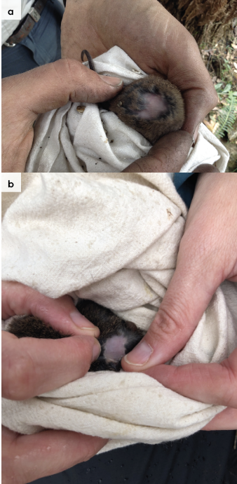
Figure 2.6: Presence of mites around the pouch and cloaca of a swamp antechinus. Photo credit: J Cripps
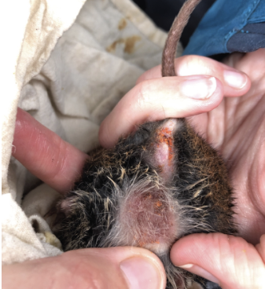

2.5.4. Administering treatment
- To avoid regular handling and minimise stress, it is preferable to administer medication in a food item, such as a mouse or chick, or it can be mixed through a small amount of Wombaroo Small Carnivore Mix or equivalent. The medicated item should be offered first to ensure the animal consumes it. Once it has been eaten, the rest of the diet can be provided.
- If the animal refuses to consume the medicated item, it will need to be restrained and medication delivered by syringe into the side of the mouth.
- This method is not recommended for quolls as there is considerable risk of being bitten. If the quoll does not eat for two consecutive days or refuses its medicated food item, seek veterinary advice.

2.6. Housing
Below are several key considerations when housing adult animals in care.

2.6.1. General housing information for dasyurids
- Dasyurids are aggressive and will fight each other. Except for orphaned young, only one animal should be housed in each enclosure. Locate enclosures in secure rooms to allow capture in the event of escape.
- Keep dasyurids in enclosures that are separate from domestic animals, so that they do not see, hear or smell them. Change out of clothes that have been worn around dogs or cats to minimise exposure to pet scent.

2.6.2. Enclosure hygiene & biosecurity
General information about hygiene and biosecurity can be found in Part A of these guidelines. New diseases emerge frequently and sick and injured animals in care are often more susceptible to picking up pathogens from the environment. It is important to maintain excellent levels of hygiene to avoid inadvertently transferring diseases between animals, and from humans, and to protect the wild population where the animal will eventually return to.

Species specific considerations:
- Wash hands with soap and water after handling dogs and cats to minimise the risk of transferring disease agents such as Toxoplasma gondii, which can be found in cat faeces.
- Ideally, exam gloves should be worn and changed in between animals.
- Leftover food and faecal matter should be spot cleaned daily from enclosures to ensure good levels of hygiene are maintained.
- Any wet/sodden or soiled organic furnishings, substrate or enrichment items should be removed as soon as possible and replaced with a clean/dry alternative.
- Enclosures used to house sick/injured dasyurids, should be cleaned and disinfected between inhabitants. Substrate should be completely replaced and furniture, such as branches or boxes made of unsealed wood, should be discarded as they cannot be effectively disinfected.
- Enclosures should be cleaned with hot soapy water and then disinfected with products such as F10SC or bleach at the recommended concentration and contact time. Bleach must be rinsed before returning an animal to the enclosure.
- Quolls, dunnarts and phascogales may develop mycobacteriosis. If the veterinarian has diagnosed this disease, the enclosure should be cleaned with 6% hydrogen peroxide or 6% acetic acid (vinegar). Exposure to hydrogen peroxide or vinegar for 30 minutes has been shown to kill mycobacteria.

2.6.3. Housing types
Different set ups are required for animals at different stages of treatment and care.
Table 2.5 describes the housing type, suggested dimensions and requirements at each stage of care. For information on housing animals during hand raising see Section 2.8.
Table 2.5: Rehabilitation housing for adult dasyurids
Intensive care housing
Indications for use | Suggested min. dimensions | Suggested requirements
Short term critical care (<48 hours)  Intensive veterinary treatment - frequent medication, oxygen supplementation, temperature control  Longer periods under veterinary supervision when strict cage rest/confinement is indicated | Quolls:  Floor area: 1 m x 1 m (1 m²)  Height: 0.5 m  Antechinus, dunnarts, phascogales:  Floor area: 0.30 m x 0.20 m  (0.06 m²)  Height: 0.2 m | ENCLOSURE CONSTRUCTION  - Purpose-built incubators, such as a Vetario or fish tank with a close-fitting lid with adequate ventilation.  - For quolls, a solid wood enclosure or plastic tub, as they can damage their teeth on the wire in caged enclosures.  ENCLOSURE FURNISHING  - A timber nest box should be offered for adults.  - Newspaper is suitable as flooring.  - Orphaned young should be housed in pouches inside an escape-proof container that has adequate ventilation.  ENVIRONMENTAL VARIABLES  - Heating is required until the young are furred. This may be supplied using a heat pad.  - Monitor the temperature with a thermometer.  PROVISION OF FOOD/WATER  - Fresh water should always be available and captive diet should be fed in stable dishes.  - Regular check of substrate to ensure water has not spilt and enclosure is not wet.

Intermediate housing (Treatment/cage rest)
Indications for use | Suggested min. dimensions | Suggested requirements
Provision of daily medication, close monitoring once animal is stabilised and no longer requires intensive care  Enclosure furnishings can be arranged to reduce opportunities to move excessively so that cage rest can be achieved with slightly more space/reduced contact | Quolls:  Floor area: 1 m x 2 m (2 m²)  Height: 1 m  Antechinuses, dunnarts, phascogales:  Similar to pre-release enclosure sizes | ENCLOSURE CONSTRUCTION  - Antechinuses, dunnarts and phascogales can be housed in a fish tank or solid wooden container.  - Quolls may be housed in aviaries with solid metal walls.  ENCLOSURE FURNISHING  - Leaf litter or mulch is suitable flooring.  - For smaller dasyurids such as dunnarts, pine shavings can be used.  - Offer native branches with grubs on the leaves for arboreal dasyurids, to encourage climbing. Furnishings can be arranged to reduce opportunities to climb/dig or move excessively so that ‘cage rest’ can be achieved with slightly more space/reduced contact.  - Nest-boxes should be offered as a sleeping area.  ENVIRONMENTAL VARIABLES  - This housing stage is suitable for weaned orphans and sick or injured adults that no longer require heating.  PROVISION OF FOOD/WATER  - Offer insects in the leaf litter.  - Fresh water should always be available and captive diet should be fed in stable dishes.

Pre-release
Indications for use | Suggested min. dimensions | Suggested requirements
No longer require regular handling/medication  Development of fitness/strength prior to release  Monitor/assess behaviour (foraging, digging, nest building)  Enclosure allows expression of a full range of natural behaviours  Pre-release assessment | Spotted tail quoll  Floor area for one animal: 3 m x 2 m (6 m²)  Height: 2 m  Increased floor area for each additional animal: 1 m²  Nest box: 25 cm x 30 cm. Height: 55 cm. Entrance hole diameter: 8.5 cm  Brush-tailed phascogale  Floor area for one animal: 3 m x 1 m (3 m²)  Height: 2 m  Increased floor area for each additional animal: 0.10 m²  Nest box: 25 cm x 17 cm. Height: 11 cm. Entrance hole diameter: 5 cm  Antechinus/Dunnart  Floor area for one animal: 0.60 m x 0.50 m (0.30 m²)  Height: 0.30 m  Increased floor area for each additional animal: 0.15 m²  Nest box: 14 cm x 12 cm. Height: 10 cm. Entrance hole diameter: 3.2 cm | ENCLOSURE CONSTRUCTION  - Quoll: Walls made of solid tin or wood. One third of the enclosure sheltered from the weather.  - Nest boxes made from plywood.  ENCLOSURE FURNISHING  - Non-toxic pine shavings or newspaper. Concrete floors can damage feet. Wire mesh buried below the soil surface will prevent animals digging out. Offer nest material such as melaleuca, paperbark, sheep’s wool or dried grass.  - Quoll: Logs, rocks, tussocks, sturdy branches for climbing, nest box or hollow log.  - Brush-tailed phascogale: vertical tree branches for climbing, tussocks, nest box or log for hiding.  - Antechinus and dunnart: Deep leaf litter mulch, tussock clumps for hides and branches for climbing. They could be offered a running wheel for exercise.  - Nest boxes lined with eucalyptus leaves or shredded paper.  PROVISION OF FOOD/WATER  - Fresh water should always be available and changed daily, and captive diet provided in stable dishes.  - Food can be placed into bark crevices, tree trunks and under leaf litter. A night light can be used to attract moths and encourage foraging behaviour.
Figure 2.7: Examples of a solid wooden container with a glass front that can be used for housing small dasyurids during the intermediate or pre-release stages. Note the nest box and branches are for climbing, and lid should be closed. Photo credit: Zoos Victoria
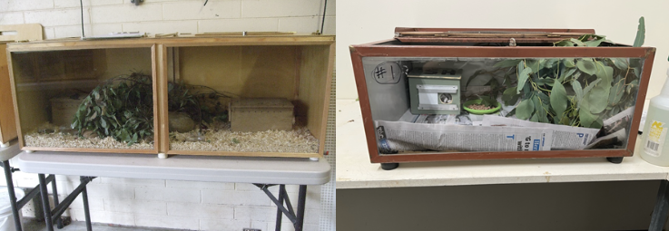

2.7. Feeding and nutrition
Keeping daily records of food offered (item and volume fed) and food consumed is good practice and will allow the rehabilitator to observe how an animal is responding to food on offer and inform future choices.
Please note: Food suppliers and specific products mentioned in these guidelines are intended as examples only. Other suitable products may also be available.
This section refers to feeding and nutrition of fully independent dasyurids in rehabilitation. Information on feeding orphaned dasyurids can be found under Section 2.8 Hand raising.
Note: Fresh water should always be available, provided in a stable/non-spill bowl or automatic drinker. Water should be changed daily.
Table 2.6: Feeding and diet guide for adult dasyurids during rehabilitation
Brush-tailed phascogale
- ½ day old chick or skinned mouse
- 1 g fly pupae
- 5 mealworms
- 3 moths every 2nd day
- 3 crickets every 2nd day
- Small Carnivore Mix
- 6 g grated cheese or egg
- 5 g fruit and vegetables: fig, apple, orange, sweet corn and peas all every 2nd day

Spotted-tailed quoll
- Offer a variety of: ½ rat, ¼ rabbit, 2 mice, 2 day-old chicks, Small Carnivore Mix
- Invertebrates: crickets, mealworms, cockroaches

Antechinus and dunnarts
- 10 g egg or cheese
- 2 mealworms
- 1/8 day-old chick (e.g. leg)
- 1 g fly pupae
- 2 crickets every 2nd day
- 2 earthworms every 2nd day
- 2 moths every 2nd day
- Native eucalypt flowers
- Dry dog food
Note: Diets are formulated to provide balanced nutrition. If the animal only consumes certain foods the diet may become unbalanced. If this happens consistently, seek veterinary advice.
Figure 2.8: A selection of food items that are suitable to feed to a small dasyurid. Photo credit: Zoos Victoria
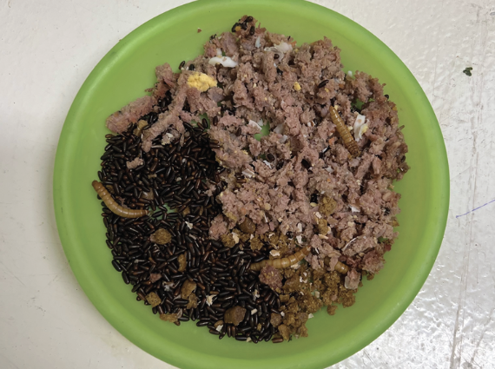

2.8. Hand raising
Hand raising recording templates for growth, development, feeding and other observations can be found in the appendices to Part A of these guidelines.

2.8.1. Equipment required for hand raising
- Milk: Wombaroo Kangaroo Milk >0.7 or Biolac M200. If using Wombaroo Kangaroo Milk to raise quolls, 1.0 ml of ‘The Good Oil ‘ should be mixed in per 10 mL of milk. If this oil product is not available, canola oil can be used instead. It is not necessary to add oil to the milk if raising dunnarts, antechinuses or phascogales. Milk should be fed at about 36°C.
- Teats: Appropriately sized teats (Wombaroo suggests C size) and bottles.
- Pouch: Pouch consisting of an inner layer made from a natural fibre, such as cotton, and an outer layer made of wool for warmth.
- Intensive care unit or box containing a heat lamp/heat pad and thermometer.
- Scales
- Record charts
Figure 2.9: Appropriately sized teats (Wombaroo suggests C size) and bottles. Photo credit: Wombaroo, https://www.wombaroo.com.au/wp-content/uploads/2020/06/Bottle-and-Teats.pdf
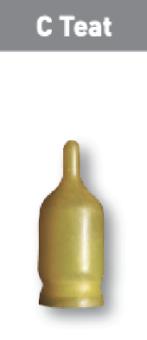

2.8.2. Growth of orphaned young
STOP – Please refer to your authorisation for mandatory conditions, regarding unfurred pouch young.
- Where possible dasyurids should be raised with others of the same species. Handling should be minimised once the young are weaned.
- Always wash and disinfect hands before feeding and sterilise equipment prior to use.
- Toileting: Rub the cloaca with a damp piece of cottonwool to stimulate the young to urinate and defecate after each feed.
- Weaning: Once the teeth have emerged, commercially available Small Carnivore Mix can be added to the milk to make a slurry. Solid food, such as chicken pieces, mealworms and crickets can be offered. Milk quantity is then gradually reduced and solid food increased until milk is eliminated from the diet.
- Water should be provided in a water bottle or shallow water dish, so the animal cannot drown. This should be replaced daily.
- A summary of the feeding requirements for spotted-tailed quolls at various levels of development can be seen in Table 2.7. While similar charts have not been published for the other dasyurids, they can be hand raised in a similar manner to quolls, making allowances for their smaller size. Weaning occurs at 65–85 days for dunnarts and 90 –140 days for antechinuses and phascogales.
Figure 2.10: Holding a juvenile dunnart in a tissue for feeding. Photo credit: Marissa Parrott
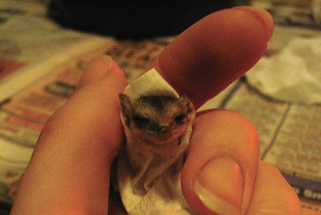
Table 2.7: Development chart for Spotted-tailed quolls (Used with permission from Wombaroo)
Milk | Age (days) | Tail (mm) | Crown-rump (mm) | Head width (mm) | Weight (g) | Feed (mL/day) | Notes
>0.7 | 90 | 110 | 125 | 31 | 190 | 21 | Eyes open, body fully furred with coarse hair. Feed every 4 hours. Maintain joey at 30°C
 | 100 | 140 | 145 | 35 | 270 | 28 | Incisors coming through. Introduce solid food
Weaning | 110 | 175 | 165 | 38 | Growth rate about 10 g per day | 30 | Gradually increase solid foods and reduce milk intake. Feed twice a day
 | 120 | 205 | 180 | 40 |  | 25
 | 130 | 225 | 195 | 42 |  | 15 | Independently foraging
 | 150 | 260 | 220 | 45 |  | 0 | Fully weaned (~750 g)

2.9. Release protocol
Ideally, wild animals will be rehabilitated and released in a short timeframe. If this is not possible and the animal is in care for significant extended periods, ensure that the animal is regularly assessed against the welfare domains to support decision-making. Animals in care for extended periods may have a reduced ability to survive in the wild. Talk to your veterinarian and consider whether euthanasia will provide the best welfare outcome for the animal.

2.9.1. Pre-release assessment
Pre-release assessment of animals in care is essential to support improved outcomes once back in the wild. Animals should be assessed based on body condition, fitness and the ability to engage in natural species-specific behaviours prior to release.
The following check list should be used to guide decision making regarding release suitability for dasyurids:
- Individual is in a state of good health. Presenting injury/sickness is completely resolved (consider a pre-release veterinary check).
- Individual is within a healthy weight range and appropriate body condition (refer to Table 2.1).
- Individual displays ability to actively forage for and consume natural foods.
- Brush-tailed phascogales and spotted-tailed quolls can climb tree trunks.
- Appropriate transport container with a towel or shredded paper (hay should not be used to prevent dispersal of seeds into the natural environment).

2.9.2. At the release site
Post release survival will be maximised by ensuring that both the release site and the way in which the animal is released are carefully considered. Release with a nest box is preferred. Animals should have had access to a nest box for at least two weeks prior to release.
- Brush-tailed phascogale: this species is strongly territorial. The females stay close to the home range of their mother. However, the males disperse widely. Phascogales should be released with a nest box they have been using while in care. Examples of suitable tree species in which to place nest-boxes include: red box (E. polyanthemos), red stringybark (E. macrorhyncha), messmate (E. obliqua) and narrow leaf peppermint (E. radiata). Avoid smooth barked eucalypts, such as river red gum (E. camaldulensis), as they cannot gain purchase on the surface. They can cross open ground and can use tree corridors along roads for dispersal and foraging. Place the nest box 1.5–5 m above the ground in a tree with a diameter greater than 70 cm.
- Antechinuses: these species are not territorial and will find communal nests upon release. Place the nest box on the ground amongst bushes.
- Spotted-tailed quolls: this species has large home ranges. The females have a discrete home range while the male’s home range will overlap with that of several females. Place the nest box on the ground in dense bushes.
- Fat-tailed dunnarts: this species is reported as having large, drifting home ranges. Place the nest box on the ground among rocks and litter.
For more information on the ecological characteristics and requirements of dasyurids that may help with their release, please refer to Table 2.1.

2.9.3. Release checklist
Check all of the requirements of your authorisation are being met, and consider the following:

Release location
- Approximate release where the animal was found (where suitable or within home range).
- Suitable vegetation for foraging and nest building.
- Away from major roads.

Release Procedure
- Limit the number of people at the release.
- Release in the early evening.
- Open the transport enclosure adjacent to a suitable tree for phascogales or dense bush for antechinus, dunnarts and quolls.
- Alternatively, place the animal into the nest-box and observe from a distance to ensure the animal is showing natural behaviours, such as looking for food.
- Supplemental food can be placed in the nest box for up to a week to support the animal during the first few days post release.
- Monitor food consumption daily and gradually reduce the amount of food left in the box.

2.10. Key references and additional reading
Henderson, N. Antechinus housing and care. https://www.michaelandnorma.com/wp-content/uploads/manuals/Antechinus.pdf
Jones, M., Dickman, C., and Archer, M. (editors) 2003. Predators with pouches: the biology of carnivorous marsupials. CSIRO Publishing.
Marten, J. 2014. Husbandry guidelines for the spotted-tailed quoll (Dasyurus maculatus). https://aszk.org.au/wp-content/uploads/2020/06/JMarten-HMG-STQuolls-FINAL.pdf
Walker, K. 2012. Husbandry guidelines fat-tailed dunnart (Sminthopsis crassicaudata). https://aszk.org.au/wp-content/uploads/2020/05/Mammals.-Fat-tailed-Dunnart-2012KW.pdf

