Chapter 3: Echidnas

Contents
3.1. Introduction 2
3.2. Species information 3
3.3. Animal and human safety considerations 5
3.3.1. Human safety considerations 5
3.3.2. Animal safety considerations 5
3.4. Capture, restraint, and transport 6
3.4.1. Visual observations 6
3.4.2. Equipment 7
3.4.3. Technique 8
3.4.4. Transport 8
3.5. Monitoring animal health and welfare 10
3.5.1. Physical examination 10
3.5.2. Ongoing monitoring of health and welfare 14
3.5.3. Common and emerging health conditions 16
3.5.4. Administering treatment during rehabilitation 25
3.6. Housing 25
3.6.1. General housing information for echidnas 25
3.6.2. Enclosure hygiene & biosecurity 26
3.6.3. Housing types 26
3.7. Feeding and nutrition 31
3.8. Hand raising 33
3.8.1. Equipment required for hand raising 33
3.8.2. Growth, development and care of orphaned young 34
3.9. Release protocol 39
3.9.1. Pre-release assessment 40
3.9.2. At the release site 40
3.9.3. Release checklist 40
3.10. Key references and additional reading 41

In Victoria, sick, injured or orphaned wildlife can only be rehabilitated by a wildlife shelter operator or foster carer who is authorised under section 28A of the Victorian Wildlife Act 1975 (Wildlife Act). Wildlife rehabilitators are subject to strict conditions. The mandatory requirements that they must meet are set out in the Wildlife Shelter and Foster Carer Authorisation issued under the Wildlife Act. These conditions enforce the minimum standards required for the humane treatment and successful rehabilitation of wildlife in care. The Wildlife Rehabilitator Authorisation Guide: Things You Need To Know explains how wildlife rehabilitators can meet these mandatory requirements and can be found here:
https://www.vic.gov.au/wildlife-rehabilitation-shelters-and-foster-carers.
These guidelines have been developed to incorporate evidenced-based best practice in wildlife care and rehabilitation to equip rehabilitators to deliver positive welfare outcomes for individual animals in their care from first aid to post-release into the wild.
You must comply with the conditions of your authorisation. These guidelines must be read in conjunction with the conditions of your authorisation.

3.1. Introduction
The short-beaked echidna, Tachyglossus aculeatus, is the only species of echidna in Australia, and one of only five species of living monotremes. Echidnas are found across a broad range of habitat types from alpine areas to grassy woodlands and coastal habitats. They can be found varying in colour from light blonde to dark brown, and they are Australia’s most widespread native mammal.
When echidnas come into care it is the responsibility of the wildlife rehabilitator to ensure that the five domains of animal welfare are satisfied. These include providing optimal nutrition and an environment appropriate to the stage of rehabilitation. The focus should be on the animal’s return to health and eventual release, which are facilitated through regular collaboration with a veterinarian. It is also important to consider the animal’s mental state and ability to exhibit normal behaviours. However, these should not detrimentally affect its recovery, potentially necessitating a gradual return to normal activity, depending on its stage of rehabilitation. Further information about the five domains of animal welfare can be found in Part A of these guidelines.
Echidnas require a specialised diet and are likely to injure themselves if not housed correctly. It is recommended that they are cared for by experienced shelters, or that care is carried out under close supervision, if the carer is less experienced.

3.2. Species information
The short-beaked echidna is profiled in Table 3.1. For further information on the echidna, refer to the recommended reading and reference material at the end of this chapter.
Table 3.1: Species profile
Species | Short-beaked echidna (Tachyglossus aculeatus)
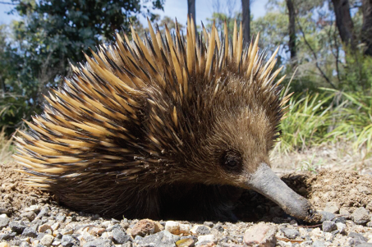  Photo credit: Mark Norman, Museums Victoria | Distribution map  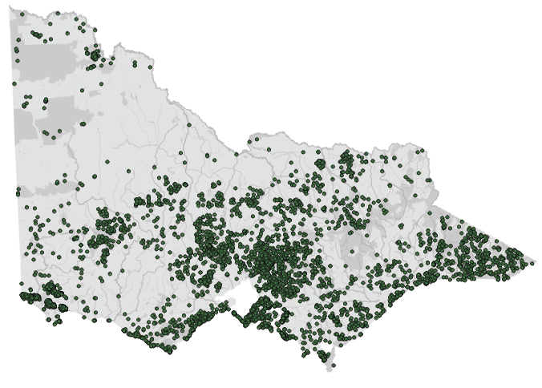  Data source: Victorian Biodiversity Atlas Jan 2023  www.environment.vic.gov.au/biodiversity/victorian-biodiversity-atlas
General appearance | Covered with cream to black spines and brown hair. Beak and strong claws. Hind limbs are rotated so that the feet point backwards at rest and when walking. The density of fur varies across the geographic range, with less dense fur seen in warmer areas and denser fur in colder climates
Conservation status* | Common
Adult morphometrics | Body weight: 2–6 kg  Head and body length: 230–350 mm  Tail length: 85–95 mm  Variation is found across different habitat types and temperatures. Size and weight is not an indication of sex
Home range | Up to 250 ha (but generally 40–70 ha)  Home range is highly variable and dependent on food availability
Behaviour | Solitary  Diurnal or active at dusk and dawn, depending on temperature
Diet | Termites, ants and other soil invertebrates
Longevity | Up to 16 years in the wild (in captivity one individual reportedly reached 49 years)
Sexual maturity | Male: 5–7 years  Female: 5–12 years
Mating season | July to September
Gestation length | Three weeks. After egg is laid and transferred to the temporary pouch, hatching occurs 10–11 days later
Litters per year | One young every 3–5 years
*From the Flora and Fauna Guarantee Act 1988 Threatened List June 2023. This list is updated regularly throughout the year. For the most current list, please visit https://www.environment.vic.gov.au/conserving-threatened-species/threatened-list.

3.3. Animal and human safety considerations
In general, animals in the wild have limited contact with people, pets, and the hustle and bustle of our daily lives. When sick, injured or orphaned wild animals come into care this unnatural close contact can carry risks to the health and safety of both people and animals. For general information on biosecurity and approaches to minimise these risks see Part A of these guidelines. Specific information on enclosure hygiene and biosecurity for echidnas is in Section 3.6.2.
The following information relates to the human and animal health and safety considerations specifically related to the rehabilitation of echidnas.

3.3.1. Human safety considerations
- Short-beaked echidna spines are often covered with soil. Minor skin irritations and/or infections can result if human skin is scratched or punctured by spines.
- When stressed, short-beaked echidnas may urinate and defaecate when handled. Since echidnas are known to carry Salmonella, which can cause severe gastrointestinal disease in people, excellent hand hygiene (washing hands with soap and water after handling or wearing gloves) is important. Echidnas should be held with their cloaca facing away from the handler.
- Echidnas are extremely strong diggers and can dig vertically downwards when feeling threatened. If attempting to pick up an echidna from such a position, be careful not to get your hands caught within the curled-up echidna and be aware of the risk of scratches and/or punctures from lateral spines and nails.

3.3.2. Animal safety considerations
- The beak or snout is a highly sensitive organ that is critical to the survival of the echidna. Rehabilitators and rescuers should exhibit extreme caution around this organ when caring for echidnas as fractures to this area often result in euthanasia.
- Fractures, dislocation, and bruising can occur when echidnas are held by one or both hindlimbs without supporting bodyweight. Echidnas should be handled with two hands underneath to support the body, handling by the hindlimbs is not an acceptable method of restraint.
- Wild echidnas often attempt to dig out of rehabilitation enclosures, and can damage the nails, soles of their feet, and the tip of their beak on enclosure wiring, drains embedded within the enclosure floor or any small gaps in walls/panels. Small gaps under doors/slides or between enclosure wall panels or drains should be closed off or sealed to prevent echidnas damaging their nails or snout.
- Enclosure substrate should be dry and thick to prevent sores (ulcerative pododermatitis) developing on the footpad or damage to the beak.
- If an echidna needs to be dug up from underground (when it is known to be sick or injured), small gardening trowels or hands are preferred. Shovels are not recommended as they can injure the echidna’s legs and/or beak. If unavoidable, care should be taken to dig away from the echidna.

3.4. Capture, restraint, and transport
STOP – A visual examination must be done BEFORE the animal is captured. This applies to the initial capture from the wild as well as prior to captures which occur during time in captive care. See Section 3.4.1 for information on what to look for when conducting a visual health assessment.
Refer to Part A of these guidelines for general advice on wildlife welfare, biosecurity and hygiene, and record requirements. The following information relates to the capture, restraint, and transport of sick, injured and orphaned echidnas.

3.4.1. Visual observations
Visual observations of wildlife should be conducted prior to any attempts to capture the animal. This is just as important prior to the first capture from the wild as it is before any capture conducted while an animal is in captive care. Observations should be conducted quietly, by one person, and from a distance which provides a clear view of the animal with as little disturbance as possible. Visual observation should focus on the animal’s demeanour, behaviour, movement, and posture. Check for evidence of injury/severe disease or deterioration and assess their breathing as demonstrated in the following table.
The echidna’s propensity to curl into a tight ball when stressed, and its sharp pointed quills, can make physical examination very difficult to conduct on a wild/stressed individual. Consequently, visual examination in this species is often the most useful way for a rehabilitator to obtain an accurate understanding of the initial health status of the animal, and to monitor for any changes in health status during time in care.
Visual examinations should initially be conducted in an area which is cool and quiet and not too bright. Quietly observe from a distance. This reduces the impact of behavioural responses to stress as a result of your observations during this exam. Patience is required to allow the echidna time to uncurl and start to sniff and investigate its surroundings. This will allow the carer an opportunity to assess the animal’s demeanour, behaviour, movement, posture and breathing (following the advice in Table 3.2) as well as to look for any evidence of injury.
However, since underlying health concerns are easily missed in this process, a thorough veterinary assessment, under sedation or anaesthesia, is required as soon as possible.
Table 3.2: Visual health observations in echidnas
 | What to look for
Demeanour | - Wild echidnas should be alert and responsive to stimuli (such as loud noises or sudden movement)
Behaviour | - Curls strongly and digs down when alerted by sound, movement or touch  - Many wild echidnas continue to forage even when humans are close by – this does not necessarily indicate poor health. Carers should continue to observe and assess other parameters in this table to determine whether the animal needs to have further assessment or not  - Echidnas are often observed sniffing the air while foraging; this is normal behaviour
Movement and posture | - Wide-based waddle using all four legs  - Hindlimbs are normally rotated backwards  - Forelimbs are strong, both forelimbs used for digging
Breathing | - Echidnas do not pant, so unusually rapid/shallow breathing may indicate significant underlying health concerns and should not be discounted  - Clear, mucous bubbles are often seen at the nostrils in a normal, healthy echidna. The presence of blood or difficulty breathing is abnormal and can indicate underlying infection or beak trauma (e.g. fracture)  - Wild echidnas make a loud snorting/hissing sound by blowing air through their nostrils when stressed, this should not be confused with difficulty breathing
Eyes, ears, mouth/beak, skin and coat condition, limbs and feet | - See Table 3.3 for guidance on what to look for

3.4.2. Equipment
- Gloves: While it may be tempting to wear thick gloves to pick up an echidna, to provide protection from the sharp quills, this will reduce dexterity and can lead to poor handling technique. Thin, leather gloves, such as gardening gloves, are recommended. This allows the carer to feel and respond to the echidna’s movements and not inadvertently grip it too tightly. We recommend long gloves or a long-sleeved shirt to protect the forearms, as this will reduce the risk of irritation from spines scratching the skin (See Figure 3.1a).
- Towel: A large towel can be placed over the echidna from above, and used to protect the arms if long sleeves/gloves are not available.
- Transport container: The container should have solid sides, provide adequate ventilation, be robust and have a secure lid. Some examples include a tall garbage bin with holes in the lid but not the sides (See Figure 3.1b), a 20 L bucket or large plastic tub with holes in the lid, or a solid, smooth-walled cat carry cage. Unsuitable containers include cardboard boxes, bird cages, and eskies as echidnas can easily destroy, escape from, or injure their noses in these types of containers.

3.4.3. Technique
It is beyond the scope of these guidelines to outline techniques for every situation that may be encountered. Examples of techniques for some specific situations are outlined in the following section.
In addition to this information, for further advice please also refer to the recommended reading list, zoological institutions, veterinarians and/or wildlife experts. Inexperienced rescuers should request assistance where possible.
- A short-beaked echidna that is not injured can be gently encouraged off the road. If it is approached too suddenly it will curl into a ball, necessitating physical removal.
- Echidnas are expert diggers. When threatened they will attempt to dig. If the animal is not injured, it is better to let it move away of its own accord rather than dig it out. If removal is required, dig down and around the echidna.
- To lift the echidna, place hands under the middle of the echidna’s body, between the front and back legs. (See Figure 3.1a). This should be attempted quickly in one swift movement as the echidna will attempt to dig back into the ground.
- Never pull or lift an echidna by its hind legs and feet, this is an unacceptable method of restraint as this increases stress and can cause injuries or dislocations.

3.4.4. Transport
- Never transport an echidna which is not restrained in a transport box as they are likely to seek refuge and curl up in small spaces such as underneath car seats and are difficult to remove without sedation.
- A towel or leaf litter can be placed on the bottom of the transport container. Do not use leaf litter if the echidna has a wound, as the wound could become contaminated.
- The container should be securely closed during transport to prevent the echidna escaping.
- Echidnas do not pant or sweat. To thermoregulate when ambient temperatures are high, they rely completely on behavioural responses (such as burrowing underground or moving to shaded areas). When echidnas are transported, they cannot adapt to heat. During transport, the ambient temperature should be less than 25ºC. Be mindful of the actual temperature within the transport container, as it is likely to be higher. Do not place transport boxes in the sun, ensure vehicles are parked in shaded areas or kept cool. Ideally, you should not leave an echidna in a transport box within a car for extended periods. Animals should be checked regularly during travel, and where possible, a datalogger or max/min thermometer such as a Kestrel© should be used to monitor the temperature of the vehicle during transport.
Figure 3.1: a. Restraint of a short-beaked echidna for examination. The hand is placed behind the front legs to stop the animal from curling. b. A plastic container, such as a garbage bin, with holes in the lid for ventilation can be used to transport the echidna. Photo credit: Zoos Victoria
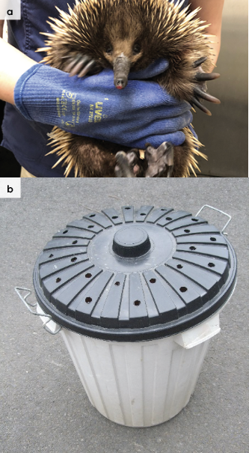

3.5. Monitoring animal health and welfare
The goal of wildlife rehabilitation is to address health and welfare concerns quickly and effectively so wildlife can be released back to the wild as soon as possible. Decision-making from the time of capture through to release, should be guided by an accurate understanding of the animal’s true state of health and welfare. Careful monitoring throughout the rehabilitation period ensures that significant issues, or deterioration in health condition, are identified immediately and quickly addressed.
It is preferred that all sick, injured or orphaned wildlife be assessed by a veterinarian to ensure that non-obvious signs of trauma or disease can be assessed and treated as soon as practicable. No medication should be provided prior to this assessment, as this can mask clinical signs and make an accurate health assessment by the veterinarian very difficult.
Templates for record-keeping of visual and physical observations and daily care can be found in Part A of these guidelines.
This section provides guidance on health assessments on arrival and on effective monitoring of the health and welfare of individuals in care through minimising human-animal interactions and stress to the animal to maximise successful release back to the wild.

3.5.1. Physical examination
Once visual observations are complete, and the animal is stable enough to withstand capture and handling, a basic physical examination should be conducted. This can be repeated when required any time the carer has the animal in the hand, such as for an enclosure change. However, if a full physical exam is not conducted, body condition and weight should be assessed every time the animal is in the hand for other reasons. Carers should make sure weighing scales are available and ready to use before capturing the animal. Physical examinations are also required if the carer notices any changes suggestive of deteriorating health or injury.
Always record the physical examination findings, so that you can compare findings as the animal’s rehabilitation progresses. This ensures any health concerns are identified as soon as possible, and the carer can plan release as soon as appropriate. A template for recording Physical Examination findings can be found in the Appendices to Part A of these guidelines.
Examinations should be conducted in a quiet location, away from domestic animals. Only one person should handle the animal, while a second person takes notes. All other people should move away, and noise kept to a minimum. Handling should also be kept to a minimum, with careful monitoring for any signs of distress (such as panting, salivating, vocalisation or sudden deterioration in demeanour). If these are seen, the examination should be stopped immediately, and the animal returned to its catch bag, transport box or enclosure and allowed to recover.

Species specific considerations:
- Physical examinations can be challenging in echidnas as they are extremely strong and tend to curl into a ball when handled. They will tuck their beak and all four legs into their body. Do not attempt to ‘uncurl’ an echidna; this may exacerbate underlying injuries and is extremely stressful for the animal. An echidna which is very easy to uncurl may be conditioned to human handling/imprinted (hand raised) or very debilitated and require veterinary assessment as soon as possible.
- If a physical examination is attempted, two people should be present to allow for one individual to hold the animal appropriately whilst the other attempts to look for and record information.
- When handled, echidnas may snort or hiss by blowing air through their nostrils, curl up around your hands and urinate or defecate.
- If an animal curls around you, stop moving and sit on the ground to allow the animal to uncurl and move away on its own.
Table 3.3: Physical examination of echidnas
 | What to look for
Body weight | - Record body weight on arrival and at least weekly while in care by placing the echidna on a set of scales in a bucket or bin. Ensure you know the weight of the bin, or tare it before adding the echidna.  - A greater than 10% change in body weight in adults over a week is cause for concern, and the carer should seek veterinary advice immediately.
Body condition | - Body condition can be difficult to determine in echidnas because of the spines covering most of their body and their tendency to curl tightly when touched. However, there are several features to consider:  - Healthy echidnas have an even, rounded appearance over their back. When body condition is lean a ‘dip’ is visible on both sides of the spine, and they appear shrunken over the abdomen. In emaciated echidnas the spine may be visible.  - The foot pads of healthy echidnas are soft, leathery and smooth (See Figure 3.2a). When echidnas are in poor body condition the footpads are shrunken and lack the puffy appearance expected in healthy echidnas. Dehydration can also lead to a shrivelled appearance to the footpads. This needs to be considered in conjunction with hydration status.  - Captive echidnas can become overweight. In these cases, fat bulges can be observed around their head and neck.
Hydration status | - Skin tent (of the furred areas of skin without quills, for example on the legs or abdomen) falls back to normal within one second.  - In dehydrated echidnas, the eyes appear sunken, and the conjunctiva around the eyes appears dry. The skin of the beak can also appear dry/wrinkled.  - The foot pads of hydrated echidnas are firm, and the skin feels elastic. In dehydrated or poorly conditioned echidnas the foot pads are ‘flat’, dry and wrinkled.
Eyes | - Eyelids open, eyes clear, no discharge or crustiness around eyelids.
Ear slits | - The external opening to the ear is a large, vertical ‘slit’ just behind the eyes.  - The ear slit should be dry and clean, with no blood or discharge present.  - Small numbers of ticks are commonly seen in the ear slits of healthy animals.
Mouth and beak | - Long, pink tongue, may be covered in sticky mucous. See Figure 3.2b.  - Very small opening to the oral cavity, there are no teeth.  - Blood from the mouth or along the beak, protruding bones, or any deviation to the beak tip, are abnormal and indicate a traumatic injury (e.g. fracture).  - Bubbly, clear mucous from the nostrils is commonly seen in healthy echidnas and is believed to be one of the behaviours used by echidnas to cope with thermal stress (the moisture helps heat to escape through the nostrils).
Skin and coat condition | - Quills should be intact, tapering to a point at the end, with healthy looking skin and fur in between. While a small number of broken spines may be normal, large areas of broken/short or missing spines, or crusty/flaking skin between spines may indicate an underlying health issue which requires further investigation.  - A small number of ticks between quills are commonly seen in healthy wild echidnas. Large numbers of ticks may indicate underlying poor health.
Limbs and feet | - Forelimbs are short with long, forward facing nails. Hindlimbs are normally rotated backwards compared to most mammals, so that the feet point backwards at rest and while walking (Figure 3.3a).  - There should be no broken nails or obvious wounds.  - Asymmetry in the wearing of nails may indicate underlying injury to limbs/digits.
Sex determination | - Determining sex can be challenging because there are no external genitalia; size and weight are not indicative of sex.  - Echidnas do not have a permanent pouch, and the ventral abdomen of males and females looks very similar unless the female is incubating an egg or is lactating.  - The male penis is internal and is not normally visible or palpable. When protruded (for example under anaesthesia) the penis has four heads and is very easy to identify.  - The presence of spurs on the hindlimbs is not indicative of sex as both males and females may have spurs (See Figure 3.3b). All juvenile echidnas have spurs. Adults may have spurs on both hindlimbs, one hindlimb or none at all.
Figure 3.2: a. The foot pads of healthy echidnas are soft, leathery and smooth. b. A healthy echidna’s beak and tongue.
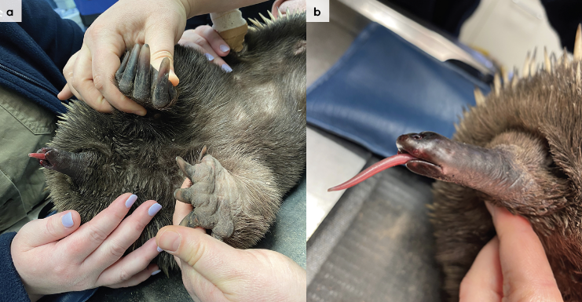
Figure 3.3: a. Echidna feet facing backwards. b. An echidna’s foot with spur. Photo credit: Zoos Victoria
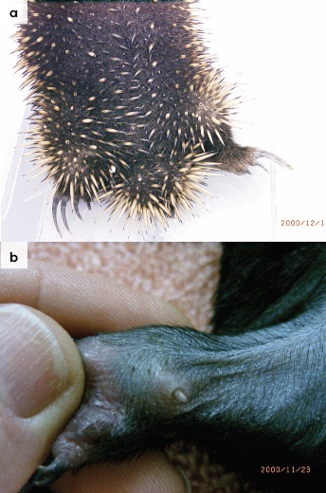

3.5.2. Ongoing monitoring of health and welfare
The aim of wildlife rehabilitation is to ensure animals recover and can be released back to the wild as quickly as possible. Careful, daily monitoring is required to ensure that animals are responding as expected to the treatment and so that any deterioration or welfare concerns can be identified and addressed as soon as possible. Carers should ensure that record-keeping is a priority to maximise positive welfare outcomes. Templates to assist wildlife rehabilitators to record and monitor wildlife health and welfare can be found in the Appendices to Part A of these guidelines. These records will be valuable tools to share with veterinarians to support decision-making.
The following is recorded daily:
- demeanour
- food consumption
- faecal/urine output
- behaviour observed
- medical treatment provided
- evidence for overnight activity.
The following is recorded weekly:
- weight
- body condition.
Over time regular monitoring will also help to develop carer skills and knowledge, as regular observations and recording will result in a deep understanding of the expected behaviour and response to treatment for the species in care.

Species specific considerations:
- Time your health and welfare observations for times of the day when the animal is expected to be active.
- If the animal is being medicated, a visual check in the morning is recommended.
- Ideally physical observations should be undertaken at the beginning and/or end of the resting period to minimise disturbance and maximise the rest/sleep period for rapid healing and ensure ease of capture.
- Echidnas held in small, hard floored enclosures for rehabilitation are prone to developing ulcerative lesions on their footpads. This is exacerbated by insufficient or wet/soiled substrate. A deep (~15–20 cm) layer of clean, dry substrate is required. Regular checks of the footpads of all echidnas in care should be part of the rehabilitation routine; this can coincide with the weekly check of weight/body condition (See Table 3.4).
- It is not unusual for wild echidnas to refuse to eat for the first 5–7 days in care. Since they have a low metabolic rate and are able to survive for up to two weeks without food, this is no cause for immediate alarm. However, this does require careful monitoring. While some echidnas can be encouraged to eat by adding formic acid to feed (see Table 3.6), there may be other underlying issues, including stress or pain, which are impacting food consumption. Careful monitoring of the animal’s demeanour, response to food, body weight and body condition can help to ensure veterinary advice is sought as soon as possible (see Table 3.3 for information on how to weigh echidnas).
- Faecal consistency should be monitored daily. Faeces of healthy wild echidnas are solid, cylindrical and consist mostly of soil, some plant matter and the undigested exoskeletons of invertebrates. Diarrhoea can result from the rapid change from the wild to captive diet, or where immune suppression/stress allows overgrowth of organisms which are considered part of the normal ‘gut flora’ (including some bacteria, yeast or coccidia). If severe diarrhoea occurs, deterioration in demeanour is observed, or there is fresh blood in the faeces, veterinary attention should be sought as soon as possible. A sample of the abnormal faeces should be taken with the echidna for microscopic examination (wet prep and faecal float). No treatment should be provided prior to veterinary assessment, as medications can mask the underlying cause of disease, making a diagnosis and appropriate treatment plan very difficult to obtain.

3.5.3. Common and emerging health conditions
Clear guidance on conditions that may require euthanasia can be found in Part A of these guidelines.
Table 3.4 lists common clinical signs and possible causes of injury/disease. Carers should be aware that these are not exhaustive. Aside from first aid, carers should avoid administering medications prior to the provision of veterinary advice.
Unusual clinical signs or mass mortality events – a number of animals dying or found dead at the same time, with similar signs – may indicate an emergency animal disease, an emerging/new infectious disease or an environmental/human related toxicity which needs further investigation. Report these immediately to the Emergency Animal Disease Watch Hotline on 1800 675 888 (24 hours).
Table 3.4: Common and emerging health conditions seen on presentation or during care
Injuries and Clinical signs | Possible causes | Rehabilitator observations and response
NOTE: Do not provide pain relief or other medication, including antibiotics, unless under veterinary guidance and supervision, as these can have severe side effects, particularly in dehydrated/shocked animals. Use of antibiotics when not indicated can contribute to antimicrobial resistance and reduce drug efficacy.
Beak trauma  Unable to walk or move normally  Swollen limb  Bruising  Fractures  Dislocation | Found adjacent to road/suspect motor vehicle accident  Caught in wire or netting, injury from garden tools  Predation injury caused by raptor, fox, cat or dog, gunshot  Poorly designed transport box/enclosure  Capture injury  Injury sustained in captivity, due to stress | - Urgent veterinary attention is required. Do not delay transfer to a veterinarian even if there is excessive bleeding from the beak tip. This is extremely difficult to stop, and any pressure on a broken bone is highly stressful and painful.  - Move animal to an appropriate transport box to restrict movement. Ensure temperature is appropriate for the species.  - Do not attempt to stabilise fractures as this is very painful, and risks making the injury worse. Fracture stabilization should only be attempted by a veterinarian following physical exam, x-rays and under general anaesthesia.  - Do not provide pain relief or other medication unless under veterinary guidance and supervision, as these can have severe side-effects, particularly in dehydrated/shocked animals.  - If suspected as the cause, assess the enclosure/box/bag to find the source of injury. Fix loose wire/gaps or sharp edges before returning animal to enclosure.  - If stress is deemed a factor, consider whether the animal is a candidate for rehabilitation. Seek advice from species experts.
Bleeding  Puncture wounds  Bruising  Quill loss | Found adjacent to road/suspect motor vehicle accident  Caught in wire or netting, injury from garden tools  Predation injury caused by raptor, fox, cat or dog, poorly designed transport box/enclosure  Capture injury  Injury sustained in captivity, due to stress | - Seek urgent veterinary assessment.  - Move animal to a small transport box to restrict movement. Ensure temperature is appropriate for species and minimize stress.  - Do not provide pain relief or other medication unless under veterinary guidance and supervision, as these can have severe side-effects, particularly in dehydrated/shocked animals.
Bite wounds  Unable to walk or move normally  Swollen limb  Bruising  Fracture | Predation injury, bite wounds caused by raptor, fox or dog  Dog bites are commonly seen around hindlimbs/tail area | - Urgent veterinary attention is required.  - Move animal to a small transport box to restrict movement. Ensure temperature is appropriate for species and minimize stress.  - Do not provide pain relief or other medication unless under veterinary guidance and supervision, as these can have severe side effects, particularly in dehydrated/shocked animals.  - Internal injuries resulting from predator attack are often more severe than they appear from the external appearance. Dog bite wounds in the hind limbs of echidnas are often associated with fractures or joint injury.
Diarrhoea  Abnormal/loose, smelly faeces | Inappropriate diet, infectious disease, alteration of microbiome, stress, antibiotic treatment | - Seek veterinary advice.  - Seek urgent veterinary advice if diarrhoea does not resolve rapidly (e.g. within 24–36 hours), or if there is any evidence of dehydration, blood in faeces or change in demeanour.  - Do not treat on assumption of infectious disease (such as coccidia or bacterial infection) as this can make veterinary diagnosis more difficult if the animal does not improve. A small number of coccidian oocysts are present in the faeces of healthy, wild echidnas so this finding would not warrant treatment for ‘coccidiosis’.  - Excellent hygiene standards are required in case diarrhoea is caused by an infectious organism. Isolate the sick animal from others in care to reduce the risk of transfer (See Part A of these guidelines for information on managing quarantine and infectious disease).  - Seek advice from species experts, ensure diet and husbandry practices are correct.  - If stress is deemed a factor, consider whether the animal is a candidate for rehabilitation.
Skin condition/damaged spines,  Ulcerated skin  Skin irritation  Damaged quills | External parasites, fungal or other skin conditions | - Seek veterinary advice or assessment to diagnose the cause and advise on treatment.  - Inflamed, flaky or crusty skin lesions have been reported in echidnas due to a wide range of infectious organisms (including fungus, bacteria and mange mites). Do not attempt to treat chronic or severe skin lesions until a veterinary assessment is obtained, as some antimicrobial creams can alter the wound, making an accurate diagnosis impossible to obtain.  - Damaged or missing spines will regrow; however, this can take a very long time. Echidnas should not be kept in captivity until all spines are regrown, as this can take years. If the animal is otherwise healthy it should be released to the wild.  - Heavy burdens of external parasites in animals may indicate an underlying disease or injury, these animals require veterinary assessment.  - A small number of ticks on the skin between spines or around the ear slits is completely normal. The animal may not require treatment or handling to remove ticks unless they are excessive in number, the animal is otherwise debilitated, or there is associated skin irritation.  - Ensure good hygiene and biosecurity practices.
Burns | Recent bushfire, campfire injury, chemical burn | - Seek urgent veterinary attention.  - Burn injuries are extremely painful, treatment and bandage changes should only occur under anaesthesia and with adequate pain management.  - Animals should be returned to a veterinarian for ongoing bandage changes.  - Echidnas bury themselves underground during bushfires, or shelter in known burrows, and are susceptible to burns over their backs as a result of heat transfer through the soil from above. Severe burns can result in large patches of short, singed or missing spines. Like other animals, the appearance of burns to the skin change over time and are very painful.  - House the animal in a fly-proof enclosure.
Large mass under skin | Sparganosis (parasite), hernia | - Veterinary advice should be sought to differentiate and treat appropriately.
Dull demeanour/poorly responsive, weak (does not curl when stressed, does not resist uncurling) | Heat stress, torpor, infectious disease, toxicity | - Seek veterinary assessment to determine the cause.  - Urgent veterinary attention is required to assess a heat impacted animal, to determine hydration status, and whether heat stress has led to more significant underlying organ damage. Heat stress is considered if the ambient temperature is >25ºC, and cloacal temperature is above 33°C. Place the animal in a cool environment and wrap the animal in a cold wet towel.  - Seek species expert advice. Poorly responsive animals may present in a very similar manner regardless of the underlying cause, an assessment of environmental factors may help to understand whether the clinical signs seen are a response to thermal range or may indicate an underlying health condition.  - Torpor may occur at low environmental temperatures. The echidna could display torpor at any time of the day or year, regardless of ambient temperature. If there are no signs of trauma, the animal is in good body condition, and there are no obvious signs of poor health, place the echidna in an environment of about 21°C and, if it becomes active and behaves normally over a period of 1–2 hours, reassess. If the animal is bright, alert and normally responsive, release it at its original location.
Figure 3.4: a. Extensive damage to an echidna’s beak, requiring euthanasia. b. An echidna with a mild beak abrasion, which will heal uneventfully, allowing the echidna to be released. Photo credit: Zoos Victoria
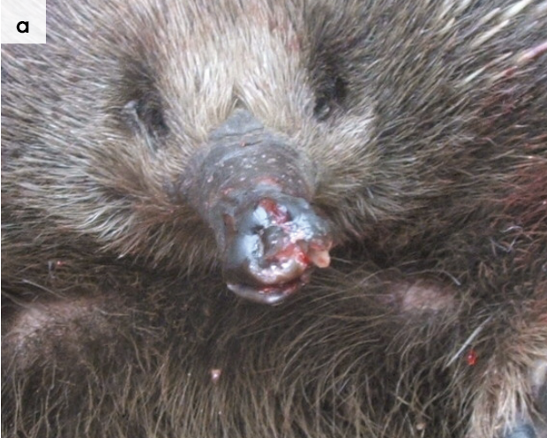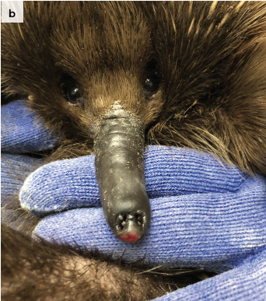
Figure 3.5: Large mass under the skin of an echidna, indicative of sparganosis.
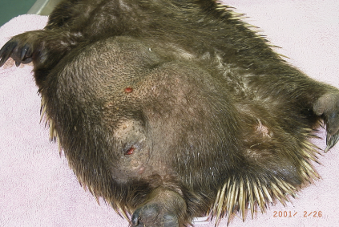
Figure 3.6: Burn on the back of an echidna. Photo credit: Zoos Victoria
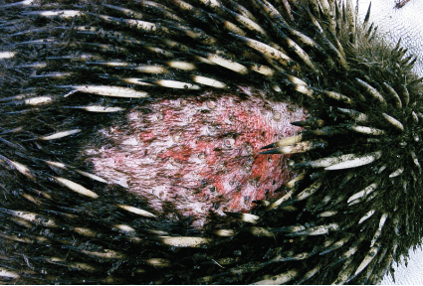

3.5.4. Administering treatment during rehabilitation
- Since oral medications cannot easily be delivered, they can be mixed into a small amount of food once echidnas are reliably consuming the captive diet. Morning medications can be mixed into a small portion of food and placed next to the echidna. The medication bowl should be removed once the contents are consumed. In the evening, medication can be presented prior to the main meal to ensure the entire amount is consumed.
- Since many wild echidnas refuse to eat when first in care, medication prescribed during this initial period often requires delivery by injection (under the skin or into the muscle). Injectable medications (which may include non-steroidal anti-inflammatory pain medication or antibiotics) should be prescribed by a veterinarian. The veterinarian is also responsible for ensuring the rehabilitator is comfortable with the technique required to administer medications correctly. Two people are required for delivering injectable medications to echidnas, one person restraining the animal (see Section 3.4), while the other injects the prescribed amount as directed by the veterinarian. The best site for injections is into the muscles of the outer thigh, which should still be accessible even if the echidna has curled into a ball. Since this process is highly stressful, medication should switch to ‘in food’ delivery as soon as possible.
- Since burns are extremely painful, sedation or anaesthesia is generally required for wound debridement or dressing changes. Wound dressing during the early stages of healing is very frequent (often every 2–3 days). It is preferable that burnt echidnas are transferred to an appropriately equipped veterinary hospital during this phase of treatment.
- Topical treatment prescribed for skin lesions can be applied to the skin between spines using a long-handled, disposable cotton tip swab.

3.6. Housing
Below are several key considerations when housing adults in care.

3.6.1. General housing information for echidnas
- Echidnas are solitary and should be housed individually during rehabilitation.
- Echidnas are very strong. They can climb and will readily attempt to escape from enclosures. They commonly use their beaks and claws to probe at small spaces, gaps under doors, drains/grills or loose enclosure wire and this can cause abrasions and cuts to the soft skin of the beak and footpads.
- A deep layer (~15–20 cm) of dry, clean substrate should be provided to allow echidnas to burrow down. This is an important behaviour which can help to reduce the stress of captivity. However, soiled/wet substrate material should be removed daily. If the soft skin of the foot pads is in direct contact with damp organic material, echidnas are prone to developing foot lesions. This is exacerbated if there are any rough/sharp edges to the floor of their enclosure.
- Prior to release, echidnas should be given adequate enclosure furniture to exhibit natural foraging behaviour. Gum branches and rotten logs can provide sensory experiences to support mental and physical wellbeing.
- Thermal range (18–25ºC): Echidnas do not pant or sweat; they are completely reliant on behavioural responses such as burrowing underground, swimming or moving to shaded areas to thermoregulate during high heat events. When housed in rehabilitation enclosures, their ability to make appropriate choices for thermoregulation is significantly curtailed. While a range of ‘optimal temperature ranges’ have been published for echidnas, and likely vary across their natural distribution in the wild, it is generally recommended to maintain captive enclosures between 17–25ºC. At the other end of the thermal range, Victorian echidnas enter torpor when temperatures drop below ~12ºC.

3.6.2. Enclosure hygiene & biosecurity
General information about hygiene and biosecurity can be found in Part A of these guidelines. New diseases emerge frequently and sick and injured animals in care are often more susceptible to picking up pathogens from the environment. It is important to maintain excellent levels of hygiene to avoid inadvertently transferring diseases between animals, and from humans, and to protect the wild population where the animal will eventually return to.

Species specific considerations:
- Coccidian oocysts are frequently found in the faeces of wild echidnas. While part of the normal flora of echidnas, they can cause disease in stressed or otherwise immune-compromised echidnas. Excellent hygiene, and daily spot removal of faeces, is required to reduce the build-up of coccidian oocysts in the environment.
- Coccidian oocysts are highly resistant to most disinfectants, including bleach and F10SC, and can remain viable (infective) in the environment for many months. Viability of coccidian oocysts is prolonged when they are protected by the presence of organic matter. All organic matter should be removed and the enclosure cleaned with boiling water, as this has been shown to kill oocysts. Rehabilitation facilities for echidnas should be designed and built using materials which are easy to clean and disinfect between occupants.

3.6.3. Housing types
Different set ups are required for animals at different stages of treatment and care.
Table 3.5 describes the housing type, suggested dimensions and requirements at each stage of care. For information on housing animals during hand raising see Section 3.8.
Table 3.5: Rehabilitation housing for adult echidnas
Intensive care housing
Indications  for use | Suggested min. dimensions | Suggested  requirements
Short term critical care (<48 hours)  Intensive veterinary treatment - frequent medication, oxygen supplementation, temperature control  Longer periods under veterinary supervision where strict cage rest/confinement is indicated | Floor area:  0.60 x 0.60 m (0.36 m²)  Height: 0.90 m  The adult echidna should be able to stand, stretch its head/neck out completely and turn around. | ENCLOSURE CONSTRUCTION  - A large plastic tub or wooden box with smooth walls (Do not house echidnas in enclosures with wire walls as they will damage their claws and beaks.).  - Echidnas can escape out of enclosures which are not ‘tall’ enough or where there are any loose wires or gaps. The lid should close securely; it should have screws or a locking system to prevent the echidna pushing it open.  - If the enclosure walls are less than one metre high, the ‘lid’ should be solid. Adequate ventilation should be provided in a solid enclosure. Rows of air holes, smaller in diameter than the echidna beak should be drilled into the ‘lid’ and along the top of the side walls. A wire grill can be used if the enclosure walls are tall enough to ensure the echidna cannot reach it. This is to prevent damage to the beak and feet.  ENCLOSURE FURNISHING  - Towels, newspaper, shredded paper or cardboard, or disposable absorbent bedding materials, including recycled paper cat litter, may be used as flooring. Change daily.  ENVIRONMENTAL VARIABLES  - No heating is required, and the enclosure should remain below 25°C to avoid overheating. A range of 18–25°C is appropriate.  - Monitor with a thermometer or manage ambient temperature using a thermostat controlled split system.  PROVISION OF FOOD/WATER  - Food and water bowls need to be made of a sturdy material, such as ceramic or steel, and have a low profile to prevent being tipped over (see Figure 3.8)

Intermediate housing (Treatment/cage rest)
Indications  for use | Suggested min. dimensions | Suggested  requirements
Provision of daily medication, close monitoring once animal is stabilised and no longer requires intensive care.  Enclosure furnishings can be arranged to reduce opportunities to dig or move excessively so that ‘cage rest’ can be achieved with slightly more space/reduced contact. | Floor area: 2 m x 1.2 m (2.4 m²) Height: 1 m  The enclosure should be large enough to allow the animal to move around, and deep enough to provide substrate for digging. | ENCLOSURE CONSTRUCTION  - While this stage of rehabilitation requires a larger enclosure, construction style and materials are the same as provided above for ‘Intensive care housing’.  ENCLOSURE FURNISHING  - An absorbable substrate, such as recycled cat litter, shredded paper or cardboard, or mulch can be provided in a deep layer (~15 cm deep) to provide opportunities for digging.  - Furnishings can be arranged to reduce opportunities to climb/dig or move excessively so that ‘cage rest’ can be achieved with slightly more space/reduced contact.  THERMAL ENVIRONMENT  - No heating is required, but ambient temperature should remain below 25oC to avoid overheating.  - Monitor with a thermometer or manage ambient temperature using a thermostat controlled split system.  PROVISION OF FOOD/WATER  - Water bowls need to be made of a sturdy material, such as ceramic or steel, and have a low profile to prevent being tipped over (see Figure 3.8)  - Food can be presented in a low-profile ceramic plant pot saucer (see Figure 3.8)

Pre-release
Indications  for use | Suggested min. dimensions | Suggested  requirements
No longer require regular handling/medication  Development of fitness/strength prior to release  Monitor/assess behaviour (foraging, digging)  Pre-release assessment | Floor area:  5 m x 4 m (20 m²)  Height: 1.5 m  The enclosure should be large enough, and contain suitable furnishing to enable assessment of natural foraging and digging behaviour prior to release | ENCLOSURE CONSTRUCTION  - The enclosure should be placed in a shaded area and have solid walls (e.g., tin or recycled plastic sheeting) to at least 1–1.5 m height.  - The solid wall should extend at least one metre underground to prevent the echidna from digging out. Wire mesh or grills to prevent digging are not suitable, as they are likely to lead to nail/foot damage if the echidna attempts to dig out  ENCLOSURE FURNISHING  - Offer a substrate of mulch or leaf litter to promote digging and foraging for insects.  - Rotting logs naturally infested with termites can be provided as enrichment and a natural food source, provided the source of the logs is known, and there is no pesticide/or other potentially toxic chemicals used in the area.  - A compost heap of grass and leaves will attract insects for foraging.  THERMAL ENVIRONMENT  - A rock cave, burrow or hollow log will provide a cool area during high ambient temperatures.  - Ambient temperature should be monitored carefully, and echidnas moved temporarily inside/to a cooler enclosure on high heat days  - Since wild echidnas swim to cool off during extreme heat, provision of a pond dug into the ground to prevent it from tipping over can help prevent overheating.  PROVISION OF FOOD/WATER  - Food and water bowls can be dug into the ground or surrounded with substrate.  - See Table 3.6 for information on pre-release diet considerations.
Figure 3.7: a. A plastic tub, suitable for intensive or intermediate care of a sick or injured adult echidna. The echidna is unable to reach the wire roof so that it cannot damage its beak. b. Short-beaked echidna in a plastic tub with shredded cardboard substrate. Note the sturdy, low-profile food and water bowls. Photo credit: Zoos Victoria
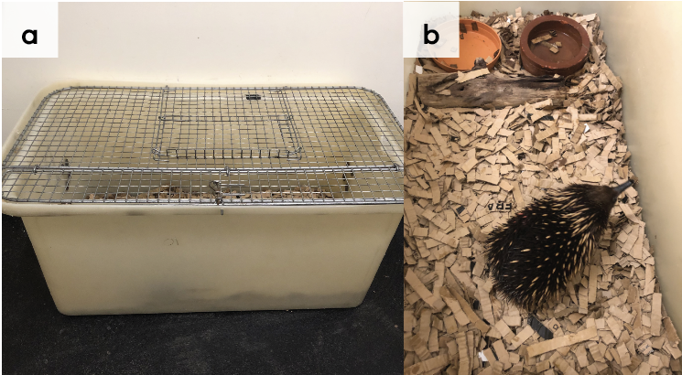

3.7. Feeding and nutrition
Keeping daily records of food offered (item and volume fed) and food consumed is good practice and will allow the rehabilitator to observe how the animal is responding to food on offer and inform future choices.
Please note: Food suppliers and specific products mentioned in these guidelines are intended as examples only. Other suitable products may also be available.
This section refers to feeding and nutrition of echidnas in rehabilitation. Information on feeding orphaned individuals can be found under Section 3.8 Hand raising.
Table 3.6: Daily feeding and diet guide for adult echidnas during rehabilitation
Diet | - There are several commercially available diets which have been developed in collaboration with a wildlife nutritionist, including the Wombaroo Complete Echidna Diet. This is the simplest way to provide a balanced diet during rehabilitation. It is generally well accepted by wild echidnas during rehabilitation. Feed according to instructions provided by manufacturer.  - Formic acid, found in most ants (with a very strong smell), can be added to food to encourage eating. Start with one drop and increase by one drop daily, up to three drops to attract the echidna’s interest. Once the echidna is reliably eating the captive diet, formic acid is not required. Note that faeces are often not as firm on the captive diet compared with the wild diet. However, since diarrhoea can indicate underlying health issues, monitor closely and seek veterinary advice if demeanour deteriorates, body condition is poor or if fresh blood is seen in faeces.
Frequency of feeding | - Food provided once per day for adult/weaned individuals.  - Fresh water should always be easily available, provided in a stable/non-spill bowl or automatic drinker. Water should be changed daily.
Figure 3.8: A wild short-beaked echidna eating Wombaroo Complete Echidna Diet from a low bowl. Photo credit: Zoos Victoria
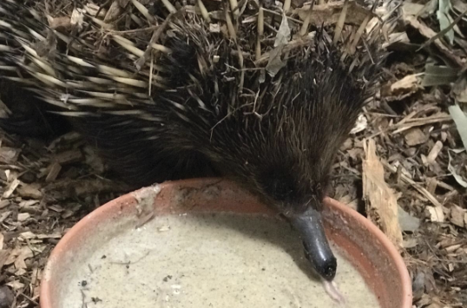

3.8. Hand raising
Hand raising record templates for growth, development, feeding and other observations can be found in the Appendices to Part A of these guidelines.

3.8.1. Equipment required for hand raising
- Milk provision: Since wild echidnas lack nipples (the puggle sucks milk directly from special glands in the skin of the pouch) no teat or bottle is required for hand raising them. Instead, milk is offered from a small, flexible bowl (see Figure 3.11). Alternatively, milk can be offered directly from the palm of a clean hand, noting that minimising interactions with humans is preferred. With appropriate hygiene, feeding from the palm is the most natural feeling for the young.
- Bedding material: small pouch made from non-abrasive materials such as soft flannelette/ cotton can be used until the echidna reaches ‘burrow’ stage (see growth and development Table 3.7). At this point, clean dirt/mulch or shredded paper can be used on the floor of the hand-rearing box/enclosure as bedding/substrate.
- Housing: Refer to the growth and development Table 3.7 where housing suitable for each stage of development is described. Echidnas can be raised successfully in simple, escape proof boxes, provided temperature regulation is possible. Thermostatically controlled portable animal intensive care units have also been used, particularly during the ‘pouch’ stage.
- Temperature monitoring: While monitoring pouch temperature is important with all orphaned marsupials, it is particularly important for orphaned echidnas given their propensity to overheat when temperatures are above 25°C. A max/min digital thermometer or datalogger for monitoring pouch/enclosure temperature is vital.
- Other: Set of scales, record charts.
Figure 3.9: An echidna is weighed on a set of scales. Photo credit: Zoos Victoria
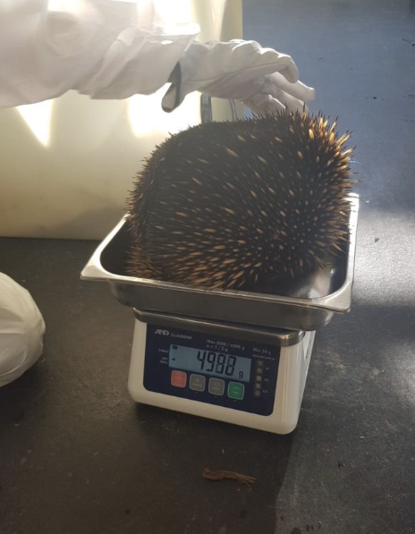

3.8.2. Growth, development and care of orphaned young
STOP – Please refer to your authorisation for mandatory conditions, regarding unfurred puggles.
- Echidnas are rarely brought into care as orphans. For this reason they should be transferred to the Australian Wildlife Health Centre, Healesville Sanctuary or a rehabilitator experienced in hand raising echidnas.
- It is not recommended to attempt to hand raise echidna puggles weighing less than 100 g (approximately 30 days), as the success rate is very low.
- There are two distinct phases described for echidnas, from hatching to weaning: pouch life (first 50 days); burrow life (from 50–120 days). Burrow life is when the young are left in the burrow for extended periods, and the mother returns at intervals for feeding, until weaned.
- Milk: Short-beaked echidna milk is very high in fats and low in lactose. Milks used should imitate this natural diet. Wombaroo Echidna Milk provides sufficient energy and protein. Other milks require additives to provide correct nutrition, and for this reason they are not recommended.
- Wash hands thoroughly with hot soapy water before all feeds. If using hands ensure that hands are clean prior to offering any milk on the palm of the hand, if a soft silicone dish is used, make sure this is washed prior to use. Both these options enable the puggle to replicate the pushing motion into skin where glands produce milk that emerges on the skin for lapping.
- Immediately after feeding, return the echidna to the cleaned nursery burrow and do not disturb between feeds, except where necessary husbandry tasks are required such as weighing and cleaning of soiled enclosure.
Table 3.7: Feeding and housing requirements for young orphaned echidnas
Age | Weight / Morphometrics | Observation | Feeding | Housing
35–45 days | 105–195 g | - Stage 1:  Pouch young  - Eyes closed  - No fur or spines  - Pink skin  - Faeces mustard colour and toothpaste consistency | - Milk formula: Wombaroo Echidna Milk Early Lactation, transitioning to Wombaroo Echidna Late Lactation – follow instructions provided by Wombaroo.  - Feed volume and frequency: Feed ~15–20% of body weight during a single feed. Initially, milk should be offered daily, however, once feeding well, increase the interval to every second day. Ensure all milk is digested from the previous feed prior to offering a new feed (milk is visible within the stomach at this young stage).  - Feeding technique: Offer milk in a small bowl or on the palm of the hand. It may take some days for the puggle to learn how to lap/suck.  - Toilet: Toileting is not required – echidna puggles will defaecate and urinate without stimulation. Given the slow digestion of echidnas, puggles may not defaecate after every feed. Record defaecation frequency. Urination may occur every 2–4 days. | - Bedding material: Flannel or cotton pouch, folded over.  - Enclosure: Smooth walled plastic tub  - Temperature range: ~23–28°C.  - Monitor temperature carefully, and where artificial heat sources are used (such as heat mat) make sure this is not in direct contact with pouch young.
45–50 days | 200–265 g | - Spines visible under skin  - Fine hairs coming through
50–60 days | 300–390 g | Stage 2:  Burrow young  - Eyes open,  - Fur still growing, small  - Dark spines coming through | - Milk formula: Wombaroo Echidna Milk Late Lactation, fed according to manufacturer instructions  - Feed volume and frequency: When gaining weight consistently, feed 20% of body weight and gradually decrease feeding frequency to every 5 days  - Feeding technique: Offer milk from bowl.  - Toilet: as above – stimulation is not required, and as feed frequency decreases, the frequency of defaecation also decreases | - Bedding material: no pouch required  - Enclosure: Larger, smooth walled plastic tub (suggested dimensions 90 cm L x 60 cm W x 70 cm H) with ~ 20 cm dirt and mulch/leaves substrate. An artificial ‘burrow’ can be made by providing an upside-down wooden box or dark hide.  - Temperature range: ~15–<21°C.
60–90 days | 400–450 g | - Eyes open  - Black fur  - Spines 2 mm length  - Faeces more formed
90–110 days | 450–500 g | - Ear opening visible  - Starting to climb and explore burrow
110–160 days | 500–800 g | - Adult appearance but small size
7 months | 800–1500 g | - Adult appearance | - Weaning process: From ~800 g weaning begins. Over a period of four to five feeds, slowly reduce the amount of milk in each feed while increasing the solid component of the diet  - Solid foods: Wombaroo Echidna Diet, range of invertebrates (see Table 3.6 above), small amount of ‘termite mound dirt’ mixed into slurry. | - Housing to follow recommendations in Table 3.5 above, pre-release enclosure.
 | 1500+ g | - Adult in appearance  - Release at over 1500 g | - Adult diet (see Table 3.6 above)
Figure 3.10: a. A young short-beaked echidna at approximately 40 days of age. This animal would still live in the pouch of its mother. b. A young short-beaked echidna at approximately 70 days of age. This animal would be left in the burrow by its mother while she foraged. Photo credit: Zoos Victoria
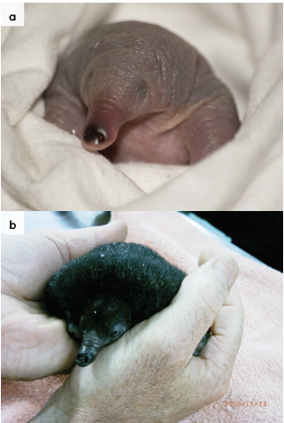
Figure 3.11: A young echidna is offered milk from a soft plastic bowl. Photo credit: Zoos Victoria
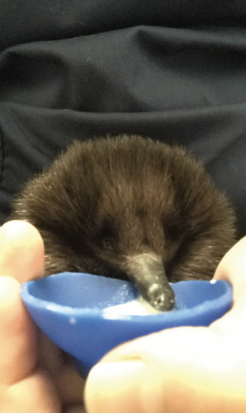

3.9. Release protocol
Ideally, wild animals will be rehabilitated and released in a short timeframe. If this is not possible and the animal is in care for significant extended periods, ensure that the animal is regularly assessed against the welfare domains to support decision-making. Animals in care for extended periods may have a reduced ability to survive in the wild. Talk to your veterinarian and consider whether euthanasia will provide the best welfare outcome for such individuals.

3.9.1. Pre-release assessment
Pre-release assessment of animals in care is essential to support improved outcomes once back in the wild. Animals should be assessed based on body condition, fitness and the ability to engage in natural species-specific behaviours prior to release.
The following check list should be used to guide decision-making regarding release suitability for echidnas:
- Individual is in a state of good health, presenting injury/sickness is completely resolved (consider a pre-release veterinary check).
- Individual is within a healthy weight range and appropriate body condition (refer to Table 3.1).
- Individual displays the ability to actively forage for and consume natural foods, individual demonstrates that it can dig down when threatened and curl into a ball.
- Appropriate transport container.

3.9.2. At the release site
Post release survival will be maximised by ensuring that both the release site and the way in which the animal is released are carefully considered.
Echidnas require the following:
- A supply of invertebrates.
- A variety of shelters, such as rocks, fallen wood, small caves or bushes.
- A thermal range which supports the activity levels required to find appropriate shelter and food in the post-release period.
For more information on the ecological characteristics and requirements of echidnas that may help with their release, please refer to Table 3.1.

3.9.3. Release checklist
Check all of the requirements of your authorisation are being met, and consider the following:

Release location
- Approximate release where the animal was found (where suitable or within home range).
- Suitable vegetation for foraging.
- Suitable soil for digging.
- Away from major roads.

Release Procedure
- Limit the number of people at the release.
- Release when the temperature is between 18°C and 25°C. This may be in the early morning, except in the warmer months when it may be better to release the echidna in the evening. Avoid releasing on days of extreme weather.
- Release close to a hiding place such as the base of a tree, large mulch pile, rabbit or wombat burrow. Do not release an echidna in a hot, unsheltered area.
- Open the door of the transport container and allow the animal to leave in its own time. The animal may elect to burrow down immediately. If this occurs, leave the echidna alone and walk away.

3.10. Key references and additional reading
Augee, M.L., Gooden, B. and Musser, A. 2006. Echidna. Extraordinary egg-laying mammal. CSIRO Publishing, Collingwood VIC, Australia.
Griffiths, M. 1989. Tachyglossidae. In: Fauna of Australia. Vol 1B Mammalia, D.W. Waktib and B.J.Richardson (eds), pp.407–435, Australian Government Publishing Service, Canberra, Australia.
Hulbert, A.J., Beard, L.A. and Grigg, G.C., 2008. The exceptional longevity of an egg-laying mammal, the short-beaked echidna (Tachyglossus aculeatus) is associated with peroxidation-resistant membrane composition. Experimental gerontology, 43(8), pp.729-733.
Koppman, L., 2005. Aspects of hand raising the short beaked echidna. Australian Wildlife Rehabilitation Conference, Surfers Paradise, Australia, 31st August – 2nd September, Available at http://www.awrc.org.au/uploads/5/8/6/6/5866843/awrc_leigh_koppman.pdf
Stannard, H.J., Bekkers, J.M., Old, J.M., McAllan, B.M. and Shaw, M.E., 2017. Digestibility of a new diet for captive short beaked echidnas (Tachyglossus aculeatus). Zoo biology, 36(1), pp.56-61.Rismiller, P.D. 1999. The Echidna, Australia’s Enigma. Hugh Lauter Levin Associates, Connecticut
Rismiller, P.D. 2019. Biology, Rescue and Rehab of Short-beaked Echidnas, ISBN 978 0 9805672 0 5.
Rismiller, P.D. and Grutzner, F. 2019. Tachyglossus aculeatus (Monotremata: Tachyglossidae). Mammalian Species 51 (980): 1-17.
Rismiller, P. 2021. Initial treatment and care guidelines for rescued echidnas. Department of Planning, Industry and Environment, NSW. https://www.environment.nsw.gov.au/-/media/OEH/Corporate-Site/Documents/Animals-and-plants/Native-animals/rescued-echidnas-treatment-care-guidelines-210315.pdf
Staker, L, 2007 Hand rearing echidnas. Accessed 10th October 2021 from http://www.lyndastaker.com/freestuff/echidnas.pdf

