Land manager activities and flying-foxes
  - Guidance for public land managers on managing risks at flying-fox camps and avoiding impacts to wildlife
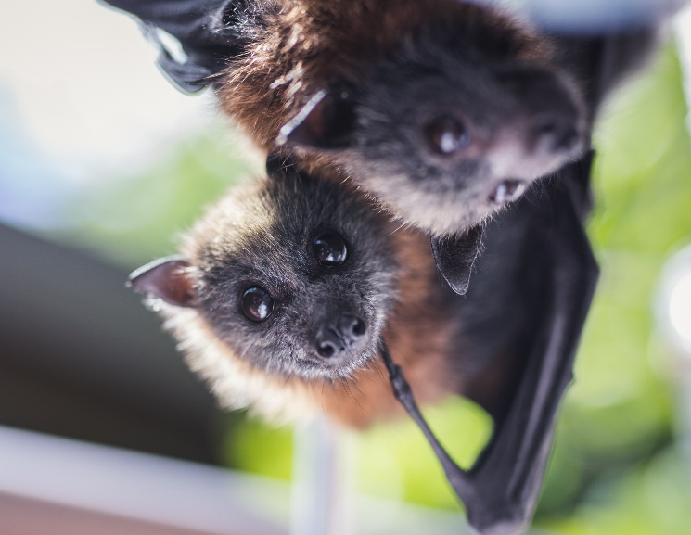

Routine management activities
Public land is often managed for many purposes, such as public recreation and environmental or heritage protection. Land managers need to manage diverse risks, in addition to those posed by wildlife. This includes managing vegetation and surfaces to minimise health and safety risks.
Minor or routine management activities that are unlikely to disperse or clear a flying-fox camp are described in the Commonwealth Guidelines and include grounds-keeping actions e.g. mowing, weed control and minor understorey pruning.
Where disturbance is incidental to routine management activities, generally no offence would apply, nor would permission be required under the Wildlife Act. All efforts must be taken to avoid and minimise any impacts, such as delaying non-urgent tree works until outside of breeding seasons and ensuring that works do not directly impact on safety of wildlife.
(1) Flying-foxes can vary in sensitivity to disturbance between camps, under different conditions and at different times of year. Timing and conditions should be considered when planning and undertaking activities. Flying-foxes may be more sensitive to disturbance:
- When females are in late-stage pregnancy, usually from Aug-Sep for GHFF and Mar-Apr for Little Red Flying-foxes (LRFF).
- When females are birthing or have dependent non-flying pups, usually from Sep-Feb for GHFF and Apr-Sep for LRFF.
- At night, when juveniles remain in the camp overnight, usually from Dec-Feb for GHFF and Jul-Sep for LRFF.
- During and just after periods of extreme heat, particularly temperatures over 38 °C.
- During and just after other extreme climatic events, e.g. hailstorms.
- During periods of significant food stress.
- During the mating season, usually from Feb-Apr for GHFF and Sep-Nov for LRFF.
When evidence shows that certain activities may cause significant wildlife disturbance and adverse outcomes - such as impacts during sensitive times (see Box 1), distressed wildlife, or reduced survival - continued incidental disturbance could be considered wilful. Appropriate permissions may be required from the Conservation Regulator to avoid committing offences under the Wildlife Act.
To ensure you do not disturb or injure wildlife during tree works, you must conduct a thorough check of each tree and surrounding trees before works, to ensure no wildlife is present. You must not prune or remove trees containing wildlife, or that could impact surrounding trees containing wildlife (including active bird nests).
If flying-foxes are likely to be disturbed or harmed by routine management activities, land managers should consider ways to minimise impacts, such as undertaking works:
- at night when camps are empty.
- outside periods when flying-foxes are present (if the camp is seasonal).
- outside periods when flying-foxes are more sensitive - see item (1).
- using battery-powered tools or machinery that produce less noise or light, if possible.
Land managers may wish to engage the services of an ecological consultant, who can assist to identify, assess and manage risks to flying-foxes. If impacts are likely, contact the Conservation Regulator to assess whether authorisation under the Wildlife Act is required.
Authorisation applications are carefully assessed with animal welfare and conservation of threatened species being considered. An authorisation may stipulate conditions to mitigate potential negative animal welfare and conservation impacts. Actions to move or nudge flying-foxes intentionally, including vegetation removal for this purpose, can only be undertaken with authorisation from the Conservation Regulator.

Event planning
Parks and gardens are often used for public events such as festivals, firework displays or performances.
© The State of Victoria Department of Energy, Environment and Climate Action 2025  This work is licensed under a Creative Commons Attribution 4.0 International licence. You are free to re-use the work under that licence, on the condition that you credit the State of Victoria as author. The licence does not apply to any images, photographs or branding, including the Victorian Coat of Arms, the Victorian Government logo and the Department of Energy, Environment and Climate Action (DEECA) logo. To view a copy of this licence, visit http://creativecommons.org/licenses/by/4.0/  Disclaimer  This publication may be of assistance to you but the State of Victoria and its employees do not guarantee that the publication is without flaw of any kind or is wholly appropriate for your particular purposes and therefore disclaims all liability for any error, loss or other consequence which may arise from you relying on any information in this publication. | Accessibility  If you would like to receive this publication in an alternative format, please telephone the DEECA Customer Service Centre on 136186, email customer.service@delwp.vic.gov.au, or via the National Relay Service on 133 677 www.relayservice.com.au. This document is also available on the internet at www.vic.gov.au/conservation-regulator
Large-scale public events located in or near flying-fox camps have the potential to disturb flying-foxes due to unusual levels of noise, light or visitation. These events may also impact flying-fox welfare, particularly if occurring at times when flying-foxes are sensitive.
Where evidence shows that event activities may cause significant wildlife disturbance and adverse outcomes - such as distress at sensitive times or reduced wildlife survival - this continued incidental disturbance may be considered wilful and an offence under the Wildlife Act.
Prior to an event, organisers are recommended to:
- assess the possible risks the event might pose to flying-foxes and other wildlife.
- plan their event to avoid or minimise risks of adverse impacts.

ensure contingencies are in place, e.g. considering alternative sites if extreme heat occurs.
- seek advice from the Conservation Regulator on authorisations needed.

Legislative framework
In Victoria, all native wildlife, including flying-foxes, are protected under the Wildlife Act 1975. The Act provides the legislative framework to protect, conserve and manage wildlife, and creates offences to kill, harm or wilfully disturb wildlife without appropriate authorisation.
Where wildlife are damaging property or the environment, or posing a threat to human safety, landholders or land managers may seek authorisation for active intervention https://www.vic.gov.au/wildlife-management-and-control-authorisations). Landowners or occupiers are responsible for managing risks caused by wildlife on their land and must comply with the Wildlife Act and the Prevention of Cruelty to Animals Act 1986 (POCTA) when planning and undertaking actions on their land, or risk being liable to enforcement. POCTA requires that people must not do or omit to do an act resulting in unreasonable pain or suffering to an animal.
Grey-headed flying-foxes (GHFF) are listed as vulnerable under Victoria’s Flora and Fauna Guarantee Act 1988 and the Commonwealth Environment Protection and Biodiversity Conservation Act 1999. Actions likely to have a significant impact require referral to decide whether the action requires assessment and approval. The Commonwealth Referral guideline for management actions in grey-headed and spectacled flying-fox camps notes that minor or routine camp management actions are less likely to require referral, as they are unlikely to pose a significant impact to grey-headed flying-foxes.

The role of the Conservation Regulator
The Conservation Regulator is responsible for regulation of fire prevention, use of public land, wildlife and biodiversity. We oversee these functions by:
- monitoring compliance with relevant laws, investigating alleged breaches and taking enforcement action where appropriate.
- issuing licences, permits and authorisations to manage and protect Victoria’s forests and wildlife.
- encouraging voluntary compliance by educating the community about the laws governing biodiversity, public land and wildlife in Victoria.

Further information
Contact us: conservationregulator@deeca.vic.gov.au.
An authorisation to disturb may require assessment of management options or a Wildlife Management Plan (WMP). The Conservation Regulator website has more information on authorisations and WMP requirements. Keep all content above this instruction text line. Delete only when document formatting is complete.

