Chapter 4: Flying Foxes

Contents
4.1. Introduction 2
4.2. Species information 3
4.3. Animal and human safety considerations 7
4.3.1. Human safety considerations 8
4.3.2. Animal safety considerations 9
4.4. Capture, restraint, and transport 9
4.4.1. Visual observations 9
4.4.2. Equipment 10
4.4.3. Technique 12
4.4.4. Transport 16
4.5. Monitoring animal health and welfare 17
4.5.1. Physical examination 17
4.5.2. Ongoing monitoring of health and welfare 20
4.5.3. Common and emerging health conditions 21
4.5.4. Administering treatment during rehabilitation 27
4.6. Housing 27
4.6.1. General housing information for flying foxes 28
4.6.2. Enclosure hygiene & biosecurity 28
4.6.3. Housing types 29
4.7. Feeding and nutrition 35
4.8. Hand raising 36
4.8.1. Equipment required for hand raising 36
4.8.2. Growth, development and care of orphaned young 37
4.9. Release protocol 44
4.9.1. Pre-release assessment 44
4.9.2. At the release site 44
4.9.3. Release checklist 45
4.10. Key references and additional reading 47

In Victoria, sick, injured or orphaned wildlife can only be rehabilitated by a wildlife shelter operator or foster carer who is authorised under section 28A of the Victorian Wildlife Act 1975 (Wildlife Act). Wildlife rehabilitators are subject to strict conditions. The mandatory requirements that they must meet are set out in the Wildlife Shelter and Foster Carer Authorisation issued under the Wildlife Act. These conditions enforce the minimum standards required for the humane treatment and successful rehabilitation of wildlife in care. The Wildlife Rehabilitator Authorisation Guide: Things You Need To Know explains how wildlife rehabilitators can meet these mandatory requirements and can be found here: https://www.vic.gov.au/wildlife-rehabilitation-shelters-and-foster-carers.
The Victorian Wildlife Rehabilitation Guidelines have been developed to incorporate evidenced-based best practice in wildlife care and rehabilitation to equip rehabilitators to deliver positive welfare outcomes for individual animals in their care from first aid to post-release into the wild.
You must comply with the conditions of your authorisation. These guidelines must be read in conjunction with the conditions of your authorisation.

4.1. Introduction
There are two species of flying fox commonly found in Victoria – the grey-headed flying fox (Pteropus poliocephalus) and the little red flying fox (Pteropus scapulatus). Registered wildlife carers with the appropriate skills, knowledge and experience as well as appropriate enclosures can care for sick, injured or orphaned little red flying foxes. The grey-headed flying fox is listed as vulnerable under the Victorian Flora and Fauna Guarantee Act 1988 and the Australian Environment Protection and Biodiversity Conservation Act 1999.
STOP – If a vulnerable species comes into care, please STOP and refer to your authorisation for mandatory conditions including notification and release requirements.
When flying foxes come into care it is the responsibility of the wildlife rehabilitator to ensure that the five domains of animal welfare are satisfied. These include providing optimal nutrition (Section 4.7) and an environment appropriate to the flying fox’s stage of rehabilitation (Section 4.6). The focus should be on the animal’s return to health and release, which is facilitated through regular collaboration with a veterinarian. It is also important to consider the animal’s mental state and ability to exhibit normal behaviours without detrimentally affecting its recovery. Welfare may be temporarily compromised by the necessity of a gradual return to normal activity, depending on its stage of rehabilitation. Further information about the five domains of animal welfare is in Part A of these guidelines.
IMPORTANT
Australian bat lyssavirus (ABLV) has been identified in all four of the species of flying fox seen in mainland Australia, two of which occur in Victoria. Flying fox rescuers and rehabilitators are strongly recommended to be vaccinated against rabies to protect from ABLV, as detailed in the Australian Immunisation Handbook. The disease can be fatal in humans. It is important to always use appropriate protection when handling bats. Members of the public should not handle bats.

4.2. Species information
Profiles for the flying fox species found in Victoria are detailed in Table 4.1.
For assistance in identification of flying fox species, refer to the recommended reading and reference material at the end of this chapter.
Table 4.1: Species Profiles
Species | Grey-headed flying fox (Pteropus poliocephalus)
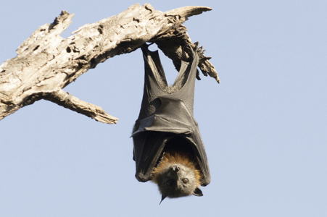  Grey-headed flying fox with young.  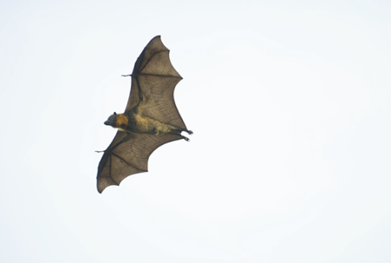  Photo credit: David Paul, Museum Victoria. | Distribution map  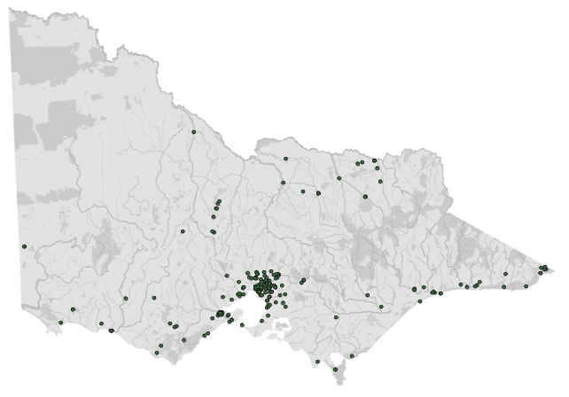  Data source: Victorian Biodiversity Atlas Jan 2023  www.environment.vic.gov.au/biodiversity/victorian-biodiversity-atlas
General appearance | Reddish brown mantle encircling the neck. Lighter grey fur on head. Rest of the head and body covered in dark grey fur extending down the legs. Black wings
Conservation status* | Vulnerable
Sexual dimorphism | Average male body weight: 842 +/- 11 g  Average female body weight: 675 +/- 10 g
Adult morphometrics | Body weight: 600–1100 g  Forearm length: 138–180mm
Habitat | Rainforest, mangrove, wet and dry forest, urban parklands
Home range | Travel 20–50 km to feed– follow flowering
Behaviour | Grey-headed flying foxes are noctural and roost communally in permanent, seasonal and intermittent camps, often in gullies near water
Diet | Native fruits and blossoms, and nectar of eucalypts
Longevity | Up to 25 years in captivity
Sexual maturity | 24–36 months
Mating season | February–April
Birthing season | September–January
Gestation period | 6 months
Litters per year | 1 (1 young)
Weaning | 5–6 months

Species | Little red flying fox (Pteropus scapulatus)
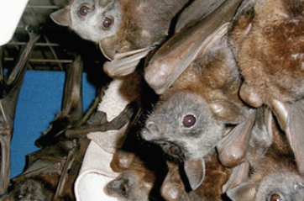  Photo credit: Dave Pinson | Distribution map  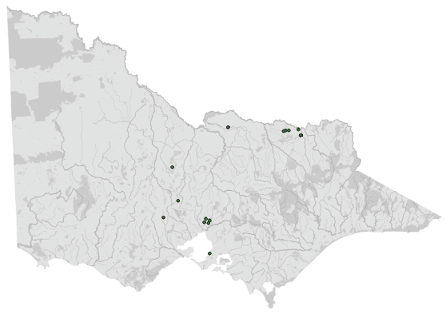  Data source: Victorian Biodiversity Atlas Jan 2023  www.environment.vic.gov.au/biodiversity/victorian-biodiversity-atlas
General appearance | Reddish brown to dark brown all over. Brown wings. Young little red flying foxes in crèche
Conservation status* | Common
Sexual dimorphism | Males tend to be larger than females
Adult morphometrics | Body weight:  350–604 g (males)  310–560 g (females)  Forearm length:  125–156 mm (males)  125–148 mm (females)
Habitat | Semi-arid to wet and dry forests, mangroves
Home range | Travel 20–30km to feed – follow plants that are flowering
Behaviour | Little red flying foxes are noctural and roost communally in transient camps
Diet | Predominantly nectar but also some fruit, leaves, bark, sap and lerp
Longevity | Up to 16 years in captivity
Sexual maturity | 18–24 months
Mating season | November–January
Birthing season | April–May
Gestation period | 5 months
Litters per year | 1 (1 young)
Weaning | 5–6 months
*From the Flora and Fauna Guarantee Act 1988 Threatened List June 2023. This list is updated regularly throughout the year. For the most current list, please visit https://www.environment.vic.gov.au/conserving-threatened-species/threatened-list.

4.3. Animal and human safety considerations
In general, animals in the wild have limited contact with people, pets, and the hustle and bustle of our daily lives. When sick, injured or orphaned wild animals come into care this unnaturally close contact can carry risks to the health and safety of both people and animals. For general information on biosecurity and approaches to minimise these risks see Part A of these guidelines. Specific information on enclosure hygiene and biosecurity for flying foxes is in Section 4.6.2.
The following information relates to human and animal health and safety considerations specifically related to the rehabilitation of flying foxes.

4.3.1. Human safety considerations
- Australian bat lyssavirus (ABLV) has been identified in both species of flying fox seen in Victoria. The virus, which is closely related to rabies, can infect humans, and infection is potentially fatal. Three human deaths have occurred in Australia (as at 2022). Only people that have been vaccinated against rabies as per the Australian Immunisation Handbook, and who are competent handlers using appropriate personal protective equipment should handle bats. Refer to: https://wildlifehealthaustralia.com.au/ProgramsProjects/BatHealthFocusGroup.aspx and https://wildlifehealthaustralia.com.au/Portals/0/Documents/ProgramProjects/PPE_Info_for_Bat_Handlers.pdf.
- The Australian Immunisation Handbook (https://immunisationhandbook.health.gov.au/recommendations/people-with-ongoing-occupational-exposure-to-lyssaviruses-are-recommended-to-receive-booster-doses-of-rabies-vaccine) provides guidance about antibody titres and booster vaccinations to ensure on-going protection against ABLV. Please refer to this handbook along with consultation from your GP for advice on maintaining antibody titres and the need for rabies vaccination boosters.
- ABLV transmission may occur from an infected animal via a bite or scratch, or from saliva contacting a wound or mucous membrane. Flying foxes can carry other viruses that have caused human deaths either directly or indirectly. As a precaution against transmission of any pathogens, wildlife rescuers and rehabilitators should avoid contact with blood, saliva, urine, faeces, ocular or nasal discharge and birth fluids from all bat species.
- The public should not handle bats. Instruct them to place a cardboard box or washing basket over the bat using a shovel or a broom, if safe to do so, and keep pets and people away from the animal until a vaccinated wildlife rescuer arrives. All flying foxes should be regarded as potentially infected with ABLV and handled with caution.
- In the event of a bat bite, scratch, or saliva contamination of a wound or mucous membrane:
- Seek medical attention immediately as post-exposure treatment may be required.
- Immediately wash the affected area thoroughly with soap and copious amounts of water for 15 minutes.
- Apply a virucidal antiseptic to the area: povidone-iodine, iodine tincture, aqueous iodine solution or alcohol (ethanol).
- ABLV can also be transmitted to other animals. Prevent pets and other animals from coming into contact with bats. If an animal might have been bitten or scratched by a bat, contact Agriculture Victoria or call the Emergency Animal Disease Watch Hotline on 1800 675 888.
- ABLV is discussed further in Section 4.5.4.

4.3.2. Animal safety considerations
- Minimise handling time to reduce stress and prevent hyperthermia.
- Transport in cooler times of the day and never leave flying foxes in hot cars.

4.4. Capture, restraint, and transport
STOP – A visual examination should be done BEFORE the animal is captured. This applies to the initial capture from the wild as well as prior to captures which occur during time in captive care. See Section 4.4.1 for information on what to look for when conducting a visual health assessment.
Refer to Part A of these guidelines for general advice on wildlife welfare, biosecurity and hygiene, and record requirements. The following information relates to the capture, restraint, and transport of sick, injured and orphaned flying foxes.

4.4.1. Visual observations
Visual observations of wildlife should be conducted prior to any attempts to capture the animal. This is just as important prior to the first capture from the wild as it is before any capture conducted while an animal is in captive care. Observations should be conducted quietly, by one person, and from a distance which provides a clear view of the animal with as little disturbance as possible. Visual observation should focus on the animal’s demeanour, behaviour, movement and posture, looking for evidence of injury/severe disease or deterioration and observe their breathing as demonstrated in the following table.
Table 4.2: Visual health observations in flying foxes
 | What to look for
Demeanour | - Bright, alert  - Will rotate ears to listen to surroundings  - Tend to make eye contact with observers at close range and will move away if threatened  - Will vocalise when interacting with other flying foxes or when in pain or distress but generally silent when on their own and not threatened
Behaviour | - Active at night
Movement and posture | - Hangs with both feet  - Holds wings close to the body with shoulders at the same height  - Coordinated movement  - Able to invert posture and hang from thumbs to urinate and defaecate normally  - Able to use thumbs to do a vertical climb of tree trunk
Breathing | - Quietly observe the animal without disturbing. Breathing should be regular  - Panting or open mouth breathing may indicate respiratory distress or overheating

4.4.2. Equipment
PPE: Refer to the Wildlife Health Australia document, “Personal Protective Equipment (PPE) Information for Bat Handlers”: https://www.wildlifehealthaustralia.com.au/Portals/0/Documents/ProgramProjects/PPE_Info_for_Bat_Handlers.pdf
- PPE includes long-sleeved clothing and/or gauntlets that will prevent scratches to the forearms; safety glasses to protect the eyes from saliva, urine or barbed wire; thick gloves to reduce the risk of bites or scratches (note: these may reduce sensation during handling; leather rigger’s gloves may be a suitable compromise.
- Catch bag: Flying foxes can be placed in a pillowcase, but they are more commonly wrapped in a towel, which supports the wings against the body and provides protection against scratches. It also allows the handler to visualise the head.
- Transport container: Flying foxes should be transported in containers tall enough for them to hang without hitting their heads, for example 30 cm (L) x 30 cm (W) x 50 cm (H). Suitable material suspended from the roof of the enclosure for the flying fox to hang on includes dowel, branches or rope. If a cardboard box is used, ventilation holes should be made in the sides of the box. A towel should be placed on the floor of the container in case the bat falls. See Figure 4.1. For bats that are too ill or injured to hang, they can be transported in a cat carry cage, pet pack or Rio basket. Containers holding flying foxes should be labelled: CAUTION: LIVE FLYING FOX.
Figure 4.1: a. Cardboard box used for transport. Note the ventilation holes and towel on the floor in case the flying fox falls. b. Wire cat carry cage converted into a simple transportation container. Photo credit: Dave Pinson
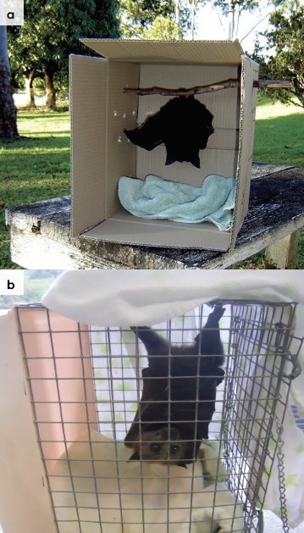
- Additional rescue equipment:
- Thick towel to restrain the bat
- Wire cutters to cut barbed wire
- Long nose pliers
- Sharp scissors to cut fruit tree netting
- Ladder
- Oral fluids
- Water in a spray bottle
- Fruit (grapes, apples or pear).

4.4.3. Technique
It is beyond the scope of these guidelines to outline techniques for every situation that may be encountered. Examples of techniques for some specific situations are outlined in the following section.
In addition to this information, for further advice please also refer to the recommended reading list, zoological institutions, veterinarians and/or wildlife experts. Inexperienced rescuers should request assistance where possible.
- Restrain the wings by folding them next to the body and wrapping in a towel with feet and head exposed (see Figure 4.2).
- Provide something for the flying fox’s feet to hold onto, such as the towel, stick or top of the rescue basket.
- Allow flying foxes to hang with the head positioned towards the ground. Flying foxes that are unable to hang, or where hanging is contraindicated (such as suspected head injury) should be wrapped in a towel and laid down at a 45-degree angle with their feet elevated in a cat carry cage, pet pack or Rio basket.
- Flying foxes can overheat and succumb to heat stress within several minutes if they are overly wrapped. Towels should be removed from around the bat once it is safely contained. Bats from a heat event should not be wrapped at all.
- Note: Rescues can be complex and risky, and it is recommended that new rescuers attend with an experienced person to develop their skills.
Figure 4.2: a. A flying fox is restrained in a towel. Note that the feet are held in one hand and the other hand can be used to restrain the head through the towel. b. Protective gloves are worn during handling. Photo credit: Dave Pinson (a) and Zoos Victoria (b)
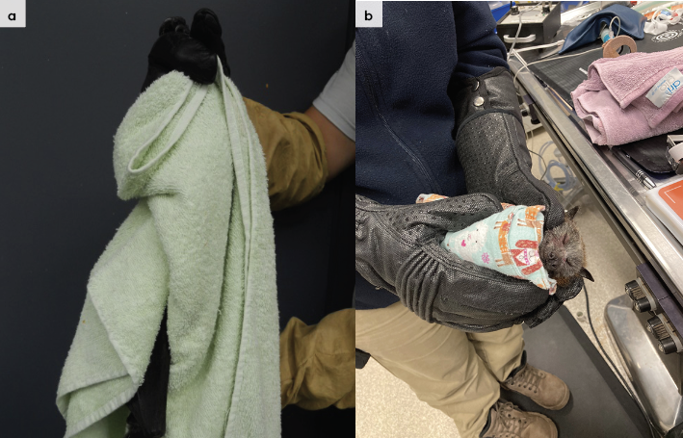

Fruit tree netting entanglement
Required equipment includes scissors, ladder, basket and towel.
The goal is to remove the flying fox and netting in one piece rather than attempt to remove the animal from the netting while the netting is still hanging.
Wrap the towel around the animal. This will cover the face and body of the animal and support it while a wide cut through the netting is made.
Two people should be involved – one to hold the flying fox and the other to cut the netting.
Cut a wide circle around the bat to remove it from the tree.
Once the bat is restrained safely on the ground, cut away the netting, being careful not to cut the wing membrane. Use your hand on the underside of the wing to guide the scissors to avoid injury to the thin membrane.
Once the bat is removed it should be rehydrated using an oral electrolyte solution.
The use and sale of netting with holes bigger than 5 mm x 5 mm is illegal in Victoria (Prevention of Cruelty to Animals (POCTA) Regulations 2019). If nets that don’t comply with this regulation are being used and the resident refuses to remove the net, call the police assistance line on 131 444. If a property owner refuses access to attend to a live trapped animal, the police assistance line should be called as this may be a breach of the Prevention of Cruelty to Animals Act, and the police will be able to mediate a solution. Where a crime is suspected, such as deliberate destruction of, or harm to, native wildlife, this should be reported to Crime Stoppers (1800 333 000). All other alleged non-compliance can be reported to DEECA on 136 186.
Flying foxes rescued from fruit netting, not presenting with obvious injuries, should be brought into care for observation. It may take up to three weeks for the full extent of the injury and membrane breakdown to become apparent. At the first sign of injury, swelling, bruising or membrane breakdown, the animal must be assessed by a veterinarian.

Barbed wire entanglement
Flying foxes are commonly entangled on barbed wire (see Figure 4.3).
Equipment required includes: long nose pliers, wire cutters, ladder, water in a spray bottle to wet entangled membranes, towels and transport cage.
Two people are required: one to hold the bat and the other to remove the bat from the wire.
Cover the bat’s head with a towel and cover the adjacent wire strands with towels to prevent further entanglement. The towel can also be used as a support for the bat to lessen tension on the wings. It can be attached to the wire with clips or pegs.
Spray the wing membrane with water to keep the bat cool on warm days and to re-hydrate the wing membrane. This will make the membrane slippery, which assists in untangling the bat.
Attempt to unwind the bat around the wire to remove it. Do not cut the barbs off as this will make the unwinding process more difficult.
Do not under any circumstances cut the wing membrane of a flying fox. If the bat cannot be removed, cut the wire and transfer the bat to a veterinarian who will remove the wire with the bat anaesthetised. Before a wire fence is cut, permission from the property owner is required.
Flying foxes rescued from barbed wire should be brought into care for a minimum of three weeks, as the full extent of membrane breakdown will only become apparent over this timeframe.

Electrocution on powerlines
Never attempt to remove any animal from a powerline without the assistance of an authorised power company representative.
Flying foxes that are electrocuted on powerlines between October and March need to be checked for the presence of a surviving pup. The pup may be alive, even if the mother has died. In other circumstances, the flying fox may be thrown off the wire and found on the ground below the powerline. Always check around the ground for young if a dead adult is spotted above. Non-fatal electrocution cases (see Figure 4.3) have an extremely poor prognosis and should be euthanised. These will present with burns, singed fur, broken bones, missing limbs and an ‘exit’ wound where the current has left the body.
Figure 4.3: a. Black flying fox caught on a barbed wire fence. b. Grey-headed flying fox caught on powerlines. Photo Credit: Dave Pinson
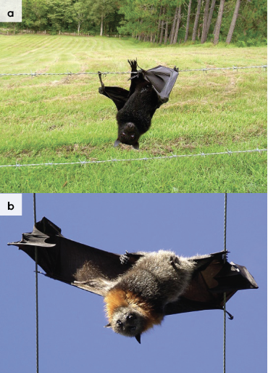

On the ground
A flying fox may be found on the ground due to raptor attack, collision with a vehicle, electrocution or illness such as ABLV infection. The flying fox should be scooped up into a thick towel. Examine the site for any signs of what brought the flying fox to the ground; check for predators, overhead powerlines, or proximity to a road.
Pups may also be found on the ground. If the mother is still around (look for an animal circling and calling), then attempt to reunite the mother and pup. Place the pup in a location where the mother can safely land. This could be on the ground or in a tree, a site where the pup can be retrieved if the attempt is unsuccessful. If the pup is very small, care should be taken to avoid hypothermia during the attempt to reunite.

4.4.4. Transport
- Transport injured or unwell adult flying foxes individually. Pups can be transported together, as a group.
- Containers holding flying foxes should be labelled: CAUTION: LIVE FLYING FOX.
- Flying foxes can be transported upright, hanging from the top of the transport enclosure (be sure to secure in the vehicle to prevent the enclosure tipping). Alternatively, transport the animal lying down wrapped in a towel, this may help keep them calm. Ensure their feet are able to grip on something to help them feel secure. Animals suffering the impacts of extreme heat, should not be wrapped.
- Secure the container in the vehicle.
- It is not necessary to provide water or food when transporting flying foxes.
- A quiet air-conditioned enclosed vehicle should be used for transportation. Ensure there is adequate ventilation, the boxes are out of direct sunlight, and air-conditioning is at the right temperature to reduce heat stress. Ensure that noise is minimal during transportation.
Figure 4.4: Transport of flying fox pups. Photo credit: Tamsyn Hogarth
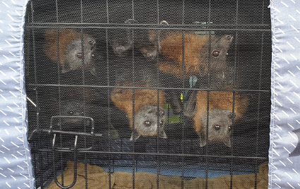

4.5. Monitoring animal health and welfare
The goal of wildlife rehabilitation is to address health and welfare concerns quickly and effectively so wildlife can be released back to the wild as soon as possible. Decision-making from the time of capture through to release should be guided by an accurate understanding of the animal’s true state of health and welfare. Careful monitoring throughout the rehabilitation period ensures that significant issues, or deterioration in health condition, are identified immediately and rapidly addressed.
It is preferred that all sick, injured or orphaned wildlife be assessed by a veterinarian to ensure that non-obvious signs of trauma or disease can be assessed and treated as soon as practicable. No medication should be provided prior to this assessment, as this can mask clinical signs and make an accurate health assessment by the veterinarian very difficult.
Templates for record-keeping visual and physical observations and daily care can be found in Part A of these guidelines.
This section provides guidance on health assessment on arrival and on effective monitoring of the health and welfare of individuals in care through minimising human-animal interactions and stress to the animal to maximise successful release back to the wild.

4.5.1. Physical examination
Once visual observations are complete, and the animal is stable enough to withstand capture and handling, a basic physical examination should be conducted. This can be repeated when required any time the carer has the animal in the hand, such as for an enclosure change. However, if a full physical exam is not conducted, body condition and weight should be assessed every time the animal is in the hand for other reasons. Carers should make sure weighing scales are available and ready to use before capturing the animal. Physical examinations are also required if the carer notices any changes suggestive of deteriorating health or injury.
Always record the physical examination findings, so that you can compare findings as the animal’s rehabilitation progresses. This ensures any health concerns are identified as soon as possible, and the carer can plan release as soon as appropriate. A template for recording physical examination findings can be found in the appendices to Part A of these guidelines.
Examinations should be conducted in a quiet location, away from domestic animals. Only one person should handle the animal, while a second person takes notes. All other people should move away, and noise kept to a minimum. Handling should also be kept to a minimum, with careful monitoring for any signs of distress (such as panting, salivating, vocalisation or sudden deterioration in demeanour). If these are seen, the examination should be stopped immediately, and the animal returned to its catch bag, transport box or enclosure and allowed to recover.

Species specific considerations:
- Physical examination of flying foxes can be challenging as they will attempt to bite and hook onto the handler with the claws on their thumbs and feet.
- For human safety reasons and to minimise stress in the flying fox, only a cursory examination will be possible. More detailed examinations require the animal to be anaesthetised.
- Physical examination will require two people. One person will either restrain the bat in a towel or else, while wearing gloves, restrain the bat’s head while holding its wings against the bat’s body. The second person, who is also wearing gloves, can then examine select body parts while carefully removing them from the towel or the handler’s grasp.
- This procedure will be stressful for the flying fox who will likely struggle and vocalise.
Table 4.3 Physical examination of flying foxes
 | What to look for
Body weight | - Record body weight on arrival and at least weekly whilst in care.  - A change greater than 10% in body weight over a week is cause for concern and the carer should seek veterinary advice immediately.
Body condition | Body condition is scored by palpating the scapula, its spine and adjacent muscles. Palpation of the pectoral muscles can also be used.  Body condition can be described as follows:  - Under condition: The bones of the scapular spine are very prominent and are easily seen and felt. Concave muscles either side of the scapular spine and concave pectoral muscles either side of the sternum.  - Ideal condition: Slightly curved muscle over the scapular spine. The scapular spine is just palpable. The pectoral muscles are well developed and rounded either side of the sternum.  - Over condition: Curved muscle mass on either side of the scapular spine. It is difficult to feel the scapular spine. ‘Obesity in wild flying foxes is rarely seen nor is generally a cause for concern as long as the flying fox is strong and fit.
Hydration status | - Hydration can be assessed by testing skin tent, done by pinching and lifting the skin between the shoulder blades.  - Dehydration can be indicated by skin remaining ‘tented’ or a slow return to normal position.  - Eyes can indicate hydration status; they should be bright, shiny and not sunken.
Eyes | - Eyes can indicate hydration status; they should be bright and shiny. Sunken eyes may indicate dehydration.  - Bat follows movement with eyes.  - Basic internal structures of eyes (e.g. pupil, iris) appear symmetrical.
Ears | - Ears swivel in response to sound.
Mouth | - Pink gums. No bleeding or broken teeth.  - Lips are normal.
Skin and coat condition | - Wing membrane feels soft and supple. Small holes are normal. Dark surface.
Limbs, feet, and tail | - No broken nails, obvious wounds or exposed bone.  - No crackling or grinding detected when the legs are manipulated. Legs not held at odd angles to the body.
Sex determination | - The sex of the flying fox is determined by examination of the genital area for the presence or absence of a penis and testicles.  - Adult females will often be lactating. Nipples are located near the armpit (2 nipples present).
Figure 4.5: A flying fox is weighed in a plastic container. Photo credit: Tamsyn Hogarth
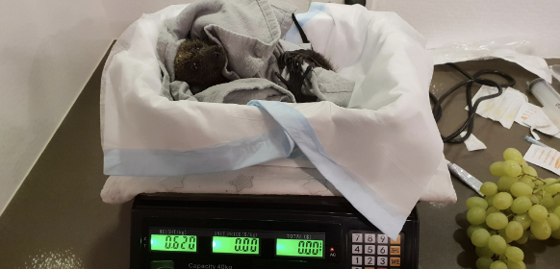
Figure 4.6: Example of body condition scoring by palpating the scapula. Photo credit: Zoos Victoria
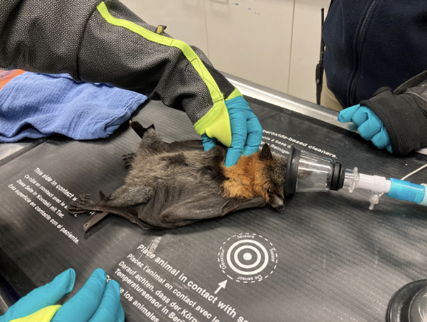

4.5.2. Ongoing monitoring of health and welfare
The aim of wildlife rehabilitation is to ensure animals recover and can be released back to the wild as quickly as possible. Careful, daily monitoring is required to ensure that animals are responding as expected to the treatment being provided and so that any deterioration or welfare concerns can be identified and addressed as soon as possible. Rehabilitators should ensure that record-keeping is a priority to maximise positive welfare outcomes. Templates to assist wildlife rehabilitators to record and monitor wildlife health and welfare can be found in the appendices to Part A of these guidelines. These records will be valuable tools to share with veterinarians to support decision-making.
The following is recorded daily:
- demeanour
- food consumption
- faecal/urine output
- behaviour observed
- medical treatment provided
- evidence of overnight activity.
The following is recorded weekly:
- weight
- body condition.
Over time, regular monitoring will also help to develop carer skills and knowledge, as regular observations and recording will result in a deep understanding of the expected behaviour and response to treatment for the species in care.

Species specific considerations:
- Time your health and welfare observations for times of the day when the animal is expected to be active.
- The flying fox should be observed at least daily.
- Note the flying fox’s demeanour and behaviour every time food is introduced or taken away, medications given, or the enclosure cleaned. Pay particular attention to any changes that have occurred since the previous day.
- Avoid disturbing sick/injured flying foxes during the daylight hours as rest/sleep is required for rapid healing.
- The use of infra-red cameras can allow monitoring of behaviour overnight.
- Be alert for signs of self-trauma. Flying foxes tend to chew sutures, bandages and damaged parts of their wings or legs. They may also damage teeth and gums by chewing on wire in their enclosure.
- Check wings daily for any sliminess or excessive moisture or trauma to the extremities, particularly over the wrists and ends of the digits.

4.5.3. Common and emerging health conditions
Clear guidance on conditions that may require euthanasia can be found in Part A of these guidelines.
Table 4.4 lists common clinical signs and possible causes of injury/disease. Carers should be aware that these are not exhaustive. Aside from first aid, carers should avoid administering medications prior to the provision of veterinary advice.
Unusual clinical signs or mass mortality events – a number of animals dying or found dead at the same time, with similar signs – may indicate an emergency animal disease, an emerging/new infectious disease or an environmental/human related toxicity which needs further investigation. Report these immediately to the Emergency Animal Disease Watch Hotline on 1800 675 888 (24 hours).
Table 4.4: Common injuries and clinical signs of emerging health conditions seen on presentation or during care
Injury or clinical signs | Possible causes | Carer observations and response
Note: Do not provide pain relief or other medication, including antibiotics, unless under veterinary guidance and supervision, as these can have severe side effects, particularly in dehydrated/shocked animals. Use of antibiotics when not indicated can contribute to antimicrobial resistance and reduce drug efficacy.
Unable to fly, fracture, dislocation, head trauma, wing membrane tears, bleeding, exposed bone on digits, eye ulcer | Netting and barbed wire entanglements, motor vehicle accident, predator attack, unknown trauma | - Urgent veterinary attention is required. Do not delay transfer to veterinarian to apply first aid, other than to stop excessive bleeding.  - Move animal to a small transport box to restrict movement. Ensure temperature is appropriate for species and minimize stress.  - Do not attempt to stabilise fractures as this is very painful, and risks making the injury worse. Fracture stabilisation should only be attempted by a veterinarian following physical exam, x-rays and under general anaesthesia.  - Do not provide pain relief or other medication unless under veterinary guidance and supervision, as these can have severe side effects, particularly in dehydrated/shocked animals.  - Exposed bone on digit tips should not be trimmed without general anaesthesia and veterinary assessment.
Burns | Bushfire, electrocution | - Urgent veterinary attention is required to assess burns. Electrocution cases often carry a poor prognosis and euthanasia is often required.
Abrasions on wing tips that occur during time in care | Abrasions from sides of enclosure | - When abrasions occur during care reassess enclosure size and materials. Risks include  - An enclosure that is an intermediate size, allowing flying foxes to flap but not achieve actual flight. Depending on the health status of the flying fox, consider moving it into a flight aviary, possibly with another carer if needed, or into a smaller enclosure that prevents attempts at flight.  - Inappropriate social grouping: avoid housing flying foxes on their own or housing females with males, especially during breeding season where males may harass females.  - Environmental stressors causing flying foxes to be agitated and flighty: look for stressors including presence of domestic animals (sight and/or smell), lights, noises and human activities that disturb flying foxes.  - If abrasions do not resolve or worsen while in care, seek veterinary advice.
Bite wounds, punctures, bruising | Predator attack  Motor vehicle accident | - Veterinary attention is required as soon as possible.  - While bite wounds/scratches may not be immediately obvious, these carry a poor prognosis and animals often present moribund (very lethargic, poorly responsive, and cold).  - Look for small clumps of dried fur stuck together with saliva. Part the fur and look for small puncture wounds.
Neurological signs, aggression, inability to fly | ABLV infection, toxoplasmosis, poisoning, head trauma | - Seek veterinary assessment.  - Carer may observe animal bumping into objects in enclosure or fail to respond to short sharp noises (such as a loud clap from behind animal).  - Pupils may be fixed/dilated and not responsive to changes in light level. You should see pupils constrict if a pen light is shone in the eye.  - Given the very wide range of causes, and the possibility of ABLV infection, carers should seek veterinary advice as soon as possible. ABLV is a notifiable disease and affected flying foxes are likely to die. Contact Agriculture Victoria or call the Emergency Animal Disease Watch Hotline on 1800 675 888. For additional information consult the Wildlife Health Australia ABLV fact sheet: https://wildlifehealthaustralia.com.au/Portals/0/Documents/FactSheets/mammals/Australian_Bat_Lyssavirus.pdf.  - If multiple animals are seen with similar signs, this may indicate a newly emerging infectious disease or a toxicity (plant toxicity or poisoning): contact your the Emergency Animal Disease Watch Hotline on 1800 675 888 to report concerns.  - If unusual toxicity or infection is suspected, you or your veterinarian should contact Zoos Victoria’s Veterinary Departments to discuss options for disease investigation.
Skin irritation/fur loss | Excessive mite infestation, bacterial or fungal infection | - Seek veterinary assessment.  - A small number of mites can be normal, and do not require treatment or removal. However, if many mites are seen, the animal is scratching/irritated, or the skin is red and inflamed – seek veterinary attention to treat ectoparasites.
Slimy, pale, smelly wing membrane | Wing membrane infection, stress or poor husbandry conditions resulting in flying foxes urinating on themselves | - Seek veterinary assistance if it does not clear up.  - Clean the wings of orphans daily with unscented, alcohol-free baby wipes or dilute iodine and then dry thoroughly.  - Antibacterial or antifungal creams can be applied to affected areas. Choice of creams should be directed by a veterinarian.  - Provide opportunities for flapping and access to sunlight for 20 minutes daily.  - Affected animals should be housed separately and strict hygiene observed to avoid cross-infection with other animals.  - Wash all materials used (blankets, wraps, etc.) in an anti-fungal laundry wash.
Heat stress  Normal behaviours in response to an extended period of very high ambient temperatures combined with a low relative humidity: Panting, wing licking and flapping, shade seeking, hanging low in trees.  Behaviours indicative of heat stress: Clustering and clumping low to or on ground, becoming unresponsive. | Extreme heat | - Caution: Some intervention activities such as spraying and removal of individual animals for treatment, particularly at the wrong time, can jeopardise other animals in the colony, as disturbance has the potential to cause panic and exacerbate heat stress. It is therefore critical that flying fox heat stress is managed in accordance with the Victorian Plan for Heat Stress in Flying Foxes.  - Do not intervene without direction from DEECA and/or land manager.  - Do not approach. Continue monitoring from a distance.  - Anyone who comes across flying foxes affected by heat stress can report these directly to DEECA via the Wildlife Emergency app or by phone on 136 186 or via Wildlife Victoria on 03 8400 7300.  - The Wildlife Emergency app, which can be downloaded from either the Google Play store or the Apple store, allows individuals to describe and geolocate the animal by dropping a pin, as well as to upload a photo. This information is sent directly to DEECA for response.  - DEECA and/or the land manger will coordinate response efforts in accordance with relevant Heat Stress Camp Plan.
Figure 4.7: Wing trauma caused by electrocution. Photo credit: Zoos Victoria
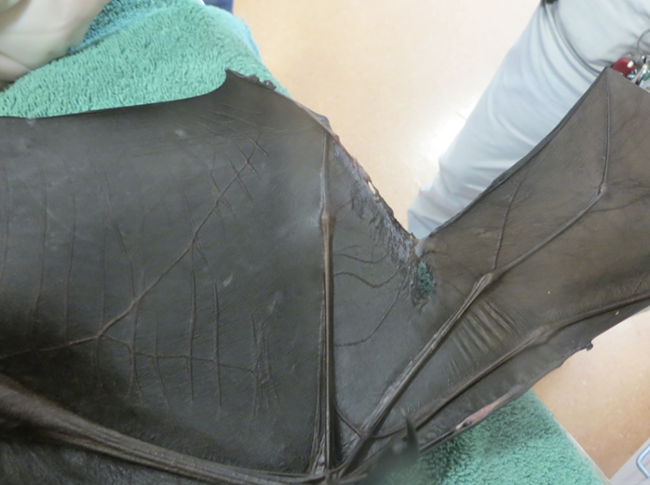

4.5.4. Administering treatment during rehabilitation
- Ensure urine and faeces are cleaned away from the bat’s wings and body when removing from the transport container and placing into an aviary.
- Dressings may be reapplied under manual restraint for some individuals. Others will require general anaesthesia by a veterinarian for dressing changes. Appropriate pain relief and careful bandaging is required to reduce the risk of self-trauma (bats chewing or licking wounds).
- It is preferable to administer medication in a food item, such as a piece of fruit or a bat smoothie (See Section 4.7). If the bat is not eating, oral medications can be delivered in a syringe directed into the cheek from the side of the mouth while the bat is restrained. Care is required to avoid being bitten or scratched while the bat is being medicated.
- If the bat does not eat for two consecutive days, seek veterinary advice.

4.6. Housing
Below are several key considerations when housing adult flying foxes in care.

4.6.1. General housing information for flying foxes
- Flying foxes are social and unless there are quarantine or medical reasons, animals should be housed in groups.
- Rehabilitators with a lone animal should move the animal to a carer with other bats as soon as possible.
- Bats are reliant on flight to stretch and flap and to source food. It is critical that any animals either raised or rehabilitated are in flight fit condition upon release, in order to survive. If you cannot provide flight fitness for an animal in your care, call on the services of those who can. Carers are encouraged to share resources for the best welfare outcomes.

4.6.2. Enclosure hygiene & biosecurity
General information about hygiene and biosecurity can be found in Part A of these guidelines. New diseases emerge frequently and sick and injured animals in care are often more susceptible to picking up pathogens from the environment. It is important to maintain excellent levels of hygiene to avoid inadvertently transferring diseases between animals, and from humans, and to protect the wild population where the animal will eventually return to.

Species specific considerations:
IMPORTANT
Australian bat lyssavirus (ABLV) has been identified in both species of flying fox seen in Victoria. Flying fox rescuers and rehabilitators are strongly recommended to be vaccinated against rabies to protect from ABLV, as detailed in the Australian Immunisation Handbook. The disease can be fatal in humans. It is important to always use appropriate protection when handling bats. Members of the public should not handle bats.
Anyone who has been bitten or scratched by a bat must immediately contact their local hospital emergency centre or the Department of Health and Human Services Communicable Disease Unit on 1300 651 160.
- All flying foxes should be considered possible ABLV carriers and should only be handled while wearing appropriate PPE. The virus lasts up to 24 hours in saliva but is short lived in the environment. It is rapidly inactivated by heat, direct sunlight, soapy water and most disinfectants, including bleach and F10.
- Flying foxes can also carry other potential pathogens such as Hendra virus, Leptospira and Salmonella. The first two are transmitted through contact with urine while Salmonella are present in faeces. It is important to always wash hands with soap and water after servicing flying foxes and ensure that any open wounds are covered.
- Flying foxes frequently carry external parasites such as mites and bat flies. Bat fly bites may cause mild skin irritation in people.
- Left-over food and faecal matter should be spot cleaned daily.
- Since these enclosures are used to house sick/injured flying foxes, they should be cleaned and disinfected between inhabitants. Items of furniture, such as branches or ropes, should be discarded as they cannot be effectively disinfected.

4.6.3. Housing types
Different set ups are required for animals at different stages of treatment and care. Table 4.5 describes the housing type, suggested dimensions and requirements at each stage of care. For information on housing animals during hand raising see Section 4.8.
Table 4.5: Rehabilitation housing for adult flying foxes
Intensive care housing
Indications for use | Suggested min. dimensions | Suggested requirements
One adult  Short term critical care (<48 hours)  Intensive veterinary treatment - frequent medication, oxygen supplementation, temperature control  Longer periods under veterinary supervision where strict cage rest/confinement is indicated | 1 m (L) x 0.50 m (W) x 0.60 m (H)  (Floor area: 0.50 m²) | ENCLOSURE CONSTRUCTION  - Purpose-built incubator such as a Vetario, cat carry cage or Rio basket.  ENCLOSURE FURNISHING  - The animal will be resting on towelling. Towels need to be changed as soon as they are soiled with faeces or urine.  - Absorbent material like puppy training pads will draw urine away from an animal’s fur and body and should be used if an animal is resting rather than hanging.  ENVIRONMENTAL VARIABLES  - Provide heat (approximately 28°C) using a heat pad, with a thermometer.  PROVISION OF FOOD/WATER  - The flying fox will likely need to be hand fed fruit pieces or ‘smoothies’ (see Table 4.6) or may take food and water from bowls connected to side of the enclosure at their head height.

Intermediate housing (Treatment/cage rest)
Indications for use | Suggested min. dimensions | Suggested requirements
One adult  Provision of daily medication, dressings on wings, close monitoring once animal is stabilised and no longer requires intensive care.  Enclosure furnishings can be arranged to reduce opportunities to move excessively so that ‘cage rest’ can be achieved with slightly more space/reduced contact | 1 m (L) x 1 m (W) x 1 m (H)  (Floor area 1 m²)  The dimensions should be large enough for the flying fox to be able to hang, move around and flap its wings. | ENCLOSURE CONSTRUCTION  - A mesh dome tent or net enclosure, canvas pet carrier or dog crate with mesh small enough to prevent bats getting their heads caught.  ENCLOSURE FURNISHING  - Newspaper or thin towelling substrate.  - Towels or blankets should always reach the floor so any young that fall to the ground can climb back up.  - Thick ropes or natural branches can be provided for flying foxes to hang from.  - All perches need to be secure and strong enough to support the weight of the flying fox.  ENVIRONMENTAL VARIABLES  - Ambient temperature.  PROVISION OF FOOD/WATER  - Food bowls hung on the side of the cage (on the floor or above the perch/mesh).  - Water is offered in open bowls or small animal water sippers hung from the roof.

Pre-release
Indications for use | Suggested min. dimensions | Suggested requirements
Up to 10 adults for soft release.  Used to acclimatise flying foxes to the prevailing weather and develop/check fitness prior to release  No longer require regular handling/medication | Floor area: 30 m²  Height: 2 m | ENCLOSURE CONSTRUCTION  - The pre-release aviary may be constructed of a synthetic polymer mesh, such as polyethylene, which is used for cricket nets.  - The mesh size is 50 mm and the twine diameter ranges from 1.8 mm to 3.0 mm.  - The enclosure should be built with a strong frame (steel) and have a double roof (i.e. a rigid mesh frame with soft netting hung from the inside). This will prevent predation by birds of prey and foxes.  - The enclosure should be situated to offer sunlight and shade.  - Pre-release housing should provide the animal with the opportunity to fly 10 wing lengths from one end of the enclosure to the other.  - Wing tips need to be monitored for evidence of abrasions caused by rubbing on the aviary walls.  - See Figure 4.5.  ENCLOSURE FURNISHING  - A soft substrate like mulch should be used on the floor and be raked and cleaned daily to remove fruit spats and faeces.  - Natural enrichment of native Eucalyptus blossom and leaves should always be provided (See Section 4.7).  PROVISION OF FOOD/WATER  - Food bowls are hung on the top side of the cage at a height that a bat can access while hanging or suspended from ropes/perching within the enclosure. They should not be placed on the floor.  - Water can be offered in open bowls or using small animal water sippers hung from the roof (see Figure 4.5).

Figure 4.8: Water-sipper bottles suspended from the roof in a pre-release enclosure. Photo Credit: Anne Fowler
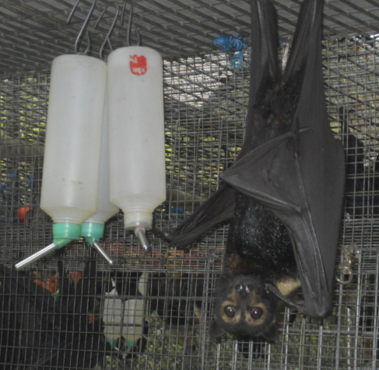
Figure 4.9: Purpose-built flight aviaries, lined with soft netting. Photo Credit: Fly By Night Bat Clinic
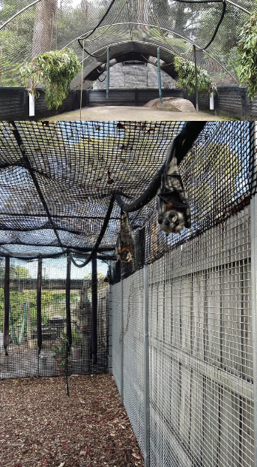

4.7. Feeding and nutrition
Keeping daily records of food offered (item and volume fed) and food consumed is good practice and will allow the rehabilitator to observe how an animal is responding to food on offer and inform future choices.
Please note: Food suppliers and specific products mentioned in these guidelines are intended as examples only. Other suitable products may also be available.
This section refers to feeding and nutrition of flying foxes in rehabilitation. Information on feeding orphaned individuals can be found under Section 4.8 Hand raising.
Table 4.6: Daily feeding and diet guide for adult flying foxes during rehabilitation
Diet | - 350–400g fruit mix (two thirds apple by weight, one third two other fruits: pear, grape, melon, pawpaw).  - No citrus or stone fruit as it encourages flying foxes to feed from netted trees.  - Figs when available as they are high in calcium.  - Flowering branches with both leaf and flowers such as Eucalyptus, lilly pilly, Melaleuca.  - Sick flying foxes may be offered ‘bat smoothies’ and fruit mix. ‘Bat smoothies’ are made by combining pure apple juice, 2 tbsp honey yoghurt and 10 g high protein supplement (such as Wombaroo or Poly-aid Plus).
Supplements | - Mix 10 g or 2 tsp Wombaroo high protein supplement through 350 g fruit mix (see Figure 4.7).
Diet Frequency Feeding | - Food and fresh water provided daily.  - Change and replace fresh fruit daily.  - Cut fruit into pieces about the size of a matchbox. Use one container for every two flying foxes.
Figure 4.10: Fruit chopped for a flying fox prior to mixing with Wombaroo High Protein supplement. Photo Credit: Dave Pinson
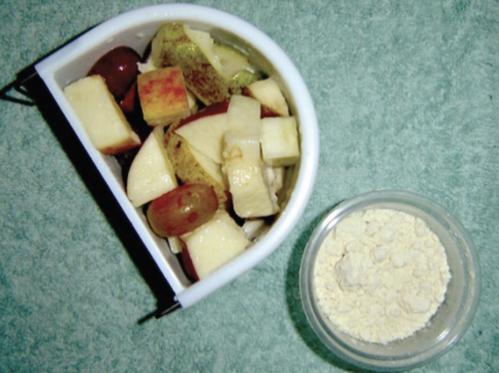

4.8. Hand raising
Hand raising record templates for growth, development, feeding and other observations are found in the appendices to Part A of these guidelines.

4.8.1. Equipment required for hand raising
- Teats, bottle/syringe (see Figure 4.11)
- Milk provision: Wombaroo flying fox milk formula
- Biolac flying fox milk
- Tissues for toileting
- Scales
- Breathable cloth wrap (mumma wrap)
- Enclosure cleaning equipment
- Record charts
Figure 4.11: Appropriate teat for flying foxes. Photo credit: Wombaroo
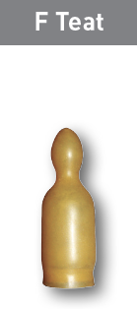

4.8.2. Growth, development and care of orphaned young
- Flying foxes can be reared from birth.
- Orphans should be raised in pairs, minimum. If a single orphan enters care, contact other rehabilitators to identify bats of similar age to ‘buddy’ with this one.
- Flying foxes are fed milk in a bottle with their heads down and tilted to the side to permit milk to run out the side if too much is taken in at once.
- Toileting: Juvenile flying foxes need to be toileted after each feed until they are four to six weeks old. The pup is inverted, and a tissue is used to gently stroke the perineal area until the animal urinates and defaecates.
- Young flying foxes should get at least 20 minutes of sunlight each day for normal bone growth.
- A chart of the feeding and housing requirements for grey-headed flying foxes is in Table 4.7. A summary of the growth of little red flying foxes is in Table 4.8. While a feeding and housing chart has not been published for little red flying foxes, they can be hand raised in a similar manner to grey-headed flying foxes, making allowances for their smaller size. They will require approximately half as much milk and fruit at each feed as grey-headed flying foxes.
- Where possible, flying foxes should be raised in the company of other juvenile flying foxes. Hand-reared flying foxes should be placed in a crèche with other flying foxes once they are weaned (at about 12 weeks) and are making their first attempts at independent flight. A crèche is a group of young newly independent flying foxes. It aims to prepare animals for soft release by allowing flight development, socialising among members of the same species, and reduced contact with humans.
- Young should be placed in the crèche for a minimum of three weeks to give them sufficient opportunities to develop flight skills.
- The crèche should:
- be housed in a secure flight enclosure and requires soft, thick knotless netting (mesh size, of 5 mm x 5 mm or less at full stretch) or similar material that allows the flying fox to hang and move around safely without damaging body parts or membrane
- include an area that provides shade and shelter and areas exposed to natural weather
- provide sufficient space to allow the flying fox to perform natural behaviours including free flight
- house at least 10 animals to allow appropriate socialisation and provide animals with a social cohort on release
- minimise interaction with people to prepare the animals for soft release.
Table 4.7: Feeding and housing requirements for grey-headed flying foxes. Wt = Weight. FA = Forearm length (See Figure 4.12).
Age | Wt (g) | FA (mm) | Feeding (Milk and solids) | Housing
Newborn | 85 | 57 | 4 ml 5 x per day | - Up to 4 orphans: 1 m x 0.5 m (0.5 m²) x 0.6 m. Rio basket or cane basket.  - Wrapped in mummawraps – cloth made of natural, breathable material wrapped similarly to a nappy or a sock-mumma or swaddle (see Figure 4.8).  - Clean wings daily.  - Provide heat (approximately 30–32°C for newborn pups, 28°C for older pups) using a heat pad, with a thermometer.
1 week | 99 | 69 | 5 ml 5 x per day
2 weeks | 117 | 79 | 6 ml 5 x per day
3 weeks | 133 | 87 | 7 ml 4–5 x per day
4 weeks | 150 | 93 | 10 ml 4 x per day | - Two pups: 1 m x 1 m (1m²) x 1m. Large enough to be able to hang, move around and flap wings. A mesh dome tent or net enclosure, canvas pet carrier or dog crate with mesh small enough to prevent bats getting their heads caught.  - Newspaper or thin towelling substrate.  - No artificial heat from five weeks.  - Food bowls hung on the side of the cage.  - Offer natural enrichment, such as sticks, bark, fresh Eucalyptus blossom and leaves. Plastic toys should be avoided as they can cause injury.
5 weeks | 167 | 99 | 11 ml 4 x per day
6 weeks | 184 | 104 | 12 ml 4 x per day
7 weeks | 201 | 109 | 13 ml 4 x per day. Introduce fruit – steamed, peeled apple, 2–4 pieces after feed
8 weeks | 217 | 114 | 13 ml 4 x per day. Feed steamed apple with peel on. Offer 50 g/day
9 weeks | 235 | 118 | 14 ml 4 x per day. Introduce fruit up to 3 types. Offer 2/3 apple, 1/3 other fruits. Eating 50–100 g/day
10 weeks | 252 | 122 | 15 ml 3–4 x per day. Fruit ½ steamed, ½ raw. Increase fruit by 25 g if eaten.  Offer 100–200 g/day.
11 weeks | 269 | 125 | 15ml 1–2 x per day
12 weeks | 286 | 129 | Wean. Offer >250 g fruit in the evening
13 weeks | 302 | 132 | Offer 250–300 g fruit in the evening | - Between 10 and 20 flying fox young: 20 m² floor area x 2 m.  - Between 20–50 flying fox young: 30 m² floor area x 2 m, constructed of a synthetic polymer mesh, such as polyethylene (used for cricket nets). Mesh size is 50 mm. Twine diameter ranges from 1.8–3.0 mm. Cyclone fencing should not be used as juveniles can escape or injure themselves by poking heads and limbs out.  - Provide natural browse such as Banksia, lilly pilly fruit, tea tree flowers and Eucalyptus branches with flowers.  - Offer ripe figs on branches and/or cored apples on ropes.
14 weeks | 319 | 136
15 weeks | 336 | 139 | Offer 300–350 g fruit in the evening
16 weeks | 353 | 143
Figure 4.12: White line indicates where to take a forearm measurement in a flying fox, from the wrist to the elbow. Photo credit: Zoos Victoria
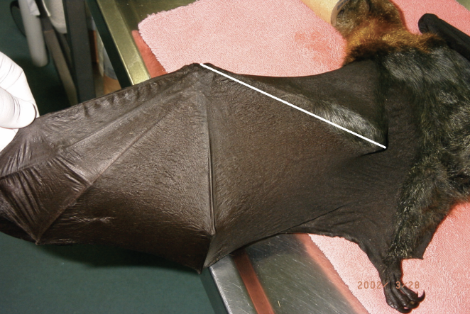
Figure 4.13: a. Basket with handle used to house orphaned flying foxes. b. Heat-stressed orphaned pups housed in a lined box that permits them to hang. Photo credit: Dave Pinson (a) and Tamsyn Hogarth (b)
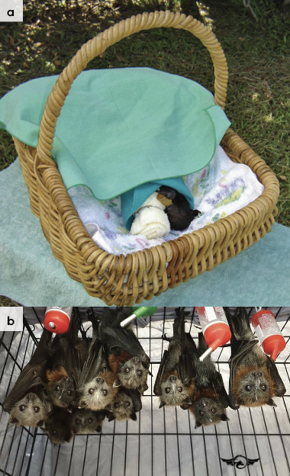
Figure 4.14: a. Forearm measurement of orphaned flying foxes should be taken on arrival and weekly during growth. b. Spectacled flying foxes wrapped into the ’mumma’ wrap. Note the blind teat used as a dummy. Photo credit: Anne Fowler
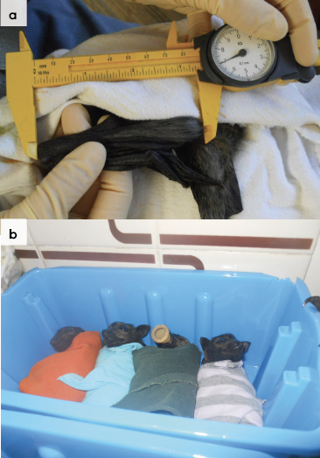
Figure 4.15: a. Cored apples suspended on a rope and a basket holding pieces of banana. b. Watermelon offered on metal spike. Photo credit: Anne Fowler (a) and Dave Pinson (b)
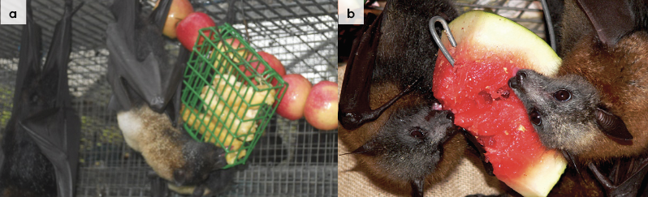
Table 4.8: Development chart for little red flying foxes
Age | Weight (g) | Forearm length (mm)
Newborn | 41 | 45
1 week | 49 | 50
2 weeks | 59 | 55
3 weeks | 68 | 61
4 weeks | 79 | 66
5 weeks | 89 | 71
6 weeks | 100 | 75
7 weeks | 111 | 80
8 weeks | 122 | 83
9 weeks | 133 | 87
10 weeks | 145 | 90
11 weeks | 157 | 93
12 weeks | 169 | 96
13 weeks | 182 | 98
14 weeks | 195 | 100
15 weeks | 208 | 101
16 weeks | 221 | 103

4.9. Release protocol
Ideally, wild animals will be rehabilitated and released in a short timeframe. If this is not possible and the animal is in care for significant extended periods, ensure that the animal is regularly assessed against the welfare domains to support decision-making. Animals in care for extended periods may have a reduced ability to survive in the wild. Talk to your veterinarian and consider whether euthanasia will provide the best welfare outcome for the animal.

4.9.1. Pre-release assessment
Pre-release assessment of animals in care is essential to support improved outcomes once back in the wild. Animals should be assessed based on body condition, fitness and the ability to engage in natural species-specific behaviours prior to release.
The following check list should be used to guide decision making regarding release suitability for flying foxes:
- Individual is in a state of good health – presenting injury/sickness is completely resolved (consider a pre-release veterinary check).
- Individual is within a healthy weight range and appropriate body condition (refer to Table 4.1).
- Individual displays ability to actively forage for and consume natural foods.
- Individual can complete a minimum of 10 laps of the pre-release enclosure, without open mouth breathing.
- Individual can invert (using thumbs) to urinate and defaecate and is able to do a vertical climb of a tree trunk.

4.9.2. At the release site
Post release survival will be maximised by ensuring that both the release site and the way in which the animal is released are carefully considered.
Adult flying foxes should be released back into the nearest established camp to where the animal was found. For information on the nearest grey-headed flying fox camp, contact your local DEECA officer. Hand raised pups should be soft released. They will not survive a hard release into the wild.
Adult flying foxes should be released during the day, so they have time to settle into the camp before the nightly flyout.
Adult flying foxes can be released at any time of year.
Avoid weather extremes such as forecast temperatures above 38°C for three or more consecutive days. Avoid wind and heavy rain or times when severe storms are predicted.
Little red flying foxes occupy regional camps on a seasonal basis. If an adult little red flying fox is in care for less than two weeks, it can be released at the point of capture as this may be where there is a current food source of flowering gums. If in care for longer, then the wildlife rehabilitator should contact DEECA on 136 186 to locate the nearest camp.
For more information on the ecological characteristics and requirements of flying foxes that may help with their release, please refer to Table 4.1.

4.9.3. Release checklist
Check all of the requirements of your authorisation are being met, and consider the following:

Release location
- For information on the nearest grey-headed flying fox camp, contact DEECA on 136 186.
- For release of little red flying foxes, that do not have established camps in Victoria, contact DEECA to discuss options.
- Some flying foxes may occupy regional camps on a seasonal basis, so it is important to check that the camp is still occupied.

Release Procedure – adult flying foxes
- Never place a flying fox for release in a tree. All releases should take flight.
- Ensure that no one is standing in the flying fox’s direct line of flight.
- Release the flying fox at shoulder height and observe it taking strong flight. If a flying fox becomes grounded it will require further care.

Release Procedure – soft release of orphaned young
Flying foxes are unique in their requirement for a highly collaborative approach to a viable release. Because of this, it is pivotal that carers engage in robust coordination and cooperation. If you are unsure how to join your hand reared animals to an existing crèche and soft release program, contact DEECA on 136 186 for advice and assistance.
Soft release is a gradual process of familiarising young flying foxes with a new environment and introducing them into the wild population, while monitoring and continuing support by providing support feeding. The soft release facility should provide sufficient opportunity for the flying foxes to become familiar with their surroundings, and to build flight fitness and social skills, before being released back to the wild. The soft release process takes a minimum of six weeks for a single release cohort.
A soft-release enclosure should:
- be located within or adjacent to an occupied flying fox camp
- be lined with thick, soft knotless netting or similar that allows the animals to hang and move around safely without difficulty or damage to body parts or membrane
- include an area that provides shade and shelter and areas exposed to natural weather
- have a hatch that can be opened to allow animals to move out of the cage
- provide easy access to surrounding trees, and external accessible hanging points for graduated support feeding.
- Soft release should only be undertaken where:
- an appropriate enclosure is available adjacent to an established flying fox colony
- occupational health and safety measures are in place.
- Preferably soft release should occur as a group and not as a single animal. (If only one animal is to be released, talk to DEECA about options).
- Flying foxes should be at least 15 weeks old and have spent at least three weeks in a crèche facility.
- All animals should have had a thorough health check by a veterinarian or experienced flying fox carer.
- All animals should be flight tested on entry to the enclosure.
- Animals should be confined in the cage for 7–10 nights prior to release via a hatch.
- The hatch should be closed once no animals have remained in the cage for three consecutive nights.
The supportive feeding regime is as follows:
- The flying foxes are housed and fed within this aviary on site for one week.
- At the end of the first week, the aviary is left open to permit the flying foxes to leave and return to the aviary of their own accord.
- After the first two weeks the aviary should be closed but supplementary food provided on the outside of the enclosure.
- Supplementary feeding is gradually reduced and stopped after 6–8 weeks if no flying foxes are returning. Care should be taken to monitor for animals who return to the soft release site injured or malnourished. These animals will require further care or euthanasia.
Figure 4.16: Soft release aviary, Yarra Bend, Victoria. Photo credit: Friends of Bats and Bushcare
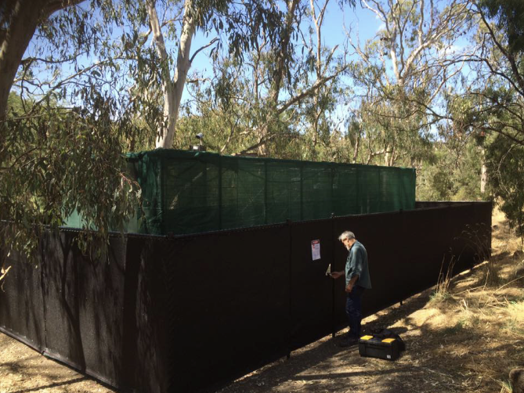

4.10. Key references and additional reading
Churchill, S. 2009. Australian Bats, 2nd ed. Allen and Unwin, Crows Nest. 255 pp.
Department of Sustainability and Environment. 2006. Protocols for management of grey-headed flying-foxes at Yarra Bend Park during severe adverse weather events: Australasian Inter-service incident management system. Department of Sustainability and Environment, East Melbourne. 68 pp.
Hall, L. and Richards, G. 2000. Flying Foxes: fruit and blossom bats of Australia. UNSW Press, Sydney. 135 pp.
Pinson, D. 2020. The Flying Fox Manual 3.1.1. https://www.ffmv3.com.au/
Welbergen, J.A. 2010. Growth, bimaturation, and sexual size dimorphism in wild grey-headed flying foxes (Pteropus poliocephalus). Journal of Mammalogy 91 1 38-47
Victoria’s flying fox colonies, DEECA, https://www.wildlife.vic.gov.au/our-wildlife/flying-foxes/victorias-flying-fox-colonies

