Chapter 5. Koalas

Contents
5.1. Introduction 2
5.2. Species information 3
5.3. Animal and human safety considerations 5
5.3.1. Human safety considerations 5
5.3.2. Animal safety considerations 6
5.4. Capture, restraint, and transport 6
5.4.1. Visual observations 6
5.4.2. Equipment 7
5.4.3. Technique 8
5.4.4. Transport 11
5.5. Monitoring animal health and welfare 12
5.5.1. Physical examination 12
5.5.2. Ongoing monitoring of health and welfare 16
5.5.3. Common and emerging health conditions 17
5.5.4. Administering treatment during rehabilitation 25
5.6. Housing 25
5.6.1. General housing information for koalas 26
5.6.2. Enclosure hygiene & biosecurity 26
5.6.3. Housing types 26
5.7. Feeding and nutrition 32
5.7.1. Feeding adults 32
5.7.2. Supplements 35
5.8. Hand raising 36
5.8.1. Equipment required for hand raising 36
5.8.2. Growth, development and care of orphaned young 37
5.9. Release protocol 41
5.9.1. Pre-release assessment 41
5.9.2. At the release site 42
5.9.3. Release checklist 42
5.10. Key references and additional reading 43

In Victoria, sick, injured or orphaned wildlife can only be rehabilitated by a wildlife shelter operator or foster carer who is authorised under section 28A of the Victorian Wildlife Act 1975 (Wildlife Act). Wildlife rehabilitators are subject to strict conditions. The mandatory requirements that they must meet are set out in the Wildlife Shelter and Foster Carer Authorisation issued under the Wildlife Act. These conditions enforce the minimum standards required for the humane treatment and successful rehabilitation of wildlife in care. The Wildlife Rehabilitator Authorisation Guide: Things You Need To Know explains how wildlife rehabilitators can meet these mandatory requirements and can be found here:
https://www.vic.gov.au/wildlife-rehabilitation-shelters-and-foster-carers.
The Victorian Wildlife Rehabilitation Guidelines have been developed to incorporate evidenced-based best practice in wildlife care and rehabilitation to equip rehabilitators to deliver positive welfare outcomes for individual animals in their care from first aid to post-release into the wild.
You must comply with the conditions of your authorisation. These guidelines must be read in conjunction with the conditions of your authorisation.

5.1. Introduction
There is only one species of koala (Phascolarctos cinereus), distributed along the east coast of Australia and into South Australia. Koalas vary in size with larger animals found in the south and smaller ones in the north.
When koalas come into care it is the responsibility of the wildlife rehabilitator to ensure that the five domains of animal welfare are satisfied. These include providing optimal nutrition and an environment appropriate to the stage of rehabilitation. The focus should be on the animal’s return to health and release, which is facilitated through regular collaboration with a veterinarian. It is also important to consider the animal’s mental state and ability to exhibit normal behaviours without detrimentally affecting its recovery. Welfare may be temporarily compromised by the necessity of a gradual return to normal activity, depending on its stage of rehabilitation. Further information about the five domains of animal welfare is in Part A of these guidelines.

5.2. Species information
The Victorian koala is profiled in Table 5.1. For further information, refer to the recommended reading and reference material at the end of this chapter.
Table 5.1: Species profile
Species | Koala (Phascolarctos cinereus)
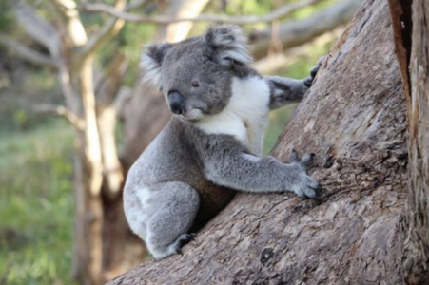  Photo credit: DEECA | Distribution map  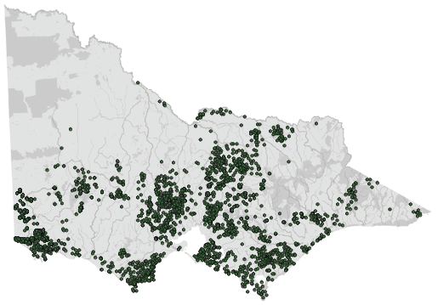  Data source: Victorian Biodiversity Atlas Jan 2023  www.environment.vic.gov.au/biodiversity/victorian-biodiversity-atlas
General appearance | Victorian koalas are larger and have longer, thicker fur and more fur on their ears than koalas from New South Wales and Queensland
Conservation status* | Koalas are considered secure in Victoria, as opposed to populations in New South Wales, the Australian Capital Territory and Queensland where they are listed as endangered under the Australian Environment Protection and Biodiversity Conservation Act 1999
Sexual dimorphism | Male: Prominent scent gland on the chest  Female: No scent gland
Adult morphometrics | Body weight: Female: 7–11 kg. Male: 9.5–14.9 kg  Head and body length: Female: 680–730 mm. Male: 750–820 mm
Home range | 0.5–11.26 ha
Behaviour | Mainly nocturnal. Solitary but aware of others near by
Diet | Koalas feed almost entirely on the leaves of Eucalyptus species. Preferred species include manna gum (E. viminalis), swamp gum (E. ovata) and blue gum (E. globulus)
Longevity | 13–16 years. Females live longer than males
Physical maturity | Male: 48 months (12 kg)  Female: 36–48 months (6 kg)
Sexual maturity | Male: 24 months but older males may restrict mating opportunities until 48 months  Female: 24 months (6.6 kg)
Mating season | Spring–Summer
Litters per year | 1 litter of 1 young (2 teats: in rare instances, may have 2 young)
Weaning | 11 months on average
Age at full pouch emergence | 7–8 months on average
Young dispersal | 12 months (female joeys stay within vicinity of mother until about 15 months)
*From the Flora and Fauna Guarantee Act 1988 Threatened List June 2023. This list is updated regularly throughout the year. For the most current list, please visit https://www.environment.vic.gov.au/conserving-threatened-species/threatened-list.

5.3. Animal and human safety considerations
In general, animals in the wild have limited contact with people, pets, and the hustle and bustle of our daily lives. When sick, injured or orphaned wild animals come into care this unnaturally close contact can carry risks to the health and safety of both people and animals. For general information on biosecurity and approaches to minimise these risks see Part A of these guidelines. Specific information on enclosure hygiene and biosecurity for koalas is in Section 5.6.2.
The following information relates to the human and animal health and safety considerations specifically related to the rehabilitation of koalas.

5.3.1. Human safety considerations
- Koalas can give a painful and deep bite that will result in bleeding, bruising and damage to underlying structures such as tendons. Bites breaking the skin can result in serious infection and should be immediately washed thoroughly with soap and water and medical attention sought without delay.
- They can scratch hard enough to break the skin causing deep lacerations.
- Tree climbing to capture koalas is dangerous. Injury or death from falling for both the koala and the handler is possible. People at the base of the tree can be injured from falling tree limbs.

5.3.2. Animal safety considerations
- As koalas tend to sleep for long periods, it is important to minimise disturbance and provide them with a quiet environment.
- Minimise handling time to reduce stress.
- Koalas tend to panic if they are unable to grip anything solid with their paws while being handled or transported.
- Do not hold a koala around the chest, unless it is a habituated juvenile, as it can result in rib fractures and injury to the handler.
- Transport in cooler times of the day and never leave koalas in hot cars.

5.4. Capture, restraint, and transport
STOP – A visual examination must be done BEFORE the animal is captured. This applies to the initial capture from the wild as well as prior to captures which occur during time in captive care. See Section 5.4.1 for information on what to look for when conducting a visual health assessment.
Refer to Part A of these guidelines for general advice on wildlife welfare, biosecurity and hygiene, and record requirements. The following information relates to the capture, restraint, and transport of sick, injured and orphaned koalas.

5.4.1. Visual observations
Visual observations of wildlife should be conducted prior to any attempts to capture the animal. This is just as important prior to the first capture from the wild as it is before any capture conducted while an animal is in captive care. Observations should be conducted quietly, by one person, and from a distance which provides a clear view of the animal with as little disturbance as possible. Visual observation should focus on the animal’s demeanour, behaviour, movement and posture, looking for evidence of injury/severe disease or deterioration and observe their breathing as demonstrated in the following table.
Table 5.2: Visual health observations in koalas
 | What to look for
Demeanour | - Reactive to noise and touch  - Avoids capture
Behaviour | - Sleeps in a tree fork for much of the day  - Seen to consume eucalypt leaves  - Appears relaxed and is not calling out, (which could indicate pain)  - Does not appear restless or moving about frequently
Abdomen | - Full in profile – level or extends beyond rib cage profile
Movement and posture | - Sits in a tree fork, gripping the branch with both front feet  - Climbs and walks using all four feet  - No evidence of lameness
Breathing | - 10–15 breaths per minute

5.4.2. Equipment
- Binoculars to make a visual assessment of a koala in a tree.
- A blanket, catch bag or large beach towel can be used to place over the koala.
- Transport container: Recommended dimensions of transport containers for koalas are: 0.2 m² x 0.6 m (H). Bags are recommended to be 0.65 m x 0.45 m in size. Suitable transport containers include: a solid walled or slatted box; washing baskets placed one above the other and tied together; a dog pet carrier with a removable top and door (Figure 5.1) to allow the handler to restrain the koala; a garbage bin with holes in the lid for ventilation (suitable for short journeys on cool days only); a hessian sack or robust fauna bag with secure ties.
- Towelling is used as a floor covering during the transport of koalas. A rolled towel propped up against the side of the enclosure will give the koala something to hold onto during travel.
- Weak koalas may need to be supported with towels placed around their body and a pillow placed under their forearms to keep their head and chest elevated.
- The transport container may be covered in a sheet to reduce visual stimuli.
- Transport cages should contain gum leaves, which will potentially reduce koala stress levels.
- A cherry picker from a power company may be required to capture a koala up a power pole. If this is required, consult the power company first as they may need to use their own cherry picker or at least, to provide safety instructions.
- Flagging poles can be used to get koalas down to a level where capture can occur.
Figure 5.1: Dog pet carrier suitable for use as a koala transport crate. Photo credit: DEECA
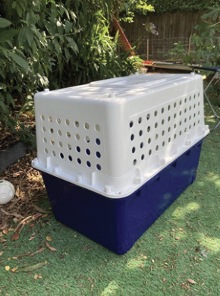

5.4.3. Technique
It is beyond the scope of these guidelines to outline techniques for every situation that may be encountered. Examples of techniques for some specific situations are outlined in the following section.
In addition to this information, for further advice please also refer to the recommended reading list, zoological institutions, veterinarians and/or wildlife experts. Inexperienced rescuers should request assistance where possible.
The method used to restrain a koala is dependent upon the situation and the temperament of the animal. The koala can be handled in the following ways:
- The koala is lifted by holding it high on the arms near the armpits (See Figure 5.2). This can be attempted with a towel which drapes over the koala’s legs and protects the handler’s arms from being scratched.
- Koalas may be handled by grasping them by the wrists and raising them slowly. Lateral traction may be required if they try to bite. This technique should only be used for very short periods. (See Figure 5.3).
- Neck and rump scruff: this technique is useful for aggressive koalas as the handler is less likely to be bitten or scratched (See Figure 5.2).
- Robust large fauna bags or large towels are useful for restraint and transport but, be aware koalas may bite through these.
Figure 5.2: a. A koala is lifted by holding it high on the arms. b. The ‘neck and rump scruff’ technique for holding a koala. Illustration credit: Colleen Wood
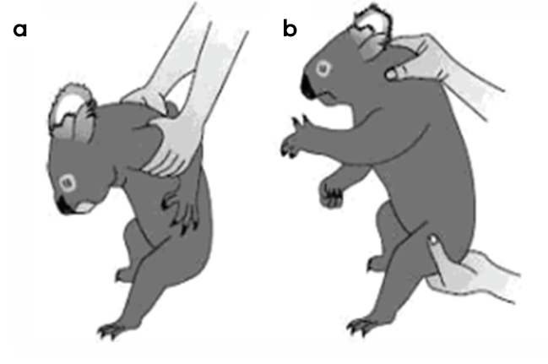
Figure 5.3: A towel is used to lift the koala by the wrists. Photo credit: Zoos Victoria
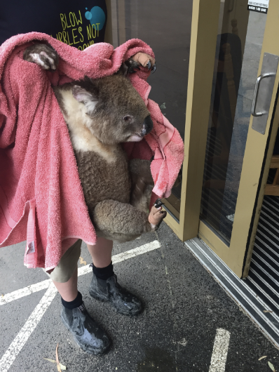
Figure 5.4: Koala manual restraint. Photo credit: Zoos Victoria
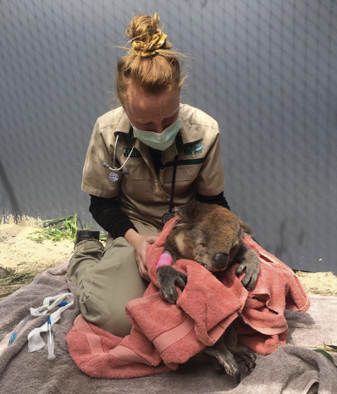

Koala found on the ground
This is a common scenario for unwell koalas. If a koala is found at the bottom of a tree for longer than 24 hours, or is at risk of predation, then it requires capture and assessment. A koala on the ground may be approached quietly from behind, and a blanket or robust fauna bag placed over its head. It is then lifted and placed into a transport container. If a koala that has been on the ground quickly climbs a tree when approached, it may not need immediate capture. It should instead be observed in situ over several subsequent days as it may still be carrying injuries such as facial or jaw fractures.

Found next to the road
It is important to remember wildlife rehabilitator safety when rescuing koalas found next to roads. Koalas may still be mobile, and the capture may need to be planned with more than one person to keep the animal, wildlife rehabilitators and the public from harm. Contact the police assistance line on 131 444 to assist with traffic management, and where appropriate use signage to warn oncoming traffic. Place a blanket over the koala and lift it into a transport container.

Low in a tree
Healthy koalas tend to sit higher up in trees. It is less common for them to be found sitting low in a tree. Koalas may also be found lower in trees in hot weather and may be less likely to move in hot conditions. The koala should be observed to determine whether it requires assistance. A wide sack or robust large fauna bag can be placed over the head and shoulders. The koala may then either descend or climb up to escape, in which case it climbs into the sack or bag. It can then be restrained by the wildlife rehabilitator through the bag and lowered to the ground. Alternatively, a catch pole hooped around the neck and below one shoulder can be used to restrain a koala low in the tree. Care should be taken not to cause any nail damage. Never pull a koala directly off the tree.

High in a tree
It is normal for koalas to sit high in a tree. Tree-climbing to capture a koala is not recommended for safety reasons. A variety of methods can be used safely:
The capture of a koala high up a tree involves the use of flags on a pole waved in front of the animal to encourage it to climb down. One person with a flag for each main trunk of the tree is required for this capture technique. If flagging is unsuccessful after 20 minutes, the flagging should cease as the animal’s level of stress and risk of injury increase with time.
Caution should be used around electric fences/power lines/falling branches.
Koalas will leave a tree after a few days of their own accord, which may present another opportunity to catch them. Establishing temporary fencing around the base of the tree can aid in trapping the animal when the koala comes down to the ground. This should be monitored continuously.

5.4.4. Transport
- Koalas should be transported in a timely manner directly to a veterinarian for assessment or to an experienced koala rehabilitator.
- Koalas should not be left free to roam within a vehicle.
- If possible, avoid travel when the temperature is greater than 25°C as this may place koalas at risk of overheating.
- If this is not possible, the transportation vehicle should be temperature controlled to ensure the koala does not overheat nor get too cold. Avoid air conditioning vents blowing directly over koalas.
- Do not place koalas in the boot of the car, as there is often inadequate ventilation, and the rescuer cannot monitor the animal closely.
- Noise during transport (such as voices and radio) should be kept to a minimum.
- Domestic animals should not be present in the vehicle.
- Clean cages between use with an appropriate disinfectant such as F10SC.

5.5. Monitoring animal health and welfare
The goal of wildlife rehabilitation is to address health and welfare concerns quickly and effectively so wildlife can be released back to the wild as soon as possible. Decision-making from the time of capture through to release should be guided by an accurate understanding of the animal’s true state of health and welfare. Careful monitoring throughout the rehabilitation period ensures that significant issues, or deterioration in health condition, are identified immediately and rapidly addressed.
It is preferred that all sick, injured or orphaned wildlife be assessed by a veterinarian to ensure that non-obvious signs of trauma or disease can be assessed and treated as soon as practicable. No medication should be provided prior to this assessment, as this can mask clinical signs and make an accurate health assessment by the veterinarian very difficult.
Templates for record-keeping visual and physical observations and daily care can be found in Part A of these guidelines.
This section provides guidance on health assessment on arrival and on effective monitoring of the health and welfare of individuals in care through minimising human-animal interactions and stress to the animal to maximise successful release back to the wild.

5.5.1. Physical examination
Once visual observations are complete, and the animal is stable enough to withstand capture and handling, a basic physical examination should be conducted. This can be repeated when required, any time the carer has the animal in the hand, such as for an enclosure change. However, if a full physical exam is not conducted, body condition and weight should be assessed every time the animal is in the hand for other reasons. Carers should make sure weighing scales are available and ready to use before capturing the animal. Physical examinations are also required if the carer notices any changes suggestive of deteriorating health or injury.
Always record the physical examination findings, so that you can compare findings as the animal’s rehabilitation progresses. This ensures any health concerns are identified as soon as possible, and the carer can plan release as soon as appropriate. A template for recording physical examination findings can be found in the appendices to Part A of these guidelines.
Examinations should be conducted in a quiet location, away from domestic animals. Only one person should handle the animal, while a second person takes notes. All other people should move away, and noise kept to a minimum. Handling should also be kept to a minimum, with careful monitoring for any signs of distress (such as panting, salivating, vocalisation or sudden deterioration in demeanour). If these are seen, the examination should be stopped immediately, and the animal returned to its catch bag, transport box or enclosure and allowed to recover.

Species specific considerations:
- Assessment is best performed under sedation or general anaesthesia as this will allow a more thorough examination, including examining the teeth to determine the animal’s age (see Table 5.4 for information on aging koalas).
- Physical examination requires two people. One person will need to restrain the koala within a towel or bag. The second person can then expose specific body parts for examination.
- Unless the koala is extremely injured or unwell, it will likely resist any attempts to examine it. The koala may try to bite and scratch the handler and may urinate and/or vocalise.
Table 5.3: Physical examination of koalas
 | What to look for
Body weight | - Record body weight on arrival and at least weekly while in care.  - A greater than 10% change in body weight over a week is cause for concern, and the carer should seek veterinary advice immediately.
Body condition | - Body condition is scored by palpation of the prominence of the scapula in relation to the muscle on either side, and palpation of muscles on the top of the head on either side of the sagittal crest. In Victoria, body condition is scored out of 5, details following:
Condition | Score* |  | Attributes
Excellent | 5 |  | Obviously convex muscle masses on either side of the scapula. Strong muscle tone. Scapular spine and edges apparent on careful palpation.
Good | 4 |  | Slightly convex muscle masses on either side of the scapula. Good muscle tone. Scapular spine readily palpable.
Fair | 3 |  | Flat to barely convex muscles on either side of the scapula. Scapular spine is more prominent on palpation.
Poor | 2 |  | Slight dishing of muscles on either side of the scapula. Scapular spine is very obvious on palpation.
Emaciated | 1 |  | Edge of the scapula easily palpable. Concave muscles on either side of the scapula. In extreme emaciation there may be almost no muscle palpable on either side of the scapula.
 | * Adopted from Medicine of Australian Mammals, Vogelnest/Woods, CSIRO 2008.
Hydration status | - Skin over scapula slides smoothly when rubbed over tissue underneath.  - In dehydrated koalas, the skin over the scapula does not slide smoothly when rubbed and becomes increasingly tacky.
Eyes | - Bright, clear.  - No discharge, pink or swollen conjunctiva.  - Not white or cloudy.
Ears | - Sit up in normal position, follow sounds. Note: ear flicking/twitching can be a sign of stress.
Mouth | - Upper incisors slightly overlap lower incisors.
Teeth | - Do not grow continuously, but wear down with age.  - Expect to see discolouration.  - Further information under ‘Tooth Wear Class and Age Determination’ and Table 5.4: ‘Koala tooth wear chart’.
Skin and coat condition | - Fluffy fur over body.  - Look for signs of ‘wet bottom’ - i.e. brownish staining and wet fur around the cloaca and rump due to constant wetting with urine which could indicate a chlamydia infection .
Limbs and feet | - Can walk and climb.  - Claws intact.
Faeces | - Firm but moist when broken, oval, 2–3 cm long.  - Small leaf particles when broken in half.  - 100–200 pellets produced daily.
Sex determination | - The sex of a koala is determined by looking for the presence of a pouch or testicles.  - Prominent scent glands in the middle of the chest in the breeding season indicate mature males. Juvenile males and females may have a slightly discoloured patch of fur on the chest in the same area.
Pouch check | - The opening is towards the bottom of the pouch, so that it can appear to be backward facing.  - There are two teats in the pouch.

Tooth Wear Class and Age Determination
All koalas presenting to care must have their teeth checked to determine their tooth wear class to determine age.
- To assess age check upper right, first and second cheek teeth (P4 & M1). Tooth is 3–5 mm in height
- Cheek teeth cusps are sharp.
- Old koalas have cheek teeth that are worn to the gum line with a flat chewing surface.
- See Table 5.4 for a guide to aging koalas by teeth wear.
- Koalas with stage VI or VII teeth are approaching the end of their life, and are not good candidates for rehabilitation and release. Euthanasia is recommended in these cases.
Table 5.4: Koala tooth wear chart
This tooth wear chart is from the following source and is published with the permission of the author. McLean, N. (2003). Ecology and management of overabundant koala (Phascolarctos cinereus) populations. PhD thesis, Department of Zoology, The University of Melbourne
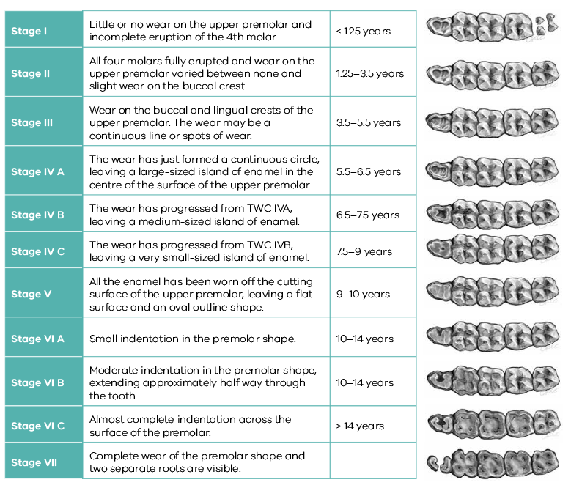

5.5.2. Ongoing monitoring of health and welfare
The aim of wildlife rehabilitation is to ensure animals recover and can be released back to the wild as quickly as possible. Careful, daily monitoring is required to ensure that animals are responding as expected to the treatment being provided and so that any deterioration or welfare concerns can be identified and addressed as soon as possible. Rehabilitators should ensure that record-keeping is a priority to maximise positive welfare outcomes. Templates to assist wildlife rehabilitators to record and monitor wildlife health and welfare can be found in the appendices to Part A of these guidelines. These records will be valuable tools to share with veterinarians to support decision-making.
The following is recorded daily:
- demeanour
- food consumption
- faecal/urine output
- behaviour observed
- medical treatment provided
- evidence of overnight activity.
The following is recorded weekly:
- weight
- body condition.
Over time, regular monitoring will also help to develop carer skills and knowledge, as regular observations and recording will result in a deep understanding of the expected behaviour and response to treatment for the species in care.

Species specific considerations:
- Time your health and welfare observations for times of the day when the koala is expected to be active.
- If the koala is receiving medication, a visual check in the morning is recommended.
- Ideally physical observations should be undertaken at the beginning and/or end of the resting period to minimise disturbance and maximise the rest/sleep period for rapid healing and ensure ease of capture.
- Change the koala’s gum branches at least daily, providing fresh new branches and removing the old ones. Gum should be turned at least daily and water replaced in the browse pots also. This is the time to observe the koala, noting its demeanour and behaviour. Koalas should be alert and responsive during the branch change and will often start eating the new leaves as soon as they are introduced. Pay particular attention to any changes that have occurred since the previous day.
- Gum changes should occur at the same time each day. The koala should not be disturbed during the rest of the day.
- Determine food consumption by making an assessment of how much of the previous day’s browse has been consumed. Koalas usually eat approximately 320– 660 g of leaf per day.
- Faecal pellets should be counted at the same time each day to accurately represent the koala’s 24-hour faecal output, a healthy koala eating well should produce 90-200 pellets per 24 hours. Faecal consistency and size should be noted. Koalas have a very slow gut transit time. A decrease in faecal pellet output is indicative of reduced food intake that occurred approximately three days earlier.

5.5.3. Common and emerging health conditions
Clear guidance on conditions that may require euthanasia can be found in Part A of these guidelines.
Table 5.5 lists common clinical signs and possible causes of injury/disease. Carers should be aware that these are not exhaustive. Aside from first aid, carers should avoid administering medications prior to the provision of veterinary advice.
Unusual clinical signs or mass mortality events – a number of animals dying or found dead at the same time, with similar signs – may indicate an emergency animal disease, an emerging/new infectious disease or an environmental/human related toxicity which needs further investigation. Report these immediately to the Emergency Animal Disease Watch Hotline on 1800 675 888 (24 hours).
Table 5.5: Common injuries and clinical signs of emerging health conditions seen on presentation or during care
Injuries or Clinical signs | Possible Causes | Rehabilitator observations and response
Note: Do not provide pain relief or other medication, including antibiotics, unless under veterinary guidance and supervision, as these can have severe side effects, particularly in dehydrated/shocked animals. Use of antibiotics when not indicated can contribute to antimicrobial resistance and reduce drug efficacy.
Unable to walk or move normally  Paralysis  Swollen limb  Bruising  Fractures  Dislocation | Found adjacent to road/suspect motor vehicle accident,  Caught in fence or wire  Predation injury caused by raptor, fox or dog  Gunshot  Capture injury  Injury sustained in captivity, for example fall from perch | - Urgent Veterinary attention is required. Do not delay transfer to a veterinarian to apply first aid, other than to stop excessive bleeding.  - Move the animal to a small transport box to restrict movement. Ensure temperature is appropriate for species; attempt to relieve stress.  - Do not attempt to stabilise a fractures as this is very painful, and risks making the injury worse. Fracture stabilization should only be attempted by a veterinarian following physical examination, x-rays and under general anaesthesia.  - Do not provide pain relief or other medication unless under veterinary guidance and supervision, as these can have severe side effects, particularly in dehydrated/shocked animals.  - If suspected as the cause, assess the enclosure to find the source of injury. Fix loose wire/gaps or sharp edges before returning the animal to enclosure.  - See Section 5.4 Capture, restraint, and transport and Section 5.6 Housing in this chapter for further advice.
Head trauma  Bleeding from nose, mouth or eyes  Swollen eye lids, blood present in eye  Abnormal behaviour  Mouth swelling, missing teeth  Lethargy | Found adjacent to road/suspect motor vehicle accident,  Caught in fence or wire  Predation injury caused by raptor, fox or dog  Gunshot  Capture injury  Injury sustained in captivity, for example fall from perch  Cranial trauma, concussion | - Urgent Veterinary attention is required. Do not delay transfer to a veterinarian to apply first aid, other than to stop excessive bleeding.  - Move the animal to a small transport box to restrict movement. Ensure the temperature is appropriate; attempt to relieve stress.  - Do not provide pain relief or other medication unless under veterinary guidance and supervision, as these can have severe side effects, particularly in dehydrated/shocked or head trauma animals.  - If suspected as the cause, assess the enclosure to find the source of injury. Fix loose wire/gaps or sharp edges before returning animal to enclosure.  - See Section 5.4 Capture, restraint, and transport and Section 5.6 Housing in this chapter for further advice.
Burns | Recent bushfire, campfire injury, chemical burn | - Seek urgent veterinary attention.  - Euthanasia may be the most humane response if the wounds are extensive.  - Burn injuries are extremely painful, treatment and bandage changes must only occur under anaesthesia and with adequate pain management.  - Do not provide pain relief or other medication unless under veterinary guidance and supervision, as these can have severe side effects, particularly in dehydrated/shocked animals.  - Burn injuries to paws may result in nail damage, digit bone damage and tendon damage. Due to the complexity of these injuries veterinary management is required.  - To ensure good welfare, animals must be returned to a veterinarian for ongoing bandage changes.  - Burnt koalas may need supplemental nutrition as metabolic demands are high when healing burns.
Bleeding  Puncture wounds  Bruising  Fur loss | Conspecific aggression, breeding season injuries  Found adjacent to road/suspect motor vehicle accident,  Predation injury caused by raptor, fox or dog  Poorly designed transport box/enclosure  Capture injury  Injury sustained in captivity, for example, fall from perch | - Seek prompt veterinary assessment.  - Euthanasia may be the most humane response if the wounds are extensive.  - Do not provide pain relief or other medication unless under veterinary guidance and supervision, as these can have severe side effects, particularly in dehydrated/shocked animals.  - The severity of bite wounds/scratches may not be immediately obvious.  - Look for clumps of dried fur stuck together with saliva. Part the fur and look for puncture wounds.  - If suspected as the cause, assess the enclosure to find the source of injury. Fix loose wire/gaps or sharp edges before returning animal to enclosure.  - See Section 5.4 Capture, restraint, and transport and Section 5.6 Housing in this chapter for further advice.
Nail injury  Toe injury  Swollen digit  Bruised digit | Conspecific aggression, breeding season injuries  Found adjacent to road/suspect motor vehicle accident,  Predation injury caused by raptor, fox or dog  Poorly designed transport box/enclosure  Capture injury  Injury sustained in captivity, for example, fall from perch  Burn injuries | - Seek prompt veterinary assessment as these lesions are slow to heal and, where nail bed infection occurs, intensive veterinary management is required.  - Apply first aid to minor wounds.  - Do not provide pain relief or other medication unless under veterinary guidance and supervision, as these can have severe side effects, particularly in dehydrated/shocked animals.  - Burn injuries to paws may result in nail damage, digit bone damage and tendon damage, due to the complexity of these injuries, veterinary treatment is required.  - If suspected as the cause, assess the enclosure to find the source of injury. Fix loose wire/gaps or sharp edges before returning animal to enclosure.  - See Section 5.4 Capture, restraint, and transport and Section 5.6 Housing in this chapter for further advice.
Blindness, closed eyes, ocular discharge, swollen conjunctiva, urine staining/dribbling around the rump, ulcerated/red cloaca, pain on urination, tooth grinding | Chlamydia infection | - Seek veterinary attention.  - Give saline bathing of the eyes.  - Give medications as directed by the veterinarian.  - House koalas individually to prevent spread to others.  - Ensure a high level of biosecurity and hygiene, including hand washing between cases, dedicated equipment, and disinfection protocols of cages and cage furniture should be followed.
Thickened, dry, crusty skin particularly on foot pads and wrists, fur loss | Sarcoptic mange, ringworm, other skin condition | - Seek veterinary attention to determine cause and confirm diagnosis.  - Give prescribed medication.  - Ensure a high level of biosecurity and hygiene including, wearing dedicated protective clothing including gloves when handling infected koalas and wash hands thoroughly afterwards. Dedicated equipment and individual pens should be used and thoroughly cleaned and disinfected after use or between animals.  - Sand or earth flooring is not recommended. Perches should be replaced before use with another animal.  - Mange and ringworm are zoonotic, refer to Part A Chapter 4. Biosecurity and hygiene.
Poor body condition, lethargy, increased thirst | Undetermined disease or underlying injury, old age, starvation, kidney insufficiency/failure | - Seek veterinary attention.  - Provide a constant supply of fresh water in a bowl.  - Koalas with kidney failure should be euthanased.
Poor body condition, low output of faecal pellets, small faecal pellets, faecal pellets contain large pieces of leaf | Undetermined disease or underlying injury, old age,  Malnutrition due to severe tooth wear | - Seek veterinary attention.  - Koalas with severely worn teeth should be euthanased.
Figure 5.5: Severe conjunctival proliferation associated with chlamydial infection. Photo credit: Bree Talbot
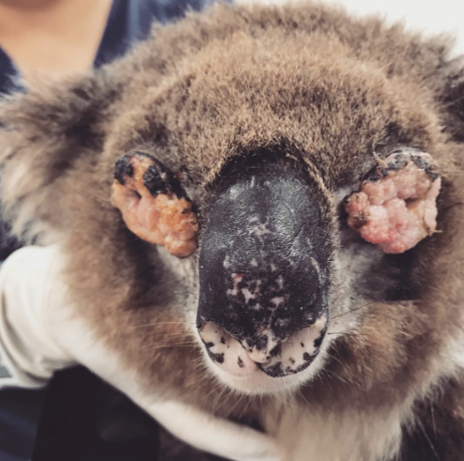
Figure 5.6: Koala on the ground drinking water, renal failure should be considered. Photo credit: Colleen Wood
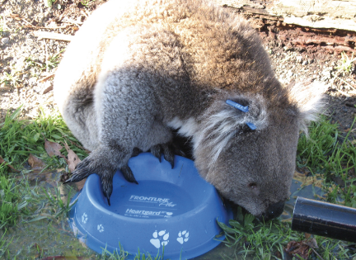
Figure 5.7: a. A koala with crusts on its forearm. b. A koala with crusts on its face and ears. Both are caused by sarcoptic mange. Photo credit: Pam Whiteley (a), Colleen Wood (b)
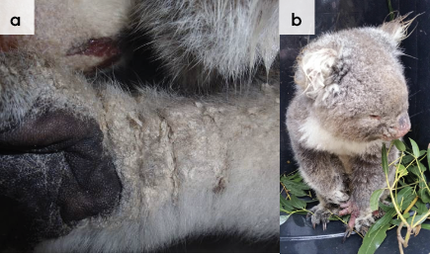
Figure 5.8: a. A koala with severe burns to both front feet. b. A severe burn on the hind foot. Both these injuries require a high level of pain relief and are best managed in a wildlife hospital. Photo credit: Zoos Victoria
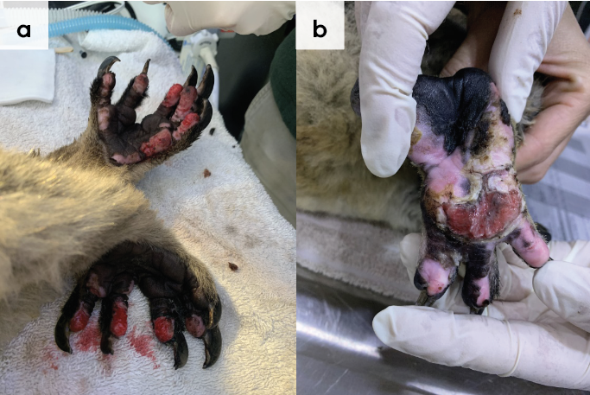

5.5.4. Administering treatment during rehabilitation
- If treating a koala with chlamydial infection, ensure any urine is cleaned away from the rump to prevent scalding. Wipe away any discharges from the eyes with a gauze swab soaked in tepid saline.
- Koalas in care may not eat for several days because they are debilitated, or their gastrointestinal bacteria have been disrupted by disease or antibiotic administration. These koalas will need to be provided with supplemental food to prevent excessive weight loss and malnutrition.
- Supplemental food can be administered into the koala’s mouth with a syringe (See Section 5.7.2). If the koala accepts this, then any medications can be mixed with the supplement. Otherwise, medication will need to be administered in a separate syringe.
- Bandage changes for burns will need to be done by a veterinarian under general anaesthesia, as they are extremely painful. Burnt animals are critical patients and should be managed in a wildlife hospital to ensure they receive appropriate care and pain relief.

5.6. Housing
Below are several key considerations when housing adult koalas in care.

5.6.1. General housing information for koalas
- Koalas are sensitive to noise, and the sight and smell of domestic pets. They should be housed individually in a quiet area of the property.
- Koalas should have access to fresh water and a minimum of three species of fresh eucalypt leaves every day. Debilitated animals will require more. Gum should also be turned at least daily and the water in gum pots replaced at each gum change. The species of eucalypt offered should be the same as those from the area where the koala was found as their gut biota may be specialised, linked to a particular species of eucalypt. Gum must be kept fresh and stored in clean water at all times. As the only source of nutrition for recovering koalas, gum should be managed very carefully.

5.6.2. Enclosure hygiene & biosecurity
General information about hygiene and biosecurity can be found in Part A of these guidelines. New diseases emerge frequently and sick and injured animals in care are often more susceptible to picking up pathogens from the environment. It is important to maintain excellent levels of hygiene to avoid inadvertently transferring diseases between animals, and from humans, and to protect the wild population where the animal will eventually return to.

Species specific considerations
- There are no documented cases of chlamydia in koalas infecting people. However, it is contagious for other koalas. If treating a koala with a chlamydial infection it should be serviced last. Water bowls, gum pots and other equipment should not be used with other koalas until they have been disinfected. Bleach, Virkon S and F10SC used at the recommended concentration and contact time are all effective. Bleach and Virkon S must be rinsed off. Wooden perches should be discarded as they cannot be adequately disinfected.
- Koalas with mange should be treated in a similar manner to those with chlamydia. Mange can spread to people. Gloves should be worn when these koalas are handled. Mites can survive for up to a week in the environment. Refer to Part A, chapter 4 Biosecurity & Hygiene.
- Remove faecal pellets at the same time each day, perform and record the pellet count.

5.6.3. Housing types
Different set ups are required for animals at different stages of treatment and care.
Table 5.6 describes the housing type, suggested dimensions and requirements at each stage of care. For information on housing animals during hand raising see Section 5.8.
Table 5.6: Rehabilitation housing for adult koalas
Intensive care housing
Indications for use | Suggested min. dimensions | Suggested requirements
Short term critical care (<48 hours)  This type of enclosure is intended for the intensive care of an extremely sick koala (See Figure 5.9). It is expected that a koala would be housed for less than seven days in an enclosure of this size.  Spending extensive periods of time in small enclosures can lead to urine scalding, dermatitis and pressure sores. | Floor area: 0.60 m x 0.60 m (0.36 m²) Height: 0.6 m | ENCLOSURE CONSTRUCTION  - Very sick and immobile koalas can be housed in solid enclosures, such as a dog hospital enclosure, lined with towels and other absorptive material. Round fabric dog beds are comfortable and make excellent intensive care beds.  - Alternatively, a plastic washing basket padded with pillows and towels, containing a rolled-up towel as a “branch” can be used. Another basket is placed over the top and secured in place with straps.  ENCLOSURE FURNISHING  - Faecal pellets should be counted daily in critical cases (See Section 5.7 for more information about this) and the bedding changed as often as it becomes wet.  - A newspaper substrate is easily changed.  - Towels can be used to absorb the urine from hospitalised koalas with limited mobility.  - Where possible koalas should be provided with a low fork to sit in if they are able, supported with towels or bedding around it, if the koala needs support.  ENVIRONMENTAL VARIABLES  - Enclosure should be placed into a warm temperature-monitored room, between 25°C and 28°C to ensure to ensure that the koala does not get hot/cold during recovery in this intensive stage.  PROVISION OF FOOD/WATER  - Water should be offered in a bowl and changed daily.  - The enclosure should be filled with browse so that the koala has food directly in front of it and feels secure and does not need to move to eat.

Intermediate housing (Treatment/cage rest)
Indications for use | Suggested min. dimensions | Suggested requirements
Provision of daily medication, close monitoring once animal is stabilised and no longer requires intensive care.  Enclosure furnishings can be arranged to reduce opportunities to climb or move excessively so that ‘cage rest’ can be achieved with slightly more space/reduced contact.  Suitable for koalas that may still need treatment | Floor area: 1.50 m x 1.50 m (2.25 m²) Height: 1.50 m  Where possible, moving koalas outside at this stage will benefit their welfare during rehabilitation. | ENCLOSURE CONSTRUCTION  - The enclosure should be large enough for a koala to be able to sit in a tree fork off the ground.  - The fork should consist of an upright pole with a side branch of more than 50 mm diameter coming off at an angle of 45–60 degrees.  - Suitable flooring includes either a concrete floor or an earth floor covered with sand. The floor should be cleaned twice daily, and the faecal pellets counted (See Section 5.7).  ENCLOSURE FURNISHING  - A bowl of soil and moss taken from the base of a koala food tree is also placed in the enclosure and refreshed weekly as koalas may choose to eat soil, although the reason for this is unknown.  - Perching is organised so that small amounts of climbing, and other movement can be observed.  ENVIRONMENTAL VARIABLES  - Room temperature or outside temperature if over warmer months of the year. The sooner they are outside the better they will respond to treatment.  PROVISION OF FOOD/WATER  - Water should be offered in a bowl and changed daily.  - The enclosure should be browsed out so that the koala has to move small distances but access to food is easy and accessible from all perching options.  - Gum is placed in pots where water is replaced daily.

Pre-release
Indications for use | Suggested min. dimensions | Suggested requirements
No longer require regular handling/medication  Development of fitness/strength prior to release  Monitoring/assessment of behaviour (climbing, and other movement)  Pre-release assessment | Minimum floor area is 20 m². Larger sizes are preferable. The enclosure should be completely enclosed with a 3 m high roof or surrounded by a fence at least 1.2 m high.  Any climbable structure should be at least  1.8 m from the perimeter fence, as koalas can jump horizontally.  Enclosure should be outdoors and allow expression of a full range of natural behaviours | ENCLOSURE CONSTRUCTION  - The enclosure may have a covered area made from solid material such as tin or wood. However, most of the enclosure should be exposed to the weather to acclimatise koalas prior to release.  - Sturdy wire may be used.  - A pre-release enclosure can also be made by fencing a 10-40 m tree that is separate from other trees with pool fencing or tin fencing to a height of 1.5 m, as shown in Figure 5.12.  - An earth floor covered with sand is suitable.  ENCLOSURE FURNISHING  - A bowl of soil taken from the base of a koala food tree should also be placed in the enclosure and refreshed weekly.  - Mobile koalas can be housed in tall enclosures that contain two Y-shaped forks, with a horizontal branch placed between the forks, ideally at a height more than 1.2 m above the ground. A near-vertical upright pole with a side branch (≥50 mm in diameter) coming off at an angle of 45–60°, no closer than 30–40 cm from the top of the upright, makes a suitable resting fork.  - A browse table can be situated outside the enclosure, to permit browse to be sorted without laying it on the ground.  - Ideally, the enclosure will contain rough and smooth tree trunks so that climbing on both types of tree trunks can be assessed while in care.  ENVIRONMENTAL VARIABLES  - Shade-cloth or a sprinkler system may be used to keep the enclosure cool in warm weather (ambient temperature >35°C).  PROVISION OF FOOD/WATER  - A water bowl should be offered on the floor of the enclosure and the water changed daily.  - Large fresh eucalypt branches may be offered in 1 m long PVC pots, filled with water. The pots should be emptied, cleaned and re-filled daily with fresh water.  - At least two pots of browse for each koala should be placed in the enclosure. They may be placed at different heights.
Figure 5.9: Photo shows a koala in an intensive care enclosure. The koala is supported in a dog bed. Note access to a water bowl and the presence of leaf in the enclosure. Photo credit: Australian Wildlife Hospital Beerwah
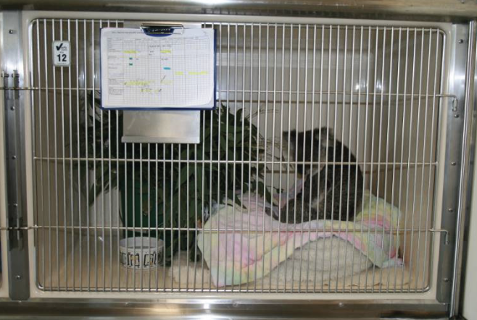
Figure 5.10: a. A padded stand for a joey. b. The same stand decorated with leaf. Photo credit: Colleen Wood
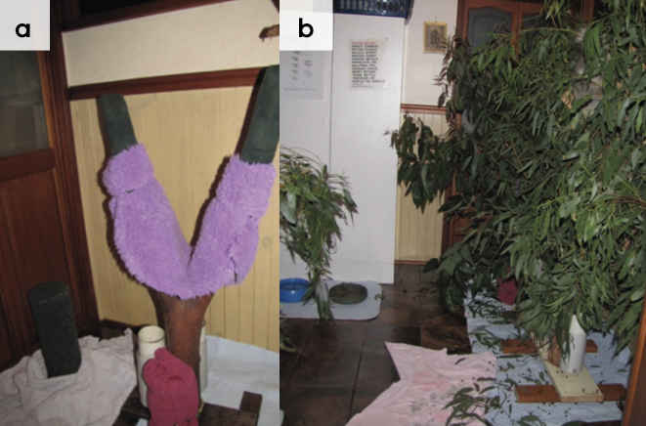
Figure 5.11: Photo of an intermediate enclosure for hospitalised koalas. Photo credit: Zoos Victoria
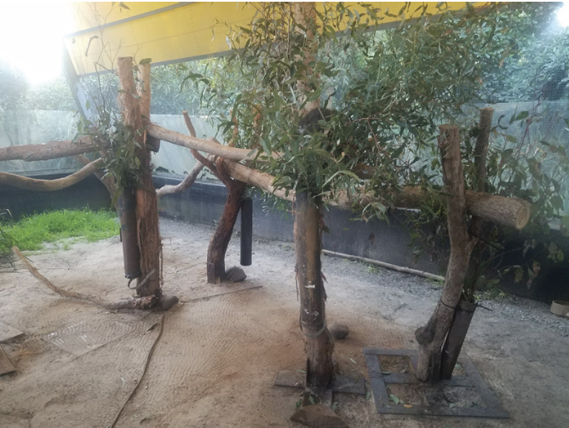
Figure 5.12: a. A pre-release enclosure for koalas: part of the enclosure is sheltered from the weather. b. A tree fenced inside an enclosure. Feed pots are placed near the base of the tree to provide supplementary leaf. Photo credit: Anne Fowler
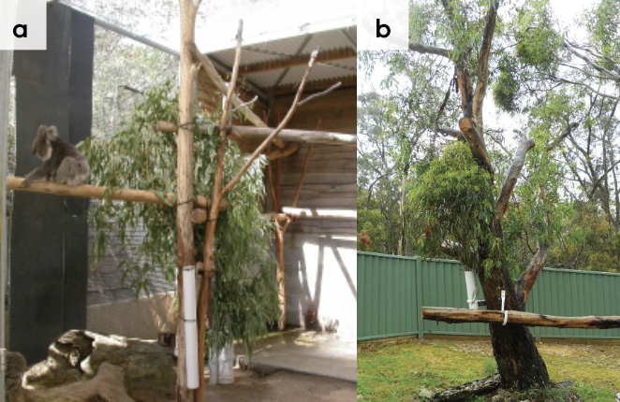

5.7. Feeding and nutrition
Keeping daily records of food offered (item and volume fed) and food consumed is good practice and will allow the rehabilitator to observe how an animal is responding to food on offer and inform future choices.
Please note: Food suppliers and specific products mentioned in these guidelines are intended as examples only. Other suitable products may also be available.
This section refers to feeding and nutrition of koalas in rehabilitation. Information on feeding orphaned individuals can be found in Section 5.8 Hand raising.

5.7.1. Feeding adults
The importance of providing fresh, healthy and suitable leaf to koalas housed in captivity cannot be over-emphasised.
- Koalas need to be offered at least three to five different species of Eucalyptus tree leaves daily. These should be species eaten by koalas local to the area from which the rehabilitated koala has come. The species most usually eaten by the animal should be offered each day. The branch that is offered should contain both tips and mature leaves. Some sick koalas prefer to eat younger leaves, while some will prefer to eat bark, or more fibrous leaves such as Melaleuca species. A koala that is not eating or is eating poorly may be doing so because inappropriate or unrecognised species are being offered rather than the koala being truly ill. This emphasises the importance of variety and careful daily observation and record keeping.
- Joeys require extra fibre and will strip bark from branches as opposed to consuming the leaf.
- An adult koala will eat between 320 and 660 g (these quantities are mentioned in Section 5.5.2) of leaf daily. The koala will obtain this amount by being offered at least 5 kg of leafy branches. The branches can be sprayed with water two to three times daily to keep the moisture levels in the leaves high. They can be rearranged at this time to stimulate eating. Gum should be kept in pots of water in the enclosure so that the gums maintain moisture during the day.
- Carers should grade the amount a koala eats over each 24-hour period. Inspection at the same time each day is recommended. Ideally a grading system using pictures will be established. Notes on which species are preferred should be made daily, as this may change.
- Branches that are not being fed that day should be stored upright in water containers such as buckets or garbage bins in a cool room. The water containers used to hold browse in the enclosure or in storage are scrubbed daily and the water is changed daily. The section of branch that is sitting in the water should be free of leaves so as not to dirty the water and decrease the longevity of the remaining branches.
- Mist leaves with water during the hotter months to maintain hydration.
- A council permit may be required to lop or prune native trees.
Figure 5.13: a. A browse table. Gum is cut and placed on the table to prevent it from touching the ground. b. Browse is offered in a PVC pot. Photo credit: Gordan Lyall (a) and Jo Griffith (b)
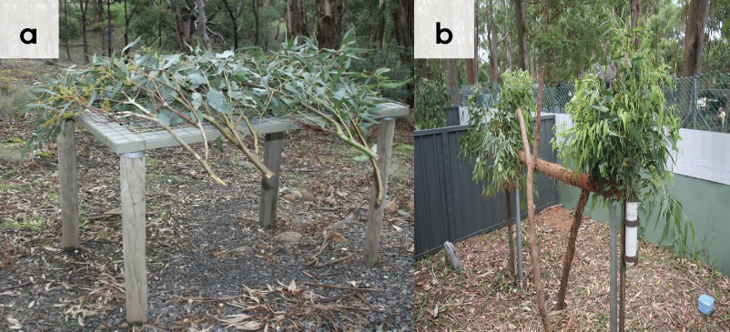
- Faeces should be counted for each 24-hour period. Faecal output less than 100 pellets produced in 24 hours can indicate that the animal is unwell or not eating enough. Intervention may be required in the form of feeding supplements and oral fluids. Normal faecal output is 100–200+ pellets in a 24-hour period. The nature of the faecal pellet is also very important (size, consistency, moisture content). Animals in poor health may have dry, hard, small or narrow faecal pellets. Gut transit time is very slow in koalas (up to 100 hours) and therefore changes in the faeces may reflect a lack of appetite or illness of several days’ duration. Pellets produced by old koalas may contain gum fragments, as their worn teeth are no longer fully masticating the leaf.
Table 5.7 and Table 5.8 list appropriate Eucalyptus species for feeding koalas. Koalas should be provided with species that are eaten by koalas in their locality.
Table 5.7: Some common Eucalyptus species fed to koalas
Common name | Scientific name
Swamp gum | Eucalyptus ovata
Manna gum | Eucalyptus viminalis
Forest red gum | Eucalyptus tereticornia
Grey gum | Eucalyptus punctata
River red gum | Eucalyptus camaldulensis
Tasmanian, Southern & Victorian blue gums | Eucalyptus globulus
Cider gum | Eucalyptus gunnii
Candlebark | Eucalyptus rubida
Bracelet honey myrtle | Melaleuca armillaris
Narrow leafed black peppermint | Eucalyptus nicholii
Table 5.8: Other, less preferred Eucalyptus species eaten by koalas
Common name | Scientific name
Narrow-leaved peppermint | Eucalyptus radiata
Broad-leaved peppermint | Eucalyptus dives
Messmate stringybark | Eucalyptus obliqua
Mountain ash | Eucalyptus regnans
Yellow gum | Eucalyptus leucoxylon
Mealy stringybark | Eucalyptus cephalocarpa
Southern mahogany | Eucalyptus botryoides

5.7.2. Supplements
- Sick koalas can be offered dietary supplements to provide extra nutrition, such as Vetafarm Koala Crittacare or Oxbow Critical Care for Herbivores. Finely blended eucalypt leaf can be added to the paste mixture to provide additional fibre.
- These can be mixed into a paste and given two to three times daily. The syringe is placed behind the incisors into the front of the mouth and the paste administered slowly, giving the koala time to swallow, before more paste is given.
- Koalas should always have their faces and fur wiped with a wet flannel after supplement feeding, or they can develop dermatitis and fur loss from spilled supplements. Wombaroo Impact can also be given to young and/or debilitated koalas to provide extra protein.
Figure 5.14: Convalescing koala being fed a mixture of blended eucalypt leaf and Crittacare from a syringe. Photo credit: Zoos Victoria
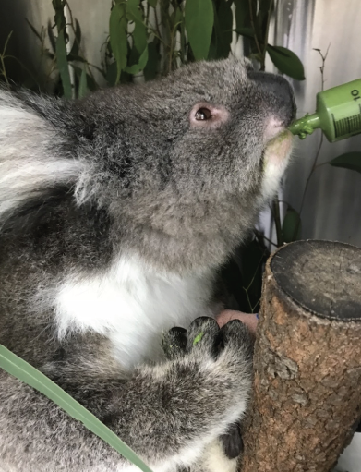

5.8. Hand raising
Hand raising record templates for growth, development, feeding and other observations are found in the appendices to Part A in these guidelines.

5.8.1. Equipment required for hand raising
- Teat (see Figure 5.15), bottle
- Pouch
- Tissues
- Milk: Wombaroo Koala Milk or Biolac M150 or M200
- Scales
- Heat source
- Thermometer
- Record chart
Figure 5.15: Appropriate teat sizes. Photo credit: Wombaroo
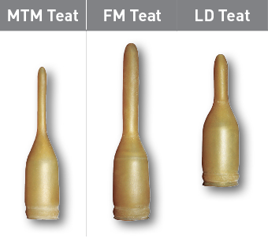

5.8.2. Growth, development and care of orphaned young
STOP – Please refer to your authorisation for mandatory conditions, regarding unfurred koala joeys.
- Table 5.9 describes the appearance of koala joeys at various stages of development.
- Koala joeys require strict hygiene to prevent deaths from bacterial and fungal conditions.
- Very young koala joeys, that have not received pap from their mother, will need to be papped by the rehabilitator.
- Pap is the caecal contents of the female koala. Papping occurs at the time of first emergence from the pouch. The joey stimulates the mother to produce pap from the mother’s cloaca. The joey may eat pap for up to an hour. This may take place over one to five weeks.
- Pap contains bacteria needed to digest Eucalyptus leaves. Without pap, joeys are unable to digest leaf and will die.
- When a koala joey enters care, any faeces it passes should be collected and examined microscopically (refrigerate or freeze if this cannot be done immediately). This is particularly critical prior to pap or leaf being offered to a joey. Signs of leaf in these “wild” faeces are good evidence that the joey has already been papped by their mother. These joeys may not require papping if they are eating leaf well and gaining weight.
- All koala joeys less than 350 g should be given access to pap. Pap (in the form of caecal contents) may be collected from a freshly killed or euthanased koala, protected from air and stored in the refrigerator (do not freeze) for up to seven days. It is preferable that these joeys are placed with wildlife rehabilitators who are caring for other koalas. Koala joeys are very likely to imprint onto humans, and being raised in the presence of other koalas makes this less likely.
- Chlamydia free koalas must be used as donors as the organism can be transferred via pap to the joey.
- An emergency alternative is to offer the joey fresh faeces from a healthy adult. To do this place a faecal scat in a bottle of boiled water that has been allowed to cool but is still warm. Mix the faeces with the water and allow it to stand for ten minutes. Drain off the liquid and mix it into the joey’s next feed at a rate of 20–30% of the milk volume. Repeat the process 12 hours later and as often as required until the joey is producing normal faeces.
- To prevent imprinting, young koalas should be raised in pairs, or in the company of adult koalas. It is important to determine that the adult koala is free of disease before a young koala is introduced to it. The adult must be screened for chlamydiosis with a PCR urogenital and ocular swab.
- If hand-reared by themselves, orphaned joeys should be moved to a facility with other koalas at 2 kg to facilitate socialisation.
- Koalas are readily fostered by adult female koalas once they reach the back riding stage. Other lactating females may assist in feeding orphaned joeys. Male koalas will also interact with joeys particularly outside the breeding season.
Table 5.9: Feeding and housing requirements for koalas (Used with permission from Wombaroo)
Milk | Age (d) | Weight (g) | Head length (mm) | Appearance | Feeds (mL/day) | Feeding frequency  Daily | Activity | Housing
Early lactation | 150 | 250 | 54 | Eyes open | 23 | 7 milk feeds (every 3 hours) | Head out of pouch |  | Intensive care  34°C In a pouch Inside a humidicrib
 | 160 | 310 | 56 | Fine fur,  Incisors through gum | 27
Transition | 165 | 345 | 58 |  | 21 mL early + 7 mL late
 | 170 | 380 | 59 |  | 14 mL early + 14 mL late
 | 175 | 415 | 60 | Sleek fur  Molars begin to erupt through gum | 7 mL early + 21 mL late
Late lactation | 180 | 450 | 61 |  | 28 | 6 milk feeds – (every 4 hours) |  |  | 34°C Pouch with teddy
 | 190 | 520 | 64 |  | 31 |  | Pap eaten
 | 200 | 600 | 67 |  | 35
 | 210 | 700 | 70 |  | 40 | Offer leaf tip, mature leaf and bark |  |  | 32°C. Inside a pouch with a teddy
 | 220 | 820 | 73 |  | 44
 | 230 | 950 | 76 |  | 49 | 4 milk feeds daily  Eating more gum tips | Begin to ride on mother’s back |  | 28°C Heating only at night.  Offer tree with perch and teddy
Late lactation | 240 | 1100 | 78 | Sleek fur  Molars begin to erupt through gum | 55 | 4 milk feeds daily  Eating more gum tips | Begin to ride on mother’s back |  | 28°C Heating only at night.  Offer tree with perch and teddy
 | 250 | 1230 | 80 |  | 60
 | 260 | 1360 | 82 |  | 64
 | 270 | 1500 | 84 | Fully furred, | 70 | 3 milk feeds  Eating 100 g leaf daily | Starting to leave mother  Fully out of pouch at 9 months |  | Intermediate housing:  No heating required  Tree with teddy inside
 | 290 | 1900 | 88 | Small adult appearance | 83 | 3 milk feeds | Becoming more active |  | Outside during day, inside on tree at night
 | 310 | 2250 | 93 |  | 95 | 2 milk feeds  Eating 200 g leaf daily | Start weaning, becoming independent |  | Pre-release housing:  Outside during day
Weaning | 330 | 2600 | 97 |  | 60 | Milk volume depends on amount of leaf eaten | Climbing and active |  | Outside all the time
 | 350 | 2900 | 101 | Full set of teeth | 30
 | 370 | 3200 | 104 |  | 0 | Eating 300 g leaf daily | Fully weaned Release when the koala weighs above 4 kg

5.9. Release protocol
Ideally, wild animals will be rehabilitated and released in a short timeframe. If this is not possible and the animal is in care for significant extended periods, ensure that the animal is regularly assessed against the welfare domains to support decision-making. Animals in care for extended periods may have a reduced ability to survive in the wild. Talk to your veterinarian and consider whether euthanasia will provide the best welfare outcome for the animal.

5.9.1. Pre-release assessment
Pre-release assessment of animals in care is essential to support improved outcomes once back in the wild. Animals should be assessed based on body condition, fitness and the ability to engage in natural species-specific behaviours prior to release.
The following check list should be used to guide decision making regarding release suitability for koalas:
- Individual is in a state of good health – presenting injury/sickness is completely resolved.
- Burns have healed and some hair regrowth has occurred, all digits must function normally (consider a pre-release veterinary check).
- Individual is within a healthy weight range and appropriate body condition (refer to Table 5.1).
- Individual displays the ability to climb up and down tree branches quickly and confidently using all four limbs. Koalas are arboreal, so must be fit to climb before release.
- Individual readily consumes leaf from the area where it was found.

5.9.2. At the release site
Post release survival will be maximised by ensuring that both the release site and the way in which the animal is released are carefully considered. Important site features or factors to consider before releasing a koala include:
- The density of koalas at a site is determined by the number of suitable food trees. A high population density at the release site does not preclude releasing a koala at its original location.
- Koalas should be released to their original location where possible to reduce the spread of disease between populations.
- If possible, a koala should be released back into the tree where it was found as they show site fidelity.
- If the specific tree of capture is not known, then a tree of medium size should be selected. Ideally, the tree selected is a food tree with rough bark, and a fork. Avoid wide, tall, smooth-barked trees as these are difficult for koalas to climb.
- For more information on the ecological characteristics and requirements of koalas that may help with their release, please refer to Table 5.1.

5.9.3. Release checklist
Check all of the requirements of your authorisation are being met, and consider the following:
- Release location
- Release where the koala was found (where suitable or within home range).
- Sufficient food trees present.
- Away from major roads.

Release Procedure
- Do not release a koala into a tree that already contains a koala.
- Koalas should ideally be released in late afternoon or early evening, as this is a normal time of greater activity.
- Do not release the koala if the weather is hot (over 38°C) or during severe storms.
- The koala’s transport enclosure should be placed several metres away from the selected tree to allow the koala to orient and acclimatise itself before it begins to climb.
- The door can then be left open while people walk quietly away. The koala will emerge in its own time to climb the tree.
- Monitor the koala for a minimum of six weeks to ensure it disperses.

5.10. Key references and additional reading
Blanshard, W. and Bodley, K. 2008. Koalas. In: Medicine of Australian Mammals. Vogelnest, L. and Woods, R. (eds). CSIRO Publishing, Collingwood. Pp. 227-327.
Jackson, S., Reid, K., Spittal, D. and Romer, L. 2003. Koalas. In: Australian Mammals: Biology and Captive Management. Jackson, S. (ed). CSIRO Publishing, Pp. 145-182.
Jackson, S., Perry, L., O’Callaghan, P., Spittal, D., Romer, L. and Reid, K. Koala Phascolarctos cinereus Captive Husbandry Guidelines. http://www.australasianzookeeping.org/Husbandry%20Manuals/KOALA%20Husbandry%20Manual.pdf
Martin, R. and Handasyde, K. 1999. The Koala: natural history, conservation & management, 2nd ed. UNSW Press, Kensington. 132 pp.

