Chapter 1: Lizards

Contents
1.1. Introduction 2
1.2. Species information 3
1.3. Animal and human safety considerations 17
1.3.1. Human safety considerations 18
1.3.2. Animal safety considerations 18
1.4. Capture, restraint, and transport 18
1.4.1. Visual observations 18
1.4.2. Equipment 19
1.4.3. Technique 20
1.4.4. Transport 21
1.5. Monitoring animal health and welfare 22
1.5.1. Physical examination 22
1.5.2. Ongoing monitoring of health and welfare 24
1.5.3. Common presenting injuries and clinical signs of emerging health conditions 25
1.5.4. Administering treatment 34
1.6. Housing 34
1.6.1. General housing information for lizards 34
1.6.2. Enclosure hygiene and biosecurity 35
1.6.3. Housing types 35
1.7. Feeding and nutrition 41
1.8. Release protocol 45
1.8.1. Pre-release assessment 45
1.8.2. At the release site 45
1.8.3. Release checklist 45
1.9. Key references and additional reading 46

In Victoria, sick, injured or orphaned wildlife can only be rehabilitated by a wildlife shelter operator or foster carer who is authorised under section 28A of the Victorian Wildlife Act 1975 (Wildlife Act). Wildlife rehabilitators are subject to strict conditions. The mandatory requirements that they must meet are set out in the Wildlife Shelter and Foster Carer Authorisation issued under the Wildlife Act. These conditions enforce the minimum standards required for the humane treatment and successful rehabilitation of wildlife in care. The Wildlife Rehabilitator Authorisation Guide: Things You Need To Know explains how wildlife rehabilitators can meet these mandatory requirements and can be found here: https://www.vic.gov.au/wildlife-rehabilitation-shelters-and-foster-carers.
The Victorian Wildlife Rehabilitation Guidelines have been developed to incorporate evidenced-based best practice in wildlife care and rehabilitation to equip rehabilitators to deliver positive welfare outcomes for individual animals in their care from first aid to post-release into the wild.
You must comply with the conditions of your authorisation. These guidelines must be read in conjunction with the conditions of your authorisation.

1.1. Introduction
Victoria is home to 87 species of lizards. This chapter addresses the husbandry, care and welfare of lizards that are commonly encountered in Victoria.
Eastern bearded dragon and Lace monitor are listed as threatened in Victoria.
STOP – If either of these species comes into care, please STOP and refer to your authorisation for mandatory conditions including notification and release requirements.
When lizards come into care, it is the responsibility of the rehabilitator to ensure that the five domains of animal welfare are satisfied. These include providing optimal nutrition (Section 1.7) and an environment appropriate to the lizard’s stage of rehabilitation (Section 1.6). This is even more important for lizards than for some other species as the rehabilitator completely controls the lizard’s environment while in care. The focus should be on the lizard’s return to health and release, which is facilitated through regular collaboration with a veterinarian It is also important to consider the lizard’s mental state and ability to exhibit normal behaviours without detrimentally affecting its recovery. Welfare may be temporarily compromised by the necessity of a gradual return to normal activity, depending on its stage of rehabilitation. Further information about the five domains of animal welfare can be found in Part A of these guidelines.
Exotic and native species non-endemic to Victoria must not be released into the wild. Non-endemic lizard species may escape their enclosures or find their way into Victoria in shipping containers or accidentally with returning international travellers. In cases where the animal is suspected to be an escaped pet, take the animal to a veterinarian to be scanned for a microchip. If an owner can be identified, the animal should be returned as soon as possible. If there is no microchip or if the person claiming ownership cannot produce a wildlife licence, contact DEECA on 136 186. Occasionally exotic lizard species may be encountered for example Asiatic house gecko (Hemidactylus frenatus). These species may be a prohibited pest animal and any possession or care is not allowed under any wildlife shelter or foster carer authorisation issued under the Wildlife Act. These animals must be euthanised as they are considered potential pests and pose a threat to native species. Notify Agriculture Victoria of all exotic lizards in the wild or any that come into care on 136 186 or email highrisk.invasiveanimals@agriculture.vic.gov.au.

1.2. Species information
Profiles for the most common lizard species found in Victoria are detailed in the tables below. For assistance in identification of lizard species, refer to the recommended reading and reference material at the end of this chapter.
Table 1.1: Species profiles
Species | Blotched blue tongue lizard (Tiliqua nigrolutea)
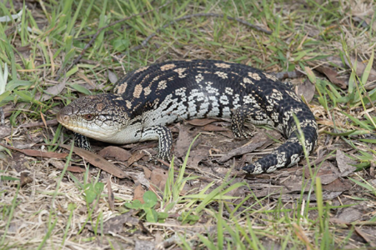  Photo credit: David Paul, Museums Victoria | Distribution map  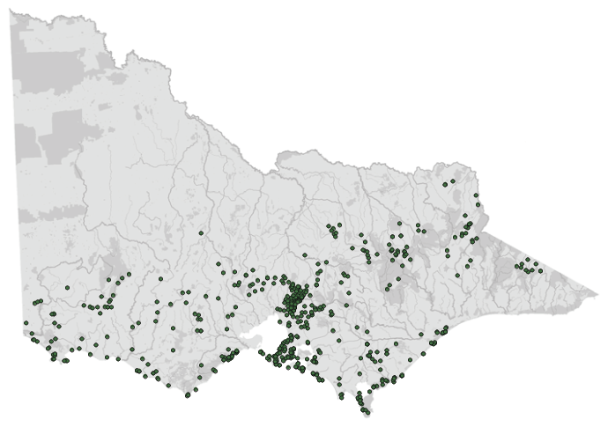  Data source: Victorian Biodiversity Atlas Jan 2023  www.environment.vic.gov.au/biodiversity/victorian-biodiversity-atlas
General appearance | Brown to black with uneven blotches of colour on the back and a lack of black line behind the eye
Conservation status* | Common
Sexual dimorphism | Blotched blue tongue lizards cannot be accurately sexed on visual inspection. Measurements of weight, head width, trunk length and snout-to-vent length can be used to compare to published morphometric data to determine sex in this species
Adult morphometrics | Body weight: 300–500 g  Length: 35–50 cm
Habitat | Suburban gardens, built-up areas, forest, grassland
Home range | 0.5–2 ha
Behaviour | Diurnal, territorial  Solitary, terrestrial
Diet | Invertebrates: snails, slugs, grasshoppers, beetles  Plant material: fruit, fungi, berries, flowers
Longevity | 12–15 years
Sexual maturity | Male: >1 year  Female: >2 years
Mating season | Spring
Gestation | 3–5 months
Incubation | Live bearer
Litters per year | 2–12
Young dispersal | From birth

Species | Eastern bearded dragon (Pogona barbata)
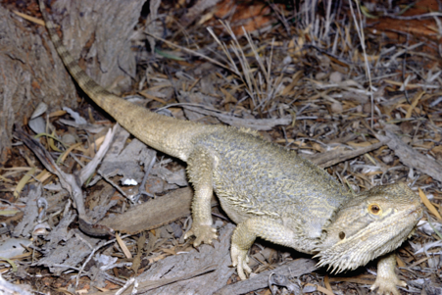  Photo credit: Ian R McCann, Museums Victoria | Distribution map  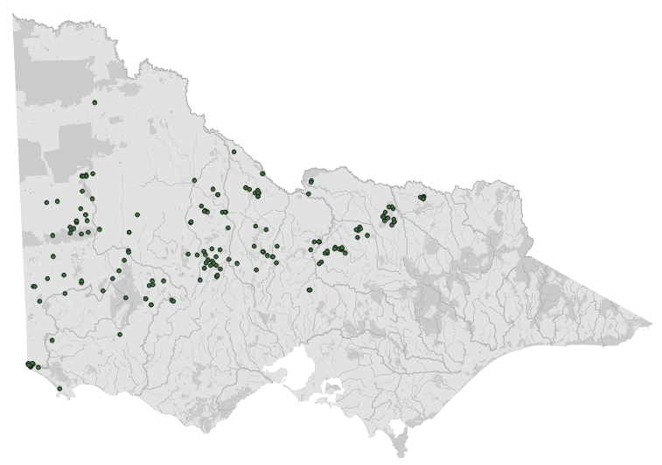  Data source: Victorian Biodiversity Atlas Jan 2023  www.environment.vic.gov.au/biodiversity/victorian-biodiversity-atlas
General appearance | Beard with spines. Grey colour
Conservation status* | Vulnerable
Sexual dimorphism | Male bearded dragons have larger femoral pores on their thighs than females. Hemipenal bulges will also be apparent on the underside of the base of the tail in male
Adult morphometrics | Body weight: 300–500 g  Length: 35–55 cm
Habitat | Wet to open forest, suburbia, arid area
Home range | Male: 0.3–4.5 ha  Female: 0.1–2.0 ha
Behaviour | Diurnal, territorial  Solitary, Semi-arboreal
Diet | Invertebrates and plants
Longevity | 10–15 years
Sexual maturity | Male: 1–2 years  Female: 1–2 years
Mating season | Spring
Gestation | Egg layer
Incubation | 45–84 days
Litters per year | 7–20 eggs
Young dispersal | From birth

Species | Eastern blue tongue lizard (Tiliqua scincoides)
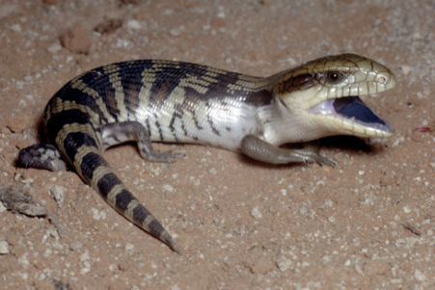  Photo credit: Ian R McCann, Museums Victoria | Distribution map  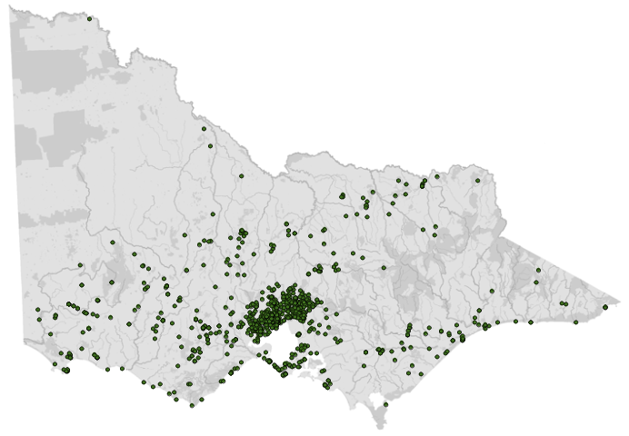  Data source: Victorian Biodiversity Atlas Jan 2023  www.environment.vic.gov.au/biodiversity/victorian-biodiversity-atlas
General appearance | Grey with brown stripes and a black line behind the eye
Conservation status* | Common
Sexual dimorphism | Eastern blue tongue lizards cannot be accurately sexed on visual inspection. Measurements of weight, head width, trunk length and snout-to-vent length can be used to compare to published morphometric data to determine sex in this species
Adult morphometrics | Body weight: 300–500 g  Length: 45–55 cm
Habitat | Suburban gardens, built-up areas, forest, grassland
Home range | Male: 3–12 ha  Female: 0.1–5 ha
Behaviour | Diurnal, territorial  Solitary, terrestrial
Diet | Invertebrates: snails, slugs, grasshoppers, beetles, cockroaches  Plant material: fruit, fungi, berries, flowers
Longevity | 12–15 years
Sexual maturity | Male: >1 year  Female: >2 years
Mating season | Spring
Gestation | 3–5 months
Incubation | Live bearer
Litters per year | 6–25
Young dispersal | From birth

Species | Gippsland water dragon (Intellagama lesuerii howittii)
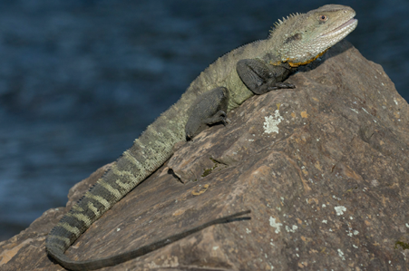  Photo credit: David Paul, Museums Victoria | Distribution map  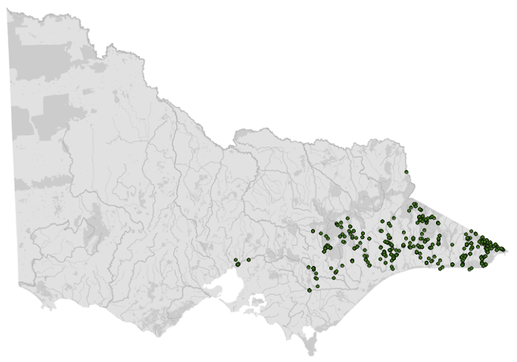  Data source: Victorian Biodiversity Atlas Jan 2023  www.environment.vic.gov.au/biodiversity/victorian-biodiversity-atlas
General appearance | Crest of scales along back. Green to grey body with stripes. No dark stripe between the ear and the eye (present in the eastern water dragon)
Conservation status* | Common
Sexual dimorphism | Male Gippsland water dragons are larger than females and have dark blue-green chests and streaks of yellow and blue around the neck and throat. They do not develop the red chest colouration found in eastern water dragons during the breeding season.
Adult morphometrics | Body weight: up to 1 kg  Length: 50–90 cm
Habitat | Adjacent to watercourses
Home range | 1 ha
Behaviour | Diurnal, males are territorial  Semi-aquatic, arboreal. Overlapping home ranges
Diet | Insects, crustaceans, frogs, reptiles, small mammals, berries, fruits
Longevity | Up to 20 years
Sexual maturity | Male: 1–2 years  Female: 1–2 years
Mating season | Late spring, early summer
Gestation | Egg layer
Incubation | 85–120 days
Litters per year | 6–18 eggs
Young dispersal | From birth

Species | Jacky lizard (Amphibolurus muricatus)
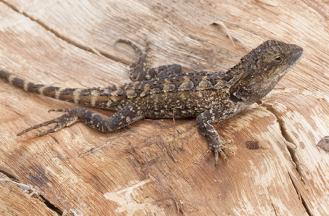  Photo credit: David Paul, Museums Victoria | Distribution map  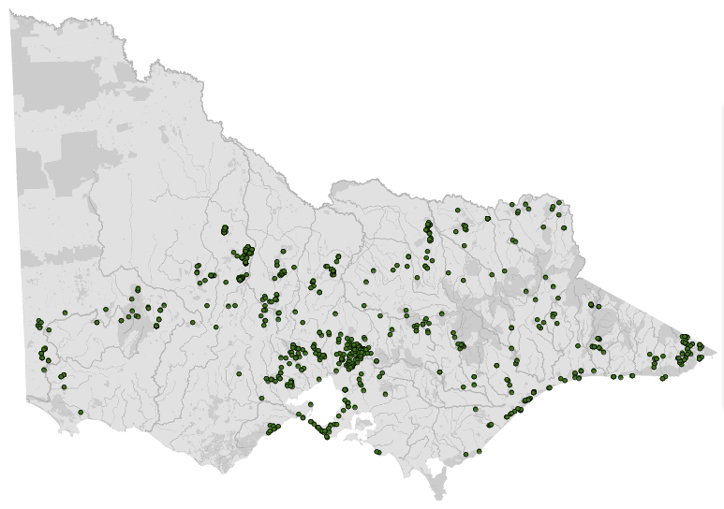  Data source: Victorian Biodiversity Atlas Jan 2023  www.environment.vic.gov.au/biodiversity/victorian-biodiversity-atlas
General appearance | Brown with light patches on back
Conservation status* | Common
Sexual dimorphism | Generally males have a greater body size and relatively larger heads than females
Adult morphometrics | Body weight: 25–60 g  Length: 25–35 cm
Habitat | Open forest, rocky ledges, coastal heath
Home range | <1 ha
Behaviour | Diurnal, territorial  Solitary, semi-arboreal
Diet | Invertebrates: grasshoppers, beetles, flies, moths, spiders  Greens
Longevity | 4 years
Sexual maturity | Male: >1 year  Female: >1 year
Mating season | Spring
Gestation | Egg layer
Incubation | 42–55 days
Litters per year | 3–10 eggs
Young dispersal | From birth

Species | Lace monitor (tree goana) (Varanus varius)
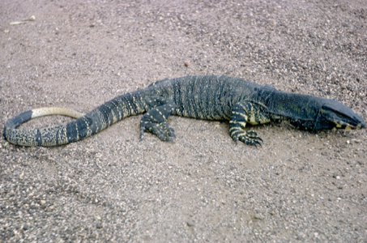  Photo credit: Ian R McCann, Museums Victoria | Distribution map  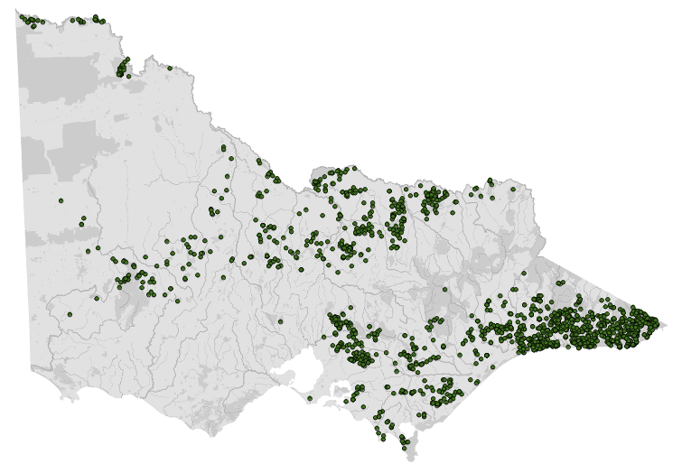  Data source: Victorian Biodiversity Atlas Jan 2023  www.environment.vic.gov.au/biodiversity/victorian-biodiversity-atlas
General appearance | Lace monitor may have yellow dots and stripes or solid colouring
Conservation status* | Endangered
Sexual dimorphism | Mature lace monitor males have ossified hemipenes, which can be detected by X-ray. Mature male lace monitors also have a broader nose and will show bulging at the base of the tail indicating the presence of hemipenes
Adult morphometrics | Body weight: Up to 20 kg  Length: 100–200 cm
Habitat | Open to wet forest
Home range | 15–125 ha
Behaviour | Diurnal, territorial  Solitary, arboreal, terrestrial
Diet | Small mammals, birds, reptiles, carrion
Longevity | Up to 40 years
Sexual maturity | Male: 2–3 years  Female: 2–3 years
Mating season | Spring
Gestation | Egg layer
Incubation | 190–230 days
Litters per year | 8–11 eggs
Young dispersal | From birth

Species | Shingle back lizard (Tiliqua rugosa)
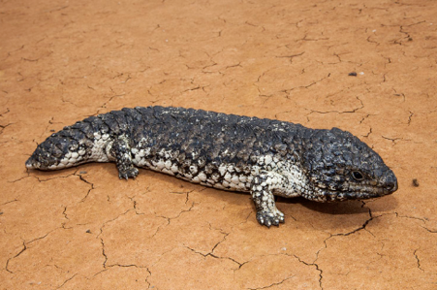  Photo credit: Mark Norman, Museums Victoria | Distribution map  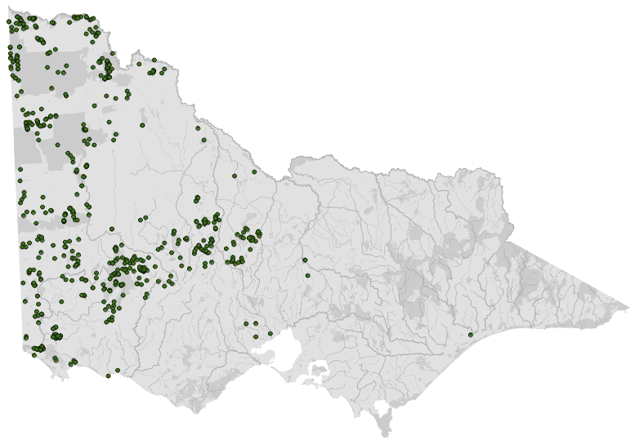  Data source: Victorian Biodiversity Atlas Jan 2023  www.environment.vic.gov.au/biodiversity/victorian-biodiversity-atlas
General appearance | Pine cone scales, short tail
Conservation status* | Common
Sexual dimorphism | Immature and underweight shingleback lizards can be difficult to sex. Females have a narrower head and wide tail whereas males have a wide head and narrow tail
Adult morphometrics | Body weight: 600–900 g  Length: 120–200 cm
Habitat | Drier forest
Home range | 1–6 (average = 4)
Behaviour | Diurnal, territorial  May share refuges, overlapping home range, pair bonds
Diet | Berries, fruit, herbaceous vegetation, flowers, fungi, carrion, invertebrates
Longevity | 20–25 years
Sexual maturity | Male: >1 year  Female: >1 year
Mating season | Spring
Gestation length | 5 months
Incubation | Live bearer
Litters per year | 1–4
Young dispersal | From birth
*From the Flora and Fauna Guarantee Act 1988 Threatened List June 2023. This list is updated regularly throughout the year. For the most current list, please visit https://www.environment.vic.gov.au/conserving-threatened-species/threatened-list.

1.3. Animal and human
safety considerations
In general, animals in the wild have limited contact with people, pets, and the hustle and bustle of our daily lives. When sick, injured or orphaned wild animals come into care this unnaturally close contact can carry risks to the health and safety of both people and animals. For general information on biosecurity and approaches to minimise these risks see Part A of these guidelines. Specific information on enclosure hygiene and biosecurity for lizards is in Section 1.6.2.
The following information relates to the human and animal health and safety considerations specifically related to the rehabilitation of lizards.

1.3.1. Human safety considerations
- Wash hands with soap and water after handling frogs to minimise the risk of infection with zoonotic disease agents such as Salmonella.
- Lizards can give a painful bite which may puncture the skin and cause localised bleeding and bruising.
- Lace monitors are dangerous animals to handle. Their large jaws cause a painful bite that can become infected. Monitor species also have venom which, when injected into a wound through a bite, can cause pain and tissue damage. Long claws can also tear clothing and human skin. Even the skin on their tail is abrasive enough to break human skin.

1.3.2. Animal safety considerations
- Do not pick lizards up by their tail. Blue tongue lizards can drop their tail and spinal damage can occur in other species.

1.4. Capture, restraint, and transport
STOP – A visual examination must be done BEFORE the animal is captured. This applies to the initial capture from the wild as well as prior to captures which occur during time in captive care. See Section 1.4.1 for information on what to look for when conducting a visual health assessment.
Refer to Part A of these guidelines for general advice on wildlife welfare, biosecurity and hygiene, and record requirements. The following information relates to the capture, restraint, and transport of sick, injured and orphaned lizards.

1.4.1. Visual observations
Visual observations of wildlife should be conducted prior to any attempts to capture the animal. This is just as important prior to the first capture from the wild as it is before any capture conducted while an animal is in captive care. Observations should be conducted quietly, by one person, and from a distance which provides a clear view of the animal with as little disturbance as possible. Visual observation should focus on the animal’s demeanour, behaviour, movement and posture. Check for evidence of injury/severe disease or deterioration and assess their breathing as demonstrated in the following table.
Table 1.2: Visual health observations in lizards
 | What to look for
Demeanour | - Reactive to being approached  - May adopt a threat posture
Behaviour | - Smaller lizards often hide in a nest box, under vegetation or under newspaper  - May be sitting under the heat lamp
Movement and posture | - Able to use all four legs without dragging any of them  - Alignment of spine appears straight/normal
Breathing | - Nostrils are clear and open, free from discharge  - Breathing is regular  - If threatened, blue tongue lizards can inhale large amounts of air and expand their bodies

1.4.2. Equipment
- Noose pole may be used to catch a lace monitor that needs to be removed from a tree.
- A towel, calico bag or pillowcase can be used to pick up and restrain a small lizard. Ensure any pillowcases or calico bags are turned inside out so that there are no loose threads on the inside that could entangle lizards or catch nails.
- Cardboard box or a solid-walled container such as a bucket or ice-cream container (with ventilation added).
- Hessian bag or plastic rubbish bin with a clipped/secured lid: Due to their size, lace monitors need to be transported in a larger container.
- Many species are agile climbers and so the transportation unit needs to have a secure lid.
Figure 1.1: Transport container suitable for a small lizard. Photo credit: Zoos Victoria
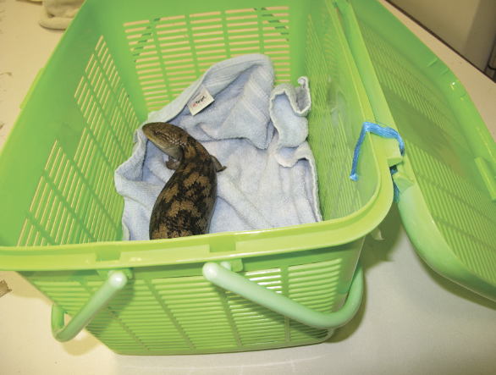
Figure 1.2: Soft pet packs can be used to transport reptile species. Photo credit: Zoos Victoria
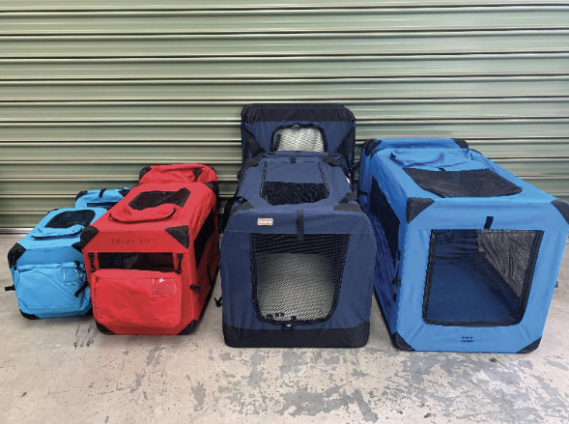

1.4.3. Technique
It is beyond the scope of these guidelines to outline techniques for every situation that may be encountered. Examples of techniques for some specific situations are outlined in the following section.
In addition to this information, for further advice please also refer to the recommended reading list, zoological institutions, veterinarians and/or wildlife experts. Inexperienced rescuers should request assistance where possible.
- Restrain smaller lizards by holding them behind the head with one hand and supporting the body with the other hand. They can then be wrapped in a towel or placed in a bag.
- Lace monitors should only be handled by experienced rehabilitators due to the high risk of injury. They can be restrained with a towel. Place the towel over the head and then hold the neck behind the head in one hand and hold the hind legs together with the tail using the other hand. Hold the lace monitor facing away from your body.

1.4.4. Transport
- Transport lizards in a well-ventilated container.
- Secure the container in the vehicle so that it cannot slide or roll over.
- Food and water do not need to be provided.
- In hot weather, transport the lizard in an air-conditioned vehicle.
Figure 1.3: a. A water dragon is restrained behind the head with one hand while the other holds the tail. b. A blotched blue tongue lizard is restrained in the hand by gently restraining behind the head. Photo credit: Zoos Victoria (a) and Anne Fowler (b)
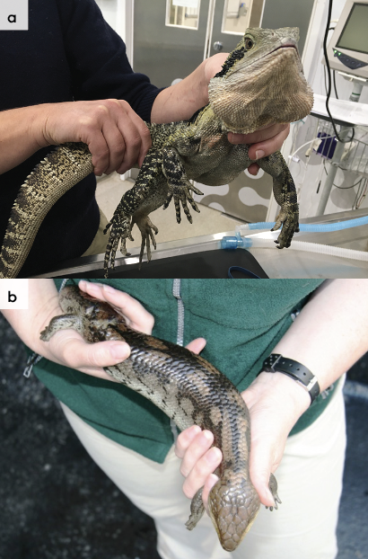

1.5. Monitoring animal health and welfare
The goal of wildlife rehabilitation is to address health and welfare concerns quickly and effectively so wildlife can be released back to the wild as soon as possible. Decision-making from the time of capture through to release should be guided by an accurate understanding of the animal’s true state of health and welfare. Careful monitoring throughout the rehabilitation period ensures that significant issues, or deterioration in health condition, are identified immediately and rapidly addressed.
It is preferred that all sick, injured or orphaned wildlife be assessed by a veterinarian to ensure that non-obvious signs of trauma or disease can be assessed and treated as soon as practicable. No medication should be provided prior to this assessment, as this can mask clinical signs and make an accurate health assessment by the veterinarian very difficult.
Templates for record-keeping visual and physical observations and daily care can be found in Part A of these guidelines.
This section provides guidance on health assessments on arrival and on effective monitoring of the health and welfare of individuals in care through minimising human-animal interactions and stress to the animal to maximise successful release back to the wild.

1.5.1. Physical examination
Once visual observations are complete, and the animal is stable enough to withstand capture and handling, a basic physical examination should be conducted. This can be repeated when required any time the carer has the animal in the hand, such as for an enclosure change. However, if a full physical exam is not conducted, body condition and weight should be assessed every time the animal is in the hand for other reasons. Carers should make sure scales are available and ready to use before capturing the animal. Physical examinations are also required if the carer notices any changes suggestive of deteriorating health or an injury.
Always record the physical examination findings so that you can compare findings as the animal’s rehabilitation progresses. This ensures any health concerns are identified as soon as possible, and the carer can plan release as soon as this is appropriate. A template for recording physical examination findings can be found in the appendices to Part A of these guidelines.
Examinations should be conducted in a quiet location, away from any domestic animals. Only one person should handle the animal, while a second person takes notes. All other people should move away, and noise kept to a minimum. Handling should also be kept to a minimum.

Species specific considerations:
- Lizards can usually be examined while conscious, under manual restraint. However, for painful conditions, deep injuries, or potentially dangerous lizards, examination under sedation or anaesthesia is required. Lizards have strong jaws. A tongue depressor can be used to carefully open the mouth of larger lizards such as blue tongues, shinglebacks or bearded dragons. A guitar pick or credit card can be used for smaller lizards, such as jacky lizards. Care is required to avoid damaging teeth and gums or causing a jaw fracture.
Table 1.3: Physical examination of lizards
 | What to look for
Body weight | - Record body weight on arrival and at least weekly whilst in care.  - A greater than 10% change in body weight is cause for concern, and the carer should seek veterinary advice. It is important to know the species’ expected body weight as smaller species will have less tolerance for weight loss.
Body condition | Body condition is assessed by examining the musculature around the pelvis (See Figure 1.4). In the skink species, fat may be stored in the tail, which can also help in the assessment of body condition:  - Under condition: Spine and hip bones prominent.  - Ideal condition: Hips are covered with muscle but the points of the hips can still be felt.  - Over condition: Points of the hips cannot be felt. Tail is thick and rounded.
Hydration status | - Check skin tenting along the body wall. This can be difficult to evaluate in lizards with tightly adherent skin, such as blue tongues.  - The eyes should be bright and shiny, not sunken.  - The skin should be bright and taut.
Eyes | - Eyes should both be open, shiny and clear, with no bubbles or discharge.  - Basic internal structures of eyes (e.g. pupil, iris) appear symmetrical.
Cloaca | - Pink.  - Free of faeces and urates (not caked on).
Mouth | - Gums are pale pink or light yellow.  - No bleeding.  - No broken or missing teeth.  - Jaw/mouth aligned normally, no evidence of displacement or fracture.
Skin condition | - Scales appear normal for species.  - Inspect ear canals for the presence of ticks. If present, gently remove ticks.  - Normal skin shedding (ecdysis) is patchy and shedding skin easily comes away from healthy underlying scales.
Limbs, feet and tail | - Can stand, walk.  - Tail is present – thickness indicates condition.  - No missing legs, toes or claws.
Figure 1.4: Body condition scoring. a. An extremely underweight lace monitor. Note the prominent spine and hip bones. b. A bearded dragon in ideal body condition. c. an overweight shingleback lizard. The area over the hips is rounded and the tail is thick and rounded. Photo credit: Zoos Victoria (a,b) and Shane Simpson (c)
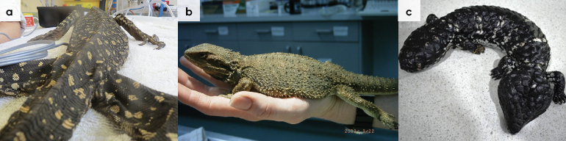

1.5.2. Ongoing monitoring of health and welfare
The aim of wildlife rehabilitation is to ensure animals recover and can be released back to the wild as quickly as possible. Careful, daily monitoring is required to ensure that animals are responding as expected to the treatment being provided and so that any deterioration or welfare concerns can be identified and addressed as soon as possible. Rehabilitators should ensure that record-keeping is a priority to maximise positive welfare outcomes. Templates to assist wildlife rehabilitators to record and monitor wildlife health and welfare can be found in the appendices to Part A of these guidelines. These records will be valuable tools to share with veterinarians to support decision-making.
The following is recorded daily:
- demeanour
- food consumption
- faecal/urine output
- behaviour observed
- medical treatment provided
- evidence of overnight activity.
The following is recorded weekly:
- weight
- body condition.
Over time, regular monitoring will also help to develop carer skills and knowledge, as regular observations and recording will result in a deep understanding of the expected behaviour and response to treatment for the species in care.

Species specific considerations:
- The lizard should be observed at least daily.
- Note the lizard’s demeanour and behaviour every time food is introduced or taken away, the animal is medicated or the enclosure is cleaned. Pay particular attention to any changes that have occurred since the previous day.
- Note faecal consistency daily. The lizard should pass solid brown faeces, pasty white urates and liquid urine, which may not be detectable if it has soaked into the substrate. If diarrhoea is noticed, a faecal sample should be collected and submitted to the veterinarian for assessment as soon as possible. Do not treat on suspicion of a bacterial or parasitic infection, as this can make definitive diagnosis very difficult and potentially prolong the course of the disease.

1.5.3. Common presenting injuries and clinical signs of emerging health conditions
Clear guidance on conditions that may require euthanasia can be found in Part A of these guidelines.
Table 1.4 lists common clinical signs and possible causes of injury/disease. Carers should be aware that these are not exhaustive. Aside from first aid, carers should avoid administering medications prior to the provision of veterinary advice.
Unusual clinical signs or mass mortality events – a number of animals dying or found dead at the same time, with similar signs – may indicate an emergency animal disease, an emerging/new infectious disease or an environmental/human related toxicity which needs further investigation. Report these immediately to the Emergency Animal Disease Watch Hotline on 1800 675 888 (24 hours).
Table 1.4: Common injuries and clinical signs of emerging health conditions seen on presentation or during care
Injury or clinical signs | Possible causes | Carer observations and response
Note: Do not provide pain relief or other medication, including antibiotics, unless under veterinary guidance and supervision, as these can have severe side effects, particularly in dehydrated/shocked animals. Use of antibiotics when not indicated can contribute to antimicrobial resistance and reduce drug efficacy.
Fracture | Motor vehicle  Lawn mower or whipper snipper accident  Predator attack | - Seek urgent veterinary attention. Do not delay transfer to a veterinarian to apply first aid, other than to stop excessive bleeding.  - Move animal to a small transport box to restrict movement. Ensure temperature is appropriate for the species and minimise stress.  - Do not attempt to stabilise fractures as this is very painful and risks making the injury worse. Fracture stabilisation should only be attempted by a veterinarian following physical examination, x-rays and under general anaesthesia.  - Do not provide pain relief, or other medication, unless under veterinary guidance and supervision, as these can have severe side effects, particularly in dehydrated/shocked animals.  - Animals with mouth injuries may require assisted feeding with a suitable liquid diet such as Hills a/d or Lafeber’s EmerAid.  - House the lizard in a quiet area, away from domestic species.
Head trauma | Motor vehicle  Lawn mower or whipper snipper accident  Predator attack | - Seek urgent veterinary attention. Do not delay transfer to a veterinarian to apply first aid, other than to stop excessive bleeding.  - Move animal to a small transport box to restrict movement. Ensure temperature is appropriate for the species and minimise stress.  - Do not provide pain relief, or other medication, unless under veterinary guidance and supervision, as these can have severe side effects, particularly in dehydrated/shocked animals.  - House the lizard in a quiet area, away from domestic species.
Nose trauma | Motor vehicle  Lawn mower or whipper snipper accident  Predator attack  Rubbing nose on the glass walls of the enclosure | - Seek veterinary attention. Seek attention urgently if fracture is suspected, severe trauma or for bleeding wounds.  - Move animal to a small transport box to restrict movement. Ensure temperature is appropriate for the species and minimise stress.  - Do not provide pain relief, or other medication, unless under veterinary guidance and supervision, as these can have severe side effects, particularly in dehydrated/shocked animals.  - Block the glass with a piece of cardboard or something similar to create a visual barrier and stop the lizard from rubbing. Provide a variety of shelters throughout the enclosure.  - Mild cases of rostral trauma can be cleaned with diluted iodine applied to the affected area.  - House the lizard in a quiet area, away from domestic species.
Skin wounds  Bleeding | Motor vehicle  Lawn mower or whipper snipper accident  Predator attack | - Seek urgent veterinary attention. Do not delay transfer to a veterinarian to apply first aid, other than to stop excessive bleeding.  - Move animal to a small transport box to restrict movement. Ensure temperature is appropriate for the species and minimise stress.  - Do not provide pain relief, or other medication, unless under veterinary guidance and supervision, as these can have severe side effects, particularly in dehydrated/shocked animals.  - House the lizard in a quiet area, away from domestic species.
Burns | Bushfire  Enclosure heat pad or lamp | - Seek urgent veterinary attention.  - Burn injuries are very painful. To ensure good welfare, animals must be assessed by a veterinarian as soon as possible.  - Treatment may require multiple visits to a veterinarian for bandage changes under anaesthesia, and to ensure adequate pain management.  - Burn injuries may result in scars that may impact future skin shedding.  - If the burn is enclosure-related, modify the enclosure to prevent it happening again.  - House the lizard in a quiet area, away from domestic species.
Discharge from the eyes or nostrils  Rapid breathing | Bacterial or viral respiratory tract infection | - Seek urgent veterinary attention.  - Ongoing care may require cleaning of discharge away from eyes and nostrils as directed by the treating veterinarian.  - Ensure medications are administered as prescribed by a veterinarian.  - Nidovirus is an emerging respiratory disease agent found in blue tongues and shinglebacks. Discuss the diagnosis and implications of infection with a veterinarian.  - House the lizard in a quiet area, away from domestic species.
Inflammation in the mouth  Red, bleeding gums  Missing or broken teeth  Cheesy material in the mouth | Poor husbandry  Disease  Trauma  Stomatitis | - Seek veterinary attention.  - Administer treatment as prescribed by the veterinarian.  - Clean away any discharges from the mouth as directed by a veterinarian.  - Provide a complete diet that is similar to that which the species would have in the wild. Avoid providing fruits to dragons as this is a factor in them developing dental disease.  - Animals with mouth injuries may require assisted feeding with a suitable liquid diet such as Hills a/d or Lafeber’s EmerAid.  - House the lizard in a quiet area, away from domestic species.
Retained pieces of skin, particularly common around the toes | Abnormal pattern of shedding of the dead skin  Dysecdysis | - Seek veterinary attention as required.  - Identify housing issues that may contribute to dysecdysis such as low temperature and humidity.  - Place coarse rocks in the enclosure to provide surfaces for the animal to rub against while shedding.  - Individuals can be soaked for 10–30 minutes in a shallow bowl of luke-warm water.  - Assist shedding after the soaking period. Carefully peel any retained skin away from around the toes as it can cause constriction and toe loss.  - House the lizard in a quiet area, away from domestic species.
Lameness  Reluctance to move  Soft rubbery jaw | Metabolic bone disease as a result of poor nutrition and/or inadequate UV light, causing calcium and/or vitamin D deficiencies | - Seek veterinary attention for guidance on nutritional support. Additionally, severely affected animals may have one or more fractured bones.  - Diurnal lizards kept indoors should be provided with adequate UV light (UV-B). If possible, take the lizard out into natural sunshine for 5–10 hours each week, but do not leave it in full sunshine.  - Provide the lizard with an area of shade. Water should always be available.  - Provide a diet that contains natural foods, such as snails. Ensure snails are free of snail bait by holding for 24 hours before feeding.  - Ensure insects are gut loaded before feeding, using Vetafarm Herpagrub or Wombaroo Insect Booster, or dust insects with calcium powder just prior to being fed.  - Mix Wombaroo Reptile supplement into any fruits and vegetables that are offered.  - Oral calcium (Calcium Sandoz or Vetafarm Calcivet) may also be given as indicated.  - House the lizard in a quiet area, away from domestic species.
Ectoparasites | Mites, ticks | - Seek veterinary advice.  - Animals with heavy burdens of parasites should be presented for veterinary examination to ensure the parasite infestation is not secondary to another disease or injury.  - Ticks can be carefully removed with tweezers while the lizard is restrained in the hand.  - The enclosure may be treated with pyrethrin sprays e.g. Callington Reptile Enclosure Insecticide (formerly Top of Descent). Use as directed on the label. Rinse the enclosure thoroughly before returning animals.  - Remove water bowls for up to 24 hours when treating enclosures to ensure no incidental ingestion of mite treatment.  - In severe cases individuals can be directly treated with Frontline flea spray (active ingredient fipronil). Be careful of eyes and eye area. A cotton tip is useful for applying the Frontline solution to these areas (spray a cotton tip and wipe around the eye area).  - After spraying, animals should be held in a clean tub or bin for 15 minutes. Following this they should be gently rinsed and returned to the treated enclosure.  - During treatment the enclosure can be placed in a water bath to prevent mites spreading to other enclosures. Disinfect or discard any cage furniture.  - The lizard should be visibly free of mites prior to release into the wild.  - House the lizard in a quiet area, away from domestic species.
Tail loss in skinks | May occur in skinks that are restrained by their tail | - Seek veterinary advice.  - Keep in a fly free enclosure for two weeks while repair occurs. Do not treat with any topical agents as these may slow repair.  - House the lizard in a quiet area, away from domestic species.
Figure 1.5: Blue tongue lizard. Abnormal posture indicates that it may be in pain. Photo credit: Zoos Victoria
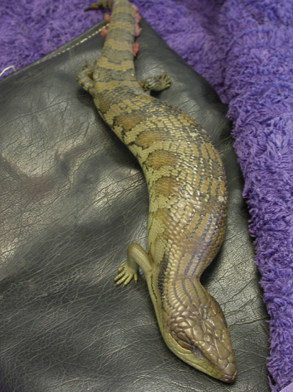
Figure 1.6: Bearded dragon with a fractured jaw. Photo credit: Zoos Victoria
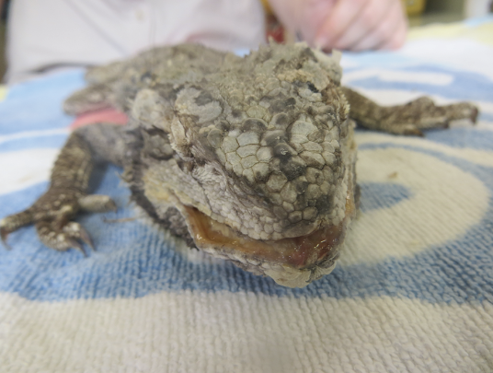
Figure 1.7: Blue tongue lizard with head trauma. Photo credit: Zoos Victoria
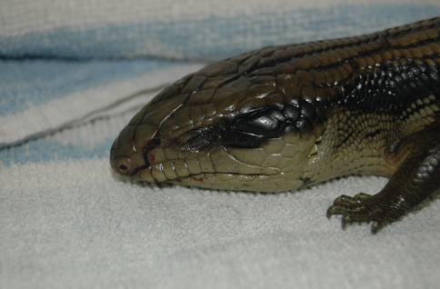

1.5.4. Administering treatment
- Oral medication can be delivered by opening the mouth of the skink or dragon using a tongue depressor or guitar pick. For lace monitors, it is preferable to place the medication in a food item as it is dangerous to attempt to open a lace monitor’s mouth.
- If an injectable agent is required, the needle should be inserted between scales. Do not attempt to inject through scales as they are too hard and will blunt or bend the needle.
- Injections can be given in a back leg or front leg. If administering regular injections, the injection site should be recorded and rotated at each treatment, so as not to repeatedly inject in the same limb each time.

1.6. Housing
Below are several key considerations when housing lizards in care.

1.6.1. General housing information for lizards
All lizards should be housed within their ‘preferred body temperature zone’ (PBTZ) during their time in care (see Table 1.6).
Intensive and intermediate housing are identical and should be used for all sick and growing lizards. Pre-release housing is not always necessary as most small lizard species can be moved from an intensive/intermediate enclosure directly to the release site.

1.6.2. Enclosure hygiene and biosecurity
General information about hygiene and biosecurity can be found in Part A of these guidelines. New diseases emerge frequently and sick and injured animals in care are often more susceptible to picking up pathogens from the environment. It is important to maintain the highest levels of hygiene and biosecurity to avoid inadvertently transferring diseases between animals and from humans, and to protect the wild population where the animal will eventually return to.

Species specific considerations:
- Wash hands with soap and water after handling lizards to minimise the risk of infection with zoonotic disease agents such as Salmonella.
- Ideally examination gloves should be worn and changed between handling each animal.
- Left-over food and faecal matter should be spot cleaned daily from enclosures to ensure good levels of hygiene are maintained.
- Enclosures used to house sick/injured lizards, should be cleaned and disinfected between inhabitants.
- Substrate should be completely replaced and furniture, such as branches or boxes made of unsealed wood, should be discarded as they cannot be effectively disinfected.
- Enclosures should be cleaned with hot soapy water and then disinfected with products such as F10 SC or bleach, used at appropriate concentrations and contact times. If using bleach, it must be thoroughly rinsed before returning the lizard to the enclosure.

1.6.3. Housing types
Different set ups are required for animals at different stages of treatment and care. Table 1.5 describes the housing type, suggested dimensions and requirements at each stage of care. Juvenile lizards have the same requirements as adults.
Table 1.5: Rehabilitation housing for adult lizards
Intensive care and intermediate housing
Indications for use | Suggested min. dimensions | Suggested requirements
Intensive veterinary treatment – frequent medication, oxygen supplementation, temperature control.  Provision of daily medication, close monitoring once animal is stabilised and no longer requires intensive care. | Jacky lizard:  Enclosure:  0.30 x 0.17 m (0.05 m²) x 0.30 m  Blue tongue lizard, bearded dragon, water dragon, shingle backs:  Enclosure:  0.60 x 0.30 m (0.18 m²) x 0.60 m  Lace monitor:  Enclosure:  2 x 1 m (2 m²)  x 1 m | ENCLOSURE CONSTRUCTION  - Glass fish tanks can be used but wooden enclosures or marine ply are preferred as they retain more heat. Polystyrene sheets can be used to increase thermal properties of glass tanks. Lace monitors may be housed outside. Solid walls to a height of at least 1.2 m, constructed of tin or wooden panels, are required to prevent damage to the nose by the lace monitor pushing against the wire or attempting to climb the wire.  ENCLOSURE FURNISHING  - Newspaper provides suitable flooring for short-term housing. Coco peat, bark, grasses or leaf mulch are used for longer term housing and will also provide enrichment. Sand should be avoided as accidental ingestion can cause impaction. Substrate for lace monitors may be leaf mulch or earth. It should be replaced when soiled.  - A natural rock may be placed in the enclosure to provide a surface for climbing and basking. The lizard may use the rock to rub against while shedding. All lizards need a place to hide. Cardboard boxes are suitable as hides as they are cheap and disposable (which helps avoid disease transmission between animals). Branches or perching material should be provided for lace monitors.  ENVIRONMENTAL VARIABLES  - A 12-hour day/night light cycle should be provided with a full-spectrum basking light, or a combination of lamps to provide both visible and UV light. These should be replaced as per the manufacturer’s guidelines. This is important as the UV degrades over time. UV meters are available commercially to measure UV output. Nothing should be positioned between the lizard and the light source. Glass and most plastics filter out UV light, while metal mesh decreases the amount of UV light that reaches the lizard by 30–50%.  - Ceramic heat lamps or heat globes may be used. Be aware that some products are designed to provide light, rather than heat, and vice versa. The heat lamp should be placed at one end of the enclosure to provide a gradient of heat across the enclosure, allowing the lizard to regulate its body temperature by moving through the gradient. A thermostat can be linked to the heater to regulate the temperature, but should not be solely relied upon to provide accurate temperatures as they can be prone to error. A thermometer should be used to monitor the heating that is provided. Ideally one thermometer should be placed at each end of the enclosure to accurately assess the temperature gradient.  PROVISION OF FOOD/WATER  - A wide, shallow water bowl should be provided.

Pre-release
Indications for use | Suggested min. dimensions | Suggested requirements
No longer require regular handling/medication.  Development of fitness/strength prior to release.  Monitoring/assessment of behaviour (foraging, digging, nest building).  Pre-release assessment. | Jacky lizard, Blue tongue lizard, bearded dragon, water dragon, shingle backs:  Enclosure:  1 x 1 m (1 m²) x 1 m. Increase floor area for each additional animal: 0.5 m²  Lace monitor:  Enclosure:  3.0 x 1.5 m (4.5 m²) x 2.0 m. Increase floor area for each additional animal: 2.0 m² | ENCLOSURE CONSTRUCTION  - Glass fish tanks can be used but wooden enclosures or marine ply are preferred as they retain more heat. Polystyrene sheets can be used to increase thermal properties of glass tanks. Lace monitors may be housed outside. Solid walls to a height of at least 1.2 m, constructed of tin or wooden panels, are required to prevent damage to the nose by the lace monitor pushing against the wire or attempting to climb the wire.  ENCLOSURE FURNISHING  - Newspaper provides suitable flooring for short-term housing. Coco peat, bark, grasses or leaf mulch are used for longer term housing and will also provide enrichment. Sand should be avoided as accidental ingestion can cause impaction. Substrate for lace monitors may be leaf mulch or earth. It should be replaced when soiled.  - A natural rock may be placed in the enclosure to provide a surface for climbing and basking. The lizard may use the rock to rub against while shedding. All lizards need a place to hide. Cardboard boxes are suitable as hides as they are cheap and disposable (which helps avoid disease transmission between animals). Branches or perching material should be provided for lace monitors.  ENVIRONMENTAL VARIABLES  - A 12-hour day/night light cycle should be provided with a full-spectrum basking light, or a combination of lamps to provide both visible and UV light. These should be replaced as per the manufacturer’s guidelines. This is important as the UV degrades over time. UV meters are available commercially to measure UV output. Nothing should be positioned between the lizard and the light source. Glass and most plastics filter out UV light, while metal mesh decreases the amount of UV light that reaches the lizard by 30–50%.  - Ceramic heat lamps or heat globes may be used. Be aware that some products are designed to provide light, rather than heat, and vice versa. The heat lamp should be placed at one end of the enclosure to provide a gradient of heat across the enclosure, allowing the lizard to regulate its body temperature by moving through the gradient. A thermostat can be linked to the heater to regulate the temperature, but should not be solely relied upon to provide accurate temperatures as they can be prone to error. A thermometer should be used to monitor the heating that is provided. Ideally one thermometer should be placed at each end of the enclosure to accurately assess the temperature gradient.  PROVISION OF FOOD/WATER  - A wide, shallow water bowl should be provided.
Table 1.6: Preferred body temperature zone (PBTZ) and basking temperatures for lizards
Species | PBTZ (°C) | Basking temp (°C)
Jacky lizard | 25–32 | 35–40
Blue tongue lizard | 28–32 | 30–40
Shingleback lizard | 28–32 | 35–40
Bearded dragon | 28–36 | 35–40
Eastern water dragon | 25–35 | 32–40
Lace monitor | 22–28 | 45

Figure 1.8: a. Shows the cage furniture for a jacky lizard. A cardboard box is used as a hide and a rough rock is present to assist with shedding. Note the thermometer placed on the back wall. b. A cardboard box is used as a hide in a kimani incubator. Note the wide, shallow water bowl. Photo credit: Anne Fowler (a) and Andrea Bromley (b)
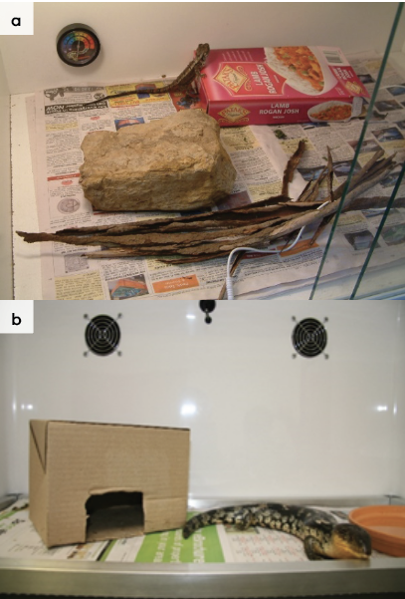
Figure 1.9: a. Enclosure for an eastern blue tongue lizard. b. A solid-walled enclosure used to house a lace monitor. Note branches for climbing up to the heat lamps. Photo credit: Zoos Victoria (a) and Andrea Bromley (b)
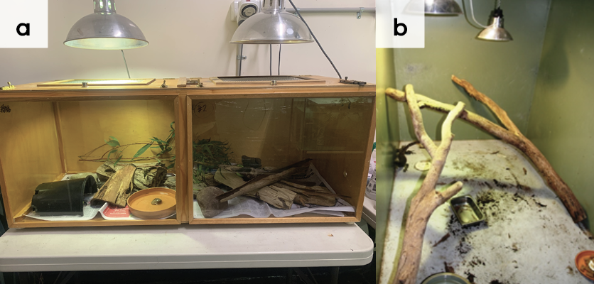

1.7. Feeding and nutrition
Keeping daily records of food offered (item and volume fed) and food consumed is good practice and will allow the rehabilitator to observe how an animal is responding to food on offer and inform future choices.
Please note: Food suppliers and specific products mentioned in these guidelines are intended as examples only. Other suitable products may also be available.
This section refers to feeding and nutrition of lizards in rehabilitation.
Juvenile lizards have the same feeding requirements as adults.
STOP – Please refer to your authorisation for mandatory conditions regarding live feeding.
Table 1.7: Feeding and diet guide for lizards during rehabilitation
 | Captive diet | Feeding frequency
Eastern blue tongue lizard | Invertebrates*: snails, slugs, mealworms, cockroaches  Vegetable mix#  Small mice | 5–10% of body weight. Feed daily if recovering from burns. Feed every two to three days if growing, sick or injured. Otherwise, adults are fed three times a week in summer, twice a week in autumn/spring and once a week in winter unless they are cooled down for brumation. Unwell lizards should not be allowed to brumate as healing cannot occur outside of their PBTZ.
Blotched blue tongue lizard | Invertebrates: snails, slugs  Vegetable mix  Small mice
Shingleback lizard | Invertebrates: snails, slugs, mealworms  Vegetable mix  Small mice
Lace monitor | Meat, mice, rats, young chickens
Eastern bearded dragon | Invertebrates: mealworms, crickets, cockroaches, moths, snails, earthworms  Pinkie mice
Eastern water dragon | Invertebrates: mealworms, crickets, cockroaches, moths, snails  Mice, rats
Jacky lizard | Invertebrates: mealworms, crickets, cockroaches
Unsuitable foods | - A fruit-only diet in dragons due to the risk of stomatitis.  - Commercially available bearded dragon pellets as they are not recognised as food by wild lizards.  - Canned and dry dog and cat food as they have high protein levels that may lead to kidney disease.  - Restrict mealworm quantity as they are high in fat and can cause gut impaction in dragon species.
Emergency foods | Hills a/d or Wombaroo Reptile Supplement mixed into a slurry with warm water. Oxbow Critical Care for skinks and bearded dragons.
* All insects should be offered Wombaroo Insect booster or Vetafarm Herpagrub for at least two to three days and preferably for seven to 14 days before being fed to ensure that they are high in nutritional value. Invertebrates should additionally be dusted with a calcium carbonate powder, or commercially available reptile specific vitamin supplement from a pet shop.
# See Table 1.8 for lizard vegetable mix composition. 10 g Wombaroo Reptile supplement should be mixed through 50 g vegetables. A small number of mealworms can be added to the mix to stimulate eating due to their movement. Items such as celery, lettuce, cos lettuce and corn are rarely fed because of their high water content and low nutritional value. Beetroot, spinach and silver beet can bind calcium, preventing its absorption from the gut, while brassicas such as broccoli and cauliflower are goitrogenic and can interfere with thyroid function.
Table 1.8: Lizard vegetable mix
VEGETABLES
Grated or finely chopped, should make up 5–15% of the mix (% by weight)
STAPLE | OCCASIONAL | RARELY/NEVER
Pumpkin, squash, parsnip, snap peas, green beans, okra, prickly pear | Carrot, capsicum, zucchini, sweet potato, tomatoes | Beetroot, broccoli, cauliflower, celery, silver beet, sweet corn, celeriac
LEAFY GREEN VEGETABLES
Chopped and shredded, should make up 85–95% of the mix (% by weight)
STAPLE | OCCASIONAL | RARELY/NEVER
Endive, chicory, escarole, watercress, dandelion greens/flowers, milk thistle, mustard greens, turnip greens | Alfalfa | Lettuce, cos lettuce, bok choy, Chinese cabbage
Figure 1.10: Lizard vegetable mix and crickets. Photo credit: Zoos Victoria
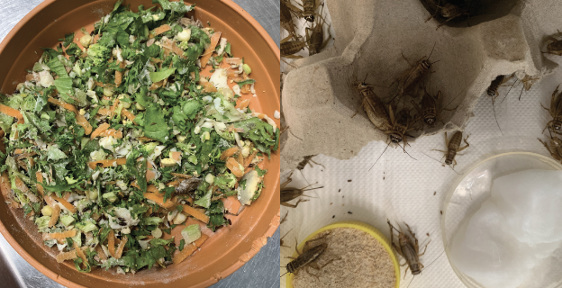
Figure 1.11: Feeding lizard from a spoon. Photo credit: Zoos Victoria
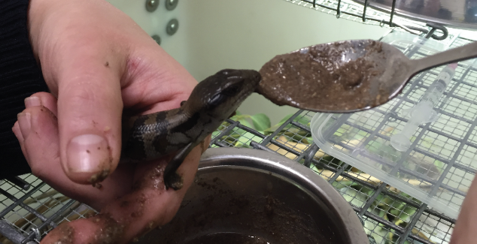

1.8. Release protocol
Ideally, wild animals will be rehabilitated and released in a short timeframe. If this is not possible and the animal is in care for significant extended periods, ensure that the animal is regularly assessed against the five welfare domains to support decision-making. Animals in care for extended periods may have a reduced ability to survive in the wild. Talk to your veterinarian and consider whether euthanasia will provide the best welfare outcome for such individuals.

1.8.1. Pre-release assessment
Pre-release assessment of animals in care is essential to support improved outcomes once back in the wild. Animals should be assessed based on body condition, fitness and the ability to engage in natural species-specific behaviours prior to release.
The following check list should be used to guide decision-making regarding release suitability for lizards:
- Lizard is in a state of good health – presenting injury/sickness is completely resolved (consider a pre-release veterinary check).
- Lizard is within a healthy weight range and appropriate body condition (refer to Table 1.1).
- Lizard displays ability to actively forage for and consume natural foods.
- Arboreal lizards can climb branches.

1.8.2. At the release site
Post release survival will be maximised by ensuring that both the release site and the way in which the animal is released are carefully considered.
Lizards require the following:
- A supply of invertebrates and food plants.
- A variety of shelters, such as rocks, fallen wood, small caves or bushes.
For more information on the ecological characteristics and requirements of lizards that may help with their release, please refer to Table 1.1.

1.8.3. Release checklist
Check all of the requirements of your authorisation are being met, and consider the following:

Release location
- Release where the lizard was found. If the site no longer provides sufficient food, water or shelter, the lizard can be released at a nearby location within its home range.
- Suitable vegetation is available, including grasses and dense lower story vegetation.
- Ample foraging areas.

Release Procedure
- Limit the number of people at the release.
- Appropriate timing: Lizards should be released during the warmest time of the day, when the weather forecast temperatures are expected to be at or above 20°C for at least three days.
- Open transport container near dense cover, ensuring that people are standing behind the animal’s flight zone.
- Allow the lizard to leave in its own time.
- Place the lizard on the ground and walk away.

1.9. Key references and additional reading
Cogger, H.G. 2018. Reptiles and amphibians of Australia, 7th Edition. Reed New Holland.
King, D., and Green, B. 1999. Goannas: The Biology of Varanid Lizards, 2nd Edition. UNSW Press.
Robertson, P., and Coventry, A.J. 2019. Reptiles of Victoria. CSIRO Publishing.
Swan, M. 2008. Keeping and Breeding Australian Lizards. Mike Swan Herp. Books.
Swanson, S. 2017. Field guide to Australian reptiles, 3rd Edition. Steve Parish Publishing.
Wilson, S., and Swan, G. 2017. A complete guide to the reptiles of Australia, 5th Edition. Reed New Holland.

