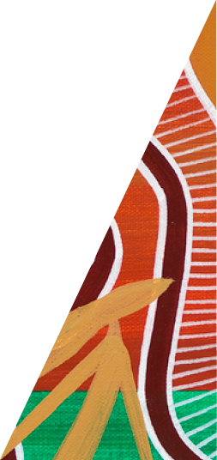Guidance Note for managing kangaroos in Victoria's growth areas

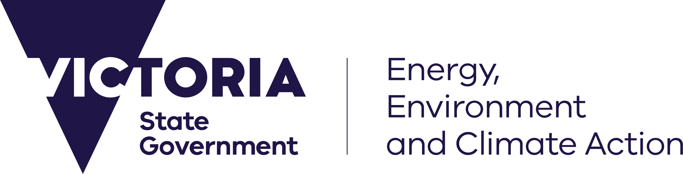



deeca.vic.gov.au

Author

This Guidance Note has been developed by the Department of Energy, Environment and Climate Actions, Biodiversity Division in consultation with the Conservation Regulator and Department of Energy, Environment and Climate Action Regions.



We acknowledge and respect Victorian Traditional Owners as the original custodians of Victoria’s land and waters, their unique ability to care for Country and deep spiritual connection to it.

We honour Elders past and present whose knowledge and wisdom   
has ensured the continuation of culture and traditional practices.

DEECA is committed to genuinely partnering with Victorian Traditional Owners and Victoria’s Aboriginal community to progress their aspirations.

© The State of Victoria Department of Energy, Environment and Climate Action September 2024.

Creative Commons

This work is licensed under a Creative Commons Attribution 4.0 International licence, visit the [Creative Commons website](http://creativecommons.org/licenses/by/4.0/) (<http://creativecommons.org/licenses/by/4.0/>).

You are free to re-use the work under that licence, on the condition that you credit the State of Victoria as author. The licence does not apply to any images, photographs or branding, including the Victorian Coat of Arms, and the Victorian Government and Department logos.

ISBN 978-1-76136-763-2 **(pdf/online/MS word)**

Disclaimer

This publication may be of assistance to you but the State of Victoria and its employees do not guarantee that the publication is without flaw of any kind or is wholly appropriate for your particular purposes and therefore disclaims all liability for any error, loss or other consequence which may arise from you relying on any information in this publication.

Accessibility

To receive this document in an alternative format, phone the Customer Service Centre on 136 186, email [customer.service@delwp.vic.gov.au](mailto:customer.service@delwp.vic.gov.au), or contact National Relay Service on 133 677. Available at [DEECA website](http://www.deeca.vic.gov.au/) (www.deeca.vic.gov.au).

Contents

1. Introduction 2

1.1 Purpose 2

1.2 What are Peri urban development areas? 2

1.3 What is a Kangaroo Management Plan 3

1.4 Landowner responsibilities 3

2. Assessing Risk and Options Analysis 4

2.1 Population surveys 4

2.2 Consideration of constraints and hazards 5

3. Management options 5

3.1 Linear Corridors and Habitat Connectivity 5

3.2 Staging of development 5

3.3 Fencing 7

3.4 Traffic management 7

3.5 Site induction 7

3.6 Water and forage removal 8

3.7 Destruction 8

3.8 Fertility control 8

3.9 Translocation 9

3.10 In-situ management of a sustainable population 9

4. Suggested reading 11

Appendix 1 - Determining sustainable population limits 13

# 1. Introduction

## 1.1 Purpose

This document provides guidance to landowners, ecological consultants, and Councils to assist with understanding the complexities of kangaroo management and ensuring that animal welfare and human safety are protected. It also provides guidance on the development of kangaroo management plans. The information provided in this document is for guidance only and does not form part of any enforceable conditions. The guidance complements other existing guidance material including:

* [Wildlife Management Methods: Kangaroos and Wallabies](https://content.vic.gov.au/sites/default/files/2021-01/Kangaroos-and-Wallabies-Wildlife-Management-methods_2018a.docx) and
* the Conservation Regulator’s wildlife management plan guidance [Preparing a Wildlife Management Plan](https://content.vic.gov.au/sites/default/files/2023-12/Wildlife-Management-Plan-guide-FA01-booklet-.pdf) – which provides guidance on preparing wildlife management plans when they are required by the Conservation Regulator. Wildlife management plans may be required to support an Authority to Control Wildlife (ATCW) permit or other *Wildlife Act 1975* (Wildlife Act) authorisation application (such as management or conservation authorisations).

## 1.2 What are Peri urban development areas?

Peri urban development areas are areas of land on the fringes of metropolitan and regional cities that have been designated for large-scale change from natural and rural uses to urban land use. These areas provide habitat for kangaroos with open grassy areas for foraging and shrubby, or tree covered areas for shelter. Development reduces both the area and the quality of these habitat.

#### Home Range and Site Fidelity

Kangaroos are strongly attached to their home range and are reluctant to vacate an area. This can become problematic when land within their home range is subject to development, and they need to disperse to other adjacent areas. If those areas already have resident kangaroos, the overall population density can increase rapidly.

While kangaroos may extend their range into nearby areas, it is uncommon for kangaroos to move entirely out of their home range, even when development is occurring. This can result in kangaroos becoming landlocked (i.e. trapped on all sides by development and other barriers), particularly when planning has not considered the risk or management of resident kangaroo populations as development occurs. Displacement and landlocking of kangaroos cause adverse animal welfare and human safety issues.

#### Animal welfare

A range of impacts on the welfare of kangaroos can arise because of poor planning and management including:

* starvation due to reduced food sources and overcrowding of kangaroos
* stress-related diseases such as Coccidiosis, Lumpy Jaw Disease and Myopathy
* pain and suffering caused by injuries resulting from human activities such as vehicle collisions, dog attacks and illegal hunting
* loss of natural behaviours due to dependence on people for food as an adverse outcome of feeding wild kangaroos leading to increased risk of dog attacks and negative interactions with humans.

#### Human safety

Vehicle accidents due to collisions or near-misses with kangaroos are the most common kangaroo-related risk to public safety. Collisions can result in death, trauma, or injury to the occupants of vehicles, and are particularly dangerous for motorcyclists. Growth area development results in more roads and increased traffic, leading to a greater risk of collisions with kangaroos.

Although rare, kangaroos can also pose a safety risk to people on foot as they have strong kicks, claws, and bites which they may use to defend themselves if they are startled or feel threatened, are protecting young, or are engaged in courtship or fighting behaviours. Risk may be higher where kangaroos are accustomed to people.

## 1.3 What is a Kangaroo Management Plan

A Kangaroo Management Plan (KMP) is developed to address risks associated with kangaroos where they are impacted (e.g. displacement, landlocked) by urban development. A KMP should contain information about the population, context, objectives for kangaroo management, an analysis of management options and specified management actions required to manage risks to animal welfare and human safety.

In peri urban development areas, some situations require a planning permit for subdivision which may be issued with a condition requiring a KMP to be prepared prior to any development commencing. The authorities responsible for issuing planning permits, (e.g., local councils) decide whether a KMP is required for the purpose of the *Planning and Environment Act 1987*.

#### Regulatory context

Land within Melbourne Strategic Assessment (MSA) area may have a requirement for the development of a KMP in the schedule to the Urban Growth Zone for certain precincts. The KMP is typically developed during the Precinct Structure Planning Process.

For areas outside of the MSA, Councils can add a condition on any planning permit issued that requires the development of a KMP. This will be at the discretion of council as there is no automatic trigger to require the development of a plan.

Where the implementation of a KMP would include active management of kangaroos, such as fertility control, herding, translocation or lethal control an ATCW is required under the Wildlife Act. Refer to [*https://www.vic.gov.au/wildlife-management-and-control-authorisations*](https://www.vic.gov.au/wildlife-management-and-control-authorisations)for more detail on this process. The Conservation Regulator has specific guidance for wildlife management plans that can be used to ensure that one KMP can meet planning and Wildlife Act requirements: [www.vic.gov.au/preparing-wildlife-management-plan](https://www.vic.gov.au/preparing-wildlife-management-plan).

Once a KMP has been prepared, the responsible authority should be contacted to confirm that the plan also meets the needs of any planning permit requirements.

The structure and content of a KMP will depend on the context of the proposed development. While this document does not include a template plan it does set out the minimum information requirements to allow the responsible authority to evaluate the proposed kangaroo management actions.

A KMP should be prepared by a suitably qualified, ecologist and as a minimum include:

* introduction/ executive summary
* a clear statement of the KMP’s purpose and objectives, including the desired end point of kangaroo management
* site information including a description of the land (with mapping) that the KMP applies to, and the broader landscape context, including protective habitat, corridors and hazards to kangaroos
* kangaroo population size, as well as composition and condition where appropriate
* risks to the welfare of the resident kangaroo population (e.g., habitat loss, starvation, disease, roadkill)
* site specific management requirements (e.g., threatened flora and fauna requiring extra protection)
* analysis of appropriate potential kangaroo management options
* proposed kangaroo management action with reasons stated
* risk management plan to eliminate or reduce risks to kangaroos and people
* engagement and communication plan for local community members, developers, and other stakeholders
* monitoring of actions and adaptation of management in response to triggers, adverse events, and unforeseen outcomes.

## 1.4 Landowner responsibilities

Planning for kangaroo management early in the development process is critical to ensure thorough evaluation of all available management options and positive kangaroo welfare outcomes.

The Wildlife Actis the primary legislation for the protection and management of wildlife in Victoria. All wildlife in Victoria, including kangaroos, are protected under the Act. It is illegal to wilfully disturb, control, or destroy kangaroos without prior approval from the Department of Energy, Environment and Climate Action’s (DEECA) Conservation Regulator.

The *Prevention of Cruelty to Animals Act 1986* is the primary legislation regulating the treatment of animals in Victoria. Under this Act, it is an offence to undertake actions that cause, or are likely to cause, unreasonable pain or suffering to any animals, including kangaroos.

Landowners are responsible for managing risks caused by wildlife on their land and for ensuring land use change does not contravene the Wildlife Actand *Prevention of Cruelty to Animals Act 1986*. Where kangaroos occupy undeveloped land in an urbanising landscape, it is the landowner's responsibility to ensure the welfare of kangaroos is not compromised.

Landowners may apply for an ATCW under the Wildlife Actto wilfully disturb, control or destroy kangaroos. Further detail on the ATCW process can be found at <https://www.vic.gov.au/wildlife-management-and-control-authorisations>.

A wildlife management plan may be required for application for an ATCW. More information about KMP’s is provided in section 1.3 above.

# 2. Assessing Risk and Options Analysis

Landowners are responsible for assessing the risks of development that may cause adverse animal welfare and human safety outcomes. Responsible and referral authorities (Councils, DEECA) can be consulted in advance to provide advice on consideration for kangaroos. If the KMP proposes disturbing kangaroos, DEECA’s Conservation Regulator should be consulted early in the planning process to provide advice. Local councils should be consulted to provide advice on any requirements under the *Planning and Environment Act 1987*.

In urban growth areas where kangaroos are present in the landscape, an ecologist with appropriate expertise should be engaged to assess risk. The ecologist should assess risks based on population survey results and the potential of future development to restrict movement to that population or cause hazards to the kangaroos or human safety by forcing dispersal into an urban environment. A full and transparent analysis of all management options should be presented with the application, with the recommended approach clearly outlined, to the responsible authority. This will give the landowner and decision-maker confidence that all risks have been identified in endorsing the recommended approach.

## 2.1 Population surveys

The area for population surveys should cover:

* the area for which the planning permit application is being made
* land extending for 1 km in all directions beyond the boundary of the permit application area, including parks, reserves, conservation areas, easements, and other green space.

First the ecologist should conduct a presence/absence survey on land extending 1 km in all directions beyond the boundary of the proposed development to establish if there are kangaroos currently in the survey area. This can be based on direct (i.e. sightings) and indirect (e.g. faeces and skeletal remains) evidence, as well as third-party (e.g. VicRoads) sources.

If kangaroos are or have been present, the ecologist should determine the most suitable population survey method(s) given the site constraints in the survey area. Four survey methods are considered best practice for kangaroos as described in the [*Handbook of macropod survey methods*](https://onlinelibrary.wiley.com/action/downloadSupplement?doi=10.1111%2Femr.12485&file=emr12485-sup-0003-SupInfo.pdf):

* Direct count.
* Sweep count.
* Faecal accumulation rate.
* Distance sampling.

The ecologist should then conduct replicate surveys to determine population size and report the accuracy and precision of the survey results.

The ecologist may also compile observations on the following aspects of the behaviour and welfare of the kangaroos:

* The apparent daily pattern of space and habitat use.
* The sex and age composition of the population.
* The reproductive status of females.
* Evidence of disease, such as lumpy jaw and Phalaris staggers.

## 2.2 Consideration of constraints and hazards

The assessment of risk should consider existing and future constraints to kangaroo movement and occupation, as well as any other hazards that may be caused by the proposed development and any potential future development within the surrounding area.

Factors that should be considered include:

* the extent that kangaroos are currently constrained to (landlocked within) an undeveloped area. This will be informed by site context and population surveys
* existing and future development based on subdivision approvals and the future urban structure shown in precinct structure plans
* existing and future fences
* existing and future roads
* other existing and future physical barriers
* connected areas of suitable kangaroo habitat
* removal of protective habitat.

# 3. Management options

Any wildlife management must have clear objectives and rationale. The objectives should articulate the aim for kangaroos at the site and consider the long-term viability or management of the kangaroo population. Potential options to manage animal welfare and human safety risks associated with the displacement and landlocking of kangaroos are outlined below. The pros and cons of each management method must be considered, and their contribution to management objectives demonstrated.

## 3.1 Linear Corridors and Habitat Connectivity

Large-scale movement of kangaroos is rare and largely constrained by infrastructure development in an urbanising landscape. There is no research-base or credible anecdotal evidence that EKG will use nominated linear corridors to transition out of a development site in an urban area. Rather, research-based evidence on home-range and site fidelity indicates that, except for dispersing males, kangaroos are unlikely to use a nominated linear corridor (e.g. creek line, powerline easement) to move to suitable but unfamiliar habitat. Furthermore, in growth areas of Victoria where kangaroos are present in the landscape, suitable habitat is likely to be already occupied by kangaroos. In urban settings, nominating linear movement corridors is not an effective management approach on its own, but can be effective in combination with retention of kangaroo habitat and ongoing kangaroo management in retained conservation reserves. See also [3.10 In-situ management of a sustainable population](bookmark://_3.10_In-situ_management).

## 3.2 Staging of development

Where kangaroos are present in the landscape in growth areas or an urban /rural interface, development should be sequenced to minimise the risk of kangaroos becoming landlocked. To achieve this, staged development plans should be informed by an assessment of risk to animal welfare and human safety, as outlined in Section 2, by a suitably qualified ecologist.

Staged development is beneficial as it is a non-lethal technique and indirect management method. However, experience shows that some kangaroos attempt to return to their home site which creates potential for poor animal welfare outcomes due to stress, starvation and/or injury when access to the home range and its food and/or shelter is disrupted. Displaced kangaroos may also be exposed to heightened threats in less secure habitat (e.g. vehicle strike). Within urban areas where kangaroos are landlocked (regardless of scale) to an undeveloped precinct or parcel, staged development and associated exclusion fencing is rarely appropriate as a standalone management option. It is not an available option if the kangaroos are already landlocked.

Staged development should:

* consider risk, impacts and likelihood of increasing the abundance of kangaroos in adjoining habitat areas
* ensure the development front begins from existing developed areas or roads that represent a hazard
* ensure development is sequenced towards undeveloped land or open space corridors that could provide movement paths for kangaroos
* maintain access to adjoining suitable habitat areas. Access needs to avoid hazards to kangaroos such as nearby roads, fences, gates and quarries)
* incorporate a commitment to monitoring and adaptation in a management plan, for the life of the development.

Figure 1 illustrates how staged development can be implemented at the urban growth/rural interface. It shows the development front beginning alongside existing development and a major road and progressing toward undeveloped land.

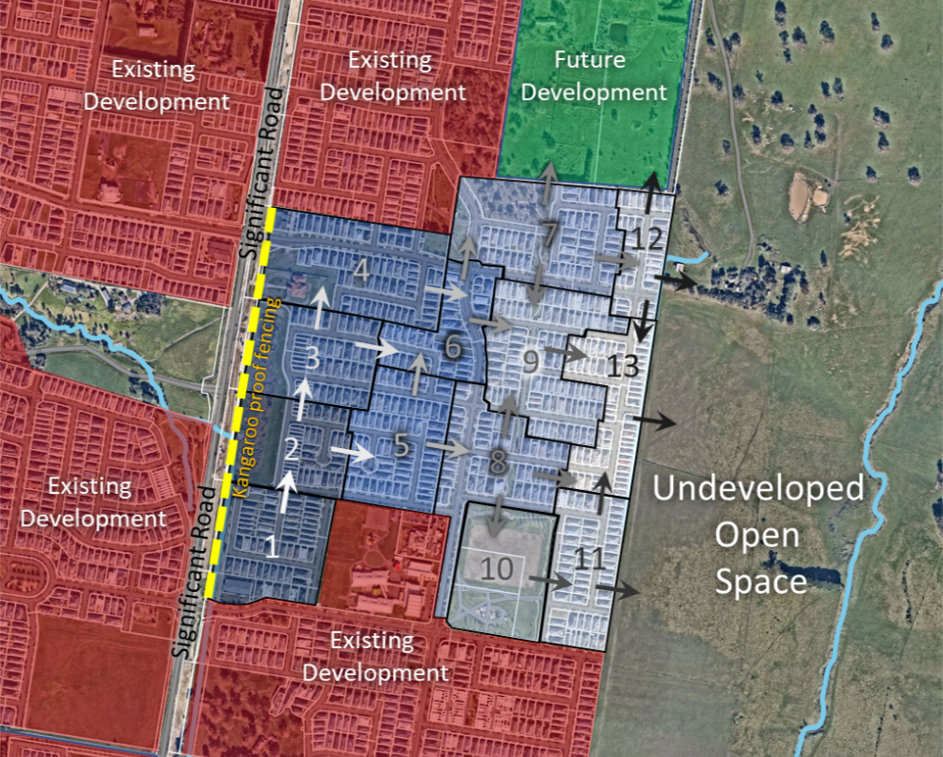

Figure 1. Example of staged development (arrows indicate potential EGK movement)

Where development is occurring or being planned on adjacent land, landowners should seek to work together, as early as possible, in the planning of development. This helps to coordinate actions to stage development across the broader area, minimising the possibility that kangaroos will become landlocked on any one property.

## 3.3 Fencing

Temporary construction fencing should be used to discourage kangaroos from entering construction sites. Fencing location and alignment should be adjusted as construction progresses and the location of hazards change.

More permanent fencing should be used where kangaroos need to be prevented from entering continued hazards such as roads.

Preventing access onto a site using exclusion fencing (tall fences with secure footings), is highly effective if designed properly – see <https://www.vic.gov.au/sites/default/files/2021-01/Kangaroos-and-Wallabies-Wildlife-Management-methods_2018a.docx>.

However, fencing is costly to install and maintain and must be monitored frequently. Kangaroos may attempt to return, pacing the site boundary and risking injury. Fencing may also disrupt the movement of other species. Kangaroos may also become confined within the property if already present during fencing construction, or if they find their way in after construction. To mitigate these possible impacts fencing should only be installed where there are no kangaroos inside the area to be fenced and there is no risk of kangaroos becoming trapped inside the fenced area. One-way gates can be useful at existing kangaroo runways through a fence, or at corners formed by the fence.

Where kangaroos are already confined (or landlocked) within an undeveloped area, exclusion fencing for roads and construction sites is generally not appropriate as a standalone management option.

## 3.4 Traffic management

To reduce the risk of vehicle collisions or near misses with kangaroos, the following should be considered where appropriate:

* Traffic management is not appropriate as a standalone management option where kangaroos are already confined (or landlocked) within an undeveloped area.
* Prior to any works commencing, installing kangaroo proof fencing along high-risk roads to prevent kangaroos being encouraged towards them (in consultation with the relevant road authority).
* Kangaroo warning signs to help inform the public about the potential presence of kangaroos (in consultation with the relevant authority).

* Internal speed limits set to 40km/h within construction areas to reduce the likelihood and severity of any collision with kangaroos.
* External speed limit changes or digital signage while collision risk is elevated on adjoining roads during construction.

## 3.5 Site induction

It is important that all onsite personnel understand what to do if they encounter a kangaroo in the construction area. To achieve this, all personnel should be provided with the following information at induction:

***If you see a kangaroo in the construction area:***

* *Let the kangaroo leave of its own accord.*
* *Don't herd the kangaroo: it is an offence under the Wildlife Act 1975. Herding can stress and confuse a kangaroo, and make it behave erratically. This can result in the kangaroo, and people, being injured.*
* *Try to identify where the kangaroo entered the construction area. Temporarily widening the entry point might encourage the kangaroo to leave through it. If the kangaroo leaves, securely close off the entry point as soon as possible.*
* *If the kangaroo is injured, or will not leave by itself, use DEECA’s Help for Injured Wildlife Tool to get the contact details of a wildlife shelter operator or vet in the area who can assist-* [*https://www.wildlife.vic.gov.au/injured-native-wildlife/help-for-injured-wildlife*](https://www.wildlife.vic.gov.au/injured-native-wildlife/help-for-injured-wildlife)*.*
* *If a kangaroo is injured or killed in a construction area the Department of Energy Environment and Climate Action must be notified as soon as possible on 136 186.*

## 3.6 Water and forage removal

Closure of water sources or removal of food sources may be trialled first as non-lethal techniques to encourage animals to move on without having to physically disturb them.

Removal of forage mimics the effects of natural density-dependent competition among kangaroos. However, removal of forage will not immediately reduce population size, and kangaroos seeking alternative food supply may become exposed to heightened threats in less secure habitat and may cause risks for other people in the community. Any removal of forage must consider application of the *Prevention of Cruelty to Animals Act 1986*, and ensure the kangaroos are not wholly or largely dependent on that food source.

Closure of water sources is only likely to be effective in hot summer weather because kangaroos meet their water needs from plant tissue and precipitation most of the time. Kangaroos seeking alternative water sources may lead to animal welfare issues or human safety risks elsewhere. Any closure of water sources must consider application of the *Prevention of Cruelty to Animals Act 1986* and ensure the kangaroos are not wholly dependent on the water source in summer.

## 3.7 Destruction

Land managers must exhaust all practical non-lethal control options before applying for an ATCW for lethal control, which is a last resort. An ATCW is an authorisation issued under section 28A or section 28A(1A) of the [Wildlife Act](https://www.legislation.vic.gov.au/in-force/acts/wildlife-act-1975/126). They are administered by the Conservation Regulator.

The Conservation Regulator undertakes a rigorous assessment of all ATCW applications to ensure that they meet the requirements of the Wildlife Act. In considering an application, the Conservation Regulator needs to be assured that there has been adequate assessment of the management options available and that any authorised control is consistent with the requirements of the Wildlife Act. In some cases, the Conservation Regulator may seek independent expert advice or require the property owner/manager to submit a wildlife management plan to support the application.

The destruction of kangaroos should only be considered where a rigorous assessment has determined that alternative options will not work or are not acceptable (e.g. due to animal welfare impacts). The detrimental health and welfare issues caused by the ongoing impacts of leaving kangaroos in a landlocked situation long term may necessitate the destruction of the animals as a humane and ethical resolution.

Destruction will immediately reduce kangaroo population size and is humane when conducted in accordance with the National Code of Practice for the Humane Shooting of Kangaroos and Wallabies for Non-Commercial Purposes. Destruction of kangaroos under an ATCW must meet the listed permit conditions and comply with all other relevant legislation including the *Firearms Act 1996* and the *Prevention of Cruelty to Animals Act 1986.*

Information about ATCWs and how to apply is available at <https://www.vic.gov.au/wildlife-management-and-control-authorisations>.

## 3.8 Fertility control

Fertility control of kangaroos requires capture on site, treatment with a contraceptive agent and then release back on to site. It is technically challenging, costly, and requires specialist skills and equipment. It also presents significant welfare risks to the animals involved as it requires kangaroos to be captured and anaesthetised and introduces the risk of myopathy (changes in blood chemistry and necrosis of muscle tissue which may result in fatality) from the stress of being captured.

Fertility control is an ongoing management option, whereby 90% of the population must be treated repeatedly to achieve zero population growth. Any attempts at fertility control require an ATCW under the Wildlife Actfrom the Conservation Regulator.

As a stand-alone management technique, fertility control is not recommended, except in smaller, confined populations of kangaroos (e.g. in-situ retention of kangaroos in a small nature reserve) as whilst it reduces the reproductive rate of population it does not directly reduce population density and may not meet animal welfare standards. Other management options may also be necessary to reduce the population density prior to fertility control methods being employed.

## 3.9 Translocation

Translocation requires authorisation under the Wildlife Actfrom the Conservation Regulator. It involves the planned relocation of one or more kangaroos from one area to another (predetermined) area. Translocating kangaroos is technically challenging and expensive and involves capturing, sedating, handling, and transporting individuals to a suitable release site at least 10 km away.

The requirements for kangaroo translocation are specified in the [Translocation policy for isolated wild Eastern Grey Kangaroo populations in Victoria](https://www.wildlife.vic.gov.au/managing-wildlife/translocation-of-wildlife).

Any application to the Conservation Regulator for translocation of kangaroos must include a wildlife management plan in line with the Wildlife Management Plan guide and checklist and must be consistent with the Translocation policy for isolated wild EGK populations in Victoria – see <https://www.wildlife.vic.gov.au/__data/assets/pdf_file/0027/391707/Approved-EGK-Translocation-Policy_v1_2018.pdf>.

Release sites must be suitable for the future survival and welfare of the translocated kangaroos, as well as the resident kangaroos. Suitable sites can be extremely difficult to find, and the selection requires written approval from the land manager. Once relocated to the release site, kangaroos may experience dislocation, hunger and aggression from resident kangaroos. Many attempt to return to the source site, creating significant safety and welfare risks for the animals and the community while they attempt to cover significant distances to return to their home range.

Translocation carries a strong potential for stress, injury and death of kangaroos when released in an unfamiliar setting. The addition of translocated kangaroos to a release site may lead to intense competition with resident kangaroos and other herbivores, posing risks to animal welfare and biodiversity values. For these reasons, translocation of non-threatened wildlife is generally not supported by DEECA. If translocation is required it is typically only carried out for threatened species recovery programs and only then with careful planning, expert practitioners, and significant resources.

Translocation also poses risks to human safety, and biodiversity values, which must also be addressed before a translocation proposal can be considered. Translocation is technically demanding and resource intensive.

## 3.10 In-situ management of a sustainable population

In-situ management is a long-term monitoring and intervention program with the objective of maintaining a healthy, sustainable kangaroo population in perpetuity. In urban growth areas, in-situ management may be considered appropriate for some conservation reserves only. It is not an appropriate approach for development areas, regardless of scale, where kangaroo habitat will be incrementally removed.

In-situ management of kangaroos in a conservation area is considered a viable option if the land manager, in consultation with DEECA, agrees that the area can provide suitable habitat for kangaroos and can be maintained to provide for a sustainable population limit, without supplementary food and water, and that doing so will not compromise other management objectives for the area such as native vegetation quality and extent and/or threatened species habitat.

Kangaroos are managed *in situ*, where a population provides an ecosystem service, such as biomass management. In urban growth areas, this population may also be valued by the local community.  In-situ management requires long-term resource commitment to a continuous program of monitoring and intervention. To be suitable for *in situ* management, a site must:

* be capable of providing complete habitat for kangaroos up to the sustainable population limit (Appendix 1 provides detail on determining sustainable population limits)
* be in a location adequately secured to enable the undertaking of permitted population control measures
* have at least 100 ha of suitable habitat secured and managed in perpetuity (e.g. a public conservation reserve, or a private conservation reserve secured on-title)
* have edible grasses and herbs throughout the year, including during drought
* have a dependable water supply throughout the year, including during drought
* have appropriate shelter in the forms of trees and/or shrubs
* have no other grazing animals (domestic stock) present
* have no serious hazards in the vicinity (such as arterial roads or highways)
* not be used for active recreation (passive recreational use is unlikely to conflict with the presence of kangaroos)
* not be used as an off-leash dog exercise area
* not have habitat zones and/or threatened species that would be at risk from a carefully managed kangaroo population.

When determining the suitability of the site, a land manager must:

* consider the logistical, resourcing and regulatory requirements for management interventions such as lethal control, fertility control and/or translocation for genetic and threatened species conservation
* consider the context of the site within the urban landscape, and the proximity to communities
* have a long-term, funded, adaptive kangaroo habitat and health monitoring and management plan in place
* consider the long-term site design and layout, not just the current situation
* exclude active open space (such as playing fields allocated for organised outdoor sports), passive recreation trails, vehicle tracks, and buffers between major roads and open space
* consider how competing land uses (such as biodiversity and passive recreation) will reduce the actual amount of habitat available for the kangaroos
* consider adjacent and nearby kangaroo habitat and whether kangaroos can move to it.

# 4. Suggested reading

Austin, C. M. & Ramp, D. (2019). Behavioural plasticity by eastern grey kangaroos in response to human behaviour. *Animals* 9, 244.

Bacci, B., Whiteley, P. L., Barrow, M., Phillips, P. H., Dalziel, J. & El‐Hage, C. M. (2014). Chronic phalaris toxicity in eastern grey kangaroos (*Macropus giganteus*). *Australian Veterinary Journal* 92, 504-508.

Borland, D., Coulson, G. & Beveridge, I. (2011). Oral necrobacillosis (‘lumpy jaw’) in a free-ranging population of eastern grey kangaroos (*Macropus giganteus*) in Victoria. *Australian Mammalogy* 34, 29-35.

Boulet, M., Borg, K., Faulkner, N. & Smith, L. (2021). Evenly split: Exploring the highly polarized public response to the use of lethal methods to manage overabundant native wildlife in Australia. *Journal for Nature Conservation* 61, 125995.

Brandimarti, M. E., Gray, R., Silva, F. R. & Herbert, C. A. (2021). Kangaroos at maximum capacity: health assessment of free-ranging eastern grey kangaroos on a coastal headland. *Journal of Mammalogy* 102, 837-851.

Brunton, E. A., Clemente, C. J. & Burnett, S. E. (2020). Not all urban landscapes are the same: interactions between urban land use and stress in a large herbivorous mammal. *Ecological Applications* 30, e02055.

Brunton, E. A., Srivastava, S. K., Shoeman, D. S. & Burnett, S. (2018). Quantifying trends and predictors of decline in Eastern Grey Kangaroo (*Macropus giganteus*) populations in a rapidly urbanising landscape. *Pacific Conservation Biology* 24, 63-73.

Brunton, E. A., Srivastava, S. K., & Burnett, S. (2018). Spatial ecology of an urban eastern grey kangaroo (*Macropus giganteus*) population: local decline driven by kangaroo–vehicle collisions. *Wildlife Research* 45, 685-695.

Coulson, G., Cripps, J. K. & Wilson, M. E. (2014). Hopping down the main street: eastern grey kangaroos at home in an urban matrix. *Animals* 4 272-291.

Coulson, G., Snape, M. A. & Cripps, J. K. (2021). How many macropods? A manager’s guide to small‐scale population surveys of kangaroos and wallabies. *Ecological Management & Restoration* 22, 75-89.

Coulson, G. & Wilson, M. E. (2023). Implementing implants: delivery efficiency, contraceptive efficacy and population outcomes in two overabundant kangaroo populations. *Wildlife Research*, on line early.

Cowan, M., Blythman, M., Angus, J. & Gibson, L. (2020). Post-release monitoring of western grey kangaroos (*Macropus fuliginosus*) relocated from an urban development site. *Animals* 10, 1914.

Descovich, K., Tribe, A., McDonald, I. J. & Phillips, C. J. (2016). The eastern grey kangaroo: current management and future directions. *Wildlife Research* 43, 576-589.

Dunne, B.  & Doran, B. (2021). Spatio‐temporal analysis of kangaroo–vehicle collisions in Canberra, Australia. *Ecological Management & Restoration* 22, 67-70.

Gordon, I., Snape, M., Fletcher, D., Howland, B., Coulson, G., Festa‐Bianchet, M., Caley, P., McIntyre, S., Pople, T., Wimpenny, C. & Baines, G. (2021). Herbivore management for biodiversity conservation: a case study of kangaroos in the Australian Capital Territory (ACT). *Ecological Management & Restoration* 22,124-137.

Hampton, J. O. & Forsyth, D. M. (2016). An assessment of animal welfare for the culling of peri-urban kangaroos. *Wildlife Research* 43, 261-266.

Herbert, C. A., Snape, M. A., Wimpenny, C. E. & Coulson, G. (2021). Kangaroos in peri‐urban areas: A fool’s paradise? *Ecological Management & Restoration* 22, 167-175.

Hing, S., Hampton, J. O. & Gibson, T. J. (2019). Animal welfare and the killing of wildlife by captive bolt in Australia. *Australian Zoologist* 40, 170-180.

Hume, G., Brunton, E. & Burnett, S. (2019). Eastern grey kangaroo (*Macropus giganteus*) vigilance behaviour varies between human-modified and natural environments. *Animals* *9*, 494.

Jaremovic, R. V. & Croft, D. B. (1991) Social Organisation of the Eastern Grey Kangaroo (Macropodidae, Marsupialia) in Southeastern New South Wales, *Mammalia* 55, 169-186.

Kerle, A. (2019). The Eastern Grey Kangaroo: a modern conservation dilemma. *Australian Zoologist* 40, 102-117.

Maguire, G., Ramp, D. & Coulson, G. (2006). Foraging behaviour and dispersion of eastern grey kangaroos (*Macropus giganteus*) in an ideal free framework. *Journal of Zoology* 268, 261-269.

Mawson, P. R., Hampton, J. O. & Dooley, B. (2016). Subsidized commercial harvesting for cost‐effective wildlife management in urban areas: a case study with kangaroo sharpshooting. *Wildlife Society Bulletin* 40, 251-260.

McKinnon, M., Ahmad, M., Bongers, M., Chevalier, R., Telfer, I. & Van Dorssen, C. (2018). Media coverage of lethal control: A case study of kangaroo culling in the Australian Capital Territory. *Human Dimensions of Wildlife* 23, 90-99.

Moore, B. D., Coulson, G. & Way, S. (2002). Habitat selection by adult female eastern grey kangaroos. *Wildlife Research* 29, 439-445.

Ramp, D., Coulson, G. (2002) Density dependence in foraging habitat preference of eastern grey kangaroos. *Oikos* 98, 393-402.

Thompson, G. G., Thompson, S. A. & Pusey, A. (2022). Poor welfare outcomes resulting from poor management decisions in a translocation of western grey kangaroos (*Macropus fuliginosus*). *Pacific Conservation Biology* 29, 130-140.

Van Eeden, L. M., Newsome, T. M., Crowther, M. S., Dickman, C. R. & Bruskotter, J. (2019). Social identity shapes support for management of wildlife and pests. *Biological Conservation* 231, 167-173.

Wilson, M. & Coulson, G. (2021). Early warning signs of population irruptions in Eastern Grey Kangaroo (*Macropus giganteus*). *Ecological Management & Restoration* 22, 157-166.

Wilson, T. M., Park, H., Parys, S. & Rao, S. (2022). Characteristics of kangaroo-related motor vehicle crashes. *Injury* 53, 3025-3029.

Wimpenny, C., Hinds, L. A., Herbert, C. A., Wilson, M. & Coulson, G. (2021). Fertility control for managing macropods – Current approaches and future prospects. *Ecological Management & Restoration* 22, 147-156.

Zenger, K. R., Eldridge, M. D. B. & Cooper, D. W. (2003) Intraspecific variation, sex-biased dispersal and phylogeography of the eastern grey kangaroo (*Macropus giganteus*). *Heredity* 91, 153-162.

# Appendix 1 - Determining sustainable population limits

A sustainable population limit is an estimate of the number of kangaroos an area can sustain without supplementary feeding and watering, while still meeting management objectives for the area.

A sustainable population limit methodology should be used, rather than other functional models (such as ecological carrying capacity). Kangaroo management has moved away from using ecological carrying capacity (which is more suited to rural and farming areas and is based on the availability of pasture per head) to sustainable population limit (which accounts for other management objectives for animal welfare, human safety and environmental protection).

The sustainable population limit is expressed as a target density (kangaroos/ha). There is limited research on the optimum density, and variation between sites means that there will be no single density that suits all contexts. Research on grassland and grassy woodland ecosystems in the Australian Capital Territory suggests that ecosystem values can be maintained with densities below 1.0 kangaroos/ha (100/km2) in grassland. This target density is adjusted for the negative effect of tree cover on herbage biomass in other vegetation communities: 0.9/ha in open woodland, 0.5 /ha in woodland and 0.1 /ha in open forest. Considering the urban nature of growth areas, and the greater management complexity they have, a low density, 0.5 kangaroos/ha (50 kangaroos/km2) is a suitable starting density.

The starting density (up to 0.5/ha) should be determined for a KMP by considering local site conditions and context, intended outcomes for the site, and any other factors, such as if the land manager want to take a more conservative, or a more experimental, approach. If the starting density is too high, there may be animal welfare implications, or ecological values may be impacted.

Land managers must regularly (typically, twice a year or more) monitor the kangaroo population and progress towards other management objectives to ensure in-situ is achieving its goals.