Chapter 6. Macropods

Contents
6.1. Introduction 2
6.2. Species information 3
6.3. Animal and human safety considerations 13
6.3.1. Human safety considerations 13
6.3.2. Animal safety considerations 14
6.4. Capture, restraint, and transport 14
6.4.1. Visual observations 14
6.4.2. Equipment 15
6.4.3. Technique 16
6.4.4. Transport 18
6.5. Monitoring animal health and welfare 18
6.5.1. Physical examination 19
6.5.2. Ongoing monitoring of health and welfare 22
6.5.3. Common and emerging health conditions 23
6.5.4. Administering treatment during rehabilitation 32
6.6. Housing 33
6.6.1. General housing information for macropods 33
6.6.2. Enclosure hygiene & biosecurity 33
6.6.3. Housing types 34
6.7. Feeding and nutrition 39
6.8. Hand raising 40
6.8.1. Equipment required for hand raising 40
6.8.2. Growth, development and care of orphaned young 43
6.9. Release protocol 63
6.9.1. Pre-release assessment 63
6.9.2. At the release site 64
6.9.3. Release checklist 64
6.10. Key references and additional reading 65

In Victoria, sick, injured or orphaned wildlife can only be rehabilitated by a wildlife shelter operator or foster carer who is authorised under section 28A of the Victorian Wildlife Act 1975 (Wildlife Act). Wildlife rehabilitators are subject to strict conditions. The mandatory requirements that they must meet are set out in the Wildlife Shelter and Foster Carer Authorisation issued under the Wildlife Act. These conditions enforce the minimum standards required for the humane treatment and successful rehabilitation of wildlife in care. The Wildlife Rehabilitator Authorisation Guide: Things You Need To Know explains how wildlife rehabilitators can meet these mandatory requirements and can be found here:
https://www.vic.gov.au/wildlife-rehabilitation-shelters-and-foster-carers.
The Victorian Wildlife Rehabilitation Guidelines have been developed to incorporate evidenced-based best practice in wildlife care and rehabilitation to equip rehabilitators to deliver positive welfare outcomes for individual animals in their care from first aid to post-release into the wild.
You must comply with the conditions of your authorisation. These guidelines must be read in conjunction with the conditions of your authorisation.

6.1. Introduction
Macropods are the kangaroo and wallaby species. They have two incisors in the lower jaw (diprotodont), no canines and are either grazers or browsers. The second and third digits on the hind feet are fused at the base of the claws (syndactyly) but the claws themselves are separate. There are five species that commonly come into care in Victoria.
When macropods come into care it is the responsibility of the rehabilitator to ensure that the five domains of animal welfare are satisfied. These include providing optimal nutrition, and an environment appropriate to the stage of rehabilitation. The focus should be on the animal’s return to health and release, which is facilitated through regular collaboration with a veterinarian. It is also important to consider the animal’s mental state and ability to exhibit normal behaviours without detrimentally affecting its recovery. Welfare may be temporarily compromised by the necessity of a gradual return to normal activity, depending on its stage of rehabilitation. Further information about the five domains of animal welfare is in Part A of these guidelines.

6.2. Species information
Profiles for the common macropod species found in Victoria are detailed at Table 6.1. It does not describe all macropod species found in Victoria. For assistance in identification of macropod species, refer to the recommended reading and reference material at the end of this chapter.
Table 6.1: Species profiles
Species | Eastern grey kangaroo (Macropus giganteus)
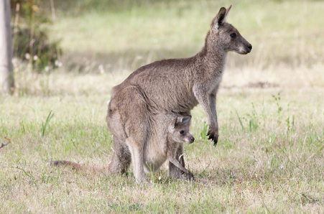  Photo credit: Rodney Start, Museums Victoria | Distribution map  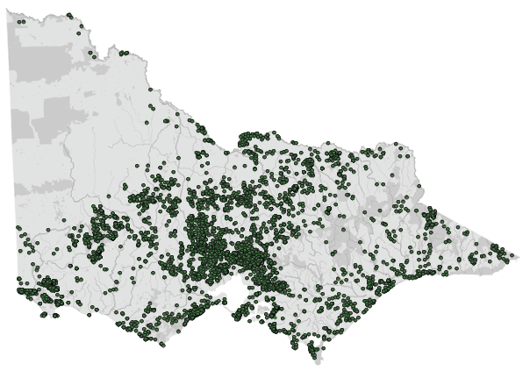  Data source: Victorian Biodiversity Atlas Jan 2023  www.environment.vic.gov.au/biodiversity/victorian-biodiversity-atlas
General appearance | Light grey with a dark eye ring
Conservation status* | Common
Sexual dimorphism | Males are up to twice the weight of females and appear more muscular in the chest and forearms
Adult morphometrics | Body weight: Males: 19–89 kg. Females: 17–42 kg  Head and body length: Males: 972–2302 mm.  Females: 958–1857 mm  Tail length: Males: 430–1090 mm. Females: 446–842 mm
Habitat | Grassland with adjacent cover, farmland
Home range | 30–160 ha
Behaviour | Active at dusk, mobs
Diet | Grazer. Grasses comprise up to 99% of the diet
Longevity | 6–20 years
Sexual maturity | Male: 18–48 months  Female: 18–21 months
Mating season | Year-round
Oestrus cycle | 36–55 days
Gestation length | 34–38 days
Litters per year | 1 litter of 1 per year
Weaning | 15–18 months
Young dispersal | 15–18 months

Species | Red kangaroo (Osphranter rufus)
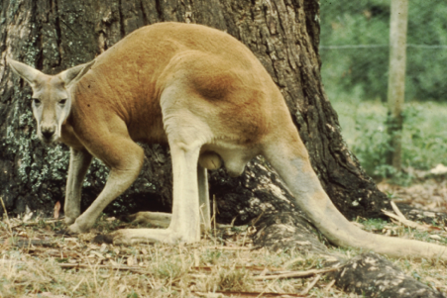  Photo credit: Zoos Victoria | Distribution map  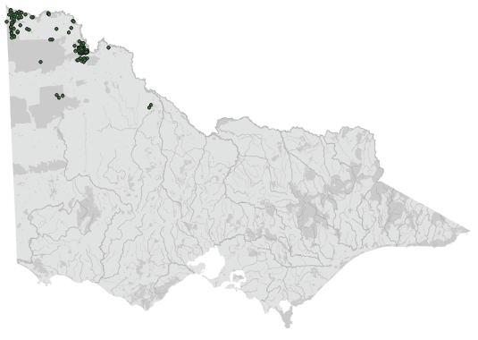  Data source: Victorian Biodiversity Atlas Jan 2023  www.environment.vic.gov.au/biodiversity/victorian-biodiversity-atlas
General appearance | White markings on face, square jaw
Conservation status* | Common
Sexual dimorphism | Males are up to twice the weight of females. They appear red above while the females are blue grey. Both sexes are white underneath
Adult morphometrics | Body weight: Males: 22–92 kg. Females: 17–39 kg  Head and body length: Males: 935–1400 mm.  Females: 745–1100 mm  Tail length: Males: 710–1000 mm. Females: 645–900 mm
Habitat | Scrub, Mallee, open woodland
Home range | 2.5–5 km²  250–500 ha
Behaviour | Active at dusk, mobs
Diet | Grazer consuming predominantly grasses and forbs
Longevity | 8–12 years
Sexual maturity | Male: 20–36 months  Female: 14–20 months
Mating season | Year round
Oestrus cycle | 34–35 days
Gestation length | 33–38 days
Litters per year | 1 litter of 1 per year
Weaning | 12 months
Young dispersal | More than 12 months

Species | Red-necked wallaby (Notamacropus rufogriseus banksianus)
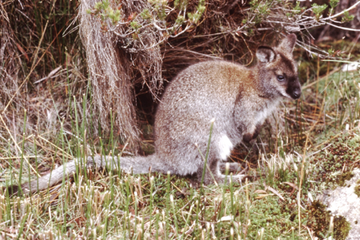  Photo credit: Zoos Victoria | Distribution map  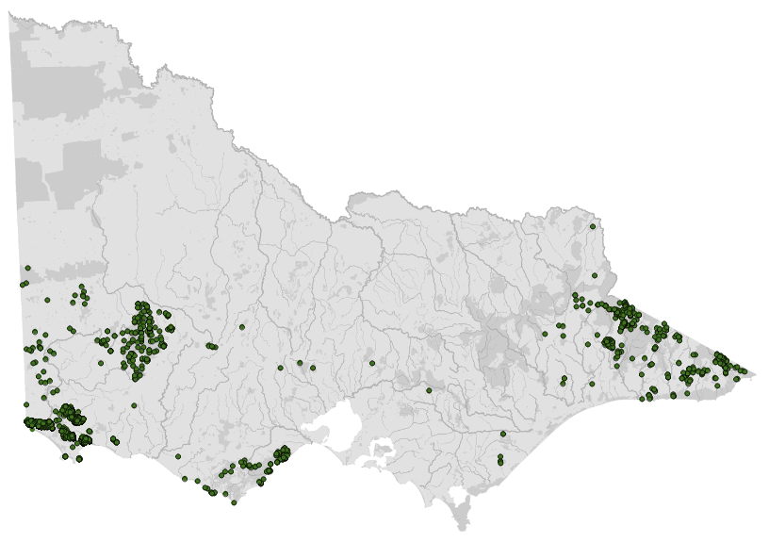  Data source: Victorian Biodiversity Atlas Jan 2023  www.environment.vic.gov.au/biodiversity/victorian-biodiversity-atlas
General appearance | Pale stripe on jaw line, shoulders have reddish brown colour while coat is grey
Conservation status* | Common
Sexual dimorphism | Males are larger and appear grey to reddish above with a reddish-brown neck. Females are paler
Adult morphometrics | Body weight: Males: 15–27 kg. Females: 11–16 kg  Head and body length: Males: 770–888 mm. Females: 708–837 mm  Tail length: Males: 703–876 mm. Females: 664–790 mm
Habitat | Dense cover, heath, edges of forest and farm
Home range | Male: 0.10–0.32 km²  10–32 ha  Female: 0.05–0.12 km²  5–12 ha
Behaviour | Active at dusk, solitairy
Diet | Predominantly grasses and herbs. Occasionally browses shrubs or tree seedlings
Longevity | 9–10 years
Sexual maturity | Male: 13–19 months  Female: 11–24 months
Mating season | Year round
Oestrus cycle | 32–33 days
Gestation length | 29–30 days
Litters per year | 1 litter of 1 per year
Weaning | 12–17 months
Young dispersal | 12 months

Species | Swamp (black) wallaby (Wallabia bicolor)
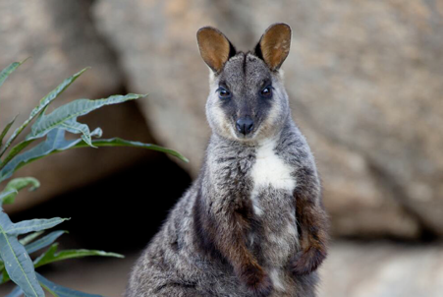  Photo credit: Mark Norman, Museums Victoria | Distribution map  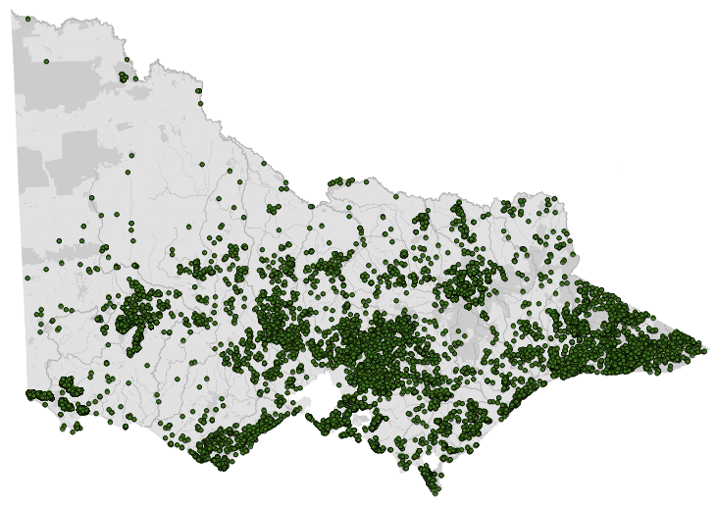  Data source: Victorian Biodiversity Atlas Jan 2023  www.environment.vic.gov.au/biodiversity/victorian-biodiversity-atlas
General appearance | Lighter area on cheek stripe, may have a white tip on thin, long tail
Conservation status* | Common
Sexual dimorphism | Males are larger. No difference in appearance between the sexes
Adult morphometrics | Body weight: Males: 12–20 kg. Females: 10–15 kg  Head and body length: Males: 723–847 mm. Females: 665–750 mm  Tail length: Males: 690–862 mm. Females: 640–728 mm
Habitat | Wet thick forest, heath, dense cover
Home range | 0.16 km²  16 ha
Behaviour | Active at dusk, solitairy
Diet | Browser, consuming shrubs and bushes
Longevity | 15 years
Sexual maturity | Male: 15–18 months  Female: 15–18 months
Mating season | Year round
Oestrus cycle | 29–36 days
Gestation length | 33–38 days
Litters per year | 1 litter of 1 per year
Weaning | 12–15 months
Young dispersal | More than 15 months

Species | Western grey kangaroo (Macropus fuliginosus)
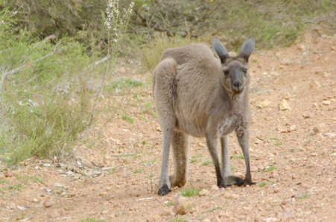  Photo credit: NW Longmore, Museums Victoria | Distribution map  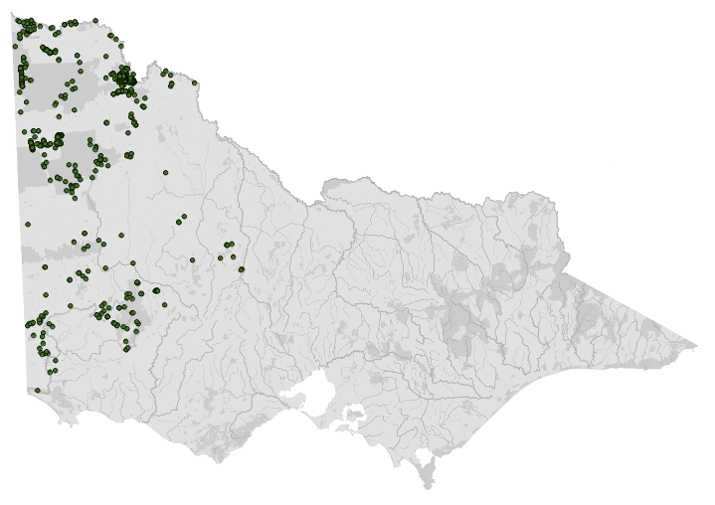  Data source: Victorian Biodiversity Atlas Jan 2023  www.environment.vic.gov.au/biodiversity/victorian-biodiversity-atlas
General appearance | Darker grey brown colour with pale chest, longer ears
Conservation status* | Common
Sexual dimorphism | Males may be up to twice the weight of females and appear more muscular
Adult morphometrics | Body weight: Males: 18–72 kg. Females: 17–39 kg  Head and body length: Males: 946–2225 mm.  Females: 971–1746 mm  Tail length: Males: 425–1000 mm. Females: 443–815 mm
Habitat | Dry forest, Mallee, dry heath
Home range | 0.4–0.7 km²  40–70 ha
Behaviour | Active at dusk, mob
Diet | Grazer, but will occasionally browse shrubs
Longevity | 10–20 years
Sexual maturity | Male: 29–31 months  Female: 14–36 months
Mating season | Year round
Oestrus cycle | 30–39 days
Gestation length | 28–33 days
Litters per year | 1 litter of 1 per year
Weaning | 15–18 months
Young dispersal | 15–18 months
*From the Flora and Fauna Guarantee Act 1988 Threatened List June 2023. This list is updated regularly throughout the year. For the most current list, please visit https://www.environment.vic.gov.au/conserving-threatened-species/threatened-list.

6.3. Animal and human
safety considerations
In general, animals in the wild have limited contact with people, pets, and the hustle and bustle of our daily lives. When sick, injured or orphaned wild animals come into care this unnaturally close contact can carry risks to the health and safety of both people and animals. For general information on biosecurity and approaches to minimise these risks see Part A of these guidelines. Specific information on enclosure hygiene and biosecurity for macropods is in Section 6.6.2.
The following information relates to the human and animal health and safety considerations specifically related to the rehabilitation of macropods.

6.3.1. Human safety considerations
- There are several diseases carried by macropods that can be transmitted to humans (zoonoses) such as Q fever, leptospirosis and salmonellosis. Persons handling macropods should protect themselves from such diseases by being vaccinated against Q fever and washing hands with soap and water or using hand sanitiser after handling animals or their equipment.
- Kangaroos can panic and/or try to defend themselves when attempts are made to handle them, or they feel threatened. Large kangaroos are very strong and can easily injure inexperienced handlers.
- Any conscious or semi-conscious kangaroo larger than approximately 10 kg should not be manually restrained due to safety risks to the handler and the associated welfare risks to the animal, such as capture myopathy. They should be appropriately sedated before attempts to handle them are made.
- Only an authorised person can possess and administer substances, such as anaesthetics and sedatives, covered by the Drugs, Poisons and Controlled Substances Regulations 2017. Therefore, it is mandatory that a veterinarian supervises the anaesthesia and/or sedation of kangaroos.
- These agents will often be administered using a tranquiliser gun, which requires a Category C firearms licence and a Public Place Permit from Victoria Police.
- Adult kangaroos can be heavy, up to 90 kg. Lifting should be done with enough people to avoid back injuries. Stretchers and bags are used for ease of transport.
- A kick from the legs of an adult kangaroo can cause serious bruising, and injuries that may require hospitalisation. Always approach a sedated or injured kangaroo from behind. A sedated animal could still kick or react violently.
- Care is required if cutting wire to remove a kangaroo caught in a fence, as it will recoil if it is under tension. Eye protection and gloves should be worn.
- Many kangaroos are found on roadsides either injured or requiring capture. It is important to remember wildlife rehabilitator safety, when rescuing macropods next to roads. Macropods may still be mobile; the capture may need to be planned with more than one person to keep the animal, wildlife rehabilitators and the public from harm. Contact the Police Assistance Line on 131 444 to assist with traffic management, and where appropriate use signage to warn oncoming traffic.

6.3.2. Animal safety considerations
- Minimise capture time (<10 minutes). Kangaroos that have experienced high levels of stress for prolonged periods can suffer capture myopathy, which can cause death. Macropods should not be chased in order to catch them, given the risk of myopathy.
- Even severely injured kangaroos may still be able to get up and potentially hop into traffic. If this is at all possible, contact the Police Assistance Line on 131 444 or 000, in case of an emergency, to assist with traffic control.
- If the macropod cannot be captured quickly and safely, or could become a traffic hazard, then an authorised tranquilliser should be engaged.

6.4. Capture, restraint, and transport
STOP – A visual examination must be done BEFORE the animal is captured. This applies to the initial capture from the wild as well as prior to captures which occur during time in captive care. See Section 6.4.1 for information on what to look for when conducting a visual health assessment.
Refer to Part A of these guidelines for general advice on wildlife welfare, biosecurity and hygiene, and record requirements. The following information relates to the capture, restraint, and transport of sick, injured and orphaned macropods.

6.4.1. Visual observations
Visual observations of wildlife should be conducted prior to any attempts to capture the animal. This is just as important prior to the first capture from the wild as it is before any capture conducted while an animal is in captive care. Observations should be conducted quietly, by one person, and from a distance which provides a clear view of the animal with as little disturbance as possible. Visual observation should focus on the animal’s demeanour, behaviour, movement and posture, looking for evidence of injury/severe disease or deterioration and observe their breathing as demonstrated in the following table.
Table 6.2: Visual health observations in macropods
 | What to look for
Demeanour | - Bright, alert
Behaviour | - Hisses or grunts and attempts to move away when approached  - Licking forelegs usually indicates a hot or stressed macropod
Movement and posture | - Uses all four legs equally when walking  - Uses both hind legs equally when hopping  - Adopts an upright posture when concerned
Breathing | - Regular with no obvious effort  - Increased respiratory effort may indicate hyperthermia, stress or respiratory disease

6.4.2. Equipment
- GPS and or map and street directory.
- Soft dark bag: Shade-cloth is the preferred material. Hessian bags can also be useful, but they have been associated with trauma to the surface of the eye and overheating. Other suitable bags include a mail bag, rice sack or wool pack.
- Ice pack or wet towels: If it is a hot day to decrease the risk of hyperthermia and capture myopathy.
- Towels and blankets: These can be used to cover the eyes of the animal.
- Veterinarian with a tranquiliser gun or injection pole: They can be required to sedate an adult animal for assessment and transportation.
- For capture of a joey: The following items are required in addition to the general items:
- Pouches and liners with a source of heat;
- Sharp scissors to cut the teat off a dead mother. This minimises the risk of damaging the joey’s mouth, which could result if it is pulled off the teat;
- Brightly coloured spray paint to mark dead animals once pouches have been checked;
- Disposable gloves to be worn when checking pouches or when body fluids are spilled or present.
Figure 6.1: a. A soft dark bag made of shade cloth used to transport sedated macropods. The bag opens at each end to facilitate entry of the macropod into the bag. The bag also has an opening along the side for ease of inspection during transport. b. A small wallaby is placed into a hessian sack. Note that the tail is held where it meets the body with the legs facing away from the handler. Photo credit: Zoos Victoria
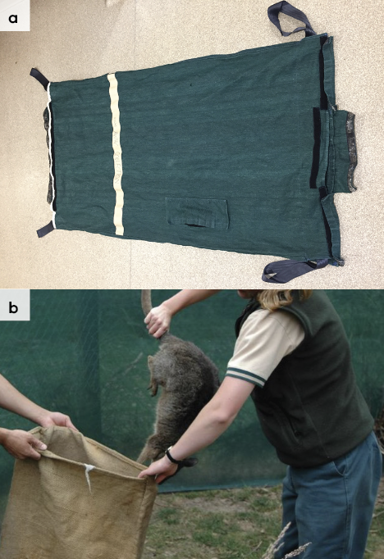

6.4.3. Technique
It is beyond the scope of these guidelines to outline techniques for every situation that may be encountered. Examples of techniques for some specific situations are outlined in the following section.
In addition to this information, for further advice please also refer to the recommended reading list, zoological institutions, veterinarians and/or wildlife experts. Inexperienced rescuers should request assistance where possible.
- If the macropod is calm and/or depressed and weighs less than approximately 10 kg, restrain it by the base of the tail and place it into a bag, with legs held away from the handler (see Figure 6.1).
- Do not hold the bag against the body while the animal is being transported, as it can still kick or bite through the bag. If in doubt, it is better to err on the side of caution and sedate the animal first to minimise the risk to both the handler and the macropod.
- If the macropod has been sedated cover the animal’s eyes first with a towel or blanket. Then place it in the bag or cover it with blankets. Keep the legs away from the handler at all times.
- Do not attempt to restrain or tie the legs due to risk of injury to the handler or animal.
- It is important to place the macropod into the bag with its neck extended and nose pointing forward. If the nose points down or the neck is kinked the macropod’s airway can become occluded potentially resulting in suffocation.

Joey found in a dead mother’s pouch
STOP – please refer to your authorisation for mandatory conditions including notification and capture requirements.
- Care needs to be taken when capturing joeys next to the road. Move the mother’s body off the road to prevent the wildlife rehabilitator or potential predators from colliding with other vehicles. Mark the body with spray paint to show that the animal has been checked. Pouches can be quite large. Check the entire pouch and all four teats.
- Removal of the joey from the pouch:
- A furred joey can be removed from the teat by firmly pressing the sides of the joey’s mouth. Alternatively, the teat can be cut with a pair of scissors. The joey will then drop it out of its mouth.
- Once removed, place the joey in a pouch.
- Keep it warmed to about 28°C to treat shock and mimic the natural temperature of the mother’s pouch.

Capture from a confined area
Displaced kangaroos may be trapped in confined areas such as backyards, factory blocks and paddocks. Assess the macropod for any injuries and survey the surroundings to determine if the animal is actually unable to escape. There are often exit points the animal can use that are not easily recognised by the general public; given time, the macropod may find its own way out. If the macropod is injured or stressed because of a perceived inability to escape it will need to be captured. An authorised tranquilliser gun operator should be contacted. Manual restraint should not be attempted. A police presence may be necessary for traffic and bystander control.

Trapped in a fence
- Check if the kangaroo is female, as a joey may be in the pouch or close by. Other people may be required to catch a dependent joey. Place a blanket over the head of the animal as soon as possible to keep it quiet. Veterinary involvement will be required to sedate the animal if handling is required. Wait until the sedative has taken effect before attempting to remove the animal from the wire.
- Permission from the property owner should be obtained before cutting the fence or wires. A short instrument (such as a spanner, branch or tyre jack) is used to untwist the wire. Protective eyewear and gloves should be worn if the fence wire is to be cut.
- If the kangaroo cannot be removed from the fence, euthanasia is required.

6.4.4. Transport
- Keep the duration of travel as short as possible. Adult animals should be anaesthetised by a vet or tranquillised by an authorised tranquilliser gun operator for the duration of the journey.
- Avoid travel at environmental temperatures greater than 30°C. If travel in hot conditions is unavoidable, the vehicle should have adjustable climate control facilities that ensure the area containing the animal is maintained at a temperature of 25°C or less for the duration of transport.
- During transport, the animal should be monitored at approximately 20-minute intervals for any signs of over-heating, such as panting or increased body temperature. Normal body temperature should be between 35 and 36.5°C and can be measured by inserting a thermometer in the cloaca. If the animal is too hot, ice packs can be placed in the groin or wet towels draped over the kangaroo’s body.
- The kangaroo should be able to maintain a relaxed and safe position for the duration of transportation. Any form of receptacle used to contain individuals should be safe and appropriate for the age and size of the animal. Their eyes should be protected with a blindfold.
- Soft dark bags can be used to transport macropods. If one is not available, a large blanket or pouch could be used to cover the animal’s head and body. Cotton wool balls can be placed into the ears to reduce the level of noise experienced by the macropod. Legs should not be tied together as this increases the likelihood of developing capture myopathy.
- The kangaroo should be laid flat; it should not slump, in case of airway constriction. A towel should be placed under the chest/shoulder area so that the nose points downwards. This reduces the risk of inhalation of saliva or food should the kangaroo regurgitate. A soft airline neck pillow is useful to ensure the head and neck is lying on a soft padded surface and ensures the neck does not kink during transport. Always ensure the head is lower than the shoulders.
- It is not necessary to provide water or food when transporting macropods.

6.5. Monitoring animal health and welfare
The goal of wildlife rehabilitation is to address health and welfare concerns quickly and effectively so wildlife can be released back to the wild as soon as possible. Decision-making from the time of capture through to release should be guided by an accurate understanding of the animal’s true state of health and welfare. Careful monitoring throughout the rehabilitation period ensures that significant issues, or deterioration in health condition, are identified immediately and rapidly addressed.
It is preferred that all sick, injured or orphaned wildlife be assessed by a veterinarian to ensure that non-obvious signs of trauma or disease can be assessed and treated as soon as practicable. No medication should be provided prior to this assessment, as this can mask clinical signs and make an accurate health assessment by the veterinarian very difficult.
Templates for record-keeping visual and physical observations and daily care can be found in Part A of these guidelines.
This section provides guidance on health assessment on arrival and on effective monitoring of the health and welfare of individuals in care through minimising human-animal interactions and stress to the animal to maximise successful release back to the wild.

6.5.1. Physical examination
Once visual observations are complete, and the animal is stable enough to withstand capture and handling, a basic physical examination should be conducted. This can be repeated when required any time the carer has the animal in the hand, such as for an enclosure change. However, if a full physical exam is not conducted, body condition and weight should be assessed every time the animal is in the hand for other reasons. Carers should make sure weighing scales are available and ready to use before capturing the animal. Physical examinations are also required if the carer notices any changes suggestive of deteriorating health or injury.
Always record the physical examination findings, so that you can compare findings as the animal’s rehabilitation progresses. This ensures any health concerns are identified as soon as possible, and the carer can plan release as soon as appropriate. A template for recording physical examination findings can be found in the appendices to Part A of these guidelines.
Examinations should be conducted in a quiet location, away from domestic animals. Only one person should handle the animal, while a second person takes notes. All other people should move away, and noise kept to a minimum. Handling should also be kept to a minimum, with careful monitoring for any signs of distress (such as panting, salivating, vocalisation or sudden deterioration in demeanour). If these are seen, the examination should be stopped immediately, and the animal returned to its catch bag, transport box or enclosure and allowed to recover.

Species specific considerations:
- Physical examination of wild macropods that weigh more than approximately 10 kg is not possible, unless the animal is extremely ill, without seriously endangering both the macropod and the handler. Sedation/anaesthesia is required by a vet. Physical examination of smaller macropods may be possible but will be extremely stressful and should be limited to a cursory examination only.
- If the macropod is contained within a bag or pouch, the opening is peeled back, and individual body parts gently examined. This method works well for hand reared joeys that are comfortable with being handled.
- Keep the macropod’s eyes covered, if possible.
Table 6.3 provides additional guidance on what to look for during physical examinations.
Table 6.3: Physical examination of macropods
 | What to look for
Body weight | - Record body weight on arrival and weekly, if possible, whilst in care. Smaller macropods can be weighed in a bag. Larger macropods should be weighed if they are sedated or anaesthetised for any reason.  - A greater than 10% change in adult body weight is cause for concern, and the carer should seek veterinary advice immediately.
Body condition | Body condition is scored by palpation of the muscle over the bones at the base of the tail. See Figure 6.2. Body condition can be described as follows:  - Under condition: Tail vertebrae feel prominent, and the muscle feels concave.  - Ideal condition: Tail vertebrae can be felt; the muscle feels level with the bones.  - Over condition: Difficult to feel tail vertebrae and the muscle feels convex.
Hydration status | - Hydration can be assessed by testing skin tent, done by pinching and lifting the skin between the shoulder blades.  - Dehydration can be indicated by skin remaining ‘tented’ or a slow return to normal position.
Eyes | - Eyes can indicate hydration status; they should be bright, shiny and clear, with pupils the same size. Sunken eyes may indicate dehydration.  - Pupils constrict with bright light.  - No discharge or cloudiness.
Ears | - Held upright.  - No visible tears or swelling.
Mouth | - Gums are pink and moist.  - Teeth are not broken.  - No visible swelling or asymmetry in the jaw or cheek.  - No drooling or dropping food while eating.
Skin and coat condition | - Dry, fluffy coat with no missing patches of fur.  - Pink cloaca without scabs, ulcers or evidence of diarrhoea.  - Forearms are not wet.  - Skin is not dry, scaly, red or ulcerated.  - No visible external parasites such as lice, flat flies, fleas or ticks.
Limbs, feet, and tail | - Uses legs equally, even in length.  - No obvious wounds, swelling, broken nails.  - No crackling or grinding detected when the legs are manipulated. Legs not held at odd angles to the body.
Sex determination | - Determined by the presence of testicles (males) or a pouch (females).
Pouch check | - There are four teats.  - A teat longer than 4 cm is likely indicative of an ‘at foot’ joey.
Figure 6.2: Location where body condition is determined by feeling the muscles at the base of the tail. Photo credit: Zoos Victoria
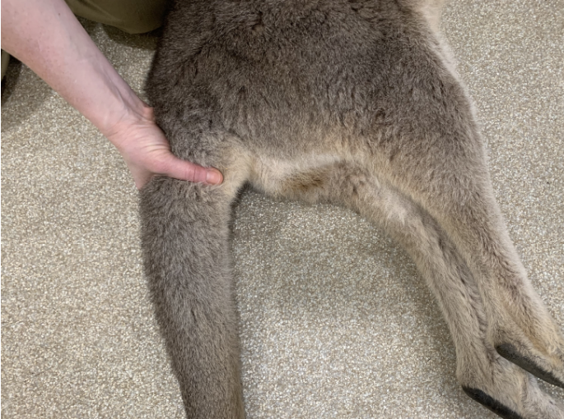

6.5.2. Ongoing monitoring of health and welfare
The aim of wildlife rehabilitation is to ensure animals recover and can be released back to the wild as quickly as possible. Careful, daily monitoring is required to ensure that animals are responding as expected to the treatment being provided and so that any deterioration or welfare concerns can be identified and addressed as soon as possible. Rehabilitators should ensure that record-keeping is a priority to maximise positive welfare outcomes. Templates to assist wildlife rehabilitators to record and monitor wildlife health and welfare can be found in the appendices to Part A of these guidelines. These records will be valuable tools to share with veterinarians to support decision-making.
The following is recorded daily:
- demeanour
- food consumption
- faecal/urine output
- behaviour observed
- medical treatment provided
- evidence of overnight activity.
The following is recorded weekly:
- weight
- body condition.
Over time, regular monitoring will also help to develop carer skills and knowledge, as regular observations and recording will result in a deep understanding of the expected behaviour and response to treatment for the species in care.

Species specific considerations:
- The macropod should be observed at least daily.
- If the macropod is being medicated, a visual check in the morning is recommended.
- Note the macropod’s demeanour and behaviour every time food is introduced or taken away, the macropod is medicated, or the enclosure is cleaned. Pay particular attention to any changes that have occurred since the previous day.
- Gently encourage the macropod to move in order to assess its movement and demeanour.
- Note faecal consistency daily. If diarrhoea is noticed, a faecal sample should be collected and submitted to the veterinarian for assessment as soon as possible. Do not treat on suspicion of a bacterial or parasitic infection, as this can make definitive diagnosis very difficult and potentially prolong the course of the disease.

6.5.3. Common and emerging health conditions
Clear guidance on conditions that may require euthanasia can be found in Part A of these guidelines.
Table 6.4 lists common clinical signs and possible causes of injury/disease. Carers should be aware that these are not exhaustive. Aside from first aid, carers should avoid administering medications prior to the provision of veterinary advice.
Unusual clinical signs or mass mortality events – a number of animals dying or found dead at the same time, with similar signs – may indicate an emergency animal disease, an emerging/new infectious disease or an environmental/human related toxicity which needs further investigation. Report these immediately to the Emergency Animal Disease Watch Hotline on 1800 675 888
(24 hours).
Table 6.4: Common injuries and clinical signs of emerging health conditions seen on presentation or during care
Clinical signs and possible causes | Possible causes | Carer observations and response
Note: Do not provide pain relief or other medication, including antibiotics, unless under veterinary guidance and supervision, as these can have severe side effects, particularly in dehydrated/shocked animals. Use of antibiotics when not indicated can contribute to antimicrobial resistance and reduce drug efficacy.
Unable to walk or move normally  Swollen limb  Bruising  Fractures  Dislocation | Found adjacent to road/suspect motor vehicle accident,  Caught in wire or netting, predation injury caused by raptor, fox, or dog, Gunshot  Capture injury  Injury sustained in captivity | - Urgent veterinary attention is required. Do not delay transfer to a veterinarian to apply first aid, other than to stop excessive bleeding.  - Large macropods will require sedation/anaesthesia, in order to move them.  - Do not attempt to stabilise fractures, as this is very painful, and risks making the injury worse. Fracture stabilisation should only be attempted by a veterinarian following physical examination, x-rays and under general anaesthesia.  - Do not provide pain relief or other medication unless under veterinary guidance and supervision, as these can have severe side effects, particularly in dehydrated/shocked animals.  - If suspected as the cause, assess the enclosure to find the source of injury. Fix loose wire/gaps or sharp edges before returning animal to enclosure.  - See Section 6.4 Capture, restraint, and transport and Section 6.6 Housing in this chapter for further advice.
Head trauma  Bleeding from nose or mouth  Swollen eye lids, blood present in eye  Abnormal behaviour  Mouth swelling, missing teeth  Lethargy | Found adjacent to road/suspect motor vehicle accident,  Caught in fence or wire  Predation injury caused by fox or dog,  Gunshot  Capture injury  Injury sustained in captivity  Cranial trauma, concussion | - Urgent veterinary attention is required. Do not delay transfer to a veterinarian to apply first aid, other than to stop excessive bleeding.  - Large macropods will require sedation/anaesthesia, in order to move them.  - Do not provide pain relief or other medication unless under veterinary guidance and supervision, as these can have severe side effects, particularly in dehydrated/shocked animals.  - If suspected as the cause, assess the enclosure to find the source of injury. Fix loose wire/gaps or sharp edges before returning animal to enclosure.  - See Section 6.4 Capture, restraint, and transport and Section 6.6 Housing in this chapter for further advice.
Bleeding  Puncture wounds  Bruising  Fur loss | Found adjacent to road/suspect motor vehicle accident,  Caught in fence or wire  Predation injury caused by fox or dog,  Gunshot  Capture injury  Injury sustained in captivity  Conspecific aggression, breeding season injuries | - Urgent veterinary attention is required. Do not delay transfer to a veterinarian to apply first aid, other than to stop excessive bleeding.  - Large macropods will require sedation/anaesthesia, in order to move them.  - Euthanasia may be the most humane response if the wounds are extensive.  - The severity of bite wounds/scratches may not be immediately obvious.  - Look for clumps of dried fur stuck together with saliva. Part the fur and look for puncture wounds.  - Do not provide pain relief or other medication unless under veterinary guidance and supervision, as these can have severe side effects, particularly in dehydrated/shocked animals.  - If suspected as the cause, assess the enclosure to find the source of injury. Fix loose wire/gaps or sharp edges before returning animal to enclosure.  - See Section 6.4 Capture, restraint, and transport and Section 6.6 Housing in this chapter for further advice.
Nail injury  Toe injury  Swollen digit  Bruised digit | Conspecific aggression, breeding season injuries  Found adjacent to road/suspect motor vehicle accident,  Predation injury caused by fox or dog  Poorly designed transport box/enclosure  Capture injury  Injury sustained in captivity  Burn injuries | - Seek prompt veterinary assessment as these lesions are slow to heal and, where nail bed infection occurs, intensive veterinary management is required.  - Large macropods will require sedation/anaesthesia in order to move them.  - Burn injuries to paws may result in nail damage, digit bone damage and tendon damage, due to the complexity of these injuries, veterinary treatment is required.  - Apply first aid to minor wounds.  - Do not provide pain relief or other medication unless under veterinary guidance and supervision, as these can have severe side effects, particularly in dehydrated/shocked animals.  - If suspected as the cause, assess the enclosure to find the source of injury. Fix loose wire/gaps or sharp edges before returning animal to enclosure.  - See Section 6.4 Capture, restraint, and transport and Section 6.6 Housing in this chapter for further advice.
Burns  Abnormal movement (note macropods with full thickness burns to their feet will no longer have feeling and will still hop) | Recent bushfire, campfire injury, chemical burn | - Seek urgent veterinary attention.  - Large macropods will require sedation/anaesthesia in order to move them.  - Burn injuries are extremely painful, treatment and bandage changes must only occur under anaesthesia and with adequate pain management.  - Burn injuries to paws may result in nail damage, digit bone damage and tendon damage, due to the complexity of these injuries, veterinary treatment is required.  - Do not provide pain relief or other medication unless under veterinary guidance and supervision, as these can have severe side effects, particularly in dehydrated/shocked animals.  - To ensure good welfare, animals must be returned to a veterinarian for ongoing bandage changes.
Lameness, reluctance to move | Trauma, capture myopathy (caused by prolonged exertion due to being chased or caught in a fence) | - Seek veterinary care as soon as possible.  - Macropods with myopathy may have a high body temperature and respiratory rate. They may tremble and pass dark coloured urine.  - Apply wet towels to the forearms and inner thighs to lower the body temperature.
Blindness, neurological signs e.g. wobbly movement, convulsions | Undetermined infectious disease e.g. toxoplasmosis or bacterial or viral meningitis, cranial trauma, toxicity such as Phalaris or degenerative such as cataracts | - Seek veterinary assessment to determine the cause.  - Seek species expert advice.  - Carer may observe the animal bumping into objects in the enclosure or fail to respond to short sharp noises (such as a loud clap from behind the animal).  - Pupils may be fixed/dilated and not responsive to changes in light level. Pupils should constrict if a pen light is shone in the eye.  - Phalaris toxicity is typically seen after animals graze on rapidly growing young plants, particularly following rain after a prolonged dry spell. Most cases occur in winter. Some affected animals will recover. Others will need to be euthanased.
Vesicles or ulcers in the mouth, cloaca, penis | Undetermined infectious disease, for example macropod herpesvirus | - Seek veterinary assessment as soon as possible.  - Affected macropods may also appear depressed, uncoordinated or have conjunctivitis or a nasal discharge.
Diarrhoea  Loose, smelly faeces | Inappropriate diet, change in diet, infectious disease, alteration of microbiome, stress, internal parasites, antibiotic treatment | - Seek veterinary advice to determine the cause.  - Seek urgent veterinary advice if diarrhoea does not resolve rapidly (e.g. within 24–36 hours), or if there is any evidence of dehydration, blood in faeces or change in demeanour.  - Do not treat on assumption of infectious disease (such as coccidia or bacterial infection) as this can make veterinary diagnosis more difficult if the animal does not improve.  - Diarrhoea may result if inappropriate milk is fed e.g. cow’s milk.  - Seek species expert advice, ensure husbandry practices are coorect. Consider any recent changes, which may have led to diarrhoea and remove the inciting cause where possible: rapid change in diet, unusual levels of sound, intervention or handling, contact with recently arrived animals.  - If stress is deemed a factor, consider whether the animal is a candidate for rehabilitation.  - If milk was recently changed, switch back to the previous milk, wait until diarrhoea has resolved and then implement a slower diet change.  - Diarrhoea can occur due to over feeding (i.e. more than 8–15% body weight.  - Do not mix oral rehydration fluids with milk as it changes the digestibility of the milk. Oral rehydration fluids/water can be provided in between milk feeds.  - Some causes of diarrhoea are transmissible to people. Ensure excellent hygiene standards to prevent spread and isolate this animal from any others in care if possible.  - Orphaned joeys may lack normal gut bacteria. Place a faecal scat from a healthy macropod in a bottle of boiled water that has cooled but is still warm. Mix the faeces with the water and allow it to stand for ten minutes. Drain off the liquid, then mix it into the joey’s next feed at a rate of 20–30% of the milk volume. Repeat the process 12 hours later.
Vomiting | Merycism | - Joeys make violent rhythmic jerking movements of the abdomen and food will occasionally squirt out of their mouth.  - Normal behaviour: that is the macropod equivalent of chewing the cud.
Noising breathing | Aspiration pneumonia | - Seek veterinary advice as soon as possible.  - A joey may have inhaled milk during feeding.
Increased drinking and urination | Kidney disease | - Seek veterinary care as soon as possible.  - Seek species expert advice, ensure husbandry practices are correct.  - Keep macropods well hydrated as kidney disease can occur secondary to dehydration.  - Seen occasionally in hand reared eastern grey kangaroo pouch young.  - There is no effective treatment.
Skin irritation, fur loss, wartlike lumps | Excessive mite, lice, flea, flat fly infestation, ringworm, poxvirus, toe/tail sucking in joeys | - Seek veterinary advice to determine the cause and treatment.  - Some fur loss/minor skin lesions are commonly seen due to fighting, and do not require any intervention.  - A small number of parasites can be normal and may not require treatment or removal.  - If there are large numbers of parasites (the animal is scratching/irritated, or the skin is red and inflamed) seek veterinary attention. Consider if the parasite infestation is secondary to an underlying disease process.  - Ringworm is zoonotic, refer to Part A, chapter 4 Biosecurity & Hygiene.  - Poxvirus is spread by biting insects and usually resolves without treatment.
Figure 6.3: a. A joey with a cataract. b. Cloacal ulceration caused by macropod herpesvirus. Photo credit: Zoos Victoria
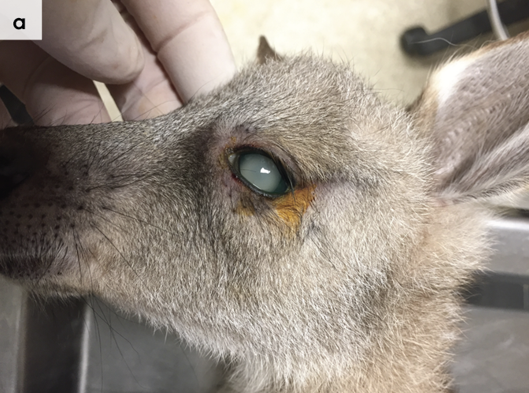
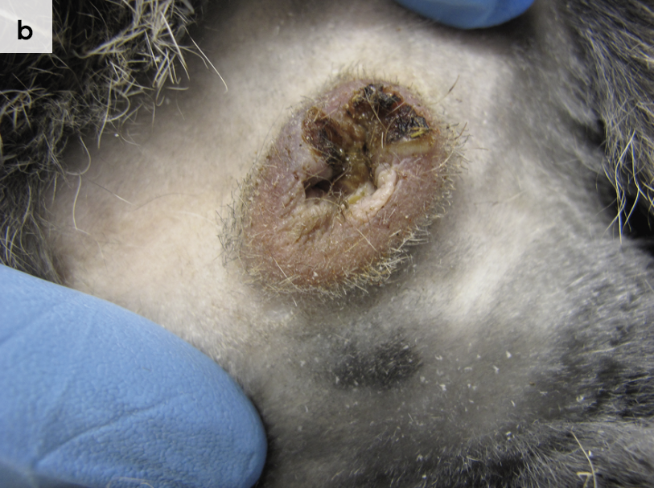

Figure 6.4: a. Poxvirus lesions on both legs of an eastern grey kangaroo. b. Ringworm lesions on the front feet of an eastern grey kangaroo. Photo credit: Zoos Victoria
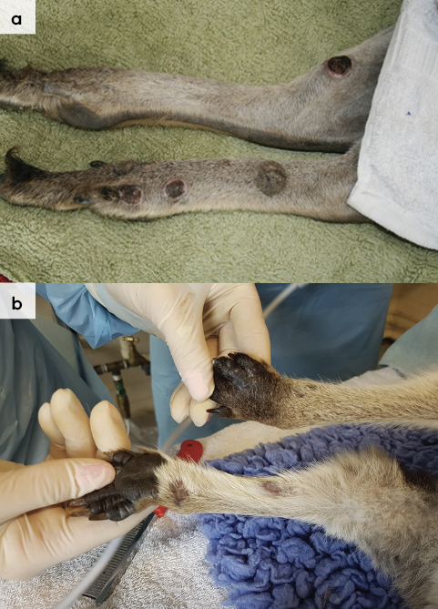
Figure 6.5: Dehydrated kangaroo tenting between shoulder blades. Photo credit: Zoos Victoria
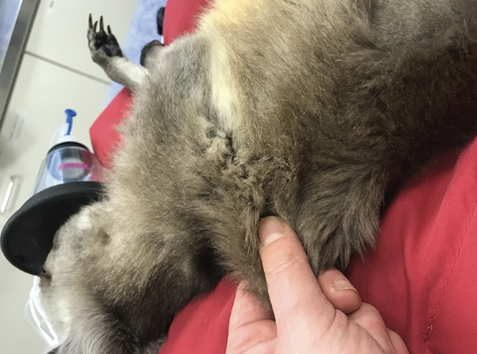
Figure 6.6: Lumpy jaw. Note the swelling beneath the jaw, which likely represents an abscess. Photo credit: Zoos Victoria
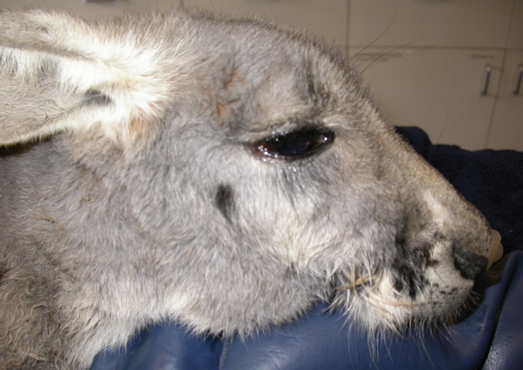
Figure 6.7: Macropod dental malocclusion. Photo credit: Zoos Victoria
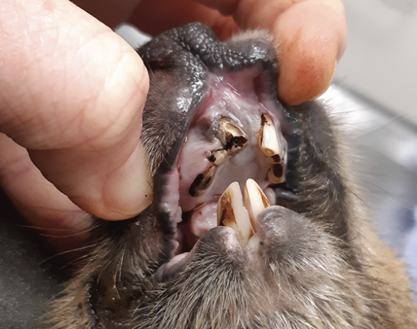

6.5.4. Administering treatment during rehabilitation
- Oral medications can be given directly into the joey’s mouth, allowing time for the joey to swallow, or else mixed into the joey’s milk.
- Due to the inability to safely restrain large macropods, they are usually not medicated orally (e.g. some deworming drugs). If there is no alternative, medication can be mixed into the macropod’s feed, as directed by a veterinarian.
- Injectable medications can be administered under the skin, between the shoulder blades, or into the large hind leg muscles, as directed by a veterinarian. Only experienced carers should give injections.

6.6. Housing
Below are several key considerations when housing adults in care.

6.6.1. General housing information for macropods
Macropods are sensitive to noise, and the sight and smell of domestic pets. They should be housed in a quiet area of the property. Macropods should have access to fresh water daily.

6.6.2. Enclosure hygiene & biosecurity
General information about hygiene and biosecurity can be found in Part A of these guidelines. New diseases emerge frequently and sick and injured animals in care are often more susceptible to picking up pathogens from the environment. It is important to maintain excellent levels of hygiene to avoid inadvertently transferring diseases between animals, and from humans, and to protect the wild population where the animal will eventually return to.

Species specific considerations:
- Wash hands with soap and water after handling dogs and cats to minimise the risk of transferring disease agents such as Toxoplasma gondii, which can be found in cat faeces.
- Ideally, exam gloves should be worn and changed in between animals.
- Macropods should not be fed on the ground. Hay racks, dishes or troughs should be used to minimise contact with faeces and parasites.
- Left-over food should be removed daily.
- Rake paddocks daily to remove faeces. If possible, rest paddocks for 30 days during the warmer months to reduce the parasite load.
- Sheds with concrete floors should be completely cleaned out between inhabitants.
- Hay/straw should be discarded, and the floor disinfected with products such as F10 or bleach.
- All organic matter should be removed and the enclosure cleaned with boiling water, as this has been shown to kill coccidial oocysts. Rehabilitation facilities for macropods should be designed and built using materials which are easy to clean and disinfect between occupants.

6.6.3. Housing types
There are no national standards regarding enclosure size for macropods during rehabilitation. Each state has a different set of guidelines which contain a variety of recommended enclosure sizes. The dimensions recommended in this chapter are suggestions based on Healesville Sanctuary’s enclosure sizes. There is no ‘one size fits all’ and it is important to continually assess the welfare of the macropod and tailor enclosures and enclosure size to suit the requirements of the individual.
Different set ups are required for animals at different stages of treatment and care.
Table 6.5 describes the housing type, suggested dimensions and requirements at each stage of care. For information on housing animals during hand raising see Section 6.8.
Table 6.5: Rehabilitation housing for adult macropods
Intensive care housing
Indications for use | Suggested min. dimensions | Suggested requirements
Short term critical care (<48 hours)  Intensive veterinary treatment – frequent medication, oxygen supplementation, temperature control | Enclosure:  2 m x 2 m (4 m²)  Height 2 m | ENCLOSURE CONSTRUCTION  - A stable or enclosed area with solid walls and subdued lighting.  ENCLOSURE FURNISHING  - The bedding should consist of a deep layer of straw, a dog bed or a foam mattress to provide support for recumbent animals.  ENVIRONMENTAL VARIABLES  - Enclosures need to be in a quiet area, with minimal traffic.  - Recumbent macropods are at high risk of myopathy and pressure sores over the points of the hips and legs. These complications should be expected and monitored as they adversely impact the welfare of the animal.  PROVISION OF FOOD/WATER  - Easy access to grass and low-profile water bowls is required.

Intermediate housing (treatment/cage rest)
Indications for use | Suggested min. dimensions | Suggested requirements
Provision of daily medication, close monitoring once animal is stabilised and no longer requires intensive care | Enclosure:  2 m x 2 m (4 m²) inside  Height 2 m  5 m x 5 m (25 m²) outside.  Height 2 m | ENCLOSURE CONSTRUCTION  - A stable or shed with solid walls is suitable.  - Double hinged half door permits the animal to be checked without too much disturbance.  - This housing should lead out to an enclosed yard with hessian or shade cloth lined fences that can be used during the day with the animal returned to intensive care housing at night.  ENCLOSURE FURNISHING  - As kangaroos rest in areas of longer grass and shrubs, creating visual barriers using bales of straw or blankets hung as dividers may assist to reduce stress.  PROVISION OF FOOD/WATER  - Access to grass and hay and low-profile water bowls is required.

Pre-release
Indications for use | Suggested min. dimensions | Suggested requirements
No longer require regular handling/medication  Development of fitness/strength prior to release  Monitoring/assessment of behaviour (foraging, digging, nest building)  Pre-release assessment | Pre-release juvenile kangaroo or wallaby less than 5 kg:  5 m x 4 m (20 m²) X 2 m (H).  5 m x 2 m (10 m²) increase in floor area for each additional animal  Pre-release kangaroo or wallaby between 5 kg and 20 kg:  10 m x 5 m (50 m²) X 2 m (H).  5 m x 5 m (25 m²) increase in floor area for each additional animal  Pre-release kangaroo greater than 20 kg:  20 m x 5 m (100 m²) X 2 m (H).  10 m x 5 m (50 m²) increase in floor area for each additional animal | ENCLOSURE CONSTRUCTION  - Fences for kangaroos need to be at least two metres high and predator proof.  - Chain mesh (50 mm x 50 mm) such as cyclone fencing can be used.  - Fence poles are placed on the outside of the enclosure to prevent climbing and injury when running along the fence.  - Fencing should have a visual barrier present. Options include Hessian or shade cloth lining, shrubs planted on the outside or solid wall fencing.  - The corners should be blocked off using shade cloth to prevent the kangaroo from running into them and injuring itself.  - Flooring may be grass, sand, soil or leaf litter.  ENCLOSURE FURNISHING  - A feed shed with solid walls made from wood, brick or tin to keep food dry and offer shelter should be provided. The flooring is ideally concreted and covered with straw that is changed regularly.  - Poisonous plants that should not be used in the yard include oleander, rhubarb, deadly nightshade, green cestrum and azaleas.  - Wallabies may be offered various hides made by leaning wooden panels against logs or using basic A-frame structures. The provision of four to five hides per animal is recommended. Wallabies require a complex environment with logs, rocks and tussocks to provide opportunities to climb, exercise and learn vigilance.  - Kangaroo enclosures should not have obstacles around the perimeter as these will interfere with running along the fence line. They require some hides such as rocks, grass tussocks or wooden shelters.  ENVIRONMENTAL VARIABLES  - Trees and shrubs should be present for shade and privacy but not located near the fence-line to prevent injury and escape.  PROVISION OF FOOD/WATER  - Hay and grass should be fed out of hay racks or troughs. It should not be fed on the ground as this will increase the risk of transfer of internal parasites and may contribute to lumpy jaw.  - Several bowls may be required to prevent the less dominant animals from missing out on feed. Metal or ceramic dog bowls or stock feed troughs may be used.
Figure 6.8: Eastern grey kangaroo in shed for hospitalisation.
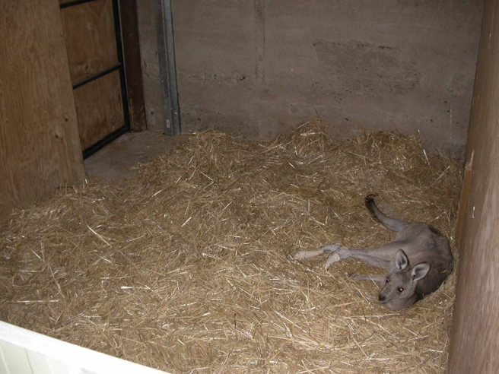
Figure 6.9: a. A macropod yard with a shed that can be used to confine adult animals for intensive care. b. Fence with cyclone fencing and shade cloth facing, inside the yard. Photo credit: Zoos Victoria
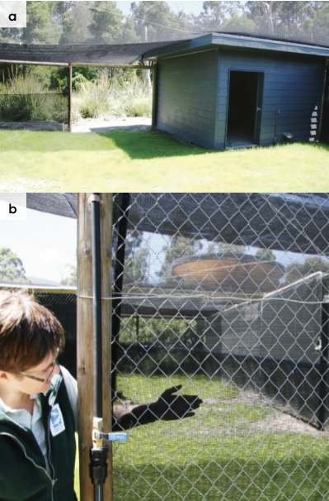
Figure 6.10: A shed used for shelter in a pre-release pen for macropods. Photo credit: Zoos Victoria
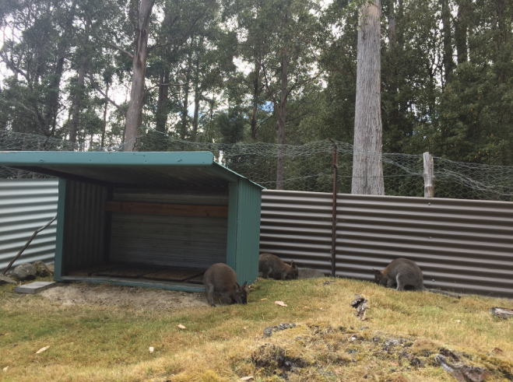

6.7. Feeding and nutrition
Keeping daily records of food offered (item and volume fed) and food consumed is good practice and will allow the rehabilitator to observe how an animal is responding to food on offer and inform future choices.
Please note: Food suppliers and specific products mentioned in these guidelines are intended as examples only. Other suitable products may also be available.
This section refers to feeding and nutrition of macropods in rehabilitation. Information on feeding orphaned individuals can be found under Section 6.8 Hand raising.
Figure 6.11: A hay rack. Note that the hay is protected from the weather and the ground is raked daily to remove faeces. Photo credit: Zoos Victoria
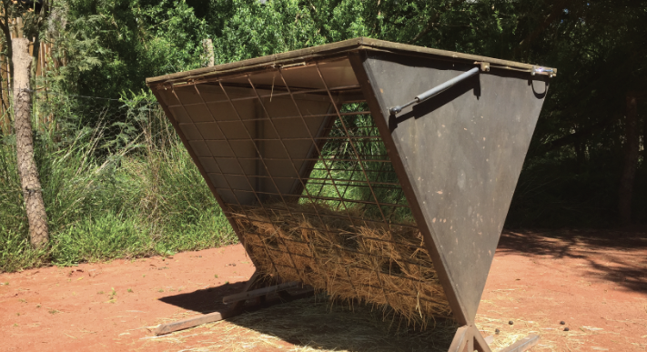
Table 6.6: Daily feeding and diet guide for adult macropods during rehabilitation
Diet | Diets for sub-adult and adult macropods consist of the following items:  - Hay and fresh grasses. Suitable hays include lucerne and grass hay. This should make up most of the diet. Yards may need to be rested in between animals, to permit grass to regrow.  - Suitable supplements such as macropod or pasture replacement pellets should make up less than 10% of the food volume offered daily.  - Non-suitable food items include bread, grain mixes and molasses. Pellets for cattle should not be offered as they may contain coccidiostats that are fatal to macropods.  Suitable browse items for swamp wallabies include:  - Grevillea, Hakea, Pomaderris, Lomandra, Lomatia, Allocasuarina, Callistemon, tea tree, gum and wattle.  - Fungi and ferns.
Pre-release considerations | - Kangaroos need to be exposed to a variety of native grasses prior to release.  - Wallabies need to be fed a variety of at least five species of leafy browse daily throughout the intermediate and pre-release stages from weaning to release.  - This food should be limited to plant species from the release site in the fortnight prior to release.  - Supplementary foods such as pellets should not be offered in the fortnight before release to encourage macropods to consume the diet they will receive once released.
Frequency/time of feeding | - Clean water is offered daily.  - Three to five species of browse items are offered daily. Some may be used as food and also to create a hide.

6.8. Hand raising
Hand raising record templates for growth, development, feeding and other observations are found in the appendices to Part A of these guidelines.

6.8.1. Equipment required for hand raising
- Milk: There are a variety of low lactose milk formulas available to raise macropods. Follow the manufacturer’s instructions when making up the milk formula. Milks that can be used include:
- Wombaroo Kangaroo Milks provide appropriate levels of protein, fat, carbohydrates and energy for all stages of growth.
- Biolac produces three milks which provide sufficient protein, fat, carbohydrates and energy for all stages of growth.
- Di-Vetelact is an older product but many carers have had success with it. It is a single formula that is diluted according to the age of the joey.
- Supplements: Suitable supplements that may be added to milk include:
- Wombaroo Impact is used to boost immunity and protein in orphaned joeys after the first month in care.
- Critical Care for Herbivores is used to provide a source of easily digestible energy to sick joeys.
- Do not add human infant vitamin supplements to the milk formula.
- Housing: Pouch, which usually has three layers:
- An inner lining made from a natural fibre without exposed strands, which may be achieved by using French seams (a seam with the raw edges enclosed). It may have curved edges.
- Outer pouch may be made from a variety of materials such as wool, polyfibre, cotton or synthetic fleece fabric.
- Hanging pouch. This pouch suspends the inner pouches and hangs on a frame, in a basket or backpack.
- Pouch size will vary with the size of the joey. The pouch should be deep enough that the legs do not hang out. A young joey should feel snug, but the pouch will become more open with increasing age.
- Intensive care unit (such as Vetario) or box containing a heat pad with thermostat.
- Appropriately sized teats and bottles.
- Other: Set of scales, record charts, digital thermometer/datalogger to monitor temperature inside the pouch/enclosure.
Figure 6.12: A pouch for a macropod. A stand is used to support the pouch. Note the outer pouch, with layered material pouches inside. Photo credit: Zoos Victoria
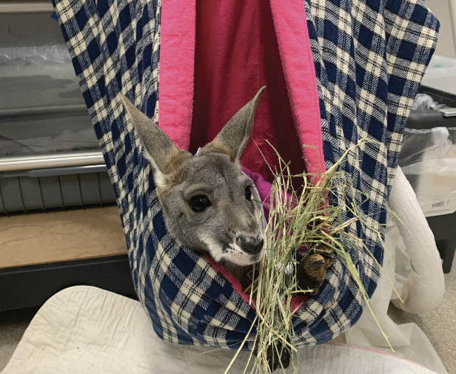
Figure 6.13: Macropod pouch placed on the floor and supported in a basket. Photo credit: Zoos Victoria
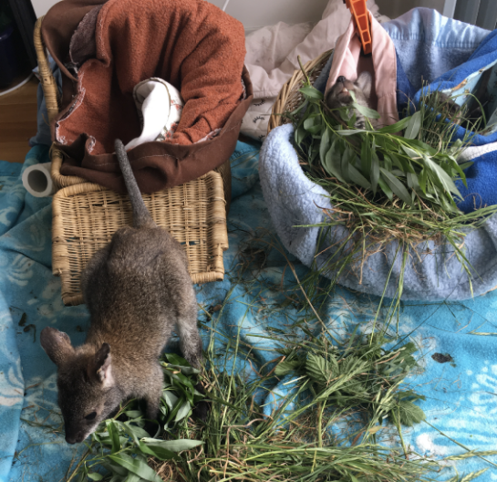

6.8.2. Growth, development and care of orphaned young
STOP – Please refer to your authorisation for mandatory conditions regarding unfurred macropod joeys.
Table 6.8 to Table 6.12 describe the appearance of macropod joeys at various stages of development.
Macropod joeys require strict hygiene to prevent deaths from bacterial and fungal conditions.
An orphaned joey should be housed in a pouch located in a quiet room of constant temperature away from pets, children, and human noises.
The ambient temperature is gradually reduced until pouch emergence when the joey is furred. This may be done by decreasing the setting on the thermostat unit or by increasing the distance between the heat unit and the animal. See Table 6.8 to Table 6.12 for heating recommendations.
A thermometer is used to monitor the temperature in the pouch by placing it between the inner and outer pouches.
Heating is provided using electrical heat pads that are covered with cloth and placed close enough to provide the correct temperature. The heat pad can be attached to a thermostat which will regulate its heat output.
To reduce the possibility of sucking extremities, a rubber teat can be pinned to the side of the pouch with a safety pin.
- Where possible, joeys should be raised in small groups of three to four for kangaroos and in pairs for wallabies. Do not encourage behaviours such as human play-boxing. This behaviour should be practised between joeys of similar weights and ages.
- Encourage the joey to lap milk from a bowl from first pouch emergence to full emergence to reduce imprinting onto humans.
No bottles should be fed in the month between weaning and release. At this age, young may attempt to drink from their mother but are discouraged. Do not feed macropods after release as this trains them to approach humans for food.
From first pouch emergence, the joey is permitted to stand and hop for one to two minutes. As the joey progresses, exercise may include short walks on the property or with supervision in the pre-release pen, building up to 30 minutes at least twice daily.
By full pouch emergence, the joey should be able to hop strongly and at speed.
By the time the joey is weaned and approaching release, it should easily hop at speed for several minutes.
Ensure the joey shows appropriate predator avoidance behaviour. Wildlife rehabilitators should make a hissing noise and thump their feet when other humans or dogs approach within 50 m of the joey. Do not house joeys within sight of pet dogs. Fear of dogs is instinctive in macropods and is decreased with continued exposure to canines.
Ensure the joey has reached the recommended weight and age prior to release. See Table 6.7.
Table 6.7: Recommended release age and weight
Species | Fully emerged (months) | Weaning age (months) | Release age (months) | Release weight range (kg)
Eastern grey kangaroo | 11 | 15–18 | 15–18 | 15–20
Western grey kangaroo | 10 | 15–18 | 15–18 | 15–20
Swamp wallaby | 8 | 12–15 | >13 | 8–10
Red-necked wallaby | 10 | 12–17 | 15 | 11
Red kangaroo | 8 | 12 | >12 | 18
Table 6.8: Eastern grey kangaroo development (Used with permission from Wombaroo)
Milk | Age  (d) | Tail (mm) | Foot (mm) | Weight (g) |  | Milk feeds daily |  | Feed  (mL/day) |  | Appearance/ feeding | Housing
0.4 | 160 | 191 | 113 | 640 |  | 6 |  | 75 |  | Eyes open, ears up, fine fur on head | Intensive care: in hospital box inside pouch 30°C.
 | 170 | 209 | 123 | 780 |  |  |  | 90 |  | Stand at each feed for 30 – 60 seconds
 | 180 | 228 | 133 | 950 |  |  |  | 100 |  | Head coming out of the pouch
Transition | 182 | 232 | 135 | 990 |  |  |  | 100 |  | 75 mL 0.4 + 25 mL 0.6
 | 185 | 238 | 138 | 1050 |  |  |  | 100 |  | 50 mL 0.4 + 50 mL 0.6
 | 188 | 244 | 141 | 1110 |  |  |  | 100 |  | 25 mL 0.4 + 75 mL 0.6
0.6 | 190 | 248 | 143 | 1150 |  | 5 |  | 100 |  | Offer grass and roots in pouch | Intensive care: housed inside with 28°C.
 | 200 | 268 | 153 | 1350 |  |  |  | 110 |  | Chest covered with fur | Exercise: 5 minutes of hopping at end of feed.
 | 210 | 288 | 163 | 1550 |  |  |  | 120 |  | Faeces: green toothpaste | Water available for lapping.
Transition | 212 | 292 | 165 | 1600 |  |  |  | 120 |  | 90 mL 0.6 + 30 mL >0.7
 | 215 | 298 | 168 | 1675 |  |  |  | 120 |  | 60 mL 0.6 + 60 mL >0.7
 | 218 | 305 | 171 | 1750 |  |  |  | 120 |  | 30 mL 0.6 + 90 mL >0.7
>0.7 | 220 | 309 | 173 | 1800 |  | 4 |  | 120 |  | Small adult in appearance with short fur | Exercise: hop for 30 minutes twice daily.
 | 230 | 329 | 183 | 2070 |  |  |  | 135 |  | Will eat grass on ground while in pouch | Intermediate housing: Human portable cot or play-pen (1 m x 2 m) can be used inside and a 4 m x 4 m yard with a shed can be used outside. The joey is taken outside for 1–2 hours a day, increasing to 4 hours by 2.7 kg for exercise and exposure to sunlight.
 | 240 | 350 | 194 | 2350 |  |  |  | 145 |  | Faeces: soft to firm green pellets. Start to self-toilet out of pouch.
 | 250 | 371 | 204 | 2700 |  |  |  | 155 |  | Emerging from pouch, head out for short periods. Offer grass and dirt.
 | 260 | 392 | 214 | 3150 |  |  |  | 165
 | 270 | 414 | 224 | 3600 |  | 3 |  | 185 |  | Offer supplements: pellets.  Offer grass and hay | Intermediate housing: outside all day, inside at night. Provide heat at night.
 | 280 | 436 | 234 | 4100 |  |  |  | 200 |  | Longer fur, not waterproof | Pre-release yard: Outside all day, locked into outside shed at night.
 | 290 | 458 | 244 | 4600 |  |  |  | 220
 | 300 | 480 | 254 | 5100 |  | 2 |  | 240 |  | Faeces: firm green pellets
 | 310 | 495 | 259 | 5600 |  |  |  | 250 |  | Fully out of pouch  Growth now 60 g/d. furred, waterproof | Pre-release yard: outside day and night.
 | 320 | 510 | 264 | 6100 |  |  |  | 260
Weaning | 330 | Growth rate now about 50 g per day |  |  | 2 |  | 240 |  | Feed volume depends on amount of solids consumed
 | 360 |  |  |  |  |  | 180
 | 390 |  |  |  | 1 |  | 120
 | 420 |  |  |  |  |  | 60 |  | Gradually increase solid food and reduce milk intake |  | Pre-release yard. Does not use shed, seeks natural cover. Grazing day and night.
 | 450 |  |  |  | 0 |  | 0 |  | Fully weaned. Earliest weight for release is 15kg |  | No longer fed supplements, on native diet for 2 weeks prior to release.

Table 6.9: Western grey kangaroo development (Used with permission from Wombaroo)
Milk | Age  (d) | Tail (mm) | Foot (mm) | Weight (g) | Milk feeds daily |  |  | Feed  (mL/day) | Appearance/ feeding | Housing
0.4 | 160 | 174 | 102 | 460 | 6 |  |  | 61 | Eyes open, ears up, fine fur on head | Intensive care: in hospital box inside pouch 30°C.
 | 170 | 191 | 111 | 560 |  |  |  | 68
 | 180 | 208 | 120 | 680 |  |  |  | 80
Transition | 182 | 212 | 122 | 712 |  |  |  | 80 | 60 mL 0.4 + 20 mL 0.6
 | 185 | 217 | 125 | 760 |  |  |  | 80 | 40 mL 0.4 + 40 mL 0.6
 | 188 | 222 | 127 | 808 |  |  |  | 80 | 20 mL 0.4 + 60 mL 0.6
0.6 | 190 | 226 | 129 | 840 | 5 |  |  | 80 | Offer grass and roots in pouch | Intensive care: housed inside with 28°C.
 | 200 | 244 | 139 | 1000 |  |  |  | 90 |  | Exercise: 5 minutes of hopping at end of feed.
 | 210 | 263 | 148 | 1160 |  |  |  | 100 | Faeces: green toothpaste. Fine fur covering body | Water available for lapping.
Transition | 212 | 267 | 150 | 1190 |  |  |  | 100 | 75 mL 0.6 + 25 mL >0.7
 | 215 | 273 | 153 | 1250 |  |  |  | 100 | 50 mL 0.6 + 50 mL >0.7
 | 218 | 378 | 155 | 1310 |  |  |  | 100 | 25 mL 0.6 + 75 mL >0.7
>0.7 | 220 | 282 | 157 | 1350 | 4 |  |  | 100 | Small adult in appearance with short fur | Exercise: hop for 30 minutes twice daily.
 | 230 | 302 | 167 | 1550 |  |  |  | 110 | Will eat grass on ground while in pouch | Intermediate housing: at pre-release yard.  Out for 1–2 hours a day, increasing to 4 hours by 2.7kg. Latest age for buddying.
 | 240 | 322 | 176 | 1770 |  |  |  | 120 | Faeces: soft to firm green pellets. Start to self-toilet out of pouch.
 | 250 | 342 | 185 | 2050 |  |  |  | 130 | Emerging from pouch, head out for short periods. Offer grass and dirt.
 | 260 | 362 | 195 | 2400 |  |  |  | 145
 | 270 | 383 | 204 | 2800 | 3 |  |  | 155 | Offer supplements: pellets.  Offer grass and hay | Intermediate housing: outside all day, inside at night.
 | 280 | 406 | 214 | 3250 |  |  |  | 170 | Longer fur, not waterproof | Pre-release yard: Outside all day, locked into outside shed at night.
 | 290 | 428 | 224 | 3700 |  |  |  | 190
 | 300 | 446 | 232 | 4200 | 2 |  |  | 210 | Faeces: firm green pellets
 | 310 | 455 | 235 | 4700 |  |  |  | 230 | Fully out of pouch  Growth now 60 g/d. furred, waterproof | Pre-release yard: outside day and night.
 | 320 | 463 | 237 | 5200 |  |  |  | 240
Weaning | 330 | Growth rate now about 40–50 g per day |  |  |  | 2 | 240 |  | Feed volume depends on amount of solids consumed
 | 360 |  |  |  |  |  | 180
 | 390 |  |  |  |  | 1 | 120 |  | Gradually increase solid food and reduce milk intake |  | Pre-release yard. Does not use shed, seeks natural cover. Grazing day and night.
 | 420 |  |  |  |  |  | 60
 | 450 |  |  |  |  | 0 | 0 |  | Fully weaned. |  | No longer fed supplements, on native diet for 2 weeks prior to release.
Table 6.10: Red-necked wallaby development (Used with permission from Wombaroo)
Milk | Age  (d) | Tail (mm) | Foot (mm) | Weight (g) | Milk feeds daily | Feed  (mL/day) | Appearance/ feeding | Housing
0.4 | 140 | 142 | 75 | 320 | 6 | 47 | Eyes open. Fine hair begins | Intensive housing: In hospital box inside pouch at 32°C. Fed inside pouch.
 | 150 | 158 | 83 | 390 |  | 55
 | 160 | 177 | 92 | 470 |  | 60 | Velvet appearance to fur begins
Transition | 162 | 181 | 93 | 488 |  | 60 | 45 mL 0.4 + 15 mL 0.6
 | 165 | 187 | 96 | 515 |  | 60 | 30 mL 0.4 + 30 mL 0.6
 | 168 | 192 | 98 | 542 |  | 60 | 15 mL 0.4 + 45 mL 0.6
0.6 | 170 | 196 | 100 | 560 |  | 60 | Head starts to come out of pouch. Can stand for 30s.  Start to offer grass with roots in pouch. | Intermediate housing: housed inside, in pouch at 28°C. Sunshine for 10 minutes daily during feed./\
 | 180 | 217 | 110 | 660 | 5 | 65 | Faeces: toothpaste | 5 minutes of activity at end of each feed.
 | 190 | 239 | 120 | 780 |  | 72 | Short, sleek fur | Stands for assisted toileting.
Transition | 192 | 243 | 122 | 808 |  | 72 | 54 mL 0.6 + 18 mL >0.7
 | 195 | 250 | 125 | 853 |  | 72 | 36 mL 0.6 + 36 mL >0.7
 | 198 | 258 | 128 | 898 |  | 72 | 18 mL 0.6 + 54 mL >0.7
>0.7 | 200 | 263 | 130 | 930 | 4 | 72 | Average weight gain 12 g/d.  Will lap water. Offer grass, hay, browse  Hopping strongly for 30 minutes twice daily | Pre-release housing: Grazes outside for most of day. Inside at night in pouch.
 | 210 | 289 | 140 | 1100 |  | 80 | Offer native browse
 | 220 | 319 | 148 | 1310 |  | 95 | Faeces: soft to firm dark green. Will start to toilet by self. Confident out of pouch | Outside during day. Can be housed in outside shed in paddock at night
 | 230 | 350 | 156 | 1540 |  | 105 | Average weight gain 23 g/d. has good coordination. Fur becomes more dense
 | 240 | 378 | 163 | 1770 | 3 | 120 | Fur becomes dense and waterproof | Able to thermoregulate
 | 250 | 403 | 168 | 2000 |  | 130
 | 260 | 415 | 174 | 2250 |  | 140
 | 270 | 428 | 179 | 2500 | 2 | 150 | Average weight gain 30 g/d. Fur is waterproof  Faeces: formed, dark green | Pre-release housing: outside day and night. Grazing through day and night. Uses natural shelter in yard rather than shed.
 | 280 | 440 | 183 | 2750 |  | 155
Weaning | 290 | Growth rate now about 25 g per day |  |  | 2 | 140 | Appearance is a small adult | Pre-release housing: outside day and night. Grazing through day and night. Uses natural shelter in yard rather than shed.
 | 310 |  |  |  |  | 100 | Active, fit, wary
 | 330 |  |  |  | 1 | 60 | Start wean
 | 350 |  |  |  |  | 30 | End wean, on native browse only
 | 370 |  |  |  | 0 | 0 | Release
Table 6.11: Swamp wallaby development (Used with permission from Wombaroo)
Milk | Age  (d) | Tail (mm) | Foot (mm) | Weight (g) |  | Feeds a day | Feed  (mL/day) |  | Appearance and feeding |  | Housing
0.4 | 110 | 68 | 48 | 145 |  | 6 | 24 |  | Faeces: yellow custard  Eyes open, ears up |  | Intensive care: in hospital box inside pouch at 32°C.
 | 120 | 75 | 56 | 190 |  |  | 31
 | 130 | 82 | 65 | 240 |  |  | 36 |  | Dark colour on hands is fur under skin
 | 140 | 95 | 74 | 300 |  |  | 45
 | 150 | 102 | 82 | 370 |  |  | 50 |  | Fine covering of fur |  | Intensive care: in hospital box in pouch at 30°C. At least 1 feed daily outside.  Exercise: 5 minutes at end of each feed.
Transition | 152 | 105 | 84 | 380 |  |  | 50 |  | 40 mL 0.4 + 10 mL 0.6
 | 155 | 108 | 86 | 405 |  |  | 50 |  | 25 mL 0.4 + 25 mL 0.6
 | 158 | 111 | 88 | 430 |  |  | 50 |  | 10 mL 0.4 + 40 mL 0.6
0.6 | 160 | 115 | 90 | 450 |  |  | 50 |  | Faeces: dark yellow custard. Starts to have head out of pouch for short period. |  | Intensive care: in hospital box in pouch at 30°C. At least 1 feed daily outside.  Exercise: 5 minutes at end of each feed.
 | 170 | 122 | 99 | 550 |  | 5 | 60 |  | Faeces: green-yellow toothpaste. Start to offer grass and roots in pouch. Fur on chest |  | Intensive care: in house in pouch at 28°C.  Exercise: 7 minutes at end of each feed.
 | 180 | 132 | 106 | 670 |  |  | 65 |  | Offered grass and browse daily in pouch  Starting to emerge from pouch |  | Intermediate housing: outside for most of day with access to pouch. Yard has shrubs and hides.  Exercise: hops for 30 minutes twice daily.
Transition | 182 | 134 | 107 | 695 |  |  | 65 |  | 50 mL 0.6 + 15 mL >0.7
 | 185 | 136 | 109 | 735 |  |  | 65 |  | 30 mL 0.6 + 35 mL >0.7
 | 188 | 138 | 111 | 785 |  |  | 65 |  | 15 mL 0.6 + 50 mL >0.7
>0.7 | 190 | 141 | 112 | 820 |  |  | 65
 | 200 | 152 | 119 | 1000 |  | 4 | 75 |  | Faeces: toothpaste green  Short fur
 | 210 | 164 | 125 | 1180 |  |  | 85 |  | Eating more grass and browse |  | Will be out of pouch for much of day.
>0.7 | 220 | Tail is adult size | 131 | 1370 |  | 4 | 100 |  | Starts to self-toilet. Long fur not waterproof |  | Pre-release housing: house outside during day. In shed at night.  Exercise: out of pouch and active for much of the day
 | 230 |  | 137 | 1580 |  |  | 110
 | 240 |  | 142 | 1830 |  | 3 | 120 |  | Faeces: soft to firm green
 | 250 |  | 134 | 2100 |  |  | 135
 | 260 |  | 148 | 2350 |  |  | 145 |  | Fully emerged from pouch.  Fur is dense and waterproof.  Faeces: formed, green |  | Pre-release housing: housed outside during day and night. Access to natural shelter in shrubs, hides in yard. No longer has access to pouch.
Weaning | 270 | Growth rate now about 25 g per day |  |  | 2 |  |  | 125 | Start to wean: will tend to wean itself quickly
 | 280 |  |  |  |  |  |  | 100 | Appearance: small adult
 | 300 |  |  |  |  |  |  | 60
 | 320 |  |  |  | 1 |  |  | 30 | End wean
 | 340 |  |  |  | 0 |  |  | 0 | Release from 8kg onwards
Table 6.12: Red kangaroo development (Used with permission from Wombaroo)
Milk | Age  (d) | Tail (mm) | Foot (mm) | Weight (g) | Milk feeds a day | Feed  (mL/day) | Appearance and feeding | Housing
0.4 | 100 | 112 | 67 | 240 | 6 | 36 | Eyes open, ears up | Intensive housing: In hospital box inside pouch at 32°C.
 | 110 | 128 | 77 | 315 |  | 47
 | 120 | 145 | 89 | 405 |  | 55 | Fur under skin on arms
 | 130 | 162 | 102 | 510 | 5 | 64 |  | Intensive housing: Inside hospital box, inside pouch at 30°C.
 | 135 | 171 | 109 | 570 |  | 68 | Starts to have head out of pouch | Sunshine for 10 minutes daily.
Transition | 137 | 175 | 111 | 594 |  | 68 | 50 mL 0.4 + 18 mL 0.6
 | 140 | 181 | 115 | 630 |  | 68 | 34 mL 0.4 + 34 mL 0.6
 | 142 | 185 | 118 | 658 |  | 68 | 18 mL 0.4 + 50 mL 0.6
0.6 | 145 | 192 | 122 | 705 |  | 68
 | 150 | 203 | 128 | 785 | 4 | 73 | Offer grass with dirt inside pouch | In room in house inside pouch at 28°C.  Exercise: 5 minutes after each feed.
 | 160 | 226 | 142 | 970 |  | 85 |  | Intermediate housing: At pre-release yard. Outside for 1–2 hours a day with access to pouch. Inside in pouch without heating at night.
Transition | 162 | 231 | 145 | 1016 | 4 | 85 | 65 mL 0.6 + 20 mL >0.7 | Intermediate housing: At pre-release yard. Outside for 1–2 hours a day with access to pouch. Inside in pouch without heating at night.
 | 165 | 238 | 149 | 1085 |  | 85 | 40 mL 0.6 + 45 mL >0.7
 | 168 | 245 | 153 | 1154 |  | 85 | 20 mL 0.6 + 65 mL >0.7
>0.7 | 170 | 250 | 156 | 1200 | 4 | 85 | Faeces: green toothpaste  Starting to eat grass and hay offered outside pouch | Intermediate housing: At pre-release yard. Outside for 1–2 hours a day with access to pouch. Inside in pouch without heating at night.
 | 180 | 275 | 169 | 1450 |  | 100 | Hopping strongly for 30 min twice daily | Pre-release housing: Grazing outside during day with exercise.  Offered pouch at night inside.
 | 190 | 302 | 180 | 1800 |  | 120 | Emerging from pouch. Furred, not waterproof  Faeces: soft and become formed over weeks  Ready to lap milk and water.  Eating grass, hay, pellets, browse
 | 200 | 330 | 191 | 2250 | 3 | 140
 | 210 | 360 | 202 | 2750 |  | 155
 | 220 | 393 | 211 | 3375 |  | 175 |  | Outside during day. Locked into shed in yard at night.
 | 230 | 430 | 220 | 4100 |  | 205
 | 240 | 467 | 227 | 4900 |  | 240
Weaning | 250 | Growth rate now about 75 g per day |  |  | 2 | 240 | Fully out of pouch | Pre-release housing: outside all day and night.  Exposed to natural weather
 | 270 |  |  |  |  | 180 | Faeces: formed green pellets  Furred, waterproof
 | 290 |  |  |  | 1 | 120 | Start weaning
 | 310 |  |  |  | 1 | 80 | Finish weaning
 | 330 |  |  |  | 1 | 40 | Release weight | No supplements fed two weeks prior to release
 | 350 |  |  |  | 0 | 0
Figure 6.14: Joey foot measurement. Photo credit: Zoos Victoria
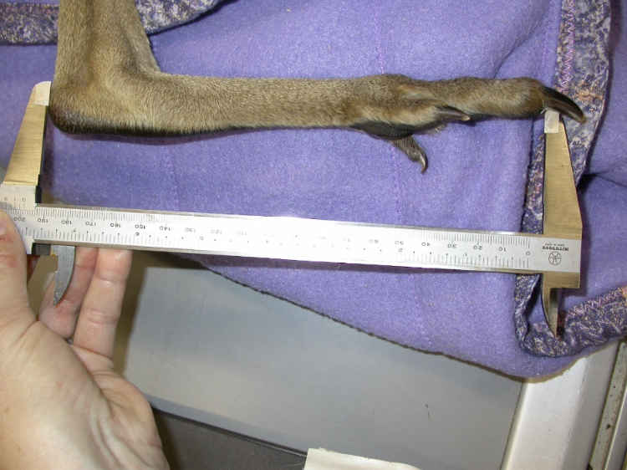

6.9. Release protocol
Ideally, wild animals will be rehabilitated and released in a short timeframe. If this is not possible and the animal is in care for significant extended periods, ensure that the animal is regularly assessed against the welfare domains to support decision-making. Animals in care for extended periods may have a reduced ability to survive in the wild. Talk to your veterinarian and consider whether euthanasia will provide the best welfare outcome the animal.

6.9.1. Pre-release assessment
Pre-release assessment of animals in care is essential to support improved outcomes once back in the wild. Animals should be assessed based on body condition, fitness and the ability to engage in natural species-specific behaviours prior to release.
- Individual is in a state of good health – presenting injury/sickness is completely resolved (consider a pre-release veterinary check).
- Individual is within a healthy weight range and appropriate body condition (refer to Table 6.1 and Table 6.7) .
- Individual displays ability to actively forage and consume natural foods.
- Individual displays appropriate predator avoidance behaviour. For kangaroos and red-necked wallabies, if a predator approaches within 50 m of the mob, they should take flight. If unable to take flight, they should stop grazing, stand up facing the predator and watch its behaviour. Swamp wallabies should demonstrate increased vigilance and seek cover.

6.9.2. At the release site
Post release survival will be maximised by ensuring that both the release site and the way in which the animal is released are carefully considered.
STOP – please refer to the conditions of your authorisation on release location requirements.
- Kangaroos should be transported and released in the early morning to reduce the risk of capture myopathy, while wallabies should be released at dusk.
- Avoid times when heavy rain and strong winds are forecast.
- Avoid release in summer when temperatures are expected to be greater than 38°C for more than three consecutive days.
- For more information on the ecological characteristics and requirements of macropods that may help with their release, please refer to Section 6.1 of this chapter.
For more information on the ecological characteristics and requirements of macropods that may help with their release, please refer to Table 6.1.

6.9.3. Release checklist
Check all of the requirements of your authorisation are being met, and consider the following:

Release location
- Approximate release where animal was found (where suitable, or within home range).
- Suitable vegetation is available, including grasses and dense lower storey vegetation.
- Away from major roads, fences and dams.

Release Procedure
- Limit the number of people at the release.

Release without ongoing support
- If the animal has been sedated for transportation, place it quietly on the ground in a bag until it has recovered.
- A non-sedated animal can be left partly in the bag in a shady area to permit itself to orient to the surroundings before being removed from the bag.
- Open the bag away from trees, fences or people.
- It is important that all people move and speak quietly.
- Observe the animal until it moves away.

Release using a temporary pen
- The pen can be constructed of Hessian cloth suspended by wooden poles.
- After acclimatisation, the gate to the temporary pen can be left open in the early morning and the animals move out in their own time.
- Permission from land holders should be sought prior to using this release technique.

6.10. Key references and additional reading
Corradin, M. 2006. Husbandry manual for swamp wallaby. https://www.yumpu.com/en/document/read/11914937/swamp-wallaby-nswfmpaorg
Coulson, G., and Eldridge, M. 2010. Macropods: the biology of kangaroos, wallabies and rat-kangaroos. CSIRO Publishing, Melbourne
Dawson, T.J. 1995. Kangaroos: the biology of the largest marsupial. University of NSW Press, Sydney.
Dooley, C. 2004. Macropology: a guide to raising and releasing kangaroos and wallabies. https://www.fourthcrossingwildlife.com/--macropology.html#:~:text=Macropology%20is%20a%20fantastic%20guide,and%20easy%20to%20use%20manual
Staker, L. 2014. Macropod husbandry, healthcare and medicinals. http://www.lyndastaker.com/manual.html

