Chapter 2: Snakes

Contents
2.1. Introduction 2
2.2. Species information 3
2.3. Animal and human safety considerations 26
2.3.1. Human safety considerations 26
2.3.2. Animal safety considerations 27
2.4. Capture, restraint, and transport 27
2.4.1. Visual observations 27
2.4.2. Equipment 28
2.4.3. Technique 29
2.5. Monitoring animal health and welfare 33
2.5.1. Physical examination 34
2.6. Ongoing monitoring of health and welfare 37
2.6.1. Common presenting injuries and clinical signs of emerging health conditions 38
2.6.2. Administering treatment 44
2.7. Housing 45
2.7.1. General housing information for snakes 45
2.7.2. Enclosure hygiene and biosecurity 47
2.7.3. Housing types 48
2.8. Feeding and nutrition 49
2.9. Release protocol 51
2.9.1. Pre-release assessment 51
2.9.2. At the release site 51
2.9.3. Release checklist 52
2.10. Key references and additional reading 52

In Victoria, sick, injured or orphaned wildlife can only be rehabilitated by a wildlife shelter operator or foster carer who is authorised under section 28A of the Victorian Wildlife Act 1975 (Wildlife Act). Wildlife rehabilitators are subject to strict conditions. The mandatory requirements that they must meet are set out in the Wildlife Shelter and Foster Carer Authorisation issued under the Wildlife Act. These conditions enforce the minimum standards required for the humane treatment and successful rehabilitation of wildlife in care. The Wildlife Rehabilitator Authorisation Guide: Things You Need To Know explains how wildlife rehabilitators can meet these mandatory requirements and can be found here: https://www.vic.gov.au/wildlife-rehabilitation-shelters-and-foster-carers.
The Victorian Wildlife Rehabilitation Guidelines have been developed to incorporate evidenced-based best practice in wildlife care and rehabilitation to equip rehabilitators to deliver positive welfare outcomes for individual animals in their care from first aid to post-release into the wild.
You must comply with the conditions of your authorisation. These guidelines must be read in conjunction with the conditions of your authorisation.

2.1. Introduction
Victoria is home to 27 species of snakes. The majority of these are venomous and potentially dangerous. Wildlife rehabilitators should not attempt to handle or capture snakes unless they have had suitable training and experience. If bitten by a snake, dial 000 immediately. Wild snakes brumate (becoming sluggish or inactive) over the winter months in southern Australia, but they also often emerge on sunny days in the colder months, and therefore can be encountered in winter. They seek refuge in rocks, logs or leaf litter, often within a few hundred metres of water. This chapter addresses the husbandry, care and welfare of snakes that are commonly encountered in Victoria.
STOP – If a threatened species comes into care, please STOP and refer to your authorisation for mandatory conditions including notification and release requirements.
This chapter also lists some non-endemic and introduced species of snakes. These species pose a threat to native species through predation and the introduction of new animal diseases and should be reported. Notify DEECA or Agriculture Victoria of all exotic snakes in the wild or any that come into care on 136 186 or email highrisk.invasiveanimals@agriculture.vic.gov.au.
When snakes come into care it is the responsibility of the rehabilitator to ensure that the five domains of animal welfare are satisfied. These include providing optimal nutrition and an environment appropriate to the stage of rehabilitation. This is even more important for snakes than for some other species as the rehabilitator completely controls the snake’s environment while in care. The focus should be on the snake’s return to health and release, which is facilitated through regular collaboration with a veterinarian. It is also important to consider the snake’s mental state and ability to exhibit normal behaviours without detrimentally affecting its recovery. Welfare may be temporarily compromised by the necessity of a gradual return to normal activity, depending on its stage of rehabilitation. Further information about the five domains of animal welfare is in Part A of these guidelines.

2.2. Species information
Profiles for the most common snake species found in Victoria are detailed in the tables below. It does not describe all the snake species in Victoria. For assistance in identification of snake species, refer to the recommended reading and reference material at the end of this chapter.
Table 2.1: Species profiles
Species | Diamond python (Morelia spilota spilota)
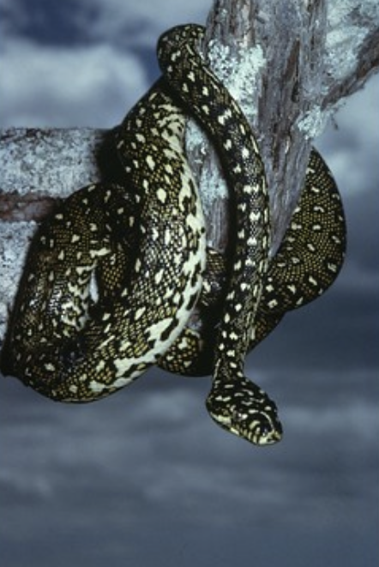  Photo credit: Ian McCann | Distribution map  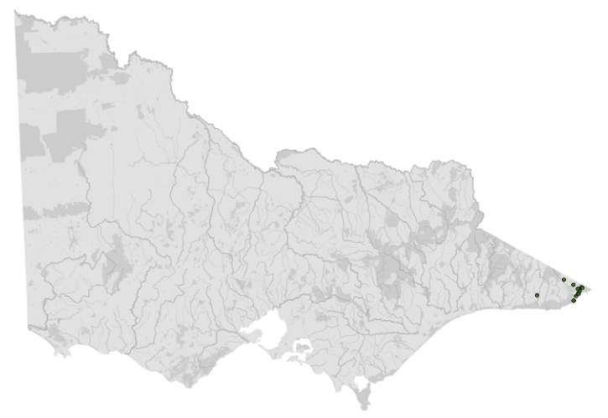  Data source: Victorian Biodiversity Atlas Jan 2023  www.environment.vic.gov.au/biodiversity/victorian-biodiversity-atlas
General appearance | Olive black with cream spots
Snout vent length | 150–400 cm
Venomous | No
Conservation status* | Critically endangered
Habitat | Wet to dry forests, also found in heathland, woodland, coastal rock outcrops
Home range | 2–20 ha
Foraging style | Ambush
Diet | Mostly mammals
Roost or hide | Tree hollow, burrows, rock crevices, dense vegetation
Peak activity | Mainly diurnal
Territorial | Yes
Sexual maturity | 2.5–3 years
Give birth/lay eggs | Summer
Incubation | 6–12 weeks
Litters per year | Average 25 eggs per clutch (9–54 recorded in the wild). Females do not breed every year

Species | Carpet python (Morelia spilota metcalfei)
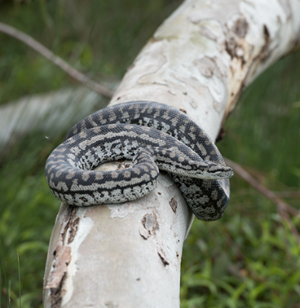  Photo credit: David Paul, Museums Victoria | Distribution map  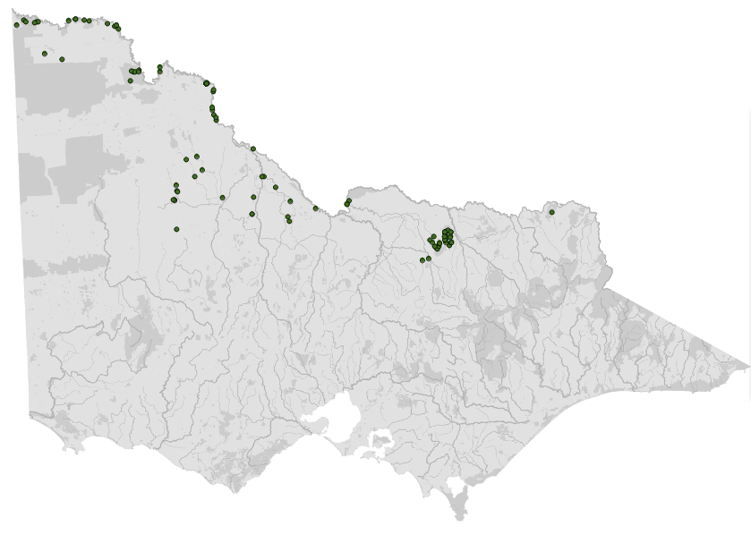  Data source: Victorian Biodiversity Atlas Jan 2023  www.environment.vic.gov.au/biodiversity/victorian-biodiversity-atlas
General appearance | Closely related to the diamond python, but has grey and black patches over back with elongated patches along sides
Snout vent length | 170–300 cm
Venomous | No
Conservation status* | Endangered
Habitat | River red gum forests and blackbox woodlands along major watercourses; rocky hills (often within woodlands) mallee shrublands and freshwater swamps
Home range | 30–150 ha
Foraging style | Ambush
Diet | Small mammals (>50% rabbit) and birds; juveniles eat mostly lizards
Roost or hide | Tree hollow, burrows, rock crevices
Peak activity | Mainly nocturnal
Territorial | Yes
Sexual maturity | 2.5–3 years
Give birth/lay eggs | Summer
Incubation | 50–60 days
Litters per year | 1 clutch of 20 eggs every 3–4 years

Species | Eastern brown snake (Pseudonaja textilis)
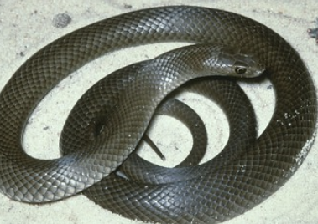  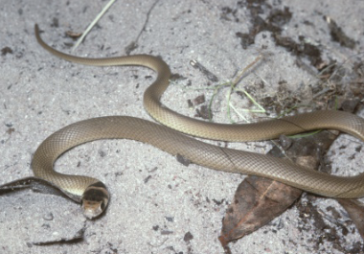  Photo credit: Ian McCann | Distribution map  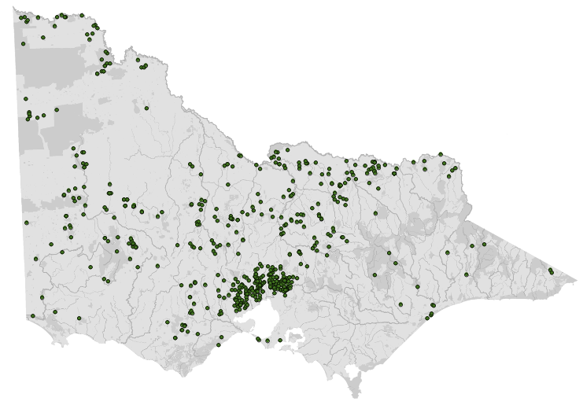  Data source: Victorian Biodiversity Atlas Jan 2023  www.environment.vic.gov.au/biodiversity/victorian-biodiversity-atlas
General appearance | Eastern brown snake. The colour may vary from pale to dark brown. Top and bottom of snake is the same colour. Note the bars on the head in the bottom image, indicating a juvenile animal
Snout vent length | 150–250 cm
Venomous | Yes, fatal
Conservation status* | Common
Habitat | Dry, rocky hillsides to wet forest
Home range | 4–6 ha
Foraging style | Search
Diet | Wide variety, includes rats and mice
Roost or hide | Burrows, hollow logs
Peak activity | Diurnal
Territorial | Yes
Sexual maturity | 3 years
Give birth/lay eggs | Summer
Incubation | 36–95 days
Litters per year | 10–35

Species | Highland copperhead (Austrelaps ramsayi)
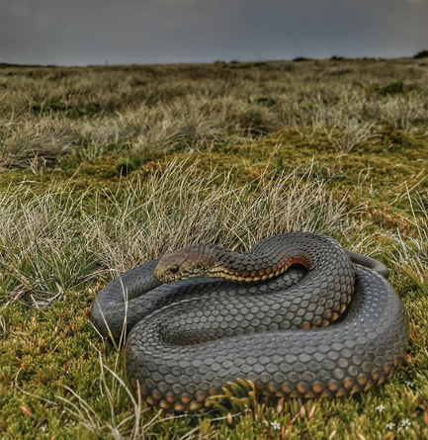  Photo credit: Nick Clemann, DEECA | Distribution map  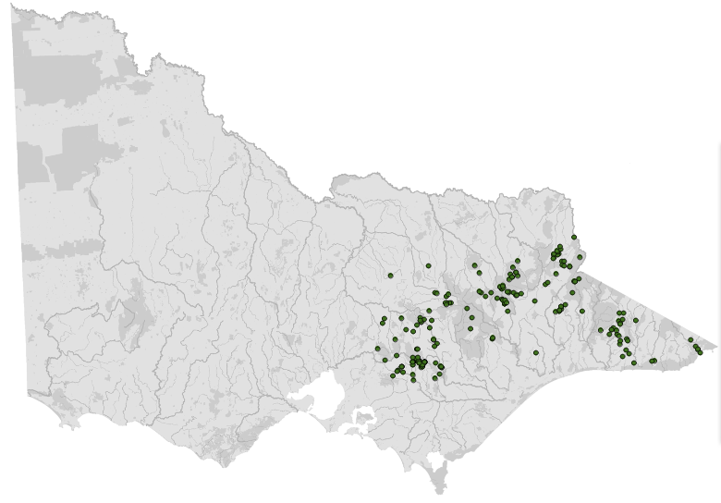  Data source: Victorian Biodiversity Atlas Jan 2023  www.environment.vic.gov.au/biodiversity/victorian-biodiversity-atlas
General appearance | Reddish brown to dark grey; prominently barred lips
Snout vent length | Males SVL 58.8 cm  Females SVL 54.5 cm
Venomous | Yes, fatal
Conservation status* | Common
Habitat | Woodlands and open forest near high altitude creeks, marshes, wetlands
Home range | Unknown
Foraging style | Search
Diet | Lizards (mostly skinks), frogs, snakes
Roost or hide | Logs, rocks, tussocks
Peak activity | Diurnal
Territorial | Yes
Sexual maturity | Males SVL 58.8 cm  Females SVL 54.5 cm
Give birth/lay eggs | Summer
Incubation | Live bearer
Litters per year | 9–31

Species | Lowland copperhead (Austrelaps superbus)
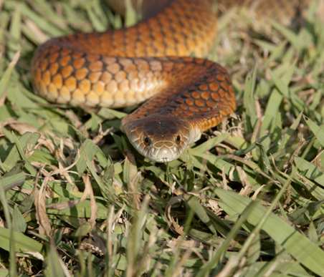  Photo credit: Colin Silvey, Museums Victoria | Distribution map  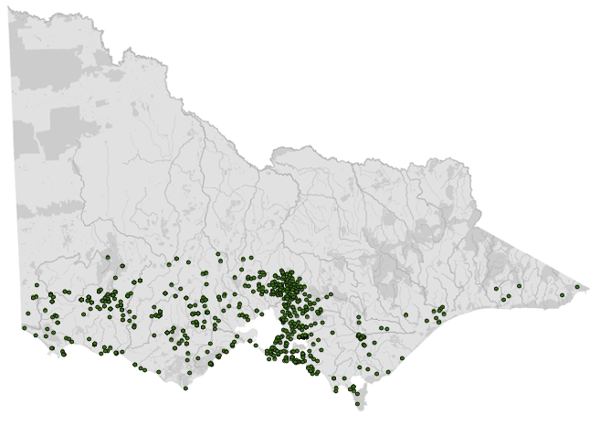  Data source: Victorian Biodiversity Atlas Jan 2023  www.environment.vic.gov.au/biodiversity/victorian-biodiversity-atlas
General appearance | Brown to black; barred colour on lips. Often has vermillion/copper coloured belly
Snout vent length | Males SVL 47.7 cm  Females SVL 43.6 cm
Venomous | Yes, fatal
Conservation status* | Common
Habitat | Marshes, swamps
Home range | Unknown
Foraging style | Search
Diet | Lizards (mostly skinks), frogs, snakes
Roost or hide | Wooden logs, rocks, tussocks
Peak activity | Diurnal
Territorial | Yes
Sexual maturity | Males SVL: 47.7 cm  Females SVL: 43.6 cm
Give birth/lay eggs | January–March
Incubation | Live bearer
Litters per year | 9–45

Species | Red-bellied black snake (Pseudechis porphyriacus)
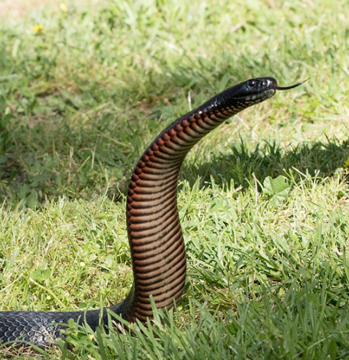  Photo credit: David Paul, Museums Victoria | Distribution map  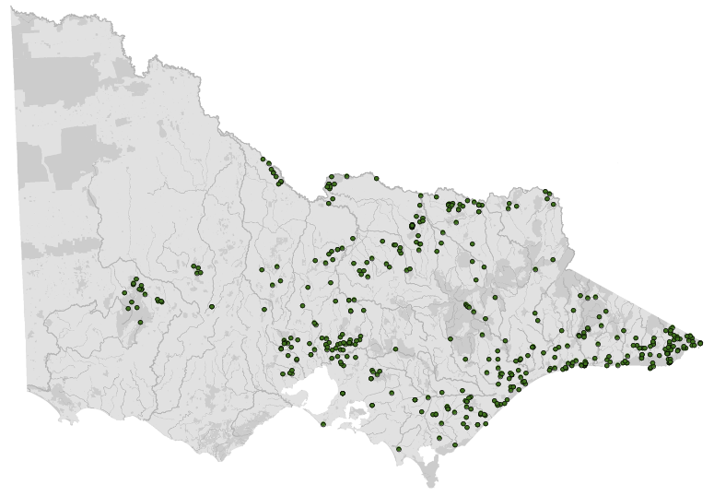  Data source: Victorian Biodiversity Atlas Jan 2023  www.environment.vic.gov.au/biodiversity/victorian-biodiversity-atlas
General appearance | Black with crimson belly
Snout vent length | 150–250 cm
Venomous | Yes, fatal
Conservation status* | Common
Habitat | Stream, swamp, lagoon
Home range | 0.02–40 ha
Foraging style | Search
Diet | Wide variety
Roost or hide | Rocks, logs, burrows
Peak activity | Diurnal
Territorial | Yes
Sexual maturity | 2–3 years
Give birth/lay eggs | February–April
Incubation | Live bearer
Litters per year | 5–18

Species | Tiger snake (Notechis scutatus)
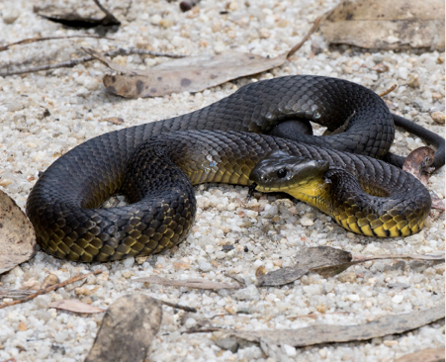  Photo credit: David Paul, Museums Victoria  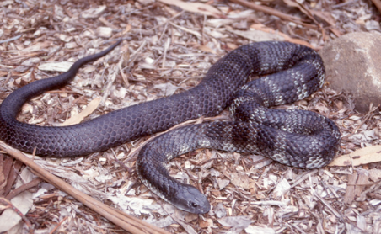  Photo credit: Nick Clemann | Distribution map  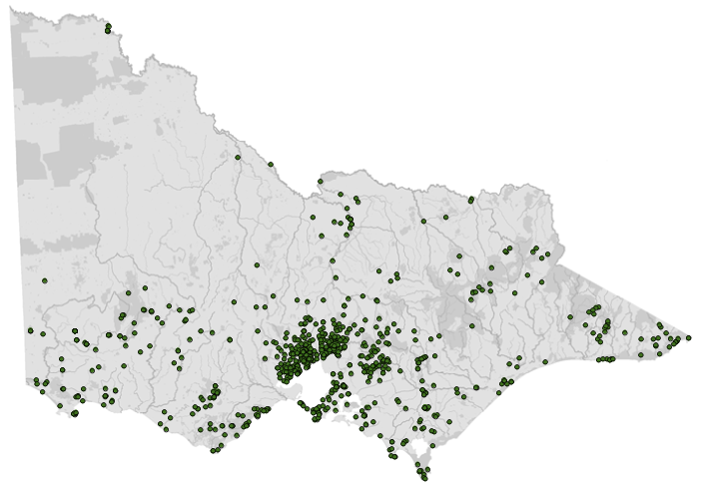  Data source: Victorian Biodiversity Atlas Jan 2023  www.environment.vic.gov.au/biodiversity/victorian-biodiversity-atlas
General appearance | May or may not have bands on body. Note the colour variations in this species
Snout vent length | SVL 75-85 cm
Venomous | Yes, fatal
Conservation status* | Common
Habitat | Woodland to river floodplain
Home range | 3–7 ha
Foraging style | Search
Diet | Wide variety
Roost or hide | Fallen timber, disused burrows
Peak activity | Diurnal but nocturnal in warm weather
Territorial | Yes
Sexual maturity | SVL 75-85 cm
Give birth/lay eggs | Late summer–mid autumn
Incubation | Live bearer
Litters per year | 10–64

Species | Little whip snake (Parasuta flagellum)
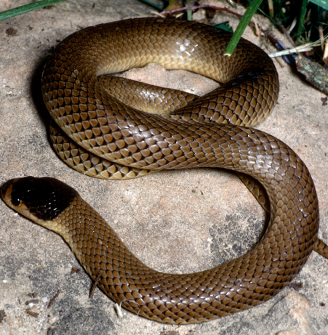  Photo credit: Ian R McCann, Museums Victoria | Distribution map  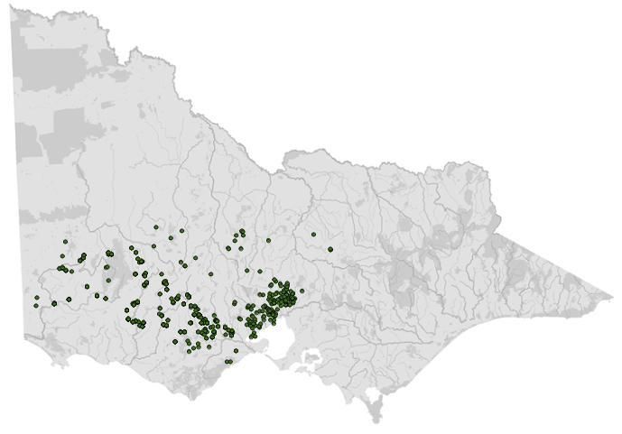  Data source: Victorian Biodiversity Atlas Jan 2023  www.environment.vic.gov.au/biodiversity/victorian-biodiversity-atlas
General appearance | Brown with black on top of head. Little whip snake showing the dark head and brown body
Snout vent length | 30–40 cm
Venomous | Yes, not fatal
Conservation status* | Common
Habitat | Woodland, rocky outcrops
Home range | 1–3 ha
Foraging style | Search and ambush
Diet | Lizards
Roost or hide | Rock crevices
Peak activity | Nocturnal
Territorial | Yes
Sexual maturity | Unknown
Give birth/lay eggs | September–February
Incubation | Live bearer
Litters per year | 2–7

Species | White-lipped snake (Drysdalia coronoides)
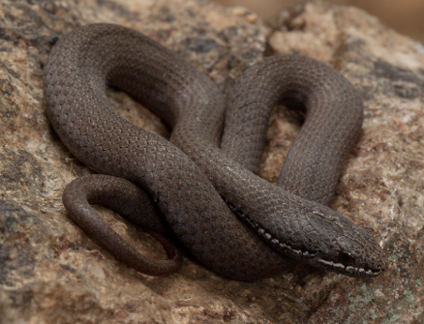  Photo credit: David Paul, Museums Victoria  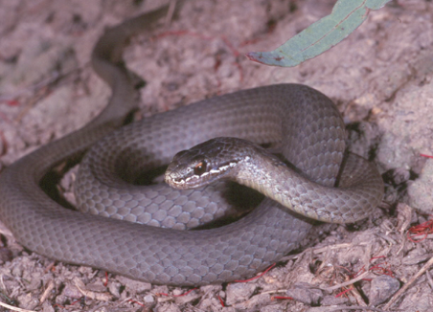  Photo credit: Nick Clemann | Distribution map  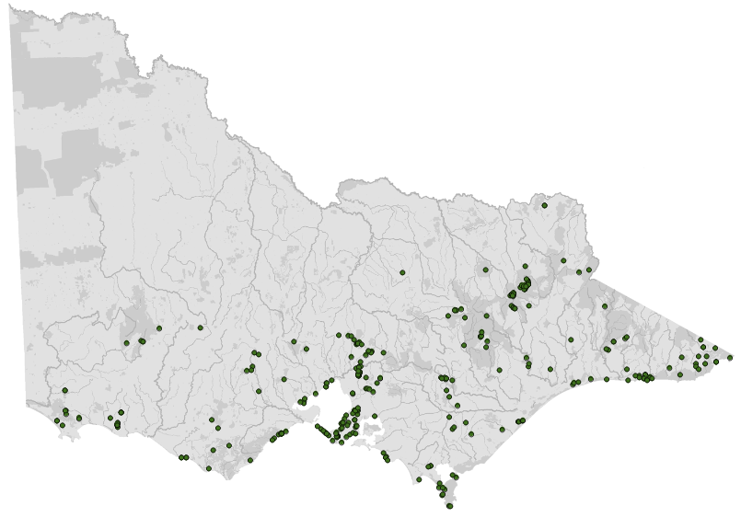  Data source: Victorian Biodiversity Atlas Jan 2023  www.environment.vic.gov.au/biodiversity/victorian-biodiversity-atlas
General appearance | White-lipped snake showing the white scales on the top lip
Snout vent length | 35–50 cm
Venomous | Yes, not fatal
Conservation status* | Common
Habitat | Near water, grasses
Home range | 1–3 ha
Foraging style | Search
Diet | Mostly skinks
Roost or hide | Rocks, logs, litter
Peak activity | Mainly diurnal
Territorial | Yes
Sexual maturity | 3 years
Give birth/lay eggs | March–April
Incubation | Live bearer
Litters per year | 2–10

Species | Eastern small-eyed snake (Cryptophis nigrescens)
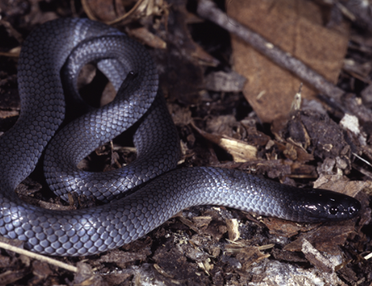  Photo credit: Nick Clemann | Distribution map  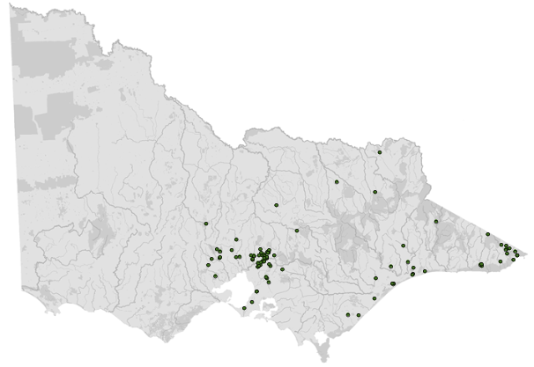  Data source: Victorian Biodiversity Atlas Jan 2023  www.environment.vic.gov.au/biodiversity/victorian-biodiversity-atlas
General appearance | Black with cream to pale pink belly
Snout vent length | Males SVL 26.3 cm  Females SVL 28.5 cm
Venomous | Yes, fatal (one human fatality)
Conservation status* | Common
Habitat | Rainforest, wet sclerophyll forest, woodlands, heaths, rocky outcrops
Home range | Unknown
Foraging style | Search and ambush
Diet | Mostly skinks
Roost or hide | Rocks, bark, fallen timber
Peak activity | Mainly nocturnal
Territorial | Yes
Sexual maturity | Males SVL 26.3 cm  Females SVL 28.5 cm
Give birth/lay eggs | October–April
Incubation | Live bearer
Litters per year | 4–8
*From the Flora and Fauna Guarantee Act 1988 Threatened List June 2023. This list is updated regularly throughout the year. For the most current list, please visit https://www.environment.vic.gov.au/conserving-threatened-species/threatened-list.
Table 2.2: Non-endemic native and exotic snake species that are kept under permit
Species | Introduced or non-endemic | Declared pest animals/kept in Victoria | Description
Children’s python (Antaresia childreni)  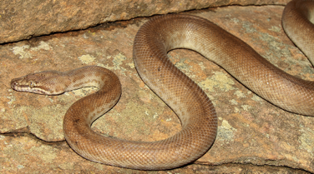  Photo credit: Shutterstock | Non-endemic | Not declared, can be kept but not released | 75–100 cm, spotted, northern Australian, non-venomous snake
Spotted python (Antaresia maculosa)  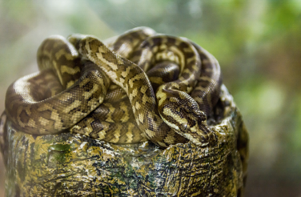  Photo credit: Shutterstock | Non-endemic | Not declared, can be kept but not released | 100–140 cm, blotched, northern Australian, non-venomous snake
Corn snake (Pantherophis guttatus)  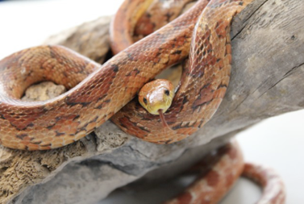  Photo credit: AgVic | Introduced | Declared pest animal, must not keep in Victoria | 61–182 cm, brightly marked, North American, non-venomous snake
Reticulated python (Malayopython reticulatus)  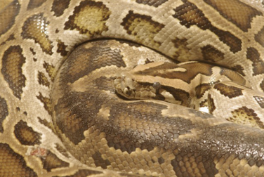  Photo credit: AgVic | Introduced | Declared pest animal, must not keep in Victoria | 1.5–6.5 m, reticulated patterned, South and Southeast Asian, non-venomous snake
Boa constrictor (Boa constrictor)  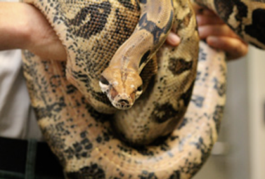  Photo credit: AgVic | Introduced | Declared pest animal. Can only be kept under restricted permit | 3–5 m, varied colouring/markings, South American, non-venomous snake
Burmese python (Python bivittatus)  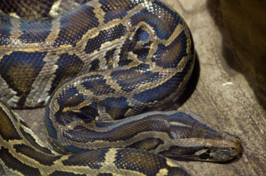  Photo credit: AgVic | Introduced | Declared pest animal, must not keep in Victoria | 3–5 m, brown blotched, Southeast Asian, non-venomous snake
The introduced species listed in Table 2.2 are not native to Australia and if given the opportunity could populate a wide range of landscapes within Victoria, impacting native wildlife through predation and the introduction of new animal diseases.
These introduced snakes are classified as a controlled pest animal under the Victorian Catchment and Land Protection Act 1994. The importation, keeping, breeding and trading of this species, without appropriate permits, is illegal and penalties apply.
These introduced snakes have been found in all states in Australia, including Victoria and are typically escapees or deliberately released animals from the illegal pet trade.
Exotic and native species non-endemic to Victoria must not be released into the wild. In cases where the animal is suspected to be an escaped pet, take the animal to a veterinarian to be scanned for a microchip. If an owner can be identified, the animal should be returned as soon as possible. Occasionally exotic snake species come into care. It is illegal for wildlife rehabilitators to be in possession of such species. These animals must be euthanised as they are considered potential pests and pose a threat to native species. Notify DEECA or Agriculture Victoria of all exotic snakes in the wild or any that come into care on 136 186 or email highrisk.invasiveanimals@agriculture.vic.gov.au or https://agriculture.vic.gov.au/biosecurity/pestanimals/report-an-exotic-pest-animal-sighting.
A few examples of non-endemic and exotic species are listed in Table 2.2. The list is not intended to be exhaustive or representative.

2.3. Animal and human
safety considerations
In general, animals in the wild have limited contact with people, pets, and the hustle and bustle of our daily lives. When sick, injured or orphaned wild animals come into care this unnaturally close contact can carry risks to the health and safety of both people and animals. For general information on biosecurity and approaches to minimise these risks see Part A of these guidelines. Specific information on enclosure hygiene and biosecurity for snakes is in Section 2.6.2.
The following information relates to the human and animal health and safety considerations specifically related to the rehabilitation of snakes.

2.3.1. Human safety considerations
- Wash hands with soap and water after handling frogs to minimise the risk of infection with zoonotic disease agents such as Salmonella.
- Wildlife rehabilitators should not attempt to handle or capture snakes unless they have had suitable training and experience due to the potential risk of harm to the snake, or to the rehabilitator. A first aid (HLTAID003) course with proficiency in bandaging for snake bite is also recommended.
- Almost all of the snakes found in Victoria are venomous. If there is any possibility that the snake is a venomous species, a licenced/trained venomous snake handler should be sought. A bite from these snakes may produce envenomation which can be fatal to humans due to paralysis of the respiratory muscles. If bitten by a snake, dial 000 immediately.
- Juvenile snakes are just as venomous as adults.
- Non-venomous snakes can still deliver a painful bite that can become infected.

2.3.2. Animal safety considerations
- When used correctly by a licensed venomous snake handler, tongs and jigger sticks are legitimate tools for capturing and handling venomous snakes. However, inappropriate force from these instruments can injure the snake.

2.4. Capture, restraint, and transport
Refer to Part A of these guidelines for general advice on wildlife welfare, biosecurity and hygiene, and record requirements. The following information relates to the capture, restraint, and transport of sick, injured and orphaned snakes.

2.4.1. Visual observations
Visual observations of wildlife should be conducted prior to any attempts to capture the animal. This is just as important prior to the first capture from the wild as it is before any capture conducted while an animal is in captive care. Observations should be conducted quietly, by one person, and from a distance which provides a clear view of the animal with as little disturbance as possible. Visual observation should focus on the animal’s demeanour, behaviour, movement and posture. Check for evidence of injury/severe disease or deterioration and assess their breathing as demonstrated in the following table.
Table 2.3: Visual health observations in snakes
Observation | What to look for
Demeanour | - Appears alert  - Tongue flicks out of the mouth at regular intervals
Behaviour | - Should attempt to move away, hide or strike if approached
Movement and posture | - Moves freely on its belly  - Entire body moves
Breathing | - Nostrils are clear and open  - Breathing is regular  - No open mouth breathing

2.4.2. Equipment
- Personal protective equipment including long sleeves and trousers with covered shoes are to be worn during capture and handling.
- First aid kit, including a snake bite bandage should be on-hand at all times during snake capture and handling.
- A pinning or hook stick can be used with a hoop net. A pinning stick has a long handle with a T-shaped end covered with rubber. Prior training in the use of a pinning stick is required to prevent damage to the snake from its use.
- Tongs and jigger sticks may be used.
- Snake bag: This is a cloth bag with a rigid rim on a short pole. See Figure 2.1. The corners of the bag are sewn to create a curved edge. The pole should be detachable from the rim so that the snake does not need to be transferred to a calico bag for transport.
- Alternatively, the snake is transported inside a pillow case or calico bag inside a container. The bag is secured with a cable tie, rope or pipe cleaner. Pillow cases and calico bags should be inspected prior to use to ensure no loose threads on the inside where snakes can become entangled during transport.
- Solid-walled enclosure with sufficient ventilation: Examples include rubbish bins with clipped lids, ClickClack containers (for small snakes), eskies or plastic tubs all with holes cut for ventilation.
- Enclosures for transportation of snakes should be labelled: ‘CAUTION: LIVE VENOMOUS (or NON-VENOMOUS) SNAKE’ with a contact number, in the event of an accident.
Figure 2.1: Snake bag. Photo credit: Zoos Victoria
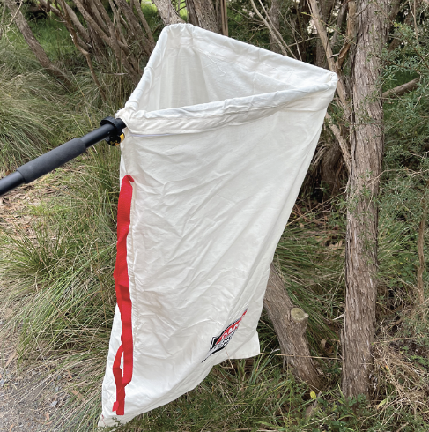

2.4.3. Technique
It is beyond the scope of these guidelines to outline techniques for every situation that may be encountered. Examples of techniques for some specific situations are outlined in the following section.
In addition to this information, for further advice please also refer to the recommended reading list, zoological institutions, veterinarians and/or wildlife experts. Inexperienced rescuers should request assistance where possible.
- Venomous snakes should not be handled unless the person has had training and demonstrated competency in handling these species.
- Whenever possible, avoid picking up the snake. Use the jigger or hook stick to move the snake into a darkened bag.
- The preferred method of snake restraint involves the use of clear plastic tubes, with lids that can be secured, slightly larger than the width of the snake (see Figure 2.5).
- A snake hook is used to reach the snake’s tail that is then held by hand. The snake is positioned on the floor against a wall. As the snake moves along the wall the tube is positioned in front of it so that the snake crawls into it. This process can also be completed with the snake in a garbage bin. Gloves should be worn as snakes will often attempt to bite the inside of the tube releasing venom. This venom can be absorbed through any wounds on the hands and via mucous membranes. Snake handling and holding equipment should always be rinsed well after use.
- The snake could also be restrained using a pinning stick to immobilise the head so that it can then be restrained by hand. This should only be done by an experienced handler. The body is supported by the other hand.
Figure 2.2: a. Restraint of a snake using the thumb and index finger to immobilise the head. b. A hook and pinning stick are shown. Photo credit: Zoos Victoria
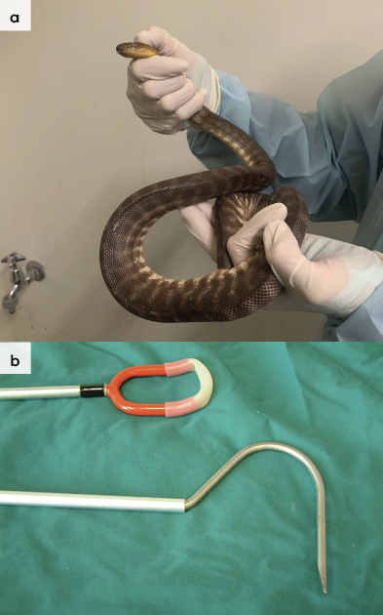

Entanglement
Snakes can become entangled in netting and wire, or stuck inside cans. Rather than attempting to free the snake at the site, cut the netting/wire and take the snake with the netting/wire to a veterinarian. The netting/wire may then be cut away or the snake extracted from the can while the snake is anaesthetised.
Figure 2.3: A tiger snake’s head is trapped inside a can. (Extreme care must be taken. Snake was anaesthetised to remove the can). Photo credit: Zoos Victoria
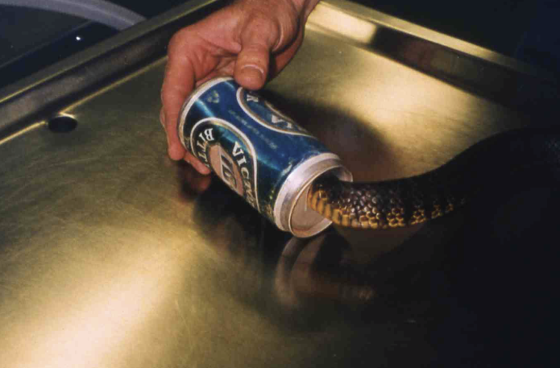

Predation
Trained and accredited snake handlers should ensure pets are restrained and removed from the scene prior to the capture process to prevent them being bitten, and to prevent further injury to the snake (for example dog bites). The pet owner should also be advised to take their pet to a veterinarian if there is a chance that the animal has been bitten. If the snake is injured, there may be a high likelihood the pet has been bitten.

Side of the road
Snakes that have been victims of vehicle trauma may be severely injured but may still be able to move quickly and unexpectedly. Performing any animal capture work near a road also poses an inherent danger to the responder, due to the presence of oncoming traffic. Use high caution and assess for potential hazards when capturing animals next to roads and when handling the snake itself. Ideally, a trained and accredited snake handler should be called to perform the rescue.

Transport
- Snakes should be transported in a solid sided container such as a bin, ClickClack or esky with air holes.
- All containers holding snakes should have lids that can be secured.
- Ideally, snake holding/transport containers should be clearly labelled with ‘Contains venomous snake’.
- The vehicle should be air conditioned but should not go below 20°C.
- Food and water do not need to be provided.
Figure 2.4: Example of label for transport container holding venomous snake. Photo credit: Zoos Victoria
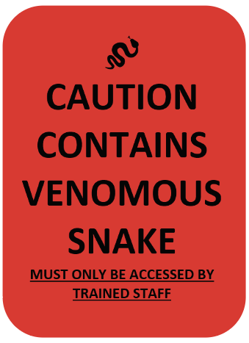

2.5. Monitoring animal health and welfare
The goal of wildlife rehabilitation is to address health and welfare concerns quickly and effectively so wildlife can be released back to the wild as soon as possible. Decision-making from the time of capture through to release should be guided by an accurate understanding of the animal’s true state of health and welfare. Careful monitoring throughout the rehabilitation period ensures that significant issues, or deterioration in health condition, are identified immediately and rapidly addressed.
It is preferred that all sick, injured or orphaned wildlife be assessed by a veterinarian to ensure that non-obvious signs of trauma or disease can be assessed and treated as soon as practicable. No medication should be provided prior to this assessment, as this can mask clinical signs and make an accurate health assessment by the veterinarian very difficult.
Templates for record-keeping visual and physical observations and daily care can be found in Part A of these guidelines.
This section provides guidance on health assessments on arrival and on effective monitoring of the health and welfare of individuals in care through minimising human-animal interactions and stress to the animal to maximise successful release back to the wild.

2.5.1. Physical examination
If not a trained snake handler, one should be engaged to assist when performing any examination or intervention with a venomous snake. Once visual observations are complete, and the animal is stable enough to withstand capture and handling, a basic physical examination should be conducted. This can be repeated when required any time the carer has the animal in the hand, such as for an enclosure change. However, if a full physical exam is not conducted, body condition and weight should be assessed every time the animal is in the hand for other reasons. Carers should make sure weighing scales are available and ready to use before capturing the animal. Physical examinations are also required if the carer notices any changes suggestive of deteriorating health or injury.
Always record the physical examination findings, so that you can compare findings as the animal’s rehabilitation progresses. This ensures any health concerns are identified as soon as possible, and the carer can plan release as soon as appropriate. A template for recording physical examination findings can be found in the appendices to Part A of these guidelines.
Examinations should be conducted in a quiet location, away from domestic animals. Only a trained venomous snake handler should handle a venomous animal, while a second person takes notes. Experienced python handlers should handle those species. All other people should move away, and noise kept to a minimum. Handling should also be kept to a minimum, with careful monitoring for any signs of distress (such as sudden deterioration in demeanour or a limp posture). If these are seen, the examination should be stopped immediately and the animal returned to its catch bag, transport box or enclosure and allowed to recover.

Species specific considerations:
- Examination of venomous snakes is best performed under general anaesthesia. Clear plastic tubing can be used to examine and anaesthetise venomous snakes. Restraint in this type of manner should be performed by a trained snake handler.
- Manual restraint can be used to examine pythons. However, care should be taken not to cause injury to the animal. Only those experienced in handling pythons should undertake manual restraint. It is important to restrain the head to avoid being bitten.
- Physical examinations should be performed when the snake’s body temperature is within its preferred body temperature zone (PBTZ) to permit the normal display of behaviour. Table 2.4 summarises normal presentations to assist with identifying illnesses and injuries.
Figure 2.5: Snake restrained inside a plastic tube. Photo credit: Shane Simpson
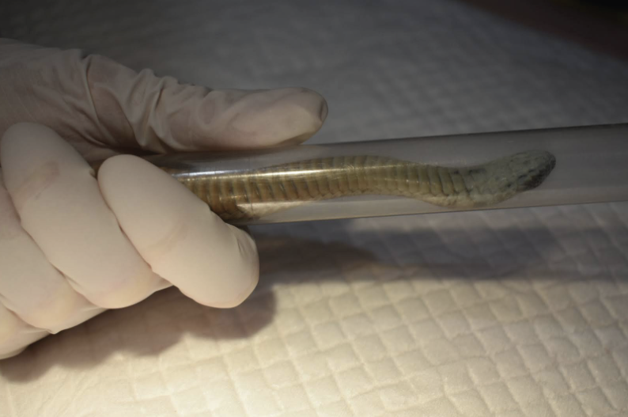
Figure 2.6: Snake physical examination. Photo credit: Zoos Victoria
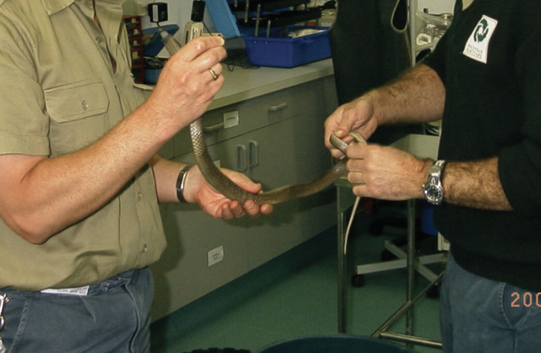
Table 2.4: Physical examination of snakes
 | What to look for
Body weight | - Record body weight on arrival and at least weekly while in care.  - A greater than 10% change in body weight is cause for concern, and the carer should seek veterinary advice.
Body condition | Body condition is scored by palpation of the muscles either side of the spine:  - Under condition: Spine is pronounced. Adjacent muscles are concave.  - Ideal condition: Spine is easily palpated. Muscle profile is triangular.  - Over condition: Spine cannot be felt. Muscles protrude above the spine.
Hydration status | - Skin should glide over muscles and should not tent.  - Skin should be taut and not wrinkled.
Eyes | - Clear unless the snake is sloughing when they will appear blue or cloudy.
Mouth | - Will be difficult to see unless anaesthetised. Should be pale pink unless pigmented.  - No swelling or cheesy material, which may indicate a mouth infection.
Cloaca | - Pink with no accumulation of faeces or urates.
Skin condition | - Scales should be smooth and shiny (unless sloughing when they become dull) with no wrinkles.
Tail | - Should end in a distinct point.
Sex determination | - Not usually relevant to its rehabilitation.  - Determined by inserting a probe into the hemipenal pocket.  - If not done properly it can be dangerous for the snake and the handler.  - It should only be performed by a veterinarian or trained snake handler.

2.6. Ongoing monitoring
of health and welfare
The aim of wildlife rehabilitation is to ensure animals recover and can be released back to the wild as quickly as possible. Careful, daily monitoring is required to ensure that animals are responding as expected to the treatment being provided and so that any deterioration or welfare concerns can be identified and addressed as soon as possible. Rehabilitators should ensure that record-keeping is a priority to maximise positive welfare outcomes. Templates to assist wildlife rehabilitators to record and monitor wildlife health and welfare can be found in the appendices to Part A of these guidelines. These records will be valuable tools to share with veterinarians to support decision-making.
The following is recorded daily:
- demeanour
- food consumption
- faecal/urine output
- behaviour observed
- medical treatment provided
- evidence of overnight activity.
The following is recorded weekly:
- weight
- body condition.
Over time, regular monitoring will also help to develop carer skills and knowledge, as regular observations and recording will result in a deep understanding of the expected behaviour and response to treatment for the species in care.

Species specific considerations:
- The snake should be observed at least daily.
- Note the snake’s demeanour and behaviour every time food is introduced or taken away, the animal is medicated or the enclosure is cleaned. Pay particular attention to any changes that have occurred since the previous day.
- Note faecal consistency. The snake should pass solid brown faeces, pasty white urates and liquid urine, which may not be detectable if it has soaked into the substrate. If diarrhoea is noticed, a faecal sample should be collected and submitted to the veterinarian for assessment as soon as possible. Do not treat on suspicion of a bacterial or parasitic infection, as this can make definitive diagnosis very difficult and potentially prolong the course of the disease.
- Venomous snakes should only be handled by trained/experienced personnel.

2.6.1. Common presenting injuries and clinical signs of emerging health conditions
Clear guidance on conditions that may require euthanasia can be found in Part A of these guidelines.
Table 2.4 lists common clinical signs and possible causes of injury/disease. Carers should be aware that these are not exhaustive. Aside from first aid, carers should avoid administering medications prior to the provision of veterinary advice.
Unusual clinical signs or mass mortality events – a number of animals dying or found dead at the same time, with similar signs – may indicate an emergency animal disease, an emerging/new infectious disease or an environmental/human related toxicity which needs further investigation. Report these immediately to the Emergency Animal Disease Watch Hotline on 1800 675 888 (24 hours).
Table 2.5: Common injuries and clinical signs of emerging health conditions seen on presentation or during care
Injury or clinical signs | Possible causes | Carer observations and response
Note: Do not provide pain relief or other medication, including antibiotics, unless under veterinary guidance and supervision, as these can have severe side effects, particularly in dehydrated/shocked animals. Use of antibiotics when not indicated can contribute to antimicrobial resistance and reduced drug efficacy.
Grazes  Scratches  Bites  Unable to move properly | Trauma from vehicles  Predators  People | - Seek veterinary attention.  - Medication should be given as directed by the veterinarian.  - All snakes should be held in their preferred body temperature zone (PBTZ) and provided with heat and UV light. See Table 2.6.
Entanglement | Rubbish  Netting  Yabby traps etc. | - Seek veterinary attention to extricate safely and for damage to scales to be assessed.
Open mouth breathing  Bubbles from the nostrils  Increased mucous in the mouth | Respiratory tract infection due to poor husbandry  Disease | - Seek veterinary attention.  - Medication should be given as directed by the veterinarian.  - All snakes should be held in their PBTZ and provided with heat and UV light. See Table 2.6.
Bleeding gums  Swollen mouth  Cheesy material visible in the mouth | Stomatitis due to poor husbandry  Disease  Trauma | - Seek veterinary attention.  - Medication should be given as directed by the veterinarian.  - All snakes should be held in their PBTZ and provided with heat and UV light. See Table 2.6.
Lumps under skin | Sparganosis  Abscess  Herniation | - Seek veterinary attention to differentiate.
Burns | Poor husbandry  Hot environmental surfaces  Bushfire | - Seek urgent veterinary attention.  - Burn injuries are very painful, to ensure good welfare, animals must be assessed by a veterinarian as soon as possible.  - Treatment may require multiple visits to a veterinarian for bandage changes under anaesthesia, and to ensure adequate pain management.  - Burn injuries may result in scars that may impact future skin shedding.  - Determine the cause of the burn and modify the enclosure to prevent it happening again.  - Newspaper is a suitable substrate in the snake enclosure as it will prevent contamination of the wound during the healing process.
Restlessness  Spending time soaking in the water bowl  Small moving specks seen on the skin, particularly around the eyes, labial pits and cloaca | Mites secondary to contact with other reptiles  Poor husbandry  Disease process or injury compromising animal | - Seek veterinary advice.  - Animals with heavy burdens of parasites should be presented for veterinary examination to ensure the parasite infestation is not secondary to another disease or injury.  - Do not house wild snakes in the same room as other/pet reptiles.  - The enclosure may be treated with pyrethrin sprays e.g. Callington Reptile Enclosure Insecticide (formerly Top of Descent). Use as directed on the label. Rinse the enclosure thoroughly before returning animals.  - Remove water bowls for up to 24 hours when treating enclosures to ensure no incidental ingestion of mite treatment by snakes.  - In severe cases snakes can be directly treated with Frontline flea spray (active ingredient fipronil). Be careful of eyes and eye area. A cotton tip is useful for applying the Frontline solution to these areas (spray a cotton tip and wipe around the eye area).  - After spraying, animals should be held in a clean tub or bin for 15 minutes. Following this they should be gently rinsed and returned to the treated enclosure.  - During treatment the enclosure can be placed in a water bath, or Vaseline lotion used around the edges to prevent mites spreading to other enclosures.  - Disinfect or discard any cage furniture between snakes.  - Snake should be visibly free of mites prior to release into the wild.
Retained pieces of skin or scales over the eyes/foggy/clouded appearing eyes | Abnormal pattern of shedding of the dead out skin  Dysecdysis | - Seek veterinary attention as required.  - Identify housing issues that may contribute to dysecdysis such as low temperature and humidity.  - Place coarse rocks in the enclosure to provide surfaces for the animal to rub against while shedding.  - Individuals can be soaked for 10–30 minutes in a shallow bowl of luke-warm water. Ensure access to a trained handler.  - Assist shedding after the soaking period.
Figure 2.7 A wild diamond python with predation injuries to its back. The bites have extended through the skin and exposed the muscles below. Photo credit: Anne Fowler
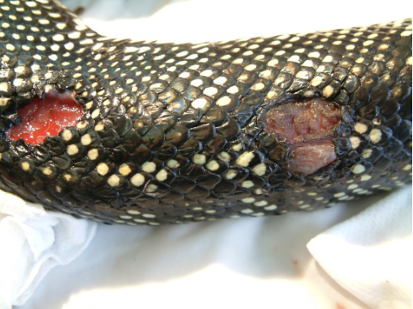
Figure 2.8 An eastern brown snake entangled in fruit tree netting. Photo credit: Zoos Victoria
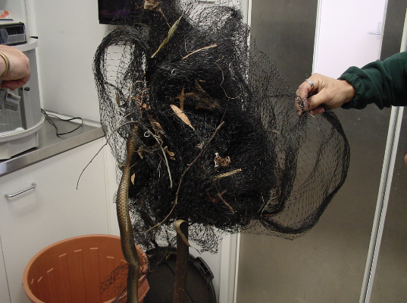
Figure 2.9 Facial burns on a python. Photo credit: Shane Simpson
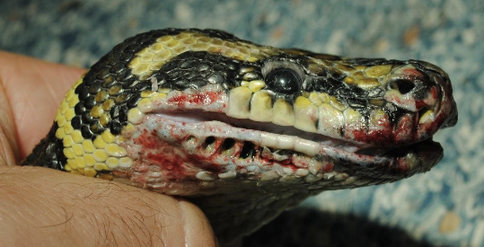
Figure 2.10 A carpet python with severe stomatitis. Note the red and swollen gums. Photo credit: Zoos Victoria
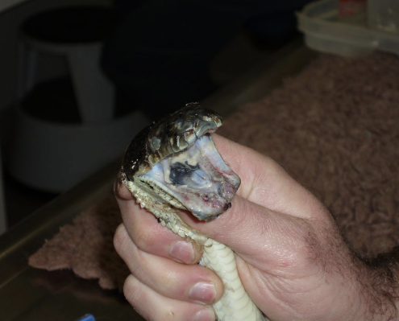
Figure 2.11 A tiger snake having a larval Spirometra erinacei (sparganosis) removed from under the skin by a veterinarian. Photo credit: Zoos Victoria
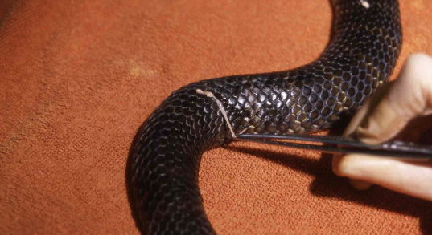

2.6.2. Administering treatment
- Oral medications are usually placed in a food item such as a rat or mouse.
- Any treatment requiring the handling of a venomous snake should only be done by someone that has had suitable training and experience under the direction of a veterinarian.
- Non-venomous snakes should be treated as directed by a veterinarian.

2.7. Housing
Below are several key considerations when housing snakes in care.

2.7.1. General housing information for snakes
All snakes should be housed within their preferred body temperature zone and preferred humidity level during their time in care. See Table 2.6.
Intensive care, intermediate and pre-release housing are identical. Snakes are generally housed individually. Wild snakes should not be housed in the same room as other reptiles. Enclosures used for captive snakes should never be used for wild snakes.
Table 2.6: Snake enclosure temperatures
Species | Basking temp (°C) | Temperature gradient (°C)  Summer | Temperature gradient (°C)  Winter | Humidity (%) | PBTZ (°C) | Other enclosure set up specifications
Diamond python/Carpet Python | 32–35 | 25–35 | 20–25 | 40–80 | 28–30 | Heat pad under enclosure floor, including nest box and a third of the enclosure. No heat lamps overnight. UV 1–4 hours/day.
Eastern brown snake | 32–35 | 25–35 | 25–30 | 40–80 | 35 | Heat pad under enclosure floor, including nest box and a third of the enclosure. No heat lamps overnight. UV 1–4 hours/day.
Copperhead | 30 | 25–30 | 25–30 | 40–80 | 28–30 | Heat pad under enclosure floor, including nest box and a third of the enclosure. No heat lamps overnight. UV 1–4 hours/day.
Little whip snake | 30 | 25–30 | 25–30 | 40–80 | 30 | Heat pad under enclosure floor, including nest box and a third of the enclosure. No heat lamps overnight. UV 1–4 hours/day.
Red–bellied black snake | 30–33 | 25–30 | 25–30 | 40–80 | 31 | Heat pad under enclosure floor, including nest box and a third of the enclosure. No heat lamps overnight. UV 1–4 hours/day.
Tiger snake | 30–33 | 25–30 | 25–30 | 40–80 | 28–30 | Heat pad under enclosure floor, including nest box and a third of the enclosure. No heat lamps overnight. UV 1–4 hours/day.
White-lipped snake | 30–33 | 25–30 | 25–30 | 40–80 | 31 | Heat pad under enclosure floor, including nest box and a third of the enclosure. No heat lamps overnight. UV 1–4 hours/day.
Eastern small-eyed snake | 28 | 25–30 | 25–30 | 40–80 | 18–23 | Heat pad under enclosure floor, including nest box and a third of the enclosure. No heat lamps overnight. UV 1–4 hours/day.

2.7.2. Enclosure hygiene and biosecurity
General information about hygiene and biosecurity can be found in Part A of these guidelines. It is important to maintain the highest levels of hygiene and biosecurity to avoid inadvertently transferring diseases between animals and from humans, and to protect the wild population where the animal will eventually return to.

Species specific considerations:
- Wash hands with soap and water after handling snakes, their substrate or furniture to minimise the risk of infection with zoonotic disease agents such as Salmonella.
- Ideally examination gloves should be worn and changed between each animal.
- Left-over food and faecal matter should be spot cleaned daily from enclosures to ensure good levels of hygiene are maintained.
- Enclosures used to house sick/injured snakes should be cleaned and disinfected between inhabitants. Substrate should be completely replaced and furniture, such as branches or boxes made of unsealed wood, should be discarded as they cannot be effectively disinfected.
- Enclosures should be cleaned with hot soapy water and then disinfected with products such as F10 SC or bleach, used at appropriate concentrations and contact times. If using bleach, it must be thoroughly rinsed before.

2.7.3. Housing types
Intensive care, intermediate and pre-release housing are identical and depend on the length of the snake. The enclosure should be large enough to allow the snake to stretch out to its longest length.
Table 2.7: Rehabilitation housing for adult snakes
Example | Snake length | Dimensions L x W x H | Housing type
Little whip snake | <0.6 m | 0.60 m x 0.30 m (0.18 m²) x 0.30 m | Glass fish tank, but wooden enclosures retain heat better. Tanks can be further insulated by sheets of polystyrene foam. House in a quiet room as snakes are sensitive to vibrations.
Tiger snake, copperhead | 0.6–1.2 m | 1.0 m x 0.4 m (0.4 m²) x 0.5 m
Eastern brown snake | 1.2–2.5 m | 1.5 m x 1.0 m (1.5 m²) x 1.2 m
Diamond python | >2.5 m | 2.0 m x 1.0 m (2.0 m²) x 1.5 m
Table 2.8: Key aspects of housing for snakes during rehabilitation
Term | Parameter
UV light | A natural light cycle of 12 hours light and 12 hours dark is required. A UV light on a timer should be used to provide some of this light cycle.
Temperature | Provide heat using ceramic heat lamps, or incandescent globes. These should never be used inside the enclosure to minimise the risk of thermal burns and should not be in direct contact with wood or plastic to reduce the risk of the enclosure catching fire. Heat pads and heat rocks may pose a risk of burning the snake but could be used with a thermostat. A heat gradient should be provided across the enclosure with a cooler area being available.
Furniture | A rough surface, such as a natural rock, may be included to provide a surface for the snake to rub against when it starts shedding. All snakes need access to a hide. This may be as simple as a cardboard box. A disposable hide is preferred to reduce the risk of disease transmission between snakes. The snake should be able to fit its entire body into the hide. Diamond pythons are arboreal and require sturdy branches for climbing and basking.
Water | A wide, shallow water bowl, large enough to contain the entire snake, is required for drinking and bathing.
Figure 2.12: An example of a snake enclosure. Note the light above the cage and the wooden box used as a hide. Newspaper is used as a substrate. Photo credit: Zoos Victoria
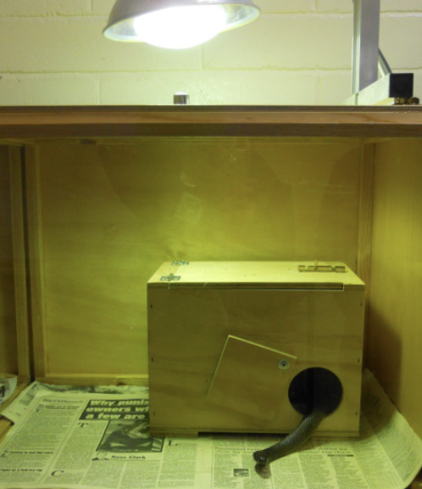

2.8. Feeding and nutrition
Keeping daily records of food offered (item and volume fed) and food consumed is good practice and will allow the rehabilitator to observe appetite, and whether the animal is consuming a balanced diet, or is preferentially consuming only certain food items offered.
Please note: Food suppliers and specific products mentioned in these guidelines are intended as examples only. Other suitable products may also be available.
This section refers to feeding and nutrition of snakes in rehabilitation.
STOP – Please refer to your authorisation for mandatory conditions regarding live feeding.
- Due to welfare concerns for both the snake and its prey, it is ethically inappropriate to offer live prey to snakes.
- As natural prey such as lizards or frogs are also protected species in Victoria, it is an offence to collect them from the wild and offer them as food.
- It is also illegal to keep exotic species of frogs and reptiles as food items for snakes.
- White-lipped, little whip and small-eyed snakes will likely require assist feeding of artificial diets if being held for a prolonged period (>1 month).
Table 2.9: Feeding and diet guide for adult snakes during rehabilitation
Species | Captive diet | Feeding frequency
Red-bellied black snake | Whole dead mice or rats that have been defrosted overnight in a refrigerator and warmed to room temperature. Do not microwave. | Adult snakes in care for less than two weeks do not require feeding. Snakes in care for longer than two weeks are offered a prey item that is 10–15% of their bodyweight fortnightly. Juvenile snakes are fed 10–15% of their bodyweight once a week.
Tiger snake
Eastern brown snake
Copperheads
White-lipped snake
Little whip snake
Diamond python/carpet python
Eastern small-eyed snake
Figure 2.13: Suitable feed for snakes. Photo credit: Zoos Victoria
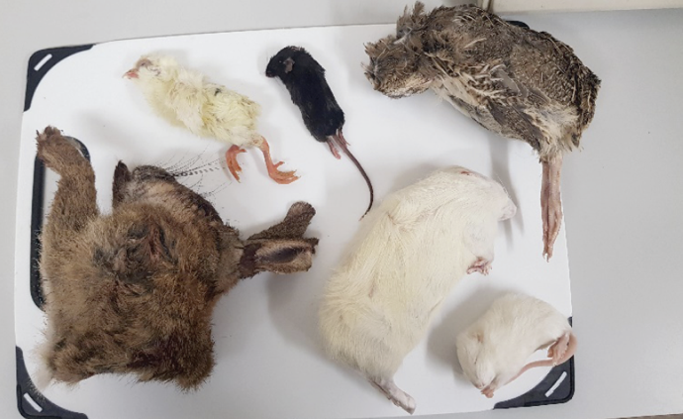

2.9. Release protocol
Ideally, wild animals will be rehabilitated and released in a short timeframe. If this is not possible and the animal is in care for significant extended periods, ensure that the animal is regularly assessed against the five welfare domains to support decision-making. Animals in care for extended periods may have a reduced ability to survive in the wild. Talk to your veterinarian and consider whether euthanasia will provide the best welfare outcome for such individuals.

2.9.1. Pre-release assessment
Pre-release assessment of animals in care is essential to support improved outcomes once back in the wild. Animals should be assessed based on body condition, fitness and the ability to engage in natural species-specific behaviours prior to release.
The following check list should be used to guide decision-making regarding release suitability for snakes:
- The snake should be examined to ensure snake mites are not present prior to release. Sutures should have been removed. If the snake had skin sutures or an injury to its skin, it should have shed its skin at least once without assistance, provided the husbandry is ideal.
- A snake should demonstrate that it can move freely in the enclosure. It should be able to coil tightly. Arboreal species should demonstrate that they can climb up branches.
- The snake should move into a shelter when disturbed.

2.9.2. At the release site
Post release survival will be maximised by ensuring that both the release site and the way in which the animal is released are carefully considered.
Snakes require the following:
- Adequate shelter at the release site.
- Snakes should only be released in warm ambient temperatures (>20°C) so they can seek shelter while mobile.
For more information on the ecological characteristics and requirements of snakes that may help with their release, please refer to Table 2.1

2.9.3. Release checklist
Check all of the requirements of your authorisation are being met, and consider the following:

Release location
- The best time to release a snake will depend on the time of day when the species is most active, as shown in Table 2.1.
- Release should be timed to occur during normal peak activity.
- For diurnal species release may be timed for the middle of the day when it is warmer.
- Nocturnal species are released on dusk when it is still warm from the day.
- Snakes should not be released in the cooler months. They should be released from September to March.
- It is preferable to release snakes when the weather is forecast to be over 20°C for three consecutive days.

Release Procedure
- Care needs to be taken when releasing snakes to avoid being bitten.
- Snakes are transported to the release site inside a calico bag sitting inside a solid transport container that should be labelled: “CAUTION: LIVE VENOMOUS (or NON-VENOMOUS) SNAKE”.
- Place the calico bag on the ground with the opening facing away from the handler and close to suitable cover.
- Partly open the calico bag and permit the snake to move out of the bag in its own time, while slowly moving back.

2.10. Key references and additional reading
Cogger, H.G. 2018. Reptiles and amphibians of Australia, 7th Edition. Reed New Holland.
Mostyn, J.J. 2006. Husbandry manual for tiger snakes. http://nswfmpa.org/Husbandry%20Manuals/Published%20Manuals/Reptilia/Tiger%20Snake.pdf
Robertson, P., and Coventry, A.J. 2019. Reptiles of Victoria. CSIRO Publishing.
Swan, M. 2007. Keeping and Breeding Australian Pythons, 2nd Edition. Mike Swan Herp. Books.
Swanson, S. 2017. Field guide to Australian reptiles, 3rd Edition. Steve Parish Publishing.
Wilson, S., and Swan, G. 2017. A complete guide to the reptiles of Australia, 5th Edition. Reed New Holland.

