Chapter 7. Microbats

Contents
7.1. Introduction 2
7.2. Species information 3
7.3. Animal and human safety considerations 35
7.3.1. Human safety considerations 35
7.3.2. Animal safety considerations 36
7.4. Capture, restraint, and transport 36
7.4.1. Visual observations 37
7.4.2. Equipment 37
7.4.3. Technique 38
7.4.4. Transport 41
7.5. Monitoring animal health and welfare 41
7.5.1. Physical examination 41
7.5.2. Ongoing monitoring of health and welfare 46
7.5.3. Common and emerging health conditions 47
7.5.4. Administering treatment during rehabilitation 52
7.6. Housing 53
7.6.1. General housing information for microbats 53
7.6.2. Enclosure hygiene & biosecurity 53
7.6.3. Housing types 53
7.7. Feeding and nutrition 57
7.8. Hand raising 59
7.8.1. Equipment required for hand raising 60
7.8.2. Growth, development and care of orphaned young 60
7.9. Release protocol 62
7.9.1. Pre-release assessment 63
7.9.2. At the release site 63
7.9.3. Release checklist 63
7.10. Key references and additional reading 64

In Victoria, sick, injured or orphaned wildlife can only be rehabilitated by a wildlife shelter operator or foster carer who is authorised under section 28A of the Victorian Wildlife Act 1975 (Wildlife Act). Wildlife rehabilitators are subject to strict conditions. The mandatory requirements that they must meet are set out in the Wildlife Shelter and Foster Carer Authorisation issued under the Wildlife Act. These conditions enforce the minimum standards required for the humane treatment and successful rehabilitation of wildlife in care. The Wildlife Rehabilitator Authorisation Guide: Things You Need To Know explains how wildlife rehabilitators can meet these mandatory requirements and can be found here:
https://www.vic.gov.au/wildlife-rehabilitation-shelters-and-foster-carers.
The Victorian Wildlife Rehabilitation Guidelines have been developed to incorporate evidenced-based best practice in wildlife care and rehabilitation to equip rehabilitators to deliver positive welfare outcomes for individual animals in their care from first aid to post-release into the wild.
You must comply with the conditions of your authorisation. These guidelines must be read in conjunction with the conditions of your authorisation.

7.1. Introduction
A total of 23 species of insectivorous bats, also called microbats, are found in Victoria. These are distinguished from flying foxes by their smaller size and presence of a tail membrane. Variation in weight occurs with seasons. Hand-rearing of neonatal microbats is possible but requires expertise and experience.
Eastern horseshoe bats, bent-winged bats, southern long-eared bats and yellow-bellied sheath-tailed bats are listed as threatened in Victoria under the Flora and Fauna Guarantee Act 1988.
STOP – If a threatened species comes into care, please STOP and refer to your authorisation for mandatory conditions including notification and release requirements.
The distribution of microbat species most likely to enter care in Victoria is shown in the species profiles at Table 7.1. The species of bat may be identified from a range of characteristics including the weight, forearm length, whether the tail is enclosed in the tail membrane, the colour of the fur and the shape of the ears and penis.
Identification can provide clues to distribution, natural diet, behaviour, roosting and the type of flight. All microbats have an insectivorous diet and roost in a variety of spaces, including natural caves, disused mines, tree hollows, under bark on trees, or in building roof or wall-spaces.
IMPORTANT: Australian bat lyssavirus (ABLV) has been identified in microbat species seen in Victoria. Microbat rescuers and rehabilitators are strongly recommended to be vaccinated against rabies to protect from ABLV, as detailed in the Australian Immunisation Handbook. The disease can be fatal in humans. It is important to always use appropriate protection when handling bats. Members of the public should not handle bats.
When microbats come into care it is the wildlife rehabilitator’s responsibility to ensure that the five domains of animal welfare are satisfied. These include providing optimal nutrition (Section 7.7) and an environment appropriate to the microbat’s stage of rehabilitation (Section 7.6). The focus should be on the animal’s return to health and release, which is facilitated through regular collaboration with a veterinarian. It is also important to consider the animal’s mental state and ability to exhibit normal behaviours without detrimentally affecting its recovery. Welfare may be temporarily compromised by the necessity of a gradual return to normal activity, depending on its stage of rehabilitation. Further information about the five domains of animal welfare is in Part A of these guidelines.
Some female microbats are able to store sperm from mating with the male over late autumn and winter before they become pregnant in spring. Bent-winged bat females do not store sperm but have delayed implantation. Any female brought into care after late autumn has the potential to become pregnant and give birth up to six or seven months later.

7.2. Species information
Profiles for the microbat species most likely to come into care and found in Victoria are detailed in Table 7.1. For assistance in identification of microbat species, refer to the recommended reading and reference material at the end of this chapter.
Table 7.1: Species profiles
Species | Chocolate wattled bat (Chalinolobus morio)
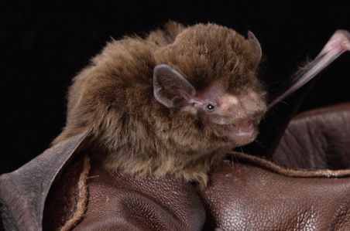  Photo credit: David Paul, Museums Victoria | Distribution map  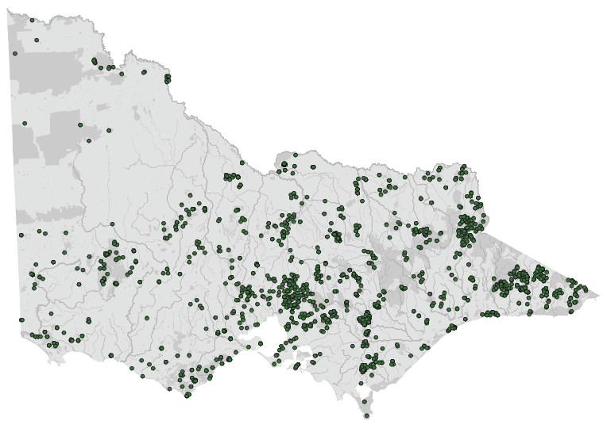  Data source: Victorian Biodiversity Atlas Jan 2023  www.environment.vic.gov.au/biodiversity/victorian-biodiversity-atlas
General appearance | Chocolate-coloured fur on back and belly. Fleshy lobes on the lower lip and between ear and mouth. They have a distinctively domed forehead
Conservation status* | Common
Adult morphometrics | Weight non-pregnant adult: 8–11 g  Adult forearm length: 34–42 mm  Tail length: 45–50 mm
Roost site | Tree hollow, building
Foraging: home range | Up to 10 km
Foraging style | Aerial, moderately fast flying
Mating | April–May
Pregnancy | August–November
Lactating | November–January
Young dependent | January–March
Age at independence | 2–3 months
Age at sexual maturity | 1 year

Species | Eastern bent-wing bat (Miniopterus orianae oceanensis)
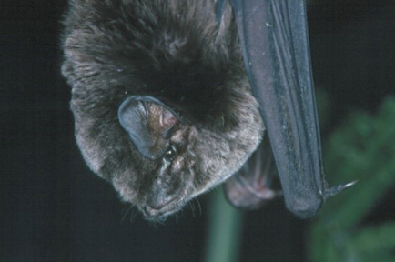  Photo credit: Lindy Lumsden | Distribution map  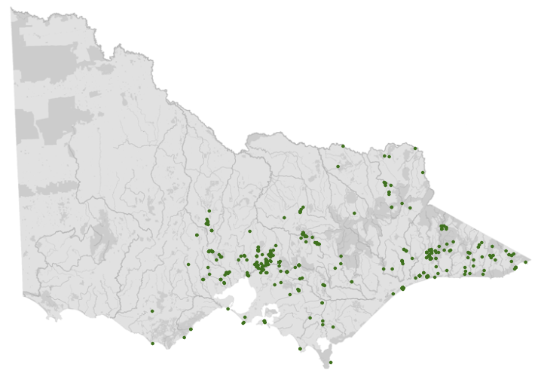  Data source: Victorian Biodiversity Atlas Jan 2023  www.environment.vic.gov.au/biodiversity/victorian-biodiversity-atlas
General appearance | Short triangular ears; domed head; long third digit which is folded back on itself while roosting. The eastern bent-winged bat occurs in central and eastern Victoria. They do not commonly come into care and are frequently mistaken for chocolate wattled bats or Gould’s wattled bats
Conservation status* | Critically endangered
Adult morphometrics | Weight non-pregnant adult: 11–16 g  Adult forearm length: 46–51 mm  Tail length: 52–58 mm
Roost site | Cave, mine
Foraging: home range | Up to 35 km
Foraging style | Aerial, fast flying
Mating | May–June
Pregnancy | May–December
Lactating | November–December
Young dependent | January–March
Age at independence | 2–3 months
Age at sexual maturity | 2 years

Species | Eastern free-tailed bat (Ozimops ridei)
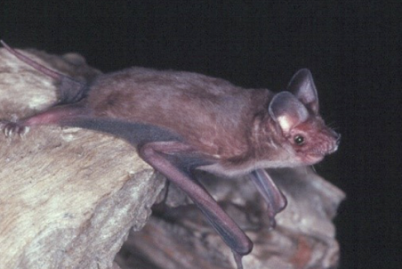  Photo credit: Lindy Lumsden | Distribution map  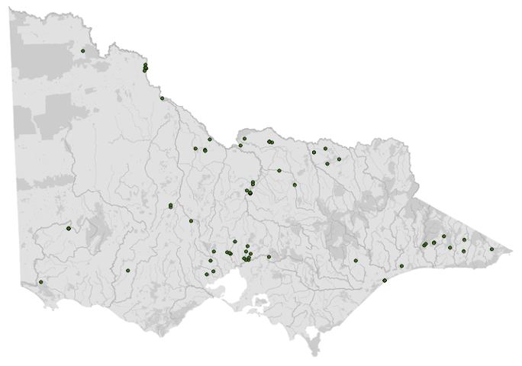  Data source: Victorian Biodiversity Atlas Jan 2023  www.environment.vic.gov.au/biodiversity/victorian-biodiversity-atlas
General appearance | Chocolate brown above, slightly paler below. Ears triangular. Upper lip overhangs lower lip. Penis length less than 5 mm. Tail bone extends beyond the end of the tail membrane
Conservation status* | Common
Adult morphometrics | Weight non-pregnant adult: 8–13 g  Adult forearm length: 31–35 mm  Tail length: 28–34 mm
Roost site | Tree hollow, building
Foraging: home range | Up to 15 km
Foraging style | Aerial, fast flying
Mating | April–August
Pregnancy | September–December
Lactating | December–February
Young dependent | February–March
Age at independence | 2–3 months
Age at sexual maturity | 1–2 years

Species | Eastern falsistrelle (Falsistrellus tasmaniensis)
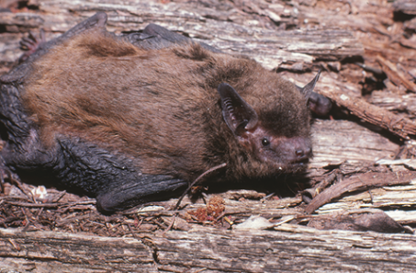  Photo credit: Lindy Lumsden | Distribution map  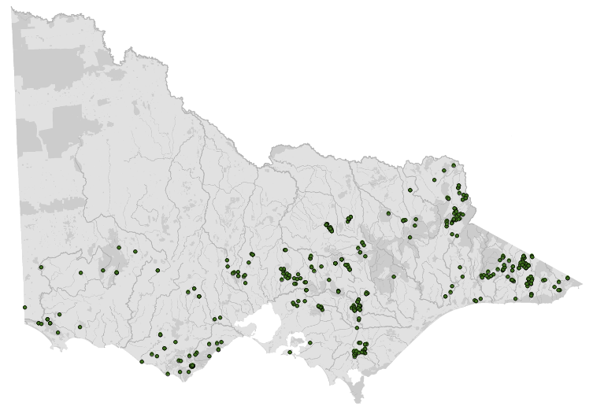  Data source: Victorian Biodiversity Atlas Jan 2023  www.environment.vic.gov.au/biodiversity/victorian-biodiversity-atlas
General appearance | The eastern falsistrelle is a large bat with a simple, dog-like face and a broad nose
Conservation status* | Common
Adult morphometrics | Weight non-pregnant adult: 16–28 g  Adult forearm length: 45–56 mm  Tail length: 40–52 mm
Roost site | Tree hollow
Foraging: home range | Up to 15 km
Foraging style | Aerial, moderately fast flying
Mating | April–May
Pregnancy | August–November
Lactating | November–January
Young dependent | January–March
Age at independence | 2–3 months
Age at sexual maturity | 1 year

Species | Eastern horseshoe bat (Rhinolophus megaphyllus megaphyllus)
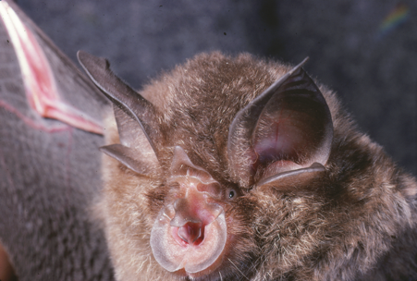  Photo credit: Lindy Lumsden | Distribution map  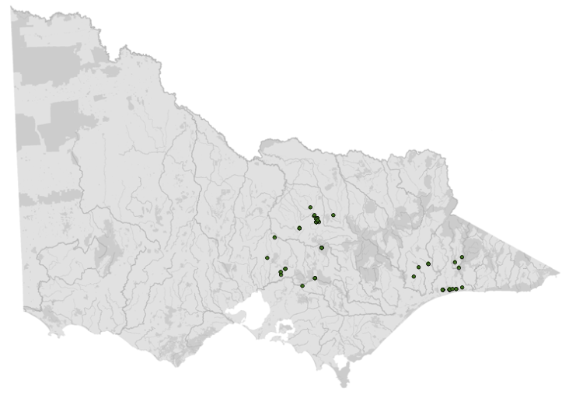  Data source: Victorian Biodiversity Atlas Jan 2023  www.environment.vic.gov.au/biodiversity/victorian-biodiversity-atlas
General appearance | Long, broad ears and distinctive horse-shoe shaped nose leaf
Conservation status* | Endangered
Adult morphometrics | Weight non-pregnant adult: 10–13 g  Adult forearm length: 45–52 mm  Tail length: 38–43 mm
Roost site | Cave, mine
Foraging: home range | Up to 3 km
Foraging style | Aerial, slow–moderate flying
Mating | May–July
Pregnancy | July–November
Lactating | November–January
Young dependent | January–March
Age at independence | 2–3 months
Age at sexual maturity | 2–3 years

Species | Gould’s long-eared bat (Nyctophilus gouldi)
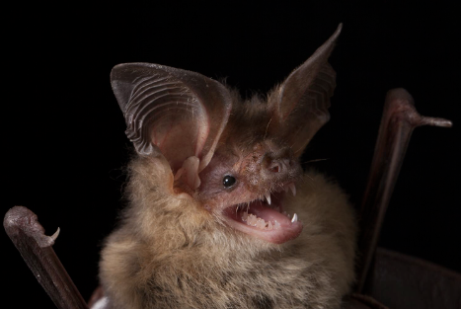  Photo credit: David Paul, Museums Victoria | Distribution map  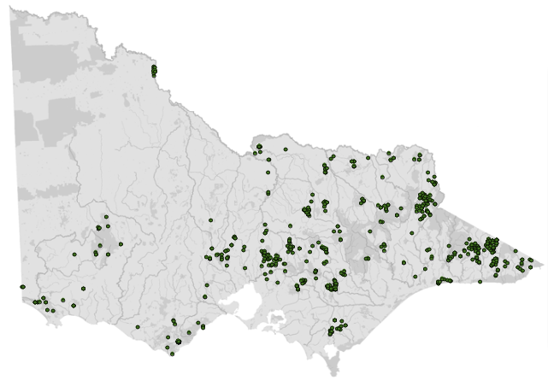  Data source: Victorian Biodiversity Atlas Jan 2023  www.environment.vic.gov.au/biodiversity/victorian-biodiversity-atlas
General appearance | Gould’s long-eared bat can be distinguished from the lesser long-eared bat by its slightly larger size and T-shaped nose leaf. In the far northwest of Victoria there is a third species of long-eared bat: the threatened south-eastern long-eared bat Nyctophilus corbeni
Conservation status* | Common
Adult morphometrics | Weight non-pregnant adult: 9–13 g  Adult forearm length: 40–48 mm  Tail length: 45–55 mm
Roost site | Tree hollow, under bark
Foraging: home range | Up to 10 km
Foraging style | Aerial as well as taking invertebrates off foliage and/or the ground, highly manoeuvrable
Mating | April–June
Pregnancy | August–November
Lactating | October–January
Young dependent | December–February
Age at independence | 2–3 months
Age at sexual maturity | 1 year

Species | Gould’s wattled bat (Chalinolobus gouldii)
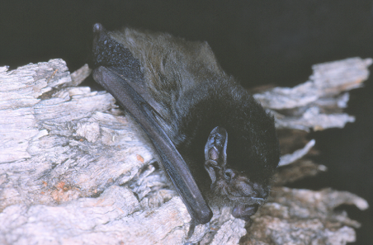  Photo credit: Lindy Lumsden | Distribution map  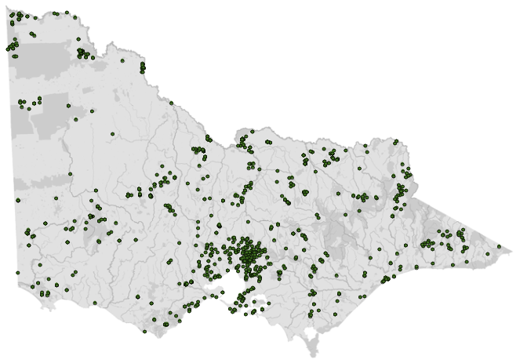  Data source: Victorian Biodiversity Atlas Jan 2023  www.environment.vic.gov.au/biodiversity/victorian-biodiversity-atlas
General appearance | The black fur on the head and shoulders contrasts with brown fur on the rest of the bat and is distinctive for this species. In NW Victoria there is another species of wattled bat, the little pied bat Chalinolobus picatus
Conservation status* | Common
Adult morphometrics | Weight non-pregnant adult: 10–20 g  Adult forearm length: 37–47 mm  Tail length: 40–50 mm
Roost site | Tree hollow, building
Foraging: home range | Up to 15 km
Foraging style | Aerial, moderately fast flying
Mating | April–July
Pregnancy | September–November
Lactating | November–January
Young dependent | January–March
Age at independence | 2–3 months
Age at sexual maturity | 1 year

Species | Inland broad-nosed bat (Scotorepens balstoni)
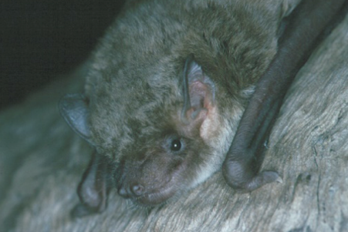  Photo credit: Lindy Lumsden | Distribution map  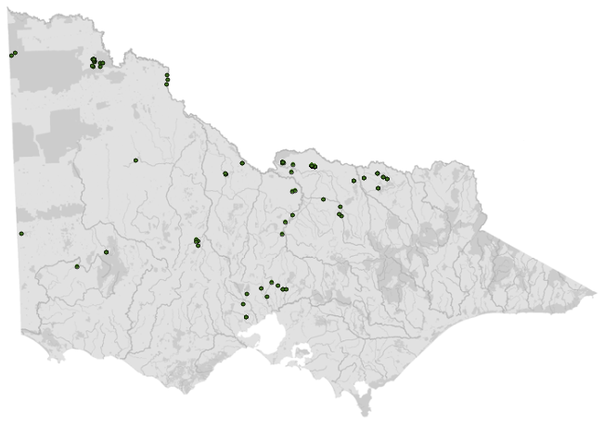  Data source: Victorian Biodiversity Atlas Jan 2023  www.environment.vic.gov.au/biodiversity/victorian-biodiversity-atlas
General appearance | This species (and the closely related eastern broad-nosed bat Scotorepens orion from eastern Victoria, and the little broad-nosed bat S. greyii from far NW Victoria) have a broad bare muzzle and short dense fur
Conservation status* | Common
Adult morphometrics | Weight non-pregnant adult: 7–14 g  Adult forearm length: 32–41 mm  Tail length: 29–42 mm
Roost site | Tree hollow, building
Foraging: home range | Up to 15 km
Foraging style | Aerial, moderately fast flying
Mating | April–June
Pregnancy | September–December
Lactating | November–January
Young dependent | January–March
Age at independence | 2–3 months
Age at sexual maturity | 1 year

Species | Large forest bat (Vespadelus darlingtoni)
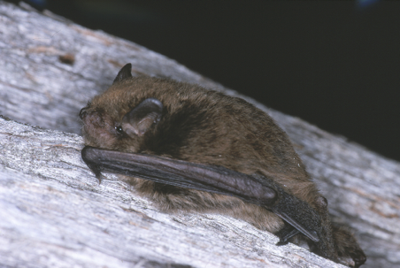  Photo credit: Lindy Lumsden | Distribution map  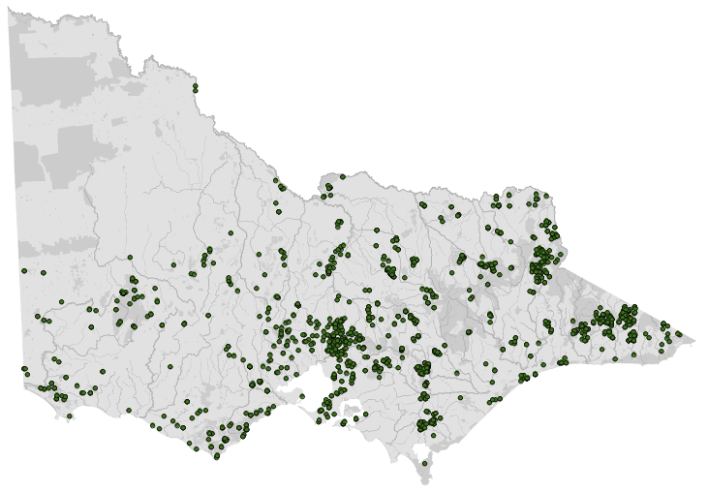  Data source: Victorian Biodiversity Atlas Jan 2023  www.environment.vic.gov.au/biodiversity/victorian-biodiversity-atlas
General appearance | The large forest bat is slightly larger than the other two species of forest bats and has darker fur that is uniform in colour over the body
Conservation status* | Common
Adult morphometrics | Weight non-pregnant adult: 6–10 g  Adult forearm length: 32–37 mm  Tail length: 32.4–38.6 mm
Roost site | Tree hollow, building
Foraging: home range | Up to 8 km
Foraging style | Aerial, slow to moderate flying
Mating | April–June
Pregnancy | August–December
Lactating | November–January
Young dependent | January–March
Age at independence | 2–3 months
Age at sexual maturity | 1 year

Species | Lesser long-eared bat (Nyctophilus geoffroyi)
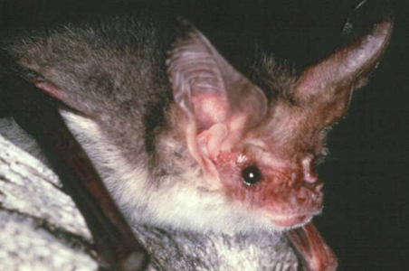  Photo credit: Lindy Lumsden | Distribution map  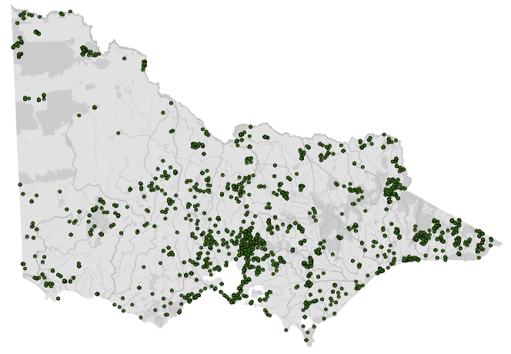  Data source: Victorian Biodiversity Atlas Jan 2023  www.environment.vic.gov.au/biodiversity/victorian-biodiversity-atlas
General appearance | The smallest of the Victorian long-eared bat species. Long ears, grey back fur with pale belly, Y-shaped groove on muzzle
Conservation status* | Common
Adult morphometrics | Weight non-pregnant adult: 6–12 g  Adult forearm length: 32–41 mm  Tail length: 31–40 mm
Roost site | Tree hollow, under bark, building
Foraging: home range | Up to 13 km
Foraging style | Aerial as well as taking invertebrates off foliage and/or the ground, highly manoeuvrable
Mating | April–June
Pregnancy | August–November
Lactating | October–January
Young dependent | December–February
Age at independence | 2–3 months
Age at sexual maturity | 1 year

Species | Little forest bat (Vespadelus vulturnus)
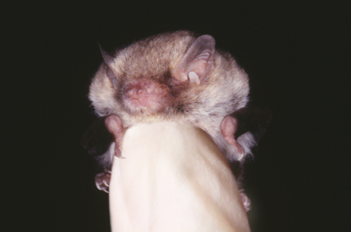  Photo credit: Lindy Lumsden | Distribution map  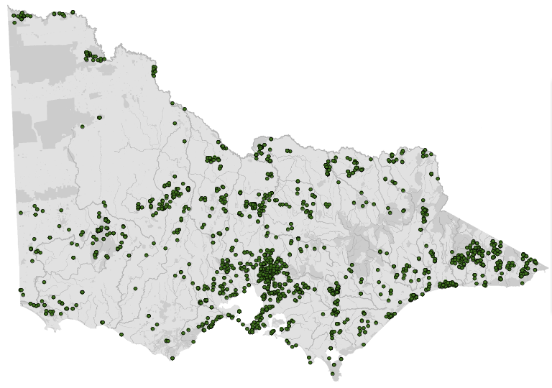  Data source: Victorian Biodiversity Atlas Jan 2023  www.environment.vic.gov.au/biodiversity/victorian-biodiversity-atlas
General appearance | Long, grey-brown fur, bicoloured. The little forest bat is the smallest Victorian species, shown here in relation to the size of a thumb
Conservation status* | Common
Adult morphometrics | Weight non-pregnant adult: 3–6 g  Adult forearm length: 25–31 mm  Tail length: 27–35 mm
Roost site | Tree hollow, building
Foraging: home range | Up to 8 km
Foraging style | Aerial, slow to moderate flying
Mating | March–July
Pregnancy | September–December
Lactating | November–January
Young dependent | January–March
Age at independence | 2–3 months
Age at sexual maturity | 1 year

Species | Southern bent-winged bat (Miniopterus orianae bassanii)
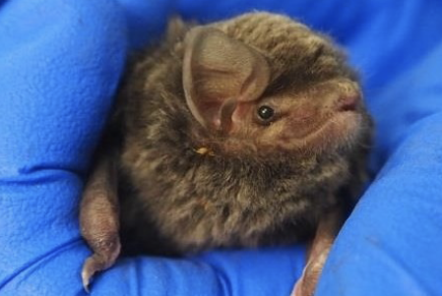  Photo credit: Emmi van Harten | Distribution map  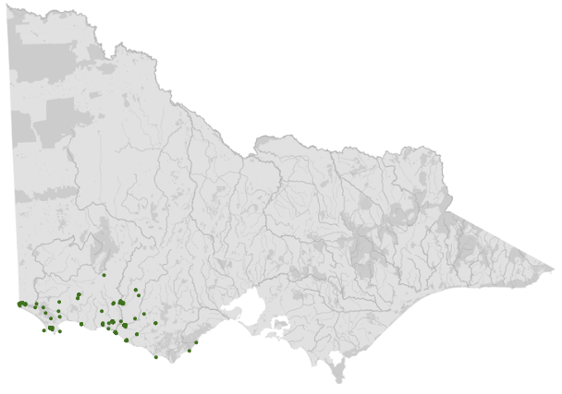  Data source: Victorian Biodiversity Atlas Jan 2023  www.environment.vic.gov.au/biodiversity/victorian-biodiversity-atlas
General appearance | Short triangular ears, domed head, long third digit which is folded back on itself while roosting. Often misidentified as an eastern bent-winged bat
Conservation status* | Critically endangered
Adult morphometrics | Weight non-pregnant adult: 11–18 g  Adult forearm length: 45–50 mm  Tail length: 52–58 mm
Roost site | Cave
Foraging: home range | Up to 70 km
Foraging style | Aerial, fast flying
Mating | May–June
Pregnancy | May–December
Lactating | November–January
Young dependent | January–March
Age at independence | 2–3 months
Age at sexual maturity | 2 years

Species | Southern forest bat (Vespadelus regulus)
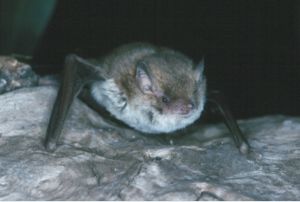  Photo credit: Lindy Lumsden | Distribution map  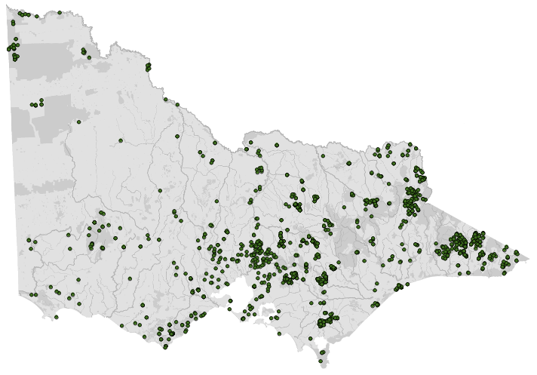  Data source: Victorian Biodiversity Atlas Jan 2023  www.environment.vic.gov.au/biodiversity/victorian-biodiversity-atlas
General appearance | Long, often rufous fur; two-toned fur with dark base. The southern forest bat (and the closely related inland forest bat Vespadelus baverstocki from far NW Victoria) can have a sandy or red fur colour
Conservation status* | Common
Adult morphometrics | Weight non-pregnant adult: 4–7 g  Adult forearm length: 28–34 mm  Tail length: 28–39 mm
Roost site | Tree hollow, building
Foraging: home range | Up to 8 km
Foraging style | Aerial, slow to moderate flying
Mating | April–June
Pregnancy | August–December
Lactating | November–January
Young dependent | January–March
Age at independence | 2–3 months
Age at sexual maturity | 1 year

Species | Southern free-tailed bat (Ozimops planiceps)
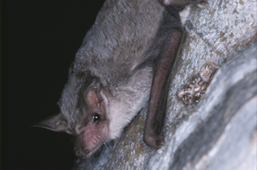  Photo credit: Lindy Lumsden | Distribution map  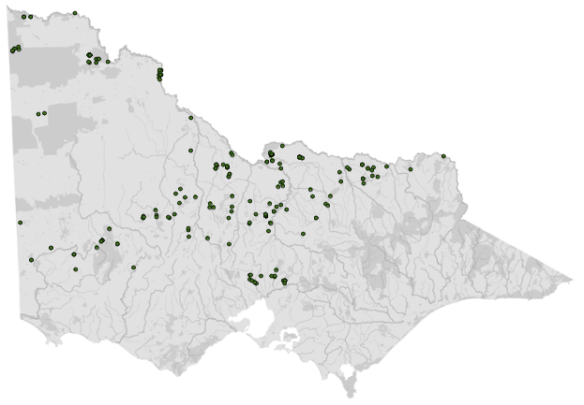  Data source: Victorian Biodiversity Atlas Jan 2023  www.environment.vic.gov.au/biodiversity/victorian-biodiversity-atlas
General appearance | The tail bone extending beyond the tail membrane is the distinguishing feature of the free-tailed bats (including the closely related inland freetail bat Ozimops petersi from NW Victoria). The southern freetail bat often gets called the long penis form due to its 9–10mm long penis
Conservation status* | Common
Adult morphometrics | Weight non-pregnant adult: 7–13 g  Adult forearm length: 32–35 mm  Tail length: 27–36 mm
Roost site | Tree hollow, building
Foraging: home range | Up to 15 km
Foraging style | Aerial, fast flying
Mating | April–August
Pregnancy | September–December
Lactating | December–February
Young dependent | February–March
Age at independence | 2–3 months
Age at sexual maturity | 1–2 years

Species | White-striped free-tailed bat (Austronomus australis)
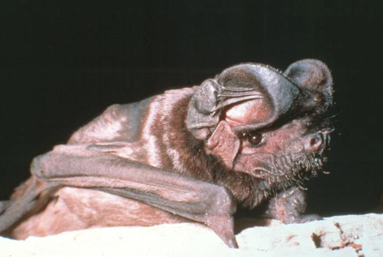  Photo credit: Lindy Lumsden | Distribution map  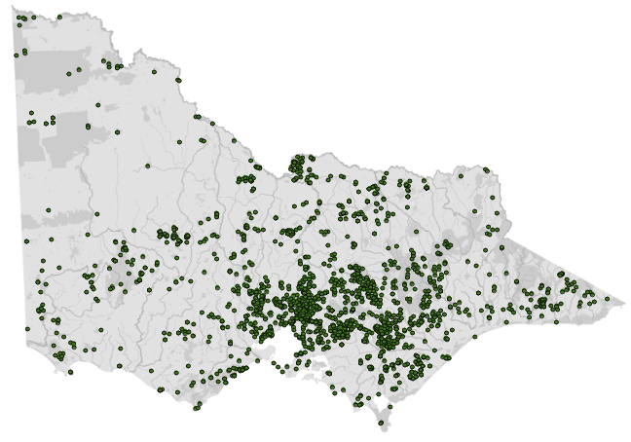  Data source: Victorian Biodiversity Atlas Jan 2023  www.environment.vic.gov.au/biodiversity/victorian-biodiversity-atlas
General appearance | Large, black fur on back; white stripes on belly where wings join; tail extends beyond membrane. Large, rounded ears, wrinkled lips and white stripes either side of the belly
Conservation status* | Common
Adult morphometrics | Weight non-pregnant adult: 30–40 g  Adult forearm length: 57–67 mm  Tail length: 40–55 mm
Roost site | Tree hollow
Foraging: home range | Up to 20 km
Foraging style | Aerial, fast flying
Mating | August
Pregnancy | August–December
Lactating | December–February
Young dependent | February–March
Age at independence | 2–3 months
Age at sexual maturity | 1–2 years

Species | Yellow-bellied sheath-tailed bat (Saccolaimus flaviventris)
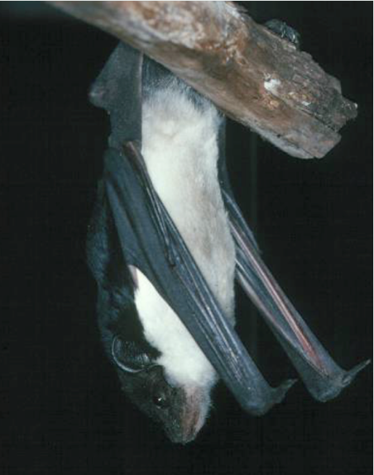  Photo credit: Lindy Lumsden | Distribution Map  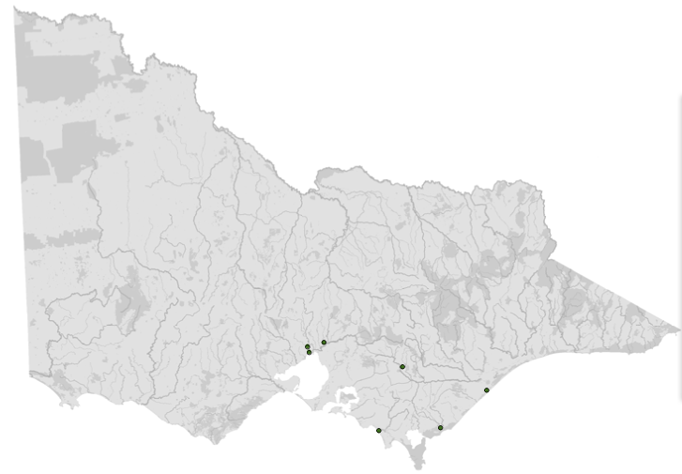  Data source: Victorian Biodiversity Atlas Jan 2023  www.environment.vic.gov.au/biodiversity/victorian-biodiversity-atlas
General appearance | The yellow-bellied sheath-tailed bat is unusual in having jet black fur on the back and white or cream fur on the belly. It is the largest microbat in Victoria. Tail extends beyond membrane. Most Victorian records are of individuals coming into care
Conservation status* | Vulnerable
Adult morphometrics | Weight non-pregnant adult: 30–60 g  Adult forearm length: 65–82 mm  Tail length: 20–35 mm
Roost site | Tree hollow
Foraging: home range | Up to 20 km
Foraging style | Aerial, fast flying
Mating | August–November
Pregnancy | December–March
Lactating | January–May
Young dependent | March–June
Age at independence | 2–3 months
Age at sexual maturity | 1–2 years
*From the Flora and Fauna Guarantee Act 1988 Threatened List June 2023. This list is updated regularly throughout the year. For the most current list, please visit https://www.environment.vic.gov.au/conserving-threatened-species/threatened-list.

7.3. Animal and human
safety considerations
In general, animals in the wild have limited contact with people, pets, and the hustle and bustle of our daily lives. When sick, injured or orphaned wild animals come into care this unnaturally close contact can carry risks to the health and safety of both people and animals. For general information on biosecurity and approaches to minimise these risks see Part A of these guidelines. Specific information on enclosure hygiene and biosecurity for microbats is in this chapter.
The following information relates to the human and animal health and safety considerations specifically related to the rehabilitation of microbats.

7.3.1. Human safety considerations
- Australian bat lyssavirus (ABLV) has been detected in the yellow-bellied sheath-tailed bat. Antibodies have been detected in a range of other species of microbats. Therefore, all Australian microbats should be considered susceptible to infection with this virus. ABLV is closely related to rabies and can infect humans. Infection is potentially fatal. Three human deaths have occurred in Australia at the time of publication, one of which was due to a microbat. Only wildlife rehabilitators that follow the Australian Immunisation Handbook guidelines for rabies vaccination, booster vaccination and titre testing, and are using appropriate personal protective equipment and are experienced should handle bats.
- The Australian Immunisation Handbook (https://immunisationhandbook.health.gov.au/recommendations/people-with-ongoing-occupational-exposure-to-lyssaviruses-are-recommended-to-receive-booster-doses-of-rabies-vaccine) provides guidance about antibody titres and booster vaccinations to ensure on-going protection against ABLV. Please refer to this handbook along with consultation from your GP for advice on maintaining antibody titres and the need for rabies vaccination boosters.
- Prior to handling, cover any cuts and abrasions with dressings and disposable gloves. ABLV transmission occurs through a bite or scratch, or infected saliva contacting a wound or mucous membrane. Flying foxes can carry other diseases that infect humans. These have not been documented in Australian microbats. As a precaution, wildlife rehabilitators should avoid contact with urine, faeces or birth fluids from all bat species, by wearing gloves when handling bats.
- The public should not handle bats. Instruct them to place a cardboard box over the bat and wait until a vaccinated wildlife rehabilitator arrives. All microbats should be regarded as potentially infected with ABLV and handled with caution.
- In the event of a bat bite, scratch or saliva contamination of a wound:
- Seek medical attention immediately. Post-exposure treatment may be required.
- Wash the affected area thoroughly with soap and copious amounts of water for fifteen minutes.
- Apply a virucidal antiseptic to the area: povidone-iodine, iodine tincture, aqueous iodine solution or alcohol (ethanol).
- ABLV can also be transmitted to other animals. Prevent pets and other animals from coming into contact with bats. If an animal might have been bitten or scratched by a bat, contact Agriculture Victoria or call the Emergency Animal Disease Watch Hotline on 1800 675 888.
- ABLV is discussed further in Part A, Chapter 4, Biosecurity and Hygiene, in these guidelines.

7.3.2. Animal safety considerations
Microbats should be transported at temperatures below 25°C. Their thermoneutral zone is 30–35°C. At higher temperatures microbats become heat stressed.

7.4. Capture, restraint, and transport
STOP – A visual examination must be done BEFORE the animal is captured. This applies to the initial capture from the wild as well as prior to captures which occur during time in captive care. See Section 7.4.1 for information on what to look for when conducting a visual health assessment.
Refer to Part A of these guidelines for general advice on wildlife welfare, biosecurity and hygiene, and record requirements. The following information relates to the capture, restraint, and transport of sick, injured and orphaned microbats.

7.4.1. Visual observations
Visual observations of wildlife should be conducted prior to any attempts to capture the animal. This is just as important prior to the first capture from the wild as it is before any capture conducted while an animal is in captive care. Observations should be conducted quietly, by one person, and from a distance which provides a clear view of the animal with as little disturbance as possible. Visual observation should focus on the animal’s demeanour, behaviour, movement and posture, looking for evidence of injury/severe disease or deterioration and observe their breathing as demonstrated in the following table.
Table 7.2: Visual health observations in microbats
 | What to look for
Demeanour | - Bright, alert if not in torpor. Horseshoe bats swivel ears in response to sound. Bat follows movement with eyes
Behaviour | - Active at night
Movement and posture | - Hangs upside down if provided with a vertically hung towel on which to cling  - Holds both wings close to the body with shoulders at the same height  - Coordinated movement
Breathing | - Observe the bat without disturbing it. Breathing should be fast but regular  - Panting or open mouth breathing is abnormal and may indicate respiratory distress or overheating (not to be confused with an alert bat that has its mouth open because it is echolocating)

7.4.2. Equipment
- PPE: Refer to the Wildlife Health Australia document, “Personal Protective Equipment (PPE) Information for Bat Handlers”: https://www.wildlifehealthaustralia.com.au/Portals/0/Documents/ProgramProjects/PPE_Info_for_Bat_Handlers.pdf.
- Gloves: Fine leather gloves, nitrile gloves or fine cloth gloves should be worn when handling the smallest species of microbats for identification and examination as they should prevent a bite from breaking the skin. Be aware that larger species of microbats may have a stronger bite so thicker handling gloves will be needed.
- Catch bag: Microbats can be restrained and transported in a calico bag or small joey pouch, in sizes such as: 0.15 m (L) x 0.15 m (W). Use calico bags with the seams on the outside and check they have no loose threads to entangle feet or wings. Each bag should be tied securely at the top.
- Transport container: The calico bag can be placed inside a solid container, such as a cardboard box or small pet carrier. Suggested dimensions are at least 0.2 x 0.2 m (0.04 m²) x 0.2 m (H) (See Figure 7.1).
- Callipers: Used to measure the forearm length for species identification (See Figure 7.2).
- Scales: Scales accurate to 0.1 g are used to weigh microbats. This will assist in species identification and monitoring weight throughout care.
Figure 7.1: Example of a microbat transport container. Photo credit: Zoos Victoria
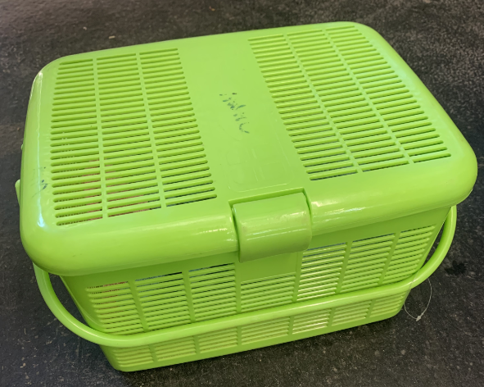

7.4.3. Technique
It is beyond the scope of these guidelines to outline techniques for every situation that may be encountered. Examples of techniques for some specific situations are outlined in the following section.
In addition to this information, for further advice please also refer to the recommended reading list, zoological institutions, veterinarians and/or wildlife experts. Inexperienced rescuers should request assistance where possible.
- Cup the bat loosely in the hand with the thumb covering the back and the head, but without putting any pressure on the head (See Figure 7.2). The bat typically sits quietly in this position as it feels secure being enclosed, and rarely attempts to bite. Areas for examination can then be exposed. Horseshoe bats tend to become stressed more easily than other species and need to be handled very gently and quietly.
- When yellow-bellied sheath-tailed bats come into care they can appear calm and quiet, but this can be a sign of extreme stress. They often have a wide-eyed look with a blue ring apparent around the eyes. They need to be kept in a quiet, low stress environment.
- Rescued microbats can be given a glucose slurry (Glucodin Powder: 1 tablespoon into 10 mL water) as stressful situations can cause their blood glucose to drop and hypoglycaemia to occur. Glucose is readily absorbed through the gums, so the bat does not have to swallow the slurry to benefit.
Figure 7.2: Restraint of a microbat for forearm length measurement using callipers. Bats sit calmly if enclosed with no pressure, especially if their feet are able to grip onto something. Photo credit: Lindy Lumsden
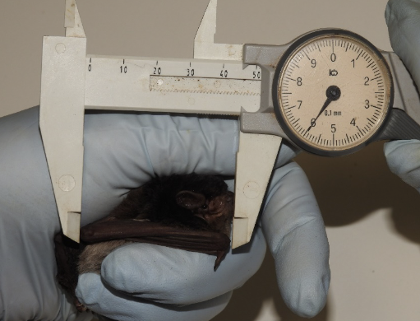

Inside a building
Microbats are sometimes discovered inside houses. They may be roosting in the roof or wall space and enter through small gaps. During winter they may be in torpor. This is a state of lowered metabolism and body temperature that microbats can adopt when the weather is cold, in order to conserve energy. Bats in torpor will appear sluggish and poorly responsive. If the microbat is inactive, it can be picked up using a calico bag which is then turned inside-out over the microbat. These bats should be examined and, if required, treated for dehydration (See Section 7.5.4). If the microbat is uninjured, it should be released at the same location on the same or following evening.
Microbats can also fly into a house while foraging. The bat should be encouraged to fly out by opening doors and windows, turning the lights down inside, and turned on outside. Then let it find its own way out. If the microbat lands on a curtain, it can be picked up using a calico bag or tea towel and taken outside.
Microbats have distinct home ranges that include regular roosting sites and are likely to return to the roost site within the house again. Blocking any gaps allowing the bats access to the inside of the house can often solve the problem. However, if still causing concerns, microbats can be excluded from roosting in a roof or wall space by finding the exit point and blocking it using a ‘bat sleeve’. This is made from a black plastic bag that is taped around the opening, leaving a tube of plastic that the microbat can exit from but cannot crawl back up into upon return. The microbats will then use another roost nearby. The exit point should be permanently closed at a later stage, once it is certain that all microbats have left the roost. This should not be undertaken during the breeding season when young are left inside the roost (October to February), or when bats enter periods of torpor (May to September).

On the ground
Any microbat found on the ground or in an exposed position outside requires assessment. Young bats that are learning to fly will sometimes crash to the ground. Adults are found on the ground, with or without obvious injuries, due to predation, accidental injury, vehicle trauma, or exhaustion. They will require a veterinary assessment. Bats on the ground can be picked up using a calico bag turned inside-out over the microbat. Gloves should be worn when capturing microbats as animals affected with ABLV may also be found on the ground.

Roost disturbance
One or more bats may be discovered inside disturbed roost sites like lopped tree limbs or firewood piles. These bats should be captured, examined and, if required, treated for dehydration (see Section 7.5.4) and injuries.
They may also just be in torpor. If uninjured, release the bat on the same evening at the same location. Bats typically have multiple roost sites, so the animal is likely to return to an undisturbed site within its home range.

Stuck on fly strips
Microbats can be found caught on adhesive fly strips. Unless these microbats are found soon after becoming stuck, they quickly become dehydrated and use up their energy reserves. The animal will need to be removed from the fly strip with an adhesive solvent, such as Zoff or De-Solv-It. All adhesive removers should then be washed off with a gentle, unscented baby shampoo. This procedure will need to be performed under anaesthesia by a veterinarian to reduce the risk of injury to the microbat. These animals will require veterinary assessment and fluids (See Section 7.5.4). Their chances of survival are related to the length of time they were stuck to the strip. All bats removed from fly paper should be kept in care until recovery and normal flight observed.
The sale and use of sticky insect traps that are not confined to protective cages is now illegal in Victoria. Glue traps should be removed and reported to Animal Welfare Victoria if used at commercial premises (https://agriculture.vic.gov.au/livestock-and-animals/animal-welfare-victoria/pocta-act-1986/humane-vertebrate-pest-control/glue-traps).

7.4.4. Transport
- Transport microbats individually.
- Microbats can be transported in a bag placed in a solid container, or loose in the solid container. If the microbat is loose in the container, a towel should be placed on the floor to give the bat something to grip and all food and water containers should be removed, as well as any bigger items such as bark or wood.
- Secure the container in the vehicle so that it cannot slide or roll over.
- It is not necessary to provide water or food when transporting microbats.
- In hot weather, transport the bat in an air‑conditioned vehicle.

7.5. Monitoring animal health and welfare
The goal of wildlife rehabilitation is to address health and welfare concerns quickly and effectively so wildlife can be released back to the wild as soon as possible. Decision-making from the time of capture through to release should be guided by an accurate understanding of the animal’s true state of health and welfare. Careful monitoring throughout the rehabilitation period ensures that significant issues, or deterioration in health condition, are identified immediately and rapidly addressed.
It is preferred that all sick, injured or orphaned wildlife be assessed by a veterinarian to ensure that non-obvious signs of trauma or disease can be assessed and treated as soon as practicable. No medication should be provided prior to this assessment, as this can mask clinical signs and make an accurate health assessment by the veterinarian very difficult.
Templates for record-keeping visual and physical observations and daily care can be found in Part A of these guidelines.
This section provides guidance on health assessment on arrival and on effective monitoring of the health and welfare of individuals in care through minimising human-animal interactions and stress to the animal to maximise successful release back to the wild.

7.5.1. Physical examination
Once visual observations are complete, and the animal is stable enough to withstand capture and handling, a basic physical examination should be conducted. This can be repeated when required any time the carer has the animal in the hand, such as for an enclosure change. However, if a full physical exam is not conducted, body condition and weight should be assessed every time the animal is in the hand for other reasons. Carers should make sure scales are available and ready to use before capturing the animal. Physical examinations are also required if the carer notices any changes suggestive of deteriorating health or an injury.
Always record the physical examination findings, so that you can compare findings as the animal’s rehabilitation progresses. This ensures any health concerns are identified as soon as possible, and the carer can plan release as soon as appropriate. A template for recording physical examination findings can be found in the appendices to Part A of these guidelines.
Examinations should be conducted in a quiet location, away from any domestic animals. Only one person should handle the animal, while a second person takes notes. All other people should move away, and noise kept to a minimum. Handling should also be kept to a minimum, with careful monitoring for any signs of distress (such as panting, salivating, vocalisation, or sudden deterioration in demeanour). If these are seen, the examination should be stopped immediately, and the animal returned to its catch bag, transport box or enclosure and allowed to recover.

Species specific considerations:
- Physical examination of microbats can be challenging because of their small size.
- For human safety reasons and to minimise stress in the microbat, only a relatively quick examination will be possible. More detailed examinations require the animal to be anaesthetised.
- Gloves should be worn.
- The microbat should be cupped in the hand, as described in Section 7.4.2. With the other hand extend the wings and legs and check for tears, exposed bone and obvious fractures.
- Check the fur for saliva or blood, which may be indicative of a predator bite wound.
- The forearm length assists in the identification of the microbat. Measure the distance between the elbow and wrist (See Section 7.4.2).
- The age of the bat is determined by looking for the presence of growth plate bands in the joints between the finger bones as shown in Figure 7.3. Microbat age should not be determined by coat length or size. Juvenile microbats grow extremely fast and can reach 90–95% of adult size and 70% of adult weight by four to seven weeks of age, but will not be weaned. They are virtually adult size once they start flying. Microbat age classes are shown in Table 7.3.
Figure 7.3: Ageing microbats by examining the bands of cartilage on the finger bones, reproduced with permission of Lindy Lumsden.
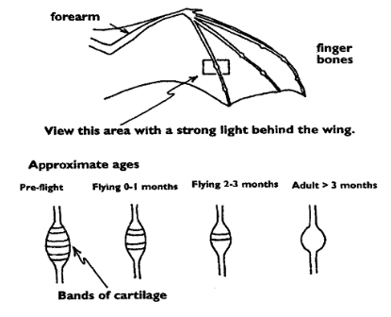
Table 7.3: Age classes
Age class | Wing bones | Teeth | Nipples
Adult | No cartilage between bones; joints are round and white | May be worn | Likely to have large nipples
Sub-adult | Small band of cartilage; joint elongated | Unworn | Tiny nipples
Juvenile | Large bands of cartilage between bones; joints elongated; increased blood supply to joints making the area appear redder | Unworn | Tiny nipples
Table 7.4: Physical examination of microbats
 | What to look for
Body weight | See species profiles (Table 7.1) for healthy weight range for microbat species.  - Record body weight on arrival and at least weekly while in care.  - A greater than 10% decrease in body weight over a week is cause for concern, and the carer should seek veterinary advice immediately.
Body condition | Body condition is scored by palpating the scapula, its spine and adjacent muscles. Palpation of the pectoral muscles can also provide an indication of body condition. Body condition scoring needs to take time of year into consideration. Wild bats can gain up to almost 50% of their body weight in autumn in readiness for winter. This is a natural process and provides the bats with sufficient fat and energy reserves to survive until spring. Bats released in autumn should be in the ‘over condition’ category.  Body condition can be described as follows:  - Under condition: Concave muscles either side of the scapular spine, which is easily felt. The bat’s body has an hourglass shape when viewed from above.  - Ideal condition: Flat muscles either side of the scapular spine, which is just palpable.  - Over condition: Curved muscle mass on either side of the scapular spine, which is difficult to feel.
Hydration status | - Skin tent between the shoulder blades falls down within 1 second. The wing membrane should appear glossy.
Eyes | - Bright, open, symmetrical.
Ears | - No tears.
Mouth | - Pink gums.
Wing membrane | - Feels soft and supple. Small holes are normal. Dark surface.
Limbs, feet, and tail | - Able to hold wings close to body. Hangs with both feet. Coordinated movement.
Sex determination | - The sex of the microbat is determined based by the presence or absence of a penis.
Anus | - Healthy but captive bats may urinate or defaecate on themselves.
Ability to fly | - Bat should be able to fly continuously, maintaining height and manoeuvring easily (assuming the bat is warm, and the space is large enough).
Figure 7.4: Examining the wing of an eastern bent-wing bat. Photo credits: Zoos Victoria
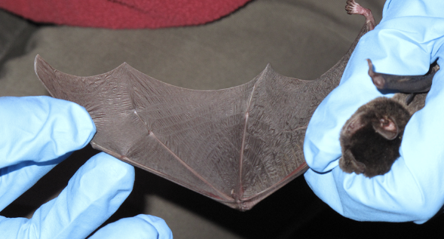
Figure 7.5: Assessing body condition. Photo credits: Zoos Victoria
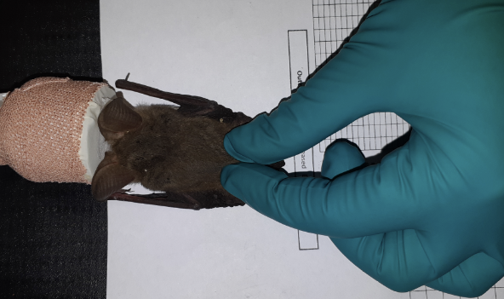

7.5.2. Ongoing monitoring of health and welfare
The aim of wildlife rehabilitation is to ensure animals recover and can be released back to the wild as quickly as possible. Careful, daily monitoring is required to ensure that animals are responding as expected to the treatment being provided and so that any deterioration or welfare concerns can be identified and addressed as soon as possible. Rehabilitators should ensure that record-keeping is a priority to maximise positive welfare outcomes. Templates to assist wildlife rehabilitators to record and monitor wildlife health and welfare can be found in the appendices to Part A of these guidelines. These records will be valuable tools to share with veterinarians to support decision-making.
The following is recorded daily:
- demeanour
- food consumption
- faecal/urine output
- behaviour observed
- medical treatment provided
- evidence of overnight activity.
The following is recorded weekly:
- weight
- body condition.
Over time, regular monitoring will also help to develop carer skills and knowledge, as regular observations and recording will result in a deep understanding of the expected behaviour and response to treatment for the species in care.

Species specific considerations:
- Time your health and welfare observations for times of the day when the animal is expected to be active, which is late afternoon and into the evening.
- If the animal is being medicated, a visual check in the morning when the microbat is least active is recommended. The microbat should be observed at least daily.
- Ideally physical observations should be undertaken at the beginning and/or end of the resting period (from dawn to late afternoon) to minimise disturbance and maximise the rest/sleep period for healing and ensure ease of capture.
- Note the microbat’s demeanour and behaviour every time food is introduced or taken away, the animal is medicated or the enclosure is cleaned. Pay particular attention to any changes that have occurred since the previous day.
- The use of infra-red cameras can allow monitoring of behaviour overnight.
- Be alert for signs of self-trauma. Microbats tend to chew sutures, bandages and damaged parts of their wings or legs.
- Check wings daily for any sliminess or excessive moisture or trauma to the extremities, particularly over the wrists and ends of the digits.

7.5.3. Common and emerging health conditions
Clear guidance on conditions that may require euthanasia can be found in Part A of these guidelines.
Table 7.5 lists common clinical signs and possible causes of injury/disease. Carers should be aware that these are not exhaustive. Aside from first aid, carers should avoid administering medications prior to the provision of veterinary advice.
Unusual clinical signs or mass mortality events – a number of animals dying or found dead at the same time, with similar signs – may indicate an emergency animal disease, an emerging/new infectious disease or an environmental/human related toxicity which needs further investigation. Report these immediately to the Emergency Animal Disease Watch Hotline on 1800 675 888 (24 hours).
Table 7.5: Common injuries and clinical signs of emerging health conditions seen on presentation or during care
Injury or clinical signs | Possible causes | Carer observations and response
Note: Do not provide pain relief or other medication, including antibiotics, unless under veterinary guidance and supervision, as these can have severe side effects, particularly in dehydrated/shocked animals. Use of antibiotics when not indicated can contribute to antimicrobial resistance and reduce drug efficacy.
Unable to fly, fracture, drooping wing, swollen wing, bruising over wing, dislocation, head trauma, wing membrane tears, bleeding, exposed bone on digits | Netting entanglement, window collision, found adjacent to road/suspect motor vehicle accident | - Urgent veterinary attention is required. Do not delay transfer to a veterinarian to apply first aid, other than to stop excessive bleeding.  - Do not attempt to stabilise fractures as this is very painful, and risks making the injury worse. Fracture stabilisation should only be attempted by a veterinarian following physical examination, x-rays and under general anaesthesia.  - Do not provide pain relief or other medication unless under veterinary guidance and supervision, as these can have severe side effects, particularly in dehydrated/shocked animals.  - Exposed bone on digit tips must not be trimmed without general anaesthesia and veterinary assessment.  - The wing membrane of microbats heals readily without treatment (Figure 7.6). Do not tape or attempt to sew the hole closed as this causes ripping and further damage. If the hole in the membrane is small and there are no other injuries the bat can be released immediately. If the hole is large, or the membrane is ripped, the microbat will need to remain in care until the wing membrane repairs sufficiently to allow flight. This may take from two weeks to two months. A small amount of pure vitamin E oil can be applied to the edges of membrane holes to prevent the healing edge constricting.  - Optimum environmental temperature and nutrition are required to prevent the bat entering torpor, as this will delay healing.  - The animal should be reassessed throughout rehabilitation to ensure healing is progressing as expected and is tolerating the time in care.  - Flight training will be required to complete the rehabilitation process for broken bones.
Bite wounds, bleeding, bruising | Predator attack, motor vehicle trauma, window strike | - Urgent veterinary attention is required.  - While bite wounds/scratches may not be immediately obvious, these carry a poor prognosis and animals often present moribund, that is they are lethargic, poorly responsive and cold. Animals in this condition must be urgently assessed by a veterinarian.  - Look for small clumps of dried fur stuck together with saliva, part the fur and look for small puncture wounds.  - Treatment with antibiotics is crucial for cat attack victims and veterinary assessment is time critical: begin this treatment as soon as possible - as prescribed by a veterinarian.
Neurological signs, aggression, inability to fly | Australian Bat Lyssavirus (ABLV) infection, toxoplasmosis, poisoning, head trauma | - Urgent veterinary attention is required.  - Animals presenting with any of these signs should be urgently assessed by a veterinarian. This is because there can be a wide range of causes and there is the additional risk of ABLV infection. ABLV is a notifiable disease and affected microbats are likely to die. Contact Agriculture Victoria or call the Emergency Animal Disease Watch Hotline on 1800 675 888. For additional information consult the Wildlife Health Australia ABLV fact sheet: https://wildlifehealthaustralia.com.au/Portals/0/Documents/FactSheets/mammals/Australian_Bat_Lyssavirus.pdf  - If multiple animals are seen with similar signs, this may indicate a newly emerging infectious disease or a toxicity (such as plant toxicity or poisoning). Contact the Emergency Animal Disease Watch Hotline on 1800 675 888 to report concerns.  - If unusual toxicity or infection is suspected, you or your veterinarian can contact Zoos Victoria’s veterinary departments to discuss options for disease investigation.
Skin irritation/fur loss | Excessive mite or bat fly infestation, bacterial or fungal infection | - Seek veterinary assessment.  - A small number of mites and/or bat flies can be normal, and do not require treatment or removal. However, if many mites and/or bat flies are seen, the animal is scratching/irritated, or the skin is red and inflamed, seek veterinary attention.
Lethargy, tacky skin | Dehydration | - Animals presenting may benefit from offering of oral fluids. This may be cooled boiled water or oral rehydration fluids such as Vytrate, Lectade (Jurox), Gastrolyte, or Spark (Vetafarm) with a syringe into the corner of the mouth. Bats should not be given oral fluids unless they appear keen to drink.  - If an animal is not keen to drink, do not persist.  - Allow the animal to settle and try again later. Microbats are likely to be more responsive to oral fluids once warmed. Cold animals are unlikely to drink.  - Moderately to severely dehydrated animals should be assessed by a veterinarian as soon as possible.
Juvenile bat on the ground | Orphan | - Orphaned bats must be assessed for injury, dehydration and illness.  - It is not possible to return a cave dwelling orphan to the colony as this will severely disturb the colony. In many cases the cave ceiling will be too high to access.  - It may be possible to return a tree or building dwelling orphan to its roost. The pup should be monitored to ensure that its mother accepts it. Otherwise the orphan will need to be hand raised.
Figure 7.6: Tear in the wing membrane of a microbat. Photo credit: Lindy Lumsden
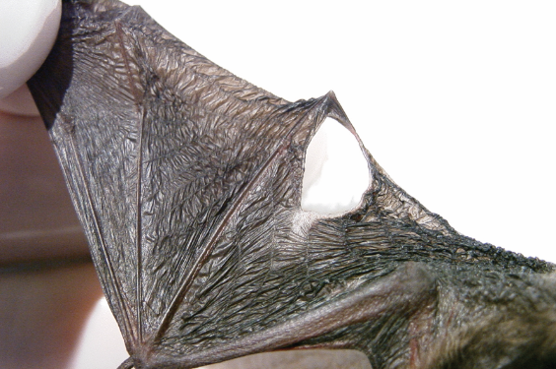
Figure 7.7: Microbat bone fracture. Photo credit: Zoos Victoria
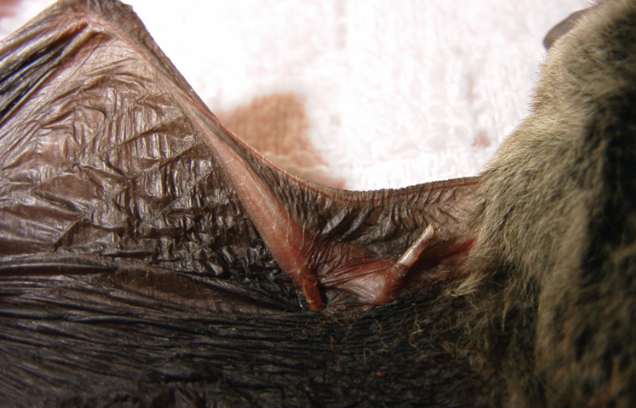
Figure 7.8: Bat fly on a southern bent-wing bat. Photo credit: Zoos Victoria
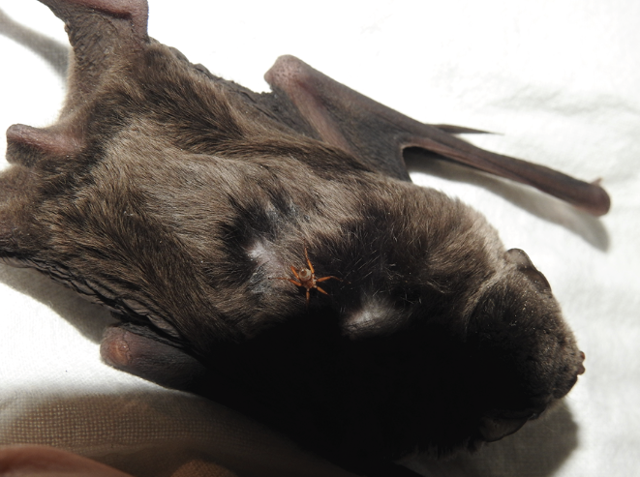

7.5.4. Administering treatment during rehabilitation
- Due to the small size of the bat, it is difficult to change dressings under manual restraint. It will be easier and less stressful if the bat is anaesthetised by a veterinarian for dressing changes. Appropriate pain relief and careful bandaging is required to reduce the risk of self-trauma (bats chewing or licking wounds), which is more likely to occur if the bandage is too tight or inappropriately applied.
- Oral medications can be delivered in a syringe directed into the side of the mouth while the bat is restrained. Care and protective gloves are required to avoid being bitten.
- Injectable medications can be administered under the skin, between the shoulder blades. Only experienced carers should give injections.

7.6. Housing
Below are several key considerations when housing adults in care.

7.6.1. General housing information for microbats
Microbats enter torpor during periods of cooler weather. Housing during rehabilitation should take this into consideration. For optimal immune function, drug metabolism and recovery from injury microbats should be kept in their thermoneutral zone.

7.6.2. Enclosure hygiene & biosecurity
General information about hygiene and biosecurity can be found in Part A of these guidelines. New diseases emerge frequently and sick and injured animals in care are often more susceptible to picking up pathogens from the environment. It is important to maintain excellent levels of hygiene to avoid inadvertently transferring diseases between animals, and from humans, and to protect the wild population where the animal will eventually return to.

Species specific considerations:
- All microbats should be considered possible ABLV carriers and should only be handled while wearing appropriate PPE. The virus lasts up to 24 hours in saliva but is short lived in the environment being rapidly inactivated by heat, direct sunlight, soapy water and most disinfectants including bleach and F10.
- Microbats can also carry other potential pathogens such as Salmonella, which are present in faeces. It is important to always wash hands with soap and water after servicing microbats.
- Microbats frequently carry external parasites such as mites and bat flies. Bat fly bites may cause mild skin irritation in people.
- Enclosures should be cleaned and disinfected between inhabitants. Items of furniture, such as bark, should be discarded as they cannot be effectively disinfected.

7.6.3. Housing types
Different set ups are required for animals at different stages of treatment and care.
Table 7.6 describes the housing type, suggested dimensions and requirements at each stage of care. For information on housing animals during hand raising see Section 7.8.
Table 7.6: Rehabilitation housing for adult microbats
Intensive care housing
Indications for use | Suggested min. dimensions | Suggested requirements
Short term critical care (<48 hours)  Intensive veterinary treatment – frequent medication, oxygen supplementation, temperature control  Longer periods under veterinary supervision where strict cage rest/confinement is indicated | 0.2 x 0.1 m (0.02 m²)  Height: 0.1 m | ENCLOSURE CONSTRUCTION  - Small plastic containers, eskies, if well ventilated, or a purpose built incubator, such as a Vetario or Brinsea can be used.  ENCLOSURE FURNISHING  - Place some type of fabric, such as a piece of blanket or pillowcase without threads, on the floor. This should be changed daily.  - Provide thread-free cloth as a roost for the bat to hide. Cloth should be hung for bats to roost in natural positions and should have multiple layers so the bat can roost between the fabric layers and feel safe.  ENVIRONMENTAL VARIABLES  - Humidity should be between 55 and 80%. Heat (31–38°C) may be provided in a plastic container by resting a covered heat pad against one side of the enclosure.  - Severely ill or injured microbats should be housed in an incubator in order to provide stable temperature and humidity, as ill bats may crawl away from heat mats in order to enter torpor.  PROVISION OF FOOD/WATER  - Provide water in a minimum of two small shallow bowls, such as bottle lids, as bats frequently defaecate in their water sources.  - The containers need to be small enough to prevent the bat from falling into the water.  - Marbles can be placed in water sources to avoid drowning.  - Water sources left inside humidicribs will dry quickly and require more frequent replenishment.

Intermediate housing (Treatment/cage rest)
Indications for use | Suggested min. dimensions | Suggested requirements
Provision of daily medication, close monitoring once animal is stabilised and no longer requires intensive care  Enclosure furnishings can be arranged to reduce opportunities to move excessively so that ‘cage rest’ can be achieved with slightly more space/reduced contact | 0.8 x 0.5 m (0.4 m²)  Height 0.6 m | ENCLOSURE CONSTRUCTION  - Vivariums of various sizes as shown in Figure 7.9, or canvas pet carriers.  ENCLOSURE FURNISHING  - A heat mat should still be made available at one end of the enclosure so the bat can choose to roost on or away from heat.  - Newspaper or other disposable material can be used as flooring.  - It should be changed daily.  - Multiple cloth hangings or bark may be used as roost sites during this stage.  - Cloth hangings should be changed as required.  ENVIRONMENTAL VARIABLES  - Suitable temperatures during this stage will allow the animal to heal and feed without further heating.  - Heating during night at the cooler times of the year may be required.  - Maximum summer temperatures of 25–28°C and minimum winter temperatures of 22–23°C will prevent the microbat from entering prolonged periods of torpor.  PROVISION OF FOOD/WATER  - Shallow lids from jars and bottles can be used as food and water bowls.  - Deeper containers are needed to keep mealworms from escaping.

Pre-release
Indications for use | Suggested min. dimensions for one to three bats | Suggested requirements
No longer require regular handling/medication  Development of fitness/strength prior to release  Monitoring and assessment of behaviour. This style of housing will allow microbats to fly and allow assessment of flight  Pre-release assessment | Little forest bat, lesser long-eared bat, Gould’s wattled bat:  3 x 3 m (9 m²)  Height: 2 m  Large microbats and those with long wings and a fast flight style, such as free-tailed bats:  8 x 8 m (64 m²)  Height: 4 m | ENCLOSURE CONSTRUCTION  - A mesh tent that can be bought from camping stores is a suitable enclosure. These tents have an attached floor, which prevents escape.  - Wire cages can damage the wings of microbats and should not be used.  - 3 x 3 m gazebo structure can also be used for smaller bats. Provide wooden bat boxes, pieces of bark and wood, and towels/blankets hanging over rope for roosts.  - Microbats should be warmed in the hand for five minutes before test flying. Ensure that disposable gloves are worn. Two days of flight training is required for every week spent confined in care.  ENCLOSURE FURNISHING  - Provide some cloth or branches that reach from the floor to the walls so that the bats can climb up to the roosts if they land on the floor. Avoid placing too many branches in the enclosure as they may reduce the space for flight.  PROVISION OF FOOD/WATER  - Offer food in shallow bowls, noting a bowl should be deep enough so that meal worms are not able to climb out.  - Provide more than one elevated feed station large enough for a bat to land upon.  - If the bat is in an outside enclosure, place an insect-attracting light outside at night.  - If the bat is in an indoor enclosure, collect insects outside in a light trap and then introduce them into the flight enclosure.  - Provide fresh water daily, on the elevated feed station.
Figure 7.9: A wooden box used for housing injured microbats. Note the bark and cloth roosts and water bowl. Photo credit: Zoos Victoria
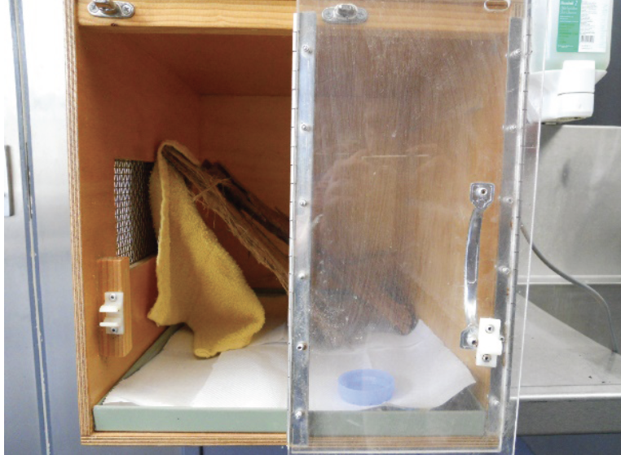

7.7. Feeding and nutrition
Keeping daily records of food offered (item and volume fed) and food consumed is good practice and will allow the rehabilitator to observe how an animal is responding to food on offer and inform future choices.
Please note: Food suppliers and specific products mentioned in these guidelines are intended as examples only. Other suitable products may also be available.
This section refers to feeding and nutrition of microbats in rehabilitation. Information on feeding orphaned individuals can be found under Section 7.8 Hand raising.
Fresh water should be always available, provided in a stable/non-spill bowl that is shallow enough to prevent drowning and includes a way to climb out, if needed. An automatic drinker could also be considered. Water should be changed daily.
Table 7.7: Daily feeding and diet guide for adult microbats during rehabilitation
Diet | - Microbats are predominantly fed on mealworms. Mealworms are the larvae of the darkling beetle (Tenebrio molitor).  - Do not offer food until hydration has been addressed.  - Bats should be warm prior to feeding. Feed one to two large live mealworms per gram of bodyweight, for example a 10 g bat will need at least 10 large mealworms daily.  - Only feed mealworms, do not substitute with other invertebrates.  - Some microbats will not be able to feed on a intact mealworm and exposing the internal gut by removing the head may be required until the bat is feeding reliably.  - Never leave live mealworms in enclosures with debilitated bats.  - Bats usually need assisted feeding initially. Remove the mealworm’s head and squeeze the gut contents into the microbat’s mouth (Figure 7.10). Initially, the bat might only take mealworm innards however the entire mealworm is required to provide a balanced diet. Once the bat is used to taking whole mealworms, they can be fed without taking the head off by presenting the back of the mealworm’s head to the bat’s mouth. Weigh the microbat daily. If the animal is losing weight, increase the number of mealworms fed so that the microbat remains in the normal weight range for the species.  - A mealworm custard can be given to sick bats or bats that are resistant to whole mealworms. See Table 7.8 for the recipe.  - A slurry of Wombaroo Carnivore mix can also be offered to sick bats.
Mealworm Care | - Mealworms should be housed in a plastic tub on a substrate of 50:50 oat bran and Wombaroo Insect Booster, replaced weekly. Offer sliced sweet potato or carrot, replace daily. Include a piece of open weave hessian as a hide for mealworms. Dust the mealworms with Wombaroo Small Carnivore Mix immediately prior to feeding.
Frequency/time of feeding | - Daily. Bats entering torpor during the cooler months may only need to be offered food every third day. Once the bat is self-feeding, offer a continuous supply of mealworms so the bat can eat when needed.
Table 7.8: Recipe for mealworm custard (Introduction to the Care and Rehabilitation of Microbats*)
Ingredients | - 1.5 cups frozen mealworms  - ½ cup cold water  - 2 teaspoons Wombaroo Small Carnivore Mix or equivalent  - 2 teaspoons vitamin powder such as Soluvet  - ½ teaspoon Liquid Oral Care  - ½ teaspoon Megaderm  - 1 scoop S26 Infasoy or equivalent
Method | On high speed in a blender, gradually add the frozen mealworms to ½ cup cold water and blend until it is the consistency of honey. Add the remaining ingredients, blend and then store in ice cube trays within a snap locked bag in the freezer. This can be kept for up to 30 days. When needed, defrost a cube in the fridge. Once thawed, the mixture will keep for 3 days in the fridge. Each cube will feed approximately 6–8 small bats/night. Hand-feed the mixture to the bat via a syringe, ensuring the mouth and surrounding fur are cleaned well afterwards to prevent fungal infections.
*The details of this reference are found in “Key references and additional reading”.
Figure 7.10: A microbat is fed gut contents from a mealworm. Photo credit: Zoos Victoria
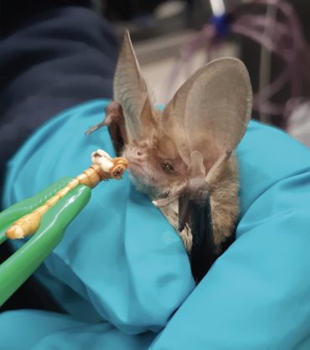

7.8. Hand raising
Hand raising record templates for growth, development, feeding and other observations are found in the appendices to Part A of these guidelines.

7.8.1. Equipment required for hand raising
- Humidicrib
- Milk: Wombaroo Bat Milk Replacer
- Alternative for most bats: 100 mL goat’s milk mixed with 1.5 scoops of S26 Infasoy powder (or equivalent), 2 mL Megaderm, 2 level teaspoons of dried egg white powder or the white of one medium egg and ¼ teaspoon Human Paediatric Probiotic Powder
- Alternative for freetail bats (Mollosidae): 100 mL goat’s milk mixed with 2 scoops of S26 Infasoy powder (or equivalent), 3 mL Megaderm and ¼ teaspoon Human Paediatric Probiotic Powder (Alternative milk recipes taken from ‘Introduction to the Care and Rehabilitation of Microbats’. Details of this reference are found in Key references and additional reading)
- Catheter, eye dropper, foam eye shadow applicator
- Syringes
- Multiple layers of soft cloth for the young microbat to roost in
- Cotton buds
- Digital scales
- Record charts.

7.8.2. Growth, development and care of orphaned young
STOP – Please refer to your authorisation for mandatory conditions, regarding hand-raising orphaned young.
- Pups should be raised in small groups where possible.
- White-striped free-tailed bats are the only microbat species susceptible to imprinting. This is prevented by housing them with others of the same species and limiting human contact.
- Drip milk onto the end of a foam eyeshadow make up applicator, which is then placed in the bat’s mouth, stimulating it to suckle. Free-tailed bats are reluctant to lap and will often only feed this way.
- If the bat refuses to feed from the sponge, offer milk via a catheter and syringe.
- Feed with the bat’s body horizontal or with its head slightly raised.
- Wipe the bat’s mouth clean afterwards.
- Pups should be fed when their stomachs are near empty. In furless pups, milk can be seen through the abdominal wall. For furred pups, gently feel the abdomen to determine if the stomach is near empty.
- Do not overfeed. Bloat is a common cause of death in microbat pups. The pup’s abdomen should be slightly rounded and of similar diameter as the rib cage. Microbat pups will not refuse food when full and there is the potential to fatally distend or perforate the stomach through over feeding.
- Hairless (or pinky) pups become dehydrated extremely quickly. Even pups feeding well may need to be supplemented with subcutaneous fluids.
- Toileting: Stimulate the genital area by gently stroking with a moist cotton bud before and after each feed to encourage urination and defaecation. Microbats are born knowing how to defaecate and urinate. Stimulation may or may not be required and should be determined on an individual basis.
- Hand-reared microbats will require a minimum of four weeks of flight training prior to release. This should commence as soon as bats are self-feeding on solid food and fully furred.
- Flight training: place bat on the flat of the gloved hand and lift and lower the hand to encourage spreading of the wings. Training may take several weeks. Exercise in a closed room is ideal; with initial practice over a bed to provide a soft landing if they fall.
- Provide flying insects, such as moths, in the two to four weeks prior to the release of hand reared juveniles. This may be done by placing a black UV light outside the enclosure to attract insects.
- The growth and feeding requirements for Gould’s wattled bats are in Table 7.9. These principles can be extrapolated to other species of microbats. However, they are only a guide, as microbat size and growth rate varies, depending on latitude.
Table 7.9: Gould’s wattled bat developmental stages, produced with input from Wombaroo and Ericka Tudhope
Age (days) | Forearm length (mm) | Weight (g) | Milk  (mL/day) | Notes
1 | 21.0 | 3.0 | 1.0 | Keep in a temperature and humidity-controlled enclosure such as a Brinsea or Vitario. Enclosure temperature 35–38°C, humidity 80–90%, furless, pink, 2 hourly feeds
3 | 24.0 | 3.5 | 1.1 | Eyes opening
5 | 26.0 | 4.0 | 1.2 | 3 hourly feeds
7 | 28.0 | 4.5 | 1.3 | Enclosure temperature 32–34°C, humidity 60%, fur growing on head and neck
9 | 29.5 | 5.2 | 1.4 | Fur growing on belly
11 | 31.0 | 5.9 | 1.6 | -
14 | 33.0 | 7.0 | 1.8 | Thickly furred, 4 hourly feeds, start adding mealworm custard to milk
17 | 35.0 | 8.5 | 2.1 | -
20 | 37.0 | 10.0 | 2.4 | Beginning to thermoregulate, 28–32°C, add mealworm viscera and replace some milk feeds with mealworm custard
24 | 39.5 | 11.7 | 2.7 | 5 hourly feeds
28 | 41.5 | 13.1 | 2.8 | Can thermoregulate. Enclosure temperature 22–28°C. Offer mealworms with heads removed. Mealworm custard can still be fed. Encourage to self-feed as soon as bat is readily taking mealworms by holding a bowl of mealworms close to the bat’s face
32 | 43.5 | 14.1 | 2.4 | Gradually reduce milk intake and increase solid food
36 | 45.5 | 14.5 | 1.6 | House at room temperature, offer heating at night, 7 hourly feeds, self-feeding
42 | 47.0 | 15.0 | 0.0 | Access to outside temperature ranges, fully weaned, adult size

7.9. Release protocol
Ideally, wild animals will be rehabilitated and released in a short timeframe. If this is not possible and the animal is in care for significant extended periods, ensure that the animal is regularly assessed against the welfare domains to support decision-making. Animals in care for extended periods may have a reduced ability to survive in the wild. Talk to your veterinarian and consider whether euthanasia will provide the best welfare outcome for the animal.

7.9.1. Pre-release assessment
Pre-release assessment of animals in care is essential to support better outcomes once back in the wild. Animals should be assessed based on body condition, fitness and the ability to engage in natural species-specific behaviours prior to release.
The following checklist should be used to guide decision making regarding release suitability for microbats:
- Individual is in a state of good health – presenting injury/sickness is completely resolved (consider a pre-release veterinary check).
- Individual is within a healthy weight range and appropriate body condition (refer to Table 7.1). Use a set of scales that can measure down to 0.1 g or 0.01 g, such as jewellery scales. Kitchen scales that only measure down to 1 g are not accurate enough.
- Weights vary throughout the year. Typically bats put on weight during autumn to prepare for the lack of insects over winter when they enter torpor. They will be at the high end of their weight range at the end of autumn/early winter. Weights are typically lowest at the end of winter and spring, except for pregnant females which can be 30% heavier prior to giving birth in early summer.
- Individual can gain height, negotiate objects and maintain continuous flight for at least several minutes.

7.9.2. At the release site
Post release survival will be maximised by ensuring that both the release site and the way in which the animal is released are carefully considered, including the following:
- Microbats found within buildings are released outside the building at the same address.
- If it is not possible to release them exactly where they were found, microbats should be released as close as possible to the site. As they have a large home range, they can be released up to one kilometre away from the finding site. For more information on the ecological characteristics and requirements of microbats that may help with their release, please refer to Table 7.1.
- If the location of a microbat’s original home range is unknown, then contact DEECA via the Customer Centre on 136 186 to determine a suitable site for release.

7.9.3. Release checklist
Check all of the requirements of your authorisation are being met, and consider the following:

Release location
- Release after dusk to avoid predation by diurnal birds.
- Hand-reared young should be released in late summer to early autumn. This is the natural dispersal time and a time of high insect activity. Adults can be released at any time of the year.
- Do not release if the weather is cold, wet or windy.
- Conditions should be warm on dusk, with no forecast rain or strong wind for the following two nights.

Release Procedure
- Provide the microbat with 50% of its daily intake of mealworms on the day of release.
- Warm the bat in a gloved hand for five minutes prior to release.
- Do not throw the bat up into the air but permit it to fly from the hand.
- If the bat does not fly from the hand, after being warmed adequately, the animal should be reassessed.
- If uninjured, then release may be attempted on the following night with the bat moved around in the hand to encourage activity and then flight.
- Free-tailed bats need to drop from a height to start flying. These bats need to be held higher than 2 m off the ground or they may crash when attempting to fly from the hand.

7.10. Key references and additional reading
Barnard, S.M. 2002. Insectivorous bats. In: Hand-rearing wild and domestic mammals, Gage. L.J. (ed). Iowa State Press, Ames, Pp. 96 – 103.
Churchill, S. 2009. Australian Bats, 2nd ed. Allen and Unwin, Crows Nest. 255 pp.
Lollar, A., and Schmidt-French, B. 2002. Captive Care and Medical Reference for the Rehabilitation of Insectivorous Bats, 2nd ed. Bat World, Mineral Wells. 340 pp.
Lyons, R., and Wimberley, T. 2014. Introduction to the Care and Rehabilitation of Microbats. Wildcare Australia Inc., Nerang. 132 pp.
Department of Agriculture webpage, Rabies and Australian bat lyssavirus | Important animal diseases | Animal diseases | Biosecurity | Agriculture Victoria.
https://agriculture.vic.gov.au/biosecurity/animal-diseases/general-livestock-diseases/rabies-and-australian-bat-lyssavirus#h2-3.
Wildlife Health Australia (WHA), BAT HEALTH FOCUS GROUP webpage. https://wildlifehealthaustralia.com.au/ProgramsProjects/BatHealthFocusGroup.aspx.
Wildlife Health Australia (WHA), PERSONAL PROTECTIVE EQUIPMENT (PPE) INFORMATION FOR BAT HANDLERS. https://wildlifehealthaustralia.com.au/Portals/0/Documents/ProgramProjects/PPE_Info_for_Bat_Handlers.pdf
The Facebook group, Australian Microbat Rehabilitation Forum, is a useful group for microbat rehabilitators to join. It offers a free, digital manual with detailed instructions on rescuing and caring for microbats (Introduction to the Care and Rehabilitation of Microbats). This manual was developed by Rachel Lyons and Trish Wimberley, prominent microbat carers in Queensland, with the help of bat ecologists and veterinarians.

