Chapter 3: Turtles

Contents
3.1. Introduction 2
3.2. Species information 3
3.3. Animal and human safety considerations 13
3.3.1. Human safety considerations 13
3.3.2. Animal safety considerations 13
3.4. Capture, restraint, and transport 13
3.4.1. Visual observations 14
3.4.2. Equipment 15
3.4.3. Technique 15
3.4.4. Transport 16
3.5. Monitoring animal health and welfare 17
3.5.1. Physical examination 17
3.5.2. Ongoing monitoring of health and welfare 19
3.5.3. Common presenting injuries and clinical signs of emerging health conditions 20
3.5.4. Administering treatment 29
3.6. Housing 29
3.6.1. General housing information for turtles 29
3.6.2. Enclosure hygiene and biosecurity 30
3.6.3. Housing types 31
3.7. Feeding and nutrition 34
3.8. Artificial incubation 35
3.8.1. Equipment required 35
3.8.2. Technique 36
3.9. Release protocol 36
3.9.1. Pre-release assessment 37
3.9.2. At the release site 37
3.9.3. Release checklist 38
3.10. Key references and additional reading 38

In Victoria, sick, injured or orphaned wildlife can only be rehabilitated by a wildlife shelter operator or foster carer who is authorised under section 28A of the Victorian Wildlife Act 1975 (Wildlife Act). Wildlife rehabilitators are subject to strict conditions. The mandatory requirements that they must meet are set out in the Wildlife Shelter and Foster Carer Authorisation issued under the Wildlife Act. These conditions enforce the minimum standards required for the humane treatment and successful rehabilitation of wildlife in care. The Wildlife Rehabilitator Authorisation Guide: Things You Need To Know explains how wildlife rehabilitators can meet these mandatory requirements and can be found here:
https://www.vic.gov.au/wildlife-rehabilitation-shelters-and-foster-carers.
The Victorian Wildlife Rehabilitation Guidelines have been developed to incorporate evidenced-based best practice in wildlife care and rehabilitation to equip rehabilitators to deliver positive welfare outcomes for individual animals in their care from first aid to post-release into the wild.
You must comply with the conditions of your authorisation. These guidelines must be read in conjunction with the conditions of your authorisation.

3.1. Introduction
There are three turtle species that commonly come into care in Victoria. This chapter addresses their husbandry, care and welfare. It does not cover marine turtles.
The Macquarie River turtle is listed as threatened in Victoria.
STOP – If any turtle species listed as threatened, or a marine turtle comes into care, please STOP and refer to your authorisation for mandatory conditions including notification and release requirements.
This chapter also lists an introduced species, the red-eared slider (Trachemys scripta elegans). This species poses a threat to native species through predation and the introduction of new animal diseases and should be reported.
Notify DEECA or Agriculture Victoria of any exotic turtles in the wild or any that come into care on 136 186 or email highrisk.invasiveanimals@agriculture.vic.gov.au.
When turtles come into care it is the responsibility of the wildlife rehabilitator to ensure that the five domains of animal welfare are satisfied. These include providing optimal nutrition and an environment appropriate to the stage of rehabilitation. The focus should be on the turtle’s return to health and release, which is facilitated through regular collaboration with a veterinarian. It is also important to consider the turtle’s mental state and ability to exhibit normal behaviours without detrimentally affecting its recovery. Welfare may be temporarily compromised by the necessity of a gradual return to normal activity, depending on its stage of rehabilitation. Further information about the five domains of animal welfare can be found in Part A of these guidelines.

3.2. Species information
Profiles for the most common turtle species found in Victoria are detailed in the following tables. It does not describe all of the turtle species found in Victoria. For assistance in identification of turtle species, refer to the recommended reading and reference material at the end of this chapter.
Table 3.1: Species profiles
Species | Broad-shelled turtle (Chelodina expansa)
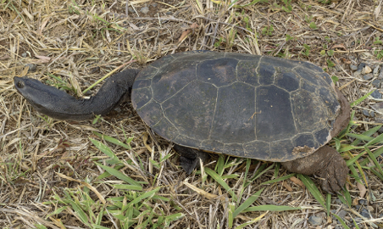  Photo credit: Shutterstock | Distribution map  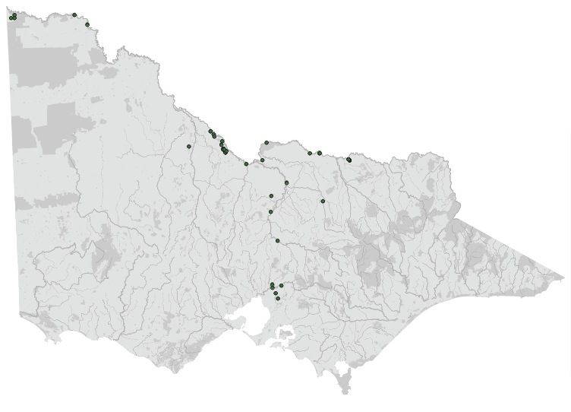  Data source: Victorian Biodiversity Atlas Jan 2023  www.environment.vic.gov.au/biodiversity/victorian-biodiversity-atlas
General appearance | Long neck, broad head
Conservation status* | Endangered
Sexual dimorphism | Males are smaller and mature earlier than females. They are distinguished by a long tail that extends beyond the margin of the carapace (the top shell) when mature
Adult morphometrics | Body weight: Male: Up to 4 kg. Female: Up to 6 kg  Length: 40–50 cm:
Habitat | In reeds and under submerged logs
Home range | Male = 11.18 ± 4.10 km  Female = 1.43 ± 1.73 km
Foraging style | Ambush hunter
Type of waterway | Permanent
Depth (m) | >2
Water quality | Turbid
Water temperature at which turtles are active | Usually above 18°C, but has occasionally been observed to be active in water above 16°C
Natural activity peak | Late afternoon
Movement | No
Hibernation – duration and timing | No
Nesting time | March–May
Nest location from water (m) and nest substrate | 30–55
Number of eggs laid | 5–30
Incubation (days) | 200–650
Age at sexual maturity (years) | Male = 9–11  Female = >14
Diet | Frogs, crustaceans, aquatic insects, fish

Species | Common long-necked turtle (Chelodina longicollis)
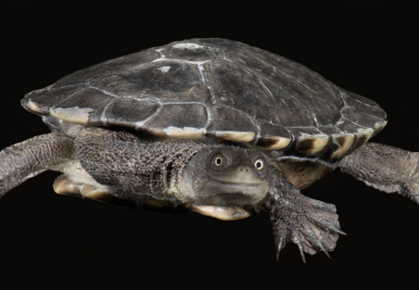  Photo credit: David Paul, Museums Victoria | Distribution map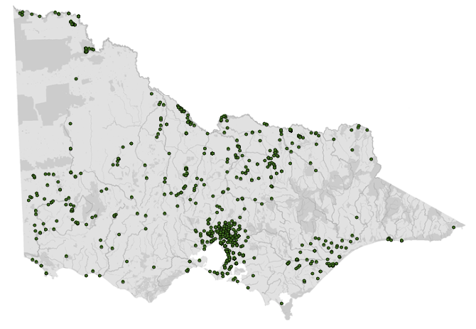  Data source: Victorian Biodiversity Atlas Jan 2023  www.environment.vic.gov.au/biodiversity/victorian-biodiversity-atlas
General appearance | Long neck, plastron scutes have black edges
Conservation status* | Common
Sexual dimorphism | Dimorphism is present but can be subtle. Males tend to be smaller, with longer tails, a concave plastron (the bottom shell) and V shaped anal scutes. Females tend to be larger, with shorter tails, a convex plastron and U shaped anal scutes
Adult morphometrics | Body weight: 0.5–2.0 kg  Length: 20–25 cm
Habitat | Oxbow lakes, ponds, swamp
Home range (ha) | 10–16
Foraging style | Snatch, grab and chase
Type of waterway | Not permanent
Depth (m) | <2
Water quality | Partly turbid
Water temperature at which turtles are active | Above 12°C
Natural activity peak | Dawn and dusk
Movement | Between watercourses
Hibernation – duration and timing | Yes – on land
Nesting time | September–November
Nest location from water (m) and nest substrate | <200
Number of eggs laid | 4–20. In favorable conditions can produce more than one clutch per year
Incubation (days) | 120–180
Age at sexual maturity (years) | Male = 7–8  Female = 10–12
Diet | Frogs, tadpoles, crustaceans, aquatic insects, fish

Species | Macquarie River turtle (Emydura macquarii)
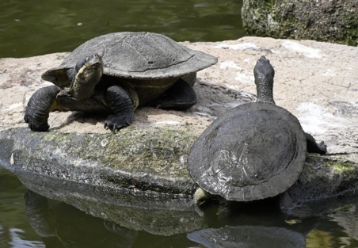  Photo credit: Zoos Victoria | Distribution map  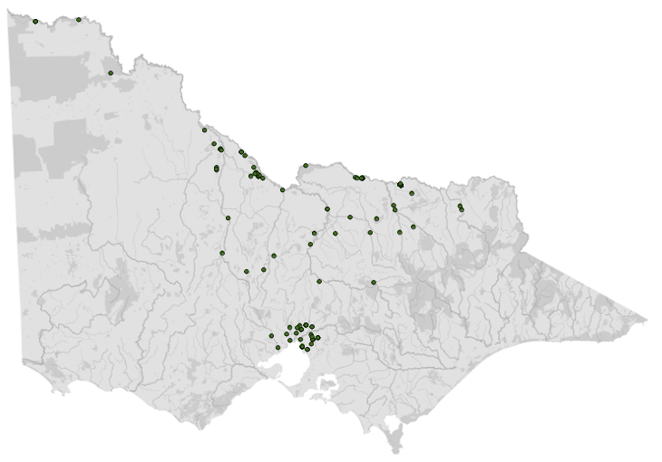  Data source: Victorian Biodiversity Atlas Jan 2023  www.environment.vic.gov.au/biodiversity/victorian-biodiversity-atlas
General appearance | Short neck, light coloured shell, cream band from mouth to neck
Conservation status* | Critically endangered
Sexual dimorphism | Males are smaller with longer tails
Adult morphometrics | Body weight: 1.2–1.8 kg  Length: 20–30 cm
Habitat | Still, deep water body
Home range (ha) | 0.01–24
Foraging style | Forage and graze
Type of waterway | Permanent
Depth (m) | >3
Water quality | Clear to turbid
Water temperature at which turtles are active | Above 16°C
Natural activity peak | Afternoon to early evening
Movement | No
Hibernation – duration and timing | Yes – in water
Nesting time | November–January
Nest location from water (m) and nest substrate | 2–40
Number of eggs laid | 10–15
Incubation (days) | 48–85
Age at sexual maturity (years) | Male = 5–6  Female = 10–12
Diet | Molluscs, crustaceans, fish, carrion, aquatic plants
*From the Flora and Fauna Guarantee Act 1988 Threatened List June 2023. This list is updated regularly throughout the year. For the most current list, please visit https://www.environment.vic.gov.au/conserving-threatened-species/threatened-list.
Figure 3.1: A photo showing a Macquarie river turtle on the left and a common long-necked turtle on the right. Note the pale stripe running along the side of the head of the Macquarie river turtle. Photo credit: Shane Simpson
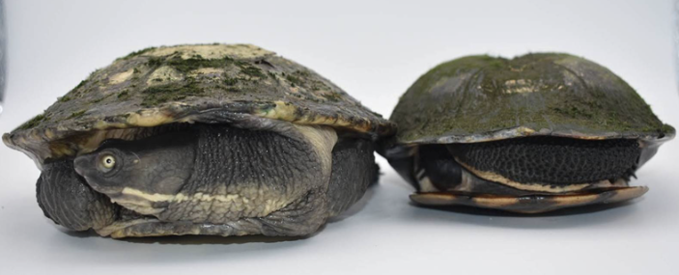
Figure 3.2: Note the proportionally smaller plastron of the Macquarie River turtle on the left compared with the larger plastron of the common long-necked turtle on the right. Photo credit: Shane Simpson
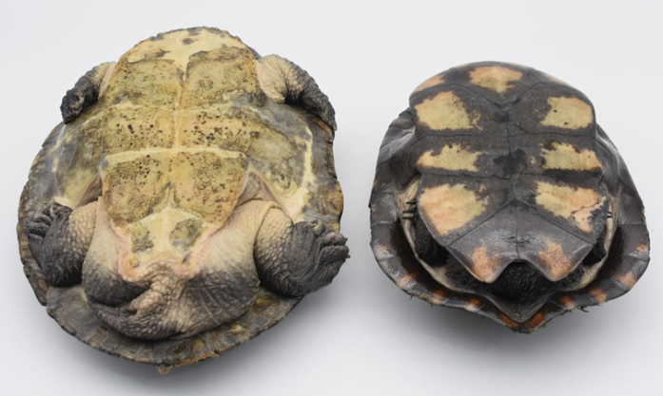
Table 3.2: Non-endemic and exotic species that may come into care
Introduced species | Krefft’s turtle (Emydura krefftii)
General appearance  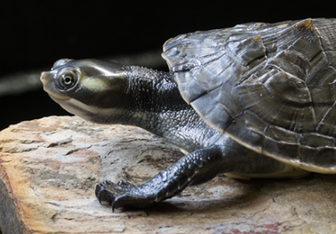  Photo credit: Shutterstock | Short neck, pale facial stripe
Sexual dimorphism | Males are smaller and have longer tails than females
Adult morphometrics | Body weight: Male: 650 +/- 37.8 g. Female: 1010 +/- 61.7 g  Average Length: 25–29 cm

Introduced species | Red-eared slider (Trachemys scripta elegans)
General appearance  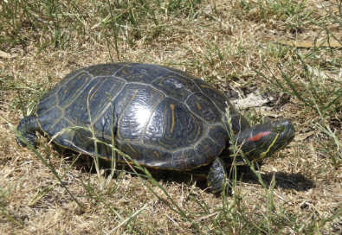  Photo credit: Agriculture Victoria | General appearance  Red facial stripe, retracts head by pulling it straight back into the shell
Sexual dimorphism | Males are smaller and have longer tails than females
Adult morphometrics | Body weight: Up to 3 kg  Length: 12–28 cm
Exotic and native species non-endemic to Victoria must not be released into the wild. Non-endemic turtle species, such as Krefft’s turtles (Emydura krefftii), may escape their enclosures or find their way into Victoria in containers. In cases where the animal is suspected to be an escaped pet, take the animal to a veterinarian to be scanned for a microchip. If an owner can be identified, the animal should be returned as soon as possible.
Occasionally exotic turtle species come into care, for example red-eared slider (Trachemys scripta elegans). Red-eared sliders are classified as a controlled pest animal under the Victorian Catchment and Land Protection Act 1994. The importation, keeping, breeding and trading of this species, without appropriate permits, is illegal. These animals must be euthanised as they are a pest and pose a threat to our native species. Notify DEECA or Agriculture Victoria of all exotic turtles in the wild on 136 186 or email highrisk.invasiveanimals@ agriculture.vic.gov.au.
The introduced specie listed, the red-eared slider (Trachemys scripta elegans), in Table 3.2 is not native to Australia and if given the opportunity could populate a wide range of landscapes within Victoria, impacting native wildlife through predation and the introduction of new animal diseases. Red-eared sliders have been found in all states in Australia, including Victoria, and are typically escapees or deliberately released animals from the illegal pet trade. Since 2000 more than 70 red-eared sliders have been detected across Greater Melbourne and Geelong. Twenty of these have been in, or adjacent to, Victorian rivers and lakes, including at Caroline Springs, Elwood Canal, Elsternwick Park Lake, Yarra River and in urban streets of Lara, Frankston, Aberfeldie, Kensington and Taylors Lakes. The illegal keeping and trading of introduced species is one of the greatest risks of the species establishing in Victoria and poses a direct threat to our native wildlife. All introduced turtle species identified should be reported via email to highrisk. invasiveanimals@agriculture.vic.gov.au.
Further information is available at:
https://agriculture.vic.gov.au/biosecurity/pestanimals/report-an-exotic-pest-animal-sighting
https://agriculture.vic.gov.au/biosecurity/pestanimals/priority-pest-animals/redeared-sliderturtle

3.3. Animal and human
safety considerations
In general, animals in the wild have limited contact with people, pets, and the hustle and bustle of our daily lives. When sick, injured or orphaned wild animals come into care this unnaturally close contact can carry risks to the health and safety of both people and animals. For general information on biosecurity and approaches to minimise these risks see Part A of these guidelines. Specific information on enclosure hygiene and biosecurity for turtles is in Section 3.6.2.
The following information relates to human and animal health and safety considerations specifically related to the rehabilitation of turtles.

3.3.1. Human safety considerations
- Wash hands with soap and water after handling turtles to minimise the risk of infection with zoonotic disease agents such as Salmonella.
- Turtles can inflict a painful bite but rarely break the skin.
- Their claws are sharp and may scratch. Hind legs are also quite powerful. Handlers should be wary of claws and ensure they have a tight grip on the carapace to reduce the risk of dropping and injury to the handler or turtle.
- As a deterrent, common long-necked turtles can produce a strong, foul-smelling, liquid from musk glands when disturbed or handled. Musk glands can be found at the corners of the bony bridge between the plastron (the bottom shell) and the carapace (the top shell). This liquid may be confused with blood as it is often orange-red in colour. Wash hands after handling to avoid wiping the liquid into the eyes or mouth.

3.3.2. Animal safety considerations
- Injuries including broken limbs and shell fractures can occur if turtles are dropped. Turtles should be firmly restrained and held over raised surfaces (table or bench) to reduce height and risk of injury.

3.4. Capture, restraint, and transport
STOP – A visual examination must be done BEFORE the animal is captured. This applies to the initial capture from the wild as well as prior to captures which occur during time in captive care. See Section 3.4.1 for information on what to look for when conducting a visual health assessment.
Refer to Part A of these guidelines for general advice on wildlife welfare, biosecurity and hygiene, and record requirements. The following information relates to the capture, restraint, and transport of sick, injured and orphaned turtle species.

3.4.1. Visual observations
Visual observations of wildlife should be conducted prior to any attempts to capture the animal. This is just as important prior to the first capture from the wild as it is before any capture conducted while an animal is in captive care. Observations should be conducted quietly, by one person, and from a distance which provides a clear view of the animal with as little disturbance as possible. Visual observation should focus on the animal’s demeanour, behaviour, movement and posture. Check for evidence of injury/severe disease or deterioration and assess their breathing as demonstrated in the following table.
Visual examination of turtles can be challenging as they tend to remain motionless with limbs and head tucked into their shell if they feel threatened. However, it should still be possible to assess the state of the turtle’s shell.
Table 3.3: Visual health observations in turtles
 | What to look for
Demeanour | - Reactive to being approached  - All limbs and head are pulled tightly into the shell and are not protruding  - Broadshell and Macquarie River turtles are more likely to have head and limbs protruding from their shell than common long-neck turtles
Shell | - Intact  - No obvious fractures, missing pieces or bleeding  - Ensure you check the top of the shell (carapace), bottom of the shell (plastron) and each side (bridge) as well as the edges of the shell  - May be covered in algae
Movement | - When left alone and observed from a distance turtles will often start walking, allowing movement to be assessed  - Able to use all four legs, none dragging abnormally
Skin | - Intact  - No obvious cuts or bleeding
Eyes | - Open, bright, not sunken

3.4.2. Equipment
No particular equipment is required to pick up a turtle that is found on the ground. A turtle in water can be caught with a fishing net.
Turtles should be transported in a solid container, such as a plastic tub with a lid to prevent escape. Tubs should also have some level of ventilation. Container size will vary with the individual but as a guide it should be twice the body length of the turtle. Most individuals should fit within a transport container 40 cm x 30 cm x 20 cm (H). A larger size will likely be required for broad-shelled turtles.
Figure 3.3: A Rio basket lined with a damp towel used to transport a turtle. Photo credit: Zoos Victoria
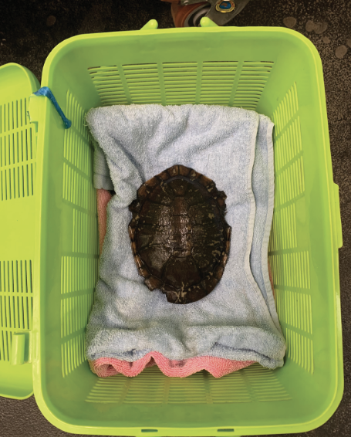

3.4.3. Technique
It is beyond the scope of these guidelines to outline techniques for every situation that may be encountered. Examples of techniques for some specific situations are outlined in the following section.
In addition to this information, for further advice please also refer to the recommended reading list, zoological institutions, veterinarians and/or wildlife experts. Inexperienced rescuers should request assistance where possible.
- A turtle should be held with two hands on either side of the carapace and plastron as shown in Figure 3.4. Raise the animal higher and tilt it to examine the underside.
Figure 3.4: Restraint of a turtle for examination using both hands. Photo credit: Zoos Victoria
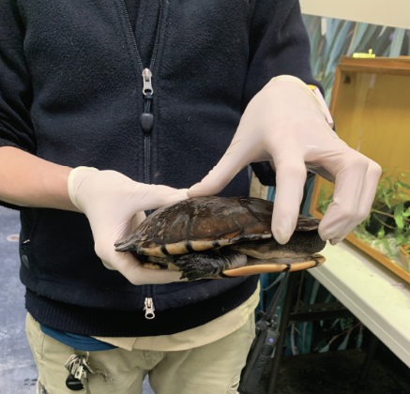
Turtles may be hit by vehicles when they cross roads to travel to and from water bodies, particularly during nesting time or after rain. After the turtle is picked up, examine it for injuries. If no injuries are present, place it on the side of the road that it was heading toward. Common long‑necked and broad-shelled turtles are more likely to cross roads during the day while the weather is sunny.

3.4.4. Transport
- Transport turtles in a well-ventilated container.
- Secure the container in the vehicle so that it cannot slide or roll over.
- Turtles should not be transported in water.
- A damp towel can be placed on the floor of the enclosure to provide humidity.
- Turtles do not require food or water during transit.
- In hot weather, transport the turtle in an air-conditioned vehicle.

3.5. Monitoring animal health and welfare
The goal of wildlife rehabilitation is to address health and welfare concerns quickly and effectively so wildlife can be released back to the wild as soon as possible. Decision-making from the time of capture through to release should be guided by an accurate understanding of the animal’s true state of health and welfare. Careful monitoring throughout the rehabilitation period ensures that significant issues, or deterioration in health condition, are identified immediately and rapidly addressed.
It is preferred that all sick, injured or orphaned wildlife be assessed by a veterinarian to ensure that non-obvious signs of trauma or disease can be assessed and treated as soon as practicable. No medication should be provided prior to this assessment, as this can mask clinical signs and make an accurate health assessment by the veterinarian very difficult.
Templates for record-keeping visual and physical observations and daily care can be found in Part A of these guidelines.
This section provides guidance on health assessments on arrival and on effective monitoring of the health and welfare of individuals in care through minimising human-animal interactions and stress to the animal to maximise successful release back to the wild.

3.5.1. Physical examination
Once visual observations are complete, and the animal is stable enough to withstand capture and handling, a basic physical examination should be conducted. This can be repeated when required any time the carer has the animal in the hand, such as for an enclosure change. However, if a full physical exam is not conducted, body condition and weight should be assessed every time the animal is in the hand for other reasons. Carers should make sure scales are available and ready to use before capturing the animal. Physical examinations are also required if the carer notices any changes suggestive of deteriorating health or an injury.
Always record the physical examination findings so that you can compare findings as the animal’s rehabilitation progresses. This ensures any health concerns are identified as soon as possible, and the carer can plan release as soon as this is appropriate. A template for recording physical examination findings can be found in the appendices to Part A of these guidelines.
Examinations should be conducted in a quiet location, away from any domestic animals. Only one person should handle the animal, while a second person takes notes. All other people should move away, and noise kept to a minimum. Handling should also be kept to a minimum.

Species specific considerations:
- Turtles can be examined while conscious. However, healthy turtles (especially common long-neck turtles) will tuck all four limbs and head into their shell. These can be difficult to extract and examine. Excessive force should not be used as this may further injure the limbs or head.
- Anaesthesia may be required to examine the head and legs and to take x-rays. The normal radiographic (process of taking x-rays) examination of a turtle involves taking three separate views. If your veterinarian is not aware of these, they should contact Zoos Victoria for advice on how to obtain these views.
Table 3.4: Physical examination
 | What to look for
Body weight | - Record body weight on arrival and at least weekly while in care.  - As a rough guide, a greater than 10% change in body weight is cause for concern, and the carer should seek veterinary advice.
Body condition | - The amount of musculature on the head, neck and limbs will provide an indication of the turtle’s body condition. A turtle whose neck vertebrae are prominent is in poor condition whereas a turtle whose neck vertebrae can just be felt is in good condition.
Hydration status | - Eyes should be bright, sunken eyes can indicate dehydration.  - Check skin tenting along the side of the neck. It should fall down within one second.  - Wrinkled skin may indicate dehydration.
Eyes | - Open, bright, no excessive mucous or other discharge.  - Basic internal structures of eyes (e.g. pupil, iris) appear symmetrical.  - No swelling.
Nostrils | - Open, clear, no excessive mucous or other discharge.
Mouth | - Yellow or cream lining.  - Jawline is stable and symmetrical, no evidence of fracture.  - No evidence of fishing line.
Limbs, feet and tail | - Uses all four legs when it walks or swims.  - Tail is functioning normally.  - No missing toes or nails.  - Feet are free from abrasions or injuries.
Sex determination | - Turtles can be sexed by looking at the shape of the plastron near the tail. Male turtles have a V-shaped rear end to the plastron, which may also be slightly concave. The tail may appear longer to accommodate the male reproductive organ. Females have a broader U-shaped end to the plastron. The tail may be shorter in length compared to males. See Figure 3.5.  - Awareness of seasons and of female turtles entering care that may be gravid (carrying eggs).
Figure 3.5: On the left, a male common long-necked turtle and on the right, a female turtle. The male has a V-shaped appearance to the rear end of the plastron. The appearance of the female is broader and more u-shaped. Photo credit: Zoos Victoria
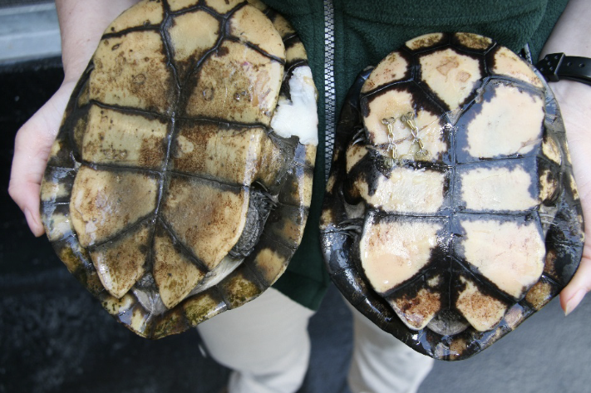

3.5.2. Ongoing monitoring of health and welfare
The aim of wildlife rehabilitation is to ensure animals recover and can be released back to the wild as quickly as possible. Careful, daily monitoring is required to ensure that animals are responding as expected to the treatment being provided and so that any deterioration or welfare concerns can be identified and addressed as soon as possible. Rehabilitators should ensure that record-keeping is a priority to maximise positive welfare outcomes. Templates to assist wildlife rehabilitators to record and monitor wildlife health and welfare can be found in the appendices to Part A of these guidelines. These records will be valuable tools to share with veterinarians to support decision-making.
The following is recorded daily:
- demeanour
- food consumption
- faecal/urine output
- behaviour observed
- medical treatment provided
- evidence of overnight activity.
The following is recorded weekly:
- weight
- body condition.
Over time, regular monitoring will also help to develop carer skills and knowledge, as regular observations and recording will result in a deep understanding of the expected behaviour and response to treatment for the species in care.

Species specific considerations:
- The turtle should be observed at least daily.
- Note the turtle’s demeanour and behaviour every time food is introduced or taken away, the animal is medicated or the enclosure is cleaned. Pay particular attention to any changes that have occurred since the previous day.
- Awareness of seasonal behaviours, such as gravid females, or brumation. Factors that need to be considered when planning care, rehabilitation and release.
- Note the turtle’s buoyancy and ability to swim. It should be able to swim to the bottom of the tank and back up to the surface. The turtle should sit level in the water and should not list to either side or float with its tail higher than its head. If the turtle does not sit level, this may indicate a build-up of air within one of its organs and the turtle should be assessed by a veterinarian as soon as possible.

3.5.3. Common presenting injuries and clinical signs of emerging health conditions
Clear guidance on conditions that may require euthanasia can be found in Part A of these guidelines.
Table 3.5 lists common clinical signs and possible causes of injury/disease. Carers should be aware that these are not exhaustive. Aside from first aid, carers should avoid administering medications prior to the provision of veterinary advice.
Unusual clinical signs or mass mortality events – a number of animals dying or found dead at the same time, with similar signs – may indicate an emergency animal disease, an emerging/new infectious disease or an environmental/human related toxicity which needs further investigation. Report these immediately to the Emergency Animal Disease Watch Hotline on 1800 675 888 (24 hours).
Table 3.5: Common injuries and clinical signs of emerging health conditions seen on presentation or during care
Injury or clinical signs | Possible causes | Carer observations and response
Note: Do not provide pain relief or other medication, including antibiotics, unless under veterinary guidance and supervision, as these can have severe side effects, particularly in dehydrated/shocked animals. Use of antibiotics when not indicated can contribute to antimicrobial resistance and reduce drug efficacy.
Leg or jaw or shell fracture | Motor vehicle  Lawn mower  Whipper snipper  Predator attack | - Seek urgent veterinary attention. Do not delay transfer to a veterinarian to apply first aid, other than to stop excessive bleeding.  - Do not attempt to stabilise fractures as this is very painful and risks making the injury worse. Fracture stabilisation, including shell fractures, should only be attempted by a veterinarian following physical examination, x-rays and under general anaesthesia, with adequate pain relief medication.  - Do not provide pain relief or other medication unless under veterinary guidance and supervision, as these can have severe side effects, particularly in dehydrated/shocked animals.  - Move animal to a small transport box to restrict movement. Ensure temperature is appropriate for the species and minimise stress.  - Monitor wounds. If the wounds are open then the turtle must not be housed in water until the wounds have healed or water access is approved by a veterinarian.  - Turtles should not be dry docked for extended periods of time as they only eat in the water. If the turtle is deemed to need extended periods of dry docking it should be transferred to a wildlife hospital to provide ongoing nutritional, fluid and medical support e.g. Zoos Victoria.  - Animals with jaw fractures may require assist feeding and should be transferred to a wildlife hospital.  - The season of presentation and term in care should be noted, as animals should not be released in the cold weather months.
Head or eye trauma | Motor vehicle  Lawn mower  Whipper snipper  Predator attack | - Seek urgent veterinary attention. Do not delay transfer to a veterinarian to apply first aid, other than to stop excessive bleeding.  - Do not provide pain relief or other medication unless under veterinary guidance and supervision, as these can have severe side effects, particularly in dehydrated/shocked animals.  - Move animal to a small transport box to restrict movement. Ensure temperature is appropriate for the species and minimise stress.  - Turtles should not be dry docked for extended periods of time as they only eat in the water. If the turtle is deemed to need extended periods of dry docking it should be transferred to a wildlife hospital for ongoing treatment and care.
Bleeding |  | - Seek urgent veterinary attention. Do not delay transfer to a veterinarian to apply first aid, other than to stop excessive bleeding.  - Do not provide pain relief or other medication unless under veterinary guidance and supervision, as these can have severe side effects, particularly in dehydrated/shocked animals.  - Move animal to a small transport box to restrict movement. Ensure temperature is appropriate for the species and minimise stress.  - Monitor wounds. If the wounds are open then the turtle must not be housed in water until the wounds have healed or water access is approved by a veterinarian.  - Turtles should not be dry docked for extended periods of time as they only eat in the water. If the turtle is deemed to need extended periods of dry docking it should be transferred to a wildlife hospital for ongoing treatment and care.
Flaking skin  Skin ulcers  Shell that is soft, pitted, eroded, discoloured or slimy | Shell and skin infections  Bacterial or fungal infection  Poor husbandry | - Seek veterinary attention.  - Do not provide pain relief or other medication unless under veterinary guidance and supervision.  - If prescribed a topical agent by a veterinarian do not return the turtle to the water for one hour to permit the treatment time to work before being washed off.  - Fungal or bacterial skin infections can take a long time to heal, requiring treatment for at least three weeks and possibly longer. Consideration of housing requirements and season of presentation should be considered.  - While under treatment, change water as frequently as possible, preferably complete daily water changes to ensure clean water and reduce the risk of further infection. Ensure the new water temperature is within 2-3°C of the tank water or temperature shock may result – particularly in smaller/younger individuals.  - Clean the tank filter monthly by rinsing it in tank water. A larger filter unit may be required.  - Remove abrasive furniture from the enclosure as this may be causing lesions.  - Ensure husbandry and feeding practices are correct for the species, including preferred optimal temperature zone (POTZ), seek advice from wildlife experts.
Fishing line wrapped around the turtle’s legs or protruding from its mouth | Fishing line entanglement and ingestion, including ingestion of hooks and lures | - Seek veterinary attention.  - All animals impacted by fishing line should be taken to a veterinarian for X-ray to ensure no hooks have been ingested.  - If fishing line is coming from the turtle’s mouth, seek urgent veterinary attention. The animal will require X-rays to locate the hook, and possible surgical removal of the hook.  - Do not cut the fishing line if it is coming out of the turtle’s mouth as it facilitates handling of the hook to locate and remove it. A piece of tape can be added to the line and stuck to the shell, to ensure it doesn’t move during transport.  - Simple entanglements involving limbs can be removed by cutting the line. Ensure this line is not connecting with a line that has been ingested, as this line may be connected to a hook that has been swallowed.  - If the limb is severely swollen, has cutting injuries or limb function is abnormal, the turtle should receive a veterinary examination, despite the entanglement being removed.  - Monitor the turtle’s faeces for the presence of hooks and/or fishing line.  - If during recovery, the turtle is deemed to need extended periods of dry docking it should be transferred to a wildlife hospital for ongoing treatment and care.
Inappetence anorexia | Not feeding because food is not offered in the water  The water/air temperature is too low  Poor husbandry  Turtle is sick and/or debilitated | - Seek veterinary assessment to ensure the animal is not sick or injured.  - Seek husbandry advice from a reptile or turtle expert.  - Ensure husbandry and feeding practices are correct for the species, including POTZ.  - Check the water temperature daily with a thermometer.  - Turtles usually only feed in water. However, if the turtle is reluctant to eat, try feeding it on land.  - Offer a variety of foods: Ox heart, turkey mince, insects (crickets/cockroaches), or feeder fish (frozen or fresh – no saltwater species). Thaw fish in the fridge and not in running water to minimise nutrient loss. It is illegal to feed live fish.  - Remove uneaten food after 8-12 hours to prevent contamination and fouling of the water.  - If the turtle continues to refuse food seek further veterinary attention.
Reduced activity  Inappetence | Sick or injured  Brumation (normally occurs over the cooler winter months) | - Seek veterinary assessment to ensure the animal is not sick or injured.  - Turtles in care should not be released during the cooler months of the year because they will be in a state of dormancy in the wild (brumation).  - The turtle can be maintained in its tank over the winter months and released once the outside temperature reaches 20°C on a consistent basis.  - If housing for extended periods, ensure husbandry practices are correct for the species. Poor husbandry can have detrimental effects to the animal.
Soft shell | Sick or injured  Bacterial or fungal infection  Poor husbandry  Poor nutrition  Metabolic bone disease | - Seek veterinary attention.  - Ensure husbandry practices are correct for the species. Turtles must be provided with the correct UV light. Seek advice from reptile or turtle experts.  - Ensure good nutrition. Provide a diet that contains natural foods, such as whole fish. Any insects that are offered should be gut loaded with quality foods, such as Vetafarm Herpagrub or Wombaroo Insect Booster. Oral calcium (Calcium Sandoz or Vetafarm Calcivet) may also be given under the guidance of a veterinarian.
Figure 3.6: a. A turtle with a piece of shell missing from the edge of the carapace. This is an old injury which does not penetrate the body cavity and needs no treatment. b. a turtle with fresh abrasions and a fracture through the plastron, which may or may not require repair, depending on its degree of stability. Photo credit: Zoos Victoria
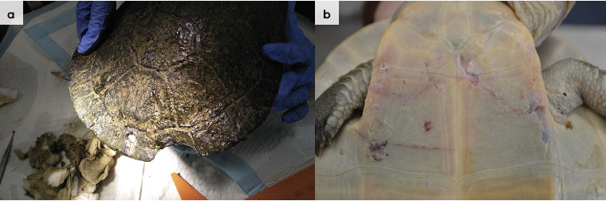
Figure 3.7: A turtle with shallow shell erosions and missing pieces of shell, possibly inflicted by a dog. The injuries are old and do not require treatment. Photo credit: Zoos Victoria
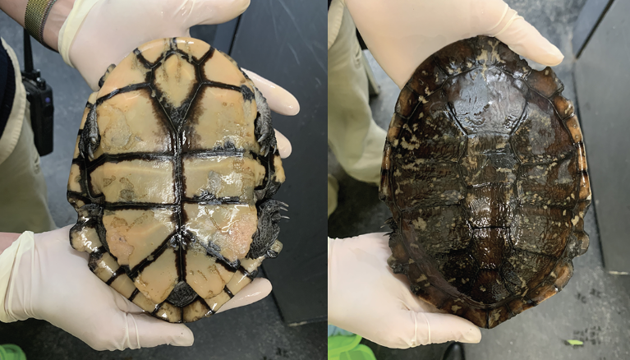
Figure 3.8: A Macquarie River turtle with a severely infected shell. Note the brown slimy area on the plastron on the turtle on the left and the red ulcerated area on the plastron on the turtle on the right. Photo credit: Zoos Victoria
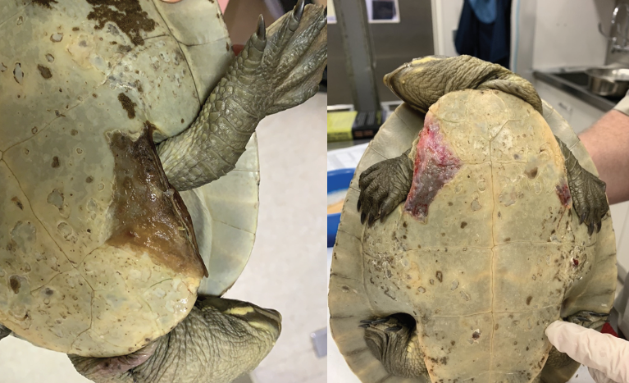

3.5.4. Administering treatment
- Due to the turtle’s ability to retract its head and hold its mouth tightly shut, it is usually not possible to administer oral medication without risking causing damage to the turtle’s mouth.
- To combat fungal and/or bacterial infections, the veterinarian may recommend an iodine soak. Iodine is diluted in water to produce a solution; the veterinarian will provide guidance on the correct concentration to use. The turtle is not submerged in this solution but placed in a shallow bath that covers the plastron and legs, but keeps the head exposed.
- For carapace lesions the veterinarian may recommend application of an iodine ointment. The turtle is dry docked for up to an hour and the ointment applied to the affected area. The turtle is then returned to its tank.
- If the veterinarian prescribes a course of injections, the injection site should be recorded and rotated at each treatment, so as not to repeatedly inject in the same limb each time.

3.6. Housing
Below are several key considerations when housing turtles in care.

3.6.1. General housing information for turtles
There are no national standards regarding enclosure size for turtles during rehabilitation. Each state has a different set of guidelines which contain a variety of recommended enclosure sizes. The dimensions recommended in this chapter are suggestions based on Zoos Victoria enclosure sizes. There is no ‘one size fits all’ and it is important to continually assess the welfare of the turtle and tailor enclosures and enclosure size to suit the requirements of the turtle.
Table 3.6: Key aspects of housing for turtles during rehabilitation
Term | Parameter
UV light | - UV lights, placed approximately 30 cm above the turtle, can be used on a 12-hour light/dark cycle.  - If possible, provide access to natural dappled sunlight for 5–10 hours each week.  - Do not leave the turtle unattended in full sunshine.
Preferred optimal temperature zone (POTZ) | - 20–26°C.
Water temperature | - The water in the tank does not require any additional heating if an appropriate basking lamp and site are provided.
Water quality | - Water parameters should be measured weekly.  - pH should be 7.  - Ammonia, nitrite and nitrate levels should be within the ranges that support fish, i.e. ammonia less than 0.02 ppm, nitrite less than 0.1 ppm and nitrate less than 50 ppm.  - A water hardness of 180–200 ppm is preferred by turtles.  - Approximately 25% of the water should be changed weekly.  - Uneaten food and faeces should be removed daily.
Dry dock area | - The turtle requires access to a dry area, which consists of a ramp leading up to a platform above the water’s surface.  - Turtle ramps can be purchased from pet shops or homemade using a sheet of plastic covered by Astroturf or other non-abrasive material.  - Basking spot and UV lamps are best situated over the dry dock area.
Basking lights and ‘hot spot’ | - Access to radiant heat is required.  - The turtle should have a basking spot set at 26–30°C.  - The turtle must be able to move away from the heat source.

3.6.2. Enclosure hygiene and biosecurity
General information about hygiene and biosecurity can be found in Part A of these guidelines. New diseases emerge frequently and sick and injured animals in care are often more susceptible to picking up pathogens from the environment. It is important to maintain the highest levels of hygiene and biosecurity to avoid inadvertently transferring diseases between animals and from humans, and to protect the wild population where the animal will eventually return to.

Species specific considerations:
- Wash hands with soap and water after handling turtles to minimise the risk of infection with zoonotic disease agents such as Salmonella.
- Ideally examination gloves should be worn and changed between handling each animal.
- Left-over food and faecal matter should be removed daily to keep the water clean and prevent a build-up of ammonia.
- Enclosures used to house sick/injured turtles, must be cleaned and disinfected between inhabitants. Tanks should be completely drained and any furniture made of unsealed wood should be discarded as it cannot be effectively disinfected.
- Tanks and plastic furniture should be cleaned with hot soapy water and then disinfected with products such as F10 SC or bleach used at appropriate concentrations and contact times. If using bleach, it must be thoroughly rinsed before returning the turtle to the enclosure.

3.6.3. Housing types
Different set ups are required for animals at different stages of treatment and care.
Table 3.7 describes the housing type, suggested dimensions and requirements at each stage of care.
Table 3.7: Rehabilitation housing for adult turtles.
Intensive care housing
Indications for use | Suggested min. dimensions | Suggested requirements
These turtles may need restricted access to water. Fluids may need to be given by a veterinarian to prevent dehydration. This stage is suitable for a maximum of one week. Turtles should only be housed in this way by rehabilitators with extensive turtle care and husbandry experience. | Large enough to turn around  Carapace length <10 cm: 0.4 x 0.3 m (0.12 m²) Carapace length >10 cm: 1.0 x 0.6 m (0.6 m²) | ENCLOSURE CONSTRUCTION  - A Kimani incubator or other type of intensive care unit or, alternatively, a plastic tub with damp towels on the floor can be used for short-term housing for less than one week.  ENCLOSURE FURNISHING  - The wet towels are replaced daily to prevent them from becoming mouldy.  ENVIRONMENTAL VARIABLES  - Temperature should be between 20–26°C  PROVISION OF FOOD/WATER  - The turtle is not fed in the intensive care unit.  - If feeding is required the turtle is placed in a shallow tub of water. This method can be utilised if the carapace is damaged as it will remain out of the water.

Intermediate housing (treatment/cage rest)
Indications for use | Suggested min. dimensions | Suggested requirements
Provision of daily medication, close monitoring once animal is stabilised and no longer requires intensive care.  The intermediate housing is the enclosure that a turtle spends the majority of its time in while in care. It can also function as the pre-release enclosure. See Figure 3.9. | Tank dimensions:  Carapace length <10 cm: 1.0 x 0.6 m (0.6 m²)  Carapace length >10 cm: 2.0 x 1.0 m (2.0 m²)  Land area = 3 x carapace length²  Add 50% for each additional turtle  Minimum depth (deep enough for the turtle to swim freely):  Carapace length <10 cm: 0.3 m Carapace length >10 cm: 0.5 m | ENCLOSURE CONSTRUCTION  - Glass fish tank.  ENCLOSURE FURNISHING  - Basking platform with ramp.  - UV light.  - Basking/heat lamp.  - A hide on the bottom of the tank made of PVC pipe or similar.  ENVIRONMENTAL VARIABLES  - Basking spot 26–30°C.  - Water temperature 20–26°C.  PROVISION OF FOOD/WATER  - The turtle can be placed in a smaller tank/tub containing water and food to avoid fouling the main tank.  - This tub is emptied and cleaned after the turtle is returned to the main tank.

Pre-release
Indications for use | Suggested min. dimensions | Suggested requirements
No longer require regular handling/medication.  Development of fitness/strength prior to release.  Instead of a fish tank, turtles may be housed in an outside pond for acclimatisation prior to release. | Turtle size: <10 cm:  Minimum floor area: 1.0 x 0.6 m (0.6 m²)  Minimum pond depth: 0.3 m  Increased floor area for each additional turtle: 0.3 m²  Turtle size: >10 cm:  Minimum floor area: 2.0 x 1.0 m (2.0 m²)  Minimum pond depth: 0.5 m  Increased floor area for each additional turtle: 1.0 m² | ENCLOSURE CONSTRUCTION  - Pre-fabricated pond. Children’s wading pool.  - Solid walls (corrugated tin or wood) sunk into the ground to 50 cm to prevent predators gaining access or turtles digging out.  ENCLOSURE FURNISHING  - Plants such as grass tussocks and branches with leaves added to provide hides. Be careful the individual cannot use these to climb out.  - Access to leaf litter or straw to allow the turtle to burrow and hide.  - Easy access in and out of the water with broad logs is required. Rocks or logs can be used as basking platforms.  ENVIRONMENTAL VARIABLES  - Turtles should only be placed in outside ponds during the warmer months of the year, when the temperature is usually above 20°C.  - Situated to receive both sunlight and shade.  PROVISION OF FOOD/WATER  - Food is placed in the pond.
Figure 3.9: A glass fish tank set up as intermediate/pre-release housing for a turtle. Photo credit: Zoos Victoria
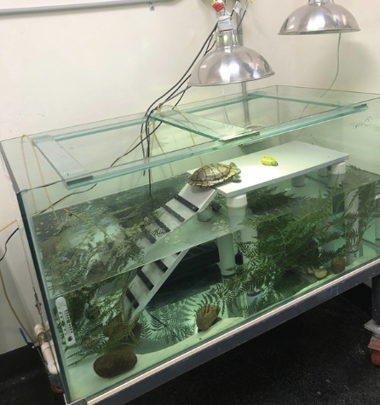

3.7. Feeding and nutrition
Keeping daily records of food offered (item and volume fed) and food consumed is good practice and will allow the rehabilitator to observe appetite, and whether the animal is consuming a balanced diet, or is preferentially consuming only certain food items offered.
Please note: Food suppliers and specific products mentioned in these guidelines are intended as examples only. Other suitable products may also be available.
This section refers to feeding and nutrition of turtles in rehabilitation.
Table 3.8: Daily feeding and diet guide for turtles during rehabilitation
Species | Broad-shelled turtle | Common long-necked turtle | Macquarie river turtle
Captive diet | Earthworms, crickets, cockroaches, mice, fish | Earthworms, crickets, cockroaches, mice, fish | Greens such as ribbon weed (Elodea sp.), duck weed, chopped endive and bok choy, earthworms, crickets, cockroaches, fish*
Feeding frequency | Adults: 3 x week during summer and warmer months, 2 x week if over wintered.  Juveniles: daily.
Amount to feed | Equivalent to the turtle’s head size.
Food placement | Water. Turtles do not eat on land.
Feeding method | Do not hand feed.
Uneaten food | Remove within 12 hours.
*Please note that there are controls on the collection of some indigenous plants and declared noxious weeds from the wild in Victoria. There are restrictions on the growing of declared noxious weeds in Victoria including some aquatic species. Web search ‘noxious weeds Victoria’ and ‘protected flora Victoria’.

3.8. Artificial incubation
If eggs are found in a gravid female that is euthanised, they can be incubated and the hatchlings released.

3.8.1. Equipment required
- Container, such as a ClickClack box, to hold the eggs
- Kimani or other incubator to hold the container
- Vermiculite
- Pencil
- Flashlight or mobile phone
- Disposable gloves.

3.8.2. Technique
- Use 50/50 vermiculite/water. For example mix 250 g vermiculite with 250 ml water until absorbed. Place the mix into a ClickClack box with a sealed lid and mark the lid with the date.
- Partially bury the eggs in the vermiculite/water mixture.
- Do not turn the eggs once laid.
- Number each egg with a pencil on the side facing up. This will ensure the egg is not rotated during the incubation period.
- Place the ClickClack box in the Kimani or incubator.
- The Kimani or incubator should be set to 28°C for the duration of the incubation period, which is approximately 60–90 days.
- Maintain humidity around 80-90%.
- Open the box once a week to allow air exchange and wipe any excess moisture off the inside of the container lid. It may be necessary to do this twice a week depending on moisture build up.
- Alternatively, a container with holes in the lid can also be used.
- Check the viability of the eggs periodically during incubation by candling them. Hold a flashlight or phone light on the bottom of the egg and shine it through the egg. If the egg is viable blood vessels will appear after approximately one week. As incubation progresses it should be possible to see the turtle forming. Closer to hatching the egg will develop darker areas where the shell and body have formed.
- When the turtles have hatched they can be set up in a small plastic tank kept at room temperature and containing approximately 5 cm of water and a few rocks to bask on. They can remain in this tank for two to three days prior to release. No feeding is required as they still have their egg yolk to provide nourishment.
- After this period of acclimatisation, the hatchlings can be returned to the wild where the female turtle was found.

3.9. Release protocol
Ideally, wild animals will be rehabilitated and released in a short timeframe. If this is not possible and the animal is in care for significant extended periods, ensure that the animal is regularly assessed against the five welfare domains to support decision-making. Animals in care for extended periods may have a reduced ability to survive in the wild. Talk to your veterinarian and consider whether euthanasia will provide the best welfare outcome for such individuals.

3.9.1. Pre-release assessment
Pre-release assessment of animals in care is essential to support improved outcomes once back in the wild. Animals should be assessed based on body condition, fitness and the ability to engage in natural species-specific behaviours prior to release.
The following information should be used to guide decision-making regarding release suitability for turtles:
- Turtle is in a state of good health – presenting injury/sickness is completely resolved (consider a pre-release veterinary check).
- Turtle is within a healthy weight range and appropriate body condition (see Table 3.1).
- Turtle displays ability to actively forage for and consume natural foods.
- Turtle can swim normally and dive to the bottom of the tank.

3.9.2. At the release site
Post release survival will be maximised by ensuring that both the release site and the way in which the animal is released are carefully considered.
- Adult turtles should be returned to their original location as soon as possible.
- Artificially hatched turtles should be released from September to April. The minimum water temperature that turtles are active will have an effect on the time of release:
- Common long-necked turtles are active at water temperatures more than 12°C.
- Broad-shelled turtles become active once the water temperature reaches 18°C.
- Macquarie river turtles are active at water temperatures more than 16°C.
- Release at water temperatures below these may result in increased predation as the turtle is only capable of slow movements.
It is important to ensure that the site is suitable for release of the turtle. Important site features or factors to consider before releasing a turtle include:
- Common long-necked turtles are found in ephemeral ponds and swamps and respond to drought and rainfall by moving to nearby watercourses. They spend more time on land than the other species, but are usually found within 300 m of water. This species has adapted to living in urban environments by using drains and roadside culverts. If found in these modified urban environments, they should be returned to them.
- Broad-shelled turtles inhabit permanent watercourses that are more than 3 m deep. This species is cryptic and does not hibernate. They prefer turbid water and hide deep in the water to ambush their prey. As they are very dependent upon a particular habitat in watercourses they must be returned to their point of origin.
- Macquarie river turtles prefer large, deep (more than 2 m), clear, flowing, stable waterbodies.
- Overlap occurs between the three turtle species.
For more information on the ecological characteristics and requirements of turtles that may help with their release see Table 3.1.

3.9.3. Release checklist
Check all of the requirements of your authorisation are being met, and consider the following:

Release location
- A suitable environment is available.

Release procedure
- Turtles should be released during the warmest time of the day.
- Be conscious of transport temperatures to reduce the risk of thermal shock. For example avoid moving a turtle from a 25°C heated car straight into 12°C water.
- Place the turtle into shallow water at the edge of the watercourse. Choose a vegetated area that provides some shelter.
- Step away as the turtle may not move while it perceives that a threat is in the area.

3.10. Key references and additional reading
Cann, J. and Sadlier, R. 2017. Freshwater turtles of Australia. CSIRO Publishing.
Cogger, H.G. 2018. Reptiles and amphibians of Australia, 7th Edition. Reed New Holland.
Egan, C. 2016. Australian Turtles: Their Care in Captivity. Quillpen Pty Ltd.
Robertson, P., and Coventry, A.J. 2019. Reptiles of Victoria. CSIRO Publishing.
Swanson, S. 2017. Field guide to Australian reptiles, 3rd Edition. Steve Parish Publishing.
Wilson, S., and Swan, G. 2017. A complete guide to the reptiles of Australia, 5th Edition. Reed New Holland.

