Chapter 8. Native rodents

Contents
8.1. Introduction 2
8.2. Species information 3
8.3. Animal and human safety considerations 26
8.3.1. Human safety considerations 27
8.3.2. Animal safety considerations 27
8.4. Capture, restraint, and transport 27
8.4.1. Visual observations 27
8.4.2. Equipment 28
8.4.3. Technique 29
8.4.4. Transport 30
8.5. Monitoring animal health and welfare 30
8.5.1. Physical examination 31
8.5.2. Ongoing monitoring of health and welfare 34
8.5.3. Common and emerging health conditions 35
8.5.4. Administering treatment during rehabilitation 41
8.6. Housing 41
8.6.1. General housing information for native rodents 42
8.6.2. Enclosure hygiene and biosecurity 42
8.6.3. Housing types 43
8.7. Feeding and nutrition 47
8.8. Hand raising 52
8.8.1. Equipment required for hand raising 52
8.8.2. Feeding orphaned young 52
8.9. Release protocol 56
8.9.1. Pre-release assessment 56
8.9.2. At the release site 57
8.9.3. Release checklist 57
8.10. Key references and additional reading 58

In Victoria, sick, injured or orphaned wildlife can only be rehabilitated by a wildlife shelter operator or foster carer who is authorised under section 28A of the Wildlife Act 1975 (Wildlife Act). Wildlife rehabilitators are subject to strict conditions. The mandatory requirements that they must meet are set out in the Wildlife Shelter and Foster Carer Authorisation issued under the Wildlife Act. These conditions enforce the minimum standards required for the humane treatment and successful rehabilitation of wildlife in care. The Wildlife Rehabilitator Authorisation Guide: Things You Need To Know explains how wildlife rehabilitators can meet these mandatory requirements and can be found here: https://www.vic.gov.au/wildlife-rehabilitation-shelters-and-foster-carers.
The Victorian Wildlife Rehabilitation Guidelines have been developed to incorporate evidenced-based best practice in wildlife care and rehabilitation to equip rehabilitators to deliver positive welfare outcomes for individual animals in their care from first aid to post-release into the wild.
You must comply with the conditions of your authorisation. These guidelines must be read in conjunction with the conditions of your authorisation.

8.1. Introduction
Currently in Victoria there are 12 extant species of rodent; nine species native to Australia and three introduced species. Under the Victorian Flora and Fauna Guarantee Act 1988 and the Australian Environment Protection and Biodiversity Conservation Act 1999 three of the species are listed as endangered and another two are listed as vulnerable or near threatened.
STOP – If an endangered, vulnerable or near threatened species comes into care, please STOP and refer to your authorisation for mandatory conditions including notification and release requirements.
When native rodents come into care it is the responsibility of the wildlife rehabilitator to ensure that the five domains of animal welfare are satisfied. These include providing optimal nutrition, and an environment appropriate to the stage of rehabilitation. The focus should be on the animal’s return to health and release, which is facilitated through regular collaboration with a veterinarian. It is also important to consider the animal’s mental state and ability to exhibit normal behaviours without detrimentally affecting its recovery. Welfare may be temporarily compromised by the necessity of a gradual return to normal activity, depending on its stage of rehabilitation. Further information about the five domains of animal welfare is in Part A of these guidelines.

8.2. Species information
Profiles for the native rodent species found in Victoria are detailed in Table 8.1. For assistance in identification of native rodent species, refer to the recommended reading and reference material at the end of this chapter.
Table 8.1: Species Profiles
Species | Water rat – Rakali (Hydromys chrysogaster)
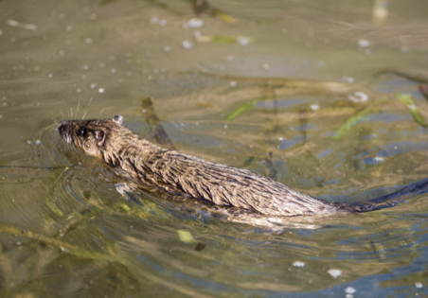  Photo credit: David Paul, Museums Victoria | Distribution map  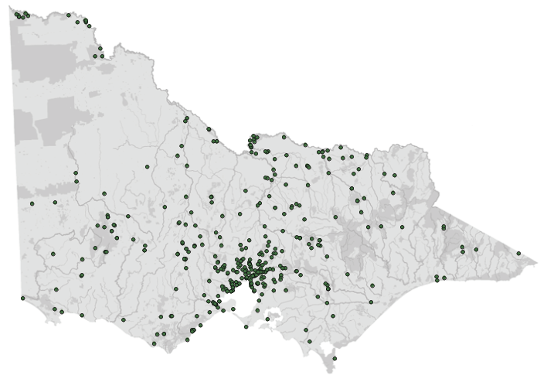  Data source: Victorian Biodiversity Atlas Jan 2023  www.environment.vic.gov.au/biodiversity/victorian-biodiversity-atlas
General appearance | Water rats are easily identified by their aquatic nature, size, thick-furred white-tipped tail which is used as a rudder in the water, and their webbed-hind feet.  Their body shape is streamlined, notably with small ears, small eyes and abundant whiskers.  Their fur colour is variable being near black, grey to brown or reddish, with cream to golden-orange underparts.
Conservation status* | Least concern
Sexual dimorphism | Males can be slightly larger than females
Adult morphometrics | Body weight: 620–1200 g  Head and body length: 300–390 mm  Tail length: 230–320 mm
Habitat | The water rat is one of Australia’s largest rodents. It is an aquatic species, widespread and common throughout most of Victoria’s waterways, living in burrows alongside lakes and river banks
Home range | Approximately 12 ha or less for both males and females, they are highly territorial and scent-mark their territories
Behaviour | Solitary. Urban and suburban habitats may be heavily impacted by pollution, plastic waste and introduced feral and domestic predators.  Water rats are mostly nocturnal but can be active at sunset and sometimes during the day, often seen swimming with top of head and back visible. The white tip on the tail can also be very visible and used to identify the species.
Diet | Consists of large insects, crustaceans, mussels, fish, frogs, lizards, small mammals and birds. The water rat will usually forage under water and eat its prey at a regular feeding site which may be identified via shells, bones and other debris
Longevity | 3–4 years
Sexual maturity | Male: approximately 4 months (full sperm production)  Female: 8 months approximately (as early as 6 months)
Mating season | Late winter to early summer (potentially breed all year)
Gestation length | 5 weeks
Litters per year | Average 1 to 2, but can produce up to 5 litters per year

Species | Australian bush rat – Mootit [Rattus fuscipes (subspecies assimilis)]
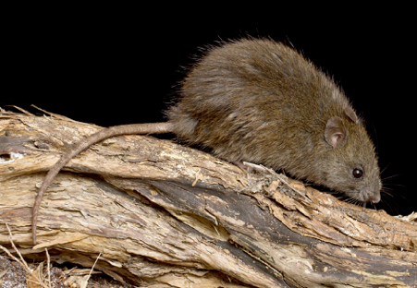  Photo credit: David Paul, Museums Victoria | Distribution map  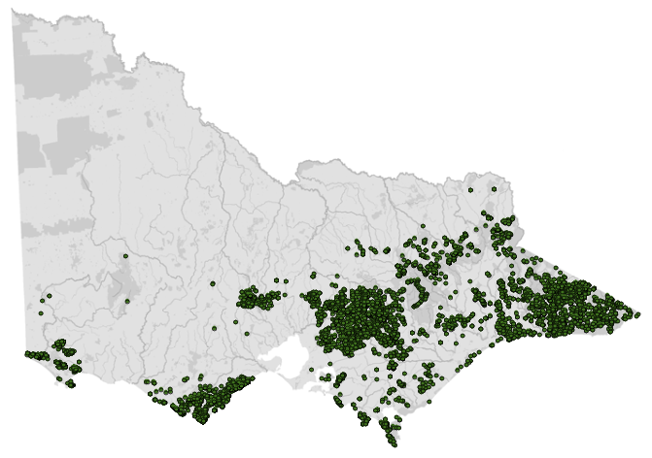  Data source: Victorian Biodiversity Atlas Jan 2023  www.environment.vic.gov.au/biodiversity/victorian-biodiversity-atlas
General appearance | Highly variable in body size and fur colouration with soft dense fur that in the upperparts is reddish brown to grey-brown, and the underparts are pale brown, grey or cream. Flanks may have a rust-coloured tinge. Tail is equal to or slightly shorter than head-body length and is naked with obviously overlapping rings of scales. Feet are pale pinkish-brown and hind feet have an elongated posthallucal pad. The eyes and rounded ears are quite prominent. They have a distinctive smell, more musky than other locally occurring native rodents
Conservation status | Least concern
Sexual dimorphism | Males are larger than females
Adult morphometrics | Weight: 65–225 g (average 125 g)  Head and body length: 100–214 mm  Tail length: 100–195 mm
Habitat | Bush rats are found in moist vegetation, gullies and areas with dense ground cover, from woodland, coastal scrub, forest and rainforest, through to alpine boulder-fields. They can be found from sea level to the highest Victorian alps
Home range | Both males and females have small home ranges (one study found 0.6–1.2 ha), with the female ranges expanding in spring, and males dispersing or vastly increasing their home ranges as they leave winter and start to breed. Male home ranges may overlap with other males and females. A male can travel more than 1 km per night in favourable conditions
Behaviour | The bush rat is nocturnal and stays close to cover and densly vegetated areas, so is rarely seen in the wild. They are solitary and make shallow underground burrows with nest chambers lined with grasses and other vegetation. Population numbers and breeding success can be closley associated with rainfall and success declines in drought or following bushfire. Bush rats tend to avoid areas impacted by human activity
Diet | Bush rats are omnivorous and can survive on a variety of foods though can selectively favour mycorrhizal fungi and leaf-litter dwelling insects. They eat fungi, fruits, seeds, stems of particular grasses, lillies and invertebrates. They have been observed eating nectar from flowers
Longevity | Bush rats are short lived and few survive to a second breeding season. Most adult males and many adult females die in the autumn following their first breeding season. The over-wintering population often largely consists of young born the previous spring or summer
Sexual maturity | Both males and females reach sexual maturity by around 4 months old. Young born in spring may reproduce in the same season (before the following winter) when conditions are favourable
Mating season | In Victoria bush rats can breed throughout the year, but generally do not breed in winter, especially in more southern or alpine areas
Gestation length | 22–24 days. Young are weaned at 4–5 weeks
Litters per year | Up to three litters of 4–5 young may be produced in a good spring-autumn season

Species | Australian swamp (velvet-furred) rat – Koota (Rattus lutreolus)
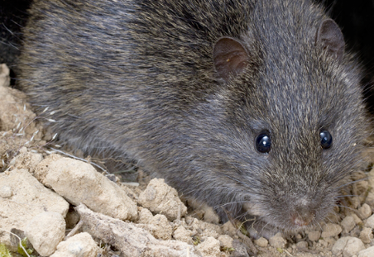  Photo credit: David Paul, Museums Victoria | Distribution map  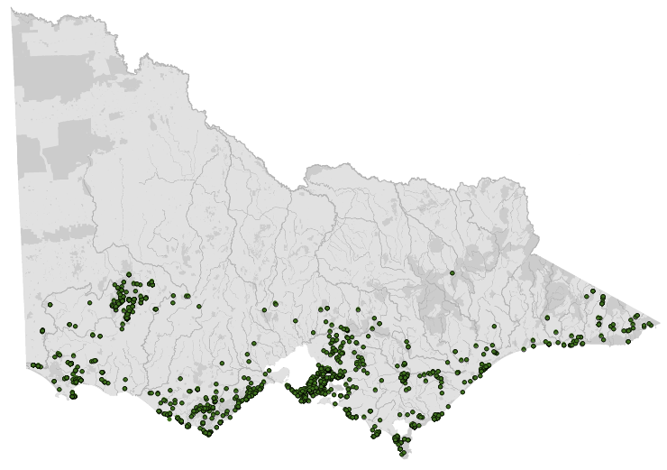  Data source: Victorian Biodiversity Atlas Jan 2023  www.environment.vic.gov.au/biodiversity/victorian-biodiversity-atlas
General appearance | The Australian swamp (or velvet-furred) rat has very dense, long, soft fur which is reddish-brown, dark brown to black on the upperparts and lighter brown, yellow-cream to grey fur on its underparts. The fur on the upper body may be golden tipped. The feet are dark brown above with very dark brown to black soles (which can distinguish it from some other native rodents). The tail is dark coloured grey, brown or black, is sparsely haired and is clearly shorter than the head-body length (about two thirds the length of the head-body). Ears are dark, rounded, quite short and can be obscured by fur. The eyes are not prominent
Conservation status | Least concern
Sexual dimorphism | Males are larger than females
Adult morphometrics | Weight: 55–160 g  Head and body length: 120–200 mm  Tail length: 56–156 mm
Habitat | They are found in a variety of thicker, wet vegetation, which can include along water courses and swampy areas, heath, grassland, sedgeland, ferny areas and scrub
Home range | In winter, males and females require a home range size of at least 0.2 ha to survive colder months when food may be less abundant. In females, this range expands to 0.5 ha from spring as animals start to breed and females will become territorial towards other females. Males may have a home range up to 4 ha, but do not appear territorial and move across multiple female territories. Females can be aggressive towards males except during mating. The size of territories (and therefore the density of the population) may be dependent on resource availability. After weaning, young animals move, often, more than 2 km to find and establish their own territory
Behaviour | Swamp rats make extensive shallow burrow systems underground, with multiple entrance tunnels which can be easily seen, as well as tunnel systems through vegetation. They can make nests up to 1 m deep, but in wetter or flood prone areas can make nests in grass tussocks.  They may be active during the day and night.
Diet | Swamp rats are largely herbivorous, eating the stems and leaves of grasses and sedges, as well as reeds and seeds. They also eat insects and fungi
Longevity | Up to 29 months
Sexual maturity | Females born early in spring-summer may produce young in the same season as their birth, but those born later in the season will generally not produce until after their first winter
Mating season | Breeding can be throughout the year, but generally occurs in spring to autumn
Gestation length | 23–27 days. Young are weaned at 3–4 weeks of age
Litters per year | Females can produce several litters of 3–5 young (average 2.5) in a spring-autumn season when conditions are favourable

Species | Mitchell’s hopping mouse – Pankot (Notomys mitchellii)
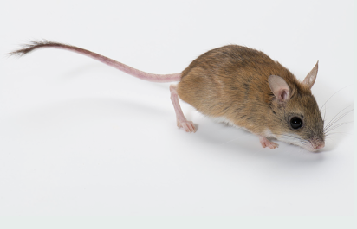  Photo credit: David Paul, Museums Victoria | Distribution map  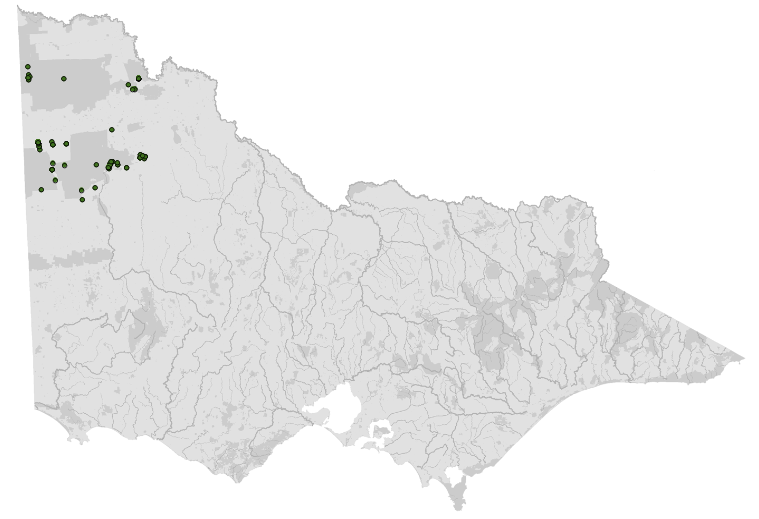  Data source: Victorian Biodiversity Atlas Jan 2023  www.environment.vic.gov.au/biodiversity/victorian-biodiversity-atlas
General appearance | The Mitchell’s hopping mouse is a bipedal native rodent with large back legs and the only hopping mouse species found naturally in Victoria, occurring in the northwest of the state in Mallee country. However, it is also a commonly held domestic pet under a basic wildlife license.  The mouse’s upperparts are a sandy-rufous grey or tawny-olive colour with a pale white chest and underbelly. The long tail is bicoloured, with a pink-brown upper, pale grey below and a pale brown tuft at the tip of the tail.  The native rodent is the largest member of the Notomys genus, and both the male and female lack the throat pouch and chest gland present in other Notomys sp.  Note: all rats and mice in Victoria can move in a ‘hopping’ motion, this is not a diagnostic characteristic.
Conservation status | Least concern
Sexual dimorphism | Females are slightly larger on average than males
Adult morphometrics | Body weight: 40–60 (52) g  Head and body length: 100–125 mm  Tail length: 140–155 mm
Habitat | Logs and deep burrows. Constructs a nest chamber of leaves and other plant material in a horizontal tunnel
Home range | Hopping mice in general have small home ranges, though have been noted to dipserse up to 15 km to find water, and up to 2 km in a single night
Behaviour | The Mitchell’s hopping mouse is a semi-arid, nocturnal, gregarious species
Diet | Omnivorous. Majority of the diet is seeds, roots, green shoots and leaves, but will also eat fungi and insects
Longevity | The species is documented as living for a maximum of 5 years in captivity, but likely shorter in the wild
Sexual maturity | Male: 90 days  Female: 73 days
Mating season | Most births will occur in late winter or spring, but the species will breed in any month if conditions are desirable
Gestation length | Approximately 40 days. Young are weaned at approximately 35 days
Litters per year | Approximately 3–4 litters of 3–5 young per year, depending on resource availability

Species | Silky mouse – Nalpo (Pseudomys apodemoides)
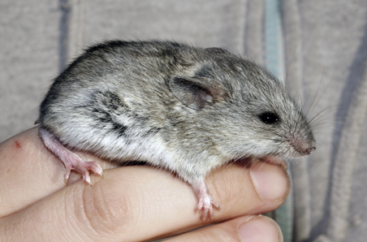  Photo credit: Shutterstock, James Trezise | Distribution map  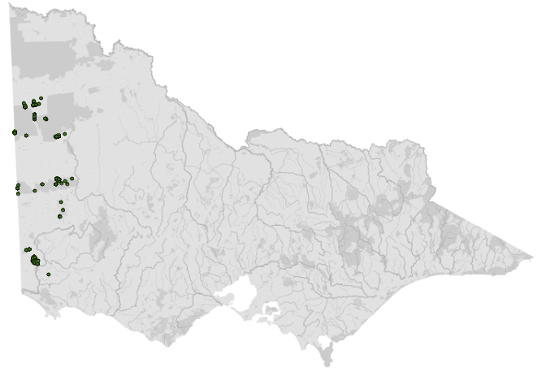  Data source: Victorian Biodiversity Atlas Jan 2023  www.environment.vic.gov.au/biodiversity/victorian-biodiversity-atlas
General appearance | The silky mouse has dense, soft fur, with the upper parts a smoky grey colour and dark guard hairs mottled throughout. The underside is pale white, including the underside of the lips and muzzle. The ears are pinkish grey and larger than the house mouse. The tail is pale pink with white hairs, and brown on the upperpart. The tail is longer than the body length, and if disturbed it is known to carry its tail on a horizontal angle or across its back
Conservation status | Least concern
Sexual dimorphism | No sexual size dimorphism
Adult morphometrics | Body weight: 15–22 g  Head and body length: 68–80 mm  Tail length: 90–105 mm
Habitat | In Victoria, the species prefers to inhabit dry mallee-heathland in the west of the state. Diverse vegetation producing seeds year-round is needed. Adults may share burrows, and several litters at various developmental stages have been found in a single burrow system
Home range | Movements within study sites ranged from 60–130 m, with 3 km being the maximum recorded distance travelled by a silky mouse
Behaviour | Silky mice are nocturnal and will shelter in extensive, deep burrow systems with multiple entry points, usually covered by dense vegetation. The burrowing system is often located at the base of the desert banksia (Banksia ornata)
Diet | The silky mouse has a variable diet, being omnivorous, and will eat seeds year round, fruits, flowers, fungi, nectar (from desert banksia which is a major food source over winter) and insects
Longevity | 2–3 years
Sexual maturity | Male: In birth year  Female: In birth year
Mating season | The silky mouse is an opportunistic breeder, mating occurs when conditions are favourable for the species. As vegetation productivity declines, breeding becomes seasonal with some populations breeding in winter and others in late spring to summer
Gestation length | 38–39 days. Young are weaned around 40 days
Litters per year | During favourable conditions, successive litters of 1–6 young can be born throughout the year

Species | Smoky mouse – Konoom (Pseudomys fumeus)
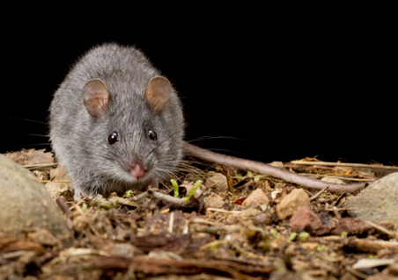  Photo credit: David Paul, Museums Victoria | Distribution map  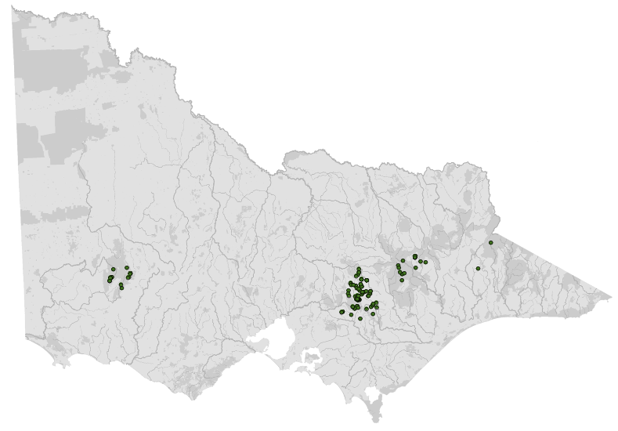  Data source: Victorian Biodiversity Atlas Jan 2023  www.environment.vic.gov.au/biodiversity/victorian-biodiversity-atlas
General appearance | Very distinctly coloured, with light blue-grey to darker slate blue-grey fur on its upper parts and white or pale grey underside.  The feet, underside of the tail, and tip of the nose are a pale pink with white hairs. The ears are dark grey at the outer edges, fading to pale pink in the centre. The tail is longer than the body and is bicoloured, with dusky-brown colouration above and soft pink below.
Conservation status* | Endangered
Sexual dimorphism | Males may be slightly larger than females
Adult morphometrics | Body weight: 45–80 (50) g  Head and body length: 85–136 (120) mm  Tail length: 105–150 (135) mm
Habitat | Lives in a wide variety of habitats from 0–1,800 m above sea level, including dry sclerophyll forests, wet forests, subalpine and coastal heathlands
Home range | The home range of the smoky mouse is most likely resource dependent, between 2–10 ha. The species has been recorded moving over 1 km in a single night
Behaviour | The smoky mouse is a nocturnal, social species and nests communally in complex burrow systems, with up to five females sharing a burrow and giving birth at the same time
Diet | The species is omnivorous, consuming seeds, flowers and fruit, insects such as beetle larvae and Bogong moths, and a higher proportion of fungi over winter
Longevity | 1–4 years in the wild
Sexual maturity | Male: Not recorded  Female: Not recorded
Mating season | Smoky mice breed seasonally in spring and summer
Gestation length | 30 days
Litters per year | 1–2 litters of 3–4 young per annual breeding season

Species | Heath mouse – Dayang (Pseudomys shortridgei)
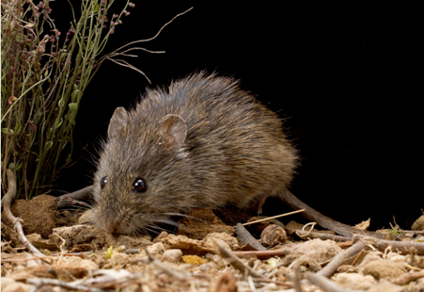  Photo credit: David Paul, Museums Victoria | Distribution map  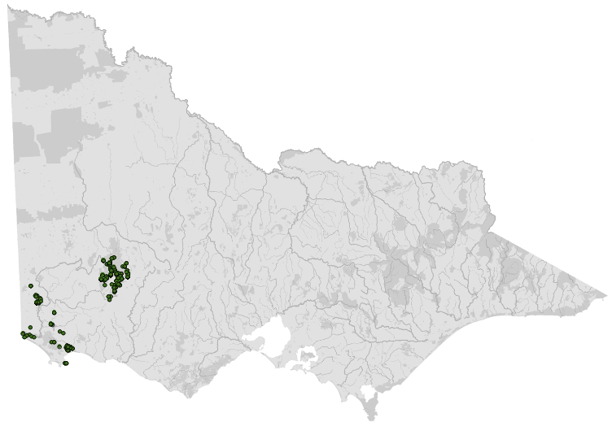  Data source: Victorian Biodiversity Atlas Jan 2023  www.environment.vic.gov.au/biodiversity/victorian-biodiversity-atlas
General appearance | Heath mice are thickset with a broad face, short muzzle and have brown coloured fur with long black guard hairs. The under parts are grey-white and the ears are short and rounded with a dark colour, covered with fine, soft hairs. The tail length is shorter than the body length and is bicoloured (upper tail dark and under white) and is well haired. The upper surfaces of the feet have long grey hairs.
Conservation status* | Endangered
Sexual dimorphism | Males are larger than females
Adult morphometrics | Body weight: 55–90 (70) g  Head and body length: 90–120 mm  Tail length: 85–100 mm
Habitat | The species uses well defined pathways and nests on the surface or shallow burrows amongst dense ground cover
Home range | Approximately 0.75–5.5 ha, most likely determined by food avaliability
Behaviour | Docile and partly diurnal
Diet | The heath mouse has a herbivorous diet including flowers, seeds and berries, eaten spring through summer. As these food resources decline the native rodents alter their diet to the stems and leaves of grasses, lillies and sedges and, after autumn rains begin, will also eat fungi
Longevity | Maximum of 4 years in the wild
Sexual maturity | Young are precocious and grow rapidly, juveniles can reach adult size in 3–4 months.  Male: 10–12 months  Female: 10–12 months
Mating season | Breeding occurs from spring to summer when adults form pairs for the 4-month breeding season
Gestation length | 28–34 days
Litters per year | The heath mouse has 1–2 litters of 2–3 young per year

Species | New Holland mouse – Pookila (Pseudomys novaehollandiae)
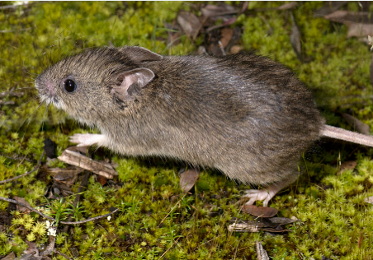  Photo credit: David Paul, Museums Victoria | Distribution map  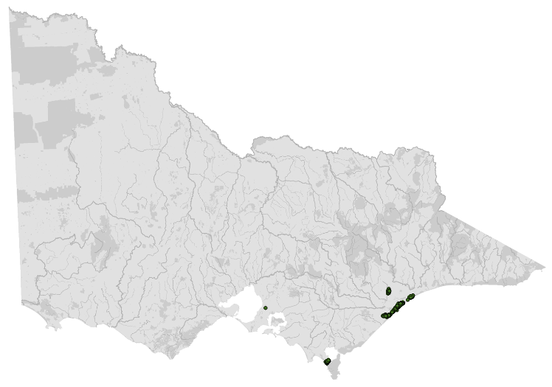  Data source: Victorian Biodiversity Atlas Jan 2023  www.environment.vic.gov.au/biodiversity/victorian-biodiversity-atlas
General appearance | Appearance: Has a sandy grey-brown coloured upper parts and white to light grey coloured underparts. The feet and underside of the tail are pale pink with white hairs. The bicoloured tail is fine and delicate, and longer than the body.  The species can be readily distinguished from the introduced house mouse by its distinctive colouration, including light pink feet and bicoloured tail, larger eyes and ears and the absence of a mousey odour. House mice that co-occur with the new Holland mouse in Victoria are usually a darker, more uniform brown with dark feet and tail.
Conservation status* | Endangered
Sexual dimorphism | Females may be slightly larger than males
Adult morphometrics | Body weight: 15–24 (18) g  Head and body length: 65–90 mm  Tail length: 80–105 mm
Habitat | The new Holland mouse is found in open coastal heathlands, heathy woodlands and vegetated sand dunes in small patches at Wilsons Promontory and the Gippsland Lakes region
Home range | 0.5–2 ha
Behaviour | The new Holland mouse is nocturnal and gregarious, living in burrow systems up to several metres long
Diet | Omnivorous, with seeds forming a large portion of their diet. They also eatleaves, flowers, green stems, fungi and invertebrates
Longevity | 1–2 years
Sexual maturity | Male: 20 weeks  Female: 7–13 weeks
Mating season | Breeding occurs late spring to early autumn
Gestation length | Approximately 31.5 (29–33) days
Litters per year | 1–2 litters of 2–6 young (average 2.6 young survive to weaning) per year

Species | Broad-toothed rat – Tooarrana (Mastacomys fuscus mordicus)
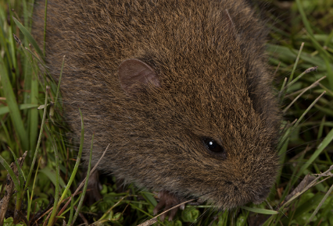  Photo credit: David Paul, Museums Victoria | Distribution map  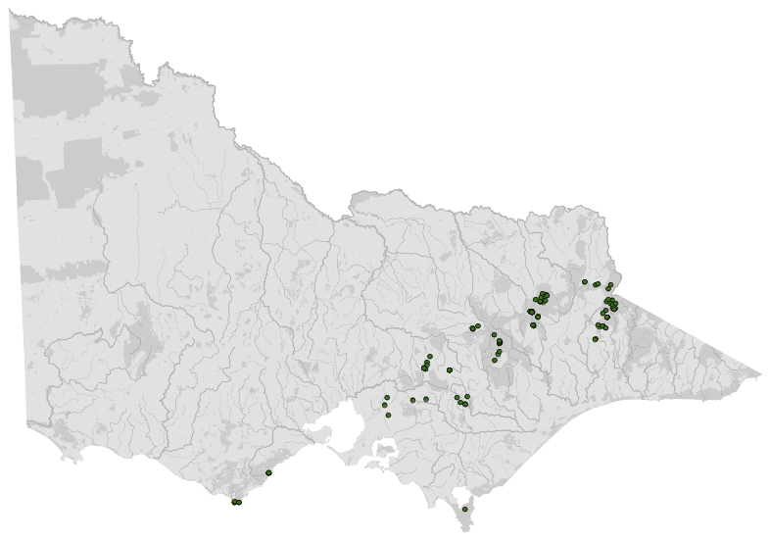  Data source: Victorian Biodiversity Atlas Jan 2023  www.environment.vic.gov.au/biodiversity/victorian-biodiversity-atlas
General appearance | The broad-toothed rat is a compact native rodent of south-eastern Australia. Often described as ‘chubby cheeked’, it has a broad short head with a rotund body shape and a hunched posture.  As the name suggests, the species has wide molars and incisor teeth, though this is often not visibly apparent, except in museum specimens.  The fur of the species is fine and dense, upper parts are sandy-dusky brown, heavily flecked with rufous colouration, buff grey under parts and black guard hairs. Feet are dusky brown with a rounded posthallucal pad. The ears are short, round, broad and have small tufts of hair in the ear (the swamp and bush rat lack the small tufts of hair in the ear). The tail is also short, brown upper and slightly paler below, covered with rings of visible scales and sparsely haired. Fresh scats are a bright green colour, though fade to dark brown and then pale tan with time.
Conservation status* | Vulnerable
Sexual dimorphism | Males are larger than females
Adult morphometrics | Body weight: 95–145 g  Head and body length: 145–175 mm  Tail length: 100–130 mm
Habitat | The broad-toothed rat is found from coastal to high altitude environments. Population strongholds persist in subalpine to alpine areas. The species prefers dense ground cover of grasses and sedges with some shrubs present, often along valley floors near streams, or along roadsides
Home range | Female: 0.1–0.16 ha  Male: 0.1–0.27 ha  The males home ranges will overlap with several females
Behaviour | The nocturnal species is shy, builds nests in dense cover and creates ‘runways’ to move through the landscape in dense ground vegetation and beneath snow. These above ground tunnels can make the species particularly susceptible to attack by predators, and exposure via loss of cover following habitat destruction or fire. In alpine environments during winter both sexes are found huddled together in communal nests
Diet | The broad-toothed rat is herbivorous, feeding primarily on the stem, leaves and seeds of sedges, grasses, herbs and heaths
Longevity | 2 years in the wild
Sexual maturity | Male: 8 to 10 months  Female: 8 to 10 months
Mating season | November–March
Gestation length | 35 days
Litters per year | 1–2 litters per season, with 2–3 rats born per litter with relatively slow growth
*From the Flora and Fauna Guarantee Act 1988 Threatened List June 2023. This list is updated regularly throughout the year. For the most current list, please visit https://www.environment.vic.gov.au/conserving-threatened-species/threatened-list.
Table 8.2: Introduced species commonly found in Victoria
Introduced Species | House mouse (Mus musculus)
General appearance  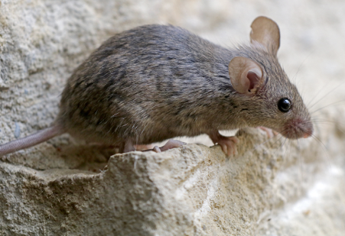  Photo credit: Shutterstock | The house mouse was introduced to Australia via European ships in the late 1700s. It is now ubiquitous across Australia, including numerous offshore islands. The species is variable in colour ranging from blackish to mid grey, grey-brown or yellow-brown (above parts), with lighter underparts of whitish, pale cream-yellow or pale grey-brown. The tail is pinkish-brown to dark brown, sparsely haired and approximately equal to or slightly longer than the head-body length. The ears are large and rounded, and the eyes are quite small (especially in comparison to some Pseudomys species). Female house mice have five pairs of teats, compared with two pairs in Pseudomys. The house mouse has a strong musty odour and can be aggressive when handled
Sexual dimorphism | No sexual size dimorphism
Adult morphometrics | Body weight: 8–25 g  Head and body length: 60–100 mm  Tail length: 75–95 mm

Introduced Species | Black rat - (Rattus rattus)
General appearance  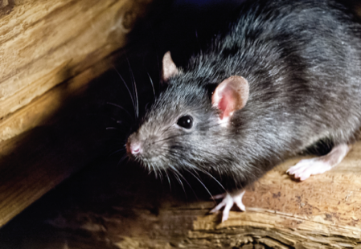  Photo credit: Shutterstock | Black rats were introduced to Australia, via European ships, likely with the First Fleet, and are now found across many urban, rural and natural environments. They have sleek, shiny fur with colours ranging from black to mid-grey or pale creamy brown (above parts), and with creamy white to pale yellow underparts. The fur on the tops of their feet is pale to white with black guard hairs. Notably their tail length is significantly longer than their head-body length, and their tail is slender and sparsely haired with obvious overlapping rings of scales. They have a long nose, large eyes and long rounded ears. They are very good climbers and are often found in roofs and trees, unlike native Victorian rodents. They are social and the presence of one rat generally indicates the presence of many others
Sexual dimorphism | Males are slightly larger than females
Adult morphometrics | Body weight: 95–340 g  Head and body length: 165–220 mm  Tail length: 185–245 mm

Introduced Species | Brown rat (Rattus norvegicus)
General appearance  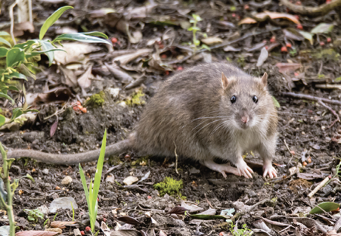  Photo credit: Shutterstock | Despite its species name (norvegicus, Norway rat) the brown rat is originally from Central Asia. This is a larger (up to double the size) species than the black rat and can be more aggressive when cornered or handled. They are a stockier rat with a rounded head and blunter muzzle than the black rat. They are generally a warm dark brown (above parts), with darker shading on their heads and paler shading on their flanks. The underparts are yellow-grey to cream coloured. However, the colours can be very variable with uniformly very dark or very pale animals possible  The brown rat has smaller eyes and shorter ears than the black rat, and longer whiskers. Their tail is grey-brown and shorter than their head-body length and is quite thick with overlapping scales. They are not particularly adept at climbing but are good swimmers. The species is most found in coastal and urban areas
Sexual dimorphism | Males are larger than females
Adult morphometrics | Body weight: 200–500 g  Head and body length: 180–255 mm  Tail length: 150–215 mm

8.3. Animal and human
safety considerations
In general, animals in the wild have limited contact with people, pets, and the hustle and bustle of our daily lives. When sick, injured or orphaned wild animals come into care this unnaturally close contact can carry risks to the health and safety of both people and animals. For general information on biosecurity and approaches to minimise these risks see Part A of these guidelines. Specific information on enclosure hygiene and biosecurity for native rodents is in Section 8.6.2.
The following information relates to human and animal health and safety considerations specifically related to the rehabilitation of native rodents.

8.3.1. Human safety considerations
- Physical injury such as bites and scratches.
- Disease risk particularly from faeces, urine, saliva and nesting material.

8.3.2. Animal safety considerations
- Stress and shock.
- Overheating.
- Injuries – wounds, broken limbs.
- Risk of injury to the tail – the tails of most Australian rodents are highly fragile and should not be held to restrain animals.
- Restrain and contain animal securely to prevent further injury.

8.4. Capture, restraint, and transport
STOP – A visual examination must be done BEFORE the animal is captured. This applies to the initial capture from the wild as well as prior to captures which occur during time in captive care. See Section 8.4.1 for information on what to look for when conducting a visual health assessment.
Refer to Part A of these guidelines for general advice on wildlife welfare, biosecurity and hygiene, and record requirements. The following information relates to the capture, restraint, and transport of sick, injured and orphaned native rodents.

8.4.1. Visual observations
Visual observations of wildlife should be conducted prior to any attempts to capture the animal. This is just as important prior to the first capture from the wild as it is before any capture conducted while an animal is in captive care. Observations should be conducted quietly, by one person, and from a distance which provides a clear view of the animal with as little disturbance as possible. Visual observation should focus on the animal’s demeanour, behaviour, movement and posture, looking for evidence of injury/severe disease or deterioration and observe their breathing as demonstrated in the following table.
Table 8.3: Visual health observations in native rodents
 | What to look for
Demeanour | - Healthy rodents should be alert and exhibit natural behaviours such as foraging, grooming, swimming (species dependent)
Behaviour | - Rodent should be alert to movement and sound (ears moving and listening), and exhibit predator avoidance by fleeing from stimuli such as noise and movement  - If the rodent is unwell, it may not move away quickly or at all  - Nose sniffing the air, preening whiskers, hopping, swimming, balancing on hind legs etc. are all normal, healthy rodent behaviours
Movement and posture | - Movement should be a fluid movement, no limping on a particular foot/leg  - If the rodent is unwell its movement may be slow or a ‘wobbly’ type movement  - The posture should be symmetrical and look similar on either side of the rodent  - The posture should not look ‘hunched over’ and swaying. A hunched appearance with higher shoulders than head or hips is indicative of an unwell rodent  - All limbs should be functional including the tail (not dragging or trailing)
Breathing | - Breathing should not be laboured/extremely fast paced  - Open mouth breathing instead of through the nose indicates potential breathing issues  - Wheezing, gurgling or crackling sounds while breathing may also indicate breathing difficulties  - There should be no blood or coloured discharge from the mouth or nose  - There should be no excessive salivation

8.4.2. Equipment
- Traps: Elliott trap – small rodents; cage trap – larger rodents (see trap images).
- Hand net: Material or mesh net (see image), to prevent the animal becoming entangled or escaping.
- Catch bag: Calico bags or thick cotton bags (see Figure 8.1) are best and prevent injury to the native rodent once inside the bag. Turn bags inside-out for use, so the rodent cannot catch their nails on the threads.
- Towel
- Transport container: Ventilated plastic (see image) or wooden container lined with a cotton t-shirt, towel or any suitable material that will not entangle the rodent (no loops in fabric that may snag nails).
- Gloves: Gloves (see image) to protect rescuer/handler from bite injuries.
Figure 8.1: a. Elliott trap. b. Cage trap. c. Hand net. d. Gloves. e. Calico bag. f. Transport container
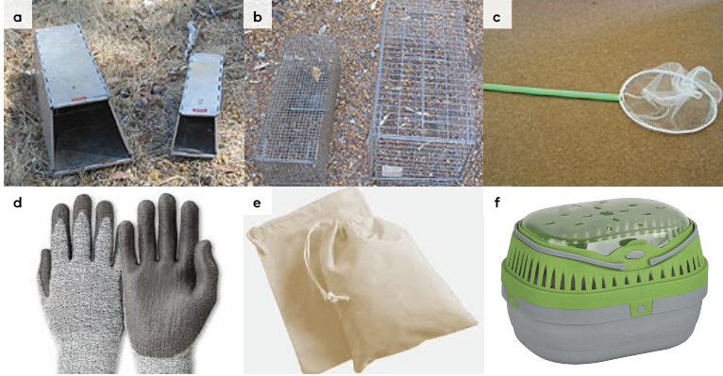

8.4.3. Technique
It is beyond the scope of these guidelines to outline techniques for every situation that may be encountered. Examples of techniques for some specific situations are outlined in the following section.
In addition to this information, please also refer to the recommended reading list, zoological institutions, veterinarians and/or wildlife experts for further advice. Inexperienced rescuers should request assistance where possible.
- Rodents can be restrained with one hand holding either side of the back of the head, using the thumb and index finger, while the palm of the same hand restrains the body. This can be done with bare hands or through a bag or towel. Be firm but careful not to block the rodent’s airway. For larger rodents, such as water rats, a second hand is required to restrain the base of the tail.
- Never restrain by the tail alone, as this can lead to degloving injuries (the skin is stripped off the underlying muscle).
- Restraint time should be kept as short as possible.
Figure 8.2: Restraint technique for a small rodent (shown on an antechinus). Photo credit: Zoos Victoria
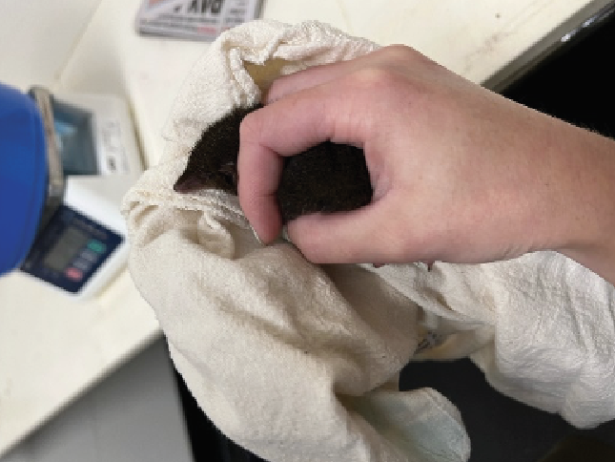

8.4.4. Transport
- All native rodents should be transported as quickly, efficiently and and safely as possible to minimise stress to the animal.
- Once the animal is in the transport container, ensure the container is securely locked and/or closed.
- In the vehicle, place the transport container in the passenger cabin of the vehicle to minimise container movement. Strap the transport container securely with the seat belt so it doesn’t move around in the vehicle, and ensure the vehicle is as quiet as possible.
- Native rodents can easily over-heat when stressed. Once the transport container is inside the passenger cabin of a vehicle ensure temperature is maintained around 18–22°C.
- If the transportation time will be longer than 20 minutes, consider adding, for example, shredded paper or an old t-shirt for shelter.
- Shade container from direct sunlight through the vehicle windows using, for example, towels or a jacket as a makeshift window cover.

8.5. Monitoring animal health and welfare
The goal of wildlife rehabilitation is to address health and welfare concerns quickly and effectively so wildlife can be released back to the wild as soon as possible. Decision-making from the time of capture through to release should be guided by an accurate understanding of the animal’s true state of health and welfare. Careful monitoring throughout the rehabilitation period ensures that significant issues, or deterioration in health condition, are identified immediately and rapidly addressed.
It is preferred that all sick, injured or orphaned wildlife be assessed by a veterinarian to ensure that non-obvious signs of trauma or disease can be assessed and treated as soon as practicable. No medication should be provided prior to this assessment, as this can mask clinical signs and make an accurate health assessment by the veterinarian very difficult.
Templates for record-keeping visual and physical observations and daily care can be found in Part A of these guidelines.
Please note: A common behavioural response to chronic high-level stress is ‘learned helplessness’. This is exhibited as increasingly passive behaviour in response to aversive stimuli and can be misinterpreted as having ‘settled in’ or being ‘relaxed’ or ‘chilled out’. Carers should always aim to treat animals as efficiently as possible so that they can be returned to the wild in the shortest possible time.
This section provides guidance on health assessment on arrival and on effective monitoring of the health and welfare of individuals in care. Minimising human-animal interactions and stress to the animal maximises successful release back to the wild.

8.5.1. Physical examination
Once visual observations are complete, and the animal is stable enough to withstand capture and handling, a basic physical examination should be conducted. This can be repeated as required any time the carer has the animal in the hand, such as for an enclosure change. However, if a full physical exam is not conducted, body condition and weight should be assessed every time the animal is in the hand for other reasons. Carers should make sure scales are available and ready to use before capturing the animal. Physical examinations are also required if the carer notices any changes suggestive of deteriorating health or an injury.
Always record the physical examination findings, so that you can compare findings as the animal’s rehabilitation progresses. This ensures any health concerns are identified as soon as possible, and the carer can plan release as soon as appropriate. A template for recording physical examination findings can be found in the appendices to Part A of these guidelines.
Examinations should be conducted in a quiet location, away from any domestic animals. Only one person should handle the animal, while a second person takes notes. All other people should move away and noise kept to a minimum. Handling should also be kept to a minimum, with careful monitoring for any signs of distress (such as panting, salivating, vocalisation, or sudden deterioration in demeanour). If these are seen, the examination should be stopped immediately, and the animal returned to its catch bag, transport box or enclosure and allowed to recover.

Species specific considerations:
- Physical examination of native rodents can be difficult due to their size. They may bite and can be difficult to restrain without harming the animal, due to their small size. An anaesthetic by a veterinarian may be needed.
- Table 8.3 provides additional guidance on what to look during physical examinations.
- Observation through a clear sided container or while in a calico bag may facilitate a conscious exam.
Table 8.4: Physical examination of native rodents
 | What to look for
Body weight | Weight ranges are variable between species, juveniles, subadults and adults. Weights given in Table 8.1 are for adults.
Body condition | A healthy rodent will have a rounded body shape.  Body condition can be assessed for smaller animals by the prominence of the spine. Condition can also be judged by body weight with reference to the normal weight range for that species. Body condition can be described as follows:  - Under condition: Backbone can be easily felt (and seen) on top and sides.  - Ideal condition: Backbone can only be felt on top. Sides are covered with muscle.  - Over condition: Difficult to feel the backbone.
Hydration status | The skin slides easily over the shoulder blades/spine, and when the skin is ‘tented’ (or gently pinched up) over the spine/between the shoulder blades it should fall back within 1 second. Do not pinch suspected Pseudomys or Notomys species as their skin can be delicate.  Rodents which are dehydrated may have dry looking gums, sunken eyes and a slow skin tent.
Eyes | The eyes should be ‘clear’, open and have no discharge.  Not white or cloudy.
Ears | Clean, no blood or discharge present, intact and functional.
Mouth | Should be dry around the edges – no signs of drooling or blood.
Skin and coat condition | Skin and coat should be smooth and clean. No infected wounds, rashes or lumps on skin present. There shouldn’t be excessive hair loss/patches, but rodents may have patchy hair loss naturally from fighting.
Limbs, feet, and tail | All rodents should have four limbs present and functional. Note missing toes, missing tail.  A healthy rodent will move well on all limbs.  Missing or damaged tails are not a cause for concern. Animals should not be taken into care for old tail injuries.  Native rodent tails may be easily broken or removed under pressure, which is likely a natural technique to escape predator attack. Animals should not be taken into care for tail injuries. Exposed tail bone in Pseudomys species will be dealt with by the animal itself.  Never hold a native rodent by the tail or apply pressure to the tail if it is suspected to be a Pseudomys species. Pseudomys and some other native rodent species may slough off their tail skin if pressure is applied.
Sex determination | - Sex can be determined by examining the animal gently for testes in males (or a darker patch in juveniles where the testes will develop in some species), and for obvious nipples in lactating females.  - Males have a longer distance between the base of the genital papillae and the anus, while females have a shorter distance (often by up to half), but this can be difficult to determine unless experienced with each species.
Figure 8.3: Physical examination for sex determination. a. Lactating female new Holland mouse. b. Male adult new Holland mouse. Photo credit: Kristy Williams, Zoos Victoria
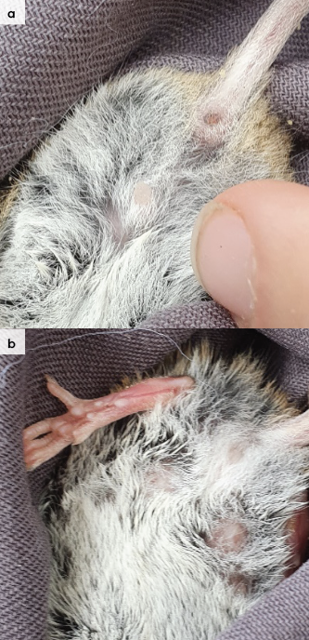

8.5.2. Ongoing monitoring of health and welfare
The aim of wildlife rehabilitation is to ensure animals recover and can be released back to the wild as quickly as possible. Careful, daily monitoring is required to ensure that animals are responding as expected to the treatment being provided and so that any deterioration or welfare concerns can be identified and addressed as soon as possible. Rehabilitators should ensure that record-keeping is a priority to maximise positive welfare outcomes. Templates to assist wildlife rehabilitators to record and monitor wildlife health and welfare can be found in the appendices to Part A of these guidelines. These records will be valuable tools to share with veterinarians to support decision-making.
The following is recorded daily:
- demeanour
- food consumption
- faecal/urine output
- behaviour observed
- medical treatment provided
- evidence of overnight activity.
The following is recorded weekly:
- weight
- body condition.
Over time, regular monitoring will also help to develop carer skills and knowledge, as regular observations and recording will result in a deep understanding of the expected behaviour and response to treatment for the species in care.

Species specific considerations:
- Time your health and welfare observations for times of the day when the rodent is expected to be active, for example, is the species nocturnal? Most Australian native rodents are nocturnal, though some may be active in daylight hours. The animal should be observed at least daily.
- If the animal is being medicated, a visual check in the morning is recommended.
- Ideally physical observations should be undertaken at the beginning and/or end of the resting period to minimise disturbance and maximise the rest/sleep period for rapid healing and ensure ease of capture.
- Note the animal’s demeanour and behaviour every time food is introduced or taken away, the animal is medicated, or the enclosure is cleaned. Pay particular attention to any changes that have occurred since the previous day.
- Note faecal consistency daily. If diarrhoea is noticed, a faecal sample should be collected and submitted to a veterinarian for assessment as soon as possible. Do not treat on suspicion of a bacterial or parasitic infection as this can make definitive diagnosis difficult and potentially prolong the course of the disease.

8.5.3. Common and emerging health conditions
Clear guidance on conditions that may require euthanasia can be found in Part A of these guidelines.
Table 8.4 lists common clinical signs and possible causes of injury/disease. Carers should be aware that these are not exhaustive. Aside from first aid, carers should avoid administering medications prior to the provision of veterinary advice.
Unusual clinical signs or mass mortality events – a number of animals dying or found dead at the same time, with similar signs – may indicate an emergency animal disease, an emerging/new infectious disease or an environmental/human related toxicity which needs further investigation. Report these immediately to the Emergency Animal Disease Watch Hotline on 1800 675 888 (24 hours).
Table 8.5: Common injuries and clinical signs of emerging health conditions seen on presentation or during care
Injuries or Clinical signs | Possible causes | Carer observations and response
Note: Do not provide pain relief or other medication, including antibiotics, unless under veterinary guidance and supervision, as these can have severe side effects, particularly in dehydrated/shocked animals. Use of antibiotics when not indicated can contribute to antimicrobial resistance and reduce drug efficacy.
Unable to walk or move normally  Paralysis  Swollen limb  Bruising  Fractures  Dislocation | Found adjacent to road/suspect motor vehicle accident,  Caught in fence or wire  Predation injury caused by raptor, bird, fox, cat or dog  Conspecific fighting  Capture injury  Injury sustained in captivity  Being crushed | - Urgent veterinary attention is required. Do not delay transfer to veterinarian to apply first aid, other than to stop excessive bleeding.  - Move animal to a small transport box to restrict movement. Ensure temperature is appropriate for species and minimise stress.  - Do not attempt to stabilise fractures as this is very painful, and risks making the injury worse. Fracture stabilisation should only be attempted by a veterinarian following physical exam, x-rays and under general anaesthesia.  - Do not provide pain relief or other medication unless under veterinary guidance and supervision, as these can have severe side effects, particularly in dehydrated/shocked animals.  - If suspected as the cause, assess the enclosure to find the source of injury. Fix loose wire/gaps or sharp edges before returning animal to enclosure. See Section 8.6 for Housing information.
Head trauma  Bleeding from nose, mouth or eyes  Swollen eye lids, blood present in eye  Abnormal behaviour  Mouth swelling, missing teeth  Lethargy | Found adjacent to road/suspect motor vehicle accident,  Caught in fence or wire  Predation injury caused by raptor, bird, fox or dog,  Capture injury  Injury sustained in captivity  Cranial trauma, concussion  Being crushed | - Urgent veterinary attention is required. Do not delay transfer to veterinarian to apply first aid, other than to stop excessive bleeding.  - Move animal to a small transport box to restrict movement. Ensure temperature is appropriate for species and minimise stress.  - Do not provide pain relief or other medication unless under veterinary guidance and supervision, as these can have severe side effects, particularly in dehydrated/shocked animals or animals with head trauma.  - If suspected as the cause, assess the enclosure to find the source of injury. Fix loose wire/gaps or sharp edges before returning animal to enclosure. See Section 8.6 for Housing information.
Bleeding  Puncture wounds  Bruising  Fur loss | Conspecific aggression, breeding season injuries  Found adjacent to road/suspect motor vehicle accident,  Predation injury caused by a bird, raptor, fox, cat or dog  Poorly designed transport box/enclosure  Capture injury  Injury sustained in captivity | - Seek prompt veterinary assessment.  - Euthanasia may be the most humane response if the wounds are extensive.  - Do not provide pain relief or other medication unless under veterinary guidance and supervision, as these can have severe side effects, particularly in dehydrated/shocked animals.  - While bite wounds/scratches may not be immediately obvious, these carry a very poor prognosis and animals often present moribund – very lethargic, poorly responsive and cold.  - Look for small clumps of dried fur stuck together with saliva, part the fur and look for very small puncture wound(s).  - If suspected as the cause, assess the enclosure to find the source of injury. Fix loose wire/gaps or sharp edges before returning the animal to enclosure. See Section 8.6 for Housing information.
Blindness or poor vision  Neurological signs  Wobbly movement or ataxia  Deafness | Infectious disease (e.g. toxoplasmosis or bacterial meningitis), cranial trauma, toxicity (e.g. 1080 poisoning) | - Given the very wide range of causes, carers should seek veterinary advice as soon as possible.  - If unusual toxicity or infection is suspected, you or your veterinarian can contact Zoos Victoria’s veterinary department to discuss options for disease investigation.  - If multiple animals are seen with similar signs, this may indicate a newly emerging infectious disease or a toxicity (e.g. plant toxicity or poisoning) – contact the Emergency Animal Disease Watch Hotline on 1800 675 888 to report concerns.  - The carer may observe the animal bumping into objects in enclosure or fail to respond to short sharp noises (e.g. loud clap from behind animal).  - Pupils may be fixed/dilated and not responsive to changes in light level. You should see pupils constrict if a pen light is shone in the eye.  - Repetitive squinting may indicate that the eye is painful.
Weakness, lethargy, lack of fear of humans, uncharacteristic daytime activity | Rat bait and other poisoning | - Rat bait poisoning is common in black rats observed during daylight hours in urban areas. Animals may be seen hunched over and seemingly unaware of the presence of humans. Baited animals will appear weak and lethargic, not eating.  - Do not mistake with natural daytime grazing behaviours of swamp rats. Swamp rats may commonly be seen foraging, particularly in the morning and evening, and may be unphased by human presence, particularly along popular walking tracks. This is natural and the animals should not be interfered with.  - Baited animals should be euthanised.
Diarrhoea  Loose faeces | Inappropriate diet, infectious disease, alteration of microbiome, stress | - Urgent veterinary advice is required if diarrhoea does not resolve rapidly (within 24–36 hours), or if there is any evidence of dehydration, blood in faeces or change in demeanour.  - Do not treat on assumption of infectious disease (e.g. coccidia or bacterial infection) as this can make veterinary diagnosis more difficult if the animal does not improve.  - Seek taxon expert advice.  - If the animal has been otherwise stable and doing well, there are a number of responses carers may implement to try to resolve diarrhoea. For example consider any recent changes which may have led to diarrhoea and respond by removing inciting cause where possible – e.g. rapid change in diet, unusual levels of sound/intervention or handling, contact with recently arrived animals.  - If milk has recently changed, immediately switch back to previous milk, wait until diarrhoea has resolved and then implement a slower diet change.  - Do not mix oral rehydration fluids in with milk as it changes the digestibility of the milk. Oral rehydration fluids/water can be provided in between milk feeds.  - Ensure excellent hygiene standards to prevent spread to other animals/carer and isolate this animal from any others in care, if possible.
Skin irritation  Fur loss  Presence of mites | Excessive mite infestation, seasonal behaviours, conspecific aggression | - Some fur loss/minor skin lesions are commonly seen due to fighting and mating and do not require any intervention.  - A small number of ticks/mites can be normal, and do not require treatment or removal. However, if there is a very high number of ticks/mites seen, the animal is scratching/irritated, or the skin is red and inflamed – seek veterinary attention to treat ectoparasites.
Bleeding tail injury  Tail fracture | Found adjacent to road/suspect motor vehicle accident,  Caught in fence or wire  Predation injury caused by raptor, bird, fox, cat or dog  Conspecific fighting  Capture injury  Injury sustained in captivity  Being crushed | - Urgent veterinary attention is required. Do not delay transfer to veterinarian to apply first aid, other than to stop excessive bleeding.  - Move animal to a small transport box to restrict movement. Ensure temperature is appropriate for species and minimise stress.  - Do not attempt to stabilise fractures as this is very painful, and risks making the injury worse. Fracture stabilisation should only be attempted by a veterinarian following physical exam, x-rays and under general anaesthesia.  - Do not provide pain relief or other medication unless under veterinary guidance and supervision, as these can have severe side effects, particularly in dehydrated/shocked animals.  - If suspected as the cause, assess the enclosure to find the source of the injury. Fix loose wire/gaps or sharp edges before returning the animal to its enclosure. See Section 8.6 for information on Housing. Never hold a native rodent by the tail or apply pressure to the tail if it is suspected to be a Pseudomys species. Pseudomys and some other native rodent species may slough off their tail skin if pressure is applied.
Figure 8.4: Tail crop on a pookila which is common for native rodents. No intervention is required. Photo credit: P Burns
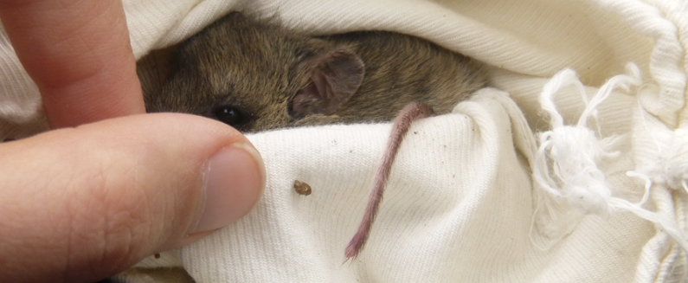
Figure 8.5: Fur loss in a spinifex hopping mouse. This could be due to fighting, mating or a mite infection. The latter can be diagnosed by a skin scraping. Photo credit: Zoos Victoria
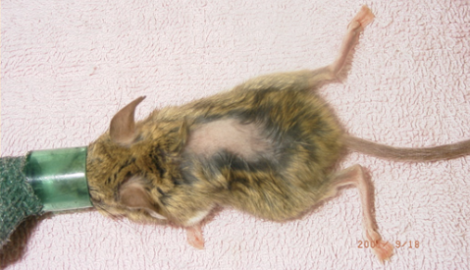
Figure 8.6: Mites associated with fur loss in spinifex hopping mice. Photo credit: Zoos Victoria
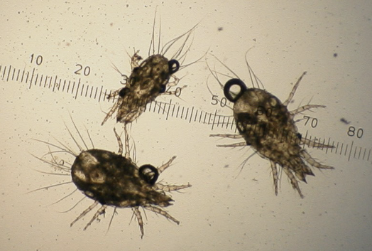

8.5.4. Administering treatment during rehabilitation
- To minimise stress and disturbance to the rodent, service the enclosure (fresh food/water, clean the enclosure) and provide medical treatment at the same time.
- If possible, provide treatment in a favourite food item.
- If there is no alternative and the rodent requires manual restraint to administer medication, prepare the surrounding area prior to treatment, for example have medication ready, towels or calico bag to gently restrain the rodent, and secure the room before removing the rodent from the enclosure.
- Most rodents will be too small to inject so medications are likely to be given orally. A small towel or calico bag can be used to restrain the animal and expose just the mouth for medications.

8.6. Housing
Below are several key considerations when housing adults in care.

8.6.1. General housing information for native rodents
- Adult rodents may be aggressive when stressed and fight each other.
- Except for orphaned young or females with their own young, only one animal should be housed in each enclosure.
- Locate enclosures in secure rooms to allow capture in the event of escape.
- Visual barriers may be placed around enclosures to prevent fear response or aggressive interactions with nearby housed rodents.
- Provide a quiet area and minimise disturbance by shutting doors to rooms containing rodent enclosures.
- Loud noise and disturbance are a stressor for rodents.
- Keep rodents in enclosures that are separate from domestic animals so that they do not see, hear or smell them.
- Change out of clothes that have been worn around dogs or cats to minimise exposure to pet scent.

8.6.2. Enclosure hygiene and biosecurity
General information about hygiene and biosecurity can be found in Part A of these guidelines. New diseases emerge frequently and sick and injured animals in care are often more susceptible to picking up pathogens from the environment. It is important to maintain excellent levels of hygiene to avoid inadvertently transferring diseases between animals, and from humans, and to protect the wild population where the animal will eventually return to.

Species specific considerations:
- Wash hands with soap and water after handling dogs and cats to minimise the risk of transferring disease agents such as Toxoplasma gondii, which can be found in cat faeces.
- Left-over food and faecal matter should be spot cleaned daily from enclosures to ensure good levels of hygiene are maintained.
- Any wet/sodden or soiled organic furnishings, substrate or enrichment items must be removed as soon as possible and replaced with a clean/dry alternative.
- Since these enclosures are used to house sick/injured rodents, they must be cleaned and disinfected between inhabitants.
- Substrate should be completely replaced and furniture, such as branches or boxes made of unsealed wood, should be discarded as they cannot be effectively disinfected.
- Enclosures should be cleaned with hot soapy water and then disinfected with products such as F10 or bleach at the recommended concentrations and contact times.

8.6.3. Housing types
Different set ups are required for animals at different stages of treatment and care.
Table 8.6 describes the housing type, suggested dimensions and requirements at each stage of care. For information on housing animals during hand raising see Section 8.8.
Table 8.6: Rehabilitation housing for adult native rodents
Intensive care housing
Indications for use | Suggested min. dimensions | Suggested requirements
Short term critical care (<48 hours)  Intensive veterinary treatment – frequent medication, oxygen supplementation, temperature control  Longer periods under veterinary supervision where strict cage rest/confinement is indicated | Water rats:  Floor area: 1 m x 1 m (1 m²)  H: 0.5 m  Small to medium mice and rats:  Floor area: 0.30 m x 0.20 m (0.06 m²)  H: 0.2 m | ENCLOSURE CONSTRUCTION  - Purpose-built incubators, such as a Vetario (see image) or strong fish tank with a close-fitting lid with adequate ventilation.  - A solid wood enclosure or plastic tub for water rats as they can damage their teeth on wire in cage enclosures.  ENCLOSURE FURNISHING  - A timber nest box should be offered for adults  (see Figure 8.10).  - Newspaper is suitable as flooring.  - Orphaned young should be housed in nests inside an escape-proof container that has adequate ventilation.  ENVIRONMENTAL VARIABLES  - Sick adult rodents are kept on a heat gradient with the warm end at 28°C.  - Heating pads are commonly used.  - All heating should be monitored with a thermometer.  PROVISION OF FOOD/WATER  - Access to fresh water, changed daily, and captive diet should be provided in stable dishes.  - Regular check of substrate to ensure water has not spilt/enclosure is not sodden.

Intermediate housing (Treatment/cage rest)
Indications for use | Suggested min. dimensions | Suggested requirements
Provision of daily medication, close monitoring once animal is stabilised and no longer requires intensive care.  Enclosure furnishings can be arranged to reduce opportunities to move excessively so that cage rest can be achieved with slightly more space/reduced contact. | Water rats  Floor area: 1 m x 2 m (2 m²)  H: 1 m  Small to medium mice and rats  Similar to pre-release enclosure sizes | ENCLOSURE CONSTRUCTION  - Mice and smaller rats can be housed in a glass tank (see Figure 8.8) or solid wooden container.  - Water rats may be housed in aviaries with solid metal walls.  ENCLOSURE FURNISHING  - Leaf litter or mulch is suitable flooring.  - For smaller rodents, pine shavings can be used.  - Furnishings can be arranged to reduce opportunities to climb/dig or move excessively so that ‘cage rest’ can be achieved with slightly more space/reduced contact.  - Nest-boxes should be offered as a sleeping area.  ENVIRONMENTAL VARIABLES  - This housing stage is suitable for sick or injured adults that no longer require heating.  PROVISION OF FOOD/WATER  - Offer insects and seeds in the leaf litter.  - Access to fresh water, changed daily, and captive diet should be provided in stable dishes.

Pre-release
Indications for use | Suggested min. dimensions | Suggested requirements
No longer require regular handling/medication  Development of fitness/strength prior to release  Monitor/assess behaviour (foraging, digging, nest building)  Enclosure allows expression of a full range of natural behaviours  Pre-release assessment | Water rats  Floor area for one animal:  3 m x 2 m (6 m²)  H: 2 m  Nest box: 25 cm x 30 cm.  H: 55 cm. Entrance hole diameter: 8.5 cm  Medium sized rodents  Floor area for one animal: 1.5 m x 1.0 m (1.5 m²)  Nest box: 25 cm x 17 cm.  H: 11 cm. Entrance hole diameter: 5 cm  Small rodent  Floor area for one animal: 0.60 m x 0.50 m (0.30 m²)  H: 0.30 m  Nest box: 14 cm x 12 cm.  H: 10 cm. Entrance hole diameter: 3.2 cm | ENCLOSURE CONSTRUCTION  - Water rats require walls made of solid tin or wood. One third of the enclosure sheltered from the weather. A shallow pool to be provided for swimming. Nest boxes made from plywood.  ENCLOSURE FURNISHING  - Non-toxic pine shavings or newspaper. Concrete floors can damage feet. Wire mesh buried below the soil surface will prevent animals digging out. Offer nest material such as Melaleuca, paperbark or dried grass.  - Logs, rocks, tussocks, sturdy branches for climbing, nest box or hollow log.  - Deep leaf litter mulch, tussock clumps for hides and branches for climbing. Nest boxes lined with eucalyptus leaves, washed and dried sea grass (check local authority for sea grass collection approval) or shredded paper.  ENVIRONMENTAL VARIABLES  - This housing stage is suitable for sick or injured adults that no longer require heating and are nearing release. They should be exposed to ambient outdoor temperatures with sheltered exposure to prevalent weather conditions.  PROVISION OF FOOD/WATER  - Access to fresh water, changed daily, and captive diet provided in stable dishes.
Figure 8.7: Vetario, suitable for intensive care.
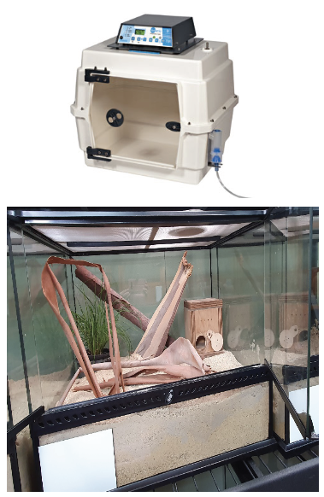
Figure 8.8: Glass tanks – Intermediate housing examples (treatment/rest)
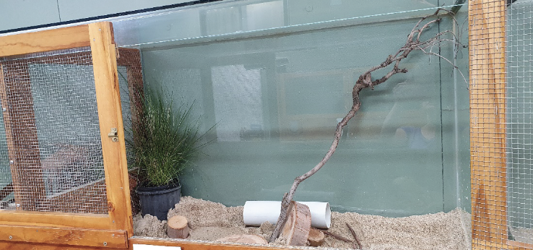
Figure 8.9: Large glass tank enclosure
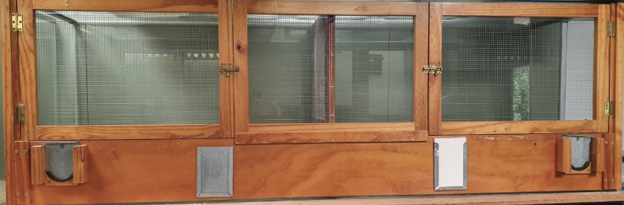
Figure 8.10: Medium to small rodent timber nest box. Photo credits: Zoos Victoria
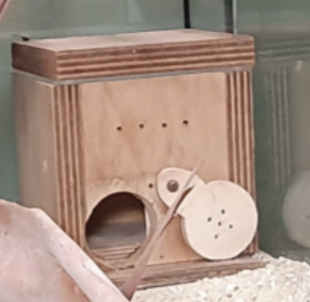

8.7. Feeding and nutrition
Keeping daily records of food offered (item and volume fed) and food consumed is good practice and will allow the rehabilitator to observe how an animal is responding to food on offer and inform future choices.
Please note: Food suppliers and specific products mentioned in these guidelines are intended as examples only. Other suitable products may also be available.
This section refers to feeding and nutrition of weaned and adult native rodents in rehabilitation. Information on feeding orphaned individuals can be found under Section 8.8 Hand raising.
- Fresh water must be always available, provided in a stable/non-spill bowl or automatic drinker. Water must be changed daily. Care must be taken that small animals cannot become trapped or drown in the water dishes.
- Ensure food is provided in an aluminium or ceramic dish that is easily sterilised and cannot be chewed on.
- Always provide fresh food daily, cut to appropriate size.
Table 8.7: Daily feeding and diet guide for adult native rodents during rehabilitation
Species | Water rat
Diet – daily diet options per animal | - 4–6 yabbies or 8–10 yabby tails (approximately 180 g total), or  - 1–2 medium size fish (e.g. pilchards/whiting), or  - 2 x day-old chicks, or  - ½ packet prawns and 8 pippis/mussels
Pre-release considerations | - The rodent must be able to swim, dive and feed without aid prior to release
Frequency/time of feeding | - Fed daily, preferably late afternoon as they are nocturnal

Species | Swamp rat
Diet | - 10–15 g seed (millet, sorghum, safflower mix)  - 10 g fruit (1 cm cube) (may include carrot)  - 10 g greens e.g. silverbeet, sow thistle, spinach  - 2 mealworms  - 2 g rodent pellets  - Native sedges, grasses
Pre-release considerations | - The native rodent should be able to move well and eat unaided prior to release
Frequency/time of feeding | - Fed daily

Species | Australian bush rat
Diet | - 10 g seed (millet, sorghum, safflower mix)  - 10 g fruit (1 cm cube) (may include carrot)  - 10 g greens e.g. silverbeet, sow thistle, spinach  - 2 mealworms  - 2 g rodent pellets  - Fungi (mushroom) – as available
Pre-release considerations | - The native rodent should be able to move well and eat unaided prior to release
Frequency/time of feeding | - Fed daily, preferably late afternoon as they are nocturnal

Species | Silky mouse
Diet | - 10 g seed (millet, sorghum, safflower mix)  - 10 g fruit (1 cm cube) (may include carrot)  - 10 g greens e.g. silverbeet, sow thistle, spinach  - 2 mealworms  - 2 g rodent pellets
Pre-release considerations | - The native rodent should be able to move well and eat unaided prior to release
Frequency/time of feeding | - Fed daily, preferably late afternoon as they are nocturnal

Species | Smoky mouse
Diet | - 10–15 g high fibre vegetables (broccoli, sweet potato, carrot)  - 10–15 g seed (millet, sorghum, safflower mix) (or acacia/banksia)  - 10–15 g fresh greens, vegetation (silverbeet, grass, browse)  - 2 mealworms  - Fungi (mushroom) – as available
Pre-release considerations | - The native rodent should be able to move well and eat unaided prior to release
Frequency/time of feeding | - Fed daily, preferably late afternoon as they are nocturnal

Species | Heath mouse
Diet | - 10 g seed (millet, sorghum, safflower mix)  - 10 g fruit (1 cm cube) (may include carrot)  - 10 g greens e.g. silverbeet, sow thistle, spinach  - 2 mealworms  - 2 g rodent pellets
Pre-release considerations | - The native rodent should be able to move well and eat unaided prior to release
Frequency/time of feeding | - Fed daily

Species | New Holland mouse
Diet | - 2–4g seed (millet)  - 4 g high fibre vegetables (broccoli, sweet potato, carrot)  - 10 g greens e.g. silverbeet, sow thistle, spinach  - 2 g rodent pellets
Pre-release considerations | - The native rodent should be able to move well and eat unaided prior to release
Frequency/time of feeding | - Fed daily, preferably late afternoon as they are nocturnal

Species | Mitchell’s hopping mouse
Diet | - 10 g Wombaroo Macropod Pellet  - 2 g spinach – chopped  - 8 g broccoli – chopped  - Twice weekly:  - 4 g mushroom – chopped  - 1 mealworm or cricket
Pre-release considerations | - The native rodent should be able to move well and eat unaided prior to release
Frequency/time of feeding | - Fed daily, preferably late afternoon as they are nocturnal

Species | Broad-toothed rat
Diet | - 20 g Wombaroo Macropod Pellet  - 15 g seed (millet, sorghum, safflower mix)  - 20–25 g greens e.g. silverbeet, sow thistle, spinach  - Native sedges, grasses  - Fungi (mushroom) – as available
Pre-release considerations | - The native rodent should be able to move well and eat unaided prior to release
Frequency/time of feeding | - Fed daily, preferably late afternoon as they are nocturnal

8.8. Hand raising
Hand raising recording templates for growth, development, feeding and other observations can be found in the appendices to Part A of these guidelines.

8.8.1. Equipment required for hand raising
- Catheter, pipette, fine paintbrush
- Small teat
- Syringes
- Pouches
- Scales
- Cotton tips, soft cotton cloth, tissues – for toileting
- Small ruler for measurements
- Kettle (or stove top) for boiling water
- Puppy formula
- Sterilising solution such as Milton
- Heat pad, hot water bottle (filled with warm water only and wrapped in a towel)
- Soft t-shirt material or blankets.

8.8.2. Feeding orphaned young
Ensure standard hygienic practices are implemented for hand rearing orphaned young, including:
- Washing hands prior to and after each feed
- Mixing formula with boiled water only – cooled to lukewarm prior to feeding
- Sterilise feeding equipment
- Provide clean bedding
- Stimulate toileting.
Young rodents cannot clean themselves, so it’s important you maintain standard hygiene practices.
Note: When toileting a young rodent extreme care is required. Gently stimulate the area. Do not over-stimulate as this may result in a bowel prolapse. If the animal has not urinated or defaecated within 30 seconds – or is not showing signs that it is about to, cease toileting.
Table 8.8: Feeding and housing requirements for juvenile native rodents
Age | Weight/morphometrics | Observations | Feeding | Housing
10–20 days | Water rats  100 g/18 cm  Medium rats  20–45 g/6–10 cm  Mice  3–6 g/2.5–4 cm | - Water rats can swim at 14 days, and dive to and from the nest at 19 days  - Eyes open  - Ears open  - Covered in fur  - Guard hair has grown | Milk formula:  - Puppy milk replacement (e.g. Wombaroo) follow the manufacturer’s instructions  Feed volume and frequency:  - Young should be fed 10–20% of their body weight each day  - Teeth should have erupted, start offering solids such as small slices of apple, sweet potato, broccoli, greens (silverbeet, spinach)  - Milk feeding schedules can be reduced depending on the young rodent’s weight (should be increasing), overall body condition and quantity of solid foods being eaten  Feeding technique:  - Use a small teat. You can also start to offer a small amount of the formula in a small ‘rodent sized’ dish i.e. a small non-tippable petri dish made of glass or ceramic  - The rodent will start to transition itself off the formula and become more interested in nibbling at the solid foods offered  Toilet:  - After feeding, young must be stimulated to toilet, very gently, with a soft, disposable cloth, tissue or cotton tip, dipped in warm water. At this stage young rodents may be starting to toilet on their own, monitor. | Bedding material:  - Soft t-shirt material, blankets (no knitted material the mice can become entangled in)  - Add in wood shavings, sphagnum moss, native grasses  Enclosure:  - Secure box or thermostatically controlled, portable animal intensive care unit  Temperature range:  - 20–28°C  (at this stage remove any ‘chewable’ heat sources if not chew proof)  - It is important to continually monitor temperature range
4–6 weeks | Water rats  620–1200 g/30–39 cm  Medium rats  160–225 g/20–23 cm  Mice  13–18 g/  5–6 cm | - Weaning age  - First moult can occur | Milk formula:  Puppy milk replacement (e.g. Wombaroo) follow the manufacturer’s instructions  Feed volume and frequency:  Young should be fed 10–20% of their body weight each day  A small amount of formula may still be offered in a small ‘rodent sized’ dish i.e. a non-tippable small petri dish made of glass or ceramic  Majority of the diet offered will be solids such as small slices of apple, sweet potato, broccoli, greens (silverbeet, spinach)  Fresh water in a very small dish should now be supplied  Feeding technique:  Offer a small amount of the formula in a small ‘rodent sized’ dish i.e. a small petri dish made of glass or ceramic  The rodent will start to transition itself off the formula and become more interested in nibbling at the solid foods offered  Toilet:  At this stage young rodents may be starting to toilet on their own, monitor.  If not, young must be stimulated to toilet after feeding, very gently, with a soft, disposable cloth, tissue or cotton tip, dipped in warm water | Bedding material:  Water rat  - Nest box: 25 cm x 30 cm. H: 55 cm. Entrance hole diameter: 8.5 cm, lined on the base with towels  - You can provide native plants e.g. Eucalyptus sp., Acacia for nesting material and to chew on  Medium rats and mice  - Add in wood shavings, sphagnum moss, native grasses  - Add in wood shavings, native grasses  Enclosure:  Water rat  - At day 19, water rats require a small secure area with access to a waterbody such as a clam pool. Swimming must always be monitored to prevent drowning  - Nest box should have a heat source at one end  Medium rats and mice  - Rodents should have access to a secure area with a nest box  - Nesting material (e.g. wood shavings, native grasses, eucalyptus leaves) provided  Temperature range:  - 15–25°C

8.9. Release protocol
Ideally, wild animals will be rehabilitated and released in a short timeframe. If this is not possible and the animal is in care for significant extended periods, ensure that the animal is regularly assessed against the welfare domains to support decision-making. Animals in care for extended periods may have a reduced ability to survive in the wild. Talk to your veterinarian and consider whether euthanasia will provide the best welfare outcome for the animal.

8.9.1. Pre-release assessment
Pre-release assessment of animals in care is essential to support improved outcomes once back in the wild. Animals should be assessed based on body condition, fitness and the ability to engage in natural species-specific behaviours prior to release. The following check list should be used to guide your decision-making regarding release suitability for native rodents:
- Rodent is in a state of good health – presenting injury/sickness is completely resolved (consider pre-release veterinary check).
- Rodent is within a healthy weight range and appropriate body condition (see Table 8.3).
- Rodent displays ability to actively forage for and consume natural foods.
- Rodent displays ability to build nests and seek cover.

8.9.2. At the release site
When releasing animals back into the wild, it is important to consider certain features of the release site and approaches to the release to maximise survivorship. Native rodents require:
- Suitable cover of native vegetation to retreat from predators and provide shelter.
- Wild food source available in species habitat.
- Minimal disturbance by people and traffic to the area.
- Minimal threats including forestry, habitat destruction, pollution and low predator numbers.
- Released where found and where known same species live in the area.

8.9.3. Release checklist
Have you checked to see if you are meeting all the requirements of your authorisation and considered the following:

Release location
Suitable vegetation is available, including grasses and dense lower story vegetation.
- Ample foraging areas close to dense vegetation.
- Dense vegetation cover for nest building.
- Soil layer soft and suitable for foraging/digging.
- Same species living in the wider area.
- No obvious threats (for example future land clearing, pollution).

Release Procedure
- Limit the number of people at the release.
- Appropriate timing (one hour after dusk – during natural peak activity).
- Open transport container away from yourself near dense cover, ensuring that people are standing behind the rodent’s ‘flight’ zone.
- Allow the rodent to leave in its own time.
- The nest box may be left in a safe, well-covered and hidden location. Supplemental food can be placed in the nest box for up to a week to support the animal during the first few days post release.
- Monitor food consumption daily and gradually reduce the amount of food left in the box.

8.10. Key references and additional reading
Breed, B. and Ford, F., (2007). Native mice and rats. Collingwood: CSIRO publishing
Menkhorst, P., & Knight, F (2011). Field Guide to Mammals of Australia (3rd ed.). Oxford University Press
Seebeck, J., & Menkhorst, P (2000). Status and conservation of the rodents of Victoria. Wildlife Research, 27(4), 357. https://doi.org/10.1071/wr97055
Jackson, S. (2003) Australian mammals biology and captive management. CSIRO Publishing, Collingwood, Australia
Geffen E, Rowe KC, Yom-Tov Y (2011) Reproductive Rates in Australian Rodents Are Related to Phylogeny. PLoS ONE 6(4): e19199. https://doi.org/10.1371/journal.pone.0019199
Van Dyck S, Strahan R. The Mammals of Australia. New Holland Publishers
SWIFFT (Statewide Integrated Flora and Fauna Teams) (2022) https ://www.swifft.net.au/
Ford, F., and Burns, P. A. (in press). Smoky Mouse (Pseudomys fumeus). In ‘The Mammals of Australia’. (Eds S. Van Dyck, R. Strahan, and Baker.)
Burns, P. A., Wilson, B.A., and Kemper, C. (in press). New Holland Mouse (Pseudomys novaehollandiae). In ‘The Mammals of Australia’. (Eds S. Van Dyck, R. Strahan, and Baker.)
Burns Phoebe A., Parrott Marissa L., Rowe Kevin C., Phillips Benjamin L. (2017) Identification of threatened rodent species using infrared and white-flash camera traps. Australian Mammalogy 40, 188-197. https://doi.org/10.1071/AM17016
Watts, C.H.S and Aslin, H.J. (1981) The Rodents of Australia.
Angus & Robertson Publishers, Australia
Olsen, P. (1982) Reproductive Biology and Development of the Water Rat, Hydromys chrysogaster, in Captivity. Wildlife Research 9(1):39-53 DOI:10.1071/WR9820039

